Annex 1. Information about studied GW.

Number | LWS | Abbreviation | City | Surface | Year of plantation | Picture
1 | Sibelga | Sbg | Brussels | 305 m² | 2016 | 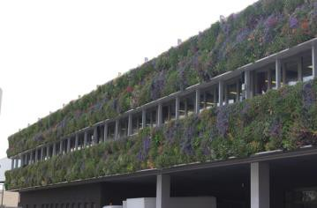
2 | Brussels Parliament | Pbx | Brussels | 74 m² | 2007 | 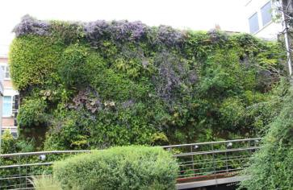
3 | Street Traversière | Tvs | Brussels | 44 m² | 2021 | 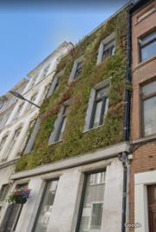
4 | Royal Snail hotel | RSn | Namur | / | 2013 | 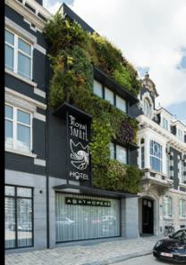
5 | Docks Bruxsel | Dks | Brussels | / | / | 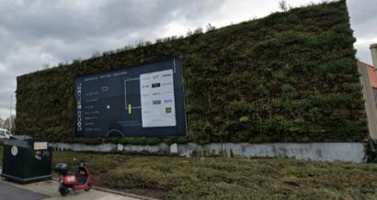
6 | Street Ernest Cambier | ECb | Ath | / | 2021 | 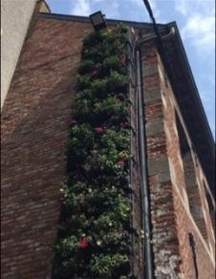

Annex 2. Name of the databases used, with their references.

Name | Reference | Website
TRY | (Kattge et al., 2011) | https://www.try-db.org/TryWeb/Home.php
Tela Botanica | (Tela Botanica, n.d.) | https://www.tela-botanica.org/
LEDA | (Kleyer et al., 2008) | https://uol.de/en/landeco/research/leda/data-  files
UCONN | (Lehrer & Brand, 2003) | https://plantdatabase.uconn.edu/index.php
eFloras | (Brach & Song, 2006) | http://www.efloras.org/index.aspx
North Carolina Extension Gardener  Plant Toolbox | (NC State University & N.C. A&T State University, n.d.) | https://plants.ces.ncsu.edu/

