Supplementary material 1
The following tables describe the hospital resources required for providing (A) EECC and (B) AOS and (C) the subset of these resources that are included in the costing.
EECC is defined according to the global consensus: Schell CO, Khalid K, Wharton-Smith A, Oliwa J, Sawe HR, Roy N, et al. Essential Emergency and Critical Care: a consensus among global clinical experts The EECC Collaborators. BMJ Global Health. 2021;6:6585. It includes only the care that supports and stabilises vital organ functions, and does not include the definitive care of the underlying pathology, or other care that is provided (see figure 1).

(A) Essential Emergency and Critical Care (EECC) Hospital Resource Requirement List
Below are the resources required for hospitals to be ready for the identification of critical illness and the care of critical illness in EECC. The resources are divided into categories of equipment, consumables, drugs, human resources, training, routines, guidelines, and infrastructure. Each resource item appears only once.
IDENTIFICATION
The following items are required for a hospital to be ready for the identification of critically ill patients in EECC.
CATEGORY | ITEM
- EQUIPMENT | 1.1.1 Clock with second hand  1.1.2 Pulse oximeter & probe  1.1.3 BP measuring equipment (eg. sphygmomanometer with a stethoscope)  1.1.4 BP cuffs of different paediatric and adult sizes  1.1.5 Light source (lamp or flashlight)  1.1.6 Thermometer
1.2 CONSUMABLES | 1.2.1 Soap or hand disinfectant  1.2.2 Examination gloves
1.3 DRUGS | None
1.4 HUMAN RESOURCES | 1.4.1 Health workers with the ability to identify critical illness 24h/day
1.5 TRAINING | 1.5.1 The health workers are trained in the identification of critical illness
1.6 ROUTINES | 1.6.1 Routines for the identification of critical illness
1.7 GUIDELINES | 1.7.1 Guidelines for the identification of critical illness
1.8 INFRASTRUCTURE | 1.8.1 Designated triage area (area for the identification of critical illness) in the Out-Patient Department or Emergency Unit (area of the hospital where patients arrive)  1.8.2 Running water

CARE
The following items are required for a hospital to be ready to provide the essential care of critically ill patients in EECC.
CATEGORY | ITEM
2.1 EQUIPMENT | 2.1.1 Suction machine (electric or manual)  2.1.2 Oxygen supply 24h/day (cylinder, concentrator (with electricity supply) or piped oxygen)  2.1.3 Flow meter (if using cylinder or piped oxygen)  2.1.4 Leak-free connectors from oxygen source to tubing  2.1.5 Bag Valve Mask (resuscitator) – neonatal, paediatric and adult sizes  2.1.6 Sharps disposal container  2.1.7 External heat source
2.2 CONSUMABLES | 2.2.1 Suction catheters of paediatric and adult sizes  2.2.2 Guedel airways of paediatric and adult sizes  2.2.3 Pillows  2.2.4 Oxygen tubing  2.2.5 Oxygen nasal prongs  2.2.6 Oxygen face masks of paediatric and adult sizes  2.2.7 Oxygen face masks with reservoir bags of paediatric and adult sizes  2.2.8 Masks for Bag Valve Mask (resuscitator) – neonatal, paediatric and adult sizes  2.2.9 Compression bandages  2.2.10 Plasters or tape  2.2.11 Gauze  2.2.12 Intravenous cannulas of paediatric and adult sizes  2.2.13 Intravenous giving sets  2.2.14 Skin disinfectant for cannulation  2.2.15 Syringes  2.2.16 Nutrition  2.2.17 Nasogastric tubes  2.2.18 Lubricant for nasogastric tube insertion  2.2.19 Intramuscular needles  2.2.20 Intraosseous cannulas of different sizes  2.2.21 Blankets  2.2.22 Facemasks for Infection Prevention and Control  2.2.23 Aprons or gowns  2.2.24 Charts/notes for documentation  2.2.25 Pens
2.3 DRUGS | 2.3.1 Oral rehydration solution  2.3.2 Intravenous crystalloid fluids (eg. normal saline or Ringer’s Lactate)  2.3.3 Intravenous Dextrose fluid (eg. 5%, 10% or 50%)  2.3.4 Oxytocin  2.3.5 Adrenaline  2.3.6 Appropriate antibiotics  2.3.7 Diazepam  2.3.8 Magnesium sulphate  2.3.9 Paracetamol  2.3.10 Local anaesthetic (eg. 2% lignocaine) (eg. for intraosseous cannulation)
2.4 HUMAN RESOURCES | 2.4.1 Health workers with the ability to care for critically ill patients 24hrs/day  2.4.2 Senior health worker who can be called to assist with the care of critically ill patients 24hrs/day
2.5 TRAINING | 2.5.1 The health workers are trained in the care of critically ill patients
2.6 ROUTINES | 2.6.1 Routines for managing critically ill patients  2.6.2 Routine for the provision of EECC without taking into account patients’ ability to pay  2.6.3 Routines for who and how to call to seek senior help 24hrs/day, 7 days/week  2.6.4 Routines for integrating EECC with other care including the definitive care of the underlying condition (eg. use of condition-specific guidelines)
2.7 GUIDELINES | 2.7.1 Guidelines for the essential care of critically ill patients
2.8 INFRASTRUCTURE | 2.8.1 Designated space for the care of critically ill patients (eg. a bay, ward, high dependency unit)  2.8.2 Areas for separating and managing patients with a suspected or confirmed contagious disease from those without

(B) Advanced Critical Care Resource Requirement List
Advanced critical care is defined as the care of critical illness that is of a higher complexity and resource level than Essential Emergency and Critical Care (EECC). It includes only the care that supports and stabilises vital organ functions, and does not include the definitive care of the underlying condition, or other care that is provided in ICUs or other units (see figure 1). This document describes the resources that are required for hospitals to be ready to provide Advanced Critical Care. As advanced critical care includes EECC, this list is limited to the additional care required over and above EECC. In this supplementary document, this “additional” package of care is referred to as “Advanced Organ Support”.

There can be a wide spectrum of levels of ACC care, in terms of i) the “functions” (e.g., from NIV to ECMO) and ii) the resource intensity (e.g., nurse: patient ratio of 1:2 or up to 4:1; or mechanical ventilation from basic to very advanced). In this study, the level of ACC used is that that corresponds to the functions and resources that are currently available in the highest-resourced ICUs in Tanzania.

AOS HRRL (i.e. the additional resources over and above EECC that are make up ACC)
Below are the resources required for hospitals to be ready for the provision of these functions. The resources are divided into categories of equipment, consumables, drugs, human resources, training, routines, guidelines, infrastructure and support services. Each resource item appears only once, and does not appear if it is included in the EECC list (ie all EECC is assumed to be available).

CATEGORY | ITEM
- EQUIPMENT | - Multiparametric patient monitor (ECG, HR, BP, SP02)  - Flashlight for pupillary reflexes  - Reflex hammer  - Scissors  - Laryngoscope  - Mackintosh laryngoscope blades of different sizes  - Straight laryngoscope blades of different sizes  - Video laryngoscope or fibreoptic flexible laryngoscope  - Magill’s forceps  - Cuff manometer  - Tracheostomy/ percutaneous tracheostomy surgical set  - Flexible bronchoscope  - High Flow Oxygen machine  - High-flow oxygen (piped)  - Piped Oxygen flow meters  - CPAP and BiPAP machine  - Mechanical ventilator  - Nebuliser for mechanical ventilator  - Humidifier  - Air compressor for dilution of oxygen  - High frequency Oscillatory Ventilator  - Blood gas analyser  - Capnograph  - Minor surgery equipment set  - Nebuliser  - Syringe drivers  - ETT (endo-tracheal tube) holder  - Invasive blood pressure monitor or module  - Infusion pumps  - Glucometers  - Dialysis machine  - Defibrillator (monophasic/biphasic)  - Ultrasound machine with echocardiography capacity and probes  - Fridge  - Blood warmer  - Spine board  - Pill crusher (for giving enteric medicine)
- CONSUMABLES | - ECG electrodes  - Rigid neck collars of different sizes  - Temperature probe for continuous monitoring  - Urine dipsticks  - Central venous catheters  - Arterial catheters  - Transducer sets for invasive pressure monitoring  - Central dialysis catheters  - Nasopharyngeal airways of adult and paediatric sizes  - Lubricating jelly  - LMAs (laryngeal mask airways) of adult and paediatric sizes  - Syringes 20ml and 50ml  - Endotracheal tubes of adult and paediatric sizes  - Introducer/stylet for intubation  - Boogie stylet for intubation  - Cricothyroidotomy kit  - Tracheostomy tubes of different sizes  - High flow nasal catheters  - CPAP/BiPAP masks  - HME (Heat & Moisture Exchange) filters  - Face-straps for CPAP/BIPAP  - Tubing for ventilator (breathing circuits)  - Reagents for blood gas analysis  - Test tubes for blood gas analysis (heparinised)  - Under water seal drainage system for chest drains  - Chest drains  - Sutures  - Pressure bag able to inflate to 300 mmHg  - Sterile clothes and drapes  - Narrow width tape  - Blood giving set  - Torniquets for bleeding control  - Compression stockings  - Lower-limb pneumatic device  - Test tubes for sample collection  - Urinary catheters  - Urine collection bag with hourly markings  - Nasogastric tubes  - Nasogastric feeding bags  - Bolus-feeding Syringe  - Glucose strips for glucometer
- DRUGS | - Propofol  - Ketamine  - Succinylcholine  - Atracurium or other non-depolarising muscle relaxant  - Fentanyl or other rapid-acting opioid  - Ephedrine or phenylephrine or metaraminol  - Nitroglycerine  - Naloxone  - Neostigmine  - Atropine  - Distilled water  - Salbutamol  - Ipratroprium  - Adrenaline  - Noradrenaline  - Dobutamine  - Vasopressin  - Betablocker e.g. labetolol  - Amlodipine  - Nimodipine  - Heparin  - Packed red blood cells  - Platelets  - Fresh Frozen Plasma  - Vitamin K  - Tranexamic acid  - LMWH e.g. Enoxaparin  - Mannitol  - Hypertonic saline  - Potassium chloride  - Calcium gluconate  - Magnesium Phosphate  - Frusemide  - Naso-gastric feed  - Total Parenteral Nutrition feed  - Insulin  - Proton Pump Inhibitor eg omeprazole  - Histamine-2 receptor blocker eg ranitidine  - Dialysis fluids  - IV Amiodarone  - IV Lidocaine  - Sodium bicarbonate  - IV paracetamol  - NSAID eg diclofenac  - Morphine  - Local anaesthetic agent (block) – eg bupivacaine  - Midazolam  - Haloperidol  - Diazepam  - Clonidine  - Flumazenil  - Phenytoin  - Phenobarbital  - Levetiracetam  - Appropriate selection of second line antibiotics (e.g meropenem, piperacillin, vancomycin)
- HUMAN RESOURCES | - Nursing staff with critical care training or comparable experience in critical care at a nurse: patient ratio 1:2, 24hrs/day, seven days a week  - Clinicians (eg doctors, junior doctors or other health-workers able to diagnose medical conditions, prescribe medications and decide care plans) with Advanced Organ Support training or comparable experience always present in the unit – ratio 1:4 daytime and 1:12 night-time  - Senior clinician (eg doctor with medical degree and experience) with Advanced Organ Support training:  - Daytime: present in the unit for some time every day, on-call for immediate telephone consultation, and always able to be in the unit within 30 minutes  - Night-time: on-call for immediate telephone consultation and able to be in the unit within 60 minutes  - Ready access to support from external specialists: (eg surgeon, infectious disease specialist/microbiologist, respiratory physician, nephrologist, cardiologist etc)  - Presence of a rapid response team with an alerting system  - Training (including simulation) in Advanced Organ Support (eg ABCs, medical emergencies, BLS/ALS, crew resource management, teamwork and communication)
- TRAINING | - Training (including simulation) in Advanced Organ Support (eg identification of patients requiring AOS, ABCs, medical emergencies, BLS/ALS, crew resource management, teamwork and communication)
- ROUTINES | - Routines for the identification of patients requiring Advanced Organ Support  - Routines for all of the Advanced Organ Support functions and common problems, emergencies and procedures (eg intubation, accidental extubation, cardiac arrest etc)  - One formal daily multidisciplinary ward round every morning plus an extra shorter ward round every afternoon/evening on weekdays  - Routines for antibiotic stewardship  - End-of-life routines
- GUIDELINES | - Guidelines for the identification of patients requiring Advanced Organ Support  - Guidelines for all the Advanced Organ Support functions (eg common problems, emergencies and procedures (eg intubation, accidental extubation, cardiac arrest etc) are available and visible to health care workers  - Guidelines for antibiotic stewardship  - End-of-life guidelines
- INFRASTRUCTURE | - Intensive Care Unit  - Adequate space around the patients’ beds  - Isolation rooms for contagious or immunocompromised patients  - Rapid communication system
- SUPPORT SERVICES | - Full blood count  - Urea and Creatinine  - Electrolytes  - Lactate  - Liver function tests  - Prothrombin Time (INR) and other coagulation tests  - Blood grouping and cross-matching  - C-reactive protein  - Portable chest x-ray (eg for endotracheal tube position, nasogastric tube position etc)

(C) Input categories included in the costing
The cost inputs included in the costing exercise.
CATEGORY | Definition as per the normative costing | Included in normative costing
3.1 EQUIPMENT | Inputs that last longer than one year and have a value of >$50USD and have a specific function in critical care | Yes
3.2 CONSUMMABLES | Non-drug items that are used up and then replaced, usually on a regular basis or as part of a patient’s care and have a specific function as part of critical care | Yes
3.3 DRUGS | Drugs/pharmaceuticals consumed as part of a patient’s care and are considered part of critical care | Yes
3.4 HUMAN RESOURCE | Staff time required for the delivery of EECC and specifically the routines (3.6 of the HRRL) that are said to be part of critical care. | Yes
3.5 TRAINING | Inputs required to ensure that staff have the skills to deliver critical care over and above any training delivered as part of their qualifications. | No – it is assumed that staff would have the necessary skills to perform these essential procedures
3.7 GUIDELINES | EECC guidelines | No – it is assumed that these would exist in a form such as WHO recommendations; the cost of their development is considered a separate activity to the provision of EECC on the ward.
3.8 INFRASTRUCTURE | Infrastructure for critical care is defined as a designated space for the management of critically ill patients and for the management of contagious disease over and above the existing hospital provision | In the baseline scenario these are not included as it is assumed that a patient is in hospital already being provided with the other elements of care.

Supplementary material 2

Scenarios used in PATH costing tool
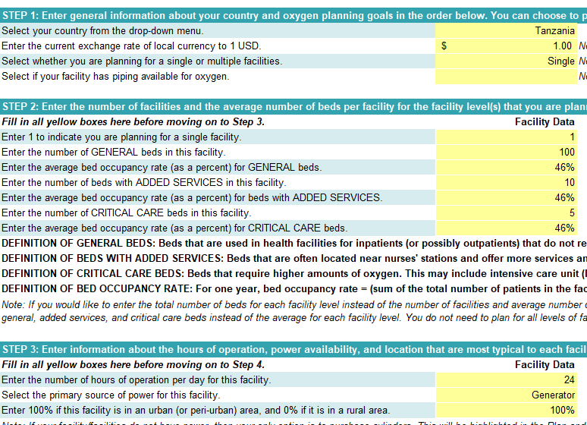

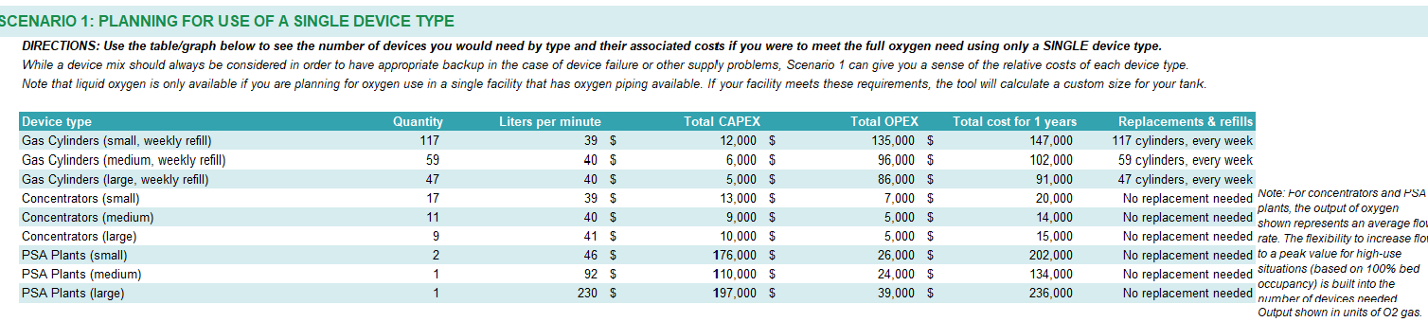

“Routines” refers to the system in the hospital for managing critically ill patients. ie. there are routines for the care of critical illness, rather than patients being managed ad hoc.
“Guidelines” refers to written material (eg. a wall chart or a booklet) that describes how critically ill patients should be identified and managed.

