SUPPLEMENTARY INFORMATION
Trademark | Type | Reference in article | Photo
Gyneas (masque en tissue réutilisable) | Community face mask | CFM-A-2L | 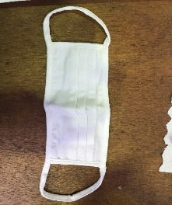
Le Mahieu (Le solidaire) | Community face mask | CFM-B-3L | 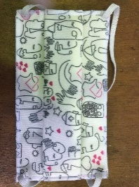
Thuasne (Start Security) | Community face mask | CFM-C-2L | 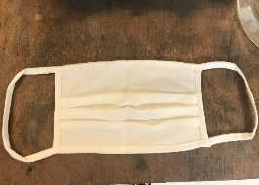
Hero Lab (J17P75) | Community face mask | CFM-D-3L | 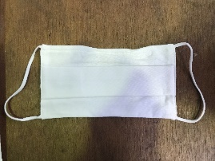
Dim (masque barrière) | Community face mask | CFM-E-3L | 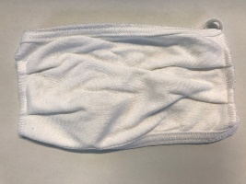
Rozen (Masque 6 ROZEN) | Community face mask | CFM-F-2L | 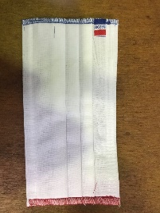
Champion (masque de protection) | Community face mask | CFM-G-3L | 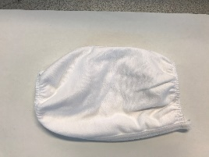
Proneem (VIRAL STOP ®) | Community face mask | CFM-H-2L | 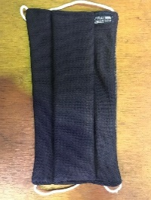
Masque Direct (assortiment fantaisie) | Community face mask | CFM-I-3L | 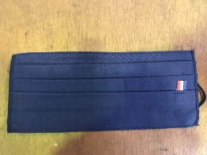
Medimasque (MT-CN) | Community face mask | CFM-J-3L | 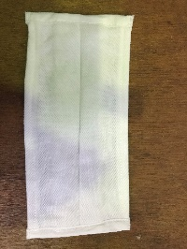
Bioserenity (SKU: 1016-07007-EU) | Medical face mask Type IIR | Medical face mask | 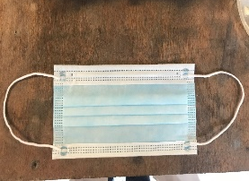

Supplementary Table S1: Medical and community face masks references used in this study. 2L refers to 2 layer masks whilst 3L refers to 3 Layer masks.

Supplementary Fig. S1: SEM images (200X magnification and scale bar corresponds to 100 μm) of : (a) CFM-A-2L, (b) CFM-B-3L, (c) meltblown layer of the surgical mask; for the new and washed masks subjected to two wash temperatures (30°C and 60°C).

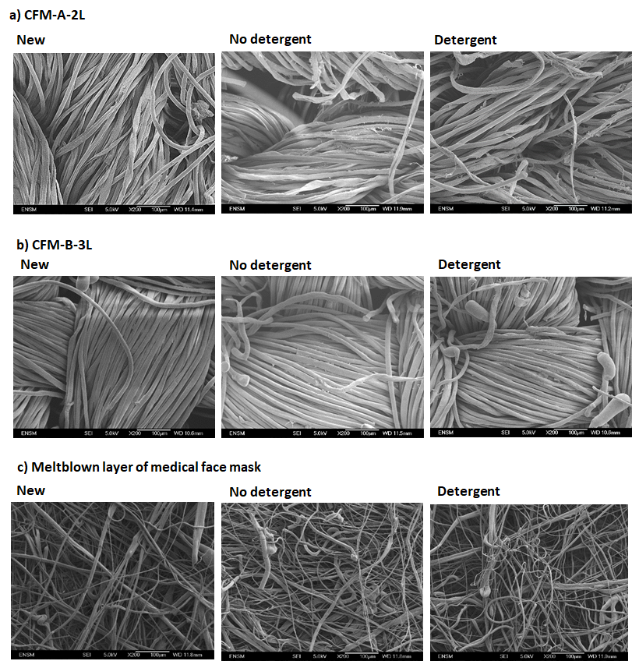

Supplementary Fig. S2: SEM images (200X magnification and scale bar corresponds to 100 μm) of : (a) CFM-A-2L, (b) CFM-B-3L, (c) meltblown layer of the surgical mask; for the new masks and masks washed with and without detergent.

