Supplementary Materials

Cloning and characterization of the DIR1 promoter from Eucommia ulmoides Oliv and its response to hormonal and abiotic stress

Ziyun Li^{1*} ·Biao Li^{1*} ·Yichen Zhao^{1,2 **}· De-Gang Zhao^{1,3}

¹ The Key Laboratory of Plant Resources Conservation and Germplasm Innovation in Mountainous Region (Ministry of Education)/ Guizhou Key Lab of Agro-Bioengineering, Institute of Agro-Bioengineering and College of Life Sciences, Guizhou University, Guiyang 550025, Guizhou, China.
² College of Tea Science, Guizhou University, GuiYang 550025, Guizhou, China.
³ Guizhou Academy of Agricultural Science, People’s Republic of China, GuiYang 550006, Guizhou, China.

*Equivalent contribution author

**Corresponding author: Yi-Chen Zhao. E-mail: yczhao@gzu.edu.cn

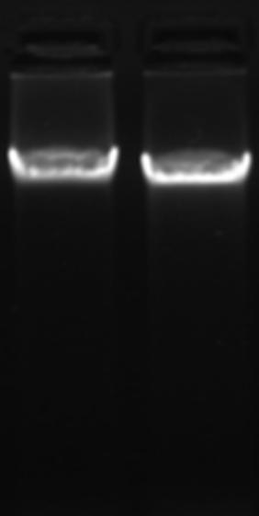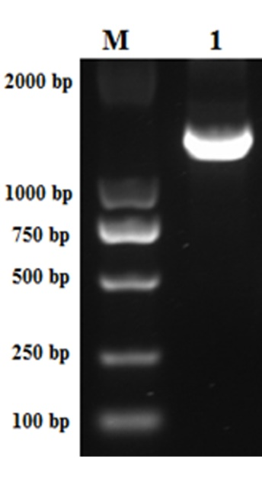
(A) (B)
Online Resource 1. Amplification of the DIR1 promoter. (A) Genomic DNA extracted from E. ulmoides. (B) M: DL2000 marker; 1: EuDIR1p-1 (1495 bp).

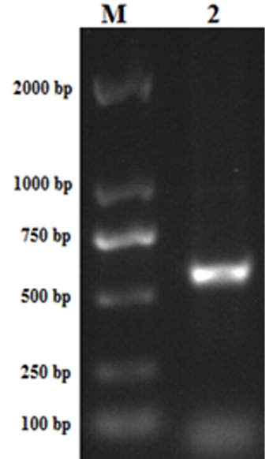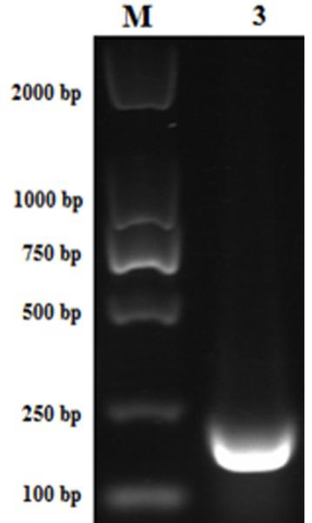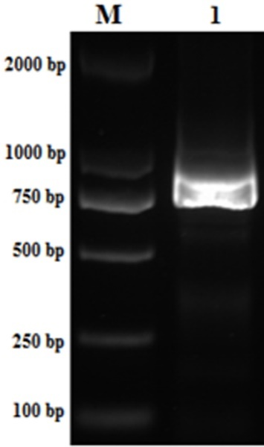
Online Resource 2. Amplification of the 5′ end-deleted DIR1 promoter. M: DL2000 marker; 1: EuDIR1p-2 (804 bp), 2: EuDIR1p-3 (549 bp), 3: EuDIR1p-4 (212 bp).

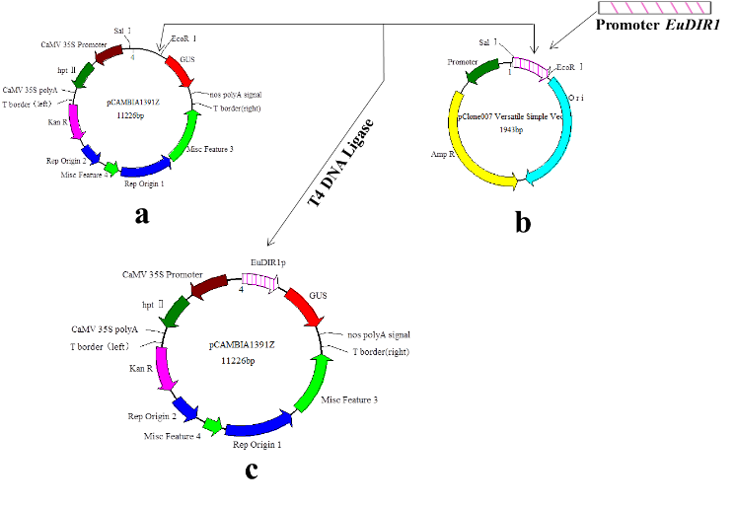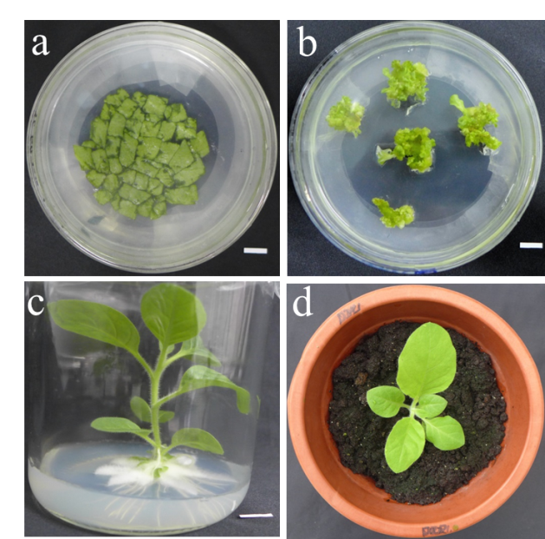
(A) (B)
Online Resource 3. Generation of EuDIR1p-GUS transgenic tobacco lines. (A) a. Plant expression vector pCAMBIA1391Z; b. Subcloning vector after insertion of the target promoter; c. pCAMBIA1391Z-pEuDIR1:: GUS after fusion of promoter and GUS gene. (B) a. Agrobacterium tumefaciens-mediated genetic transformation of tobacco leaf disc; b. Screening of transgenic shoots using 20 mg/L hygromycin; c. Transfer of hygromycin-resistant tobacco shoots to the rooting medium; d. Transfer of the hygromycin-resistant seedlings to soil.

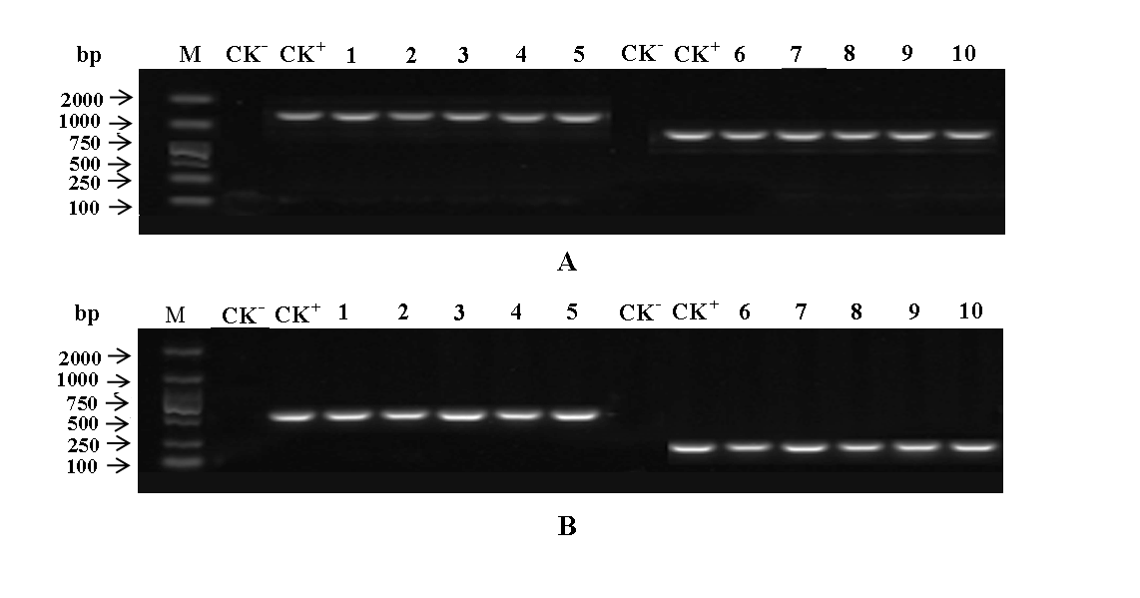
Online Resource 4. Identification of cloned fragments from transgenic tobacco. M: DL2000 marker; CK⁺: Positive control. CK⁻: Wild-type negative control. (A) Lanes 1–5 EuDIR1p-1; lanes 6–10 EuDIR1p-2; (B) Lanes 1–5 EuDIR1p-3; lanes 6–10 EuDIR1p-4.

