Support information

Manuscript entitled “QICAR methods for assessing the ecotoxicity of soil metal(loid)s to lettuce”.

Number SI pages: 7
Number the tables: 3
Number the figures: 4

Table S1 Test concentrations of different metal(loid) ions
Ions | The test concentrations (μM)
Ag⁺ | 0 | 0.05 | 0.1 | 0.2 | 0.5 | 1 | 5 | 15
Cu²⁺ | 0 | 0.05 | 0.2 | 0.4 | 1 | 4 | 10 | 20
Zn²⁺ | 0 | 1 | 5 | 20 | 40 | 80 | 200 | 500
Ni²⁺ | 0 | 0.5 | 1 | 2 | 5 | 20 | 50 | 150
Cd²⁺ | 0 | 0.5 | 2 | 5 | 10 | 50 | 100 | 200
Co²⁺ | 0 | 2 | 5 | 10 | 20 | 50 | 100 | 250
La³⁺ | 0 | 0.2 | 0.5 | 1 | 2 | 10 | 50 | 200
Sc³⁺ | 0 | 0.5 | 2 | 5 | 10 | 100 | 400 | 1000
Cr³⁺ | 0 | 1 | 2 | 5 | 20 | 50 | 100 | 200
Cr⁶⁺ | 0 | 2 | 10 | 50 | 100 | 200 | 500 | 1000
As³⁺ | 0 | 0.2 | 5 | 20 | 50 | 100 | 200 | 500
As⁵⁺ | 0 | 0.2 | 1 | 5 | 10 | 50 | 200 | 500
Se⁴⁺ | 0 | 0.5 | 5 | 50 | 100 | 200 | 500 | 1000
Se⁶⁺ | 0 | 0.5 | 5 | 50 | 500 | 2000 | 5000 | 10000
Sb³⁺ | 0 | 10 | 100 | 500 | 1000 | 5000 | 10000 | 30000
Sb⁵⁺ | 0 | 10 | 100 | 500 | 1000 | 5000 | 10000 | 40000
V⁵⁺ | 0 | 10 | 50 | 200 | 500 | 1000 | 2000 | 5000
Mo⁶⁺ | 0 | 20 | 100 | 500 | 1000 | 2000 | 5000 | 10000
Mg²⁺ | 0 | 1000 | 2000 | 4000 | 8000 | 20000 | 40000 | 80000

Table S2 The values of 23 physicochemical properties of metal ions | Ion characteristic properties | Z/AR | 0.57 | 1.09 | 1.44 | 2.60 | 2.26 | 1.96 | 1.62 | 3.42 | 3.76 | 3.27 | 4.72 | 5.13 | 1.27 | 1.31 | 1.20 | 1.16 | 1.60 | 1.17 | 2.99
 | Ion characteristic properties | Z/AR² | 0.33 | 0.40 | 0.69 | 1.36 | 1.70 | 1.28 | 0.88 | 2.92 | 2.83 | 2.14 | 3.72 | 4.38 | 0.81 | 0.85 | 0.72 | 0.68 | 1.28 | 0.68 | 1.49
 | Ion characteristic properties | Z/r | 0.87 | 2.91 | 4.03 | 9.26 | 5.17 | 3.95 | 4.88 | 8.00 | 10.87 | 8.33 | 13.64 | 14.29 | 2.74 | 2.70 | 2.68 | 2.78 | 2.90 | 2.11 | 10.17
 | Ion characteristic properties | Z/r² | 0.76 | 2.82 | 5.41 | 17.15 | 8.92 | 5.19 | 7.93 | 16.00 | 23.63 | 13.89 | 30.99 | 34.01 | 3.75 | 3.65 | 3.60 | 3.86 | 4.20 | 2.22 | 17.24
 | Ion characteristic properties | Z²/r | 0.87 | 8.72 | 12.08 | 46.30 | 15.52 | 11.84 | 14.63 | 32.00 | 54.35 | 41.67 | 81.82 | 85.71 | 5.48 | 5.41 | 5.37 | 5.56 | 5.80 | 4.21 | 61.02
 | Ion characteristic properties | Z | 1.00 | 3.00 | 3.00 | 5.00 | 3.00 | 3.00 | 3.00 | 4.00 | 5.00 | 5.00 | 6.00 | 6.00 | 2.00 | 2.00 | 2.00 | 2.00 | 2.00 | 2.00 | 6.00
 | Ion characteristic properties | AR/AW | 0.02 | 0.02 | 0.05 | 0.04 | 0.02 | 0.01 | 0.04 | 0.01 | 0.02 | 0.01 | 0.02 | 0.01 | 0.03 | 0.02 | 0.02 | 0.07 | 0.02 | 0.02 | 0.02
 | Ion characteristic properties | IP | 7.58 | 19.18 | 24.76 | 65.28 | 28.35 | 25.30 | 30.96 | 42.95 | 62.63 | 56.00 | 90.63 | 81.70 | 20.29 | 17.96 | 17.08 | 15.04 | 18.17 | 16.91 | 68.83
 | Ion characteristic properties | σp | 0.07 | 0.17 | 0.14 | 0.12 | 0.11 | 0.12 | 0.11 | 0.10 | 0.11 | 0.12 | 0.11 | 0.10 | 0.10 | 0.12 | 0.13 | 0.17 | 0.13 | 0.08 | 0.12
 | Ion characteristic properties | AN/ΔIP | 6.21 | 7.36 | 1.76 | 1.32 | 3.40 | 5.80 | 1.66 | 3.09 | 2.64 | 4.29 | 1.38 | 2.43 | 2.31 | 3.50 | 2.94 | 1.62 | 2.66 | 6.07 | 2.93
 | Ion characteristic properties | Xm²r | 4.28 | 1.25 | 1.38 | 1.43 | 2.76 | 3.19 | 1.69 | 3.08 | 2.19 | 2.52 | 1.21 | 2.73 | 2.64 | 2.01 | 2.63 | 1.24 | 2.52 | 2.71 | 2.75
 | Ion characteristic properties | |log(-KOH)| | 12.00 | 8.50 | 5.10 | 3.30 | 4.78 | 2.72 | 3.80 | 2.75 | 2.20 | 2.72 | 7.51 | 2.75 | 6.80 | 8.80 | 8.90 | 11.40 | 10.60 | 9.00 | 3.89
 | Ion characteristic properties | Xm | 1.93 | 1.10 | 1.36 | 1.63 | 2.18 | 2.05 | 1.66 | 2.48 | 2.18 | 2.05 | 1.66 | 2.48 | 1.90 | 1.65 | 1.88 | 1.31 | 1.91 | 1.69 | 2.16
 | Ion characteristic properties | ΔE0 | 0.80 | 2.38 | 2.08 | 1.00 | 0.71 | 0.66 | 0.41 | 0.37 | 0.71 | 0.59 | 0.13 | 0.05 | 0.16 | 0.76 | 0.28 | 2.37 | 0.26 | 0.40 | 0.08
 | Ion characteristic properties | ΔIP | 7.57 | 7.74 | 11.96 | 17.40 | 9.71 | 8.80 | 14.46 | 11.00 | 12.50 | 11.90 | 17.40 | 14.00 | 12.57 | 8.57 | 9.19 | 7.39 | 10.52 | 7.91 | 14.34
 | Ion characteristic properties | BP | 2163.00 | 3457.00 | 2831.00 | 3409.00 | 603.00 | 1587.00 | 2672.00 | 685.00 | 603.00 | 1587.00 | 2672.00 | 685.00 | 2562.00 | 907.00 | 2870.00 | 1090.00 | 2732.00 | 765.00 | 4612.00
 | Ion characteristic properties | D | 10.50 | 6.15 | 2.99 | 6.11 | 5.72 | 6.68 | 7.19 | 4.79 | 5.72 | 6.68 | 7.19 | 4.79 | 8.96 | 7.13 | 8.90 | 1.74 | 8.90 | 8.65 | 10.28
 | Ion characteristic properties | MP | 961.00 | 920.00 | 1539.00 | 3456.00 | 808.00 | 630.90 | 1857.00 | 221.00 | 808.00 | 630.90 | 1857.00 | 221.00 | 1084.60 | 419.73 | 1495.00 | 649.00 | 1453.00 | 321.18 | 2617.00
 | Ion characteristic properties | r | 1.15 | 1.03 | 0.75 | 0.54 | 0.58 | 0.76 | 0.62 | 0.50 | 0.46 | 0.60 | 0.44 | 0.42 | 0.73 | 0.74 | 0.75 | 0.72 | 0.69 | 0.95 | 0.59
 | Ion characteristic properties | CR | 1.34 | 1.69 | 1.44 | 1.22 | 1.20 | 1.40 | 1.18 | 1.16 | 1.20 | 1.40 | 1.18 | 1.16 | 1.17 | 1.25 | 1.16 | 1.36 | 1.15 | 1.48 | 1.30
 | Ion characteristic properties | AR | 1.75 | 2.74 | 2.09 | 1.92 | 1.33 | 1.53 | 1.85 | 1.17 | 1.33 | 1.53 | 1.27 | 1.17 | 1.57 | 1.53 | 1.67 | 1.72 | 1.25 | 1.71 | 2.01
 | Ion characteristic properties | AW | 107.87 | 138.91 | 44.96 | 50.94 | 74.92 | 121.76 | 52.00 | 78.96 | 74.92 | 121.76 | 52.00 | 78.96 | 63.55 | 65.39 | 58.93 | 24.31 | 58.69 | 112.41 | 95.94
 | Ion characteristic properties | AN | 47.00 | 57.00 | 21.00 | 23.00 | 33.00 | 51.00 | 24.00 | 34.00 | 33.00 | 51.00 | 24.00 | 34.00 | 29.00 | 30.00 | 27.00 | 12.00 | 28.00 | 48.00 | 42.00
 | Ions |  | Ag+ | La3 | Sc3 | V5 | As3 | Sb3 | Cr3 | Se4 | As5 | Sb5 | Cr6 | Se6 | Cu2 | Zn2 | Co2 | Mg2 | Ni2 | Cd2 | Mo6

Table S3 Multivariate linear regression equations based on principal component analysis (PCA). PCs represent principal components, CCR is the cumulative contribution rate based on PCA, R² is the coefficient of determination, R²_{Adj} is the adjusted coefficient of determination, RMSE is the root-mean-square error and p is the statistical level of significance for the tested metal ions and soft ions
Species | Types | PCs | Regression equations | CCR | R² | R²_{Adj} | RMSE | F | p
lettuce | Tested metal ions | X₁ = 0.707 D - 0.707σp | log {EC₅₀} = -0.416x₁ + 2.242 | 0.80 | 0.496 | 0.460 | 0.69 | 13.769 | 0.002
lettuce |  | X₂ = 0.707 Xm²r - 0.707σp | log {EC₅₀} = -0.851x₁ + 1.502 | 0.82 | 0.300 | 0.250 | 0.81 | 5.996 | 0.028
lettuce | Soft ions | X₁ = 0.585 D + 0.563 |log(-K_{OH})| - 0.584 Z/AR | log {EC₅₀} = 0.044x₂ + 1.956 | 0.89 | 0.699 | 0.649 | 0.37 | 13.923 | 0.010
lettuce |  | X₂ = 0.707 D + 0.707 |log(-K_{OH})| | log {EC₅₀} = -0.393x₁ + 2.551 | 0.90 | 0.691 | 0.640 | 0.38 | 13.430 | 0.011

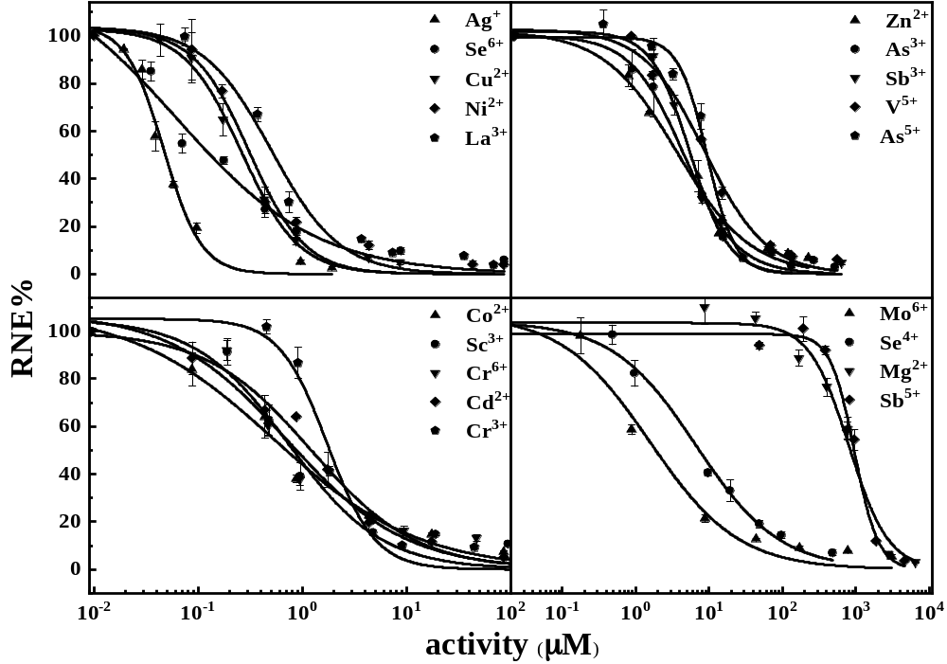
Fig. S1 The dose-response relationships between free ion activity and relative net root elongation (RNE, %) of lettuce
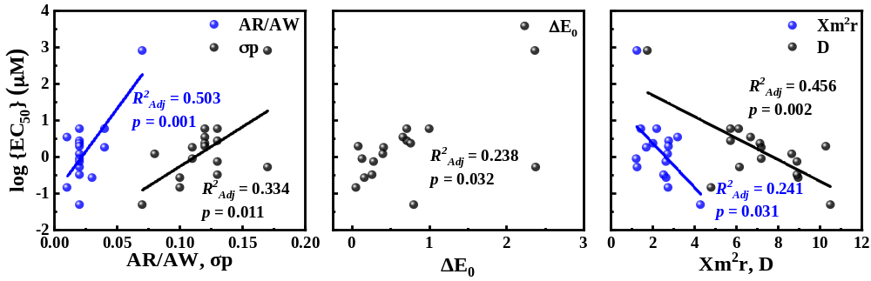

Fig. S2 Univariate linear relationships between log {EC₅₀} of metal(loid) ions and their correlated physicochemical properties (AR/AW, D, σp, Xm²/r, ΔE₀)

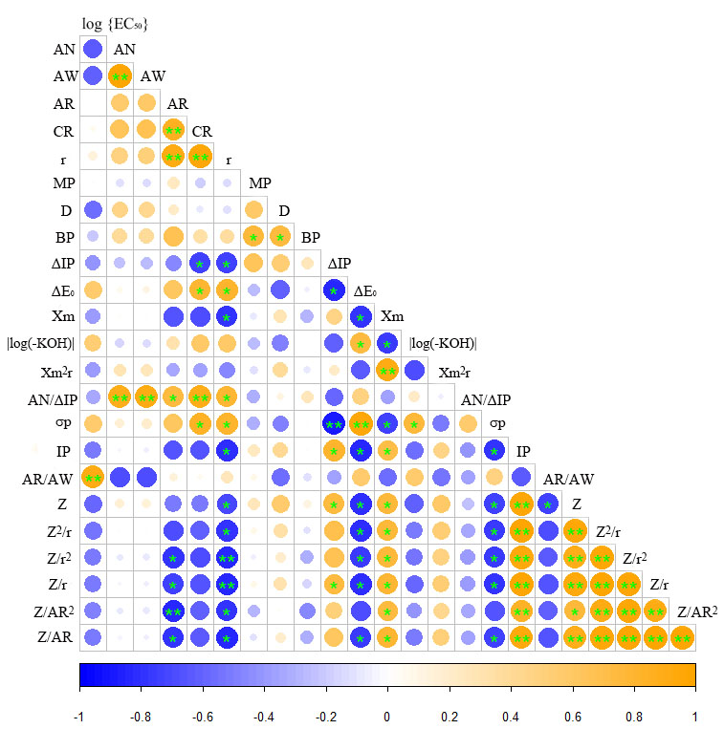
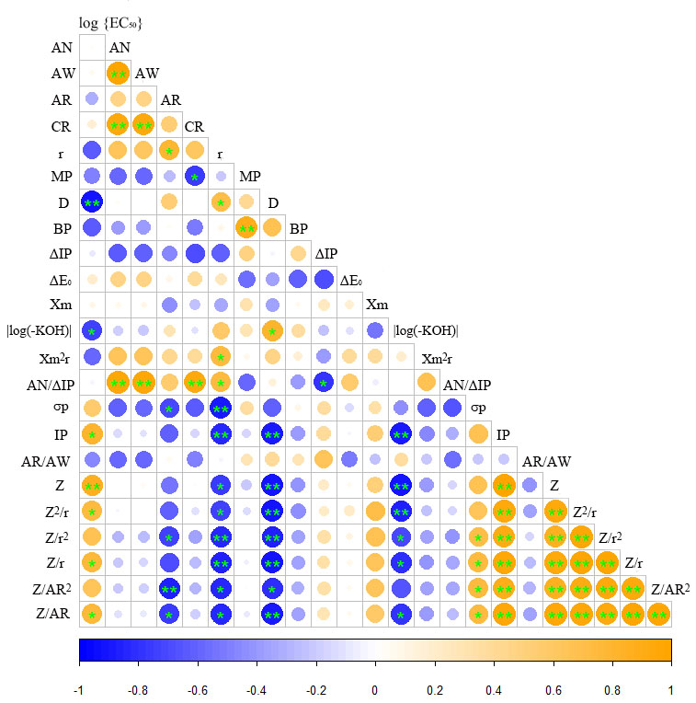
(b)
(a)

Fig. S3 Correlations between log {EC₅₀} of soft-hard ions and their physicochemical properties. (a) Soft ions; (b) hard ions. ** p < 0.01, * p < 0.05; Pearson correlation
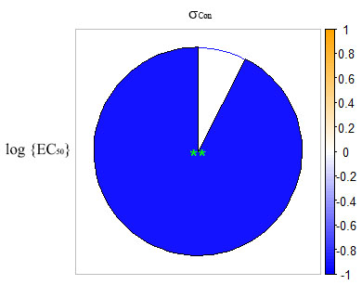
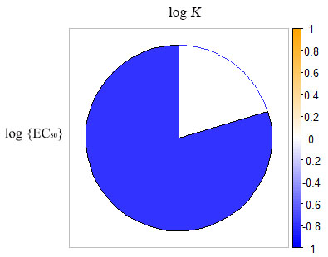
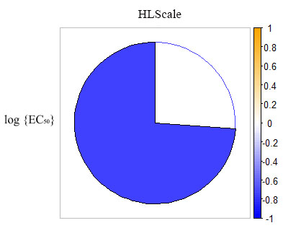

(a)
(b)
(c)
Fig. S4 Correlation between log {EC₅₀} of metal(loid) ions and ligand binding constants. (a) The logarithm of the conditional binding constant (log K) based on the biotic ligand model theory; (b) softness consensus scale (σ_{Con}); (c) normalized hard ligands scale (HLScale). The correlation varies with the color and the size of the pie; the darker the color and the larger the pie, the greater the correlation. ** p < 0.01, * p < 0.05; Pearson correlation

