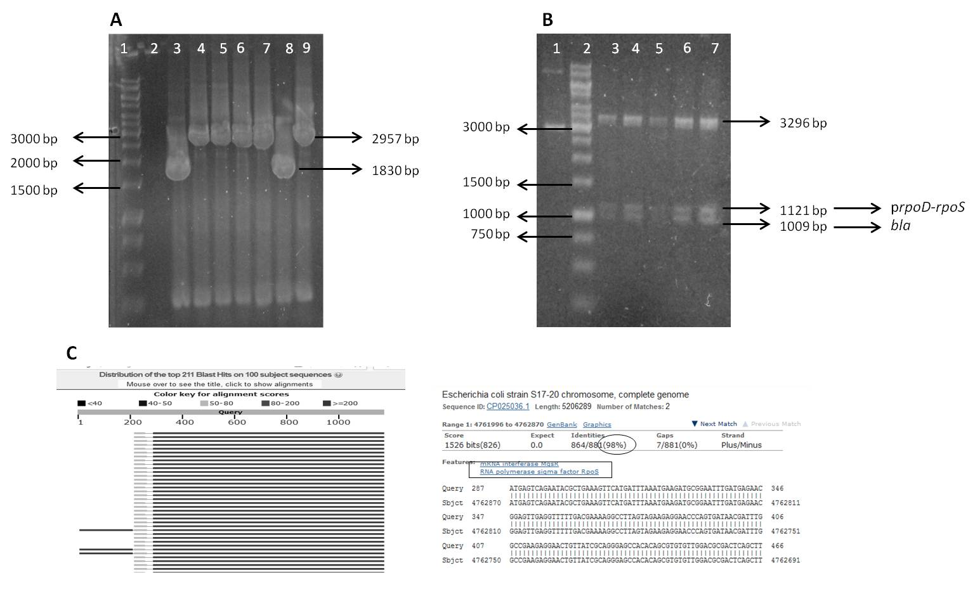
Suppl. 1 Characterizations of pCAD₂⁺_sod plasmid. a Isolated plasmids, from seven transformant samples, were amplified using primers F_{AanIbla} and R_{NotIsod} and the product showed that plasmids from transformants 4, 5, 6, 7, and 9 were confirmed to have an inserted fragment (1127 bp), since it gave PCR products of 2957 bp. b HpaI restriction enzyme digested the plasmid into three fragments, i.e the plasmid backbone (3296 bp), prpoD_rpoS (1121 bp), and bla (1009 bp). c The gene sequencing analysis of the isolated plasmid, using F_{Konf} and R_{Konf} primer pair, were confirmed to have insertion of prpoD_rpoS fragment from the BLAST (NCBI) alignment result

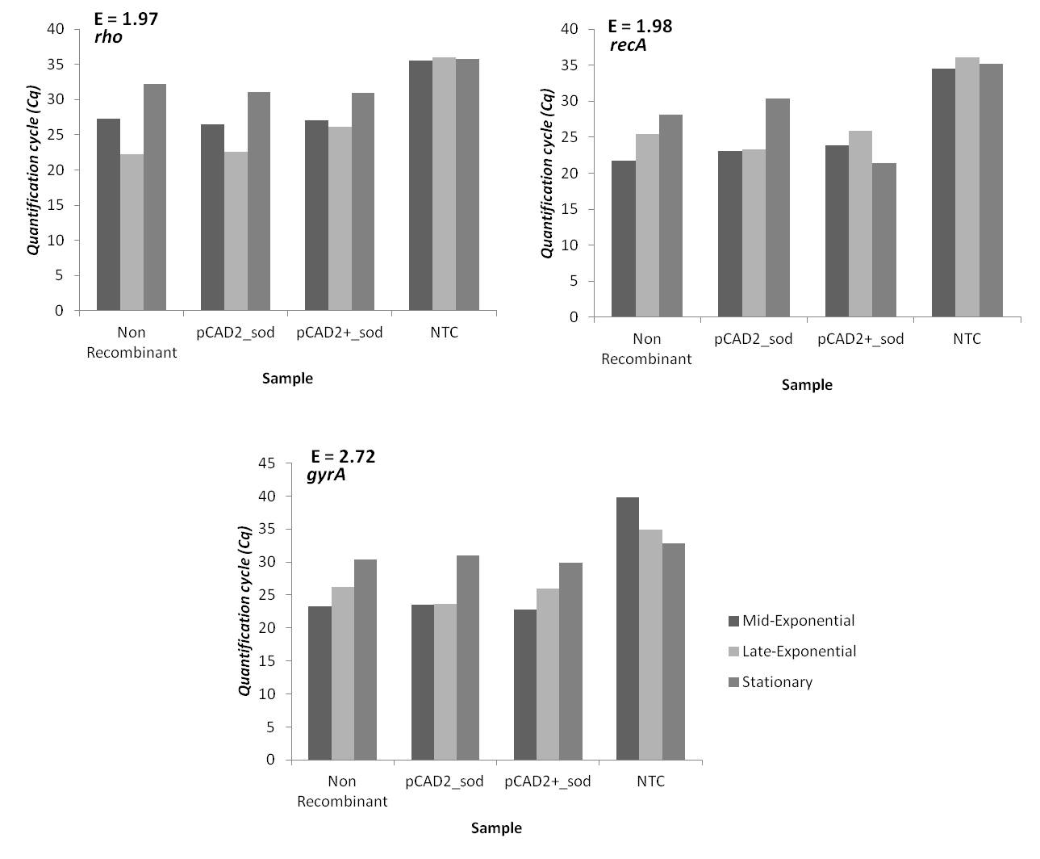
Suppl. 2 Cq values of reference gene candidates. Based on the experiments, rho and gyrA gene gave a nearly consistent Cq values from all samples in various growth phases, yet the efficiency of gyrA was higher than acceptable amplification efficiencies in range of 1.85-2.05 [21]. Despite the amplification efficiency was acceptable, recA gene gave an inconsistency of the Cq value in the stationary phase. Thus, rho was chosen as reference gene in this research

