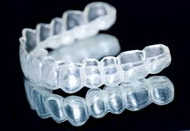

Figure S1: A sample of at-home bleaching trays.

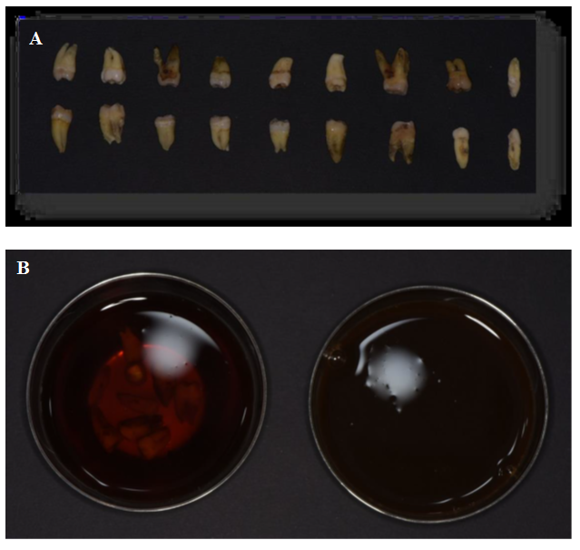
Figure S2. A) The extracted human teeth, B) The stored teeth into tea (the left side) and coffee (the right side).

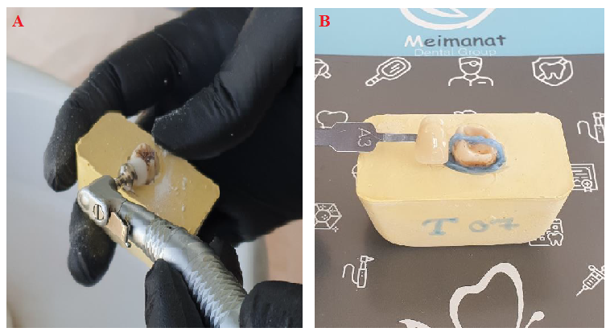
Figure S3: Placement of teeth in plaster, employment pumice powder onto the teeth surface and preparation of teeth for bleaching process.

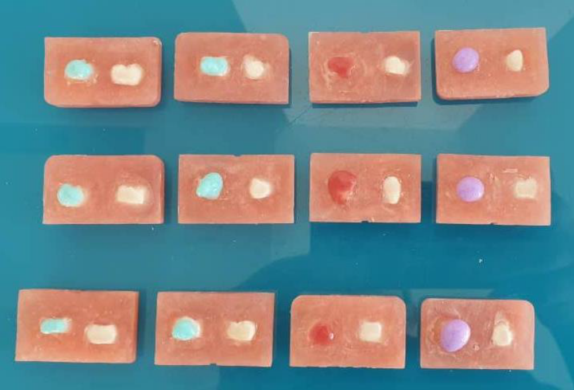
Figure S4. Employment of the prepared gel and commercial gels onto the specimens of teeth.

Table S1. The applied commercial and prepared bleaching gel accompanied with dental changing color.
Specimens name | Shade value scale  (before bleaching) | Shade value scale with gel 1ª  (after bleaching) | Shade value scale with gel 2^{b}  (after bleaching) | Color of specimens (after bleaching)
T 01 | A3 | 0M2 | 0M3 | 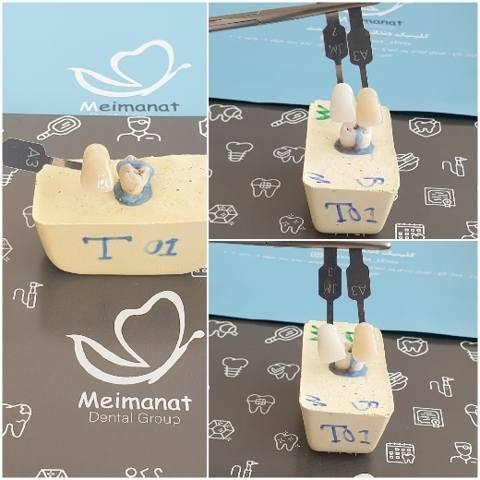
T 02 | A3 | 0M2 | 0M2 | 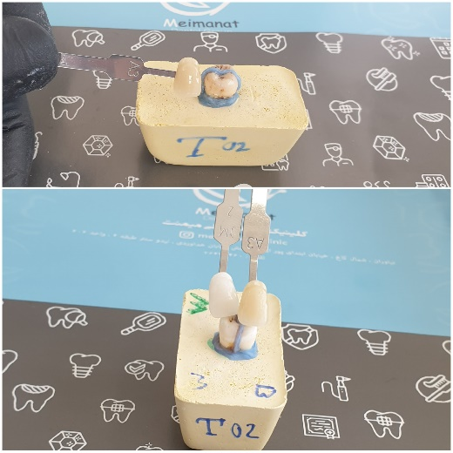
T 03 | A3 | 0M3 | 0M3 | 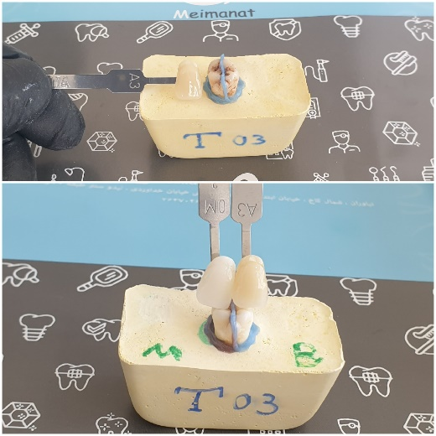
T 04 | B3 | 0M3 | 0M3 | 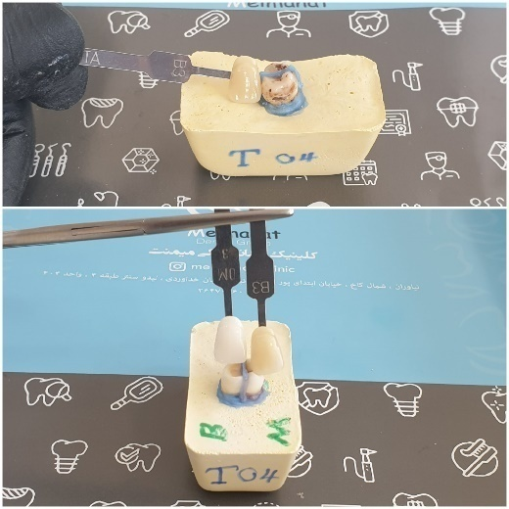
T 05 | A3 | 0M3 | 0M3 | 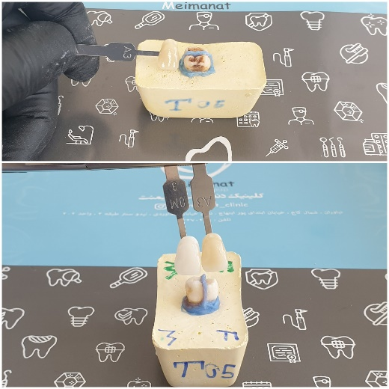
T 06 | A3 | 0M3 | 0M3 | 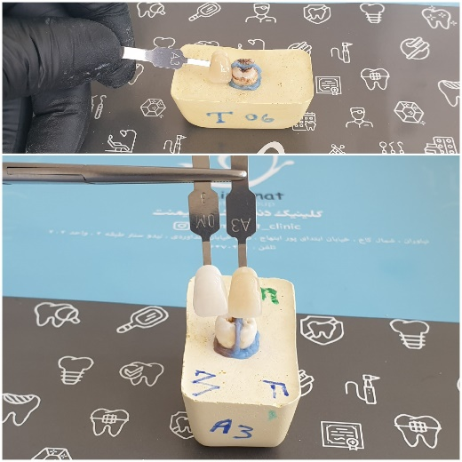
T 07 | A3 | 0M3 | 0M3 | 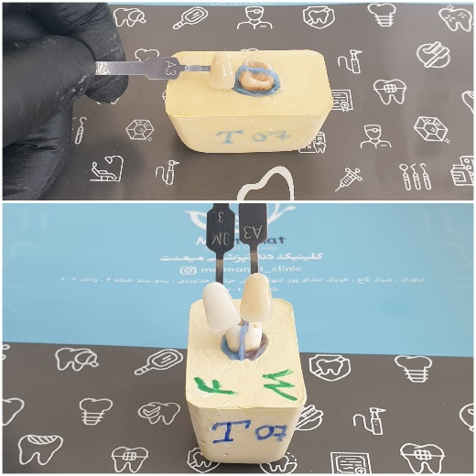
C 01 | A2 | 0M3 | 0M3 | 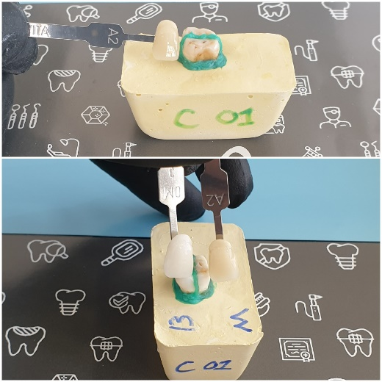
C 02 | A2 | 0M2 | 0M1 | 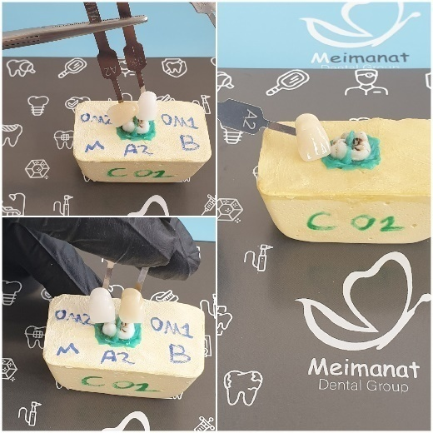
C 03 | A2 | 0M1 | 0M1 | 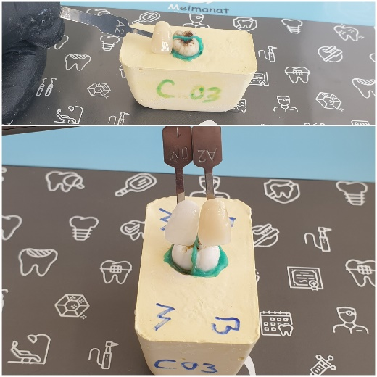
C 04 | A3 | 0M2 | 0M3 | 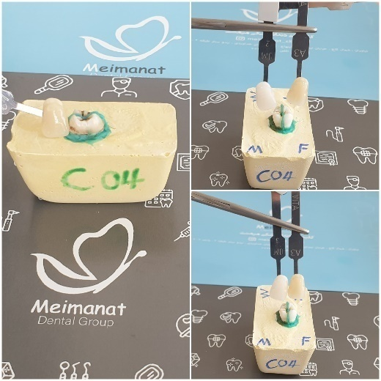
C 05 | A3 | 0M1 | 0M3 | 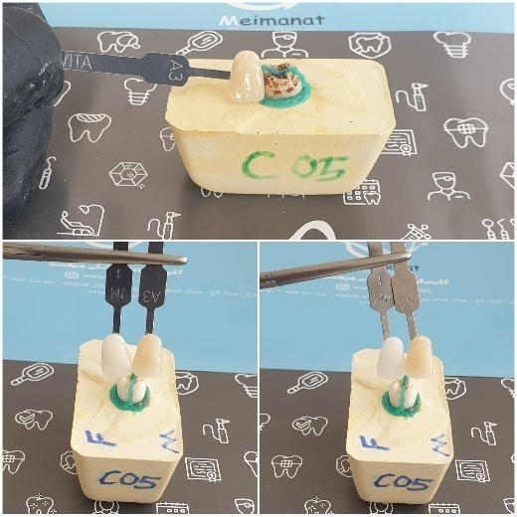
C 06 | A1 | 0M2 | 0M2 | 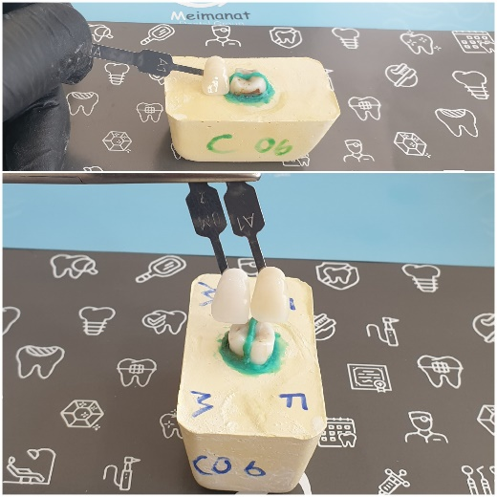
C 07 | A3 | 1M1 | 0M3 | 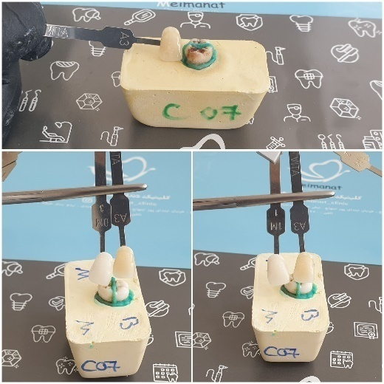
a: the commercial bleaching gel (BOOST and FGM).
b: the prepared bleaching gel.

