Table 9 Identification of glaze colourants and a characterization of their deterioration
Object after restoration | Inv. No. | Glaze colour | Colouring/ opacifying agent | Identified defect | Corrosion product | Ceramic body colour
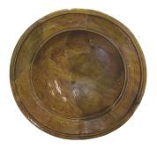 | 1 |  | Fe₂O₃, Sb₂O₃, CuO / ZnO | unidentified | unidentified | 
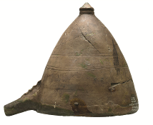 | 2 |  | CuO, Fe₂O₃,  Sb₂O₃ / TiO₂ | delayed crazing | Calcium Lead Phosphate Hydroxide  Ca_{5.5}Pb_{4.5} (PO₄)₆ (OH)₂ | 
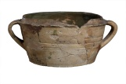 | 3 |  | CuO, Fe₂O₃, Sb₂O₃, SnO₂ | delayed crazing | Lead Sulphate Pb(SO₄)
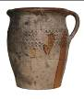 | 4 |  | Fe₂O₃, Sb₂O_{3,} CuO / CaO | unidentified | unidentified | 
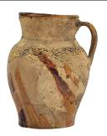 | 5 |  | Fe₂O₃, Sb₂O_{3,} CuO / ZnO | unidentified | unidentified | 
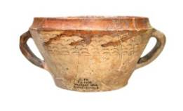 | 6 |  | Fe₂O₃, Sb₂O₃, CuO / ZnO | unidentified | unidentified
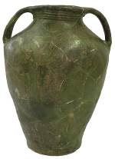 | 7 |  | CuO, Fe₂O₃, Sb₂O₃ | corrosion crust | Calcium Lead Phosphate Chloride  Ca₂Pb₃(PO₄)₃Cl  Calcium Phosphate Hydroxide Hydrate  CaPO₃(OH)·2H₂O | 
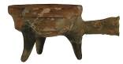 | 8 |  | Fe₂O₃, Sb₂O₃, CuO/ ZnO | instant crazing | unidentified | 
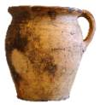 | 9 |  | Fe₂O₃, Sb₂O₃, CuO | corrosion crust | Calcium Lead Phosphate Chloride  Ca₂Pb₃ (PO₄)₃Cl  Calcium Sulphate  CaSO₄ | 
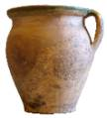 | 10 |  | CuO, Fe₂O₃ | unidentified | unidentified | 
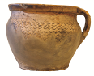 | 11 |  | Fe₂O₃, CuO | unidentified | unidentified | 
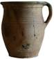 | 12 |  | CuO, Fe₂O₃, Sb₂O₃ / SnO₂ | unidentified | unidentified | 
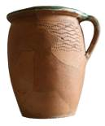 | 13 |  | CuO, Fe₂O₃ | unidentified | unidentified | 
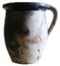 | 14 |  | Fe₂O₃ / ZnO | unidentified | unidentified | 
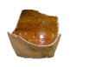 | 15 |  | Fe₂O₃, CuO | unidentified | unidentified | 
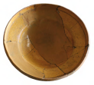 | 16 |  | Fe₂O₃, Sb₂O₃  / ZnO | unidentified | unidentified | 
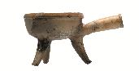 | 17 |  | Fe₂O₃, CuO / TiO₂ | corrosion crust | noncrystalline | 
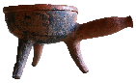 | 18 |  | Fe₂O₃, transparent | unidentified | unidentified | 
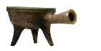 | 19 |  | Fe₂O₃, CuO / CaO, TiO₂ | corrosion crust | Calcium Phosphate Hydroxide  Ca₅(PO₄)₃(OH) | 
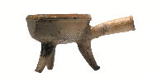 | 20 |  | Fe₂O₃, MnO / CaO, TiO₂ | unidentified | unidentified | 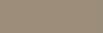
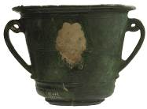 | 21 |  | CuO, Fe₂O₃ | corrosion crust | noncrystalline | 
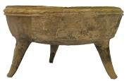 | 22 |  | Fe₂O₃, CuO | delayed crazing | unidentified | 
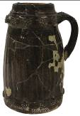 | 23 |    | Fe₂O₃, Sb₂O₃,CuO / ZnO  Brown: Fe₂O_{3,} MnO / ZnO | peeling | unidentified | 
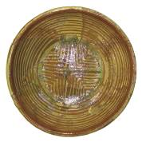 | 24 |  | Fe₂O₃, Sb₂O_{3,} CuO / TiO₂ | crazing | noncrystalline | 
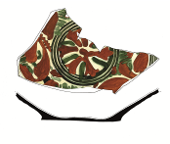 | 25 |  | Fe₂O₃ / TiO₂ | peeling | unidentified | 
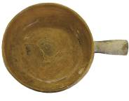 | 26 |  | Fe₂O₃ | delayed crazing | unidentified | 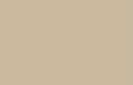
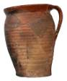 | 27 |  | Fe₂O₃ / TiO₂, ZnO | unidentified | unidentified | 
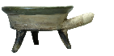 | 28 |  | CuO, Fe₂O₃ / TiO₂ | unidentified | unidentified | 
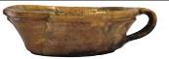 | 29 |    | Fe₂O₃, CuO, Sb₂O₃ | peeling | unidentified | 
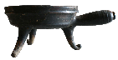 | 30 |  | Fe₂O₃, CuO, MnO / SnO₂ | corrosion crust | Lead Sulphide PbS  Lead Sulphate  Pb(SO₄) | 
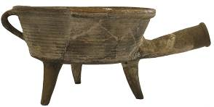 | 31 |  | Fe₂O₃ / ZnO | corrosion crust | Calcium Sulfate Hydrate  CaSO₄·2H₂O | 
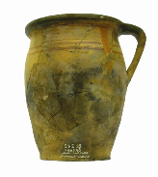 | 32 |  | Fe₂O₃, CuO / TiO₂ | unidentified | unidentified | 
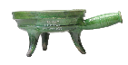 | 33 |  | CuO, Fe₂O₃ / ZnO | corrosion crust | Calcium Sulphate Hydrate  CaSO₄·2H₂O | 
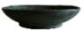 | 34 |  | CuO, Fe₂O₃ / SnO₂ | corrosion crust | Lead Sulphate  Pb(SO₄) | 
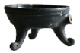 | 35 |  | CuO, Fe₂O₃ / SnO₂ | corrosion crust | Lead Sulphide PbS  Lead Sulphate  Pb(SO₄)
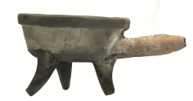 | 36 |  | Fe₂O₃, MnO, Sb₂O₃ / ZnO | unidentified | unidentified | 
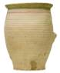 | 37 |  | Fe₂O₃, Sb₂O₃, CuO / TiO₂ | unidentified | unidentified
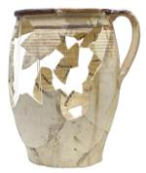 | 38 |  | Fe₂O₃,CuO / TiO₂ | specking | unidentified
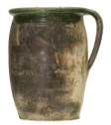 | 39 |  | CuO, Fe₂O₃ / TiO₂ | crazing | unidentified
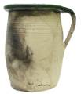 | 40 |  | Sb₂O₃, Fe₂O₃ | crazing | unidentified | 