Quantitative phase measurements using 2-D discrete cosine transform in Hilbert phase microscopy
Mahyar Radak^{*1}
- Department Physics Iran University of Science and Technology, Tehran
- m_radak@physics.iust.ac.ir
Abstract
Discrete cosine transform (DCT) is closely related to discrete Fourier transform. This is a separable linear conversion. It can be said that DCT is simpler and faster than DFT as well as FFT. DCT is suitable for extended periodic and symmetric sequences, while DFT is suitable for long periodic sequences. So DCTs are the equivalent of almost double-length DFTs that work on real data with uniform symmetry. Hilbert Phase Microscopy (HPM) is a shot in nature and is a new optical technique for measuring small, high-resolution transverse images associated with clear optical objects. In this paper, we introduce the phase extraction method of a simulated interference scheme with the cosine discrete Fourier transform algorithm in the Hilbert phase microscope.

Keywords: Hilbert Phase Microscopy (HPM), Discrete cosine transform (DCT), Quantitative phase measurements

- Introduction
Quantitative phase imaging (QPI) is an emerging field for the study of poorly dispersed samples and their adsorption. [1] The main challenge in contrasting thin samples of light, including living cells, is that they do not absorb or scatter light, meaning that they are transparent or phased [2]. The pioneers of the cohesive light microscope, or the original idea of ​​QPI, were first Ernest Abe (1840-1905), Fritz Zernick (1888-1966), and Dennis Gabor (1900-1979). Quantitative information includes local thickness and sample refractive index structure. [2-4]. Quantitative phase imaging (QPI) has emerged as a valuable method for examining cells and tissues [5]. QPI deals with the "phase problem", which is a major issue related to the loss of phase information in physical measurements in optical imaging [6-8]. QPI is a class of light microscope techniques that allows the visualization of quantitative light field maps, both amplitude and phase information, and the QPI method uses artificial intelligence [9]. In 1982, it was reported that off-axis interferometry and fast Fourier transform (FFT) processing were combined to study the topography of structures [10]. Off-axis CCD interference measurement, the possibility of single-shot measurements and thus providing a fast acquisition rate [11] This is a QPI technique that combines the characteristics of off-axis single-shot methods with the stability of normal path interference and is very sensitive. . High-throughput phase images with these features, DPM has recently enabled new biomedical studies [12]. Techniques such as phase contrast and the Numarski microscope distribute phase information vigorously, representing biological systems. In particular, the Hilbert conversion relationship between the real and imaginary parts of a complex signal is commonly used to retrieve phase changes of time-unit interferences for marginal pattern analysis. HPM enables the retrieval of a complete phase image of a field from a single spatial interference recording, which extends the concept of analytical continuity across different spatial contexts, in perfect proportion to time measurement [13]. Interferometer and non-interferometer techniques were proposed for phase imaging of biological samples [14] then the dispersion was presented with a triple brightness phase interferometer [15].

- Materials And Methods
Fourier transform is a representation of an image as a complex summation of different magnitudes, frequencies and phases. Fourier transform plays an important role in a wide range of image processing applications, including enhancement, analysis, retrieval, and compression.
Fourier transform is a representation of an image as a complex summation of different magnitudes, frequencies and phases.
If f (m, n) is a function of two discrete spatial variables m and n, the two-dimensional Fourier transform f (m, n) is defined by the relation.
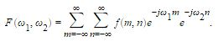

(1)
The variables ω1 and ω2 are frequency variables. Their units are radians in each instance. F (ω1, ω2) is often called the frequency range display f (m, n). F (ω1, ω2) is a complex value function that is periodic in both ω1 and ω2, with period 2π. Due to the periodicity, usually only the range -π≤ω1, Ω2≤π is displayed. Note that F (0,0) is the sum of all values ​​of f (m,n).

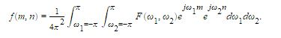
(2)
The inverse of a transform is an operation that when performed on a transformed image produces the original image. The inverse two-dimensional Fourier transform is given by
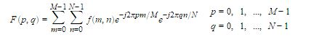
(3)
Roughly speaking, this equation means that f(m,n) can be represented as a sum of an infinite number of complex exponentials (sinusoids) with different frequencies. The magnitude and phase of the contribution at the frequencies (ω1,ω2) are given by F(ω1,ω2).
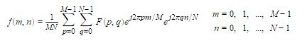
(4)
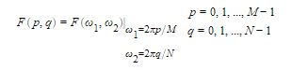
A discrete transform is a transform whose input and output values are discrete samples, making it convenient for computer manipulation. There are two principal reasons for using this form of the transform: The input and output of the DFT are both discrete, which makes it convenient for computer manipulations. There is a fast algorithm for computing the DFT known as the fast Fourier transform (FFT). The DFT is usually defined for a discrete function f(m,n) that is nonzero only over the finite region 0≤m≤M−1 and 0≤n≤N−1. The two-dimensional M-by-N DFT and inverse M-by-N DFT relationships are given by

(5)

Discrete cosine transform (DCT) is closely related to discrete Fourier transform. This is a separable linear conversion. That is, a two-dimensional conversion is equivalent to a one-dimensional DCT performed in a single dimension, followed by a one-dimensional DCT in another dimension. The definition of DCT is two-dimensional for the input image A and the output image B.
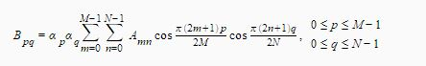
(6)

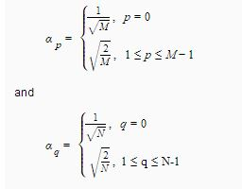

M and N are the row and column size of A, respectively. If you apply the DCT to real data, the result is also real. The DCT tends to concentrate information, making it useful for image compression applications. This transform can be inverted using idct2 [16-17].

For a registered hologram of a sample, the irradiance function in the image plane is expressed in the x or y direction with relation
(7) 𝐼(𝑥) = 𝐼𝑅 + 𝐼𝑠(𝑥) + 2[𝐼𝑅𝐼𝑆(𝑥)]1/2 cos [𝑞𝑥 + 𝜑(𝑥)]
Where 𝐼𝑅 and 𝐼𝑆 are the reference wavelength and wavelength distributions, respectively are objects. The spatial frequency of freezers and 𝜑 (𝑥) phase Is the result of the object, the parameter that seeks to extract it we are 𝐼𝑠 (𝑥) for the sample under study in this experiment has weak changes in the x-direction, so it can be considered almost constant. Term u(x)=2[𝐼𝑅𝐼𝑆(𝑥)]1/2 cos[𝑞𝑥 + 𝜑(𝑥)] can be Using the frequency filter method maintained. Analytical signal A complex created by the real function u (x) has the following relation defined:
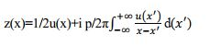
(8)

In relation (2) the imaginary part of the phrase is actually a relation of conversion Hilbert is u (x). Thus the phase of the complex function z (x) is related Ф (𝑥) = tan-1 {im [z (x)]} /{real [z (x)]}. Is calculated. It should be noted that the phase Φ is obtained between π and -π and should be phase Unwrapping screw should be done on it. Finally the object phase Is extracted by relation.
(9) 𝜑 (𝑥) = Ф (𝑥) – qx [13],[18]

- Results

- Unwrapping phase with FFT method
This method is the same as the usual method previously used with the help of fast Fourier transform
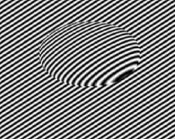
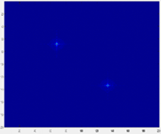

FFT

FIG 1. Fast Fourier transform algorithm on the sample interference design image and then with the appropriate filter in the range of 110 × 90 pixels
In this part, we show the phase image with the help of Hilbert transform, and by removing the initial interference pattern on the sample, we show the numerical phase value for the Hilbert phase microscope. In this section, we separate the phase part from the interference.
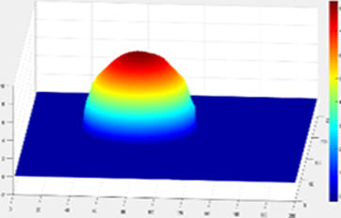
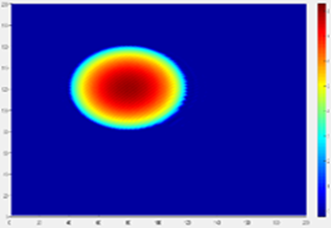

FIG 2. The final numerical phase was extracted by Hilbert microscope from the transparent cell interference design algorithm, which showed the right side of the three-dimensional image of the phase
Here we saw the old method applied to transparent cells and the hologram of simulated interference design. We now present proposed method with a discrete cosine transformation algorithm to open the hologram phase of a transparent dynamic sample.

- Unwrapping phase with 2-D discrete cosine transform (DCT) method
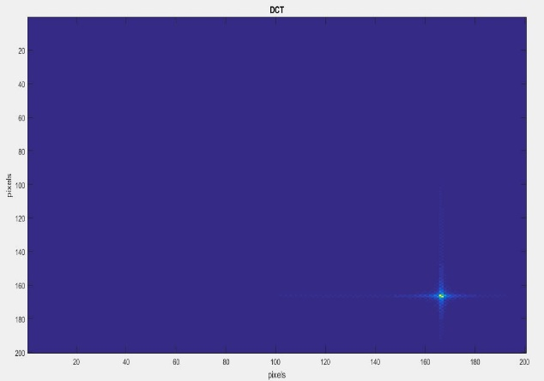
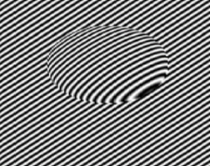


DCT

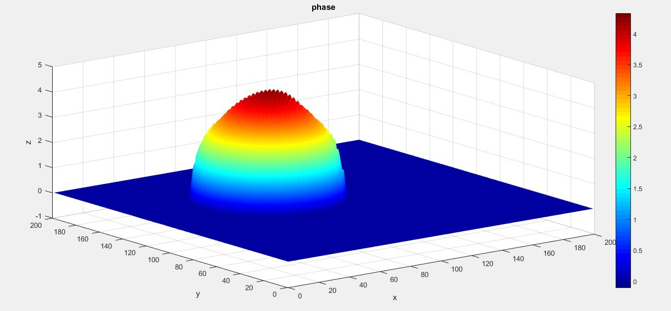
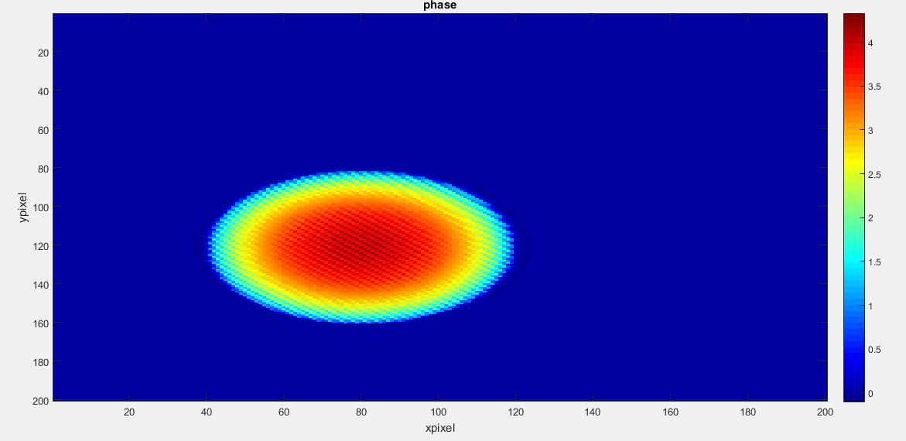
FIG 3. 2-D discrete cosine transform algorithm on the sample interference design image

FIG 4. The final numerical phase was extracted by Hilbert microscope from the transparent cell interference design algorithm using the 2-D discrete cosine transform algorithm that showed the right side of the phase 3D image

- Conclusions in summary
In this paper, we first simulated the transparent sample hologram of the transparent sample with MATLAB and then extracted the phase sample interference pattern with the help of fast FFT conversion and the numerical phase of the interference pattern with Hilbert conversion. Then, by proposing a smart cosine discrete conversion algorithm instead of a fast Fourier transform, we observed that the obtained phase had less deviation than the previous method and was obtained with a simpler algorithm than the old method.

4. ACKNOWLEDGEMENT
Simulations and algorithms were implemented in MATLAB software.
5. Competing interests
There is NO Competing Interests.
References
[1] Popescu, G. (2011). Quantitative phase imaging of cells and tissues. New York: McGraw-Hill.
[2] Abbe, E. (1873). Contributions to the theory of the microscope and the microscopic
Perception. Archives for Microscopic Anatomy, 9, 431.
[3] Zernike, F. (1942a). Phase contrast, a new method for the microscopic observation of transparent objects, Part 2. Physica, 9, 974–986.
[4] Gabor, D. (1946). Theory of communication. Journal of the Institute of Electrical Engineers, 93,329.
[5] Atti Della Fondazione Giorgio Ronchi E Contributi Dell'Istituto Nazionale Di Ottica, Volume 30, La Fondazione-1975, page 554.
[6] Park, YongKeun, Christian Depeursinge, and Gabriel Popescu. "Quantitative phase imaging in biomedicine." Nature photonics 12.10 (2018): 578-589.‏
[7] Lee, KyeoReh, et al. "Quantitative phase imaging techniques for the study of cell pathophysiology: from principles to applications." Sensors 13.4 (2013): 4170-4191.‏
[8] Popescu, Gabriel. Quantitative phase imaging of cells and tissues. McGraw-Hill Education, 2011.‏
[9] Kim, Myung K. "Digital holographic microscopy." Digital Holographic Microscopy. Springer, New York, NY, 2011. 149-190.‏
[10] Takeda, Mitsuo, Hideki Ina, and Seiji Kobayashi. "Fourier-transform method of fringe-pattern analysis for computer-based topography and interferometry." JosA 72.1 (1982): 156-160.‏
[11] Park, YongKeun, Christian Depeursinge, and Gabriel Popescu. "Quantitative phase imaging in biomedicine." Nature photonics 12.10 (2018): 578-589.‏
[12] Ahmadzadeh, Ezat, et al. "Automated three-dimensional morphology-based clustering of human erythrocytes with regular shapes: stomatocytes, discocytes, and echinocytes." Journal of Biomedical Optics 22.7 (2017): 076015.‏
[13] Ikeda, Takahiro, et al. "Hilbert phase microscopy for investigating fast dynamics in transparent systems." Optics letters 30.10 (2005): 1165-1167.‏
[14] Jafarfard, Mohammad Reza, and Mohammad Hossein Mahdieh. "Characterization of optical fiber profile using dual-wavelength diffraction phase microscopy and filtered back projection algorithm." Optik 168 (2018): 619-624.‏
[15] Tayebi, Behnam, et al. "Optical unwrapping by triple illumination interferometer." Photonic Instrumentation Engineering II. Vol. 9369. SPIE, 2015.‏
[16] Jain, Anil K., Fundamentals of Digital Image Processing, Englewood Cliffs, NJ, Prentice Hall, 1989, pp. 150-153.
[17] Pennebaker, William B., and Joan L. Mitchell, JPEG: Still Image Data Compression Standard, Van Nostrand Reinhold, 1993.
[18] Marquet, Pierre, et al. "Digital holographic microscopy: a noninvasive contrast imaging technique allowing quantitative visualization of living cells with subwavelength axial accuracy." Optics letters 30.5 (2005): 468-470.‏

