SUPPLEMENTARY INFORMATION
Attomolar detection of hepatitis C virus core protein powered by molecular antenna-like graphene effect
Irene Palacio^{1*}, Miguel Moreno², Almudena Náñez², Agnes Purwidyantri³, Telma Domingues^{3,4}, Patrícia D. Cabral^{3,4}, Jérôme Borme³, Marzia Marciello⁵, Jesús Ignacio Mendieta-Moreno⁶, Beatriz Torres-Vázquez^{2,7}, José Ignacio Martínez¹, María Francisca López¹, Mar García-Hernández¹, Luis Vázquez¹, Pavel Jelínek⁶, Pedro Alpuim^{3,4,*}, Carlos Briones^{2,8,*} and José Ángel Martín-Gago^{1,*}
¹ Institute of Material Science of Madrid (ICMM-CSIC), C/Sor Juana Inés de la Cruz 3, 28049 Madrid, Spain
² Centro de Astrobiología (CAB, INTA-CSIC), 28850 Torrejón de Ardoz, Madrid, Spain
³ International Iberian Nanotechnology Laboratory (INL), 4715-330 Braga, Portugal
⁴ Centro de Física das Universidades do Minho e Porto (CF-UM-UP), Universidade do Minho, 4710-057 Braga, Portugal
⁵ Department of Chemistry in Pharmaceutical Sciences, Faculty of Pharmacy, Complutense University (UCM), Plaza Ramón y Cajal, 28040 Madrid, Spain
⁶ Institute of Physics, Czech Academy of Sciences, 16200 Prague, Czech Republic
⁷ Universidad de Alcalá, Facultad de Medicina, Madrid, Spain
⁸ Centro de Investigación Biomédica en Red de enfermedades hepáticas y digestivas (CIBERehd), Instituto de Salud Carlos III, Madrid, Spain
* Corresponding authors: P. Alpuim, pedro.alpuim.us@inl.int; C. Briones, cbriones@cab.inta-csic.es; J. A. Martín-Gago, gago@icmm.csic.es; I. Palacio, i.palacio@csic.es

INDEX
- Sensor layout
- Colorimetric thiol detection
- AFM: HVC core protein on functionalized graphite as a model system
- Reproducibility experiments: Variation in graphene V_{Dirac} point during the functionalization stages before HCV core protein detection
- Reproducibility experiments: Transfer characteristics in buffer solution for different HCV core protein concentrations
- Reproducibility experiments: Transfer characteristics in human blood plasma for different HCV core protein concentrations
- Specificity tests of the g-SGFET aptasensor to HCV core protein in human plasma
- Control experiment: not functionalized g-SGFET
- Theoretical details on the geometrical models and charge transfer
- Raman spectra of graphene used in the g-SGFETs
- Aptamers and HCV

- Sensor layout
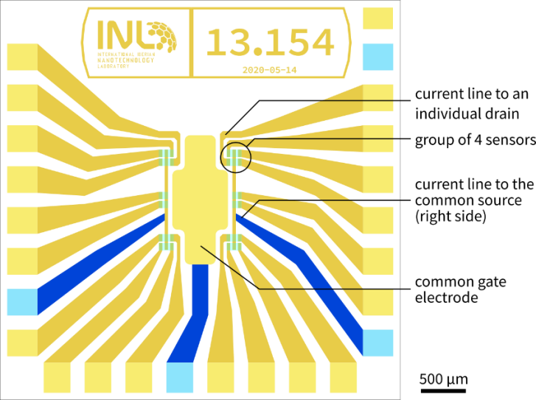
The square biosensor chip measures 4.5 mm on each side. It is arranged as a common-source layout connecting several graphene channels simultaneously, connected at the other extremity by individual drain electrodes. A total of 20 sensors are placed on the chip, sharing the same geometry, with a channel area exposed to the solution of 19 µm × 75 µm. The sensors are distributed into 4 groups of 4, and 2 groups of 2. The sensors are placed around a common gate electrode made of thin-film gold, which has an exposed area 480 times larger than the exposed area of an individual graphene channel. The golden gate electrode is covered by a self-assembled monolayer (SAM) of dodecanethiol (DDT), following the protocol indicated in ref. 29 of the main text. In contrast, the golden leads of source and drain, making the electrical contact to graphene, are passivated with silicon nitride.
Figure S1. Sensor chip layout

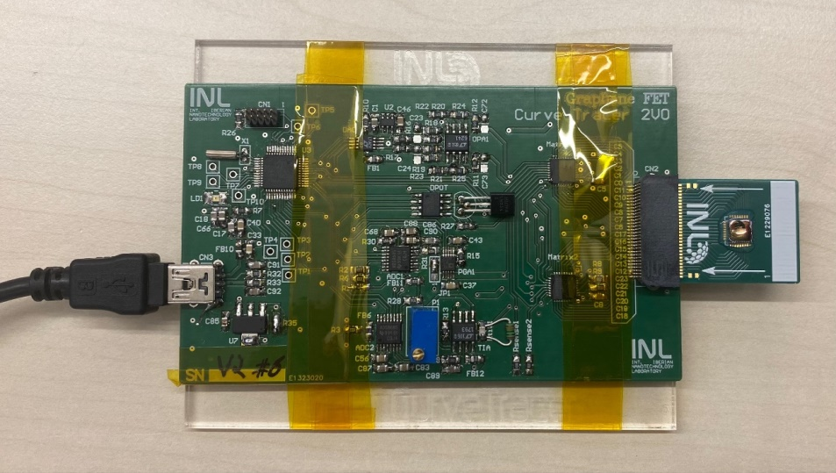
Figure S2. Reader platform of the size of a credit card with a sensor chip mounted on a PCB, inserted into the platform connector.
The chip is wire-bonded onto a PCB and inserted into an electronic platform with the size of a credit card (~ 8.5 x 5.5 cm). The platform comprises an electronic reader based on a homemade Arduino-compatible architecture equipped with discrete analog data acquisition components. The platform communicates with a portable computer through a USB connector.
- Colorimetric thiol detection
Figure S3. Top: UV-VIS spectrum of the product reaction obtained between the functionalized g-SGFET and DTP. Bottom: scheme of DTP reaction with free thiol groups of the g-SGFET.

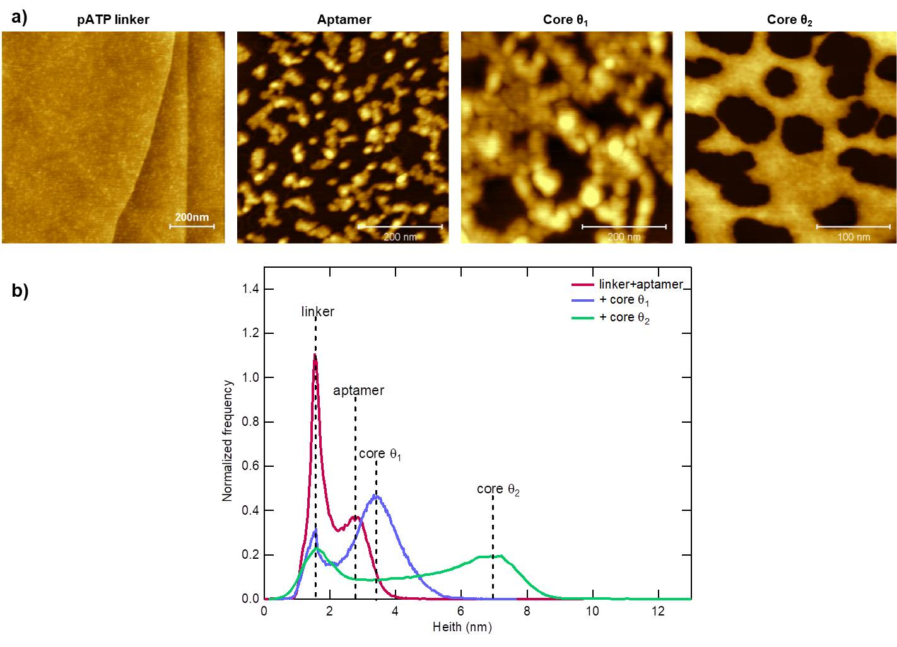
The presence of free thiol groups on covalently functionalized g-SGFET was confirmed by a colorimetric method, through the deposition of a saturated solution of 2,2’-dithiodipyridine (DTP) on graphene surface for 1h. Indeed, the thiol groups react with DTP forming 2,2’-dipyridyl disulfide and 2-mercaptopyridine. This last molecule quickly tautomerizes into 2-thipyridone forming a yellow solution, which indicates the presence of free thiols on g-SGFET surface. UV absorption peak at λ=343 nm (molar extinction coefficient at 343 nm = 8080 M⁻¹cm⁻¹) proves the formation of 2-mercaptopyridine while the peak observed at 269 nm is associated with the unreacted DTP, as shown in Fig. S3. No functionalized g-SGFET was used as blank.
- AFM: HCV core protein on functionalized graphite as a model system

Figure S4. (a) AFM images on a functionalized graphite surface for each biosensor fabrication stage, namely pATP functionalized graphene, after the aptamer linkage to it, after the HCV core protein interaction and after a further HCV core protein adsorption. b) Corresponding height distributions.
In order to check the validity of the experimental approach, a series of experiments were carried out by ex-situ AFM on graphite (that was used as a model system for this purpose). Thus, the morphological changes at the surface of the biosensing device for the sequential steps (i.e., graphite-pATP, graphite-pATP + aptamer, graphite-pATP + aptamer + HCV core protein, graphite-pATP + aptamer + HCV core protein + HCV core protein) were characterized by AFM. The corresponding AFM images are shown in Figure S4a. For the initial system a rather flat surface is imaged with small structures, 0.2-0.4 nm high, on top due to the functionalization. When the aptamer is linked to this surface, a sort of binary image is obtained, corresponding to graphite functionalized surface (dark background) and aptamer molecules (protruding structures). Finally, when this surface is exposed to a buffer solution containing the HCV core protein, it is still observed this sort of dark-bright morphology due to the partial coverage of the surface by the aptamer. It is worth noting that the different coverages of the graphite surface by the aptamer and HCV core protein observed in the images are due to the inhomogeneity of the deposition. Besides, the AFM measurements were not made at the same location on the surface.
One useful way to follow these sequential adsorption processes is to plot their corresponding height distribution (Fig. S4b). In this case, the first peak at low height value (x-axis) is set always equal and corresponds to the graphite functionalized surface (i.e. the darker zones in those AFM images with dark and bright zones). The second peak, at higher x-axis values, corresponds in each case to the adsorbed structures. Note that the peak due to the bound aptamer occurs at lower x-axis values than that obtained when HCV core protein is first deposited (which would correspond to the height of aptamer + HCV core protein structures). Finally, when further HCV core protein is deposited, this peak is wider and occurs at larger x-axis values, suggesting that core protein may adsorb not only on the specific aptamer molecules but also on already deposited core proteins. It is worth noting that the core protein seems to lack affinity for the graphite functionalized surface, since the dark patches in the AFM images are featureless and no other peaks appear in the corresponding height distribution.
- Reproducibility experiments: Variation in graphene V_{Dirac} point during the functionalization stages before HCV core protein detection
To check the reproducibility on the variation of the graphene's charge neutrality point just before biorecognition, several experiments on different g-SGFETs were carried out. In Figure S5, up to 10 different chips demonstrate similar shifts in the V_{Dirac} through the subsequent functionalization stages of target molecules in buffer (a) and in human plasma (b).

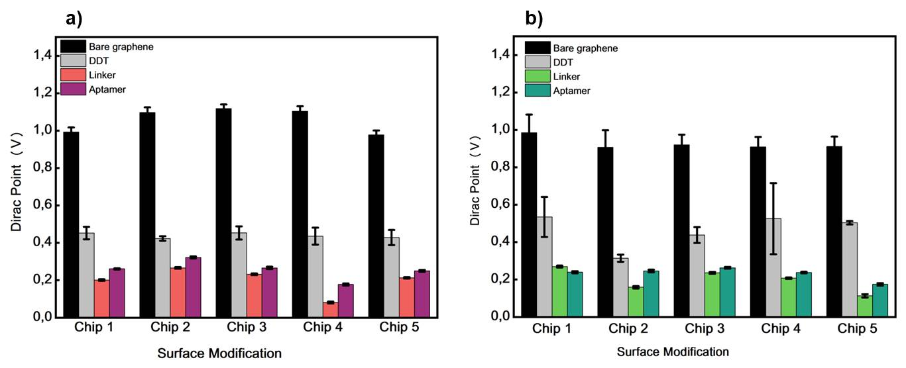
Figure S5. Variation in graphene V_{Dirac} point during the different stages before HCV core protein detection in 10 different g-SGFETs. From bare graphene, DDT treatment, covalent functionalization with the linker, and aptamer functionalization.
- Reproducibility experiments: Transfer characteristics in buffer solution for different HCV core protein concentrations
In order to check the reproducibility of the TCs and effective reponse results for the detection of the HCV core protein from concentrations to 10⁻¹⁸ M up to 10⁻¹¹ M in a buffer solution, measurements were repeated in several g-SGFETs. As shown in Fig. S6 the results are comparable with the ones shown in the main text (Fig. 2 b and d). Moreover the robustness and time durability of the biosensor have been also checked before carring the measurements on the transistors of Fig. S6, and after being placed on a desk for several weeks after functionalization.
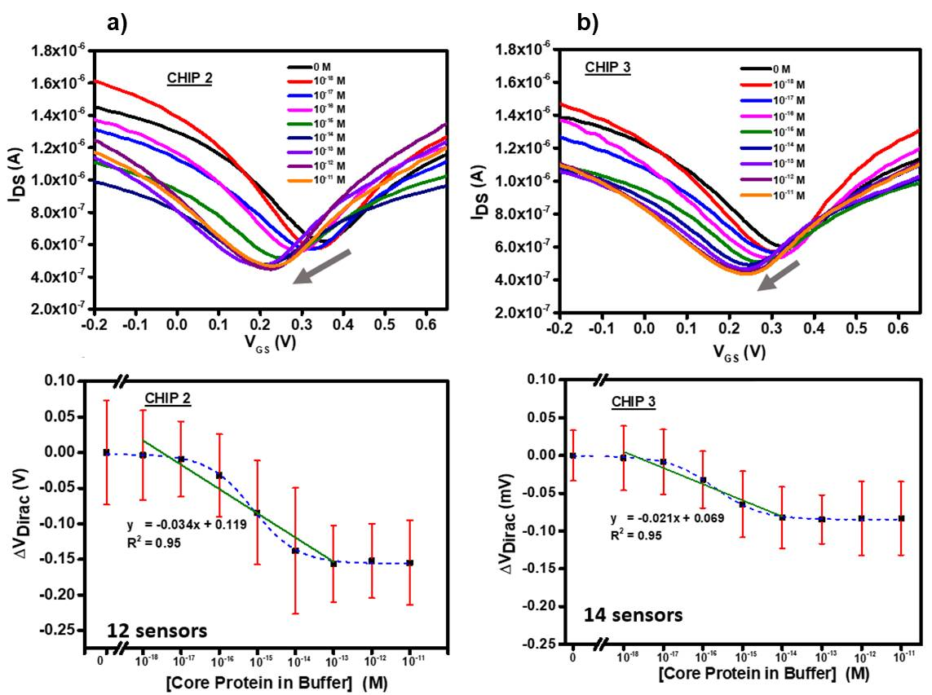
Figure S6. Transfer characteristics in a buffer solution (top panel) and effective response (lower panel) extracted from the I_{DS} current generated by different HCV protein concentrations and fitted to a dose-response (dashed line) for two different g-SGFETs.

- Reproducibility experiments: Transfer characteristics in human blood plasma for different HCV core protein concentrations
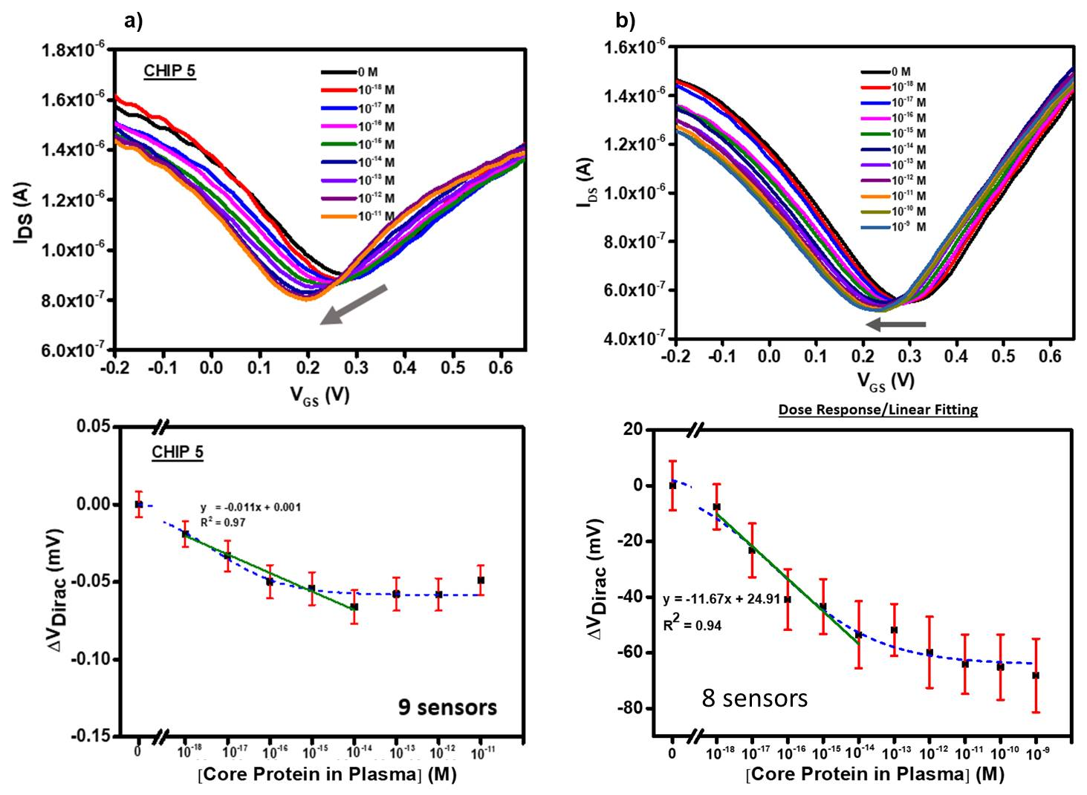
Again and to check the reproducibility of the TCs and effective response results for the detection of the HCV core protein from concentrations to 10⁻¹⁸ M up to 10⁻¹¹ M in human blood plasma of a HCV-negative donor, measurements were repeated in several g-SGFETs. As shown in Fig. S7 the results are comparable with the ones shown in the main text (Fig. 2 c and e).

Figure S7. Transfer characteristics in human blood plasma (top panel) and effective response (lower panel) extracted from the I_{DS} current generated by different HCV core protein concentrations and fitted to a dose-response (dashed line) for two different g-SGFETs.

- Specificity tests of the g-SGFET aptasensor to HCV core protein in human plasma
The specificity of the AptD-1312 aptamer in the detection was not only checked in buffer solution (Fig. 3 c and d of main text) but also in human blood plasma. To that end, the effective reponse in 5 different g-SGFETs functionalized with an unspecific aptamer (D-ACTG) were measured showing no response as expected.
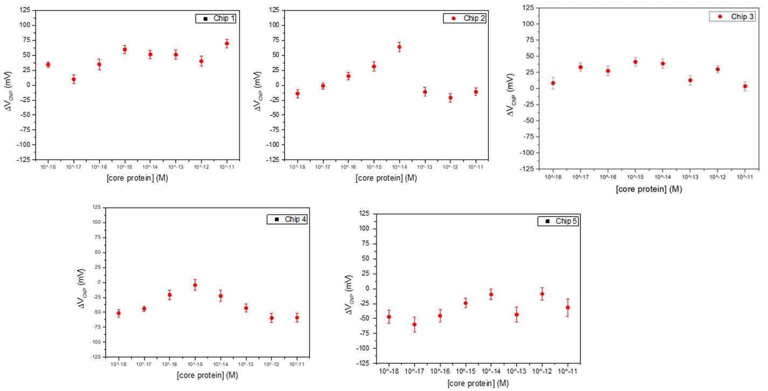
Figure S8. Specificity tests of the g-SGFET aptasensor. Effective response extracted from the I_{DS} current generated by different HCV protein concentrations in human blood plasma in 5 different g-SGFETs, show the biosensor's lack of recognition of HCV core protein when the unspecific DNA sequence D-ACTG had been covalently immobilized onto the graphene surface instead of the AptD-1312 aptamer.
- Control experiment: not functionalized g-SGFET
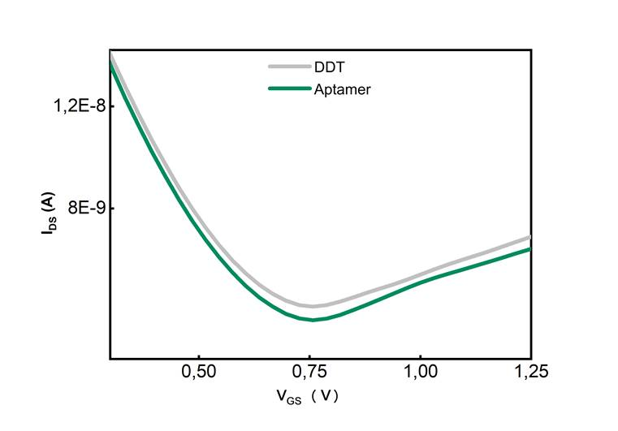
To ensure that the system is robust and that, in the absence of the pATP linker, no signal is produced by the aptamer or the buffer, we have studied the transfer characteristics of a g-SGFET without functionalization. It can be seen that after channel exposure to the aptamer, there is no V_{Dirac} change showing that the aptamer doesn't attach to the graphene surface.
Figure S9. Transfer curves of a g-SGFET without functionalization before (grey curve) and after (green curve) the exposure to the aptamer. The sensor exhibits almost zero response.

- Theoretical details on the geometrical models and charge transfer
Relaxed structures of the possible absorption geometries for the linker pATP molecule. These simulations have been performed with Fireball DFT in a periodic system with 10×10 kpoints.
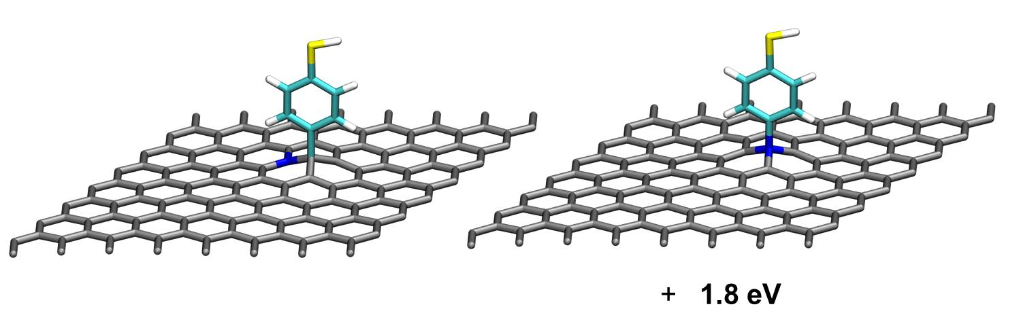
Figure S10. Possible adsorption geometry of the linker molecule (pATP) on a graphene sheet.

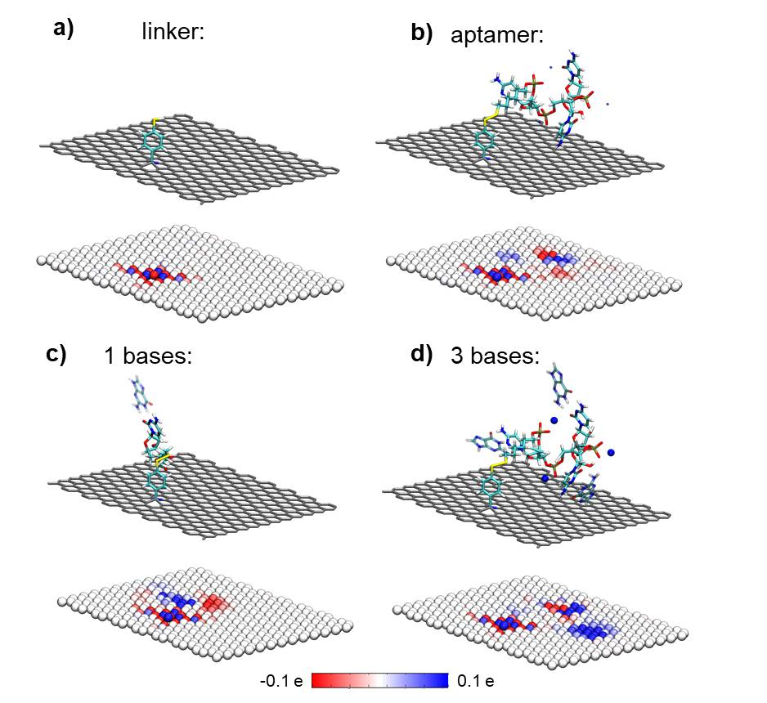
Figure S11. Plot of partial atomic charges in the different stages of the functionalization of a graphene sheet: a) linker; b) linker + aptamer; c)linker +aptamer + one complementary nucleobase and d) linker + aptamer + 3 complementary nucleobases (red color/negative value represents excess of atomic charge, while blue color/positive value means loss of atomic charge).
Fig. S11a shows the structure of the linker, S11b aptamer, S11c aptamer with one complementary nucleobase and S11d aptamer with three complementary nucleobases. Just beneath them, the graphene sheet with the color represents the partial atomic charges for the linker (Fig. S11a), aptamer (Fig. S11b), aptamer with one complementary nucleobase (Fig. S11c) and aptamer with three complementary nucleobases (Fig. S11d). All these structures have been calculated after a geometrical relaxation with QM/MM with the graphene and the linker in QM region (Fireball DFT) and the rest of the system in MM (AMBER). The final calculation of charge has been done with a full system DFT simulation.
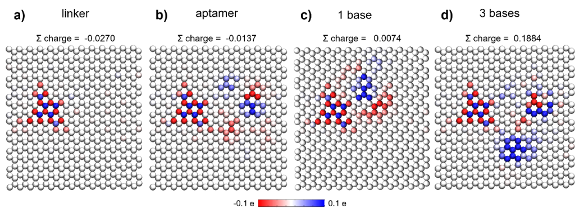
Figure S12. Plot of partial atomic charges in the different stages of the functionalization of a graphene sheet: a) linker; b) linker + aptamer; c) linker + aptamer + one complementary nucleobase and d) linker + aptamer + 3 complementary nucleobases (red color/negative value represents excess of atomic charge, while blue color/positive value means loss of atomic charge).
Top view of the graphene sheet with the color representing the Lowdin partial atomic charges for the linker (Fig. S12a), aptamer (Fig. S12b), aptamer with one complementary nucleobase (Fig. S12c) and aptamer with three complementary nucleobases (Fig. S12d). On top of each image the sum of the partial atomic charge of all the atoms. These calculations have been made with the whole system in DFT, here we represent only the partial charge of the graphene sheet to compare the effect of adding a more polarizable molecule nearby.
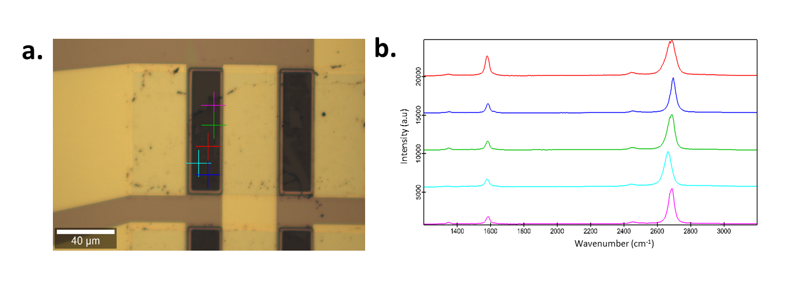
- Raman spectra of graphene used in the g-SGFETs
Figure S13. Raman spectra of the single layer graphene on the chip taken from several data points showing the chracteristics 2D, G and D bands of a of single-layer graphene. The confocal micro-Raman system WITec alpha 300R was used with a 50× lens and the spectra taken at an excitation wavelength of 532 nm.

11. Aptamers and HCV
Aptamers are single-stranded (ss) RNA or DNA molecules selected in vitro from combinatorial populations of nucleic acids, using an amplification-selection protocol known as SELEX^{1,2}. The specificities and affinities of aptamers for their ligands are analogous or even higher than those of antibody-antigen pairs. In addition, aptamers show numerous advantages over antibodies (reviewed in ref³), including those related to their in vitro production, lower cost and the possibility of introducing chemical modifications to increase their stability and/or functionality. As a result, aptamers show increasing applicability in different fields of biotechnology and biomedicine, including viral diagnosis and therapy^{4,5}. Aptamer-based biosensors (also known as ‘aptasensors’) have been developed using different transduction systems that produce a quantitative or semi-quantitative signal when specific aptamer-target interactions occur⁶.

Hepatitis C virus (HCV) is the etiological agent of chronic hepatitis C and a major cause of cirrhosis and hepatocellular carcinoma^{7,8}. It is estimated that up to 1.5 million new HCV infections occur each year, and around 58 million people have chronic HCV infection worldwide⁹. HCV infection is diagnosed using a two steps-protocol: a serologic assay to detect anti-HCV antibodies and, if the screening test is positive, a confirmative RTqPCR amplification of the viral genome¹⁰. This makes HCV diagnosis a time consuming and expensive method, which evidences that cost-effective and rapid point-of-care (POC) tests with enough sensitivity are required, among them those using aptamers as bio-recognition probe molecules.

REFERENCES
1. Ellington, A. D. & Szostak, J. W. In vitro selection of RNA molecules that bind specific ligands. Nature 346, 818–822 (1990).
2. Tuerk, C. & Gold, L. Systematic evolution of ligands by exponential enrichment: RNA ligands to bacteriophage T4 DNA polymerase. Science (80-. ). 249, 505–510 (1990).
3. Kaur, H., Bruno, J. G., Kumar, A. & Sharma, T. K. Aptamers in the therapeutics and diagnostics pipelines. Theranostics 8, 4016–4032 (2018).
4. Zou, X., Wu, J., Gu, J., Shen, L. & Mao, L. Application of aptamers in virus detection and antiviral therapy. Front. Microbiol. 10, 1462 (2019).
5. Kim, T.-H. & Lee, S.-W. Aptamers for Anti-Viral Therapeutics and Diagnostics. Int. J. Mol. Sci. 22, 4168 (2021).
6. Liu, L. S., Wang, F., Ge, Y. & Lo, P. K. Recent Developments in Aptasensors for Diagnostic Applications. ACS Applied Materials and Interfaces 13, 9329–9358 (2021).
7. Manns, M. P. et al. Hepatitis C virus infection. Nat. Rev. Dis. Prim. 3, 1–19 (2017).
8. Pietschmann, T. & Brown, R. J. P. Hepatitis C Virus. Trends in Microbiology 27, 379–380 (2019).
9. WHO. Global progress report on HIV, viral hepatitis and sexually transmitted infections, 2021. (2021). Available at: https://www.who.int/news-room/fact-sheets/detail/hepatitis-c.
10. Chevaliez, S. Strategies for the improvement of HCV testing and diagnosis. Expert Review of Anti-Infective Therapy 17, 341–347 (2019).

