The impact of placental genetic risk for schizophrenia and birth asphyxia on brain development

Laura A. Wortinger * ^{1, 2}, Alexey A. Shadrin ^{2, 3, 4}, Attila Szabo ^{2, 3, 4}, Stener Nerland ^{1, 2}, Runar Elle Smelror ^{1, 2}, Kjetil Nordbø Jørgensen ^{1, 5}, Claudia Barth ^{1, 2}, Dimitrios Andreou ^{1, 2, 7} Marianne Thoresen ^{8, 9}, Ole A. Andreassen ^{2, 3, 4}, Srdjan Djurovic ^{4, 6, 10}, Gianluca Ursini ^{11, 12} and Ingrid Agartz ^{1, 2, 4, 7}

¹Department of Psychiatric Research, Diakonhjemmet Hospital, Oslo, Norway
² NORMENT, Institute of Clinical Medicine, University of Oslo, Oslo, Norway
³NORMENT, Division of Mental Health and Addiction, Oslo University Hospital, Oslo, Norway
⁴KG Jebsen Centre for Neurodevelopmental Disorders, University of Oslo, Oslo, Norway
⁵Department of Psychiatry, Telemark Hospital, Skien, Norway
⁶Department of Medical Genetics, Oslo University Hospital, Oslo, Norway
⁷Centre for Psychiatry Research, Department of Clinical Neuroscience, Karolinska Institutet and Stockholm Health Care Services, Stockholm County Council, Stockholm, Sweden
⁸Department of Physiology, Institute of Basic Medical Sciences, University of Oslo, Oslo, Norway
⁹Neonatal Neuroscience, Translational Health Sciences, University of Bristol, Bristol, United Kingdom
¹⁰NORMENT, Department of Clinical Science, University of Bergen, Bergen, Norway
¹¹Lieber Institute for Brain Development, Johns Hopkins Medical Campus, Baltimore, MD, USA
¹²Department of Psychiatry and Behavioral Sciences, Johns Hopkins University School of Medicine, Baltimore, MD, USA

* To whom correspondence should be addressed: Dr. Laura A. Wortinger, Department of Psychiatric Research, Diakonhjemmet Hospital, Postbox 23 Vinderen, 0319, Oslo, Norway; telephone: +4792282220; e-mail: l.a.w.bakke@medisin.uio.no

Supplementary Figure 1. ComBat harmonization
Supplementary Figure 2. Boxplot visualizing nHC and adult ICV outliers

Supplementary Figure 1. Intracranial volume before and after ComBat harmonization.

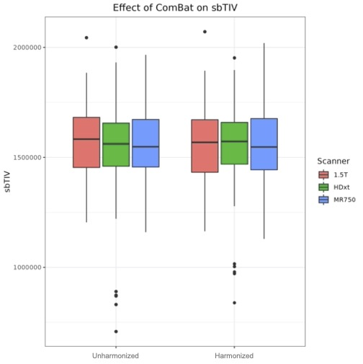

Supplementary Figure 2. Boxplot visualizing neonatal head circumference and adult intracranial volume outliers
