Synthesis of a Class of I^{(III)}/S^{(VI)} Reagents and Their Reactivity in Photochemical Cycloaddition Reactions with Unsaturated Bonds
Li Li, Kun Deng, Zhaofeng Wang*, Yong Huang*
*correspondence to: zfwangchem@hnu.edu.cn; yonghuang@ust.hk

Supporting Information

Table of Contents
- General Information.
- Synthesis of I^{(III)}/S^{(VI)} Reagents 3.
- Light-mediated [4+2] Cycloaddition: reaction scope.
- Light-mediated [3+2] Cycloaddition: reaction scope.
- Light-mediated and Rh-mediated Tandem [3+2] Cycloaddition: reaction scope.
- Synthetic Application of [4+2] and [3+2] Products.
- References.
- NMR Spectra.

- General Information.
Chemicals were purchased from commercial suppliers and used without further purification unless otherwise stated. Anhydrous solvents were dried by passing through an activated alumina column on a PureSolvTM solvent purification system (Innovative Technologies, Inc., MA). Analytical thin-layer chromatography (TLC) was performed using Huanghai silica gel plates with HSGF 254. Visualization of the developed chromatogram was performed by irradiation with UV light or treatment with a solution of appropriate stains. Flash column chromatography was performed on silica gel (Qindao Puke Co., China., 200-300 mesh) or neutral silica gel (Bio-Gene Tech. Ltd., 230-400 mesh). Organic solutions were concentrated under reduced pressure on an EYELA rotatory evaporator. Unless otherwise stated, reactions were carried out under an argon atmosphere. Yields refer to purified compounds unless otherwise noted. NMR spectra were recorded at 298 K (unless otherwise stated) on a Bruker AV 400 MHz NMR spectrometer. Chemical shifts (δ) are quoted in ppm relative to residual solvent signals, CDCl₃ referenced at δ 7.26 and 77.16 ppm, DMSO-d₆ referenced at δ 2.50 and 39.52 ppm, CD₃CN referenced at δ 1.94 and 1.39, 118.69 ppm, Acetone-d₆ referenced at δ 2.05 and 29.92, 206.68 ppm. Coupling constants (J) are quoted in hertz (Hz). Multiplicity is reported with the following abbreviations: s = singlet, brs = broad singlet, d = doublet, t = triplet, q = quartet, p = quintet, dt = doublet of triplets, td = triplet of doublets, tt = triplet of triplets, sp = septet, m = multiplet, app = apparent. Mass spectra were collected on an Agilent GC/MS 5975C system, a MALDI Micro MX mass spectrometer, or an API QSTAR XL System.
- Synthesis of I, S-ylides 3.
Figure S1. Cyclic and linear hypervalent iodine reagents 3a-3u

General procedure for the synthesis of ylides 1
According to the literature,^{[1]} the slightly modified method is as follows. Under N₂, acid (5.0 mmol) in CH₂Cl₂ (10 mL) at 0 °C before adding SOCl₂ (7.5 mmol, 1.5 equiv) and one drop of DMF. After 60 minutes stirring at 50 °C, and the volatiles were carefully evaporated under high-vacuum. During that time, trimethylsulfoxonium iodide (3.3 g, 16.5 mmol, 3.0 equiv) was suspended under N₂ in dry THF (40 mL) in a flame-dried 100 mL round bottom flask that was protected from light with aluminium foil. Potassium tertbutoxide (1.8 g, 16.5 mmol, 3.3 equiv) was added, and the mixture was stirred at reflux for 3 hours. After cooling to 0 °C, a solution of acid chloride obtained above in THF (10 mL) was added dropwise to the mixture. The mixture was stirred at room temperature for another hour and then solvents were removed under vacuum. Then 80 ml water were added, extraction with CH₂Cl₂ (50 × 3 mL). Purification by flash chromatography (dichloromethane/MeOH = 30/1) provided the ylide.

General procedure A for the synthesis of cyclic I, S-ylides 3
A solution of 1-acetoxy-1,2-benziodoxol-3(1H)-one (1.53 g, 5.0 mmol, 1.0 equiv.) in dichloromethane (10.0 mL, 0.5 M) was treated with trimethylsilyl trifluoromethanesulfonate (0.9 mL, 5.0 mmol, 1.0 equiv.) at room temperature. After 10 minutes, a solution of pyridine (0.44 mL, 5.5 mmol, 1.1 equiv.) in dichloromethane (2.0 mL) was added dropwise over 10 minutes and the resulted suspension was stirred for 30 min at room temperature. A solution of the corresponding sulfoxonium ylides (5.0 mmol, 1.0 equiv.) in dichloromethane (2.0 mL) was added dropwise over 10 minutes and the resulting reaction mixture was stirred until TLC indicated all the ylide was consumed (usually 8 hours). The reaction solution was washed with distilled water (200 mL × 2) and dried with anhydrous sodium sulfate. The solvent was removed under vacuum and the residue was purified by flash column chromatography (DCM/acetone = 10:1) to provide 3 as white solid.
General procedure B for the synthesis of linear I, S-ylide 3
A solution of aryliodoso diacetate (5.0 mmol, 1.0 equiv.) in MeOH (5.0 mL, 1.0 M) was treated with corresponding acid HX (5.0 mmol, 1.0 equiv) at room temperature. This clear solution was added dropwise to the ice bath-cooled solution of sulfoxonium ylides (5.0 mmol, 1.0 equiv.) in MeOH (5.0 mL, 1.0 M) over 10 min with stirring. The resulting reaction mixture was stirred at 0 °C for 1 hour. During this period, a large amount of a white precipitate was formed. The solid was collected by filtration, washed successively with MeOH (5 mL × 3) and Et₂O (5 ml × 3), dried under high vacuum and stored at -20 °C. If the hypervalent iodine reagent failed to precipitate, it was subjected to flash column chromatography, eluting with DCM/Acetone mixtures.

1-(1-(dimethyl(oxo)-λ⁶-sulfaneylidene)-2-oxo-2-phenylethyl)-1,2-benziodoxol-3(1H)-one (3a)
Prepared according to the general procedure A using 2-(dimethyl(oxo)-λ⁶-sulfaneylidene)-1-phenylethan-1-one (981.3 mg, 5.0 mmol). Purification by flash chromatography (dichloromethane/acetone = 4/1) provided 3a as a white solid (773.9 mg, 35% yield).
¹H NMR (400 MHz, DMSO-d₆) δ 8.12 (d, J = 8.1 Hz, 1H), 8.04 (dd, J = 7.4, 1.7 Hz, 1H), 7.82 (ddd, J = 8.3, 7.1, 1.7 Hz, 1H), 7.69 (t, J = 7.3 Hz, 1H), 7.43 – 7.35 (m, 3H), 7.31 (dd, J = 8.5, 6.4 Hz, 2H), 4.03 (s, 3H), 3.76 (s, 3H).
¹³C NMR (101 MHz, DMSO-d₆) δ 188.97, 166.51, 140.48, 134.76, 134.27, 131.69, 130.96, 130.70, 128.47, 127.22, 126.29, 118.76, 66.08, 42.42, 42.37.
HRMS (ESI) calculated for C₁₇H₁₆IO₄S⁺ [M+H]⁺ m/z: 442.9808, found: 442.9810.

1-(1-(dimethyl(oxo)-λ⁶-sulfaneylidene)-2-oxododecyl)-1,2-benziodoxol-3(1H)-one (3b)
Prepared according to the general procedure A using 1-(dimethyl(oxo)-λ⁶-sulfaneylidene)tridecan-2-one (823.4 mg, 3.0 mmol). Purification by flash chromatography (dichloromethane/acetone = 4/1) provided 3b as a white solid (1.1 g, 71% yield).
¹H NMR (400 MHz, Acetone-d₆) δ 8.21 (dd, J = 7.3, 1.7 Hz, 1H), 7.93 (dd, J = 8.1, 1.0 Hz, 1H), 7.73 (td, J = 8.1, 7.6, 1.7 Hz, 1H), 7.66 (td, J = 7.3, 1.0 Hz, 1H), 3.94 (s, 3H), 3.79 (s, 3H), 2.66 (dt, J = 15.0, 7.4 Hz, 1H), 2.48 (dt, J = 15.1, 7.4 Hz, 1H), 1.53 (p, J = 7.4, 6.8 Hz, 2H), 1.32 – 1.15 (m, 16H), 0.86 (t, J = 6.8 Hz, 3H);
¹³C NMR (101 MHz, Acetone-d₆) δ 193.55, 167.48, 136.03, 134.18, 132.69, 131.02, 125.85, 119.02, 64.00, 43.70, 43.10, 40.13, 32.69, 30.41, 29.97, 26.31, 23.39, 14.44.
HRMS (ESI) calculated for C₂₂H₃₄IO₄S⁺ [M+H]⁺ m/z: 521.1217, found:521.1213.
The crystal structure of 3b has been deposited at the Cambridge Crystallographic Data Centre, CCDC 2068912.

(1-(dimethyl(oxo)-λ⁶-sulfaneylidene)-2-oxo-2-phenylethyl)(phenyl)iodonium hexafluorophosphate (3c)
Prepared according to the general procedure B using phenyliodoso diacetate (1.6 g, 5.0 mmol), HPF₆ (0.68 ml,65% w/w, 5.0 mmol) and 2-(dimethyl(oxo)-λ⁶-sulfaneylidene)-1-phenylethan-1-one (981.3 mg, 5.0 mmol). After filtration, 3c was collected as a white solid (2.5 g, 90% yield).
¹H NMR (400 MHz, CD₃CN) δ 7.79 (d, J = 8.5 Hz, 2H), 7.73 (t, J = 7.5 Hz, 1H), 7.63 – 7.55 (m, 3H), 7.55 – 7.44 (m, 4H), 3.73 (s, 6H).
¹³C NMR (101 MHz, CD₃CN) δ 188.84, 138.55, 133.02, 132.57, 132.19, 131.44, 128.59, 127.41, 118.18, 60.83, 42.54.
¹⁹F NMR (376 MHz, CD₃CN) δ -72.40 (d, J = 706 Hz).
³¹P NMR (162 MHz, CD₃CN) δ -144.54 (h, J = 706 Hz).
HRMS (ESI) calculated for C₁₆H₁₆IO₂S⁺ [M-PF₆]⁺ m/z: 398.9910, found: 398.9917.

(1-(dimethyl(oxo)-λ⁶-sulfanylidene)-2-oxo-2-phenylethyl)(phenyl)-λ³-iodanyl trifluoromethanesulfon-ate (3d)
Prepared according to the general procedure B using phenyliodoso diacetate (1.6 g, 5.0 mmol), HOTf (0.44 ml,5.0 mmol) and 2-(dimethyl(oxo)-λ⁶-sulfaneylidene)-1-phenylethan-1-one (981.3 mg, 5.0 mmol). After filtration, 3d was collected as a white solid (2.3 g, 85% yield).
¹H NMR (400 MHz, CD₃CN) δ 7.79 – 7.76 (m, 2H), 7.73 – 7.67 (m, 1H), 7.61 – 7.52 (m, 3H), 7.52 – 7.44 (m, 4H), 3.74 (s, 6H).
¹³C NMR (101 MHz, CD₃CN) δ 188.87, 138.77, 132.96, 132.33, 132.02, 131.29, 128.51, 127.41, 122.51, 119.33, 118.49, 61.47, 42.44.
¹⁹F NMR (376 MHz, CD₃CN) δ -79.12.
HRMS (ESI) calculated for C₁₆H₁₆IO₂S⁺ [M-OTf]⁺ m/z: 398.9910, found: 398.9917.

(1-(dimethyl(oxo)-λ⁶-sulfaneylidene)-2-oxo-2-phenylethyl)(phenyl)iodonium tetrafluoroborate (3e)
Prepared according to the general procedure B using phenyliodoso diacetate (1.6 g, 5.0 mmol), HBF₄ (0.66 ml,48% w/w, 5.0 mmol) and 2-(dimethyl(oxo)-λ⁶-sulfaneylidene)-1-phenylethan-1-one (981.3 mg, 5.0 mmol). After filtration, 3e was collected as a white solid (2.2 g, 92% yield).
¹H NMR (400 MHz, CD₃CN) δ 7.80 – 7.75 (m, 2H), 7.74 – 7.68 (m, 1H), 7.62 – 7.53 (m, 3H), 7.53 – 7.43 (m, 4H), 3.74 (s, 6H).
¹³C NMR (101 MHz, CD₃CN) δ 188.90, 138.66, 132.93, 132.48, 132.15, 131.37, 128.57, 127.40, 118.14, 61.00, 42.44.
¹⁹F NMR (376 MHz, CD₃CN) δ -150.05, -150.10.
HRMS (ESI) calculated for C₁₆H₁₆IO₂S⁺ [M-BF₄]⁺ m/z: 398.9910, found: 398.9919.
The crystal structure of 3c has been deposited at the Cambridge Crystallographic Data Centre, CCDC 2068911.

(1-(dimethyl(oxo)-λ⁶-sulfaneylidene)-2-oxo-2-(4-cyclohexylphenyl)ethyl)(phenyl)iodonium tetrafluor-oborate (3f)
Prepared according to the general procedure B using phenyliodoso diacetate (966.0 mg, 3.0 mmol), HPF₆ (0.41 ml,65% w/w, 3.0 mmol) and 1-(4-cyclohexylphenyl)-2-(dimethyl(oxo)-λ⁶-sulfanylidene)ethan-1-one (834.4 g, 3.0 mmol). After flash column chromatography, eluting with DCM/Acetone mixtures, 3f was collected as a white solid (1.77 g, 94% yield).
¹H NMR (400 MHz, Acetone-d₆) δ 7.96 – 7.90 (m, 2H), 7.77 – 7.70 (m, 1H), 7.63 (dd, J = 8.4, 7.1 Hz, 2H), 7.52 – 7.45 (m, 2H), 7.38 – 7.32 (m, 2H), 3.91 (s, 6H), 2.65 – 2.59 (m, 1H), 1.89 – 1.82 (m, 4H), 1.79 – 1.71 (m, 1H), 1.54 – 1.38 (m, 4H), 1.35 – 1.27 (m, 1H).
¹³C NMR (101 MHz, Acetone-d₆) δ 188.76, 151.80, 136.30, 132.61, 132.34, 132.22, 127.86, 126.81, 118.65, 61.45, 44.34, 42.32, 34.08, 26.58, 25.83.
¹⁹F NMR (376 MHz, Acetone-d₆) δ -71.28 (d, J = 709 Hz).
³¹P NMR (162 MHz, Acetone-d₆) δ -144.12 (h, J = 709 Hz).
HRMS (ESI) calculated for C₂₂H₂₆IO₂S⁺ [M-PF₆]⁺ m/z: 481.0693, found: 481.0691.

(1-(dimethyl(oxo)-λ⁶-sulfaneylidene)-2-oxo-2-(p-tolyl)ethyl)(phenyl)iodonium hexafluorophosphate (3g)
Prepared according to the general procedure B using phenyliodoso diacetate (966.0 mg, 3.0 mmol), HPF₆ (0.41 ml,65% w/w, 3.0 mmol) and 2-(dimethyl(oxo)-λ⁶-sulfanylidene)-1-(p-tolyl)ethan-1-one (630.0 mg, 3.0 mmol). After filtration, 3g was collected as a white solid (1.3 g, 75% yield).
¹H NMR (400 MHz, Acetone-d₆) δ 8.03 – 7.92 (m, 2H), 7.81 – 7.73 (m, 1H), 7.71 – 7.60 (m, 2H), 7.51 – 7.41 (m, 2H), 7.38 – 7.28 (m, 2H), 3.94 (s, 6H), 2.42 (s, 3H).
¹³C NMR (101 MHz, Acetone-d₆) δ 188.76, 141.88, 135.97, 132.66, 132.33, 132.18, 128.96, 127.74, 118.72, 61.33, 42.30, 20.60.
¹⁹F NMR (376 MHz, Acetone-d₆) δ -71.80 (d, J = 708 Hz).
³¹P NMR (162 MHz, Acetone-d₆) δ -144.19 (h, J = 709 Hz).
HRMS (ESI) calculated for C₁₇H₁₈IO₂S⁺ [M-PF₆]⁺ m/z: 413.0067, found: 413.0070.

(1-(dimethyl(oxo)-λ⁶-sulfaneylidene)-2-oxo-2-(4-chloorophenyl)ethyl)(phenyl)iodonium hexafluoro-ophosphate (3h)
Prepared according to the general procedure B using phenyliodoso diacetate (966.0 mg, 3.0 mmol), HPF₆ (0.41 ml,65% w/w, 3.0 mmol) and 1-(4-chlorophenyl)-2-(dimethyl(oxo)-λ⁶-sulfanylidene)ethan-1-one (690.0 mg, 3.0 mmol). After flash column chromatography, eluting with DCM/Acetone mixtures, 3h was collected as a light yellow solid (1.5 g, 87% yield).
¹H NMR (400 MHz, Acetone-d₆) δ 8.05 – 7.97 (m, 2H), 7.77 (t, J = 7.4 Hz, 1H), 7.65 (t, J = 7.8 Hz, 2H), 7.58 – 7.53 (m, 4H), 3.96 (s, 6H).
¹³C NMR (101 MHz, Acetone-d₆) δ 187.54, 137.63, 136.67, 132.82, 132.42, 132.25, 129.36, 128.64, 118.67, 61.87, 42.18.
¹⁹F NMR (376 MHz, Acetone-d₆) δ -71.80 (d, J = 708 Hz).
³¹P NMR (162 MHz, Acetone-d₆) δ -144.20 (h, J = 709 Hz).
HRMS (ESI) calculated for C₁₆H₁₅IClO₂S⁺ [M-PF₆]⁺ m/z: 432.9520, found: 432.9522.

(1-(dimethyl(oxo)-λ⁶-sulfaneylidene)-2-oxo-2-(3-chlorophenyl)ethyl)(phenyl)iodonium hexafluoropho-sphate (3i)

Prepared according to the general procedure B using phenyliodoso diacetate (966.0 mg, 3.0 mmol), HPF₆ (0.41 ml,65% w/w, 3.0 mmol) and 1-(3-chlorophenyl)-2-(dimethyl(oxo)-λ⁶-sulfanylidene)ethan-1-one (690.1 mg, 3.0 mmol). After filtration, 3i was collected as a white solid (1.59 g, 89% yield).
¹H NMR (400 MHz, Acetone-d₆) δ 7.99 (dd, J = 8.0, 1.3 Hz, 2H), 7.82 – 7.75 (m, 1H), 7.66 (t, J = 7.8 Hz, 2H), 7.61 (dt, J = 8.0, 1.7 Hz, 1H), 7.56 (t, J = 7.6 Hz, 1H), 7.52 – 7.45 (m, 2H), 3.98 (s, 6H).
¹³C NMR (101 MHz, Acetone-d₆) δ 187.13, 140.97, 133.76, 132.97, 132.45, 132.22, 131.08, 130.50, 127.39, 125.92, 118.74, 62.13, 42.15.
¹⁹F NMR (376 MHz, Acetone-d₆) δ -71.89 (d, J = 708 Hz).
³¹P NMR (162 MHz, Acetone-d₆) δ -144.21 (h, J = 708 Hz).
HRMS (ESI) calculated for C₁₆H₁₅IClO₂S⁺ [M-PF₆]⁺ m/z: 432.9520, found: 432.9521.

(1-(dimethyl(oxo)-λ⁶-sulfaneylidene)-2-oxo-2-(3,4-dimethylphenyl)ethyl)(phenyl)iodonium hexafluor-ophosphate (3j)

Prepared according to the general procedure B using phenyliodoso diacetate (966.0 mg, 3.0 mmol), HPF₆ (0.41 ml,65% w/w, 3.0 mmol) and 2-(dimethyl(oxo)-λ⁶-sulfanylidene)-1-(3,4-dimethylphenyl)ethan-1-one (720.4 mg, 3.0 mmol). After flash column chromatography, eluting with DCM/Acetone mixtures, 3j was collected as a white solid (1.69 g, 96% yield).
¹H NMR (400 MHz, Acetone-d₆) δ 8.00 – 7.94 (m, 2H), 7.80 – 7.74 (m, 1H), 7.66 (dd, J = 8.5, 7.1 Hz, 2H), 7.30 – 7.21 (m, 3H), 3.95 (s, 6H), 2.33 (s, 3H), 2.23 (s, 3H).
¹³C NMR (101 MHz, Acetone-d₆) δ 189.05, 140.54, 136.66, 136.42, 132.66, 132.30, 132.15, 129.53, 128.73, 125.19, 118.90, 61.36, 42.31, 18.97, 18.85.
¹⁹F NMR (376 MHz, Acetone-d₆) δ -71.77 (d, J = 708 Hz).
³¹P NMR (162 MHz, Acetone-d₆) δ -144.19 (h, J = 709 Hz).
HRMS (ESI) calculated for C₁₈H₂₀IO₂S⁺ [M-PF₆]⁺ m/z: 427.0223, found: 427.0232.

(1-(dimethyl(oxo)-λ⁶-sulfaneylidene)-2-oxo-2-(5-methylthiophen)ethyl)(phenyl)iodonium hexafluoro-phosphate (3k)

Prepared according to the general procedure B using phenyliodoso diacetate (966.0 mg, 3.0 mmol), HPF₆ (0.41 ml,65% w/w, 3.0 mmol) and 2-(dimethyl(oxo)-λ⁶-sulfanylidene)-1-(5-methylthiophen-2-yl)ethan-1-one (648.1 mg, 3.0 mmol). After flash column chromatography, eluting with DCM/Acetone mixtures, 3k was collected as a white solid (869.9 g, 50% yield).
¹H NMR (400 MHz, Acetone-d₆) δ 8.13 – 8.08 (m, 2H), 7.77 – 7.70 (m, 1H), 7.68 – 7.62 (m, 3H), 6.90 (dd, J = 3.8, 1.2 Hz, 1H), 3.92 (s, 6H), 2.53 (d, J = 1.1 Hz, 3H).
¹³C NMR (101 MHz, Acetone-d₆) δ 178.49, 147.57, 138.61, 132.28, 132.25, 132.18, 132.12, 126.65, 118.60, 58.42, 42.90, 14.66.
¹⁹F NMR (376 MHz, Acetone-d₆) δ -71.55 (d, J = 708 Hz).
³¹P NMR (162 MHz, Acetone-d₆) δ -144.17 (h, J = 709 Hz).
HRMS (ESI) calculated for C₁₅H₁₆IO₂S⁺ [M-PF₆]⁺ m/z: 418.9631, found: 418.9632.

(1-(dimethyl(oxo)-λ⁶-sulfaneylidene)-2-oxo-2-(thiophen-2-yl)ethyl)(phenyl)iodonium hexafluoroph-osphate (3l)
Prepared according to the general procedure B using phenyliodoso diacetate (1.6 g, 5.0 mmol), HPF₆ (0.68 ml,65% w/w, 5.0 mmol) and 2-(dimethyl(oxo)-λ⁶-sulfanylidene)-1-(thiophen-2-yl)ethan-1-one (1.0 g, 5.0 mmol). After filtration, 3l was collected as a white solid (2.5 g, 89% yield).
¹H NMR (400 MHz, Acetone-d₆) δ 8.15 – 8.10 (m, 2H), 7.85 (dd, J = 5.0, 1.1 Hz, 1H), 7.81 (dd, J = 3.8, 1.1 Hz, 1H), 7.78 – 7.73 (m, 1H), 7.69 – 7.63 (m, 2H), 7.22 (dd, J = 5.0, 3.8 Hz, 1H), 3.96 (s, 6H).δ 7.80 – 7.77 (m, 2H), 7.76 – 7.70 (m, 1H), 7.64 – 7.45 (m, 7H), 3.73 (s, 6H).
¹³C NMR (101 MHz, Acetone-d₆) δ 178.88, 141.05, 132.29, 132.26, 132.10, 131.50, 127.86, 118.61, 59.29, 42.77.
¹⁹F NMR (376 MHz, Acetone-d₆) δ -71.96 (d, J = 707 Hz).
³¹P NMR (162 MHz, Acetone-d₆) δ -144.21(h, J = 708 Hz).
HRMS (ESI) calculated for C₁₄H₁₄IO₂S₂⁺ [M-PF₆]⁺ m/z: 404.9474, found: 404.9481.

(1-(dimethyl(oxo)-λ⁶-sulfaneylidene)-2-oxo-2-(benzo[b]thiophen-2-yl)ethyl)(phenyl)iodonium hexafluorophosphate (3m)
Prepared according to the general procedure B using phenyliodoso diacetate (966.0 mg, 3.0 mmol), HPF₆ (0.41 ml,65% w/w, 3.0 mmol) and 1-(benzo[b]thiophen-2-yl)-2-(dimethyl(oxo)-l6-sulfanylidene)ethan-1-one (756.1 mg, 3.0 mmol). After flash column chromatography, eluting with DCM/Acetone mixtures, 3m was collected as a light yellow solid (1.24 g, 67% yield).
¹H NMR (400 MHz, Acetone-d₆) δ 8.18 – 8.15 (m, 2H), 8.09 – 8.00 (m, 2H), 7.96 – 7.94 (m, 1H), 7.82 – 7.75 (m, 1H), 7.69 – 7.65 (m, 2H), 7.57 – 7.46 (m, 2H), 3.98 (s, 6H).
¹³C NMR (101 MHz, Acetone-d₆) δ 179.75, 141.03, 140.72, 138.83, 132.60, 132.40, 132.31, 128.22, 127.09, 125.65, 125.30, 122.62, 118.94, 60.77, 42.59.
¹⁹F NMR (376 MHz, Acetone-d₆) δ -71.88 (d, J = 708 Hz).
³¹P NMR (162 MHz, Acetone-d₆) δ -144.18 (h, J = 709 Hz).
HRMS (ESI) calculated for C₁₈H₁₆IO₂S₂⁺ [M-PF₆]⁺ m/z: 454.9631, found: 454.9635.

(1-(dimethyl(oxo)-λ⁶-sulfaneylidene)-2-oxo-2-(furan-2-yl)ethyl)(phenyl)iodonium hexafluorophosph-ate (3n)

Prepared according to the general procedure B using phenyliodoso diacetate (966.0 mg, 3.0 mmol), HPF₆ (0.41 ml,65% w/w, 3.0 mmol) and 2-(dimethyl(oxo)-λ⁶-sulfanylidene)-1-(furan-2-yl)ethan-1-one (558.1 mg, 3.0 mmol). After filtration, 3n was collected as a white solid (1.3 g, 76% yield).
¹H NMR (400 MHz, Acetone-d₆) δ 8.26 – 8.18 (m, 2H), 7.95 (dd, J = 1.8, 0.8 Hz, 1H), 7.77 – 7.71 (m, 1H), 7.63 (dd, J = 8.4, 7.1 Hz, 2H), 7.28 (dd, J = 3.6, 0.8 Hz, 1H), 6.73 (dd, J = 3.6, 1.8 Hz, 1H), 3.93 (s, 6H).
¹³C NMR (101 MHz, Acetone-d₆) δ 172.88, 151.24, 145.88, 133.17, 132.22, 131.93, 119.01, 116.69, 112.55, 57.07, 42.81.
¹⁹F NMR (376 MHz, Acetone-d₆) δ -72.07 (d, J = 707 Hz).
³¹P NMR (162 MHz, Acetone-d₆) δ -144.22 (h, J = 708 Hz).
HRMS (ESI) calculated for C₁₄H₁₄IO₃S⁺ [M-PF₆]⁺ m/z: 388.9703, found: 388.9704.

(1-(dimethyl(oxo)-λ⁶-sulfaneylidene)-2-oxo-2-([1,1'-biphenyl]-4-yl)ethyl)(phenyl)iodonium hexafluor-ophosphate (3o)
Prepared according to the general procedure B using phenyliodoso diacetate (644.0 mg, 2.0 mmol), HPF₆ (0.28 ml,65% w/w, 2.0 mmol) and 1-([1,1'-biphenyl]-4-yl)-2-(dimethyl(oxo)-λ⁶-sulfanylidene)ethan-1-one (544.2 mg, 2.0 mmol). After filtration, 3o was collected as a white solid (1.1 g, 89% yield).
¹H NMR (400 MHz, Acetone-d₆) δ 8.11 – 8.00 (m, 2H), 7.85 – 7.81 (m, 2H), 7.81 – 7.74 (m, 3H), 7.73 – 7.63 (m, 4H), 7.57 – 7.49 (m, 2H), 7.49 – 7.39 (m, 1H), 4.00 (s, 6H).
¹³C NMR (101 MHz, Acetone-d₆) δ 188.40, 143.84, 139.58, 137.60, 132.88, 132.39, 132.21, 129.04, 128.38, 128.18, 127.06, 126.76, 118.86, 61.62, 42.31.
¹⁹F NMR (376 MHz, Acetone-d₆) δ -72.14 (d, J = 707 Hz).
³¹P NMR (162 MHz, Acetone-d₆) δ -144.22 (h, J = 709 Hz).
HRMS (ESI) calculated for C₂₂H₂₀IO₂S⁺ [M-PF₆]⁺ m/z: 475.0223, found: 475.0227.

(1-(dimethyl(oxo)-λ⁶-sulfaneylidene)-2-oxo-2-(o-tolyl)ethyl)(phenyl)iodonium hexafluorophosphate (3p)
Prepared according to the general procedure B using phenyliodoso diacetate (966.0 mg, 3.0 mmol), HPF₆ (0.41 ml,65% w/w, 3.0 mmol) and 1-([1,1'-biphenyl]-2-yl)-2-(dimethyl(oxo)-λ⁶-sulfanylidene)ethan-1-one (630.2 mg, 3.0 mmol). After flash column chromatography, eluting with DCM/Acetone mixtures, 3p was collected as a light yellow solid (1.5 g, 91% yield).
¹H NMR (400 MHz, Acetone-d₆) δ 7.78 – 7.73 (m, 3H), 7.59 (t, J = 7.7 Hz, 2H), 7.42 (t, J = 7.5 Hz, 1H), 7.33 – 7.26 (m, 2H), 7.21 (d, J = 7.5 Hz, 1H), 3.98 (s, 6H), 2.13 (s, 3H).
¹³C NMR (101 MHz, Acetone-d₆) δ 189.70, 139.19, 135.04, 133.48, 132.43, 131.96, 130.89, 130.02, 126.67, 125.53, 118.57, 63.16, 42.31, 17.99.
¹⁹F NMR (376 MHz, Acetone-d₆) δ -71.77 (d, J = 708 Hz).
³¹P NMR (162 MHz, Acetone-d₆) δ -144.19 (h, J = 709 Hz).
HRMS (ESI) calculated for C₁₇H₁₈IO₂S⁺ [M-PF₆]⁺ m/z: 413.0067, found: 413.0063.

(1-(dimethyl(oxo)-λ⁶-sulfaneylidene)-2-oxo-2-(-phenoxyphenyl)ethyl)(phenyl)iodonium hexafluoroph-osphate (3q)
Prepared according to the general procedure B using phenyliodoso diacetate (966.0 mg, 3.0 mmol), HPF₆ (0.41 ml,65% w/w, 3.0 mmol) and 2-(dimethyl(oxo)-λ⁶-sulfanylidene)-1-(2-phenoxyphenyl)ethan-1-one (864.2 g, 3.0 mmol). After filtration, 3q was collected as a white solid (1.68 g, 88% yield).
¹H NMR (400 MHz, Acetone-d₆) δ 7.91 – 7.90 (m, 2H), 7.77 – 7.70 (m, 1H), 7.63 – 7.51 (m, 3H), 7.44 (dd, J = 7.6, 1.8 Hz, 1H), 7.34 – 7.27 (m, 3H), 7.15 – 7.09 (m, 1H), 7.05 – 7.03 (m, 1H), 6.85 – 6.74 (m, 2H), 3.79 (s, 6H).
¹³C NMR (101 MHz, Acetone-d₆) δ 186.33, 156.82, 152.86, 133.18, 132.36, 132.10, 132.00, 131.61, 129.91, 129.30, 124.10, 123.74, 119.34, 118.43, 118.09, 62.96, 42.15.
¹⁹F NMR (376 MHz, Acetone-d₆) δ -71.56 (d, J = 708 Hz).
³¹P NMR (162 MHz, Acetone-d₆) δ -144.14 (h, J = 709 Hz).
HRMS (ESI) calculated for C₂₂H₁₀IO₃S⁺ [M-PF₆]⁺ m/z: 491.0172, found: 491.0177.

(1-(dimethyl(oxo)-λ⁶-sulfaneylidene)-2-oxo-2-(4-nitrilephenyl)ethyl)(phenyl)iodonium hexafluoroph-osphate (3r)

Prepared according to the general procedure B using phenyliodoso diacetate (966.0 mg, 3.0 mmol), HPF₆ (0.41 ml,65% w/w, 3.0 mmol) and 4-(2-(dimethyl(oxo)-λ⁶-sulfanylidene)acetyl)benzonitrile (663.2 mg, 3.0 mmol). After filtration, 3r was collected as a white solid (1.14 g, 65% yield).
¹H NMR (400 MHz, Acetone-d₆) δ 8.00 – 7.93 (m, 2H), 7.77 (t, J = 7.4 Hz, 1H), 7.71 (d, J = 7.9 Hz, 2H), 7.65 (t, J = 7.8 Hz, 2H), 3.98 (s, 6H).
¹³C NMR (101 MHz, Acetone-d₆) δ 187.03, 143.19, 133.01, 132.52, 132.50, 132.28, 128.24, 118.66, 117.84, 114.36, 62.44, 42.11.
¹⁹F NMR (376 MHz, Acetone-d₆) δ -71.77 (d, J = 708 Hz).
³¹P NMR (162 MHz, Acetone-d₆) δ -144.20 (h, J = 709 Hz).
HRMS (ESI) calculated for C₁₇H₁₅INO₂S⁺ [M-PF₆]⁺ m/z: 423.9863, found: 423.9864.

(1-(dimethyl(oxo)-λ⁶-sulfaneylidene)-2-oxo-2-(naphthalen-1-yl)ethyl)(phenyl)iodonium tetrafluorobo-rate (3s)
Prepared according to the general procedure B using phenyliodoso diacetate (966.0 mg, 3.0 mmol), HPF₆ (0.41 ml,65% w/w, 3.0 mmol) and 2-(dimethyl(oxo)-λ⁶-sulfanylidene)-1-(naphthalen-1-yl)ethan-1-one (738.2 g, 3.0 mmol). After filtration, 3s was collected as a white solid (1.24 g, 75% yield).
¹H NMR (400 MHz, Acetone-d₆) δ 8.06 – 8.00 (m, 2H), 7.84 (d, J = 8.4 Hz, 1H), 7.68 – 7.48 (m, 6H), 7.42 – 7.38 (m, 3H), 4.20 – 3.97 (m, 6H).
¹³C NMR (101 MHz, Acetone-d₆) δ 189.15, 137.24, 133.59, 132.96, 132.00, 131.66, 130.21, 129.59, 128.44, 127.08, 126.62, 125.07, 125.05, 124.79, 118.36, 64.62, 42.26.
¹⁹F NMR (376 MHz, Acetone-d₆) δ -149.05.
HRMS (ESI) calculated for C₂₀H₁₈IO₂S⁺ [M-BF₄]⁺ m/z: 449.0067, found: 449.0065.

(1-(dimethyl(oxo)-λ⁶-sulfaneylidene)-2-oxo-2-(3-phenyl)propan)(phenyl)iodonium hexafluorophosph-ate (3t)
Prepared according to the general procedure B using phenyliodoso diacetate (1.6 g, 5.0 mmol), HPF₆ (0.68 ml,65% w/w, 5.0 mmol) and 1-(dimethyl(oxo)-λ⁶-sulfanylidene)-3-phenylpropan-2-one (1.0 g, 5.0 mmol). After flash column chromatography, eluting with DCM/Acetone mixtures, 3t was collected as a white foamy solid (2.5 g, 91% yield).
¹H NMR (400 MHz, Acetone-d₆) δ 7.91 – 7.89 (m, 2H), 7.73 – 7.66 (m, 1H), 7.59 – 7.48 (m, 2H), 7.35 – 7.21 (m, 5H), 4.22 (s, 2H), 3.83 (s, 6H).
¹³C NMR (101 MHz, Acetone-d₆) δ 189.36, 135.15, 132.59, 132.05, 131.89, 129.33, 128.58, 126.88, 118.28, 59.43, 45.61, 42.41.
¹⁹F NMR (376 MHz, Acetone-d₆) δ -72.18 (d, J = 707 Hz).
³¹P NMR (162 MHz, Acetone-d₆) δ -144.22 (h, J = 708 Hz).
HRMS (ESI) calculated for C₁₇H₁₈IO₂S⁺ [M-PF₆]⁺ m/z: 413.0067, found: 413.0082.

(1-(dimethyl(oxo)-λ⁶-sulfaneylidene)-2-oxo-2-(4-phenylbutan))(phenyl)iodonium hexafluorophosphate (3u)
Prepared according to the general procedure A using phenyliodoso diacetate (966.0 mg, 3.0 mmol), HPF₆ (0.41 ml,65% w/w, 3.0 mmol) and 1-(dimethyl(oxo)-λ⁶-sulfanylidene)-4-phenylbutan-2-one (672.3 mg, 3.0 mmol). After flash column chromatography, eluting with DCM/Acetone mixtures, 3t was collected as a white foamy solid (1.4 g, 81% yield).
¹H NMR (400 MHz, CD₃CN) δ 7.87 – 7.80 (m, 2H), 7.73 – 7.64 (m, 1H), 7.56 – 7.52 (m, 2H), 7.34 – 7.26 (m, 2H), 7.25 – 7.21 (m, 3H), 3.58 (s, 6H), 3.07 – 3.03 (m, 2H), 2.94 – 2.90 (m, 2H).
¹³C NMR (101 MHz, CD₃CN) δ 190.88, 140.95, 132.70, 132.35, 132.13, 128.49, 126.22, 117.89, 59.13, 42.85, 39.97, 30.77.
¹⁹F NMR (376 MHz, CD₃CN) δ -72.45 (d, J = 708 Hz).
³¹P NMR (162 MHz, CD₃CN) δ -144.54 (h, J = 707 Hz).
HRMS (ESI) calculated for C₁₈H₂₀IO₂S⁺ [M-PF₆]⁺ m/z: 427.0223, found: 427.0229.

- Light-mediated Tandem [4+2] Cycloaddition: reaction scope.

General Procedure C
To a 10 mL oven-dried tube equipped with a stirring bar was added reagent 3 (0.2 mmol, 1.0 equiv.), alkene 4 (0.8 mmol, 4.0 equiv.), anhydrous MeCN (1.0 mL). The reaction vial was capped with a rubber septum under an argon atmosphere, and it was fixed on a blue LED light reaction equipment (1 W, 452 nm) for 5 hours. Solvent was removed under vacuum and the crude mixture was purified by flash column chromatography to yield the corresponding products 5.

2-(dimethyl(oxo)-λ⁶-sulfanylidene)-4-ethyl-3,4-dihydronaphthalen-1(2H)-one (5a)
This compound was synthesized following the general procedure C using reagent 3c (108.8 mg, 0.2 mmol), and but-1-ene (0.8 ml, 0.8 mmol，10% in hexane). Purification by flash chromatography on silica gel (DCM/ MeOH: 30/1) provided the title compound as white solid (39.0 mg, 78% yield).
¹H NMR (400 MHz, CDCl₃) δ 7.91 (dd, J = 7.4, 1.7 Hz, 1H), 7.37 – 7.27 (m, 2H), 7.16 (dd, J = 7.3, 1.5 Hz, 1H), 3.55 (d, J = 10.6 Hz, 6H), 2.80 – 2.71 (m, 2H), 2.70 – 2.62 (m, 1H), 1.67 – 1.60 (m, 2H), 0.92 (t, J = 7.4 Hz, 3H).
¹³C NMR (101 MHz, CDCl₃) δ 176.15, 144.33, 134.55, 130.34, 127.60, 126.51, 124.92, 71.23, 42.65, 42.40, 40.76, 27.18, 23.89, 12.21.
HRMS (ESI-TOF) [M+H]⁺ calculated for [C₁₄H₁₉O₂S]⁺ m/z: 251.1100, found 251.1092.

2-(dimethyl(oxo)-λ⁶-sulfanylidene)-4-propyl-3,4-dihydronaphthalen-1(2H)-one (5b)
This compound was synthesized following the general procedure C using reagent 3c (108.8 mg, 0.2 mmol), and pent-1-ene (56.0 mg, 0.8 mmol). Purification by flash chromatography on silica gel (DCM/ MeOH: 30/1) provided the title compound as white solid (45.4 mg, 86% yield).
¹H NMR (400 MHz, CDCl₃) δ 7.91 (dd, J = 7.5, 1.7 Hz, 1H), 7.36 – 7.27 (m, 2H), 7.15 (dd, J = 7.4, 1.5 Hz, 1H), 3.55 (d, J = 12.4 Hz, 6H), 2.86 (tt, J = 7.5, 3.9 Hz, 1H), 2.80 – 2.59 (m, 2H), 1.65 – 1.53 (m, 2H), 1.47 – 1.33 (m, 1H), 1.30 – 1.21 (m, 1H), 0.89 (t, J = 7.3 Hz, 3H).
¹³C NMR (101 MHz, CDCl₃) δ 176.26, 144.66, 134.63, 130.42, 127.57, 126.55, 125.01, 71.27, 42.71, 42.49, 38.84, 36.69, 24.34, 20.75, 14.25.
HRMS (ESI-TOF) [M] calculated for [C₁₅H₂₀O₂S] m/z: 264.1184, found 264.1123.

4-butyl-2-(dimethyl(oxo)-λ⁶-sulfanylidene)-3,4-dihydronaphthalen-1(2H)-one (5c)
This compound was synthesized following the general procedure C using reagent 3c (108.8 mg, 0.2 mmol), and hex-1-ene (67.2 mg, 0.8 mmol). Purification by flash chromatography on silica gel (DCM/ MeOH: 30/1) provided the title compound as white solid (50.0 mg, 90% yield).
¹H NMR (400 MHz, CDCl₃) δ 7.93 (dd, J = 7.5, 1.6 Hz, 1H), 7.33 (ddd, J = 12.9, 7.3, 1.6 Hz, 2H), 7.17 (dd, J = 7.3, 1.5 Hz, 1H), 3.57 (d, J = 10.0 Hz, 6H), 2.85 (td, J = 7.0, 3.2 Hz, 1H), 2.81 – 2.62 (m, 2H), 1.69 – 1.55 (m, 2H), 1.40 – 1.25 (m, 4H), 0.89 (t, J = 7.0 Hz, 3H).
¹³C NMR (101 MHz, CDCl₃) δ 176.27, 144.73, 134.61, 130.46, 127.56, 126.55, 124.99, 71.22, 42.71, 42.49, 39.10, 34.11, 29.83, 24.28, 22.86, 14.14.
HRMS (ESI-TOF) [M] calculated for [C₁₆H₂₂O₂S] m/z: 278.1341, found 278.1277.

2-(dimethyl(oxo)-λ⁶-sulfanylidene)-4-pentyl-3,4-dihydronaphthalen-1(2H)-one (5d)
This compound was synthesized following the general procedure C using reagent 3c (108.8 mg, 0.2 mmol), and hept-1-ene (79.0 mg, 0.8 mmol). Purification by flash chromatography on silica gel (DCM/ MeOH: 30/1) provided the title compound as white solid (41.4 mg, 71% yield).
¹H NMR (400 MHz, CDCl₃) δ 7.92 (dd, J = 7.5, 1.6 Hz, 1H), 7.38 – 7.28 (m, 2H), 7.17 (dd, J = 7.4, 1.5 Hz, 1H), 3.57 (d, J = 10.4 Hz, 6H), 2.88 – 2.82 (m, 1H), 2.81 – 2.61 (m, 2H), 1.65 – 1.55 (m, 2H), 1.45 – 1.35 (m, 1H), 1.33 – 1.22 (m, 5H), 0.88 (t, J = 6.9 Hz, 3H).
¹³C NMR (101 MHz, CDCl₃) δ 176.24, 144.73, 134.60, 130.45, 127.54, 126.53, 124.99, 71.28, 42.71, 42.47, 39.10, 34.36, 31.99, 27.27, 24.26, 22.64, 14.15.
HRMS (ESI-TOF) [M+H]⁺ calculated for [C₁₇H₂₅O₂S]⁺ m/z: 293.1570, found 293.1568.

2-(dimethyl(oxo)-λ⁶-sulfanylidene)-4-hexyl-3,4-dihydronaphthalen-1(2H)-one (5e)
This compound was synthesized following the general procedure C using reagent 3c (108.8 mg, 0.2 mmol), and oct-1-ene (89.6 mg, 0.8 mmol). Purification by flash chromatography on silica gel (DCM/ MeOH: 30/1) provided the title compound as white solid (58.2 mg, 95% yield).
¹H NMR (400 MHz, Acetone) δ 7.90 (dd, J = 7.6, 1.6 Hz, 1H), 7.33 (td, J = 7.4, 1.6 Hz, 1H), 7.26 (td, J = 7.5, 1.4 Hz, 1H), 7.20 (d, J = 7.5 Hz, 1H), 3.62 (d, J = 13.9 Hz, 6H), 2.88 – 2.80 (m, 1H), 2.76 – 2.62 (m, 2H), 1.74 – 1.62 (m, 1H), 1.61 – 1.51 (m, 1H), 1.45 – 1.37 (m, 1H), 1.34 – 1.28 (m, 8H), 0.93 – 0.84 (m, 3H).
¹³C NMR (101 MHz, Acetone) δ 174.89, 144.73, 135.49, 129.70, 127.26, 125.92, 125.06, 70.65, 70.61, 41.12, 41.06, 39.04, 34.29, 31.70, 27.43, 24.34, 22.41, 13.47.
HRMS (ESI-TOF) [M+Na]⁺ calculated for [C₁₈H₂₆NaO₂S]⁺ m/z: 329.1546, found 329.1543.

2-(dimethyl(oxo)- λ⁶-sulfanylidene)-4-octyl-3,4-dihydronaphthalen-1(2H)-one (5f)
This compound was synthesized following the general procedure C using reagent 3c (108.8 mg, 0.2 mmol), and dec-1-ene (112.0 mg, 0.8 mmol). Purification by flash chromatography on silica gel (DCM/ MeOH: 30/1) provided the title compound as white solid (52.2 mg, 78% yield).
¹H NMR (400 MHz, CDCl₃) δ 8.32 (dd, J = 7.5, 1.7 Hz, 1H), 7.78 – 7.69 (m, 2H), 7.57 (dd, J = 7.3, 1.5 Hz, 1H), 3.97 (d, J = 10.3 Hz, 6H), 3.26 (tq, J = 7.5, 3.6 Hz, 1H), 3.21 – 3.02 (m, 2H), 2.04 – 1.97 (m, 2H), 1.82 – 1.74 (m, 1H), 1.70 – 1.63 (m, 11H), 1.28 (t, J = 6.8 Hz, 3H).
¹³C NMR (101 MHz, CDCl₃) δ 176.28, 144.75, 134.62, 130.46, 127.56, 126.54, 124.99, 71.24, 42.73, 42.50, 39.12, 34.42, 31.95, 29.82, 29.62, 29.39, 27.63, 24.27, 22.74, 14.19.
HRMS (ESI-TOF) [M+H]⁺ calculated for [C₂₀H₃₁O₂S]⁺ m/z: 335.2039, found 335.2039.

4-decyl-2-(dimethyl(oxo)-λ⁶-sulfanylidene)-3,4-dihydronaphthalen-1(2H)-one (5g)
This compound was synthesized following the general procedure C using reagent 3c (108.8 mg, 0.2 mmol), and dodec-1-ene (134.4 mg, 0.8 mmol). Purification by flash chromatography on silica gel (DCM/ MeOH: 30/1) provided the title compound as white solid (58.0 mg, 80% yield).
¹H NMR (400 MHz, CDCl₃) δ 7.91 (dd, J = 7.6, 1.6 Hz, 1H), 7.40 – 7.28 (m, 2H), 7.16 (dd, J = 7.3, 1.5 Hz, 1H), 3.56 (d, J = 10.0 Hz, 6H), 2.86 – 2.82 (m, 1H), 2.80 – 2.61 (m, 2H), 1.65 – 1.56 (m, 2H), 1.42 – 1.34 (m, 1H), 1.30 – 1.22 (m, 15H), 0.88 (t, J = 6.8 Hz, 3H).
¹³C NMR (101 MHz, CDCl₃) δ 176.21, 144.73, 134.58, 130.45, 127.54, 126.53, 124.99, 71.39, 42.71, 42.48, 39.09, 34.40, 31.97, 29.81, 29.72, 29.67, 29.65, 29.39, 27.62, 24.27, 22.74, 14.18.
HRMS (ESI-TOF) [M] calculated for [C₂₂H₃₄O₂S] m/z: 362.2280, found 362.2232.

4-(cyclohexylmethyl)-2-(dimethyl(oxo)-λ⁶-sulfanylidene)-3,4-dihydronaphthalen-1(2H)-one (5h)
This compound was synthesized following the general procedure C using reagent 3c (108.8 mg, 0.2 mmol), and allylcyclohexane (99.4 mg, 0.8 mmol). Purification by flash chromatography on silica gel (DCM/ MeOH: 30/1) provided the title compound as white solid (44.6 mg, 70% yield).
¹H NMR (400 MHz, CDCl₃) δ 7.91 (dd, J = 7.6, 1.6 Hz, 1H), 7.35 (td, J = 7.4, 1.7 Hz, 1H), 7.31 (dd, J = 7.4, 1.5 Hz, 1H), 7.15 (dd, J = 7.4, 1.4 Hz, 1H), 3.57 (d, J = 5.2 Hz, 6H), 3.06 – 2.95 (m, 1H), 2.80 – 2.57 (m, 2H), 1.78 – 1.64 (m, 5H), 1.57 – 1.50 (m, 1H), 1.44 – 1.40 (m, 1H), 1.33 – 1.12 (m, 5H), 1.01 – 0.83 (m, 2H).
¹³C NMR (101 MHz, CDCl₃) δ 176.18, 145.10, 134.56, 130.51, 127.26, 126.42, 124.96, 71.33, 42.67, 42.39, 42.16, 35.69, 34.88, 34.13, 33.08, 26.64, 26.29, 26.15, 24.10.
HRMS (ESI-TOF) [M+H]⁺ calculated for [C₁₉H₂₇O₂S]⁺ m/z: 319.1726, found 319.1680.

4-benzyl-2-(dimethyl(oxo)-λ⁶-sulfanylidene)-3,4-dihydronaphthalen-1(2H)-one (5i)
This compound was synthesized following the general procedure C using reagent 3c (108.8 mg, 0.2 mmol), and allylbenzene (94.5 mg, 0.8 mmol). Purification by flash chromatography on silica gel (DCM/ MeOH: 30/1) provided the title compound as white solid (56.0 mg, 86% yield).
¹H NMR (400 MHz, CDCl₃) δ 7.98 (dd, J = 7.1, 2.0 Hz, 1H), 7.36 – 7.27 (m, 4H), 7.25 – 7.19 (m, 1H), 7.08 (dd, J = 6.9, 1.8 Hz, 2H), 6.99 (dd, J = 7.0, 1.8 Hz, 1H), 3.19 – 3.11 (m, 1H), 2.98 – 2.86 (m, 2H), 2.77 – 2.60 (m, 2H).
¹³C NMR (101 MHz, CDCl₃) δ 176.16, 143.49, 140.16, 134.53, 130.53, 129.31, 128.38, 127.88, 126.86, 126.24, 125.06, 71.44, 42.88, 42.47, 41.33, 41.15, 23.80.
HRMS (ESI-TOF) [M+H]⁺ calculated for [C₁₉H₂₁O₂S]⁺ m/z: 313.1257, found 313.1269.

2-(dimethyl(oxo)-λ⁶-sulfanylidene)-4-phenethyl-3,4-dihydronaphthalen-1(2H)-one (5j)
This compound was synthesized following the general procedure C using reagent 3c (108.8 mg, 0.2 mmol), and but-3-en-1-ylbenzene (105.6 mg, 0.8 mmol). Purification by flash chromatography on silica gel (DCM/ MeOH: 30/1) provided the title compound as white solid (56.0 mg, 86% yield).
¹H NMR (400 MHz, CDCl₃) δ 7.95 (dd, J = 7.4, 1.7 Hz, 1H), 7.42 – 7.26 (m, 4H), 7.24 – 7.10 (m, 4H), 3.57 (d, J = 13.4 Hz, 6H), 2.94 – 2.90 (m, 1H), 2.85 – 2.80 (m, 1H), 2.79 – 2.68 (m, 2H), 2.67 – 2.54 (m, 1H), 2.00 – 1.94 (m, 2H).
¹³C NMR (101 MHz, CDCl₃) δ 176.16, 144.12, 142.19, 134.65, 130.51, 128.46, 128.41, 127.64, 126.74, 125.87, 125.12, 71.15, 42.63, 42.56, 38.72, 36.10, 33.82, 24.38.
HRMS (ESI-TOF) [M] calculated for [C₂₀H₂₂O₂S] m/z: 326.1341, found 326.1276.

4-((benzyloxy)methyl)-2-(dimethyl(oxo)-λ⁶-sulfanylidene)-3,4-dihydronaphthalen-1(2H)-one (5k)
This compound was synthesized following the general procedure C using reagent 3c (108.8 mg, 0.2 mmol), and ((allyloxy)methyl)benzene (118.4 mg, 0.8 mmol). Purification by flash chromatography on silica gel (DCM/ MeOH: 30/1) provided the title compound as white solid (47.8 mg, 70% yield).
¹H NMR (400 MHz, CDCl₃)) δ 7.96 – 7.87 (m, 1H), 7.40 – 7.32 (m, 6H), 7.32 – 7.29 (m, 1H), 7.24 (dd, J = 7.1, 1.7 Hz, 1H), 4.65 (d, J = 12.2 Hz, 1H), 4.41 (d, J = 12.2 Hz, 1H), 3.70 – 3.60 (m, 1H), 3.54 (s, 3H), 3.42 (dd, J = 9.3, 4.8 Hz, 1H), 3.36 (s, 3H), 3.29 – 3.25 (m, 1H), 3.00 (dd, J = 14.2, 3.0 Hz, 1H), 2.74 (dd, J = 14.2, 4.9 Hz, 1H).
¹³C NMR (101 MHz, CDCl₃) δ 175.72, 140.33, 138.39, 135.31, 130.72, 128.55, 128.10, 127.74, 127.26, 125.06, 73.12, 71.32, 42.57, 42.18, 39.57, 21.37.
HRMS (ESI-TOF) [M+H]⁺ calculated for [C₂₀H₂₃O₃S]⁺ m/z: 343.1362, found 343.1360.

4-(3-(dimethyl(oxo)-λ⁶-sulfanylidene)-4-oxo-1,2,3,4-tetrahydronaphthalen-1-yl)butyl benzoate (5l)
This compound was synthesized following the general procedure C using reagent 3c (108.8 mg, 0.2 mmol), and hex-5-en-1-yl benzoate (163.2 mg, 0.8 mmol). Purification by flash chromatography on silica gel (DCM/ MeOH: 30/1) provided the title compound as white solid (45.4 mg, 62% yield).
¹H NMR (400 MHz, Acetone-d₆) δ 8.08 – 7.99 (m, 2H), 7.90 (dd, J = 7.6, 1.6 Hz, 1H), 7.68 – 7.60 (m, 1H), 7.52 (dd, J = 8.4, 7.1 Hz, 2H), 7.37 – 7.18 (m, 3H), 4.31 (t, J = 6.6 Hz, 2H), 3.61 (d, J = 15.3 Hz, 6H), 2.87 – 2.82 (m, 1H), 2.78 – 2.63 (m, 2H), 1.84 – 1.75 (m, 2H), 1.74 – 1.67 (m, 1H), 1.67 – 1.56 (m, 1H), 1.56 – 1.45 (m, 3H), 1.41 – 1.33 (m, 1H).
¹³C NMR (101 MHz, Acetone-d₆) δ 174.88, 165.86, 144.59, 135.52, 132.88, 130.60, 129.69, 129.24, 128.50, 127.29, 125.95, 125.07, 70.48, 64.62, 41.11, 41.03, 38.98, 34.19, 27.12, 25.95, 24.42.
HRMS (ESI-TOF) [M+H]⁺ calculated for [C₂₃H₂₇O₄S]⁺ m/z: 399.1625, found 399.1630.

3-(dimethyl(oxo)-λ⁶-sulfanylidene)-4-oxo-1,2,3,4-tetrahydronaphthalen-1-yl acetate (5m)
This compound was synthesized following the general procedure C using reagent 3c (108.8 mg, 0.2 mmol), and vinyl acetate (68.8 mg, 0.8 mmol). Purification by flash chromatography on silica gel (DCM/ MeOH: 30/1) provided the title compound as white solid (25.8 mg, 46% yield).
¹H NMR (400 MHz, CDCl₃) δ 8.03 – 7.95 (m, 1H), 7.49 – 7.38 (m, 3H), 6.07 (dd, J = 6.2, 4.6 Hz, 1H), 3.60 (d, J = 9.2 Hz, 6H), 2.96 – 2.83 (m, 2H), 2.08 (s, 3H).
¹³C NMR (101 MHz, CDCl₃) δ 175.23, 170.43, 137.04, 135.22, 130.81, 128.79, 127.13, 125.04, 69.55, 42.88, 42.30, 25.68, 21.28.
HRMS (ESI-TOF) [M+Na]⁺ calculated for [C₁₄H₁₆NaO₄S]⁺ m/z: 303.0662, found 303.0659.

4-(3-(dimethyl(oxo)-λ⁶-sulfanylidene)-4-oxo-1,2,3,4-tetrahydronaphthalen-1-yl)butyl (7,7-dimethylbicyclo[2.2.1]heptan-1-yl)methanesulfonate (5n)
This compound was synthesized following the general procedure C using reagent 3c (108.8 mg, 0.2 mmol), and hex-5-en-1-yl (7,7-dimethylbicyclo[2.2.1]heptan-1-yl)methanesulfonate (240.0 mg, 0.8 mmol). Purification by flash chromatography on silica gel (DCM/ MeOH: 30/1) provided the title compound as white solid (68.8 mg, 70% yield).
¹H NMR (400 MHz, CDCl₃) δ 7.93 (d, J = 7.4 Hz, 1H), 7.33 (dt, J = 12.9, 7.3 Hz, 2H), 7.16 (d, J = 7.2 Hz, 1H), 4.27 (qd, J = 7.0, 2.6 Hz, 2H), 3.63 – 3.52 (m, 7H), 2.99 (d, J = 15.1 Hz, 1H), 2.90 – 2.74 (m, 2H), 2.66 – 2.60 (m, 1H), 2.53 – 2.36 (m, 2H), 2.17 – 2.00 (m, 2H), 1.96 (d, J = 18.4 Hz, 1H), 1.76 – 1.70 (m, 2H), 1.67 – 1.60 (m, 3H), 1.48 – 1.38 (m, 4H), 1.34 – 1.27 (m, 1H), 1.12 (s, 3H), 0.89 (s, 3H).
¹³C NMR (101 MHz, CDCl₃) δ 176.16, 144.32, 134.60, 130.50, 127.56, 126.67, 125.08, 71.24, 70.60, 70.58, 58.02, 48.06, 46.71, 42.82, 42.65, 42.59, 39.02, 34.18, 29.20, 27.08, 26.95, 25.65, 24.94, 24.38, 19.88, 19.78.
HRMS (ESI-TOF) [M+H]⁺ calculated for [C₂₆H₃₉O₅S₂]⁺ m/z: 495.2233, found 495.2239.

3-(3-(dimethyl(oxo)-l6-sulfanylidene)-4-oxo-1,2,3,4-tetrahydronaphthalen-1-yl)propyl 4-methylbenzenesulfonate (5o)
This compound was synthesized following the general procedure C using reagent 3c (108.8 mg, 0.2 mmol), and pent-4-en-1-yl 4-methylbenzenesulfonate (96.6 mg, 0.8 mmol). Purification by flash chromatography on silica gel (DCM/ MeOH: 30/1) provided the title compound as white solid (55.6 mg, 64% yield).
¹H NMR (400 MHz, CDCl₃) δ 7.92 (dd, J = 7.0, 2.1 Hz, 1H), 7.79 – 7.72 (m, 2H), 7.34 – 7.30 (m, 4H), 7.08 – 7.06 (m, 1H), 4.07 – 3.94 (m, 2H), 3.57 (dd, J = 18.4, 0.9 Hz, 6H), 2.84 – 2.73 (m, 2H), 2.62 – 2.58 (m, 1H), 2.44 (s, 3H), 1.82 – 1.67 (m, 2H), 1.65 – 1.52 (m, 2H).
¹³C NMR (101 MHz, CDCl₃) δ 175.89, 144.77, 143.47, 134.56, 133.00, 130.47, 129.86, 127.87, 127.42, 126.84, 125.15, 70.93, 70.53, 42.58, 42.36, 38.48, 30.02, 26.98, 24.21, 21.64.
HRMS (ESI-TOF) [M+H]⁺ calculated for [C₂₂H₂₇O₅S₂]⁺ m/z: 435.1294, found 435.1299.

2-(dimethyl(oxo)-l6-sulfanylidene)-4-(trimethylsilyl)-3,4-dihydronaphthalen-1(2H)-one (5p)
This compound was synthesized following the general procedure C using reagent 3c (108.8 mg, 0.2 mmol), and trimethyl(vinyl)silane (80.0 mg, 0.8 mmol). Purification by flash chromatography on silica gel (DCM/ MeOH: 30/1) provided the title compound as white solid (29.4 mg, 50% yield).
¹H NMR (400 MHz, CDCl₃) δ 7.91 (dd, J = 7.7, 1.5 Hz, 1H), 7.32 – 7.28 (m, 1H), 7.20 (td, J = 7.5, 1.3 Hz, 1H), 7.02 (dd, J = 7.6, 1.3 Hz, 1H), 3.54 (d, J = 59.8 Hz, 6H), 2.97 – 2.79 (m, 2H), 2.49 (dd, J = 5.6, 1.8 Hz, 1H), -0.00 (s, 9H).
¹³C NMR (101 MHz, CDCl₃) δ 177.03, 143.69, 134.25, 130.38, 127.05, 125.03, 124.95, 72.07, 43.10, 42.14, 32.15, 21.25, -1.79.
HRMS (ESI-TOF) [M+H]⁺ calculated for [C₁₅H₂₃O₂SSi]⁺ m/z: 295.1183, found 295.1187.

2-(3-(dimethyl(oxo)-λ⁶-sulfanylidene)-4-oxo-1,2,3,4-tetrahydronaphthalen-1-yl)ethyl cinnamate (5q)
This compound was synthesized following the general procedure C using reagent 3c (108.8 mg, 0.2 mmol), and but-3-en-1-yl cinnamate (161.6 mg, 0.8 mmol). Purification by flash chromatography on silica gel (DCM/ MeOH: 30/1) provided the title compound as white solid (44.4 mg, 56% yield).
¹H NMR (400 MHz, Acetone-d₆) δ 7.93 (dd, J = 7.5, 1.6 Hz, 1H), 7.76 – 7.68 (m, 3H), 7.49 – 7.43 (m, 3H), 7.40 – 7.23 (m, 3H), 6.61 (d, J = 16.1 Hz, 1H), 4.28 – 4.15 (m, 2H), 3.66 (d, J = 29.6 Hz, 6H), 2.83 – 2.72 (m, 2H), 2.15 – 2.08 (m, 1H), 2.00 – 1.92 (m, 1H).
¹³C NMR (101 MHz, Acetone-d₆) δ 174.68, 166.22, 144.35, 143.48, 135.59, 134.58, 130.28, 129.90, 128.93, 128.17, 127.39, 126.33, 125.25, 118.29, 70.54, 62.52, 41.07, 40.97, 36.01, 33.05, 24.60.
HRMS (ESI-TOF) [M+H]⁺ calculated for [C₂₃H₂₅O₄S]⁺ m/z: 397.1468, found 397.1475.

2-(dimethyl(oxo)-λ⁶-sulfanylidene)-3,4-diethyl-3,4-dihydronaphthalen-1(2H)-one (5r)
This compound was synthesized following the general procedure C using reagent 3c (108.8 mg, 0.2 mmol), and hex-3-ene (67.2 mg, 0.8 mmol). Purification by flash chromatography on silica gel (DCM/ MeOH: 30/1) provided the title compound as yellow oil (30.6 mg, 55% yield).
¹H NMR (400 MHz, CDCl₃) δ 7.87 (dd, J = 7.4, 1.7 Hz, 1H), 7.37 – 7.27 (m, 2H), 7.13 (dd, J = 7.2, 1.5 Hz, 1H), 3.58 (dd, J = 23.3, 0.9 Hz, 6H), 2.77 – 2.64 (m, 2H), 1.67 – 1.53 (m, 2H), 1.43 – 1.36 (m, 2H), 0.92 – 0.85 (m, 6H).
¹³C NMR (101 MHz, CDCl₃) δ 175.60, 143.14, 133.83, 130.31, 128.99, 126.49, 124.80, 45.83, 43.84, 42.11, 37.87, 29.71, 29.04, 12.34, 12.14.
HRMS (ESI-TOF) [M+H]⁺ calculated for [C₁₆H₂₃O₂S]⁺ m/z: 279.1413, found 279.1413.

6-(dimethyl(oxo)-λ⁶-sulfanylidene)-6a,7,8,9,10,11,12,13,14,15,16,16a-dodecahydrocyclododeca[a]n-aphthalen-5(6H)-one (5s)
This compound was synthesized following the general procedure C using reagent 3c (54.4 mg, 0.1 mmol), and cyclododecene (133.0 mg, 0.8 mmol). Purification by flash chromatography on silica gel (DCM/ MeOH: 30/1) provided the title compound as white solid (32.4 mg, 45% yield).
¹H NMR (400 MHz, CDCl₃) δ 7.88 (dd, J = 7.6, 1.5 Hz, 1H), 7.36 – 7.32 (m, 1H), 7.28 – 7.24 (dm, 1H), 7.14 (dd, J = 7.5, 1.3 Hz, 1H), 3.57 (d, J = 7.1 Hz, 6H), 3.13 – 3.08 (m, 2H), 1.82 – 1.80 (m, 1H), 1.70 – 1.48 (m, 6H), 1.46 – 1.20 (m, 13H).
¹³C NMR (101 MHz, CDCl₃) δ 175.29, 144.01, 133.89, 130.86, 128.92, 126.39, 124.54, 44.06, 42.82, 37.88, 35.24, 34.39, 30.17, 26.44, 26.35, 23.06, 22.82, 22.71, 22.37, 22.31, 22.24.
HRMS (ESI-TOF) [M+H]⁺ calculated for [C₂₂H₃₃O₂S]⁺ m/z: 361.2196, found 361.2183.

4-(dimethyl(oxo)-λ⁶-sulfanylidene)-1,2,3,3a,4,9b-hexahydro-5H-cyclopenta[a]naphthalen-5-one (5t)
This compound was synthesized following the general procedure C using reagent 3c (108.8 mg, 0.2 mmol), and cyclopentene (54.4 mg, 0.8 mmol). Purification by flash chromatography on silica gel (DCM/ MeOH: 30/1) provided the title compound as white solid (21.0 mg, 40% yield).
¹H NMR (400 MHz, CDCl₃) δ 7.99 (dd, J = 7.7, 1.5 Hz, 1H), 7.42 – 7.38 (m, 1H), 7.32 – 7.25 (m, 2H), 3.60 (d, J = 32.1 Hz, 6H), 3.54 – 3.47 (m, 1H), 3.17 – 3.06 (m, 1H), 2.31 – 2.16 (m, 2H), 2.03 – 1.95 (m, 1H), 1.68 – 1.57 (m, 2H), 1.46 – 1.36 (m, 1H).
¹³C NMR (101 MHz, CDCl₃) δ 142.49, 133.69, 130.94, 127.07, 125.95, 124.68, 43.54, 42.88, 41.75, 36.57, 35.10, 32.48, 23.45.
HRMS (ESI-TOF) [M+H]⁺ calculated for [C₁₅H₁₈O₂S]⁺ m/z: 262.1028, found 262.1025.

10-(dimethyl(oxo)-λ⁶-sulfanylidene)-2,3,4,4a,10,10a-hexahydrophenanthren-9(1H)-one (5u)
This compound was synthesized following the general procedure C using reagent 3c (108.8 mg, 0.2 mmol), and cyclohexene (65.7 mg, 0.8 mmol). Purification by flash chromatography on silica gel (DCM/ MeOH: 30/1) provided the title compound as white solid (33.1 mg, 60% yield).
¹H NMR (400 MHz, CDCl₃) δ 7.98 (dd, J = 7.6, 1.5 Hz, 1H), 7.46 – 7.42 (m, 1H), 7.39 – 7.29 (m, 2H), 3.58 (d, J = 35.0 Hz, 6H), 3.30 (d, J = 3.9 Hz, 1H), 2.92 – 2.84 (m, 1H), 2.60 – 2.55 (m, 1H), 1.85 – 1.77 (m, 1H), 1.61 – 1.45 (m, 3H), 1.42 – 1.27 (m, 3H).
¹³C NMR (101 MHz, CDCl₃) δ 175.18, 140.40, 135.41, 130.77, 125.88, 125.81, 125.05, 43.66, 43.49, 38.74, 35.07, 31.33, 27.61, 25.75, 20.17.
HRMS (ESI-TOF) [M+H]⁺ calculated for [C₁₆H₂₁O₂S]⁺ m/z: 277.1257, found 277.1252.
The crystal structure of 5u has been deposited at the Cambridge Crystallographic Data Centre, CCDC 2068911.

10-(dimethyl(oxo)-λ⁶-sulfanylidene)-2,3,4,4a,10,10a-hexahydro-1,4-methanophenanthren-9(1H)-one (5v)
This compound was synthesized following the general procedure C using reagent 3c (108.8 mg, 0.2 mmol), and bicyclo[2.2.1]hept-2-ene (75.2 mg, 0.8 mmol). Purification by flash chromatography on silica gel (DCM/ MeOH: 30/1) provided the title compound as white solid (46.2 mg, 80% yield).
¹H NMR (400 MHz, Acetone-d₆) δ 7.93 (dd, J = 7.7, 1.5 Hz, 1H), 7.32 (td, J = 7.4, 1.5 Hz, 1H), 7.26 – 7.14 (m, 2H), 3.68 (s, 3H), 3.60 (s, 3H), 3.22 (d, J = 9.8 Hz, 1H), 2.99 (dd, J = 9.8, 1.7 Hz, 1H), 2.90 (s, 2H), 2.30 – 2.23 (m, 1H), 2.21 – 2.14 (m, 1H), 2.07 (p, J = 2.2 Hz, 1H), 1.66 (dt, J = 12.7, 4.6 Hz, 1H), 1.62 – 1.47 (m, 3H), 1.42 (dddd, J = 11.3, 8.9, 5.6, 2.8 Hz, 1H), 1.05 (dt, J = 9.8, 1.7 Hz, 1H).
¹³C NMR (101 MHz, Acetone-d₆) δ 172.55, 141.98, 133.76, 129.98, 128.42, 125.19, 123.97, 77.38, 48.46, 47.46, 46.17, 43.65, 41.16, 40.63, 31.74.
HRMS (ESI-TOF) [M+H]⁺ calculated for [C₁₇H₂₁O₂S]⁺ m/z: 289.1257, found 289.1259.

4-benzyl-2-(dimethyl(oxo)-λ⁶-sulfanylidene)-4-methyl-3,4-dihydronaphthalen-1(2H)-one (5w)
This compound was synthesized following the general procedure C using reagent 3c (108.8 mg, 0.2 mmol), and (2-methylallyl)benzene (105.6 mg, 0.8 mmol). Purification by flash chromatography on silica gel (DCM/ MeOH: 30/1) provided the title compound as yellow oil (52.8 mg, 81% yield).
¹H NMR (400 MHz, CDCl₃) δ 8.08 – 7.99 (m, 1H), 7.38 – 7.28 (m, 2H), 7.22 – 7.15 (m, 3H), 7.00 – 6.92 (m, 1H), 6.81 (dd, J = 6.5, 3.0 Hz, 2H), 3.61 (d, J = 47.7 Hz, 6H), 2.92 (dd, J = 89.5, 13.0 Hz, 2H), 2.70 – 2.54 (m, 2H), 1.35 (s, 3H).
¹³C NMR (101 MHz, CDCl₃) δ 175.97, 146.32, 138.13, 134.39, 130.61, 130.44, 127.58, 126.42, 126.08, 125.68, 125.17, 71.89, 46.38, 42.84, 42.39, 38.91, 32.65, 25.09.
HRMS (ESI-TOF) [M+H]⁺ calculated for [C₂₀H₂₃O₂S]⁺ m/z: 327.1413, found 327.1422.

4-butyl-7-cyclohexyl-2-(dimethyl(oxo)-λ⁶-sulfanylidene)-3,4-dihydronaphthalen-1(2H)-one (5x)
This compound was synthesized following the general procedure C using reagent 3f (125.2 mg, 0.2 mmol), and hex-1-ene (67.2 mg, 0.8 mmol). Purification by flash chromatography on silica gel (DCM/ MeOH: 30/1) provided the title compound as white solid (50.4 mg, 70% yield).
¹H NMR (400 MHz, CDCl₃) δ 7.83 (d, J = 7.9 Hz, 1H), 7.15 (dd, J = 7.9, 1.8 Hz, 1H), 6.99 (d, J = 1.8 Hz, 1H), 3.55 (d, J = 12.7 Hz, 6H), 2.84 – 2.79 (m, 1H), 2.79 – 2.61 (m, 2H), 2.55 – 2.48 (m, 1H), 1.90 – 1.83 (m, 3H), 1.80 – 1.72 (m, 1H), 1.64 – 1.55 (m, 2H), 1.48 – 1.37 (m, 4H), 1.37 – 1.21 (m, 6H), 0.89 (t, J = 6.9 Hz, 3H).
¹³C NMR (101 MHz, CDCl₃) δ 176.55, 150.80, 144.79, 132.44, 126.07, 125.05, 70.58, 44.74, 42.81, 42.60, 39.29, 34.38, 34.14, 29.89, 26.94, 26.23, 24.31, 22.85, 14.16.
HRMS (ESI-TOF) [M+H]⁺ calculated for [C₂₀H₃₃O₂S]⁺ m/z: 361.2196, found 361.2186.

4-butyl-2-(dimethyl(oxo)-λ⁶-sulfanylidene)-7-methyl-3,4-dihydronaphthalen-1(2H)-one (5y)
This compound was synthesized following the general procedure C using reagent 3g (111.6 mg, 0.2 mmol), and hex-1-ene (63.2 mg, 0.8 mmol). Purification by flash chromatography on silica gel (DCM/ MeOH: 30/1) provided the title compound as white solid (56.0 mg, 96% yield).
¹H NMR (400 MHz, CDCl₃) δ 7.80 (d, J = 7.8 Hz, 1H), 7.10 (d, J = 7.8 Hz, 1H), 6.97 (s, 1H), 3.55 (d, J = 10.6 Hz, 6H), 2.79 – 2.60 (m, 3H), 2.37 (s, 3H), 1.70 – 1.51 (m, 2H), 1.42 – 1.18 (m, 5H), 0.89 (t, J = 7.0 Hz, 3H).
¹³C NMR (101 MHz, CDCl₃) δ 176.43, 144.85, 140.67, 132.02, 128.16, 127.31, 125.08, 70.76, 42.75, 42.51, 39.10, 34.06, 29.82, 24.28, 22.83, 21.65, 14.11.
HRMS (ESI-TOF) [M+H]⁺ calculated for [C₁₇H₂₅O₂S]⁺ m/z: 293.1570, found 293.1579.

4-butyl-7-chloro-2-(dimethyl(oxo)-λ⁶-sulfanylidene)-3,4-dihydronaphthalen-1(2H)-one (5z)
This compound was synthesized following the general procedure C using reagent 3h (115.6 mg, 0.2 mmol), and hex-1-ene (63.2 mg, 0.8 mmol). Purification by flash chromatography on silica gel (DCM/ MeOH: 30/1) provided the title compound as white solid (34.3 mg, 55% yield).
¹H NMR (400 MHz, CDCl₃) δ 7.84 (d, J = 8.2 Hz, 1H), 7.25 (dd, J = 8.2, 2.1 Hz, 1H), 7.15 (d, J = 2.1 Hz, 1H), 3.55 (d, J = 8.5 Hz, 6H), 2.80 (td, J = 7.4, 3.7 Hz, 1H), 2.78 – 2.59 (m, 2H), 1.64 – 1.53 (m, 2H), 1.39 – 1.20 (m, 4H), 0.89 (t, J = 6.9 Hz, 3H).
¹³C NMR (101 MHz, CDCl₃) δ 175.11, 146.48, 136.14, 133.18, 127.37, 126.71, 126.66, 71.46, 42.65, 42.42, 39.06, 33.82, 29.68, 24.14, 22.78, 14.08.
HRMS (ESI-TOF) [M+H]⁺ calculated for [C₁₆H₂₂ClO₂S]⁺ m/z: 313.1024, found 313.1031.

4-butyl-5-chloro-2-(dimethyl(oxo)-λ⁶-sulfanylidene)-3,4-dihydronaphthalen-1(2H)-one (5aa)
This compound was synthesized following the general procedure C using reagent 3i (115.6 mg, 0.2 mmol), and hex-1-ene (63.2 mg, 0.8 mmol). Purification by flash chromatography on silica gel (DCM/ MeOH: 30/1) provided the title compound as white solid (18.8 mg, 30% yield).
¹H NMR (400 MHz, CDCl₃) δ 7.84 (dd, J = 7.7, 1.4 Hz, 1H), 7.41 (dd, J = 7.9, 1.3 Hz, 1H), 7.22 (t, J = 7.8 Hz, 1H), 3.57 (d, J = 13.9 Hz, 6H), 3.40 – 3.35 (m, 1H), 2.85 – 2.60 (m, 2H), 1.70 – 1.55 (m, 1H), 1.52 – 1.26 (m, 6H), 0.91 (t, J = 6.9 Hz, 3H).
¹³C NMR (101 MHz, CDCl₃) δ 175.13, 142.57, 136.65, 132.57, 131.62, 127.15, 123.80, 71.18, 42.49, 42.40, 35.29, 31.54, 29.79, 22.67, 22.22, 14.12.
HRMS (ESI-TOF) [M+H]⁺ calculated for [C₁₆H₂₂ClO₂S]⁺ m/z: 313.1024, found 313.1024.

4-butyl-2-(dimethyl(oxo)-λ⁶-sulfanylidene)-6,7-dimethyl-3,4-dihydronaphthalen-1(2H)-one and
4-butyl-2-(dimethyl(oxo)-λ⁶-sulfanylidene)-7,8-dimethyl-3,4-dihydronaphthalen-1(2H)-one (5ab)
This compound was synthesized following the general procedure C using reagent 3j (114.4 mg, 0.2 mmol), and hex-1-ene (67.2 mg, 0.8 mmol). Purification by flash chromatography on silica gel (DCM/ MeOH: 30/1) provided the title compound as white solid (50.2 mg, 82% yield).
¹H NMR (400 MHz, CDCl₃) δ 7.78 – 7.60 (m, 2H), 7.11 (d, J = 7.8 Hz, 1H), 6.94 (s, 1H), 3.61 – 3.51 (m, 13H), 3.19 – 3.10 (m, 1H), 2.85 – 2.72 (m, 3H), 2.64 – 2.59 (m, 2H), 2.33 – 2.24 (m, 14H), 1.73 – 1.53 (m, 4H), 1.45 – 1.25 (m, 12H), 0.92 – 0.87 (m, 7H).
¹³C NMR (101 MHz, CDCl₃) δ 177.05, 176.65, 143.43, 142.29, 139.90, 139.24, 134.63, 132.63, 128.75, 127.74, 126.03, 122.64, 70.57, 69.47, 42.74, 42.67, 42.51, 38.55, 34.95, 34.11, 32.00, 30.03, 29.79, 24.31, 22.80, 22.74, 22.57, 21.27, 19.87, 19.34, 14.82, 14.08, 14.05.
HRMS (ESI-TOF) [M+H]⁺ calculated for [C₁₈H₂₇O₂S]⁺ m/z: 307.1726, found 307.1729.

5-(dimethyl(oxo)-λ⁶-sulfanylidene)-2-methyl-5a,6,7,8,9,9a-hexahydro-6,9-methanonaphtho[2,1-b]thiophen-4(5H)-one (5ac)
This compound was synthesized following the general procedure C using reagent 3k (112.8 mg, 0.2 mmol), and bicyclo[2.2.1]hept-2-ene (75.2 mg, 0.8 mmol). Purification by flash chromatography on silica gel (DCM/ MeOH: 30/1) provided the title compound as white solid (53.0 mg, 86% yield).
¹H NMR (400 MHz, CDCl₃) δ 6.53 (d, J = 1.4 Hz, 1H), 3.54 (d, J = 10.6 Hz, 6H), 3.17 – 2.98 (m, 2H), 2.46 (d, J = 1.1 Hz, 3H), 2.30 – 2.24 (m, 1H), 2.11 (dd, J = 3.6, 1.7 Hz, 1H), 1.71 – 1.61 (m, 2H), 1.56 – 1.38 (m, 3H), 1.17 – 1.14 (m, 1H).
¹³C NMR (101 MHz, CDCl₃) δ 171.41, 145.84, 143.71, 135.39, 126.16, 48.11, 45.67, 45.49, 44.96, 42.98, 42.71, 33.30, 29.38, 29.14, 16.00.
HRMS (ESI-TOF) [M+Na]⁺ calculated for [C₁₆H₂₀NaO₂S]⁺ m/z: 331.0797, found 331.0795.

6-(dimethyl(oxo)-λ⁶-sulfanylidene)-4-propyl-5,6-dihydrobenzo[b]thiophen-7(4H)-one (5ad)
This compound was synthesized following the general procedure C using reagent 3l (110.0 mg, 0.2 mmol), and pent-1-ene (56.0 mg, 0.8 mmol). Purification by flash chromatography on silica gel (DCM/ MeOH: 30/1) provided the title compound as white solid (27.0 mg, 50% yield).
¹H NMR (400 MHz, CDCl₃) δ 7.34 (d, J = 4.9 Hz, 1H), 6.93 (d, J = 4.9 Hz, 1H), 3.52 (d, J = 5.9 Hz, 6H), 2.91 (dt, J = 8.0, 6.2 Hz, 1H), 2.83 (dd, J = 13.8, 5.7 Hz, 1H), 2.53 (dd, J = 13.8, 6.7 Hz, 1H), 1.75 – 1.67 (m, 1H), 1.58 – 1.47 (m, 1H), 1.46 – 1.38 (m, 1H), 1.37 – 1.28 (m, 1H), 0.92 (t, J = 7.3 Hz, 3H).
¹³C NMR (101 MHz, CDCl₃) δ 173.00, 149.03, 138.67, 128.12, 126.92, 69.04, 43.19, 42.79, 36.06, 35.82, 26.50, 20.49, 14.28.
HRMS (ESI-TOF) [M] calculated for [C₁₃H₁₈O₂S] m/z: 270.0748, found 270.0682.

3-(dimethyl(oxo)-λ⁶-sulfanylidene)-1-propyl-2,3-dihydrodibenzo[b,d]thiophen-4(1H)-one (5ae)
This compound was synthesized following the general procedure C using reagent 3m (120.0 mg, 0.2 mmol), and hex-1-ene (67.2 mg, 0.8 mmol). Purification by flash chromatography on silica gel (DCM/ MeOH: 30/1) provided the title compound as white solid (40.33 mg, 63% yield).
¹H NMR (400 MHz, CDCl₃) δ 7.93 – 7.85 (m, 1H), 7.79 – 7.70 (m, 1H), 7.45 – 7.34 (m, 2H), 3.58 (d, J = 23.8 Hz, 6H), 3.27 – 3.21 (m, 1H), 2.95 – 2.84 (m, 2H), 1.74 – 1.67 (m, 1H), 1.62 – 1.54 (m, 1H), 1.52 – 1.42 (m, 1H), 1.40 – 1.29 (m, 3H), 0.90 (t, J = 7.0 Hz, 3H).
¹³C NMR (101 MHz, CDCl₃) δ 173.16, 143.73, 141.38, 138.63, 138.42, 125.69, 124.27, 123.51, 122.74, 69.27, 43.10, 42.76, 33.95, 31.88, 30.09, 25.01, 22.87, 14.10.
HRMS (ESI-TOF) [M+H]⁺ calculated for [C₁₇H₂₁O₂S₂]⁺ m/z: 321.0977, found 321.0975.

5-(dimethyl(oxo)-λ⁶-sulfanylidene)-5a,6,7,8,9,9a-hexahydro-6,9-methanonaphtho[2,1-b]furan-4(5H)-one (5af)
This compound was synthesized following the general procedure C using reagent 3n (106.8 mg, 0.2 mmol), and bicyclo[2.2.1]hept-2-ene (75.2 mg, 0.8 mmol). Purification by flash chromatography on silica gel (DCM/ MeOH: 30/1) provided the title compound as white solid (33.4 mg, 60% yield).
¹H NMR (400 MHz, CDCl₃) δ 7.37 (d, J = 1.8 Hz, 1H), 6.24 (d, J = 1.8 Hz, 1H), 3.61 – 3.49 (m, 6H), 3.18 – 2.98 (m, 2H), 2.27 – 2.21 (m, 1H), 2.09 (dd, J = 4.0, 2.0 Hz, 1H), 1.72 – 1.63 (m, 2H), 1.56 – 1.37 (m, 3H), 1.20 – 1.17 (m, 1H).
¹³C NMR (101 MHz, CDCl₃) δ 167.82, 147.43, 144.27, 129.80, 110.32, 48.15, 45.64, 44.42, 43.22, 42.66, 42.36, 33.41, 29.33, 29.25. 42.65, 42.59, 39.02, 34.18, 29.20, 27.08, 26.95, 25.65, 24.94, 24.38, 19.88, 19.78.
HRMS (ESI-TOF) [M+H]⁺ calculated for [C₁₅H₁₉O₃S]⁺ m/z: 279.1049, found 279.1046.

- Light-mediated Tandem [3+2] Cycloaddition: reaction scope.

General Procedure D
To a 10 mL oven-dried tube equipped with a stirring bar was added reagent 3 (0.2 mmol, 1.0 equiv.), alkene 6 (0.4 mmol, 2.0 equiv.), anhydrous MeCN (1.0 mL). The reaction vial was capped with a rubber septum under an argon atmosphere, and it was fixed on a blue LED light reaction equipment (1 W, 452 nm) for 3 hours. Solvent was removed under vacuum and the crude mixture was purified by flash column chromatography to yield the corresponding products 7.

4-(dimethylethylsulfonium)-2,2,5-triphenyl-2,3-dihydrofuran hexafluorophosphate (7a)
This compound was synthesized following the general procedure D using reagent 3c (108.8 mg, 0.2 mmol), and ethene-1,1-diyldibenzene (72.0 mg, 0.4 mmol). Purification by flash chromatography on silica gel (DCM/ Acetone: 4/1) provided the title compound as white solid (98.8 mg, 95% yield).
¹H NMR (400 MHz, Acetone-d₆) δ 7.97 – 7.90 (m, 2H), 7.78 – 7.71 (m, 1H), 7.68 – 7.58 (m, 6H), 7.51 – 7.44 (m, 4H), 7.44 – 7.37 (m, 2H), 4.49 (s, 2H), 4.13 (s, 6H).
¹³C NMR (101 MHz, Acetone-d₆) δ 171.02, 143.10, 133.01, 129.53, 128.91, 128.82, 128.48, 126.94, 125.57, 99.84, 95.07, 44.14, 40.87.
¹⁹F NMR (376 MHz, Acetone-d₆) δ -72.20 (d, J = 707 Hz).
³¹P NMR (162 MHz, Acetone-d₆) δ -144.21 (h, J = 708 Hz).
HRMS (ESI-TOF) [M-PF₆]⁺ calculated for [C₂₄H₂₃O₂S]⁺ m/z: 375.1413, found 375.1417.

5-(4-chlorophenyl)-4-(dimethylethylsulfonium)-2,2-diphenyl-2,3-dihydrofuran hexafluorophosphate (7b)
This compound was synthesized following the general procedure D using reagent 3h (115.6 mg, 0.2 mmol), and ethene-1,1-diyldibenzene (72.0 mg, 0.4 mmol). Purification by flash chromatography on silica gel (DCM/ Acetone: 4/1) provided the title compound as white solid (95.2 mg, 86% yield).
¹H NMR (400 MHz, Acetone-d₆) δ 8.00 – 7.94 (m, 2H), 7.71 – 7.65 (m, 2H), 7.62 – 7.57 (m, 4H), 7.50 – 7.44 (m, 4H), 7.44 – 7.38 (m, 2H), 4.45 (s, 2H), 4.15 (s, 6H).
¹³C NMR (101 MHz, Acetone-d₆) δ 169.84, 142.99, 138.59, 131.46, 129.01, 128.84, 128.53, 125.58, 125.50, 99.78, 95.17, 44.17, 40.90.
¹⁹F NMR (376 MHz, Acetone-d₆) δ -72.48 (d, J = 707 Hz).
³¹P NMR (162 MHz, Acetone-d₆) δ -144.22 (h, J = 708 Hz).
HRMS (ESI-TOF) [M-PF₆]⁺ calculated for [C₂₄H₂₂ClO₂S]⁺ m/z: 409.1024, found 409.1022.

5-([1,1'-biphenyl]-4-yl)-4-(dimethylethylsulfonium)-2,2-diphenyl-2,3-dihydrofuran hexafluorophosp-hate (7c)
This compound was synthesized following the general procedure D using reagent 3o (124.0 mg, 0.2 mmol), and ethene-1,1-diyldibenzene (72.0 mg, 0.4 mmol). Purification by flash chromatography on silica gel (DCM/ Acetone: 4/1) provided the title compound as white solid (93.0 mg, 78% yield).
¹H NMR (400 MHz, DMSO-d₆) δ 8.00 – 7.89 (m, 4H), 7.82 – 7.75 (m, 2H), 7.58 – 7.52 (m, 6H), 7.50 – 7.44 (m, 5H), 7.44 – 7.37 (m, 2H), 4.28 (s, 2H), 4.04 (s, 6H).
¹³C NMR (101 MHz, DMSO-d₆) δ 169.00, 144.74, 143.53, 139.09, 130.58, 129.65, 129.32, 129.05, 128.87, 127.49, 127.37, 125.81, 125.76, 100.19, 94.37, 44.22, 40.92.
¹⁹F NMR (376 MHz, DMSO-d₆) δ -70.11 (d, J = 710 Hz).
³¹P NMR (162 MHz, DMSO-d₆) δ -144.16 (h, J = 712 Hz).
HRMS (ESI-TOF) [M-PF₆]⁺ calculated for [C₃₀H₂₇O₂S]⁺ m/z: 451.1726, found 451.1723.

4-(dimethylethylsulfonium)-2,2-diphenyl-5-(o-tolyl)-2,3-dihydrofuran hexafluorophosphate (7d)
This compound was synthesized following the general procedure D using reagent 3p (111.6 mg, 0.2 mmol), and ethene-1,1-diyldibenzene (72.0 mg, 0.4 mmol). Purification by flash chromatography on silica gel (DCM/ Acetone: 4/1) provided the title compound as white solid (70.5 mg, 66% yield).
¹H NMR (400 MHz, Acetone-d₆) δ 7.66 – 7.55 (m, 6H), 7.54 – 7.38 (m, 8H), 4.49 (s, 2H), 4.02 (s, 6H), 2.33 (s, 3H).
¹³C NMR (101 MHz, Acetone-d₆) δ 171.59, 143.03, 137.42, 132.08, 131.01, 129.66, 128.82, 128.57, 126.63, 126.19, 125.69, 102.70, 96.13, 43.01, 40.56, 18.76.
¹⁹F NMR (376 MHz, Acetone-d₆) δ -72.21 (d, J = 707 Hz).
³¹P NMR (162 MHz, Acetone-d₆) δ -144.22 (h, J = 708 Hz).
HRMS (ESI-TOF) [M-PF₆]⁺ calculated for [C₂₅H₂₅O₂S]⁺ m/z: 389.1570, found 389.1564.

4-(dimethylethylsulfonium)-5-(2-phenoxyphenyl)-2,2-diphenyl-2,3-dihydrofuran hexafluorophosp-hate (7e)
This compound was synthesized following the general procedure D using reagent 3q (127.2 mg, 0.2 mmol), and ethene-1,1-diyldibenzene (72.0 mg, 0.4 mmol). Purification by flash chromatography on silica gel (DCM/ Acetone: 4/1) provided the title compound as white solid (74.6 mg, 61% yield).
¹H NMR (400 MHz, Acetone-d₆) δ 7.76 (dd, J = 7.7, 1.7 Hz, 1H), 7.66 – 7.62 (m, 1H), 7.58 – 7.51 (m, 4H), 7.50 – 7.44 (m, 2H), 7.43 – 7.33 (m, 7H), 7.31 – 7.24 (m, 1H), 7.15 – 7.09 (m, 2H), 7.02 – 7.00 (m, 1H), 4.40 (s, 2H), 4.08 (s, 6H).
¹³C NMR (101 MHz, Acetone-d₆) δ 167.76, 155.76, 155.65, 143.02, 133.80, 130.92, 130.30, 128.71, 128.42, 125.61, 124.72, 123.37, 119.61, 118.61, 117.96, 101.10, 95.69, 43.66, 40.49.
¹⁹F NMR (376 MHz, Acetone-d₆) δ -72.26 (d, J = 707 Hz).
³¹P NMR (162 MHz, Acetone-d₆) δ -144.22 (h, J = 708 Hz).
HRMS (ESI-TOF) [M-PF₆]⁺ calculated for [C₃₀H₂₇O₃S]⁺ m/z: 467.1675, found 467.1692.

5-(3,4-dimethylphenyl)-4-(dimethylethylsulfonium)-2-phenyl-2,3-dihydrofuran hexafluorophosphate
(7f)
This compound was synthesized following the general procedure D using reagent 3j (114.4 mg, 0.2 mmol), and styrene (41.6 mg, 0.4 mmol). Purification by flash chromatography on silica gel (DCM/ Acetone: 4/1) provided the title compound as white solid (86.8 mg, 92% yield).
¹H NMR (400 MHz, Acetone-d₆) δ 7.63 – 7.58 (m, 4H), 7.54 – 7.43 (m, 3H), 7.37 (d, J = 7.7 Hz, 1H), 6.28 (t, J = 10.0 Hz, 1H), 4.14 – 4.05 (m, 1H), 4.00 (d, J = 14.1 Hz, 6H), 3.68 – 3.62 (m, 1H), 2.36 (s, 3H), 2.34 (s, 3H).
¹³C NMR (101 MHz, Acetone-d₆) δ 173.28, 142.67, 139.02, 137.51, 130.14, 129.92, 129.17, 128.99, 127.14, 126.40, 124.57, 98.69, 85.83, 40.92, 40.59, 38.78, 19.12, 18.80.
¹⁹F NMR (376 MHz, Acetone-d₆) δ -72.05 (d, J = 707 Hz).
³¹P NMR (162 MHz, Acetone-d₆) δ -144.21 (h, J = 708 Hz).
HRMS (ESI-TOF) [M-PF₆]⁺ calculated for [C₂₀H₂₃O₂S]⁺ m/z: 327.1413, found 327.1412.

4-(dimethylethylsulfonium)-5-(4-Cyanophenyl)-2,2-diphenyl-2,3-dihydrofuran hexafluorophosphate (7g)
This compound was synthesized following the general procedure D using reagent 3r (113.8 mg, 0.2 mmol), and ethene-1,1-diyldibenzene (72.0 mg, 0.4 mmol). Purification by flash chromatography on silica gel (DCM/ Acetone: 4/1) provided the title compound as white solid (30.6 mg, 28% yield).
¹H NMR (400 MHz, Acetone-d₆) δ 8.12 (d, J = 8.5 Hz, 2H), 8.03 (d, J = 8.5 Hz, 2H), 7.62 – 7.56 (m, 4H), 7.53 – 7.39 (m, 6H), 4.49 (s, 2H), 4.20 (s, 6H).
¹³C NMR (101 MHz, Acetone-d₆) δ 168.93, 142.87, 132.35, 131.05, 130.65, 128.86, 128.59, 125.52, 117.53, 115.88, 100.96, 95.70, 44.12, 40.93.
¹⁹F NMR (376 MHz, Acetone-d₆) δ -72.27 (d, J = 707 Hz).
³¹P NMR (162 MHz, Acetone-d₆) δ -144.23 (h, J = 708 Hz).
HRMS (ESI-TOF) [M-PF₆]⁺ calculated for [C₂₅H_{22N}O₂S]⁺ m/z: 400.1366, found 400.1362.

4-(dimethylethylsulfonium)-5-(naphthalen-1-yl)-2,2-diphenyl-2,3-dihydrofuran tetrafluoroborate (7h)
This compound was synthesized following the general procedure D using reagent 3s (107.2 mg, 0.2 mmol), and ethene-1,1-diyldibenzene (72.0 mg, 0.4 mmol). Purification by flash chromatography on silica gel (DCM/ MeOH: 30/1) provided the title compound as white solid (51.2 mg, 50% yield).
¹H NMR (400 MHz, CD₃CN) δ 8.20 (d, J = 8.3 Hz, 1H), 8.06 (d, J = 8.2 Hz, 1H), 7.80 (dd, J = 7.1, 1.2 Hz, 1H), 7.74 (dd, J = 8.4, 1.1 Hz, 1H), 7.70 – 7.63 (m, 2H), 7.61 – 7.54 (m, 5H), 7.53 – 7.48 (m, 4H), 7.47 – 7.42 (m, 2H), 4.37 (s, 2H), 3.66 (s, 6H).
¹³C NMR (101 MHz, CD₃CN) δ 170.88, 142.86, 133.35, 132.51, 130.30, 128.96, 128.88, 128.82, 128.71, 127.88, 127.25, 125.60, 125.14, 124.33, 123.99, 103.34, 96.45, 42.90, 40.88.
¹⁹F NMR (376 MHz, CD₃CN) δ -151.33.
HRMS (ESI-TOF) [M-BF₄]⁺ calculated for [C₂₈H₂₅O₂S]⁺ m/z: 425.1570, found 425.1567.

4-(dimethylethylsulfonium)-2-phenyl-5-(thiophen-2-yl)-2,3-dihydrofuran hexafluorophosphate (7i)
This compound was synthesized following the general procedure D using reagent 3l (110.0 mg, 0.2 mmol), and ethene-1,1-diyldibenzene (72.0 mg, 0.4 mmol). Purification by flash chromatography on silica gel (DCM/ MeOH: 30/1) provided the title compound as white solid (80.1 mg, 89% yield).
¹H NMR (400 MHz, Acetone-d₆) δ 8.17 (dd, J = 3.9, 1.1 Hz, 1H), 8.09 (dd, J = 5.0, 1.1 Hz, 1H), 7.61 – 7.57 (m, 2H), 7.53 – 7.44 (m, 3H), 7.37 (dd, J = 5.0, 3.9 Hz, 1H), 6.26 (dd, J = 10.4, 9.3 Hz, 1H), 4.20 – 4.17 (m, 6H), 4.17 – 4.11 (m, 1H), 3.75 – 3.69 (m, 1H).
¹³C NMR (101 MHz, Acetone-d₆) δ 165.15, 138.74, 135.37, 134.49, 129.24, 128.99, 128.86, 127.57, 126.34, 96.02, 85.46, 40.86, 40.47, 39.40.
¹⁹F NMR (376 MHz, Acetone-d₆) δ -72.28 (d, J = 707 Hz).
³¹P NMR (162 MHz, Acetone-d₆) δ -144.25 (h, J = 708 Hz).
HRMS (ESI-TOF) [M-PF₆]⁺ calculated for [C₁₆H₁₇O₂S₂]⁺ m/z: 305.0664, found 305.0662.

3-(dimethylethylsulfonium)-5,5-diphenyl-4,5-dihydro-2,2'-bifuran hexafluorophosphate (7j)
This compound was synthesized following the general procedure D using reagent 3n (106.8 mg, 0.2 mmol), and ethene-1,1-diyldibenzene (72.0 mg, 0.4 mmol). Purification by flash chromatography on silica gel (DCM/ Acetone: 4/1) provided the title compound as white solid (77.6 mg, 76% yield).
¹H NMR (400 MHz, CDCl₃) δ 7.88 (d, J = 1.8 Hz, 1H), 7.45 – 7.41 (m, 4H), 7.40 – 7.35 (m, 5H), 7.34 – 7.29 (m, 2H), 6.68 (dd, J = 3.7, 1.8 Hz, 1H), 4.09 (s, 2H), 3.80 (s, 6H).
¹³C NMR (101 MHz, CDCl₃) δ 157.92, 149.49, 141.67, 141.31, 128.89, 128.76, 125.71, 120.13, 113.25, 95.58, 95.55, 43.92, 42.67.
¹⁹F NMR (376 MHz, CDCl₃) δ -70.53 (d, J = 712 Hz).
³¹P NMR (162 MHz, CDCl₃) δ -144.17 (h, J = 713 Hz).
HRMS (ESI-TOF) [M-PF₆]⁺ calculated for [C₂₂H₂₁O₃S]⁺ m/z: 365.1206, found 365.1198.

5-benzyl-4-(dimethylethylsulfonium)-2,2-diphenyl-2,3-dihydrofuran hexafluorophosphate (7k)
This compound was synthesized following the general procedure D using reagent 3t (111.6 mg, 0.2 mmol), and ethene-1,1-diyldibenzene (72.0 mg, 0.4 mmol). Purification by flash chromatography on silica gel (DCM/ MeOH: 30/1) provided the title compound as white solid (53.4 mg, 50% yield).
¹H NMR (400 MHz, CD₃CN) δ 7.41 – 7.39 (m, 4H), 7.39 – 7.34 (m, 7H), 7.33 – 7.30 (m, 4H), 4.12 (s, 2H), 3.91 (s, 2H), 3.71 (s, 6H).
¹³C NMR (101 MHz, CD₃CN) δ 174.69, 142.76, 133.87, 129.47, 128.86, 128.70, 128.46, 127.65, 125.29, 96.36, 95.14, 42.86, 41.47, 33.75.
¹⁹F NMR (376 MHz, CD₃CN) δ -72.78 (d, J = 705 Hz).
³¹P NMR (162 MHz, CD₃CN) δ -144.59 (h, J = 707 Hz).
HRMS (ESI-TOF) [M-PF₆]⁺ calculated for [C₂₅H₂₅O₂S]⁺ m/z: 389.1570, found 389.1570.

2-methyl-4-(dimethylethylsulfonium)-2,5-diphenyl-2,3-dihydrofuran hexafluorophosphate (7l)
This compound was synthesized following the general procedure D using reagent 3c (108.8 mg, 0.2 mmol), and prop-1-en-2-ylbenzene (47.2 mg, 0.4 mmol). Purification by flash chromatography on silica gel (DCM/ Acetone: 4/1) provided the title compound as white solid (69.6 mg, 76% yield).
¹H NMR (400 MHz, Acetone-d₆) δ 7.92 – 7.88 (m, 2H), 7.77 – 7.71 (m, 1H), 7.67 – 7.61 (m, 2H), 7.60 – 7.56 (m, 2H), 7.52 – 7.46 (m, 2H), 7.44 – 7.38 (m, 1H), 4.05 (d, J = 10.2 Hz, 6H), 3.90 (d, J = 3.0 Hz, 2H), 2.01 (s, 3H).
¹³C NMR (101 MHz, Acetone-d₆) δ 171.50, 143.93, 132.85, 129.45, 128.82, 128.81, 128.20, 127.29, 124.34, 99.07, 92.65, 44.46, 40.88, 40.73.
¹⁹F NMR (376 MHz, Acetone-d₆) δ -72.25 (d, J = 707 Hz).
³¹P NMR (162 MHz, Acetone-d₆) δ -144.24 (h, J = 708 Hz).
HRMS (ESI-TOF) [M-PF₆]⁺ calculated for [C₁₉H₂₁O₂S]⁺ m/z: 313.1257, found 313.1256.

4-(dimethylethylsulfonium)-5-phenyl-3',4'-dihydro-2'H,3H-spiro[furan-2,1'-naphthalene] hexafluor-ophosphate (7m)
This compound was synthesized following the general procedure D using reagent 3c (108.8 mg, 0.2 mmol), and 1-methylene-1,2,3,4-tetrahydronaphthalene (57.6 mg, 0.4 mmol). Purification by flash chromatography on silica gel (DCM/ Acetone: 4/1) provided the title compound as white solid (58.0 mg, 60% yield).
¹H NMR (400 MHz, CDCl₃) δ 7.74 (dd, J = 7.1, 1.7 Hz, 2H), 7.66 – 7.59 (m, 1H), 7.57 – 7.48 (m, 3H), 7.34 – 7.25 (m, 2H), 7.13 (dd, J = 7.6, 1.5 Hz, 1H), 3.67 – 3.64 (m, 1H), 3.57 – 3.51 (m, 7H), 2.91 – 2.78 (m, 2H), 2.41 – 2.28 (m, 2H), 2.09 – 1.99 (m, 1H), 1.98 – 1.86 (m, 1H).
¹³C NMR (101 MHz, CDCl₃) δ 172.79, 137.37, 136.57, 133.30, 129.21, 129.13, 129.11, 127.35, 126.96, 126.58, 98.50, 92.33, 44.37, 40.85, 40.55, 35.79, 29.06, 19.36.
¹⁹F NMR (376 MHz, CDCl₃) δ -70.57 (d, J = 712 Hz).
³¹P NMR (162 MHz, CDCl₃) δ -144.25 (h, J = 713 Hz).
HRMS (ESI-TOF) [M-PF₆]⁺ calculated for [C₂₁H₂₃O₂S]⁺ m/z: 339.1413, found 339.1409.

4'-(dimethylethylsulfonium)-5'-phenyl-10,11-dihydro-3'H-spiro[dibenzo[a,d][7]annulene-5,2'-furan] hexafluorophosphate (7n)
This compound was synthesized following the general procedure D using reagent 3c (108.8 mg, 0.2 mmol), and 5-methylene-10,11-dihydro-5H-dibenzo[a,d][7]annulene (41.2 mg, 0.2 mmol). Purification by flash chromatography on silica gel (DCM/ Acetone: 4/1) provided the title compound as white solid (41.5 mg, 76% yield).
¹H NMR (400 MHz, CDCl₃) δ 7.98 – 7.89 (m, 2H), 7.77 – 7.71 (m, 1H), 7.68 – 7.63 (m, 2H), 7.54 – 7.50 (m, 2H), 7.23 – 7.19 (m, 6H), 3.94 (s, 2H), 3.59 – 3.47 (m, 2H), 3.39 (s, 6H), 3.08 – 2.92 (m, 2H).
¹³C NMR (101 MHz, CDCl₃) δ 171.68, 140.31, 137.24, 133.53, 131.50, 129.47, 129.36, 128.68, 126.59, 126.26, 123.77, 98.96, 94.36, 48.37, 40.80, 32.40.
¹⁹F NMR (376 MHz, CDCl₃) δ -70.63 (d, J = 712 Hz).
³¹P NMR (162 MHz, CDCl₃) δ -144.43 (h, J = 713 Hz).
HRMS (ESI-TOF) [M-PF₆]⁺ calculated for [C₂₆H₂₅O₂S]⁺ m/z: 401.1570, found 401.1569.

4-(dimethylethylsulfonium)-2,3,5-triphenyl-2,3-dihydrofuran hexafluorophosphate (7o)
This compound was synthesized following the general procedure D using reagent 3c (108.8 mg, 0.2 mmol), and 1,2-diphenylethene (72.0 mg, 0.4 mmol). Purification by flash chromatography on silica gel (DCM/ Acetone: 4/1) provided the title compound as white solid (73.8 mg, 71% yield).
¹H NMR (400 MHz, Acetone-d₆) δ 8.08 – 8.01 (m, 2H), 7.85 – 7.78 (m, 1H), 7.76 – 7.67 (m, 4H), 7.62 – 7.57 (m, 4H), 7.55 – 7.50 (m, 4H), 6.06 (d, J = 6.9 Hz, 1H), 5.14 (d, J = 6.9 Hz, 1H), 3.87 (s, 3H), 3.71 (s, 3H).
¹³C NMR (101 MHz, Acetone-d₆) δ 174.50, 139.23, 138.10, 133.50, 130.08, 129.75, 129.58, 129.23, 129.11, 128.16, 126.99, 126.09, 103.32, 94.45, 58.05, 41.29, 41.24.
¹⁹F NMR (376 MHz, Acetone-d₆) δ -72.42 (d, J = 707 Hz).
³¹P NMR (162 MHz, Acetone-d₆) δ -144.25 (h, J = 708 Hz).
HRMS (ESI-TOF) [M-PF₆]⁺ calculated for [C₂₄H₂₃O₂S]⁺ m/z: 375.1413, found 375.1422.

3-methyl-4-(dimethylethylsulfonium)-2,5-diphenyl-2,3-dihydrofuran hexafluorophosphate (7p)
This compound was synthesized following the general procedure D using reagent 3c (108.8 mg, 0.2 mmol), and (E)-prop-1-en-1-ylbenzene (47.2 mg, 0.4 mmol). Purification by flash chromatography on silica gel (DCM/ MeOH: 30/1) provided the title compound as white solid (77.9 mg, 85% yield).
¹H NMR (400 MHz, Acetone-d₆) δ 7.90 (t, J = 1.4 Hz, 1H), 7.88 (t, J = 1.8 Hz, 1H), 7.80 – 7.74 (m, 1H), 7.70 – 7.62 (m, 4H), 7.55 – 7.48 (m, 3H), 5.83 (d, J = 5.9 Hz, 1H), 4.17 (s, 3H), 4.02 – 3.96 (m, 1H), 3.90 (d, J = 0.9 Hz, 3H), 1.80 (d, J = 6.7 Hz, 3H).
¹³C NMR (101 MHz, Acetone-d₆) δ 172.88, 138.50, 133.22, 129.61, 129.34, 129.11, 129.06, 127.37, 125.93, 104.86, 92.75, 47.36, 41.78, 41.12, 20.50.
¹⁹F NMR (376 MHz, Acetone-d₆) δ -72.43 (d, J = 707 Hz).
³¹P NMR (162 MHz, Acetone-d₆) δ -144.5425 (h, J = 708 Hz).
HRMS (ESI-TOF) [M-PF₆]⁺ calculated for [C₁₉H₂₁O₂S]⁺ m/z: 313.1257, found 313.1257.
The crystal structure of 7p has been deposited at the Cambridge Crystallographic Data Centre, CCDC 2128864.

- Light-mediated and Rh-mediated Tandem [3+2] Cycloaddition: reaction scope.

General Procedure E
To a 10 mL oven-dried tube equipped with a stirring bar was added reagent 3 (0.2 mmol, 1.0 equiv.), anhydrous MeCN (1.0 mL). The reaction vial was capped with a rubber septum under an argon atmosphere, and it was fixed on a Purple LED light reaction equipment (40 W) for 3 hours. Solvent was removed under vacuum and the crude mixture was purified by flash column chromatography to yield the corresponding products 9.

General Procedure F
To a 10 mL oven-dried tube equipped with a stirring bar was added reagent 3 (0.2 mmol, 1.0 equiv.), Rh₂(OAc)₄ (2.2 mg, 0.02 equiv.), anhydrous MeCN (0.5 mL). The reaction vial was vigorously stirred in the open air for ten minutes. Solvent was removed under vacuum and the crude mixture was purified by flash column chromatography to yield the corresponding products 9.

2-methyl-4-(imethylethylsulfonium)-5-phenyloxazole hexafluorophosphate (9a)
This compound was synthesized following the general procedure E using reagent 3c (108.8 mg, 0.2 mmol), and acetonitrile (1.0 mL). Purification by flash chromatography on silica gel (DCM/ Acetone: 4/1) provided the title compound as white solid (51.1 mg, 67% yield).
Note:This compound was also synthesized following the general procedure F using reagent 3c (108.8 mg, 0.2 mmol), and acetonitrile (0.5 mL). Purification by flash chromatography on silica gel (DCM/ Acetone: 4/1) provided the title compound as white solid (72.4 mg, 95% yield).

¹H NMR (400 MHz, Acetone-d₆) δ 7.93 (d, J = 6.9 Hz, 2H), 7.71 – 7.61 (m, 3H), 4.33 (d, J = 1.2 Hz, 6H), 2.69 (s, 3H).
¹³C NMR (101 MHz, Acetone-d₆) δ 162.98, 158.93, 132.33, 129.19, 129.08, 124.52, 124.10, 40.71, 40.64, 13.00, 12.94.
¹⁹F NMR (376 MHz, Acetone-d₆) δ -71.85 (d, J = 707 Hz).
³¹P NMR (162 MHz, Acetone-d₆) δ -144.33 (h, J = 708 Hz).
HRMS (ESI-TOF) [M-PF₆]⁺ calculated for [C₁₂H₁₄NO₂S]⁺ m/z: 236.0740, found 236.0745.

2-methyl-4-(dimethylethylsulfonium)-5-phenethyloxazole hexafluorophosphate (9b)
This compound was synthesized following the general procedure F using reagent 3u (114.4 mg, 0.2 mmol), and Acetonitrile (0.5 mL). Purification by flash chromatography on silica gel (DCM/ Acetone: 4/1) provided the title compound as white solid (49.9 mg, 61% yield).
¹H NMR (400 MHz, Acetone-d₆) δ 7.36 – 7.32 (m, 2H), 7.29 – 7.20 (m, 3H), 4.11 – 4.02 (m, 6H), 3.40 (t, J = 7.5 Hz, 2H), 3.11 (t, J = 7.5 Hz, 2H), 2.62 (d, J = 1.5 Hz, 3H).
¹³C NMR (101 MHz, Acetone-d₆) δ 163.38, 162.43, 139.55, 128.68, 128.63, 126.77, 124.63, 40.52, 33.28, 27.40, 12.94.
¹⁹F NMR (376 MHz, Acetone-d₆) δ -71.53 (d, J = 17.9 Hz).
³¹P NMR (162 MHz, Acetone-d₆) δ -144.30 (h, J = 708 Hz).
HRMS (ESI-TOF) [M-PF₆]⁺ calculated for [C₁₄H₁₈NO₂S]⁺ m/z: 264.1053, found 264.1059.

4-(dimethylethylsulfonium)-2,5-diphenyloxazole hexafluorophosphate (9c)
This compound was synthesized following the general procedure F using reagent 3c (108.8 mg, 0.2 mmol), and Benzonitrile (0.5 mL). Purification by flash chromatography on silica gel (DCM/ Acetone: 4/1) provided the title compound as white solid (80.0 mg, 79% yield).
¹H NMR (400 MHz, Acetone-d₆) δ 8.27 – 8.22 (m, 2H), 8.14 – 8.08 (m, 2H), 7.74 – 7.66 (m, 6H), 4.49 (s, 6H).
¹³C NMR (101 MHz, Acetone-d₆) δ 161.46, 158.75, 132.78, 132.58, 129.46, 129.36, 129.19, 127.17, 126.14, 124.78, 124.04, 40.87.
¹⁹F NMR (376 MHz, Acetone-d₆) δ -72.40 (d, J = 707 Hz).
³¹P NMR (162 MHz, Acetone-d₆) δ -144.25 (h, J = 708 Hz).
HRMS (ESI-TOF) [M-PF₆]⁺ calculated for [C₁₇H₁₆NO₂S]⁺ m/z: 298.0896, found 298.0892.

2-(tert-butyl)-4-( dimethylethylsulfonium)-5-(naphthalen-1-yl)oxazole hexafluorophosphate (9d)
This compound was synthesized following the general procedure F using reagent 3s (118.8 mg, 0.2 mmol), and trimethylacetonitrile (0.5 mL). Purification by flash chromatography on silica gel (DCM/ Acetone: 4/1) provided the title compound as white solid (89.9 mg, 95% yield).
¹H NMR (400 MHz, Acetone-d₆) δ 8.29 (d, J = 8.3 Hz, 1H), 8.15 – 8.12 (m, 1H), 8.02 – 8.00 (m, 1H), 7.96 – 7.94 (m, 1H), 7.76 – 7.67 (m, 3H), 4.33 (s, 6H), 1.54 (s, 9H).
¹³C NMR (101 MHz, Acetone-d₆) δ 172.99, 157.96, 133.63, 133.01, 131.47, 131.21, 128.85, 128.14, 127.53, 127.14, 125.06, 124.65, 121.08, 40.44, 34.40, 27.46.
¹⁹F NMR (376 MHz, Acetone-d₆) δ -72.39 (d, J = 707 Hz).
³¹P NMR (162 MHz, Acetone-d₆) δ -144.27 (h, J = 708 Hz).
HRMS (ESI-TOF) [M-PF₆]⁺ calculated for [C₁₉H₂₂NO₂S]⁺ m/z: 328.1366, found 328.1367.
2-(tert-butyl)-4-(dimethylethylsulfonium)-5-phenyloxazole hexafluorophosphate (9e)
This compound was synthesized following the general procedure F using reagent 3c (108.8 mg, 0.2 mmol), and Trimethylacetonitrile (0.5 mL). Purification by flash chromatography on silica gel (DCM/ Acetone: 4/1) provided the title compound as white solid (81.2 mg, 96% yield).
¹H NMR (400 MHz, Acetone-d₆) δ 8.00 – 7.92 (m, 2H), 7.71 – 7.62 (m, 3H), 4.39 – 4.33 (m, 6H), 1.51 (s, 9H).
¹³C NMR (101 MHz, Acetone-d₆) δ 171.76, 158.66, 132.32, 129.20, 129.10, 124.25, 40.66, 34.21, 27.41.
¹⁹F NMR (376 MHz, Acetone-d₆) δ -72.29 (d, J = 707 Hz).
³¹P NMR (162 MHz, Acetone-d₆) δ -144.30 (h, J = 708 Hz).
HRMS (ESI-TOF) [M-PF₆]⁺ calculated for [C₁₅H₂₀NO₂S]⁺ m/z: 278.1209, found 278.1207.
The crystal structure of 9e has been deposited at the Cambridge Crystallographic Data Centre, CCDC 2152681.

2-(tert-butyl)-5-(furan-2-yl)-4-(dimethylethylsulfonium)oxazole hexafluorophosphate (9f)
This compound was synthesized following the general procedure F using reagent 3n (106.8 mg, 0.2 mmol), and Trimethylacetonitrile (0.5 mL). Purification by flash chromatography on silica gel (DCM/ Acetone: 4/1) provided the title compound as white solid (49.6 mg, 60% yield).
¹H NMR (400 MHz, Acetone-d₆) δ 8.08 (s, 1H), 7.46 (d, J = 3.6 Hz, 1H), 6.91 – 6.83 (m, 1H), 4.43 (d, J = 4.4 Hz, 6H), 1.49 (s, 9H).
¹³C NMR (101 MHz, Acetone-d₆) δ 170.59, 148.68, 148.00, 139.52, 123.17, 116.74, 113.19, 40.44, 34.19, 27.39.
¹⁹F NMR (376 MHz, Acetone-d₆) δ -72.46 (d, J = 707 Hz).
³¹P NMR (162 MHz, Acetone-d₆) δ -144.30 (h, J = 708 Hz).
HRMS (ESI-TOF) [M-PF₆]⁺ calculated for [C₁₃H₁₈NO₃S]⁺ m/z: 268.1002, found 268.1003.
3-methyl-4-(dimethylethylsulfonium)-2,5-diphenylfuran hexafluorophosphate (10a)
This compound was synthesized following the general procedure D using reagent 3c (108.8 mg, 0.2 mmol), and prop-1-yn-1-ylbenzene (46.4 mg, 0.4 mmol). Purification by flash chromatography on silica gel (DCM/ Acetone: 4/1) provided the title compound as white solid (68.4 mg, 75% yield).
¹H NMR (400 MHz, Acetone-d₆) δ 7.91 – 7.86 (m, 2H), 7.79 – 7.75 (m, 2H), 7.74 – 7.69 (m, 1H), 7.68 – 7.58 (m, 4H), 7.57 – 7.52 (m, 1H), 4.35 (s, 6H), 2.67 (s, 3H).
¹³C NMR (101 MHz, Acetone-d₆) δ 159.17, 152.10, 131.82, 130.44, 129.54, 129.12, 128.85, 128.29, 127.28, 114.60, 114.44, 42.82, 10.07.
¹⁹F NMR (376 MHz, Acetone-d₆) δ -72.45 (d, J = 706 Hz).
³¹P NMR (162 MHz, Acetone-d₆) δ -144.27 (h, J = 707 Hz).
HRMS (ESI-TOF) [M-PF₆]⁺ calculated for [C₁₉H₁₉O₂S]⁺ m/z: 311.1100, found 311.1102.

3-butyl-4-(dimethylethylsulfonium)-2,5-diphenylfuran hexafluorophosphate (10b)
This compound was synthesized following the general procedure D using reagent 3c (108.8 mg, 0.2 mmol), and hex-1-yn-1-ylbenzene (63.2 mg, 0.4 mmol). Purification by flash chromatography on silica gel (DCM/ Acetone: 4/1) provided the title compound as white solid (69.7 mg, 70% yield).
¹H NMR (400 MHz, Acetone-d₆) δ 7.89 (d, J = 7.3 Hz, 2H), 7.80 – 7.76 (m, 2H), 7.24 – 7.22 (m, 1H), 7.69 – 7.65 (m, 2H), 7.61 – 7.57 (m, 2H), 7.55 – 7.51 (m, 1H), 4.27 (s, 6H), 3.10 – 3.01 (m, 2H), 1.81 – 1.73 (m, 2H), 1.49 (q, J = 7.4 Hz, 2H), 0.95 (t, J = 7.3 Hz, 3H).
¹³C NMR (101 MHz, Acetone-d₆) δ 157.97, 151.92, 132.04, 130.48, 129.57, 129.18, 128.61, 127.32, 126.94, 120.75, 114.24, 43.48, 32.44, 23.72, 22.34, 13.02.
¹⁹F NMR (376 MHz, Acetone-d₆) δ -72.32 (d, J = 707 Hz).
³¹P NMR (162 MHz, Acetone-d₆) δ -144.26 (h, J = 708 Hz).
HRMS (ESI-TOF) [M-PF₆]⁺ calculated for [C₂₂H₂₅O₂S]⁺ m/z: 353.1570, found 353.1577.

3-cyclohexyl-4-(dimethylethylsulfonium)-2,5-diphenylfuran hexafluorophosphate (10c)
This compound was synthesized following the general procedure D using reagent 3c (108.8 mg, 0.2 mmol), and (cyclohexylethynyl)benzene (73.7 mg, 0.4 mmol). Purification by flash chromatography on silica gel (DCM/ Acetone: 4/1) provided the title compound as white solid (65.0 mg, 62% yield).
¹H NMR (400 MHz, Acetone-d₆) δ 7.87 – 7.81 (m, 2H), 7.73 – 7.69 (m, 1H), 7.69 – 7.62 (m, 4H), 7.62 – 7.57 (m, 3H), 4.25 (d, J = 2.0 Hz, 6H), 3.05 – 2.98 (m, 1H), 2.05 – 1.97 (m, 2H), 1.77 – 1.71 (m, 2H), 1.68 – 1.61 (m, 3H), 1.48 – 1.36 (m, 2H), 1.17 – 1.07 (m, 1H).
¹³C NMR (101 MHz, Acetone-d₆) δ 157.83, 152.94, 131.89, 130.51, 130.17, 129.97, 129.92, 129.08, 128.69, 127.51, 125.48, 113.66, 43.87, 35.62, 32.75, 26.34, 25.41.
¹⁹F NMR (376 MHz, Acetone-d₆) δ -72.40 (d, J = 707 Hz).
³¹P NMR (162 MHz, Acetone-d₆) δ -144.26 (h, J = 708 Hz).
HRMS (ESI-TOF) [M-PF₆]⁺ calculated for [C₂₄H₂₇O₂S]⁺ m/z: 379.1726, found 379.1721.
4-cyclopentyl-2-(dimethyl(oxo)-λ⁶-sulfanylidene)naphthalen-1(2H)-one (11a)
This compound was synthesized following the general procedure C using reagent 3c (108.8 mg, 0.2 mmol), and ethynylcyclopentane (75.3 mg, 0.8 mmol). Purification by flash chromatography on silica gel (DCM/ MeOH: 30/1) provided the title compound as light yellow solid (37.5 mg, 65% yield).
¹H NMR (400 MHz, CDCl₃) δ 8.48 – 8.45 (m, 1H), 7.96 (d, J = 8.3 Hz, 1H), 7.64 – 7.60 (m, 1H), 7.46 – 7.42 (m, 1H), 7.17 (s, 1H), 3.80 (s, 6H), 3.52 – 3.44 (m, 1H), 2.25 – 2.10 (m, 2H), 1.88 – 1.65 (m, 6H).
¹³C NMR (101 MHz, CDCl₃) δ 170.59, 138.34, 131.64, 129.79, 125.12, 124.43, 124.35, 124.11, 115.49, 94.38, 40.90, 40.84, 33.01, 25.03.
HRMS (ESI-TOF) [M+H]⁺ calculated for [C₁₇H₂₁O₂S]⁺ m/z: 289.1257, found 289.1258.
The crystal structure of 11a has been deposited at the Cambridge Crystallographic Data Centre, CCDC 2144537.

4-butyl-2-(dimethyl(oxo)-λ⁶-sulfanylidene)naphthalen-1(2H)-one (11b)
This compound was synthesized following the general procedure C using reagent 3c (108.8 mg, 0.2 mmol), and 1-Hexyne (67.3 mg, 0.8 mmol). Purification by flash chromatography on silica gel (DCM/ Acetone: 4/1) provided the title compound as white solid (37.6 mg, 68% yield).
¹H NMR (400 MHz, CDCl₃) δ 8.46 (d, J = 8.1 Hz, 1H), 7.83 (d, J = 8.3 Hz, 1H), 7.62 (t, J = 7.6 Hz, 1H), 7.49 – 7.41 (m, 1H), 3.79 (s, 5H), 2.89 – 2.80 (m, 2H), 1.72 – 1.65 (m, 2H), 1.52 – 1.42 (m, 2H), 0.99 (t, J = 7.3 Hz, 3H).
¹³C NMR (101 MHz, CDCl₃) δ 170.94, 137.92, 131.68, 129.87, 125.16, 124.46, 123.94, 121.20, 118.71, 94.13, 40.78, 32.50, 32.27, 22.89, 14.08.
HRMS (ESI-TOF) [M+H]⁺ calculated for [C₁₆H₂₁O₂S]⁺ m/z: 277.1257, found 277.1263.

2-(dimethyl(oxo)-λ⁶-sulfanylidene)-4-pentylnaphthalen-1(2H)-one (11c)
This compound was synthesized following the general procedure C using reagent 3c (108.8 mg, 0.2 mmol), and 1-Heptyne (78.6 mg, 0.8 mmol). Purification by flash chromatography on silica gel (DCM/ MeOH: 30/1) provided the title compound as little yellow oil (36.6 mg, 63% yield).
¹H NMR (400 MHz, CDCl₃) δ 8.46 (d, J = 7.4 Hz, 1H), 7.83 (d, J = 8.3 Hz, 1H), 7.67 – 7.58 (m, 1H), 7.46 – 7.42 (m, 1H), 3.80 (s, 5H), 2.88 – 2.79 (m, 2H), 1.74 – 1.67 (m, 2H), 1.50 – 1.35 (m, 4H), 0.94 (t, J = 6.9 Hz, 3H).
¹³C NMR (101 MHz, CDCl₃) δ 170.93, 137.92, 131.66, 129.88, 125.16, 124.46, 123.93, 121.29, 118.68, 94.13, 40.79, 32.57, 32.06, 30.04, 22.64, 14.15.
HRMS (ESI-TOF) [M+H]⁺ calculated for [C₁₇H₂₃O₂S]⁺ m/z: 291.1413, found 291.1419.

(E)-4-(cyclohexylmethylene)-2-(dimethyl(oxo)-λ⁶-sulfanylidene)-3,4-dihydronaphthalen-1(2H)-one (12)
This compound was synthesized following the general procedure C using reagent 3c (108.8 mg, 0.2 mmol), and 1-Cyclohexylallene (97.8 mg, 0.8 mmol). Purification by flash chromatography on silica gel (DCM/ Acetone: 4/1) provided the title compound as little yellow oil (44.3 mg, 70% yield).
¹H NMR (400 MHz, Acetone-d₆) 1H NMR δ 7.95 – 7.93 (m, 1H), 7.53 – 7.50 (m, 1H), 7.41 – 7.35 (m, 1H), 7.32 – 7.27 (m, 1H), 5.77 (d, J = 9.0 Hz, 1H), 3.64 (s, 6H), 3.43 (d, J = 1.8 Hz, 2H), 2.51 – 2.44 (m, 1H), 1.78 – 1.71 (m, 4H), 1.45 – 1.34 (m, 2H), 1.31 – 1.19 (m, 4H).
¹³C NMR (101 MHz, Acetone-d₆) δ 173.94, 139.58, 134.80, 132.80, 131.55, 130.13, 126.80, 124.81, 123.59, 41.13, 37.01, 32.84, 25.83, 25.68, 22.64.
HRMS (ESI-TOF) [M+H]⁺ calculated for [C₁₉H₂₅O₂S]⁺ m/z: 317.1570, found 317.1572.

- Synthetic Application of [4+2] and [3+2] Products.

Large scale experiment.
This compound was synthesized following the general procedure C using reagent 3c (544.0 mg, 1.0 mmol), and allylbenzene (945.0 mg, 8.0 mmol). Purification by flash chromatography on silica gel (DCM/ MeOH: 30/1) provided the title compound as white solid (296.5 mg, 95% yield).

4-benzyl-3,4-dihydronaphthalen-1(2H)-one (8)
This compound was synthesized using following procedure^{[2]}, wet Raney nickel (230 μL of heterogeneous solution) was added to a solution of 5i (62.4 mg, 0.2 mmol) in i-PrOH (3 mL) and the system was then warmed until the reflux temperature. After 1 hour, the crude product is filtered through a pad of celite and washed with 5 mL of i-PrOH. Solvent was removed under vacuum and the crude mixture was purified by flash column chromatography to yield the product 8 (34.0 mg, 72%)^{[3]}.
¹H NMR (400 MHz, CDCl₃) δ 8.09 (dd, J = 7.9, 1.5 Hz, 1H), 7.49 (td, J = 7.5, 1.5 Hz, 1H), 7.39 – 7.32 (m, 3H), 7.30 – 7.26 (m, 1H), 7.24 – 7.18 (m, 3H), 3.29 – 3.23 (m, 1H), 3.15 (dd, J = 13.6, 6.0 Hz, 1H), 2.94 – 2.80 (m, 2H), 2.60 (dt, J = 17.8, 4.9 Hz, 1H), 2.22 – 2.13 (m, 1H), 2.01 – 1.94 (m, 1H).
¹³C NMR (101 MHz, CDCl₃) δ 198.30, 147.46, 139.82, 133.55, 132.03, 129.11, 128.63, 128.47, 127.48, 126.99, 126.52, 41.33, 40.05, 34.81, 26.14.
HRMS (ESI-TOF) [M+H]⁺ calculated for [C₁₇H₁₇O]⁺ m/z: 237.1274, found 237.1278.

4-benzyl-2-(dimethylethylsulfonium)-3,4-dihydronaphthalen-1(2H)-one trifluoromethanesulfonate (9)
To a 10 mL oven-dried tube equipped with a stirring bar was added 5i (62.4 mg, 0.2 mmol), HOTf (19.5 μL, 0.22 mmol) and anhydrous MeCN (1.0 mL). The reaction vial was capped with a rubber septum under an air atmosphere for 10 minutes. Solvent was removed under vacuum and the crude mixture was washed with hexane (10 mL) and Et₂O (1mL) to yield white solid 9 (83.2 mg, 90% yield).
¹H NMR (400 MHz, CD₃CN) δ 8.08 (dt, J = 7.9, 1.6 Hz, 2H), 7.90 – 7.79 (m, 2H), 7.68 (td, J = 7.6, 1.4 Hz, 2H), 7.58 – 7.46 (m, 3H), 7.44 – 7.37 (m, 7H), 7.34 – 7.30 (m, 7H), 5.63 (dd, J = 14.5, 4.5 Hz, 2H), 5.36 (dd, J = 14.2, 4.3 Hz, 1H), 3.87 (d, J = 3.4 Hz, 9H), 3.83 (d, J = 5.0 Hz, 1H), 3.79 (d, J = 4.4 Hz, 6H), 3.74 – 3.70 (m, 3H), 3.16 – 3.13 (m, 3H), 2.88 – 2.70 (m, 3H), 2.59 – 2.51 (m, 3H), 2.39 – 2.29 (m, 1H).
¹³C NMR (101 MHz, CD₃CN) δ 188.00, 187.39, 146.59, 146.08, 138.84, 138.24, 136.23, 136.02, 130.91, 129.95, 129.75, 129.38, 129.08, 128.78, 128.68, 128.03, 127.95, 127.82, 127.77, 127.31, 126.92, 126.77, 122.00, 118.83, 68.35, 65.34, 40.53, 39.66, 39.36, 39.29, 39.06, 38.27, 37.86, 37.81, 26.42, 24.36.
¹⁹F NMR (376 MHz, CD₃CN) δ -79.49.
HRMS (ESI-TOF) [M-OTf]⁺ calculated for [C₁₉H₂₁O₂S]⁺ m/z: 313.1257, found 313.1254.

4-benzyl-2-((4-methoxyphenyl)thio)-3,4-dihydronaphthalen-1(2H)-one (10)
To a 15 mL oven-dried tube equipped with a stirring bar was added 5i (31.2 mg, 0.1 mmol), 4-hydroxydinaphtho[2,1-d:1',2'-f][1,3,2]dioxaphosphepine 4-oxide (3.4 mg, 0.01 mmol), 4-methoxybenzenethiol (70.0 mg, 0.5 mmol) and anhydrous DCM (1.0 mL). The reaction vial was capped with a rubber septum under an air atmosphere and it was fixed on oil bath at 80℃ for 10 hours. Solvent was removed under vacuum and the crude mixture was purified by flash column chromatography (Hexane/ EA : 10/1) to provide the title compound as yellow oil (21.0 mg, 56% yield).
¹H NMR (400 MHz, CDCl₃) δ 8.11 (dd, J = 7.9, 1.5 Hz, 1H), 7.55 (td, J = 7.5, 1.5 Hz, 1H), 7.46 – 7.32 (m, 4H), 7.32 – 7.20 (m, 4H), 7.06 (dd, J = 7.5, 1.8 Hz, 2H), 6.89 – 6.79 (m, 2H), 4.09 (dd, J = 8.2, 5.6 Hz, 1H), 3.82 (s, 3H), 3.45 – 3.41 (m, 1H), 3.25 (dd, J = 13.7, 5.3 Hz, 1H), 2.77 (dd, J = 13.7, 10.1 Hz, 1H), 2.25 – 2.15 (m, 2H).
¹³C NMR (101 MHz, CDCl₃) δ 194.04, 160.07, 146.04, 139.14, 136.61, 133.74, 131.30, 129.23, 128.99, 128.58, 128.26, 127.79, 127.08, 126.44, 122.98, 114.63, 114.48, 55.32, 52.64, 41.19, 38.09, 33.16.
HRMS (ESI-TOF) [M+Na]⁺ calculated for [C₂₄H₂₂NaO₂S]⁺ m/z: 397.1233, found 397.1233.
2,2,5-triphenyl-4-(p-tolyl)-2,3-dihydrofuran (11)
To a 15 mL oven-dried tube equipped with a stirring bar was added 7a (52.0 mg, 0.1 mmol), p-tolylboronic acid (27.2 mg, 0.2 mmol), cesium carbonate (65.0 mg, 0.2 mmol), bis(acetonitrile)dichloropalladium(II) (0.5 mg, 0.002 mmol) and anhydrous MeOH (1.0 mL). The reaction vial was capped with a rubber septum and degassed with nitrogen 3 times. The tube was fixed on oil bath at 50℃ for 24 hours. Solvent was removed under vacuum and the crude mixture was purified by flash column chromatography (Hexane/ EA : 5/1) to provide the title compound as yellow oil (20.2 mg, 52% yield). ¹H NMR (400 MHz, CDCl₃) δ 7.62 (dd, J = 4.1, 1.9 Hz, 2H), 7.57 – 7.52 (m, 4H), 7.36 – 7.29 (m, 7H), 7.26 – 7.22 (m, 2H), 7.11 (d, J = 8.1 Hz, 2H), 7.02 (d, J = 8.0 Hz, 2H), 3.88 (s, 2H), 2.30 (s, 3H).
¹³C NMR (101 MHz, CDCl₃) δ 146.33, 135.80, 132.48, 131.81, 128.54, 128.23, 128.13, 128.05, 127.24, 127.14, 125.84, 109.42, 88.25, 50.00, 21.13.
HRMS (ESI-TOF) [M+Na]⁺ calculated for [C₂₉H₂₄NaO]⁺ m/z: 411.1719, found 411.1720.
4-(methylsulfinyl)-2,2,5-triphenyl-2,3-dihydrofuran (12)
To a 10 mL oven-dried flask equipped with a stirring bar was added 7a (52.0 mg, 0.1 mmol), potassium iodide (49.8 mg, 0.3 mmol) and anhydrous acetone (2.0 mL). The reaction mixture was heated until reflux for 2 hours. After cooling down to room temperature, solvent was removed under vacuum and the crude mixture was purified by flash column chromatography (Hexane/ EA : 2/1) to provide the title compound as yellow oil (31.7 mg, 88% yield).
¹H NMR (400 MHz, CDCl₃) δ 7.75 – 7.69 (m, 2H), 7.51 – 7.43 (m, 7H), 7.39 – 7.28 (m, 6H), 4.19 (d, J = 14.7 Hz, 1H), 3.74 (d, J = 14.7 Hz, 1H), 2.72 (s, 3H).
¹³C NMR (101 MHz, CDCl₃) δ 159.40, 144.94, 144.11, 130.80, 128.59, 128.51, 128.47, 127.89, 127.72, 125.88, 125.50, 111.20, 91.74, 39.98, 38.36.
HRMS (ESI-TOF) [M+Na]⁺ calculated for [C₂₃H₂₀NaO₂S]⁺ m/z: 383.1076, found 383.1081.

4-(2,2-diphenylvinyl)-2,2,5-triphenyl-2,3-dihydrofuran (13)
To a 15 mL oven-dried tube equipped with a stirring bar was added 7a (52.0 mg, 0.1 mmol), {Ir[dF(CF₃)ppy]₂(dtbbpy)}PF₆ (2.2 mg, 0.002 mmol) and anhydrous MeCN (1.0 mL). 1,1-diphenyl ethylene (36.0 mg, 0.2 mmol) was added and the reaction tube was capped with a rubber septum and degassed with nitrogen 3 times. The tube was placed close to blue LED and stirred at room temperature for 16 hours. Solvent was removed under vacuum and the crude mixture was purified by flash column chromatography (Hexane/ EA : 10/1) to provide the title compound as yellowish solid (33.3 mg, 70% yield).
¹H NMR (400 MHz, CDCl₃) δ 7.83 – 7.77 (m, 2H), 7.49 – 7.30 (m, 14H), 7.25 (m, J = 8.4, 4.4, 3.7, 1.8 Hz, 9H), 6.98 (s, 1H), 2.99 (d, J = 1.1 Hz, 2H).
¹³C NMR (101 MHz, CDCl₃) δ 145.96, 143.13, 140.88, 139.14, 131.32, 130.88, 128.82, 128.35, 128.29, 128.11, 128.08, 127.87, 127.35, 127.08, 126.72, 125.77, 122.16, 110.72, 89.74, 46.55.
HRMS (ESI-TOF) [M+Na]⁺ calculated for [C₃₆H₂₈NaO]⁺ m/z: 499.2032, found 499.2035.

- References.
[1]. Clare, D. et al. Chemospecific cyclizations of α-carbonyl sulfoxonium ylides on aryls and heteroaryls. Angew. Chem., Int. Ed. 2019, 58, 16198−16202.
[2]. H. Yamanaka, S. et al. Studies on pyrimidine derivatives. XXIII. Synthesis of acylmethylpyrimidines and related compounds via imidoyl-substituted oxosulfonium ylides. Chem. Pharm. Bull. (Tokyo). 1981, 29, 2837–2843.
[3]. Tyllick, C. et al. Cycloalkylation studies. 1. A practical synthetic approach to the 2,3:6,7-dibenzobicyclo[3.2.2]nona-2,6-diene system. J. Org. Chem. 1991, 56, 2938–2940.

- NMR spectra.
¹H NMR of the 3a (400 MHz, DMSO-d₆)
¹³C NMR of the 3a (101 MHz, DMSO-d₆)
¹H NMR of the 3b (400 MHz, Acetone-d₆)
¹³C NMR of the 3b (101 MHz, Acetone-d₆)
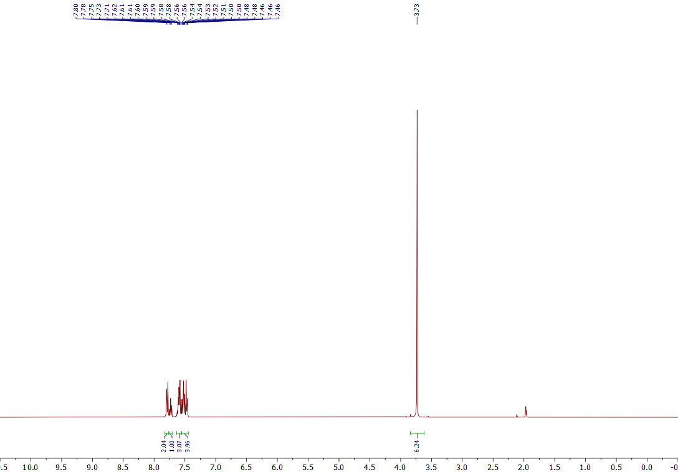
¹H NMR of the 3c (400 MHz, CD₃CN)
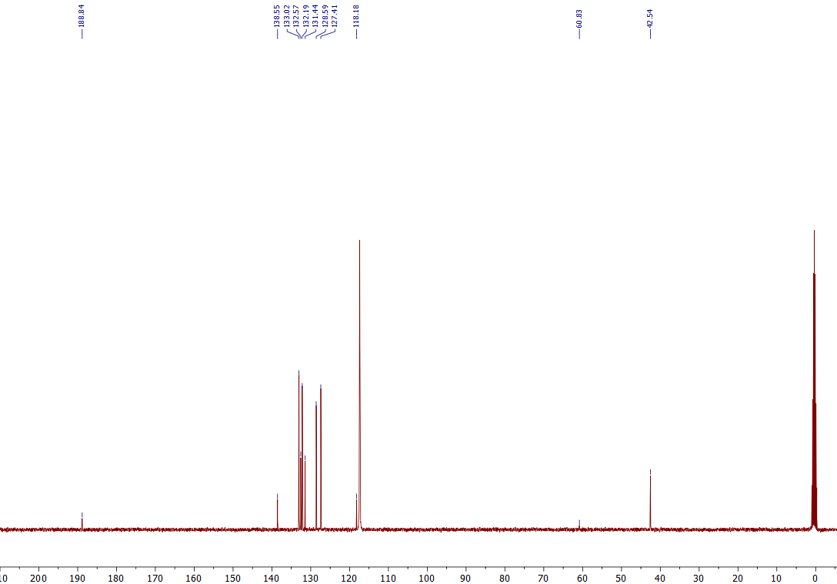
¹³C NMR of the 3c (101 MHz, CD₃CN)

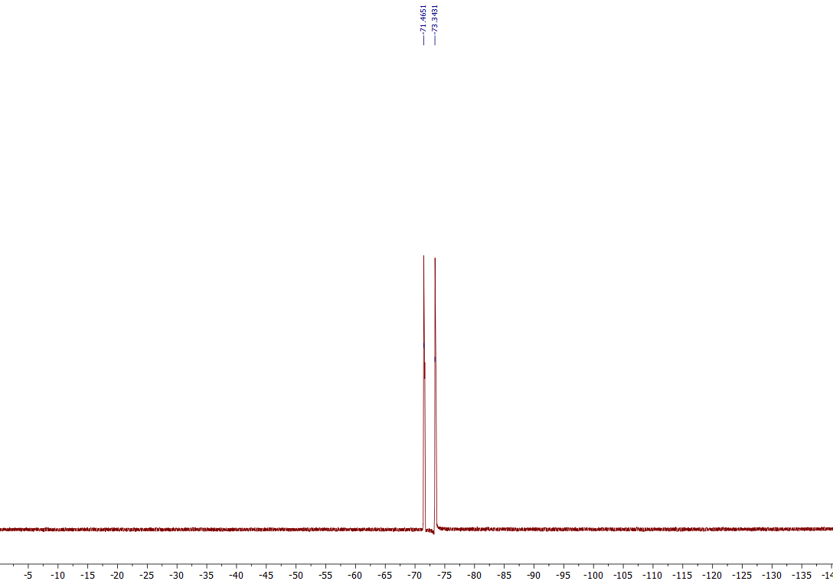
¹⁹F NMR of the 3c (376 MHz, CD₃CN)
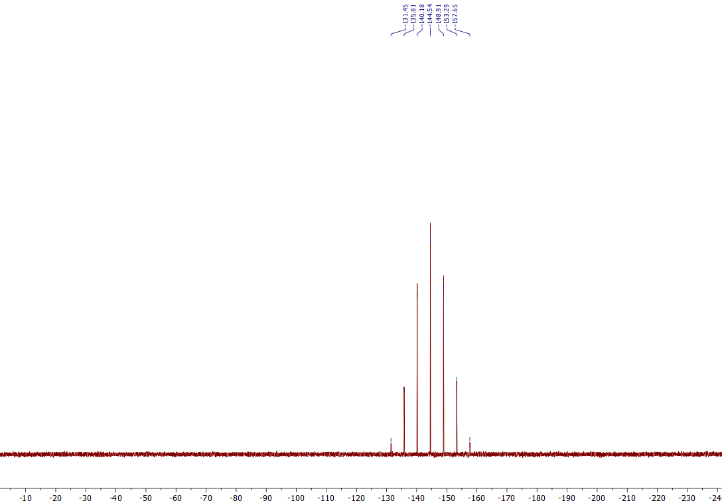
³¹P NMR of the 3c (162 MHz, CD₃CN)

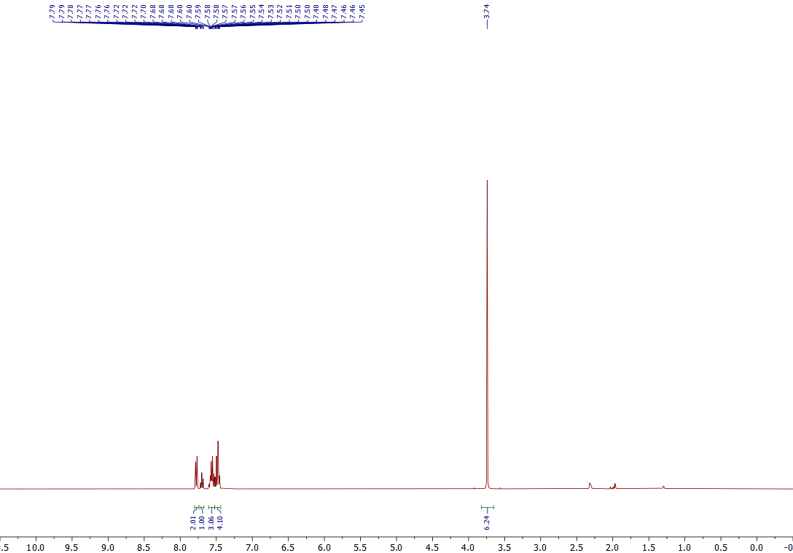
¹H NMR of the 3d (400 MHz, CD₃CN)
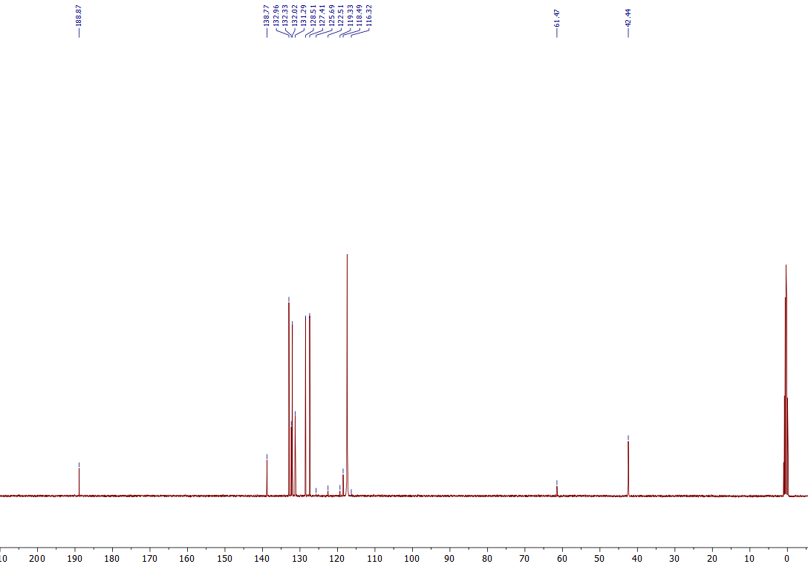
¹³C NMR of the 3d (101 MHz, CD₃CN)

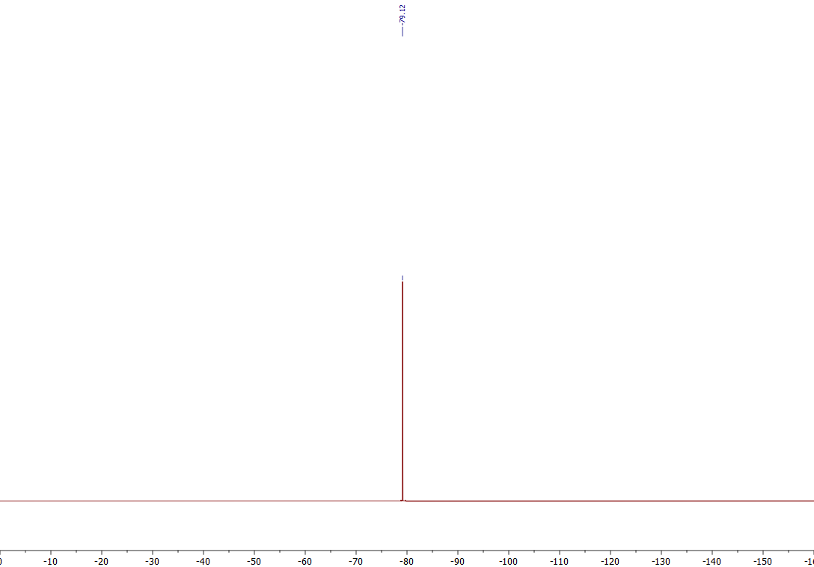
¹⁹F NMR of the 3d (376 MHz, CD₃CN)

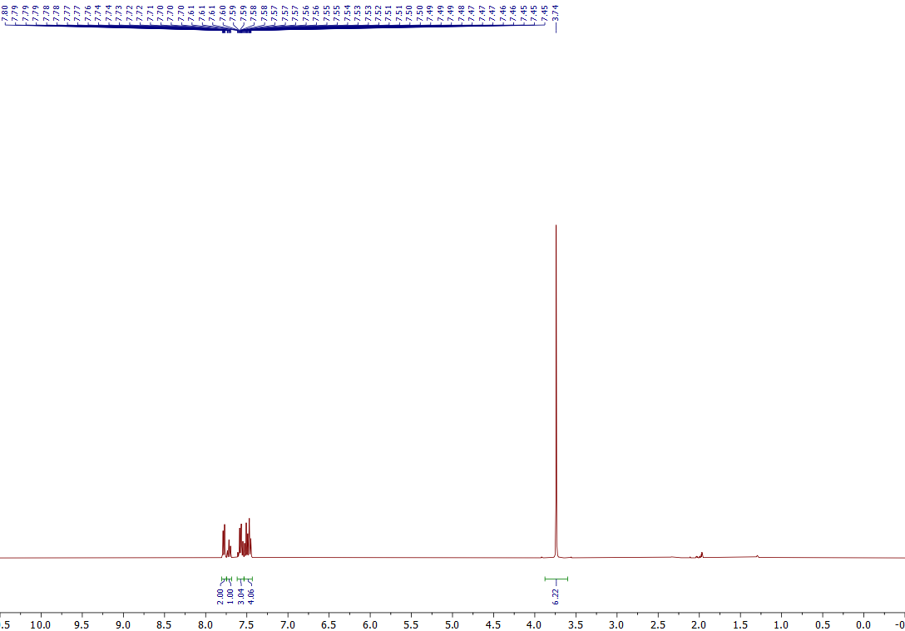
¹H NMR of the 3e (400 MHz, CD₃CN)
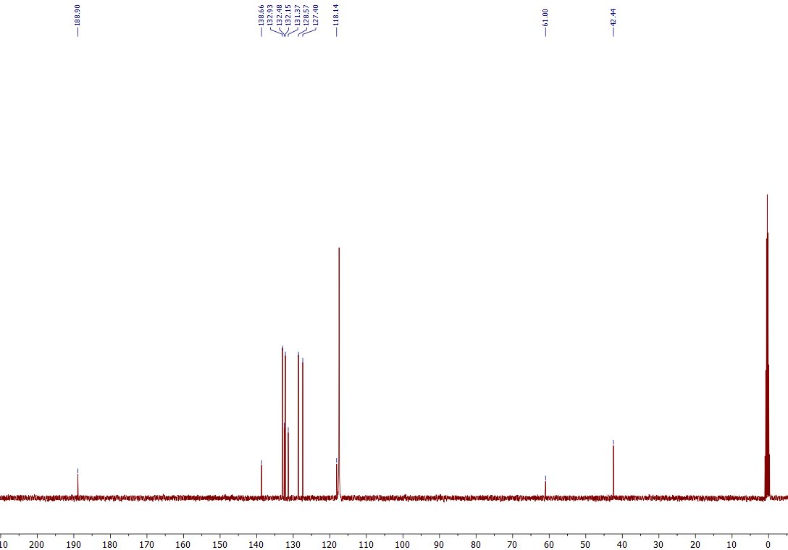
¹³C NMR of the 3e (101 MHz, CD₃CN)
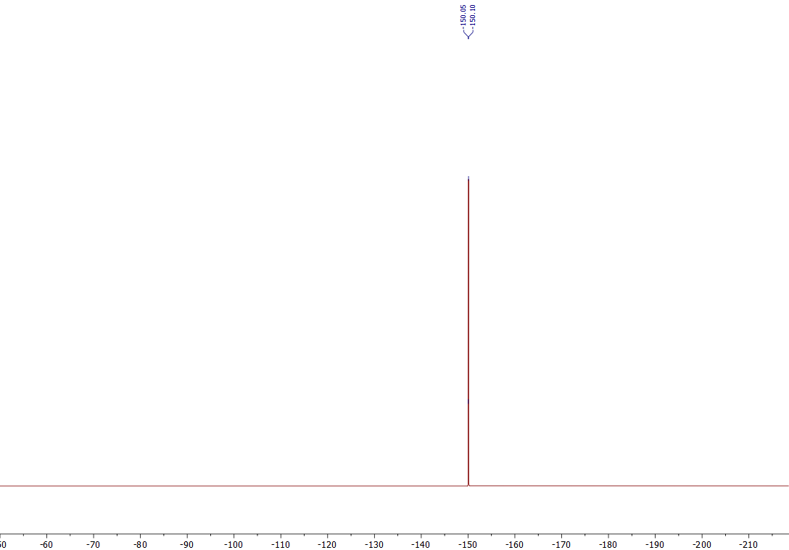
¹⁹F NMR of the 3e (376 MHz, CD₃CN)

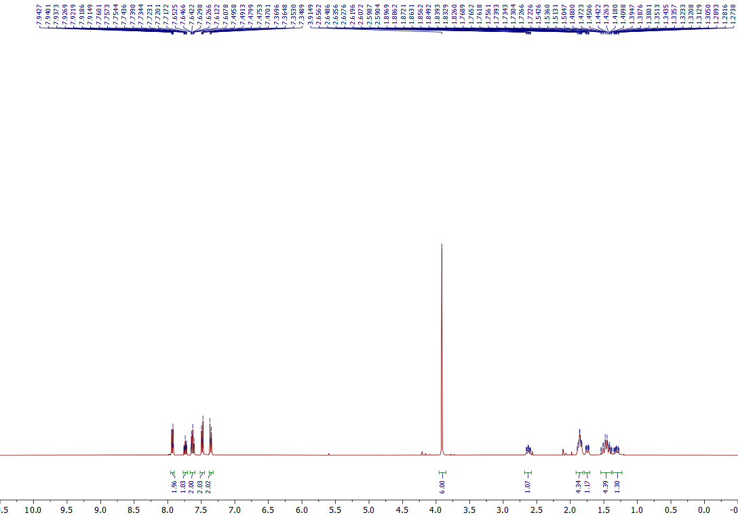

¹H NMR of the 3f (400 MHz, Acetone-d₆)
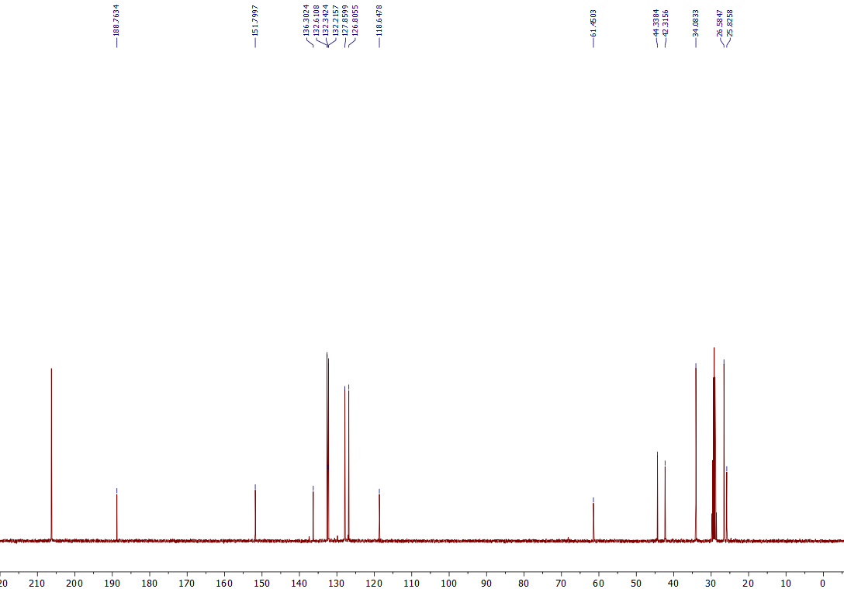
¹³C NMR of the 3f (101 MHz, Acetone-d₆)

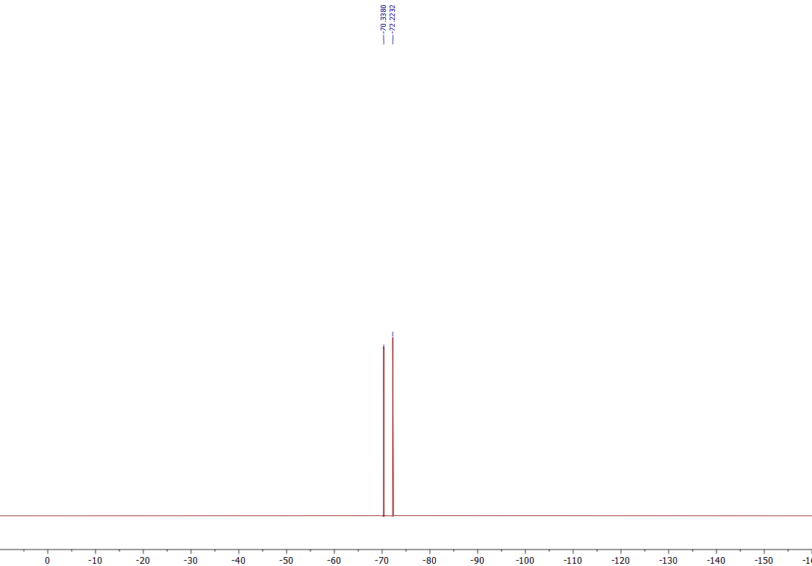
¹⁹F NMR of the 3f (376 MHz, Acetone-d₆)

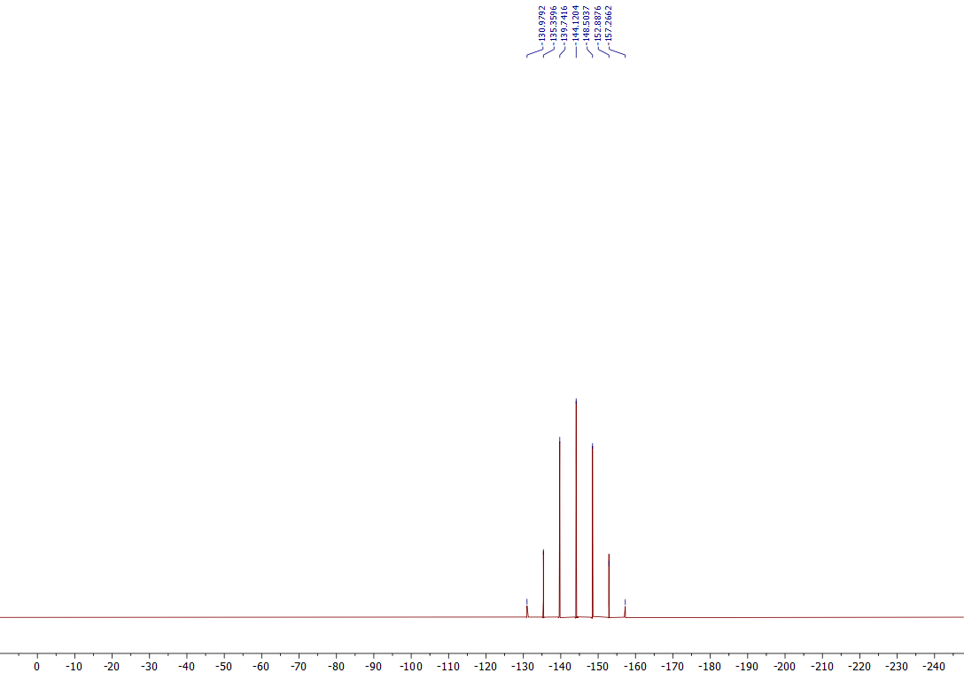
³¹P NMR of the 3f (162 MHz, Acetone-d₆)

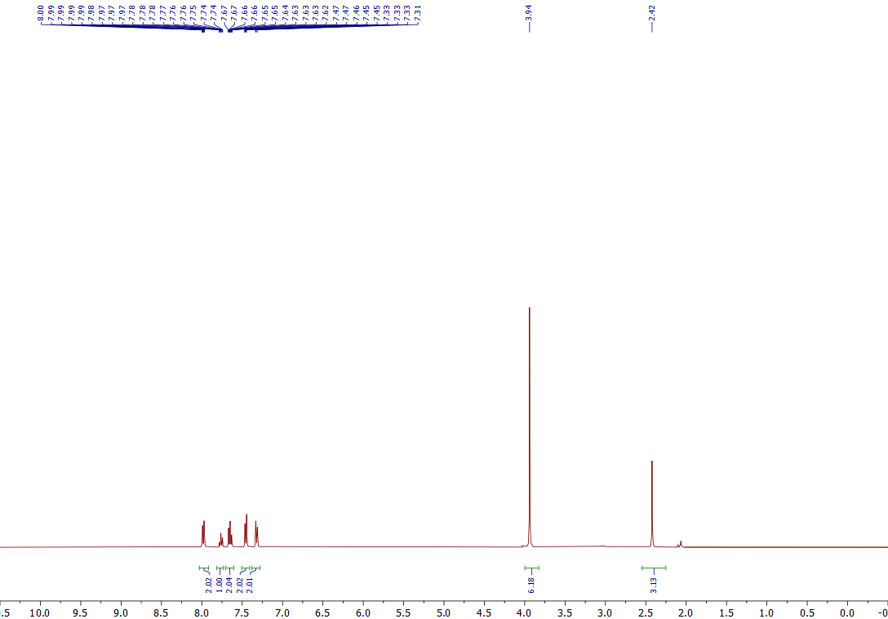
¹H NMR of the 3g (400 MHz, Acetone-d₆)
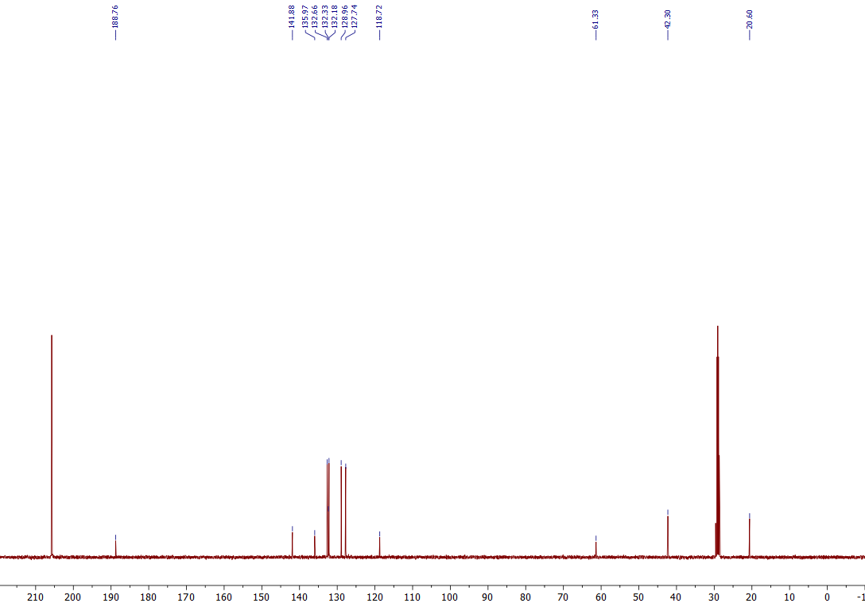
¹³C NMR of the 3g (101 MHz, Acetone-d₆)
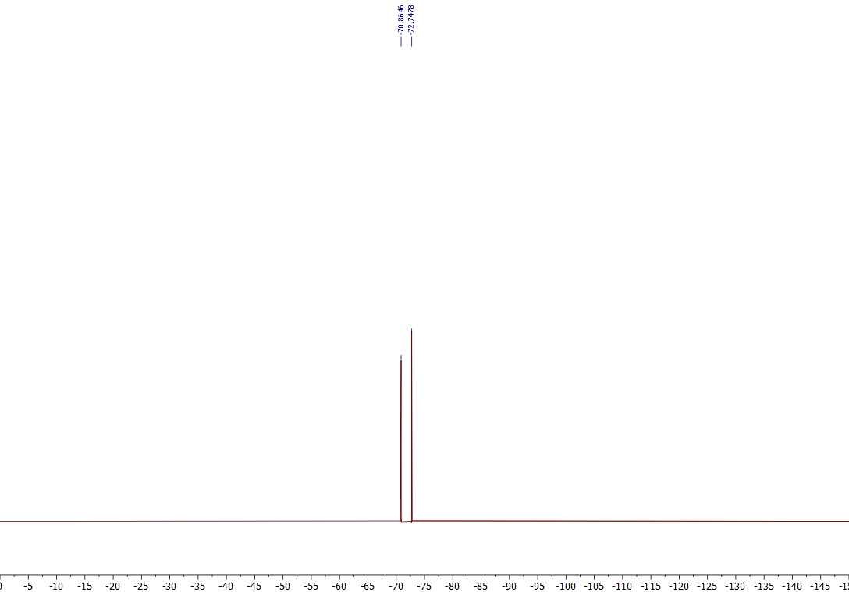
¹⁹F NMR of the 3g (376 MHz, Acetone-d₆)
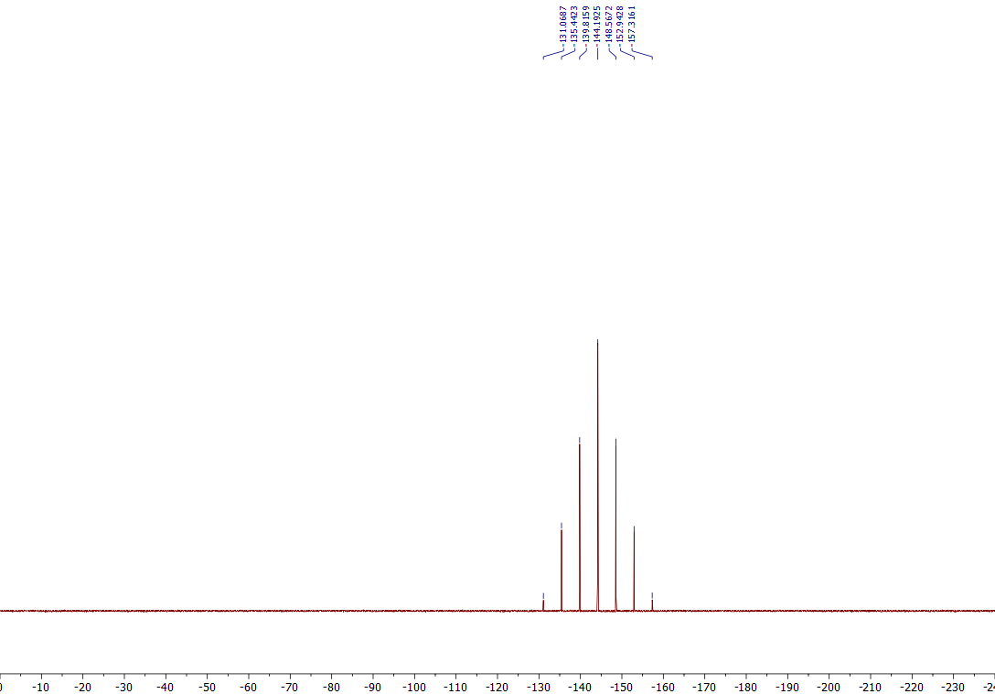
³¹P NMR of the 3g (162 MHz, Acetone-d₆)

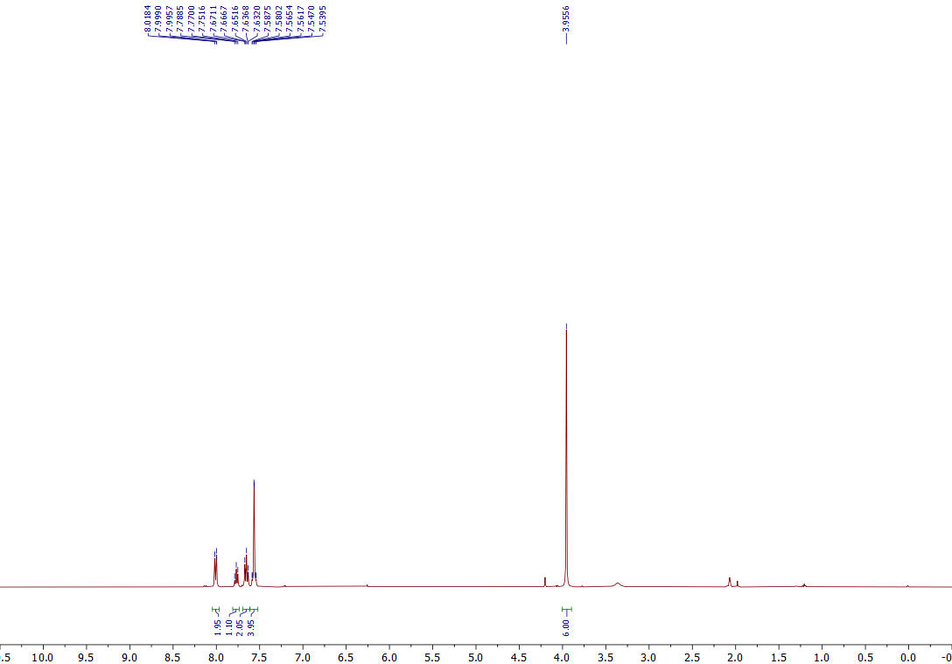

¹H NMR of the 3h (400 MHz, Acetone-d₆)
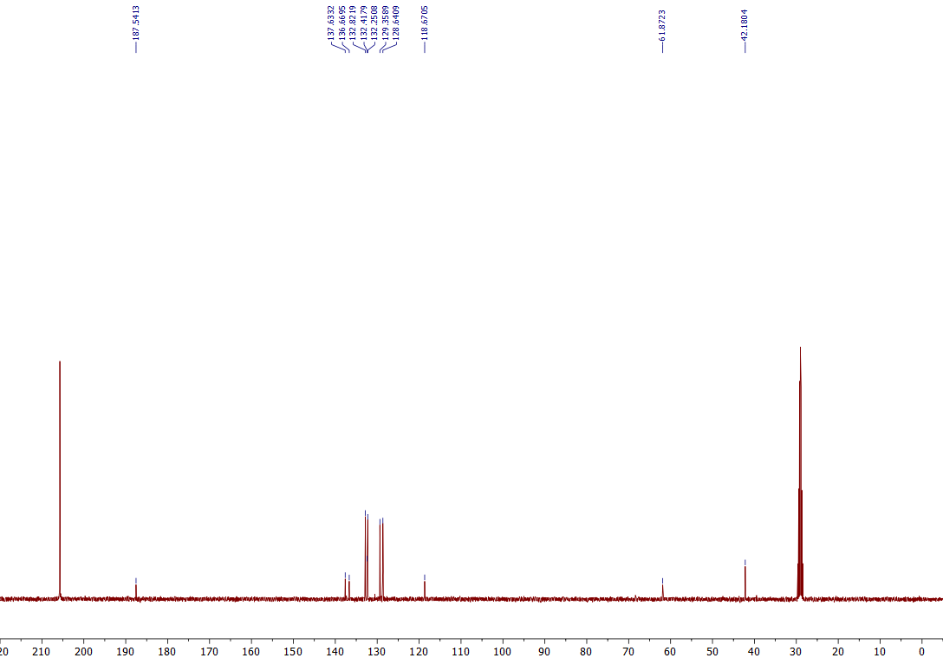
¹³C NMR of the 3h (101 MHz, Acetone-d₆)

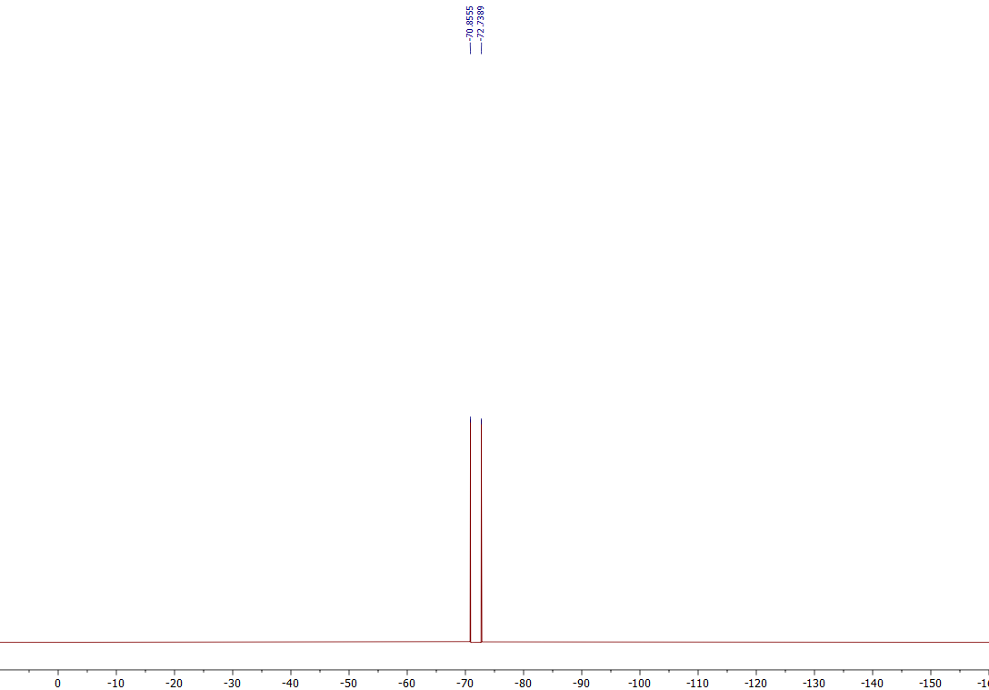
¹⁹F NMR of the 3h (376 MHz, Acetone-d₆)
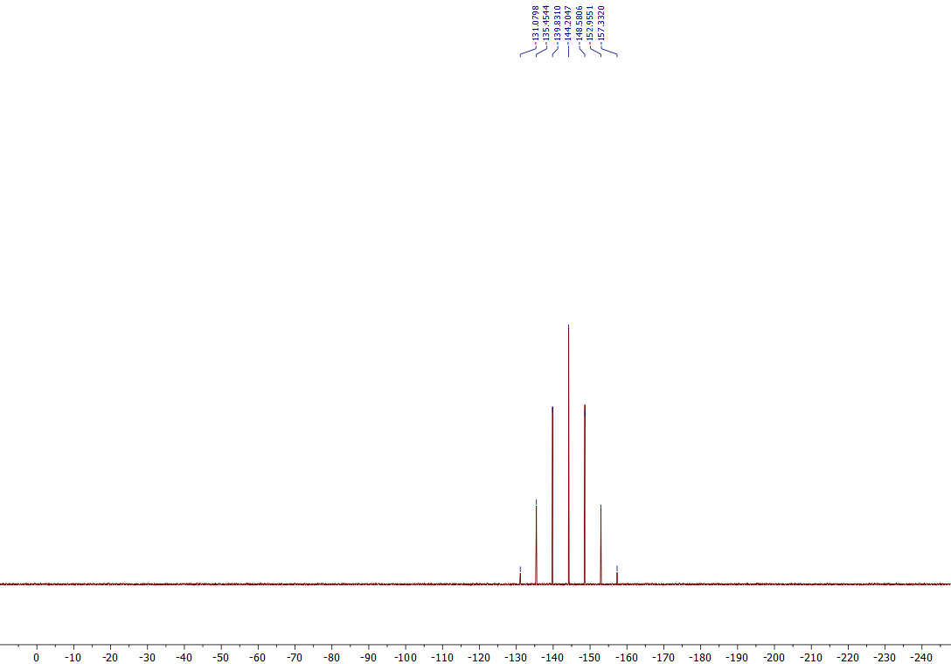
³¹P NMR of the 3h (162 MHz, Acetone-d₆)

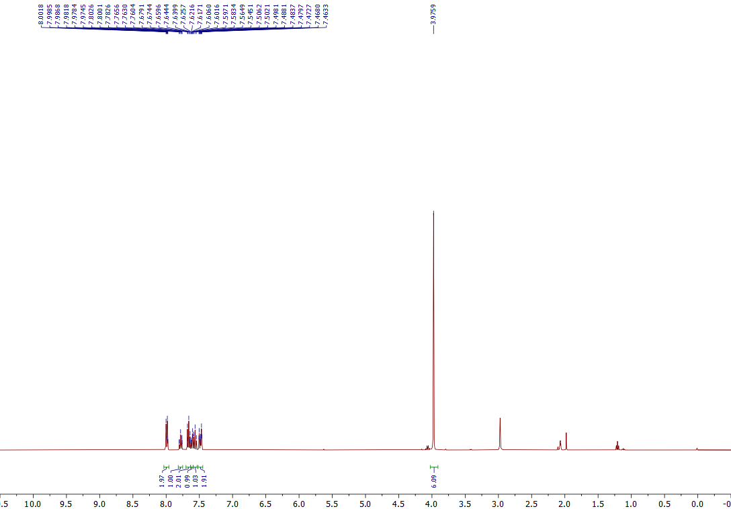

¹H NMR of the 3i (400 MHz, Acetone-d₆)
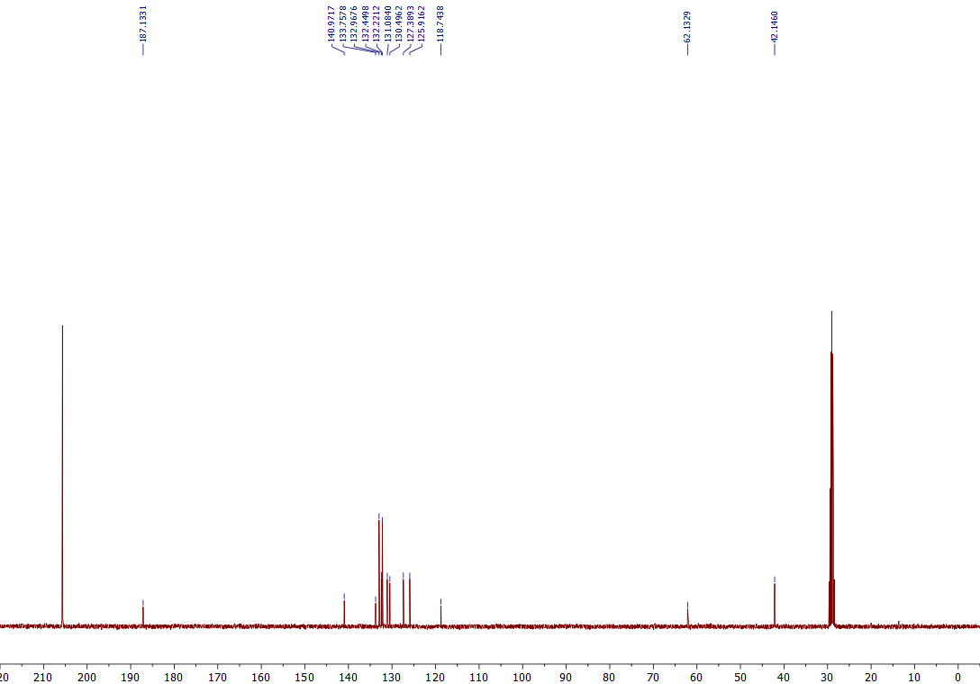
¹³C NMR of the 3i (101 MHz, Acetone-d₆)

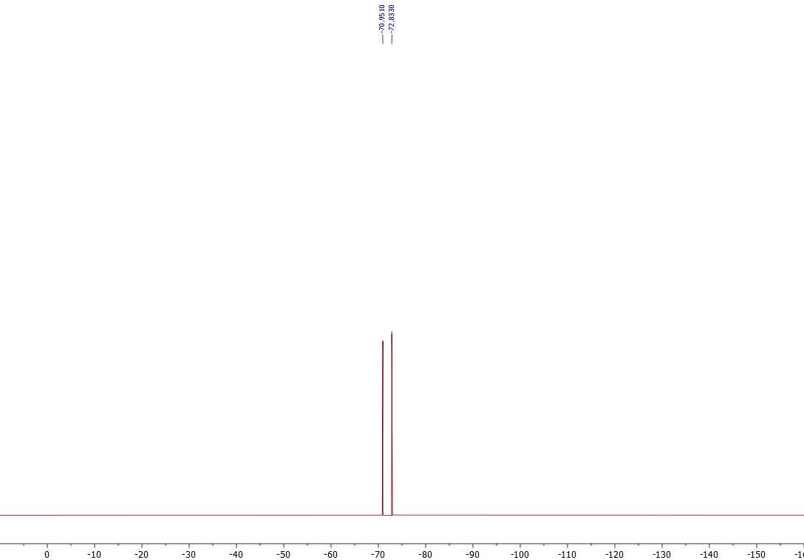
¹⁹F NMR of the 3i (376 MHz, Acetone-d₆)
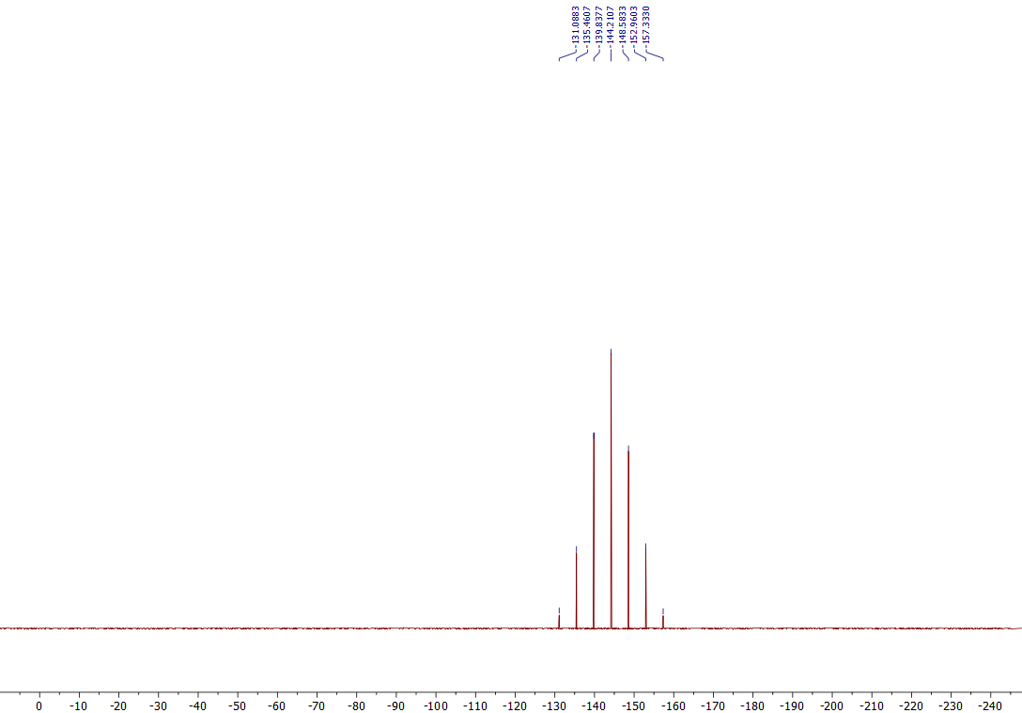
³¹P NMR of the 3i (162 MHz, Acetone-d₆)

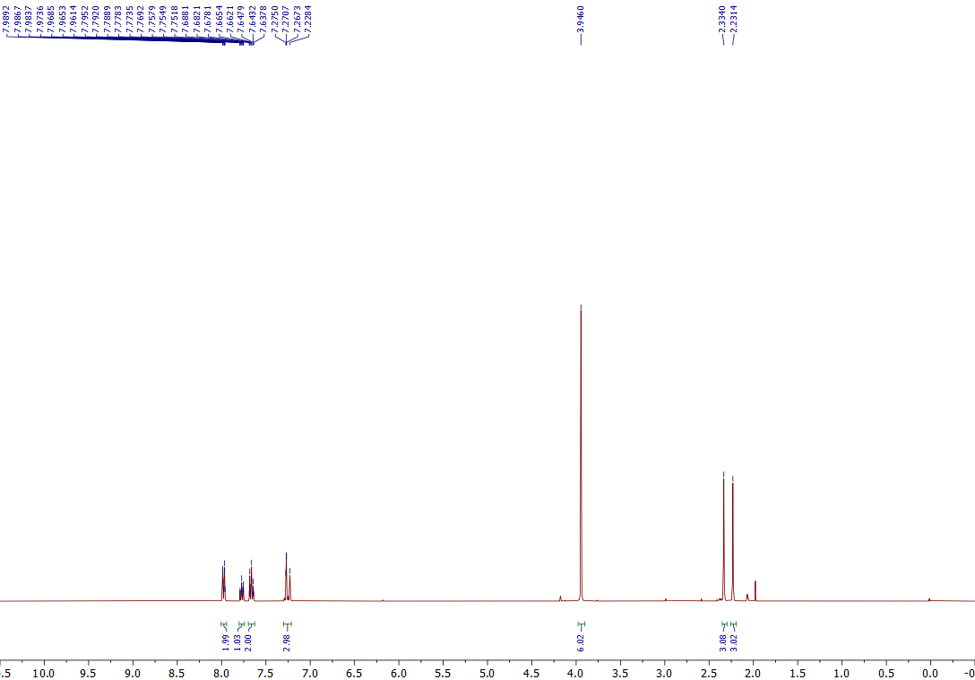

¹H NMR of the 3j (400 MHz, Acetone-d₆)
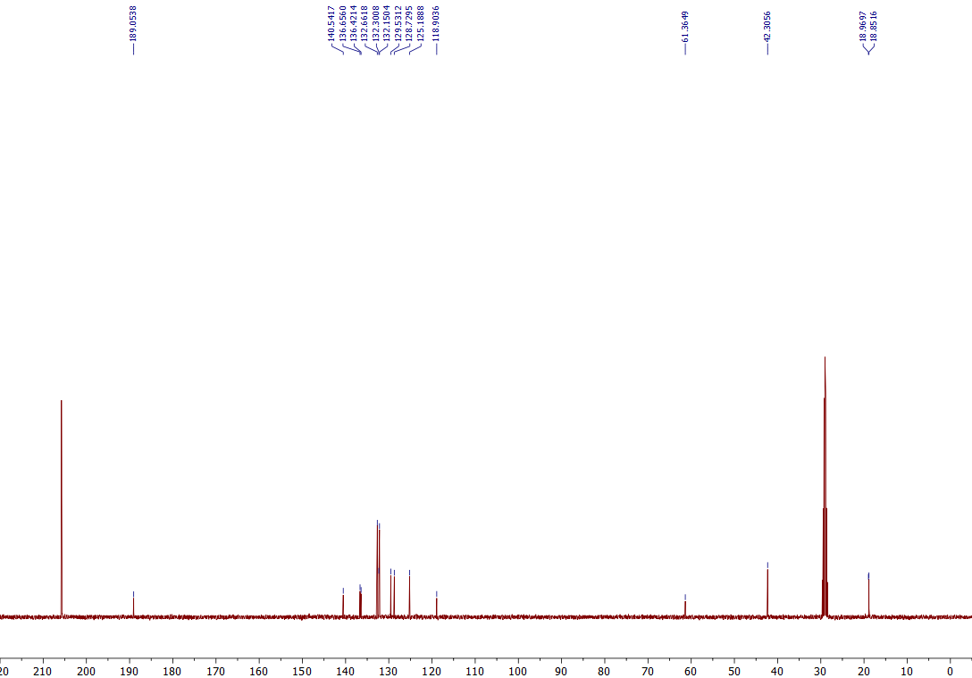
¹³C NMR of the 3j (101 MHz, Acetone-d₆)

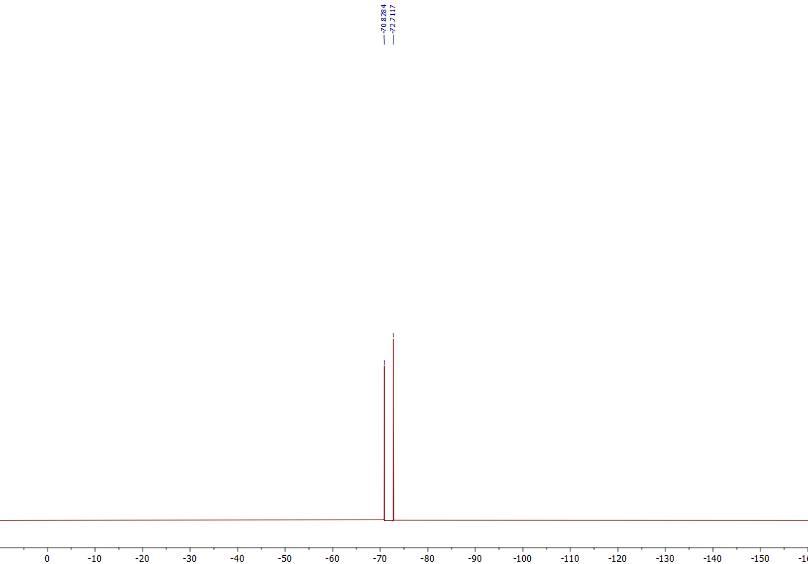
¹⁹F NMR of the 3j (376 MHz, Acetone-d₆)

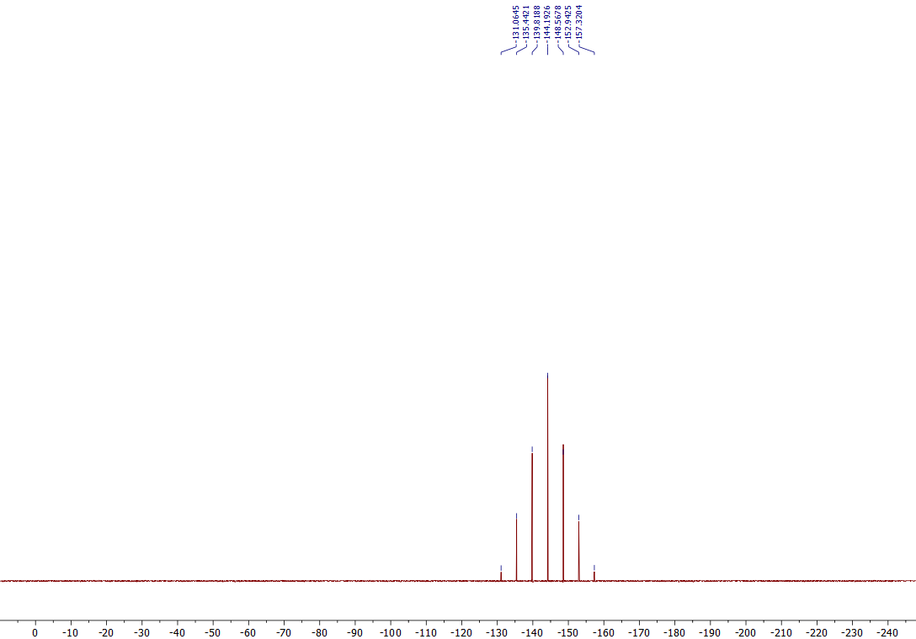
³¹P NMR of the 3j (162 MHz, Acetone-d₆)

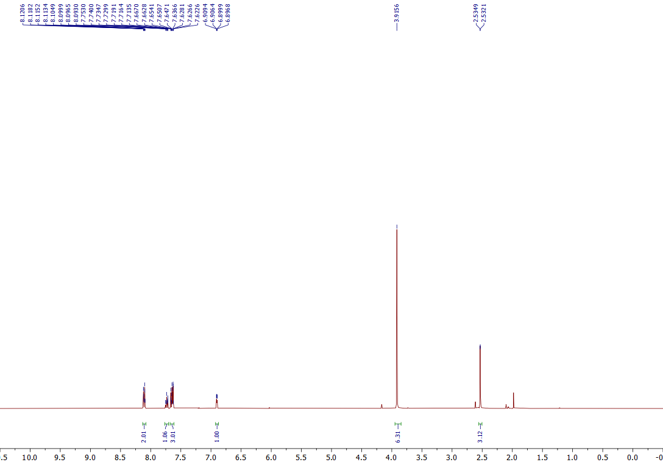

¹H NMR of the 3k (400 MHz, Acetone-d₆)
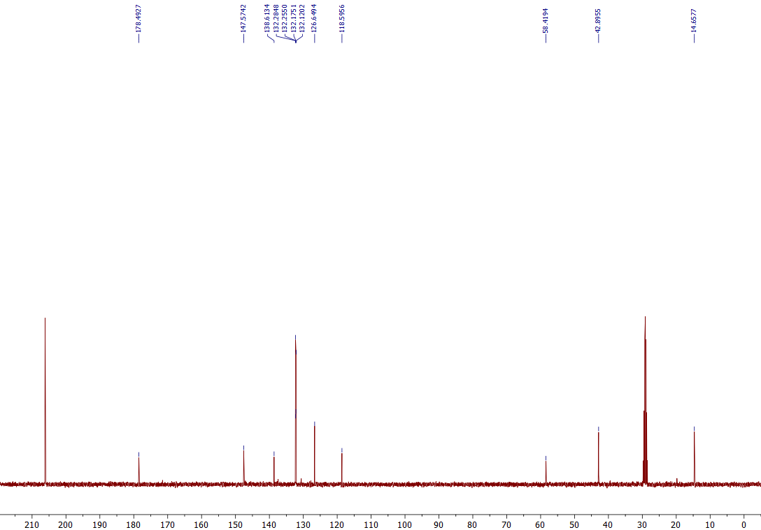
¹³C NMR of the 3k (101 MHz, Acetone-d₆)

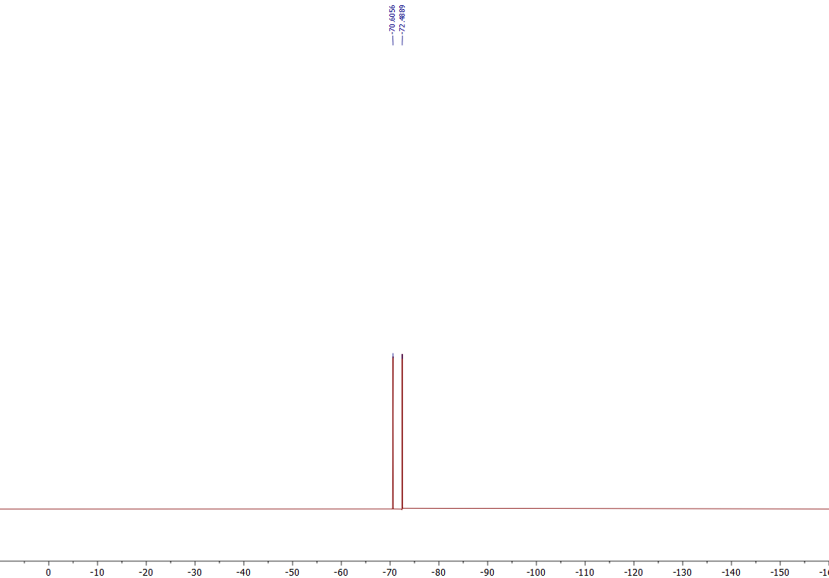
¹⁹F NMR of the 3k (376 MHz, Acetone-d₆)

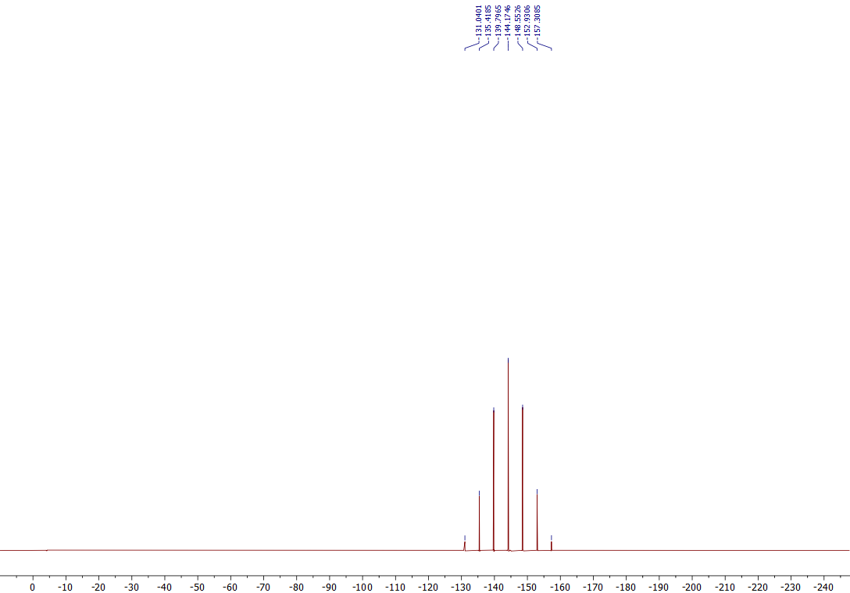
³¹P NMR of the 3k (162 MHz, Acetone-d₆)

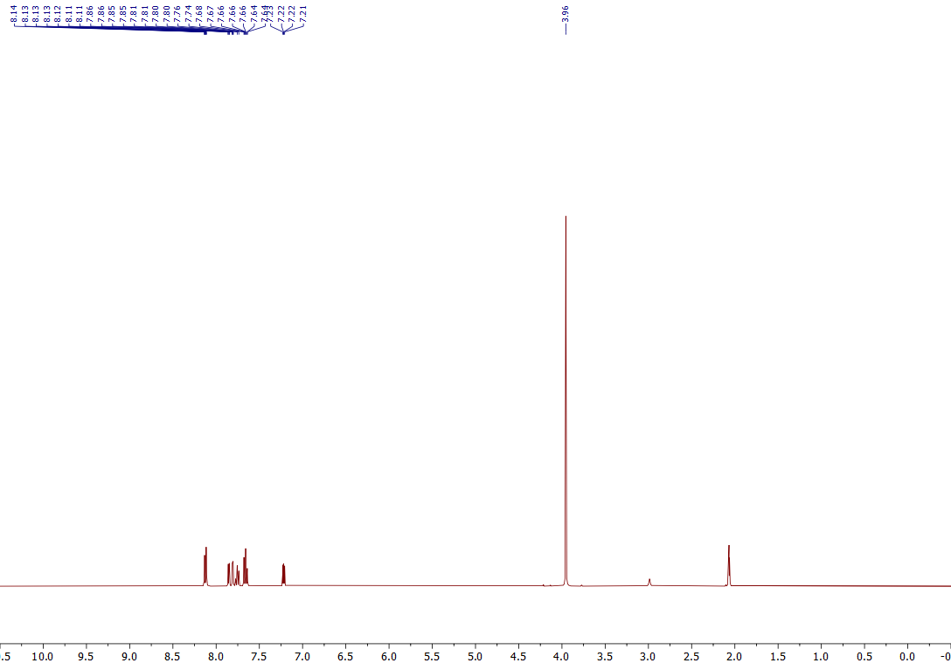
¹H NMR of the 3l (400 MHz, Acetone-d₆)
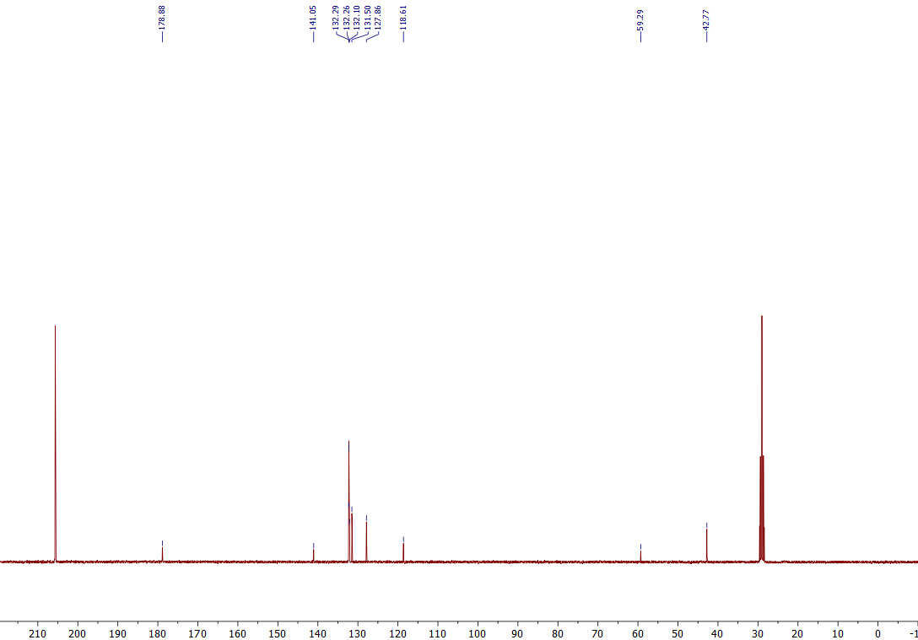
¹³C NMR of the 3l (101 MHz, Acetone-d₆)

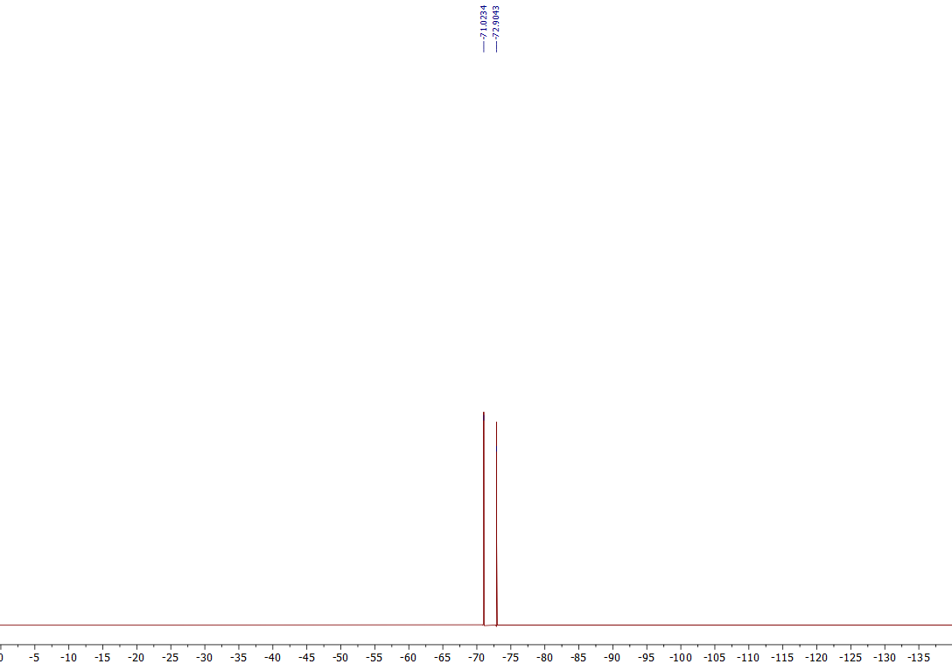
¹⁹F NMR of the 3l (376 MHz, Acetone-d₆)
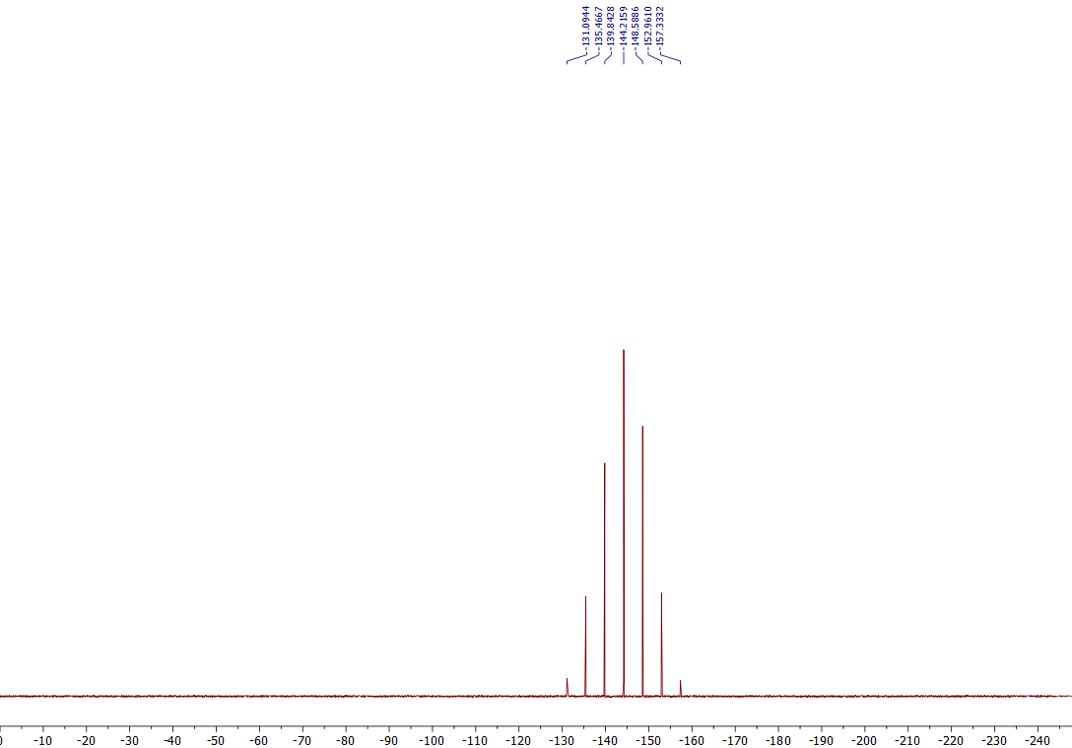
³¹P NMR of the 3l (162 MHz, Acetone-d₆)

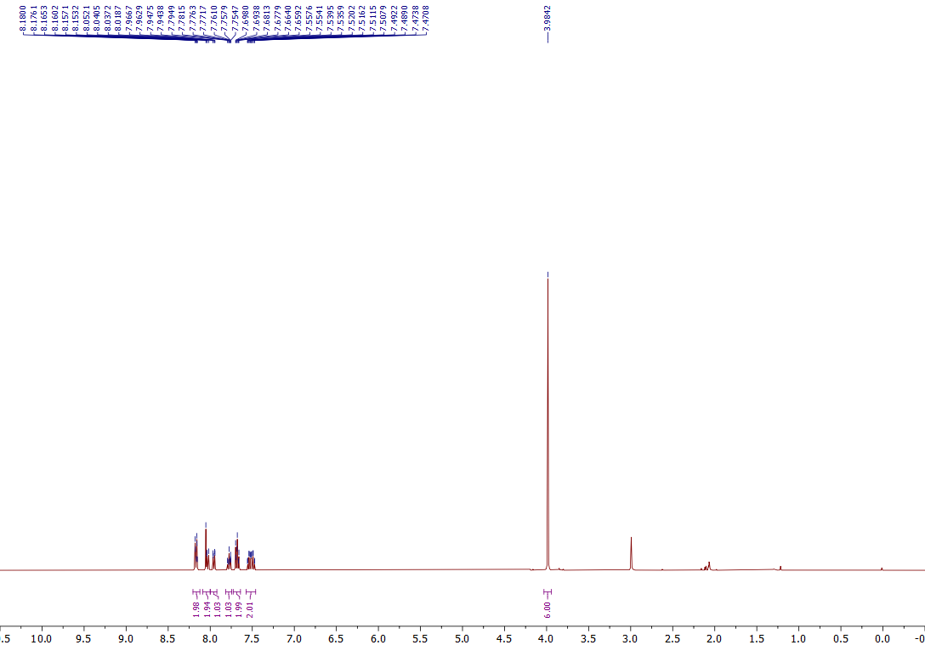

¹H NMR of the 3m (400 MHz, Acetone-d₆)
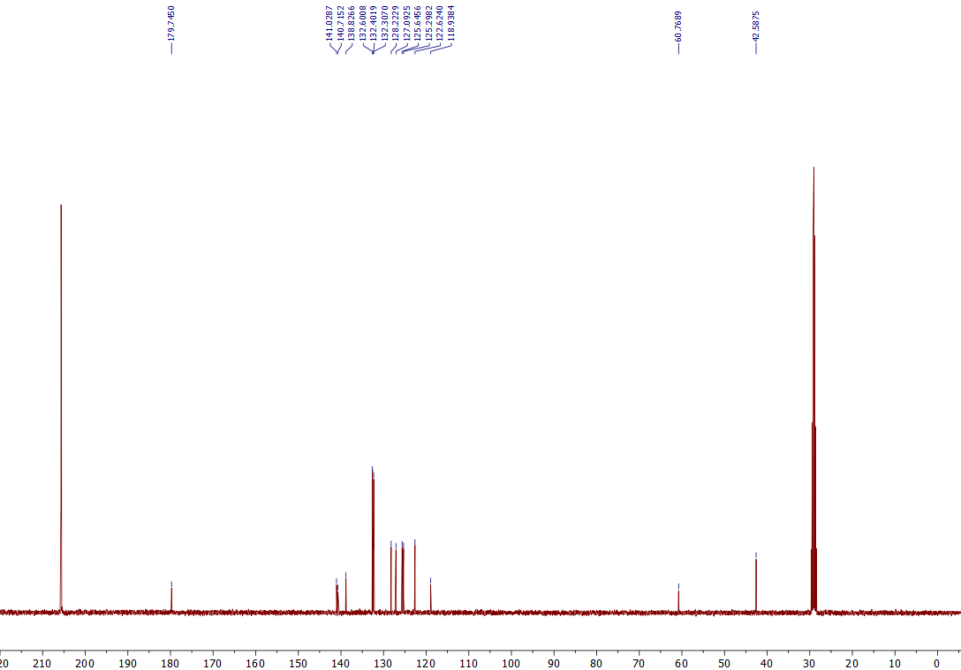
¹³C NMR of the 3m (101 MHz, Acetone-d₆)

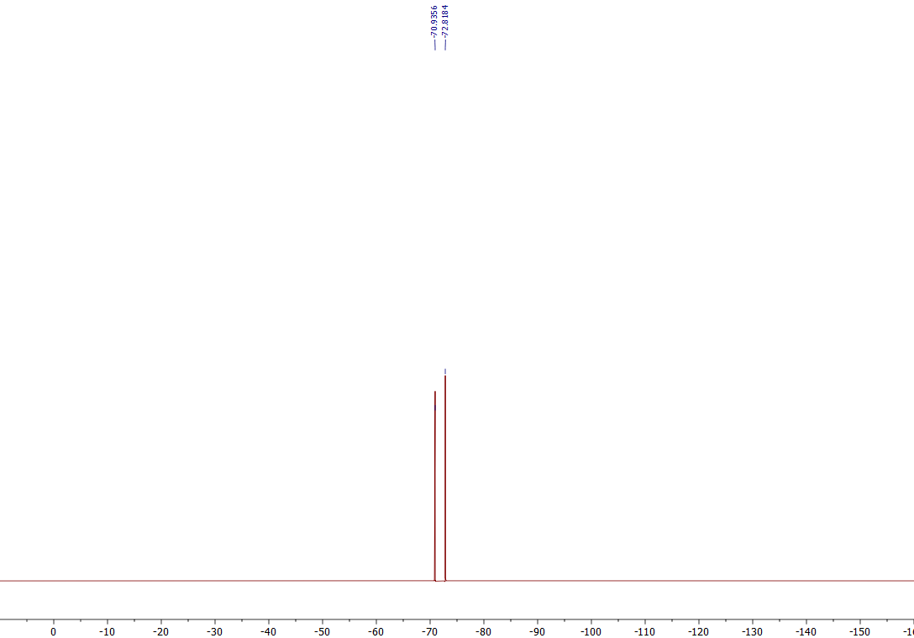
¹⁹F NMR of the 3m (376 MHz, Acetone-d₆)
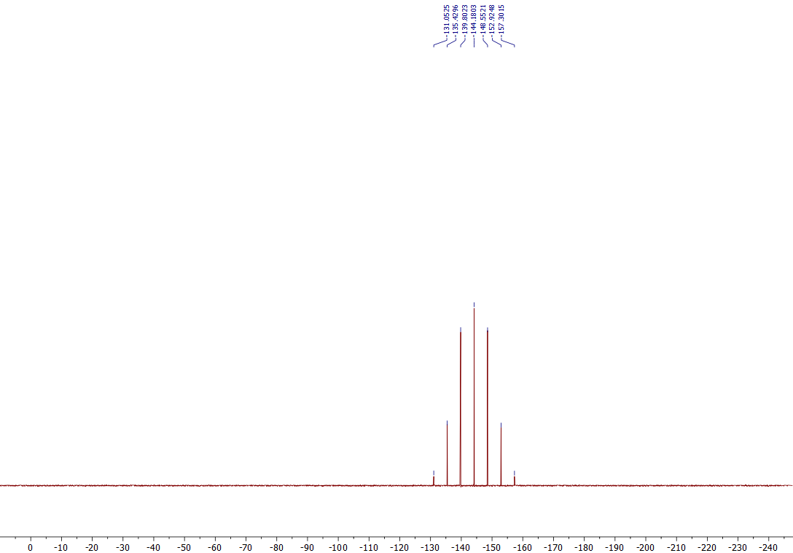
³¹P NMR of the 3m (162 MHz, Acetone-d₆)

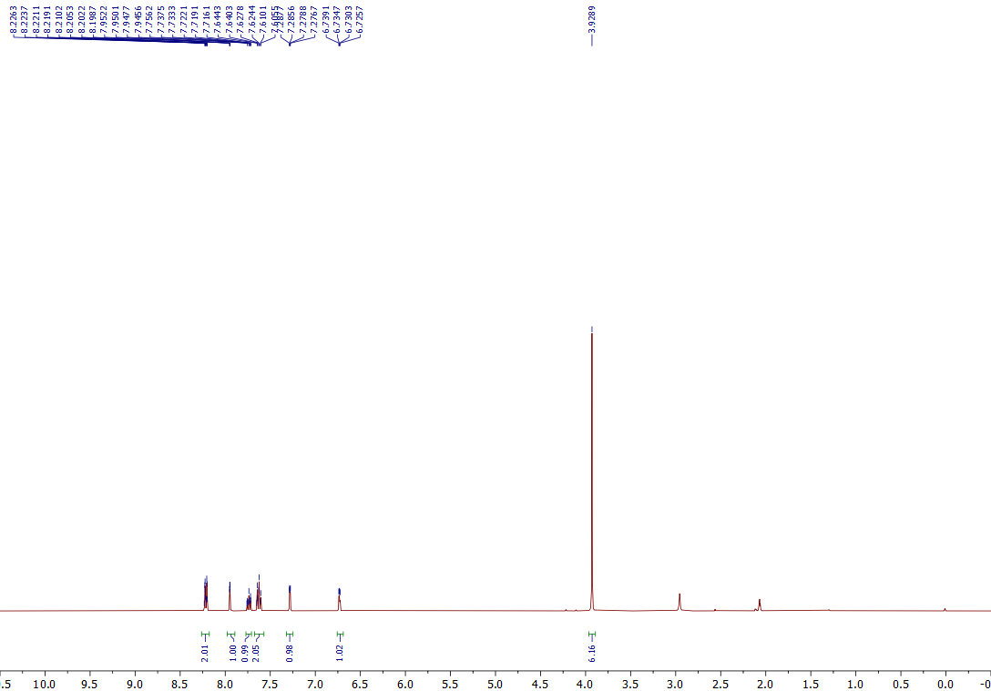

¹H NMR of the 3n (400 MHz, Acetone-d₆)
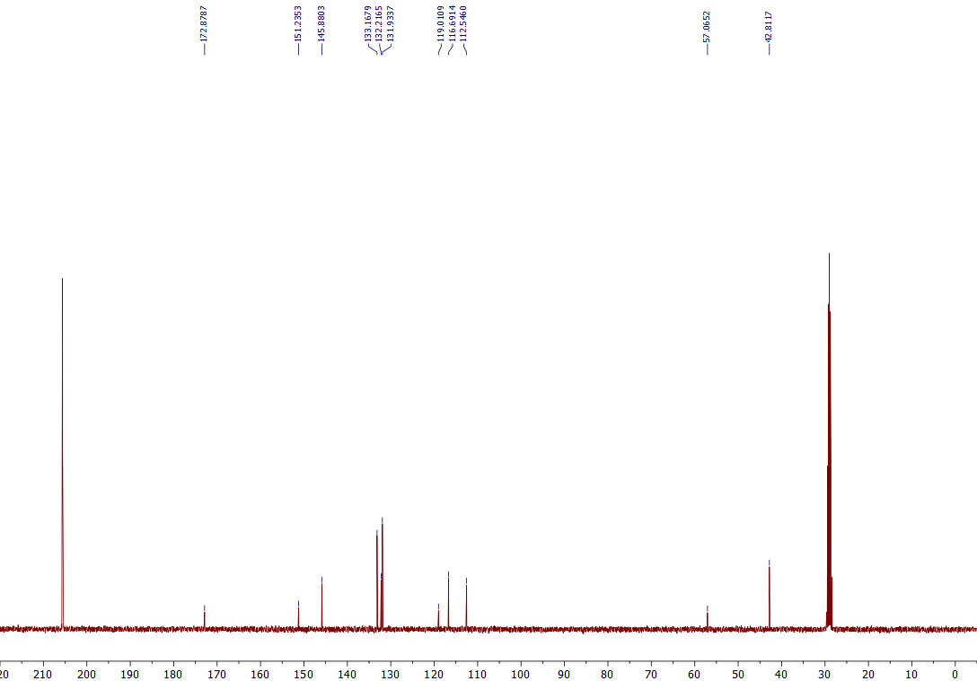
¹³C NMR of the 3n (101 MHz, Acetone-d₆)

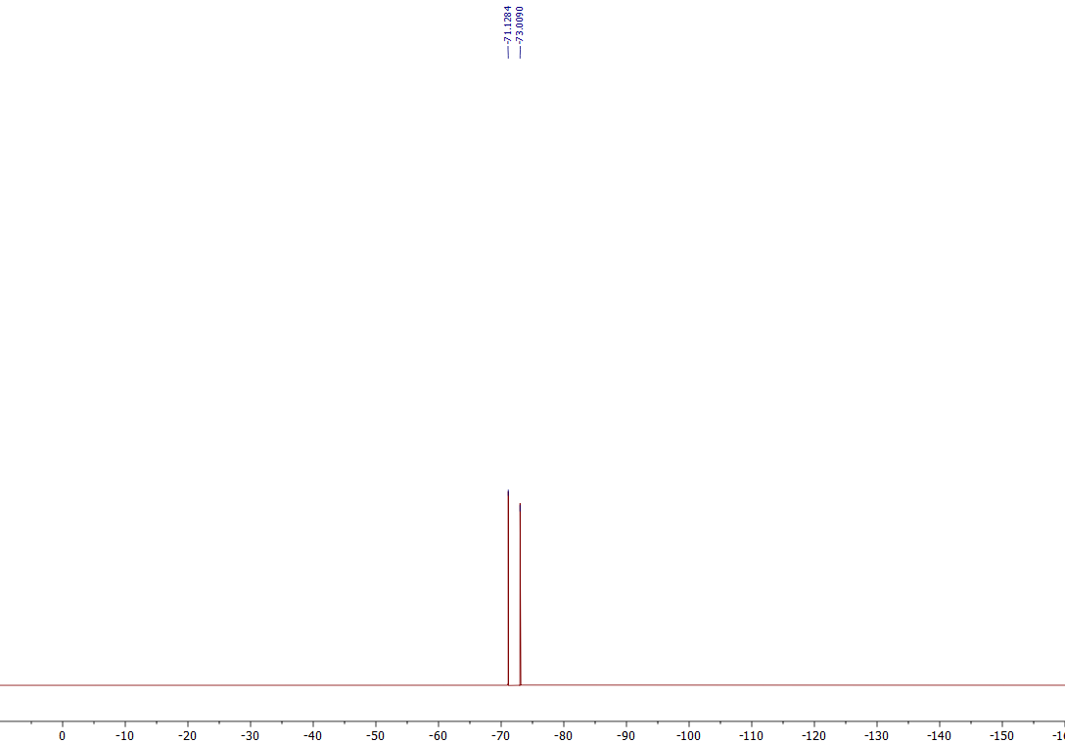
¹⁹F NMR of the 3n (376 MHz, Acetone-d₆)
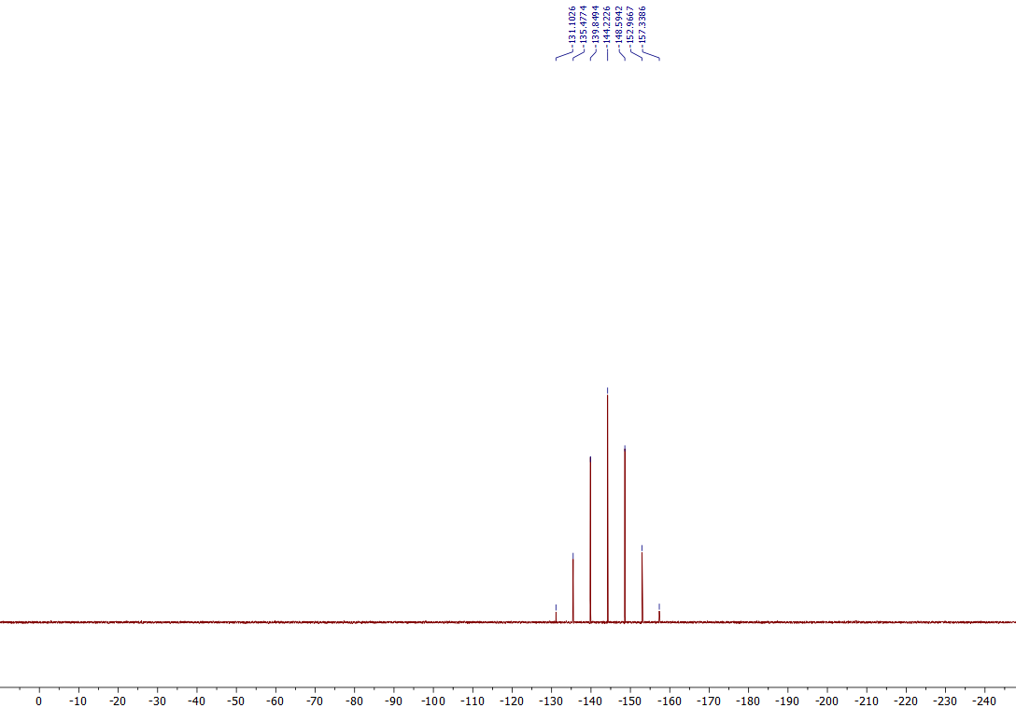
³¹P NMR of the 3n (162 MHz, Acetone-d₆)

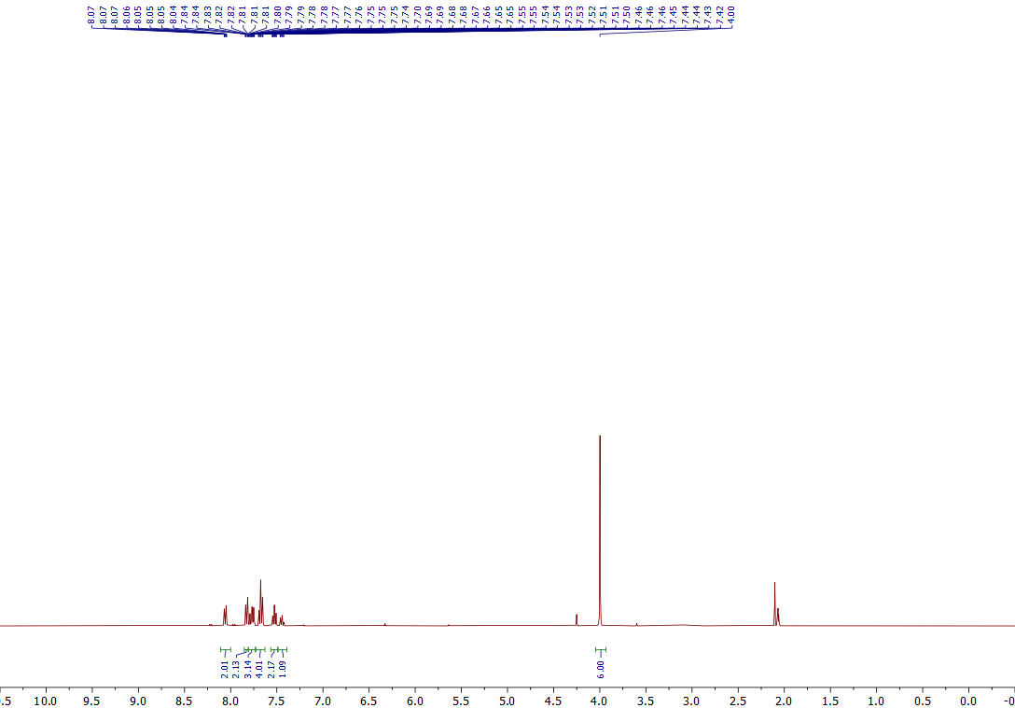
¹H NMR of the 3o (400 MHz, Acetone-d₆)
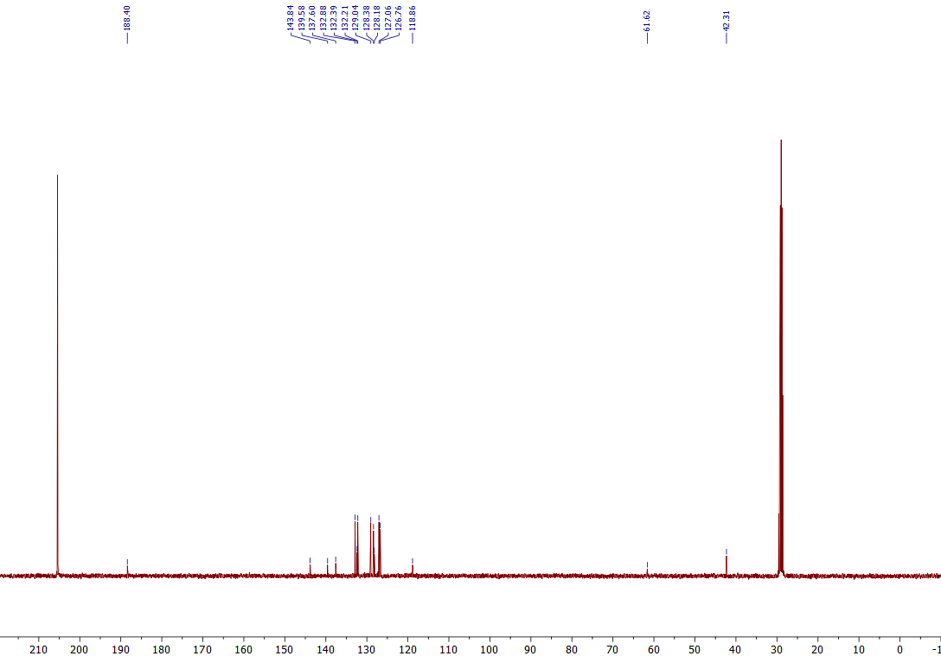
¹³C NMR of the 3o (101 MHz, Acetone-d₆)
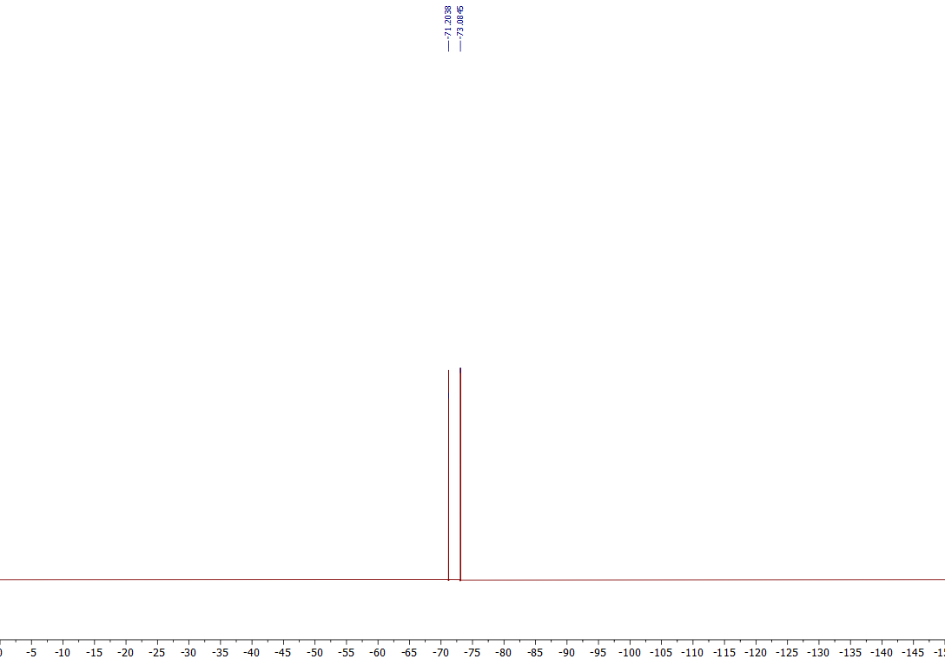
¹⁹F NMR of the 3o (376 MHz, Acetone-d₆)
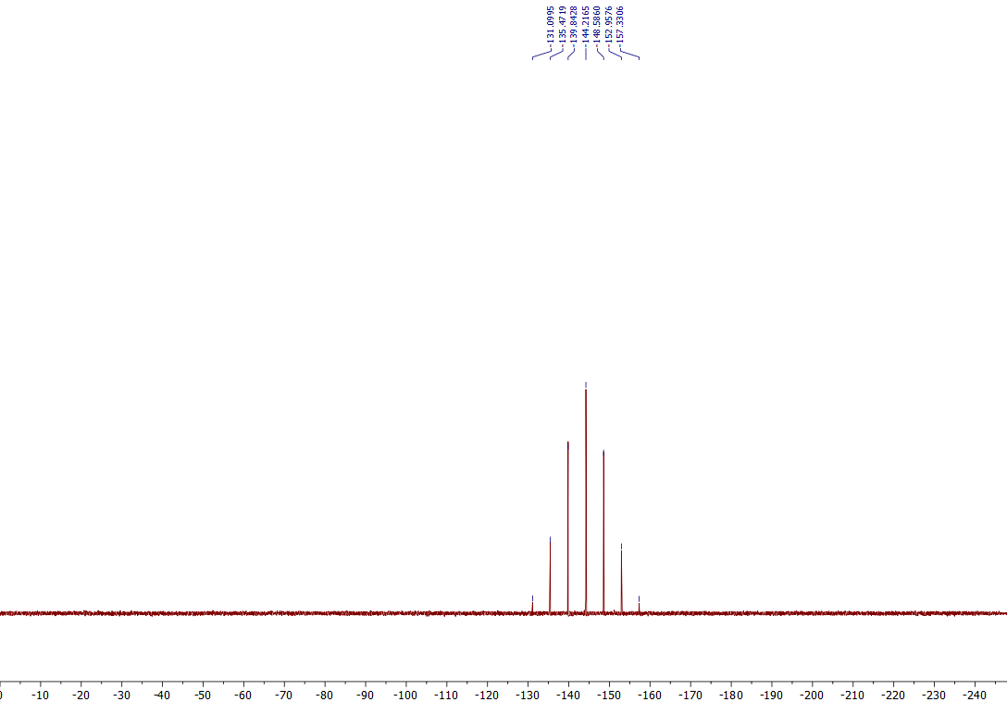
³¹P NMR of the 3o (162 MHz, Acetone-d₆)

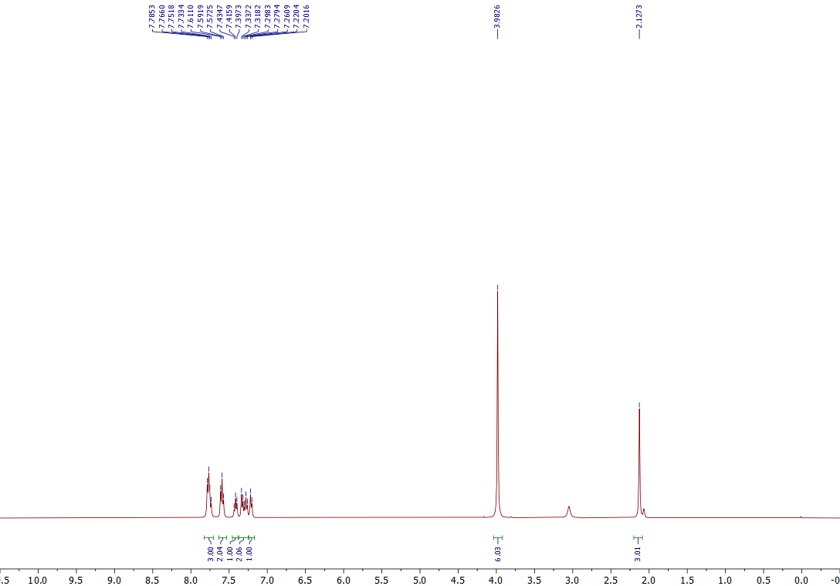

¹H NMR of the 3p (400 MHz, Acetone-d₆)

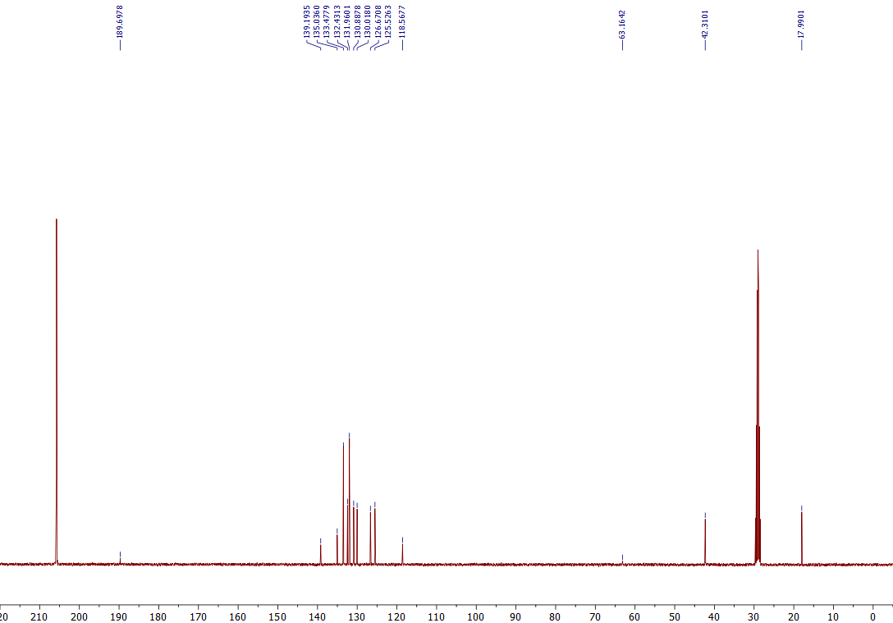
¹³C NMR of the 3p (101 MHz, Acetone-d₆)

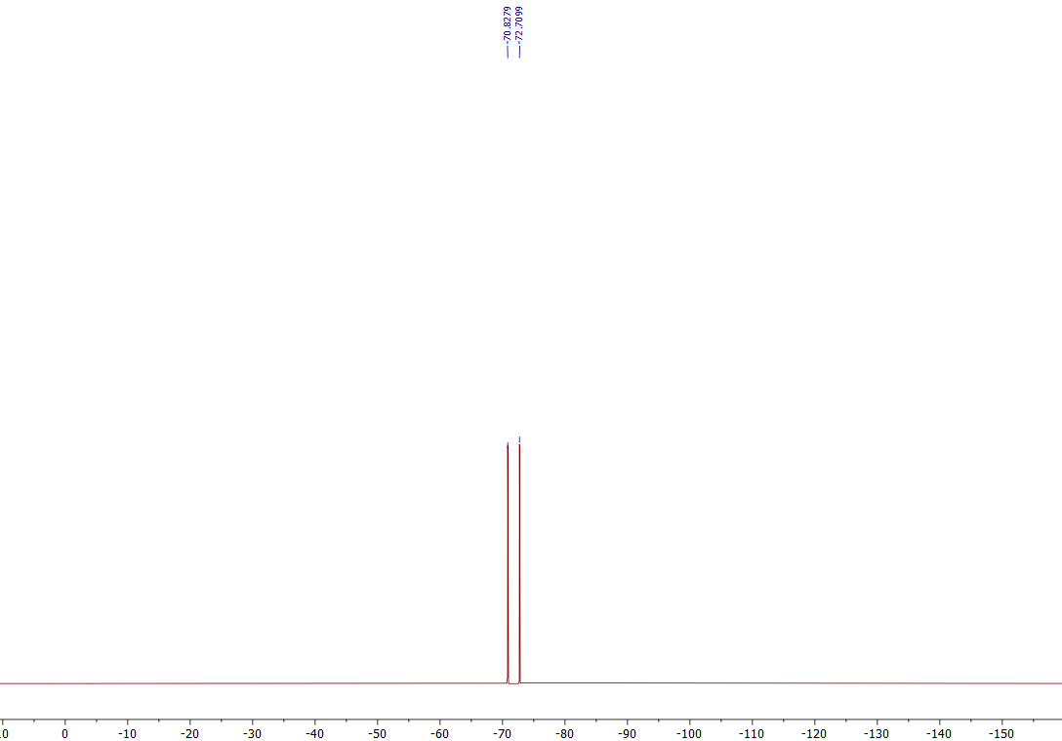
¹⁹F NMR of the 3p (376 MHz, Acetone-d₆)
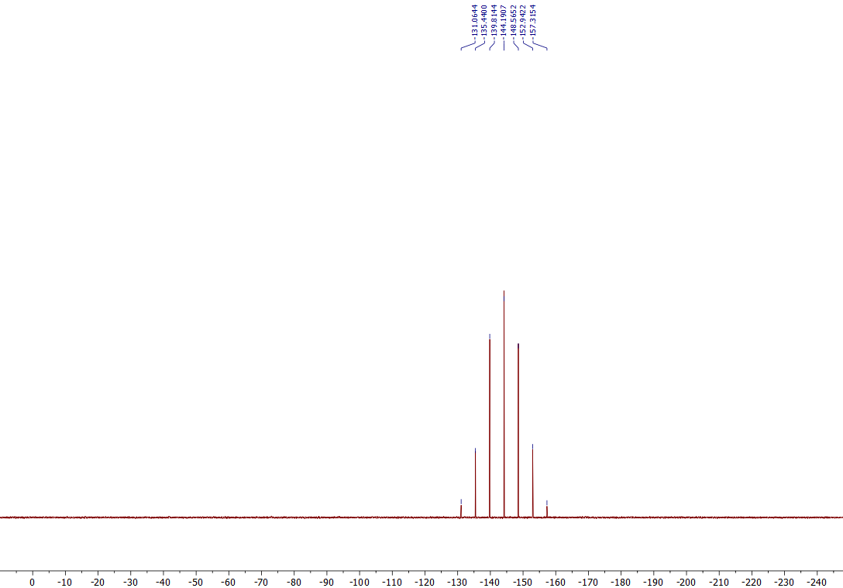
³¹P NMR of the 3p (162 MHz, Acetone-d₆)

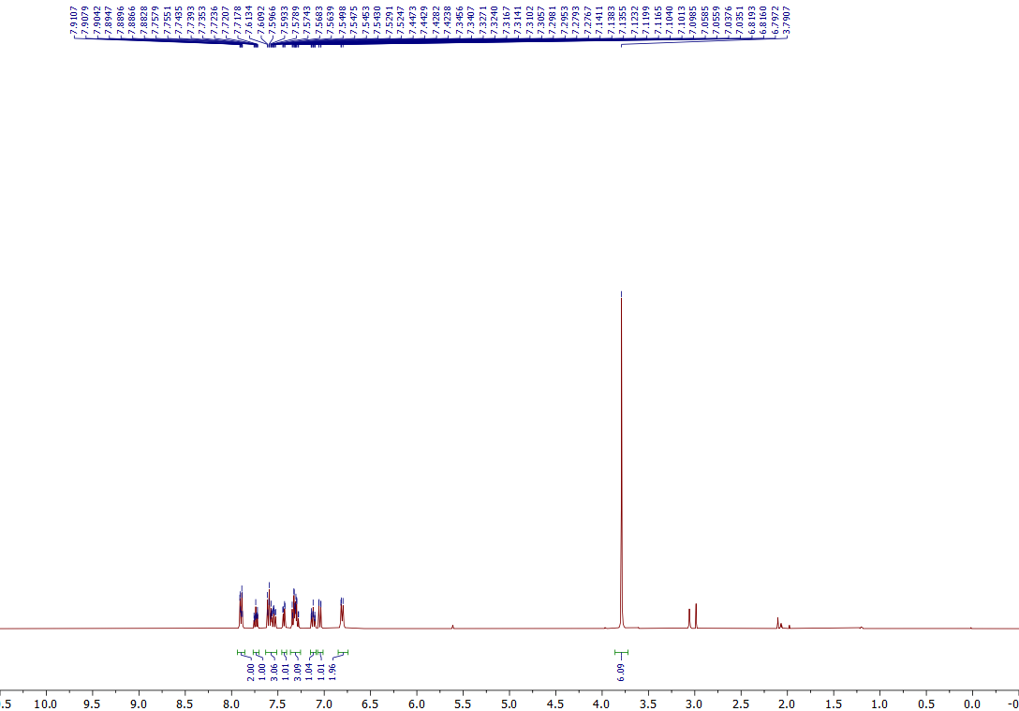

¹H NMR of the 3q (400 MHz, Acetone-d₆)
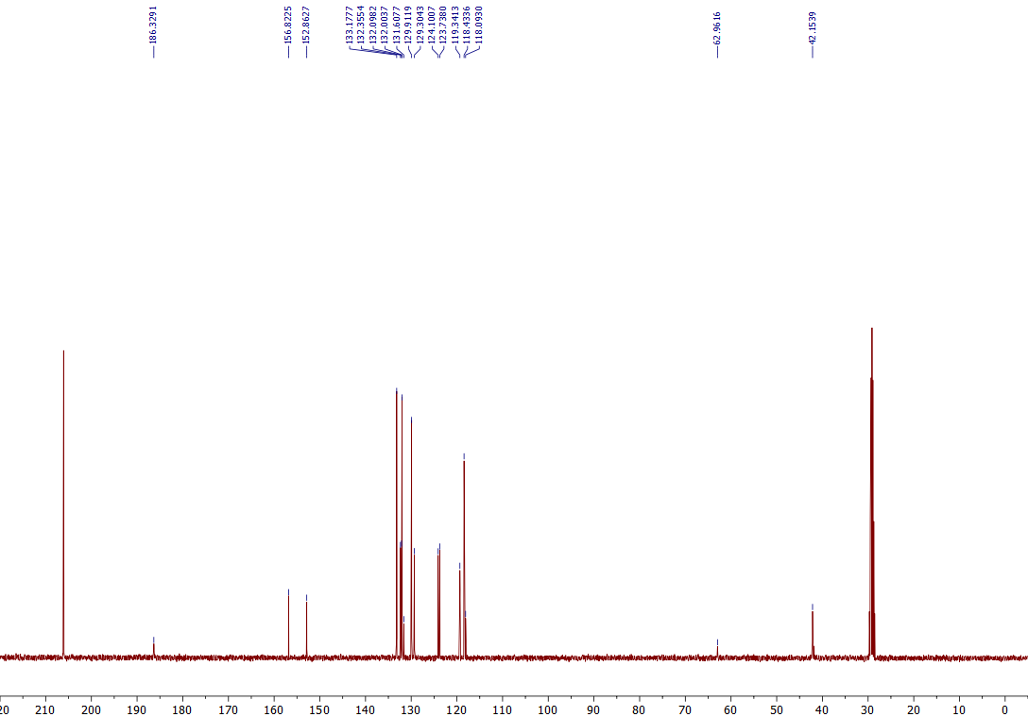
¹³C NMR of the 3q (101 MHz, Acetone-d₆)

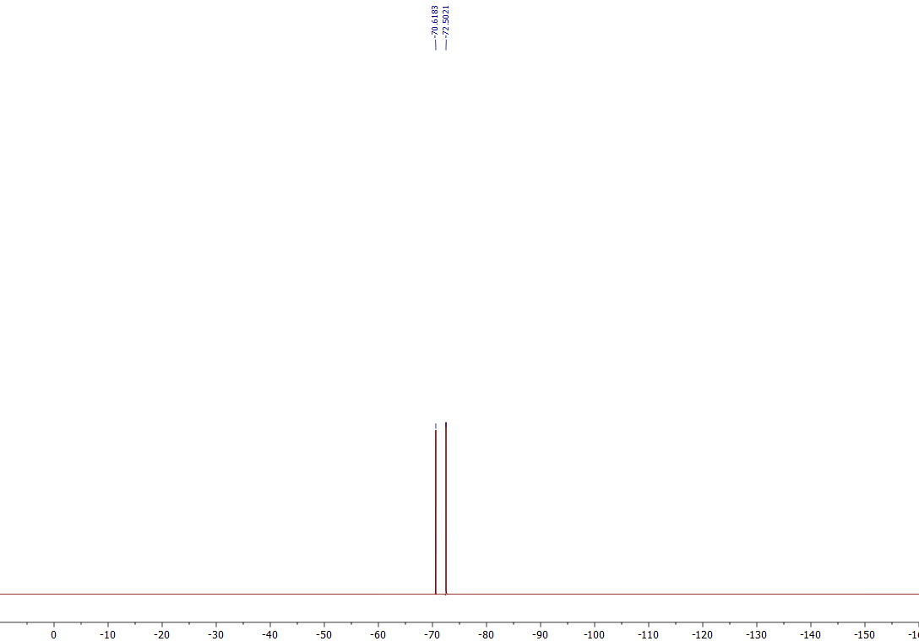
¹⁹F NMR of the 3q (376 MHz, Acetone-d₆)

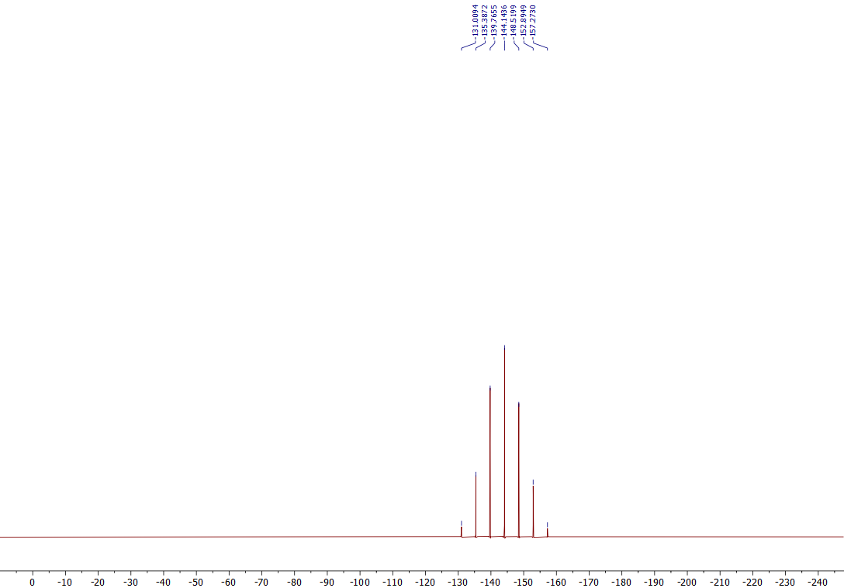
³¹P NMR of the 3q (162 MHz, Acetone-d₆)

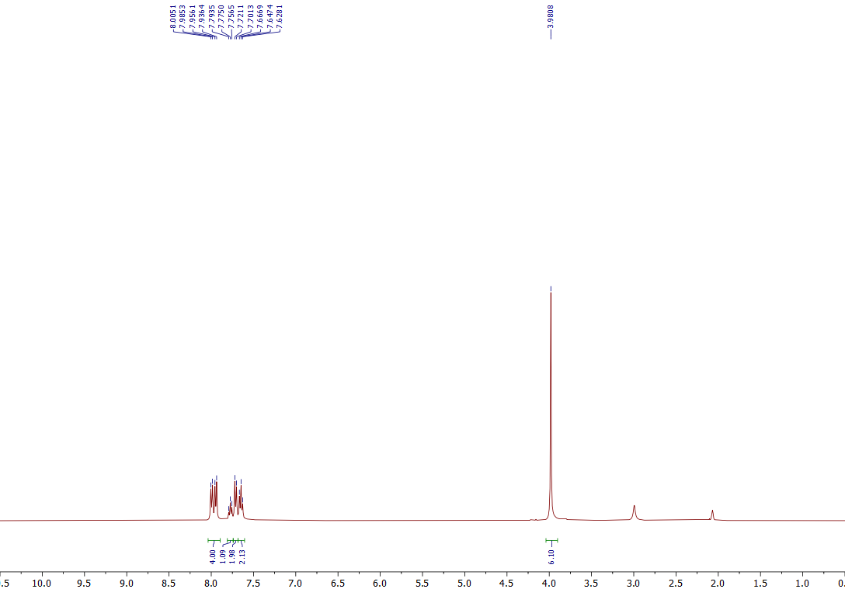

¹H NMR of the 3r (400 MHz, Acetone-d₆)
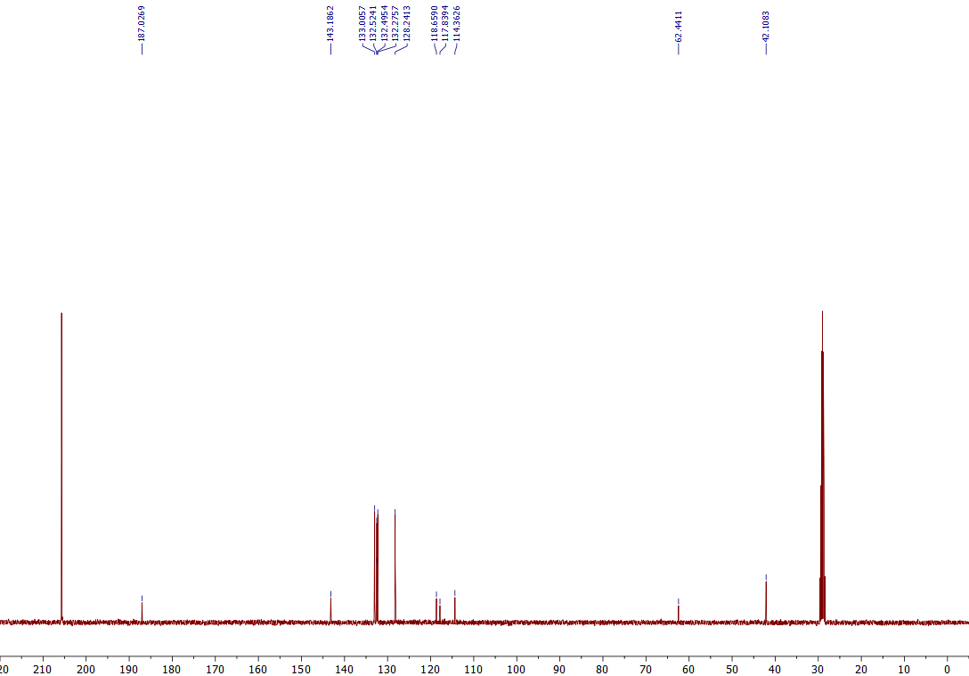
¹³C NMR of the 3r (101 MHz, Acetone-d₆)

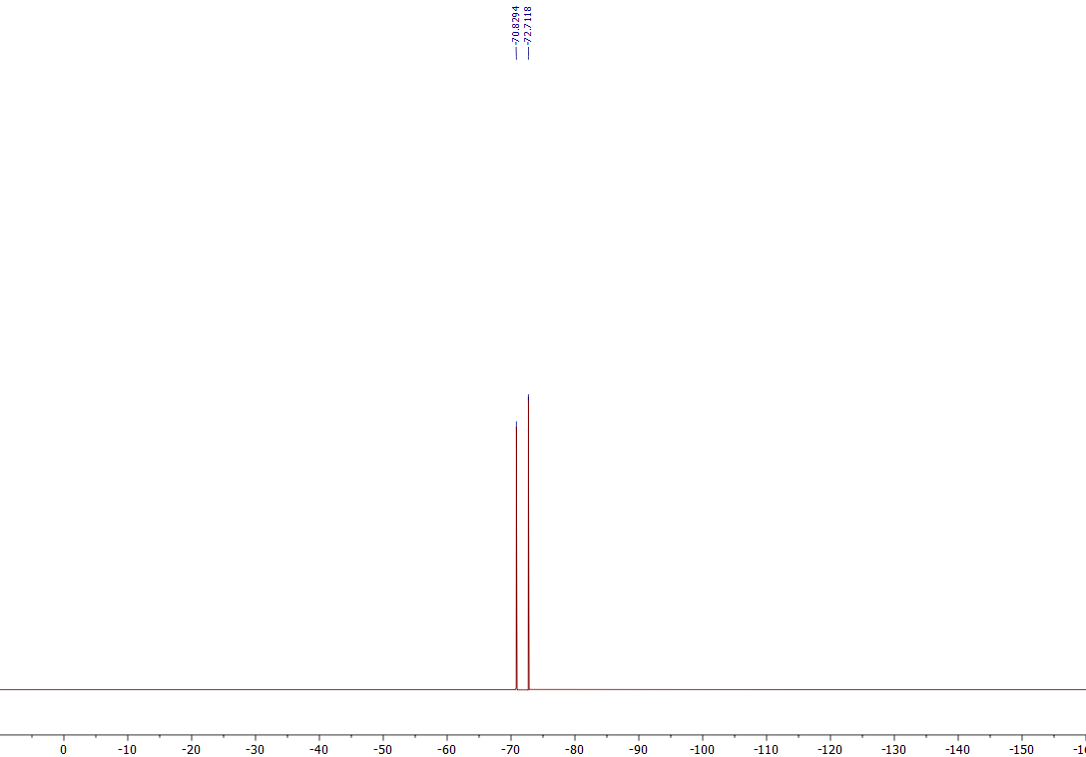
¹⁹F NMR of the 3r (376 MHz, Acetone-d₆)

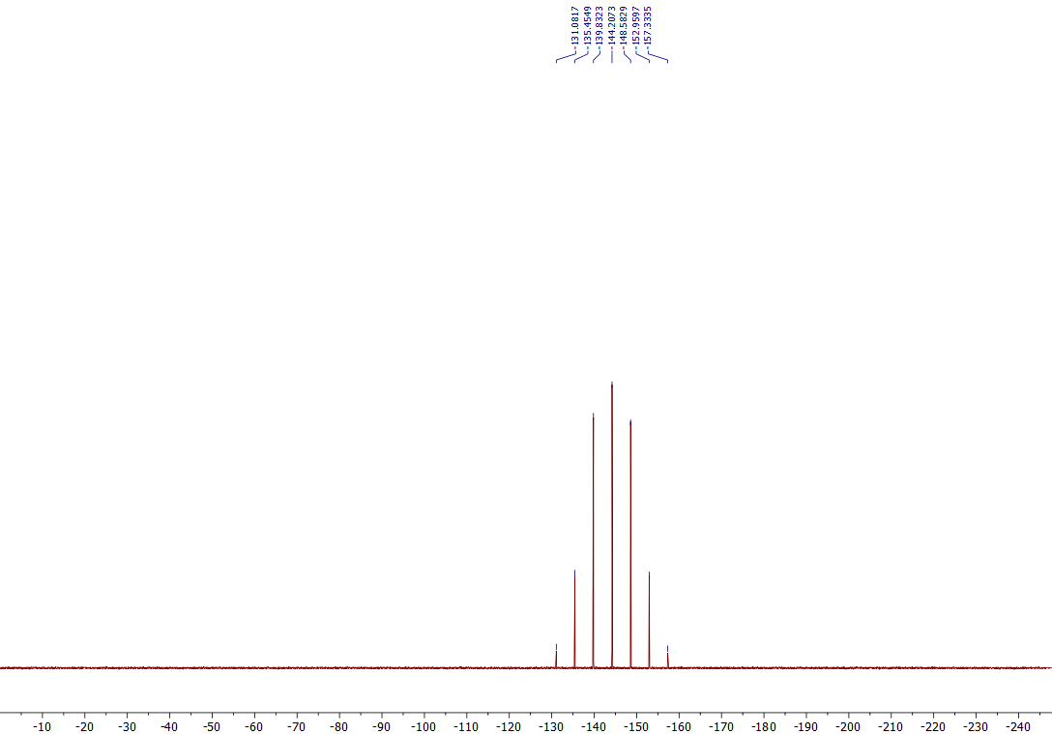
³¹P NMR of the 3r (162 MHz, Acetone-d₆)

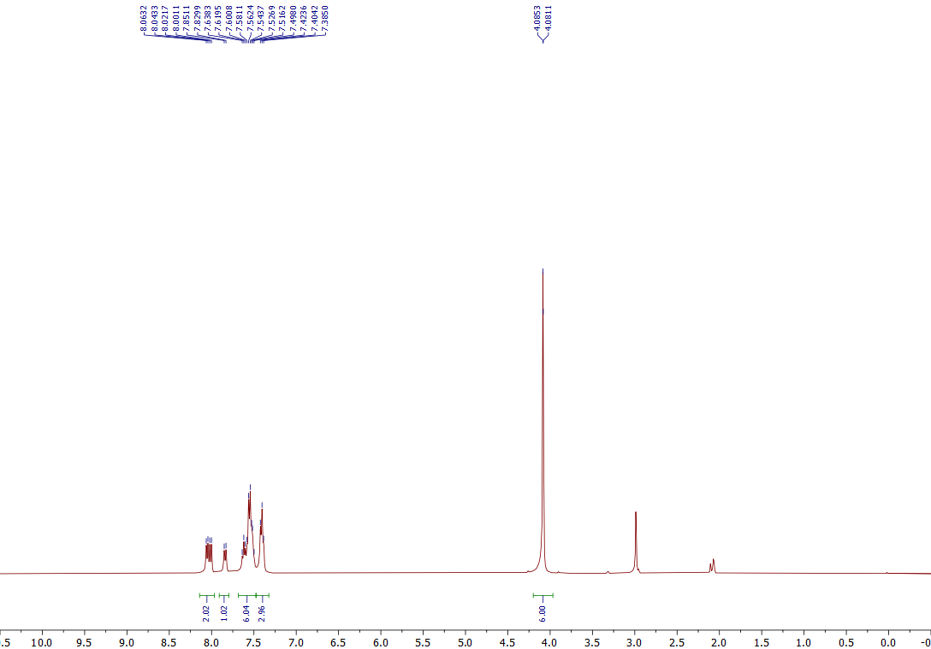

¹H NMR of the 3s (400 MHz, Acetone-d₆)
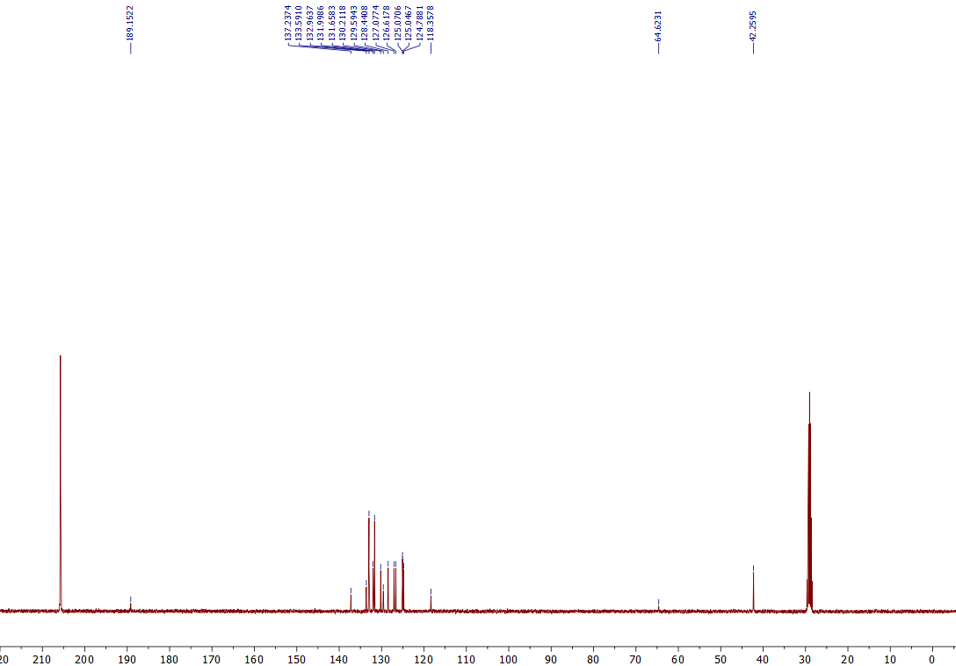
¹³C NMR of the 3s (101 MHz, Acetone-d₆)

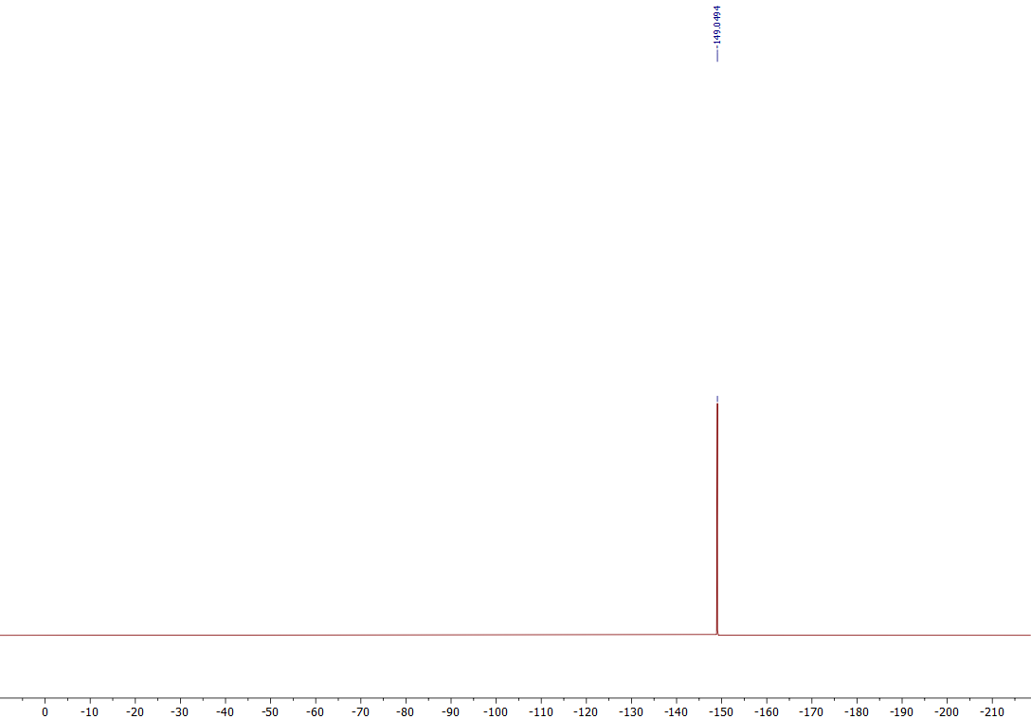
¹⁹F NMR of the 3s (376 MHz, Acetone-d₆)

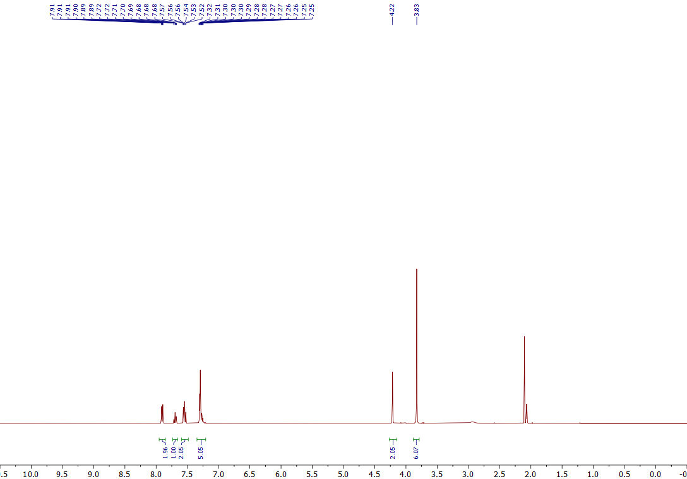
¹H NMR of the 3t (400 MHz, Acetone-d₆)
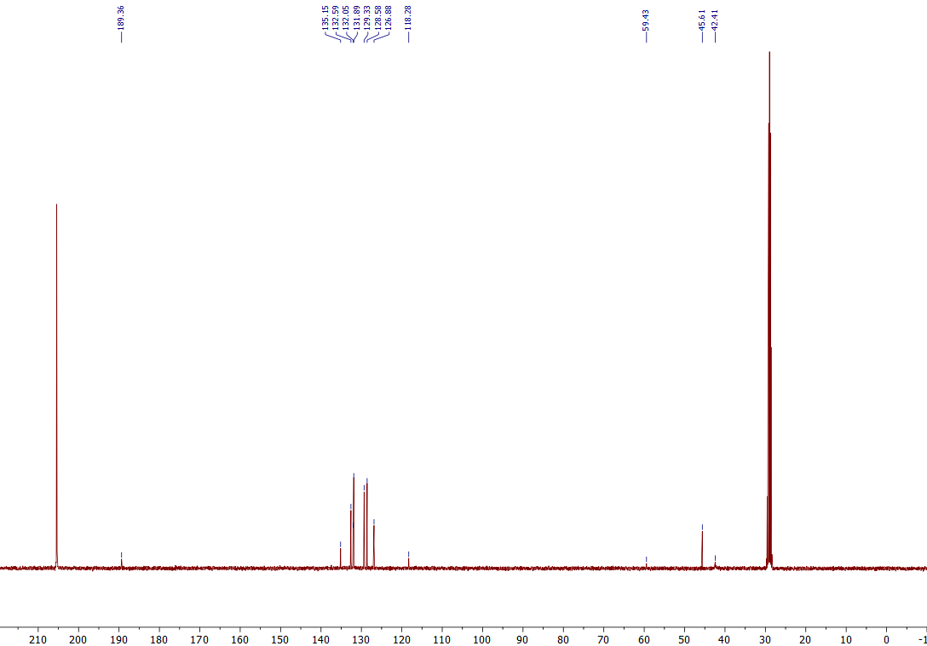
¹³C NMR of the 3t (101 MHz, Acetone-d₆)

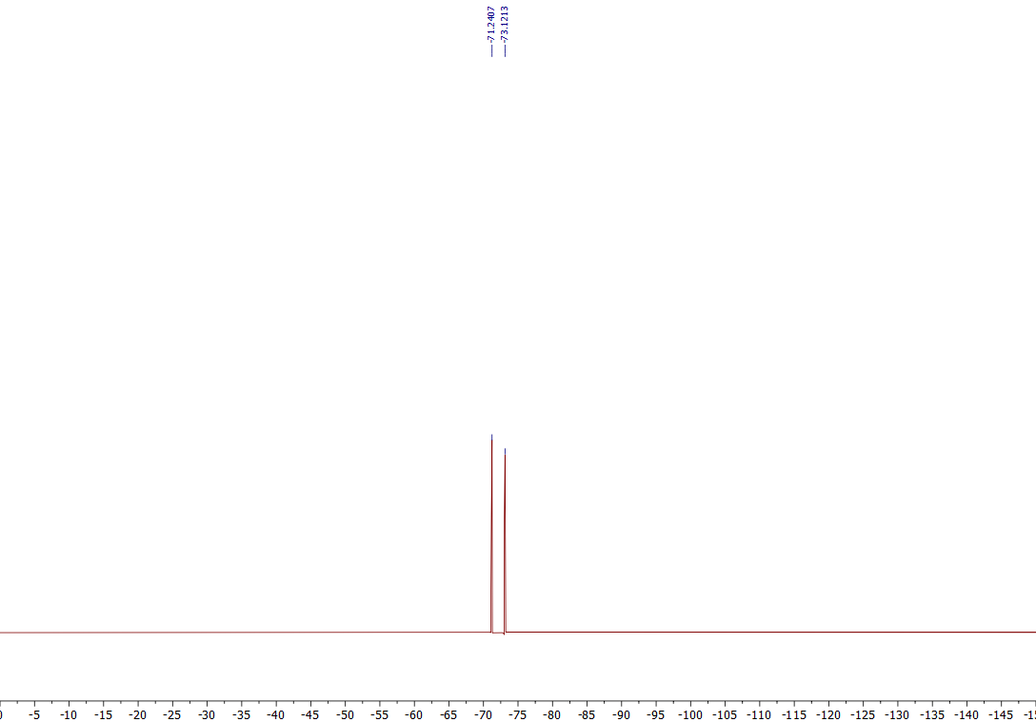
¹⁹F NMR of the 3t (376 MHz, Acetone-d₆)
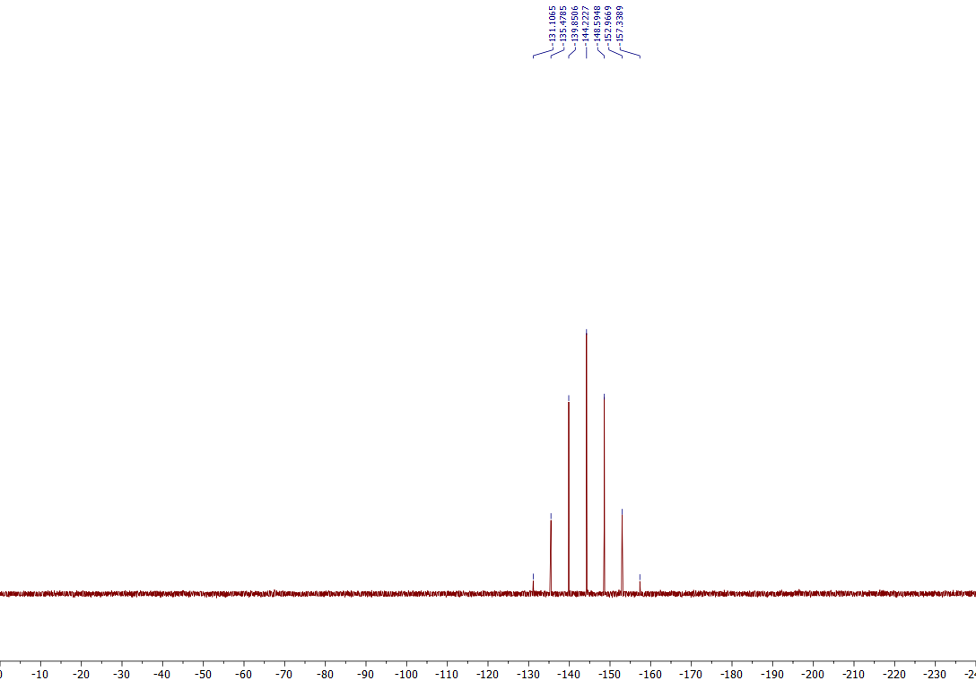
³¹P NMR of the 3t (162 MHz, Acetone-d₆)

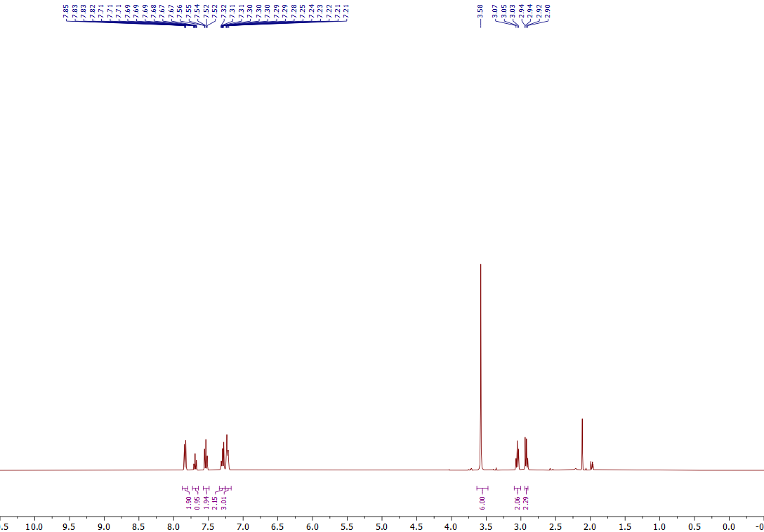

¹H NMR of the 3u (400 MHz, CD₃CN)

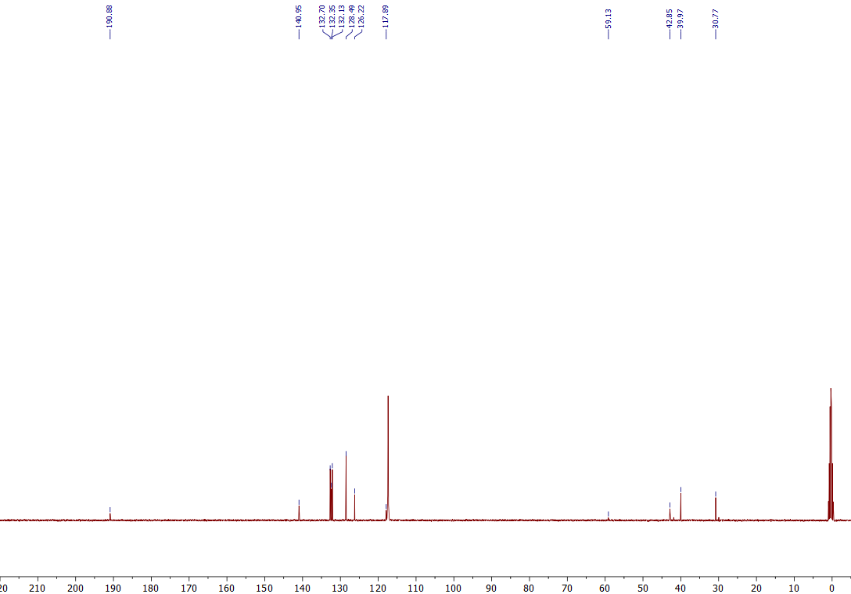
¹³C NMR of the 3u (101 MHz, CD₃CN)

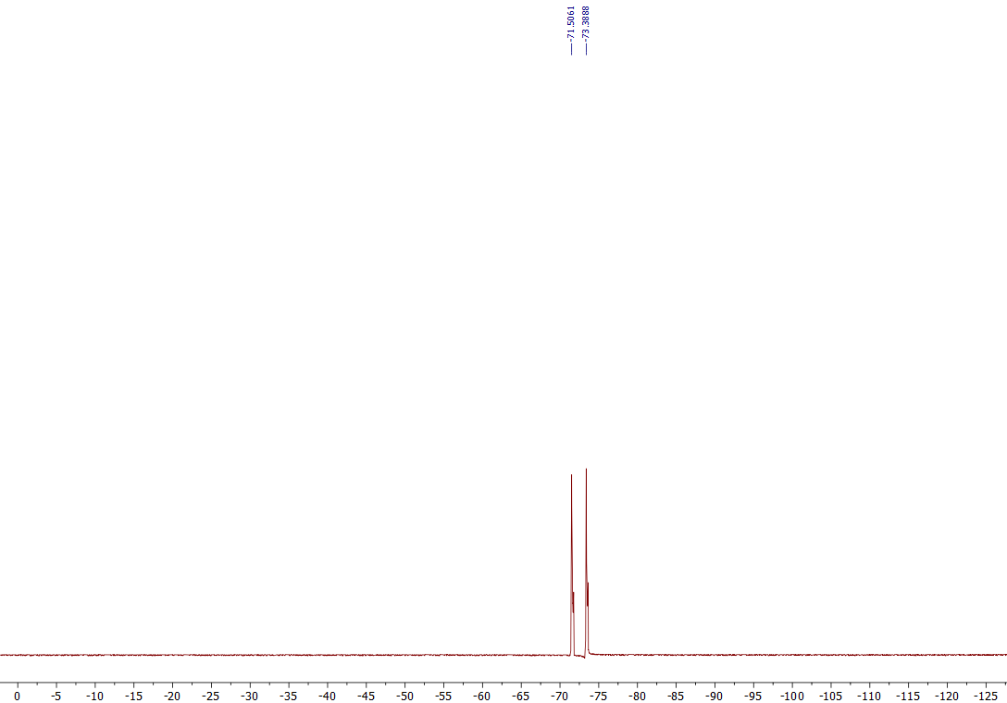
¹⁹F NMR of the 3u (376 MHz, CD₃CN)
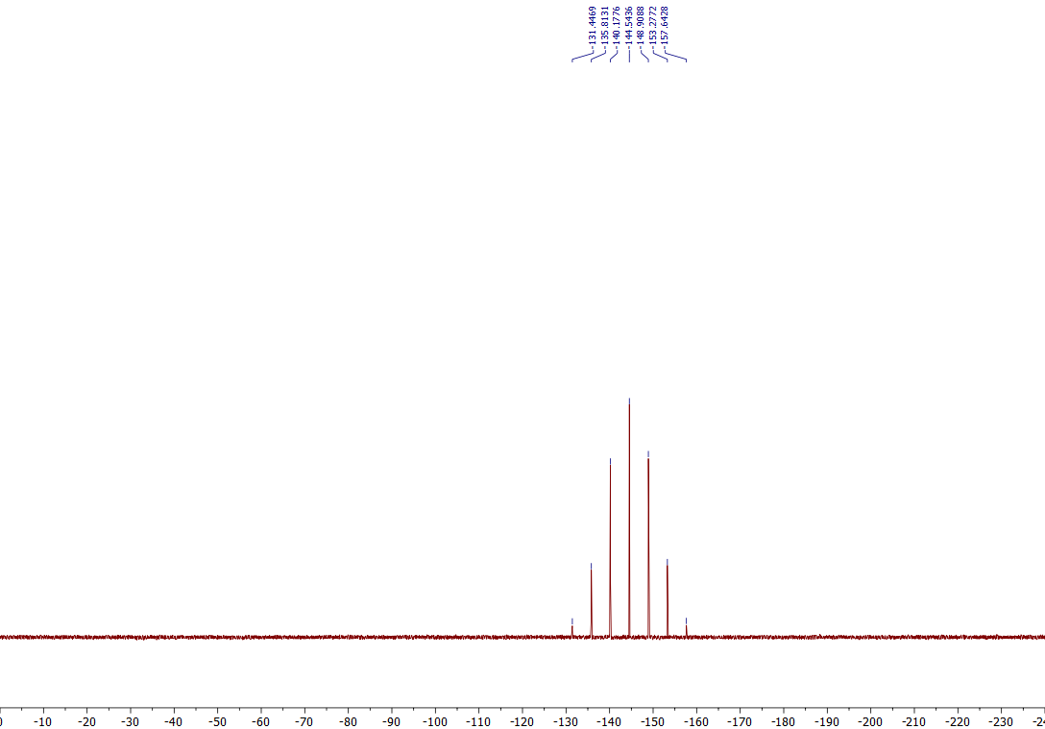
³¹P NMR of the 3u (162 MHz, CD₃CN)

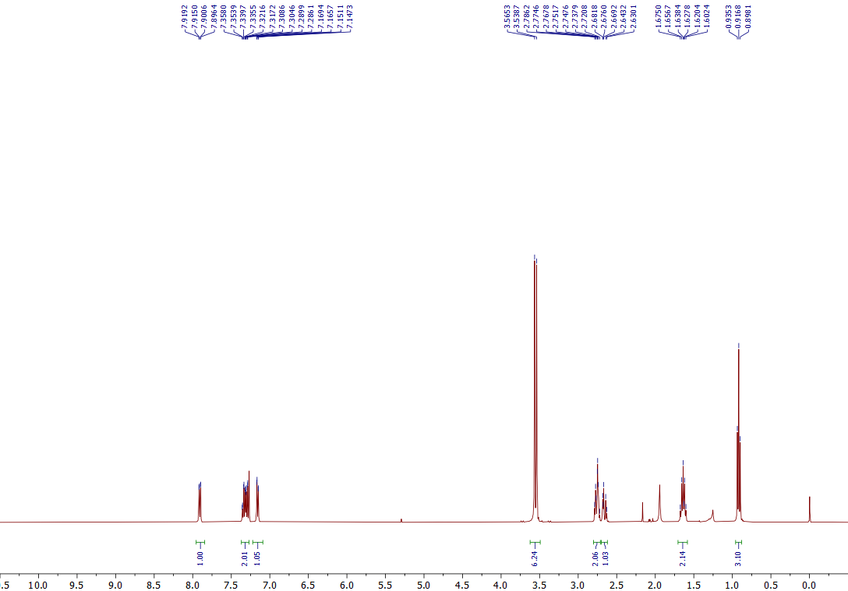
¹H NMR of the 5a (400 MHz, CDCl₃)
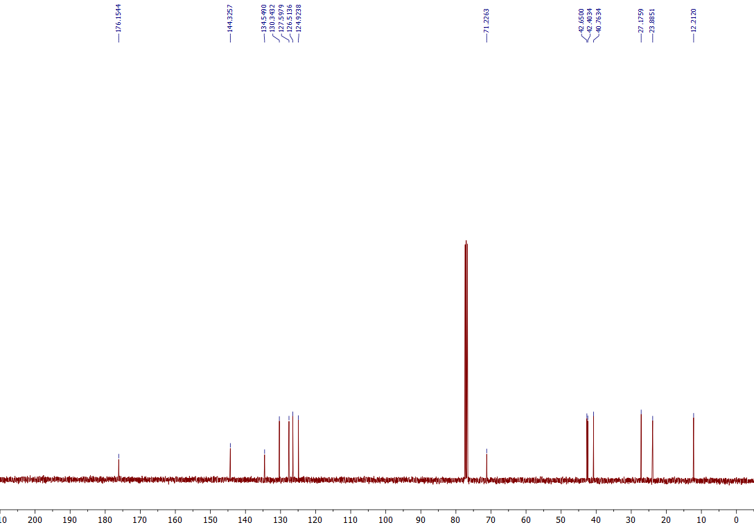
¹³C NMR of the 5a (101 MHz, CDCl₃)

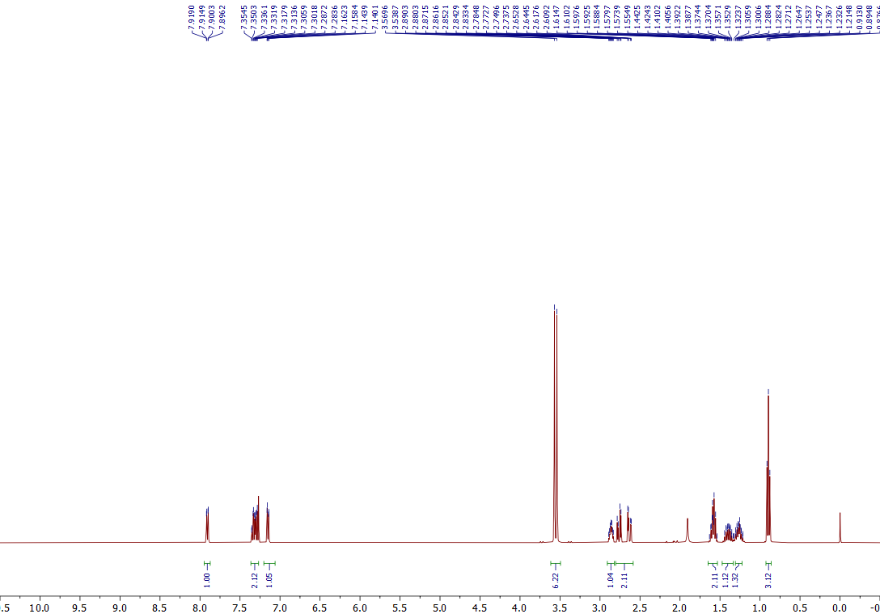
¹H NMR of the 5b (400 MHz, CDCl₃)
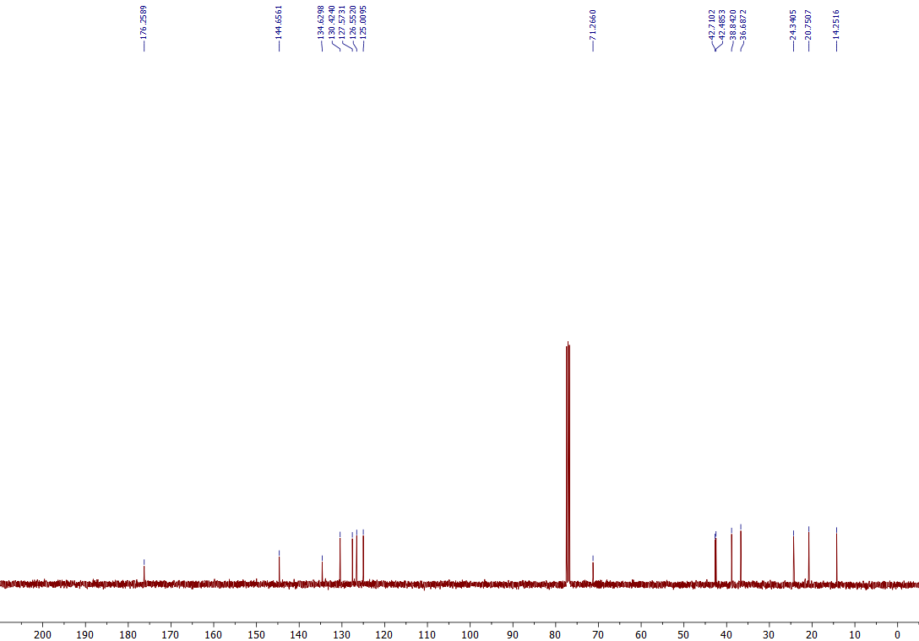
¹³C NMR of the 5b (101 MHz, CDCl₃)

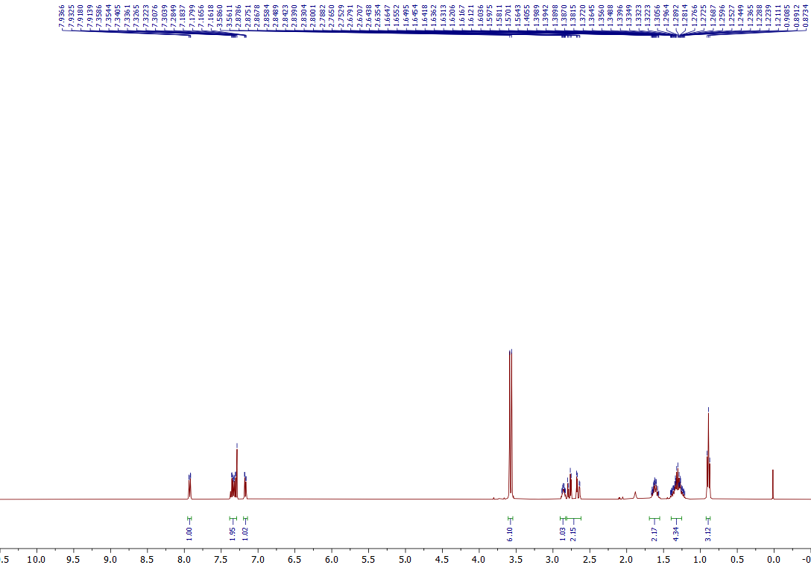
¹H NMR of the 5c (400 MHz, CDCl₃)
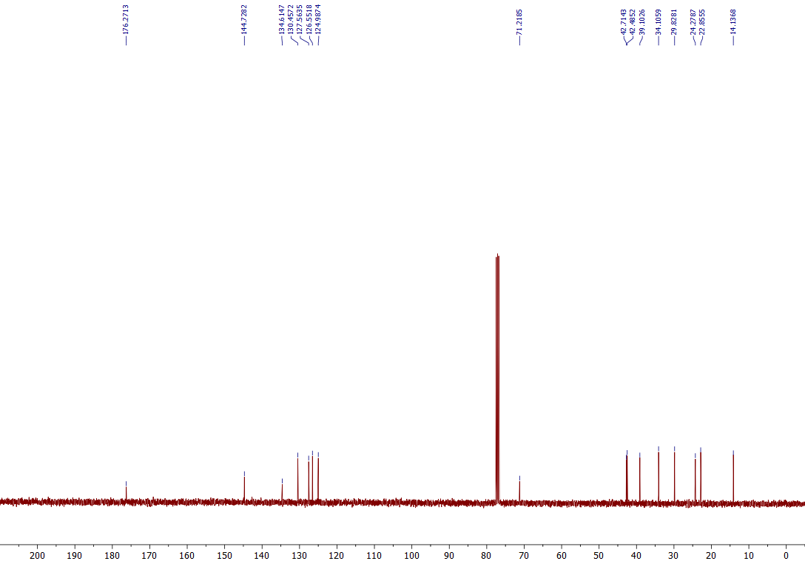
¹³C NMR of the 5c (101 MHz, CDCl₃)

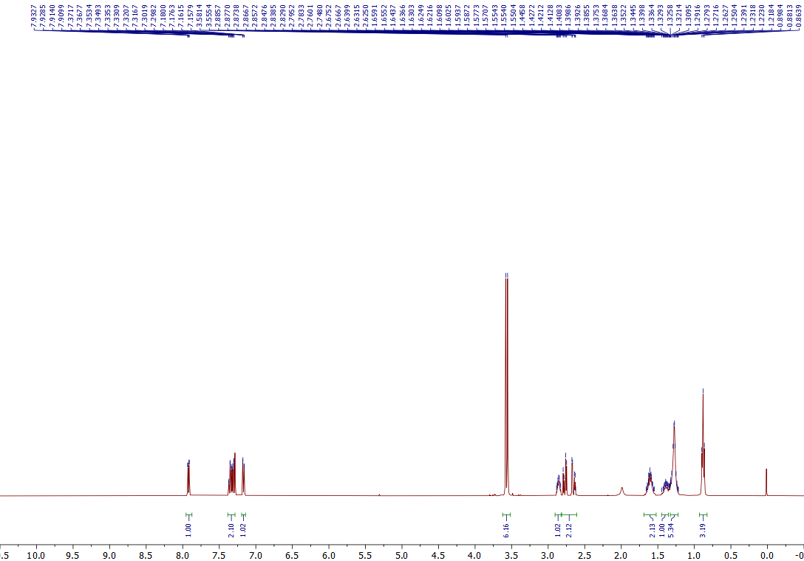
¹H NMR of the 5d (400 MHz, CDCl₃)
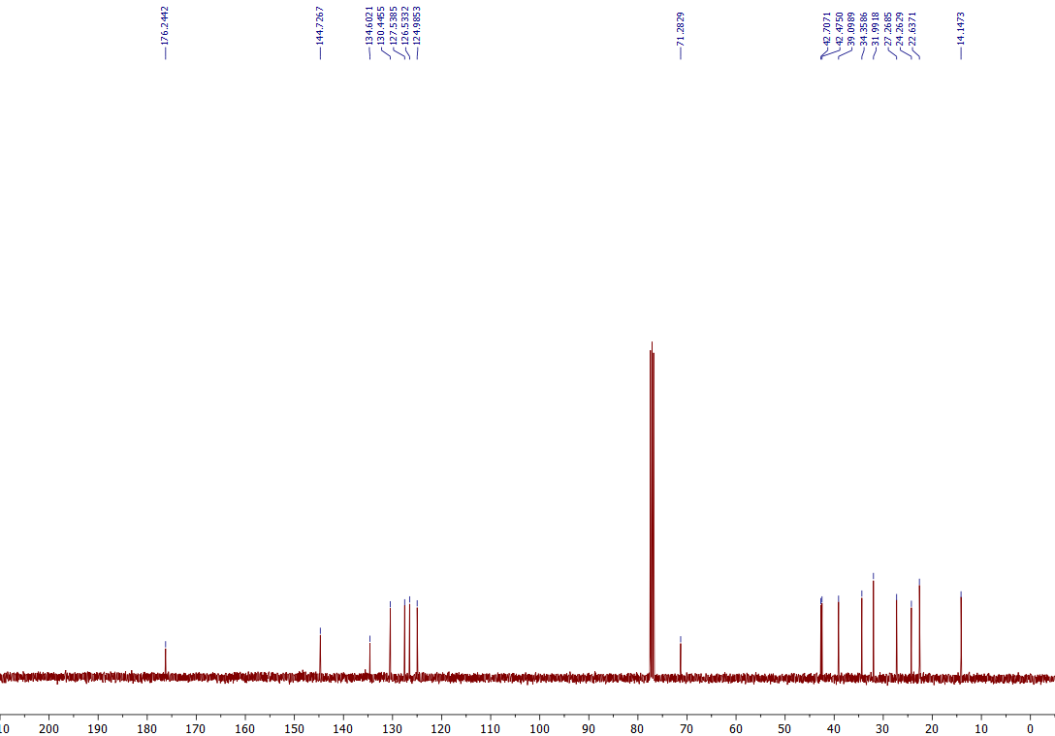
¹³C NMR of the 5d (101 MHz, CDCl₃)
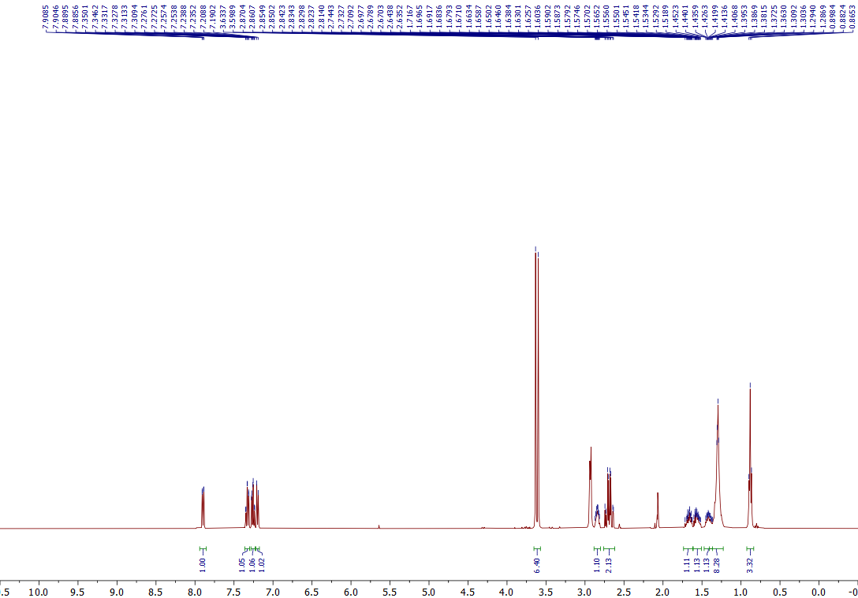
¹H NMR of the 5e (400 MHz, Acetone-d₆)
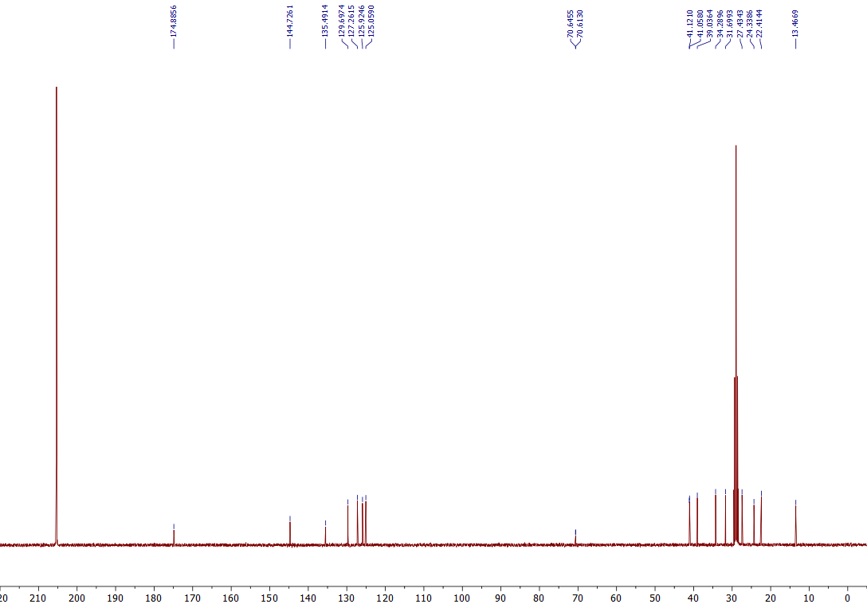
¹³C NMR of the 5e (101 MHz, Acetone-d₆)

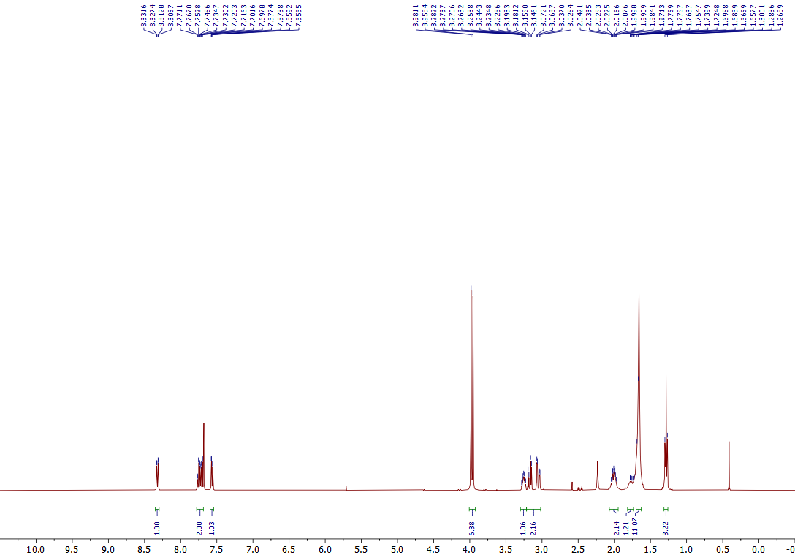
¹H NMR of the 5f (400 MHz, CDCl₃)
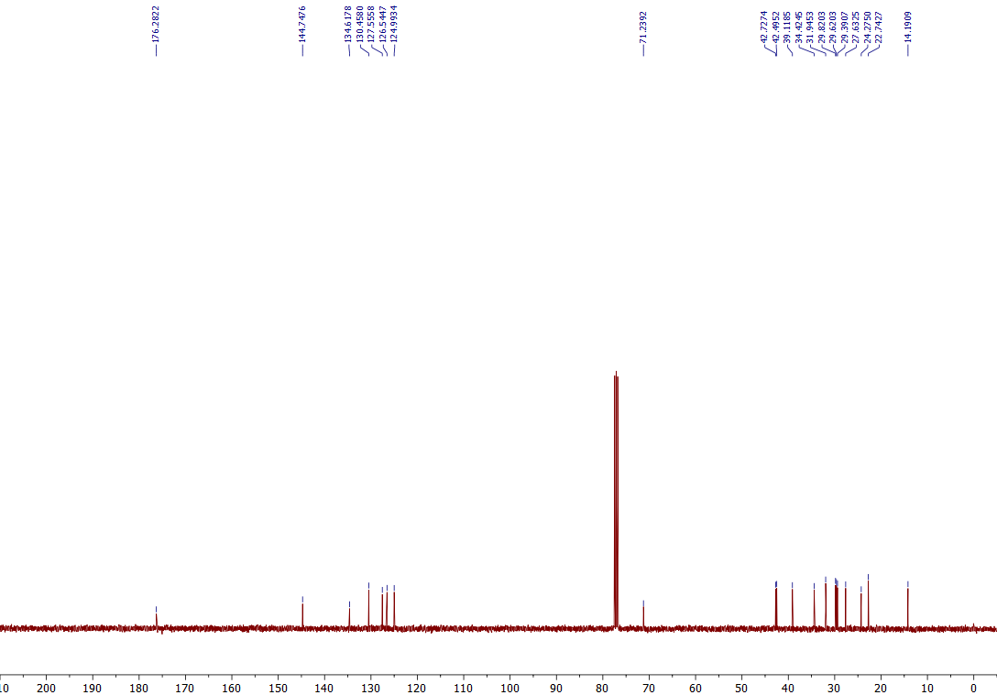
¹³C NMR of the 5f (101 MHz, CDCl₃)

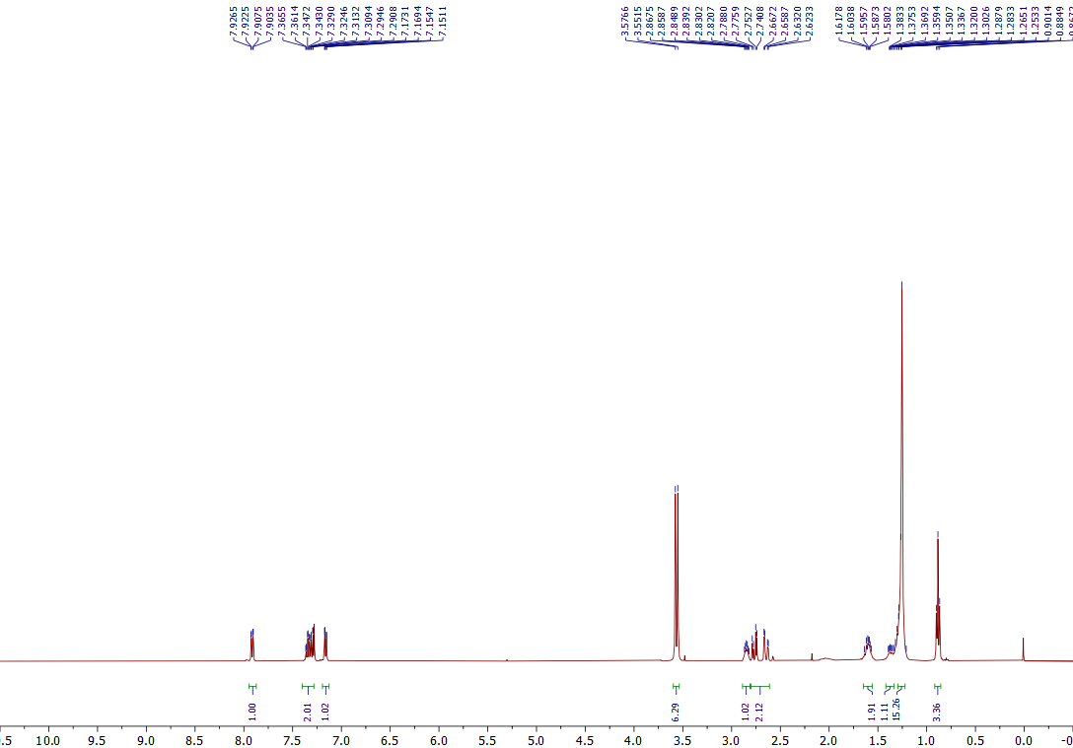
¹H NMR of the 5g (400 MHz, CDCl₃)
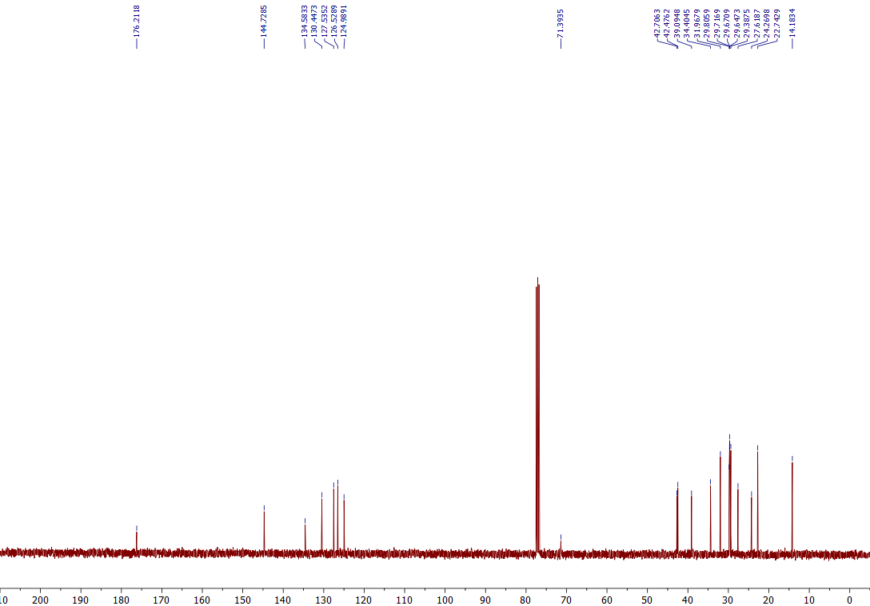
¹³C NMR of the 5g (101 MHz, CDCl₃)

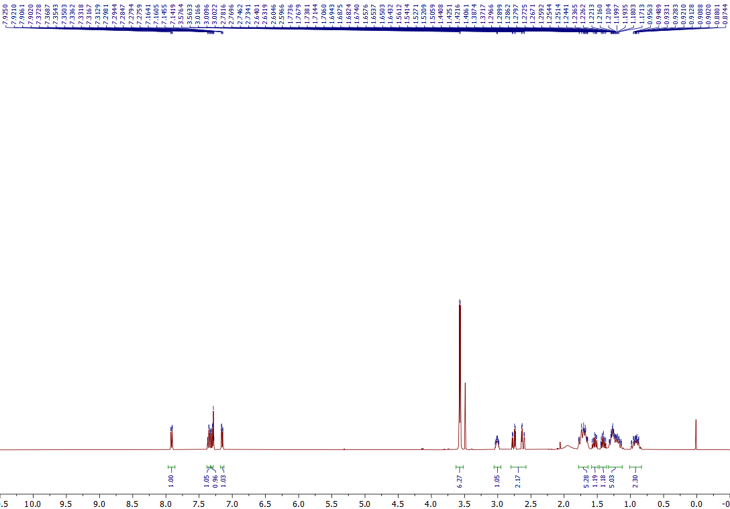
¹H NMR of the 5h (400 MHz, CDCl₃)

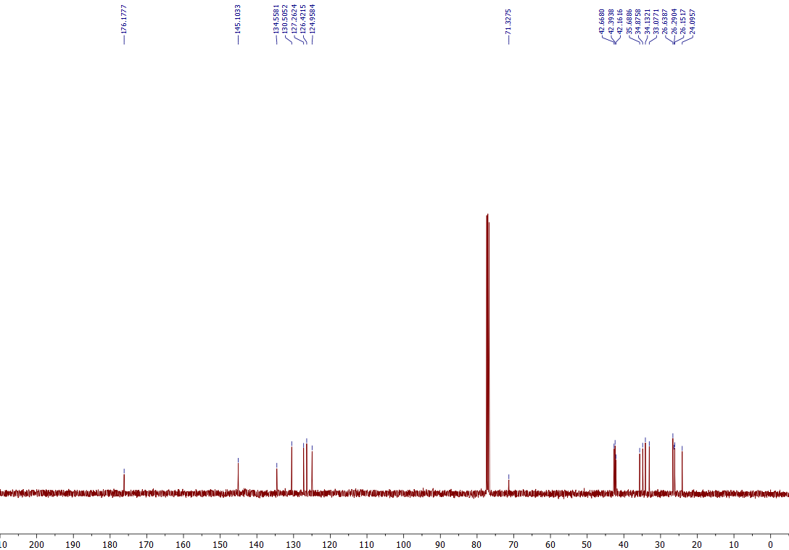
¹³C NMR of the 5h (101 MHz, CDCl₃)

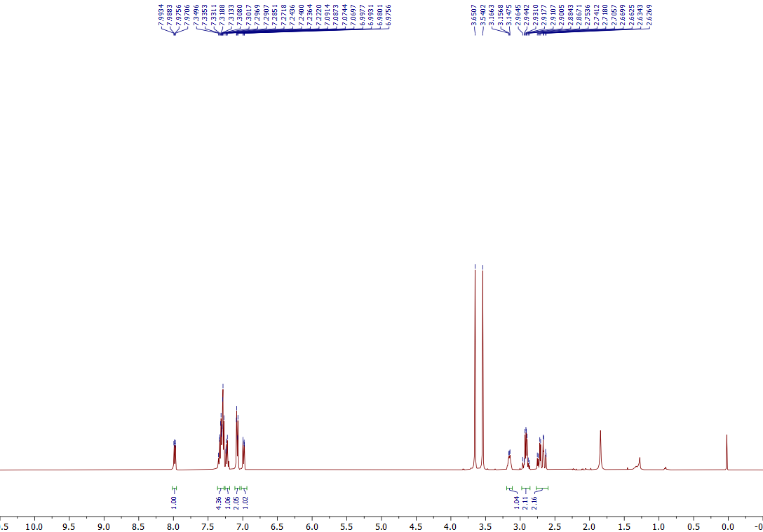
¹H NMR of the 5i (400 MHz, CDCl₃)

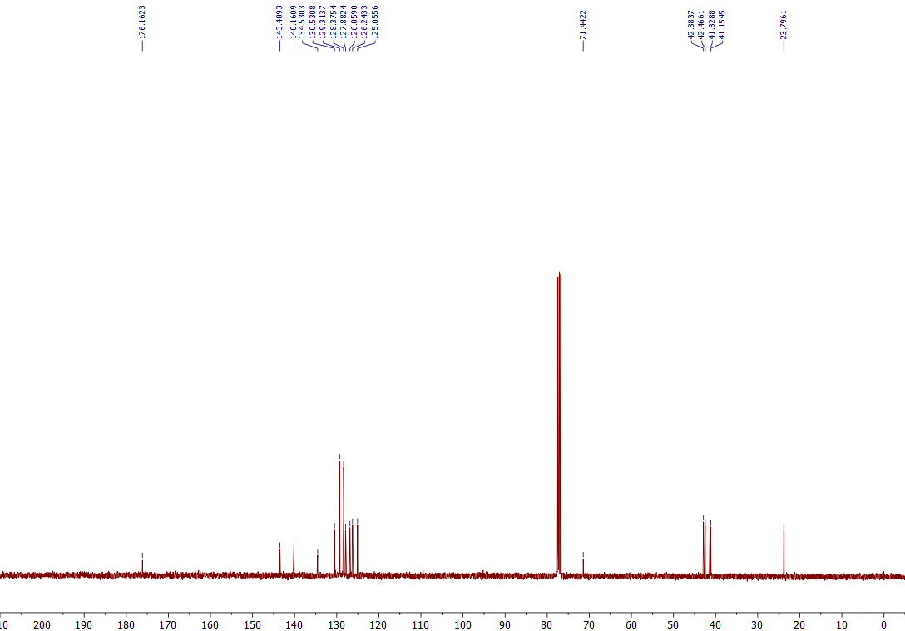
¹³C NMR of the 5i (101 MHz, CDCl₃)

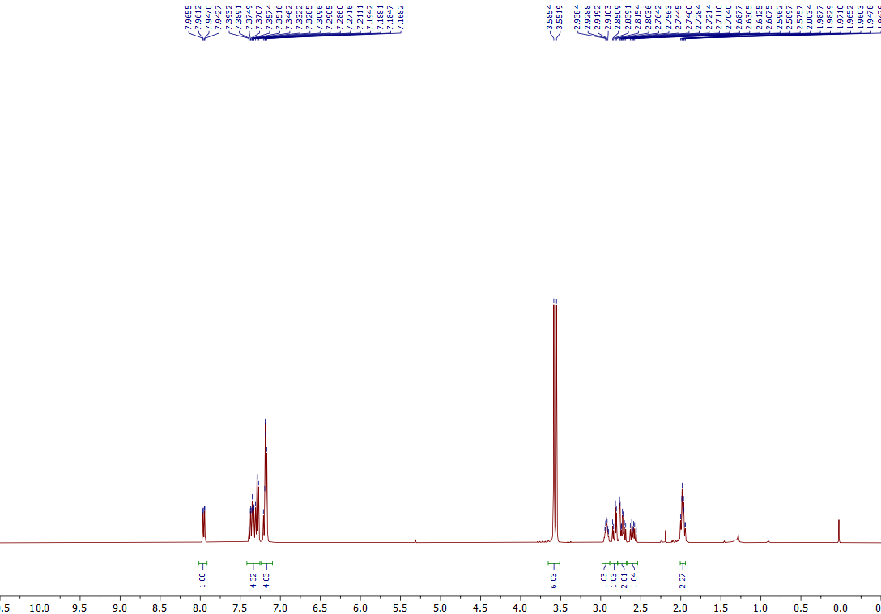
¹H NMR of the 5J (400 MHz, CDCl₃)

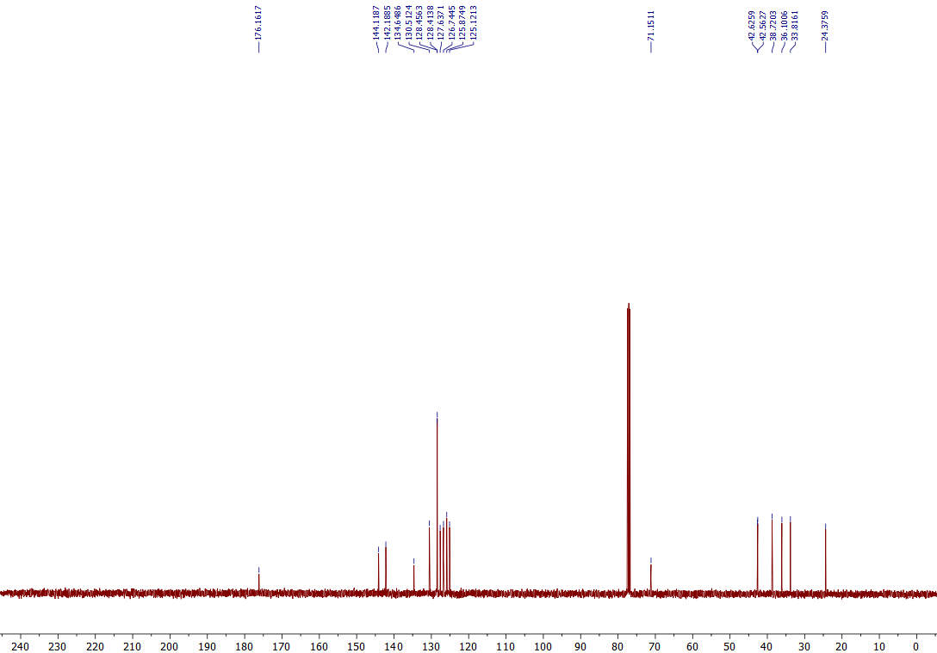
¹³C NMR of the 5J (101 MHz, CDCl₃)
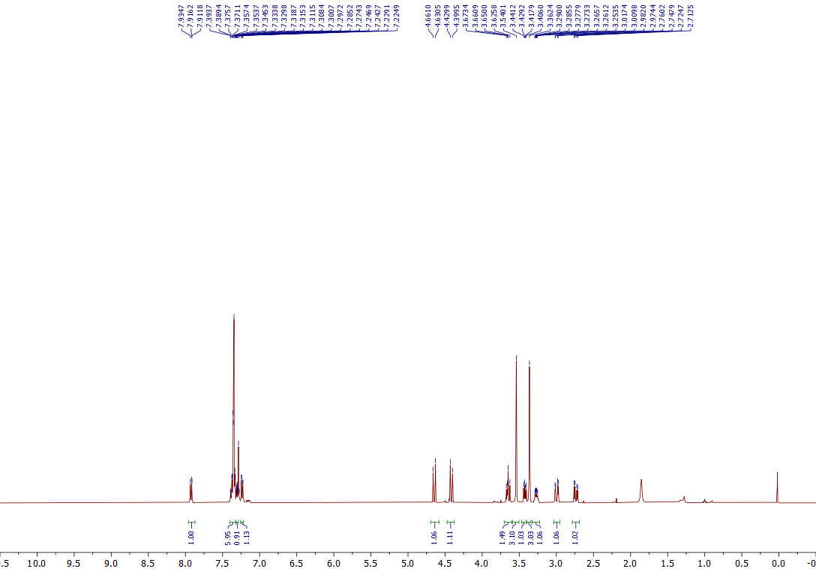
¹H NMR of the 5k (400 MHz, CDCl₃)
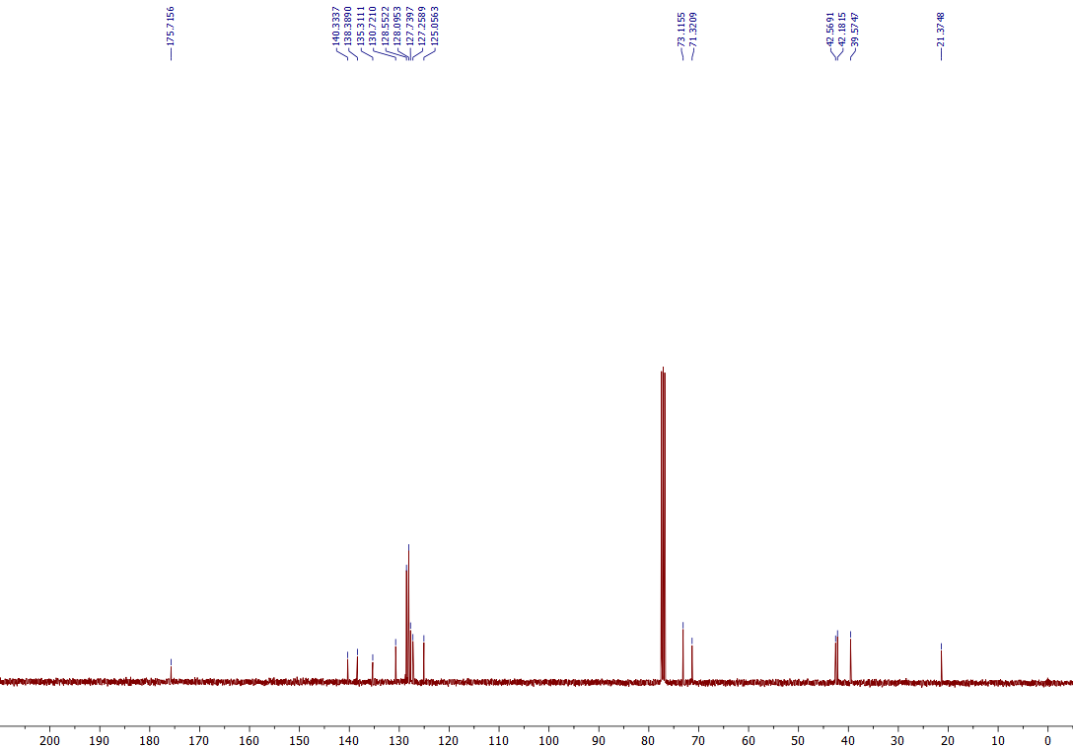
¹³C NMR of the 5k (101 MHz, CDCl₃)

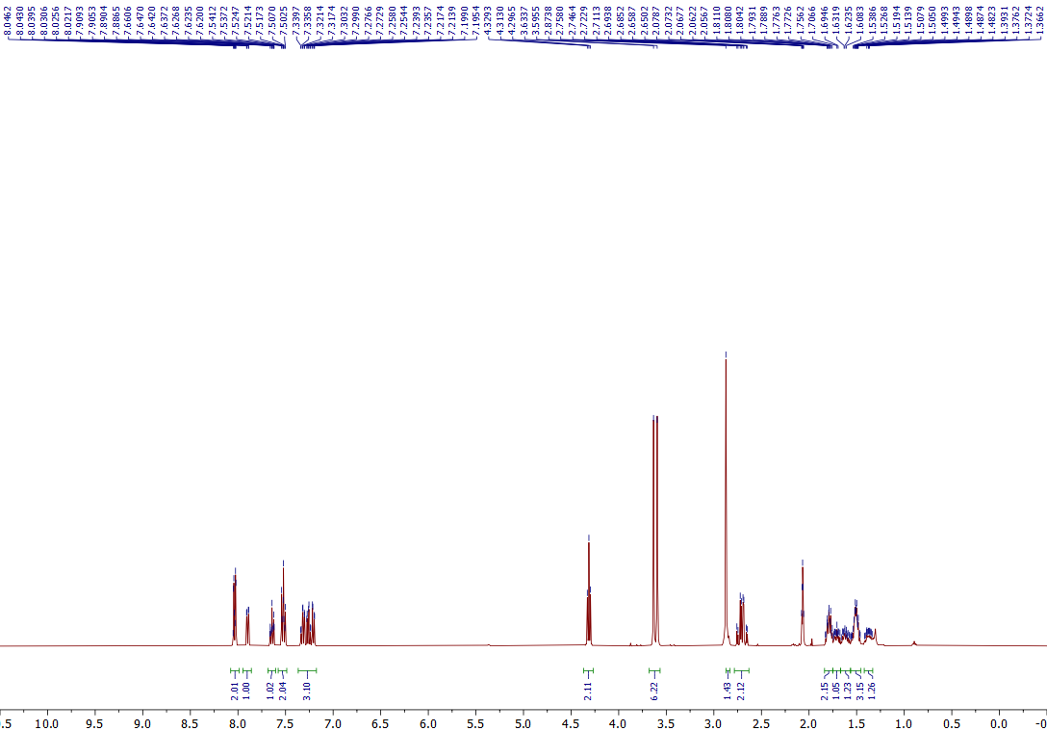
¹H NMR of the 5l (400 MHz, Acetone-d₆)

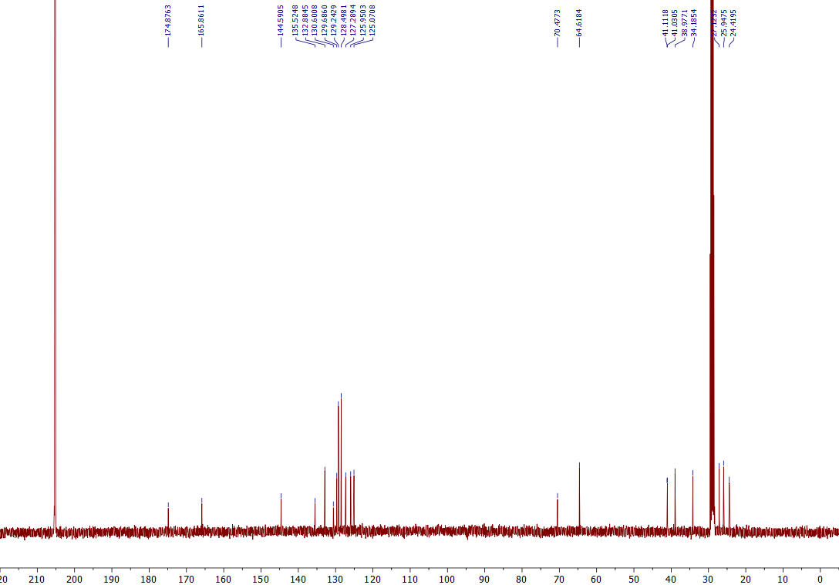
¹³C NMR of the 5l (101 MHz, Acetone-d₆)
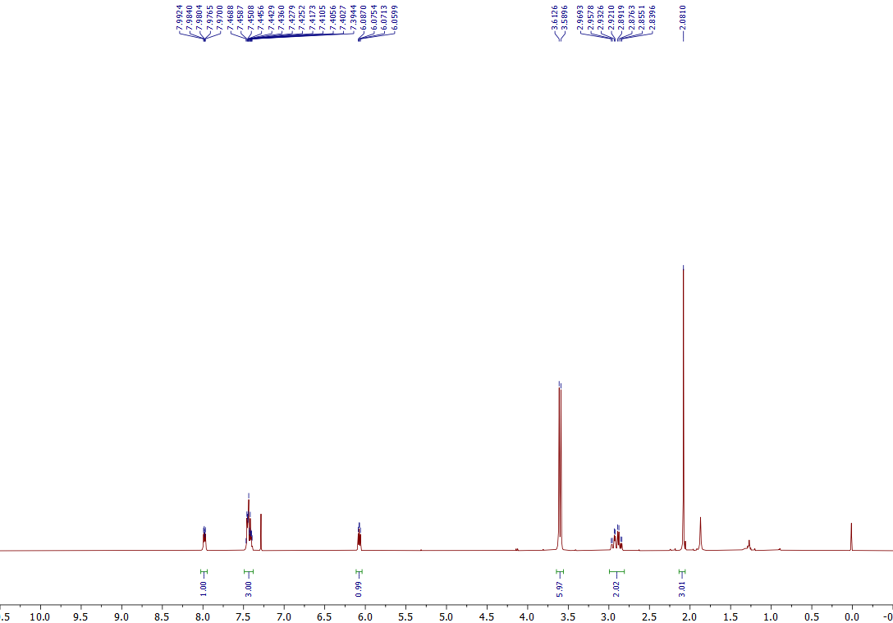
¹H NMR of the 5m (400 MHz, CDCl₃)
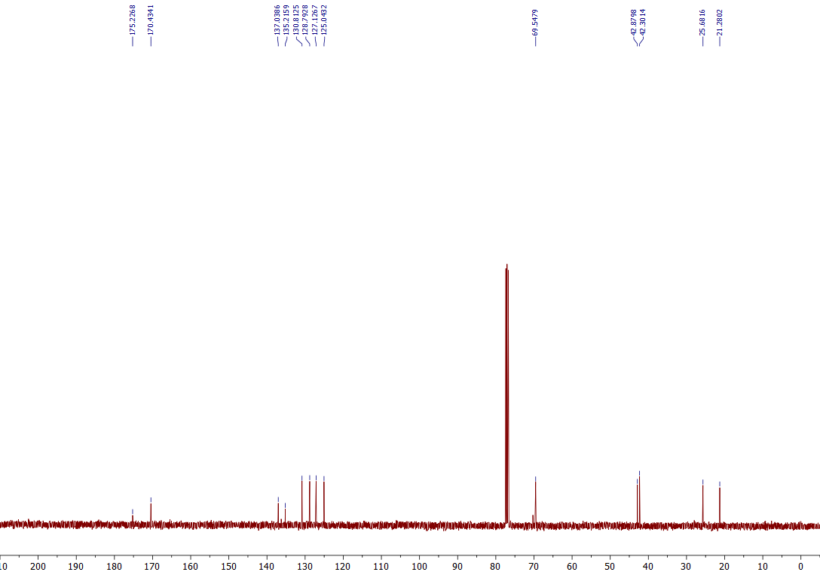
¹³C NMR of the 5m (101 MHz, CDCl₃)

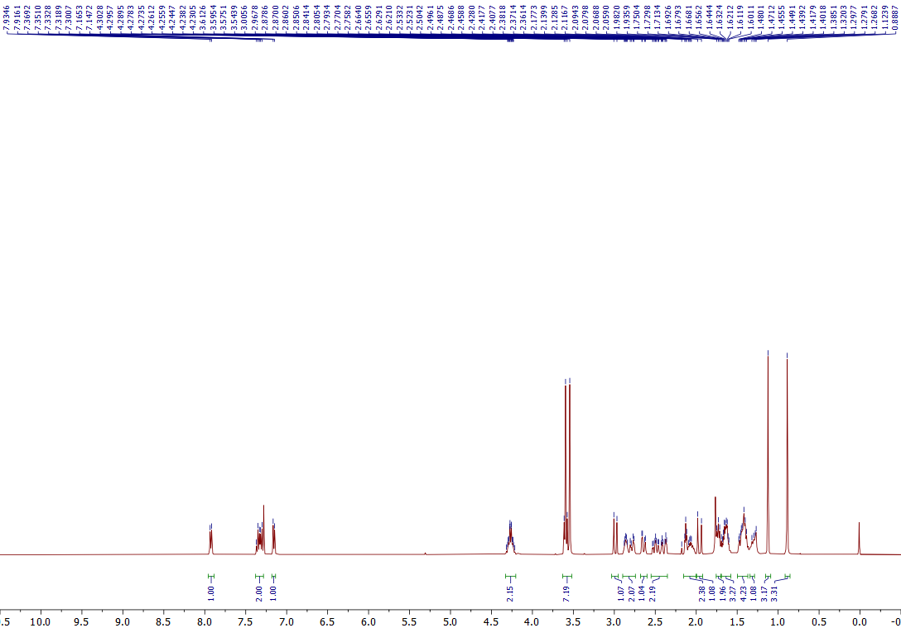
¹H NMR of the 5n (400 MHz, CDCl₃)
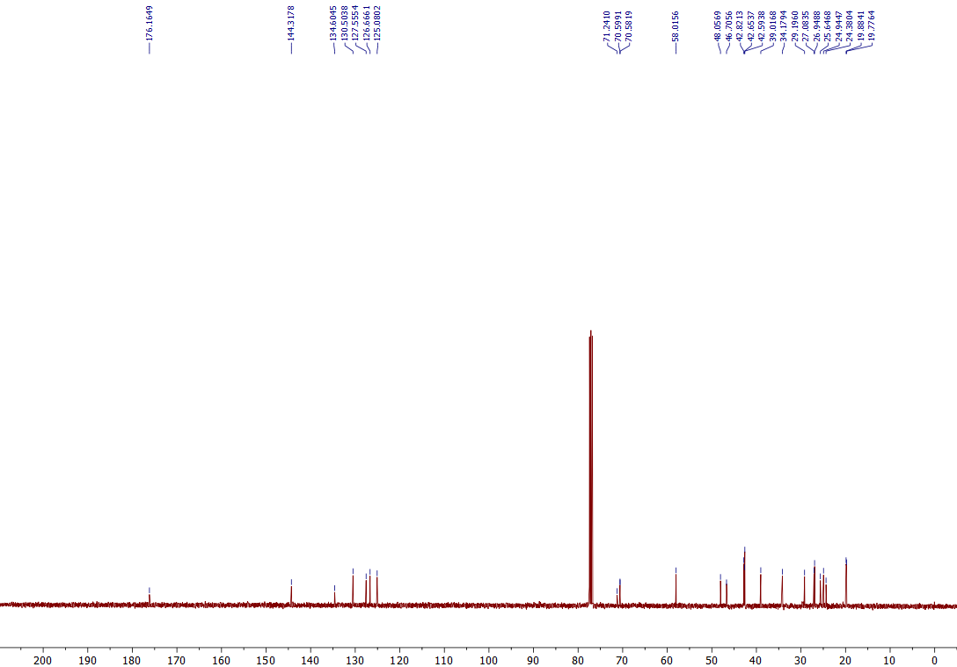
¹³C NMR of the 5n (101 MHz, CDCl₃)
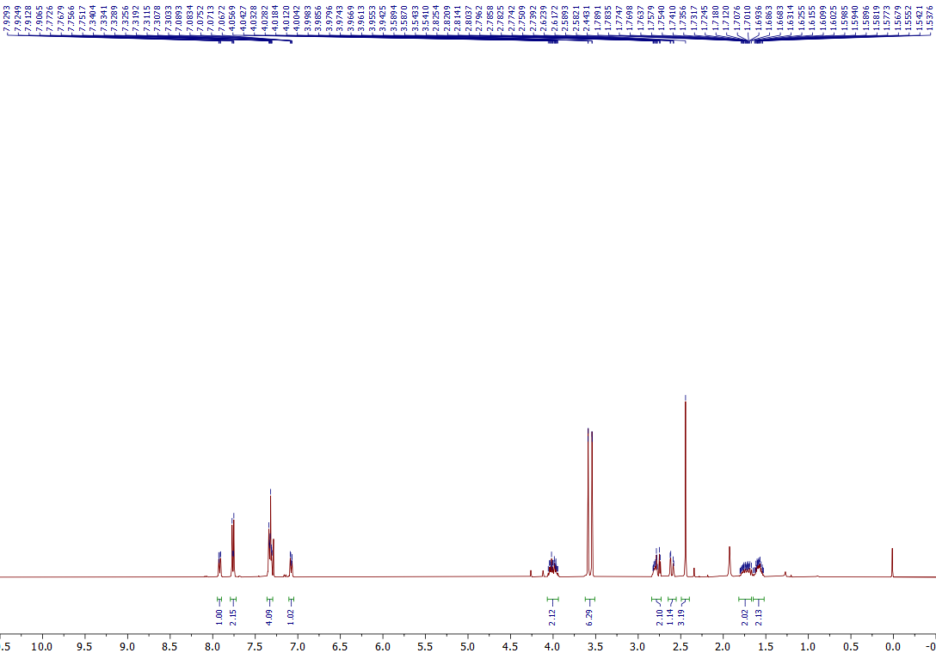
¹H NMR of the 5o (400 MHz, CDCl₃)
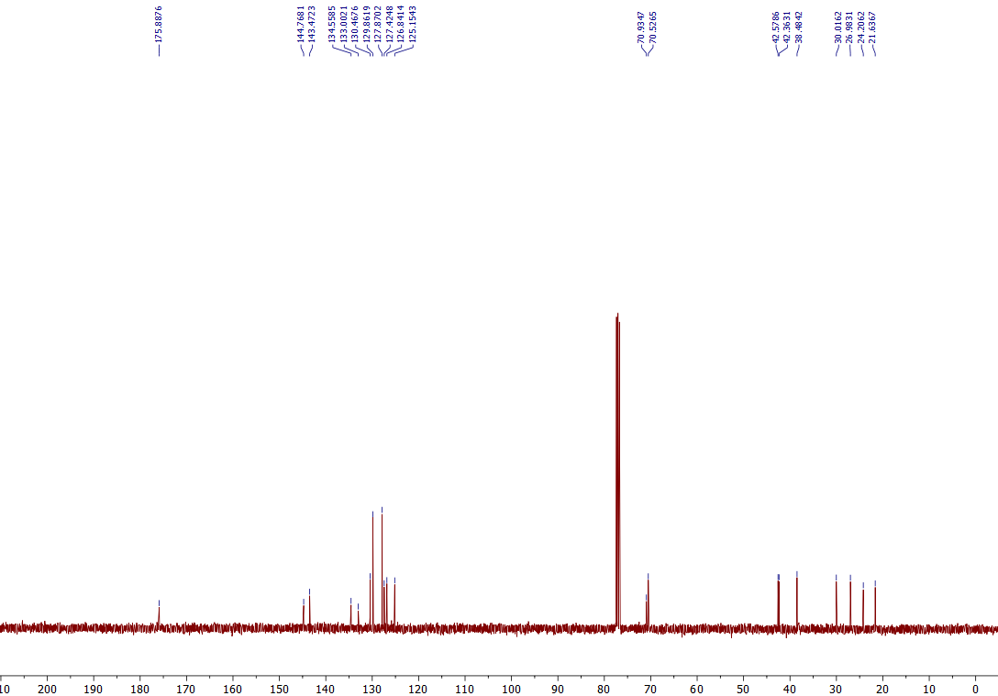
¹³C NMR of the 5o (101 MHz, CDCl₃)

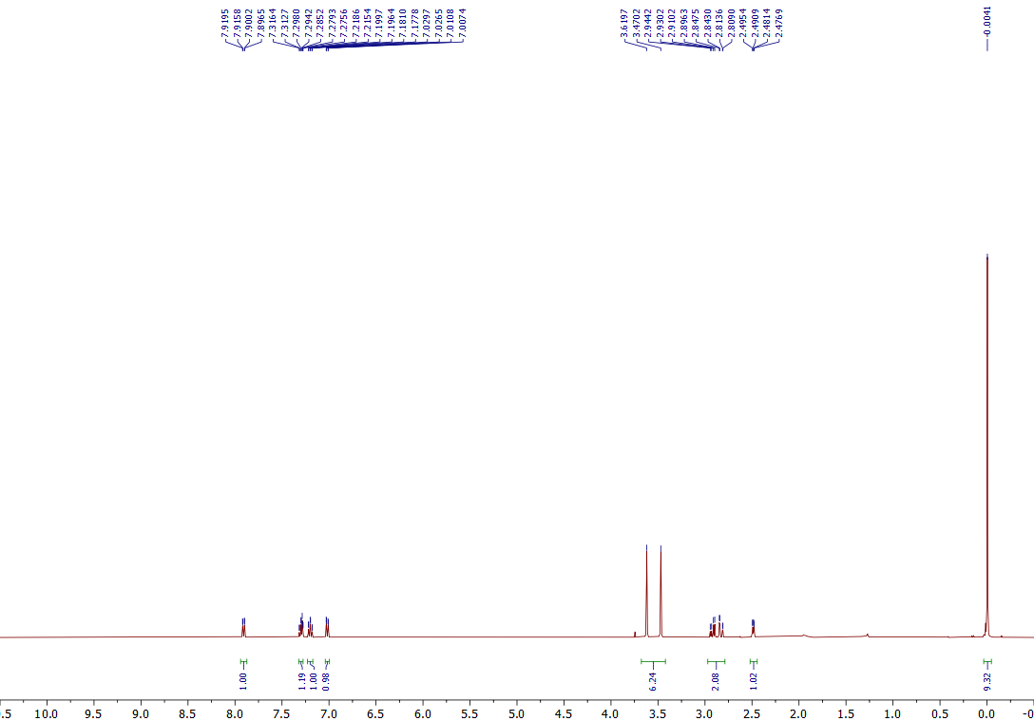
¹H NMR of the 5p (400 MHz, CDCl₃)
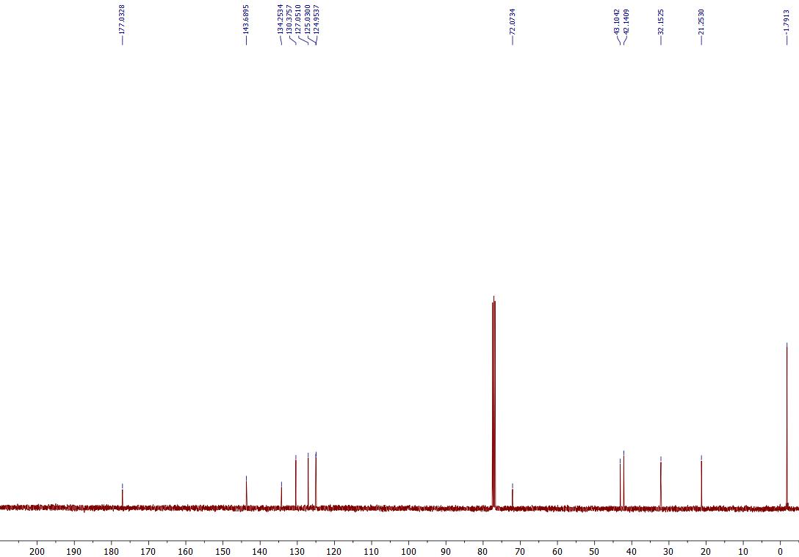
¹³C NMR of the 5p (101 MHz, CDCl₃)

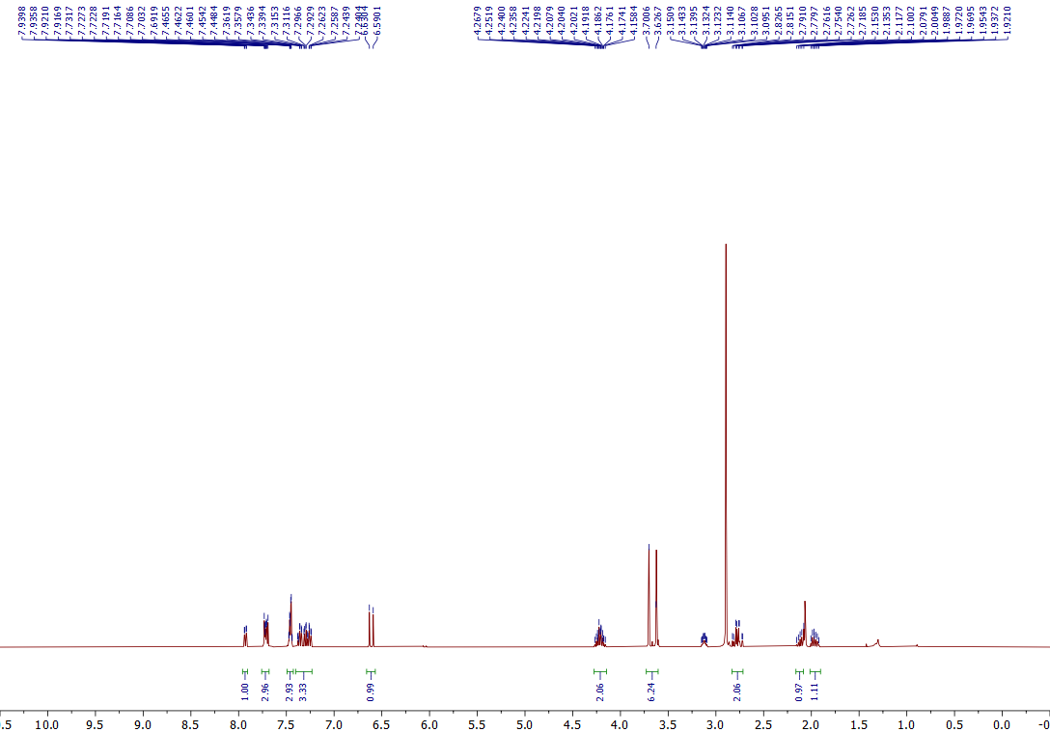
¹H NMR of the 5q (400 MHz, Acetone-d₆)
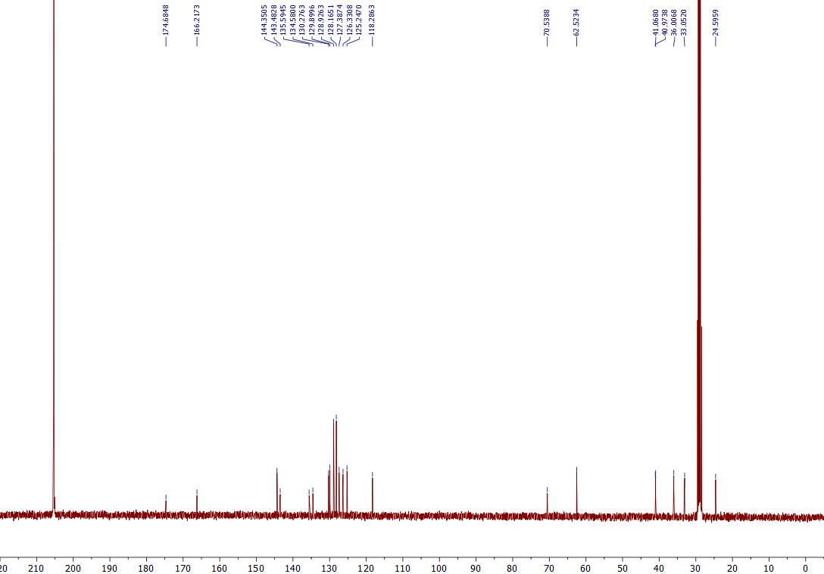
¹³C NMR of the 5q (101 MHz, Acetone-d₆)
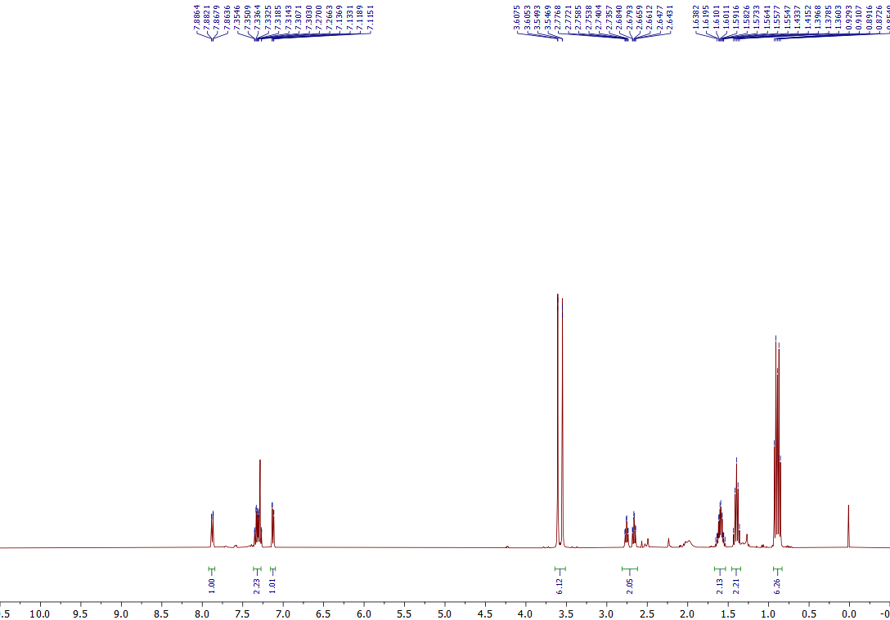
¹H NMR of the 5r (400 MHz, CDCl₃)
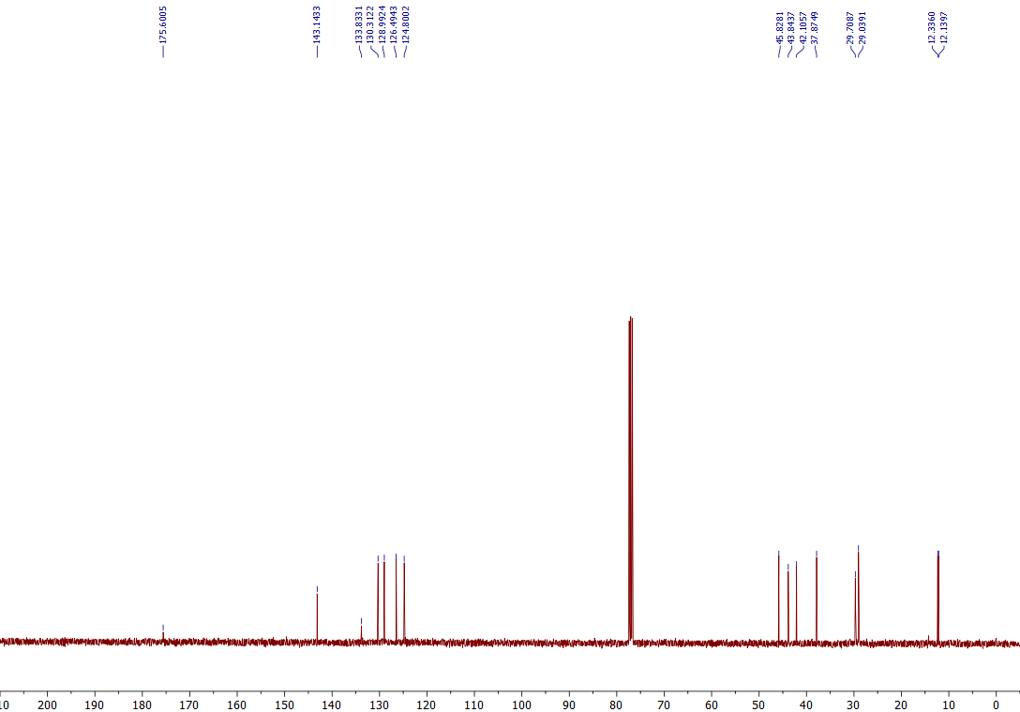
¹³C NMR of the 5r (101 MHz, CDCl₃)

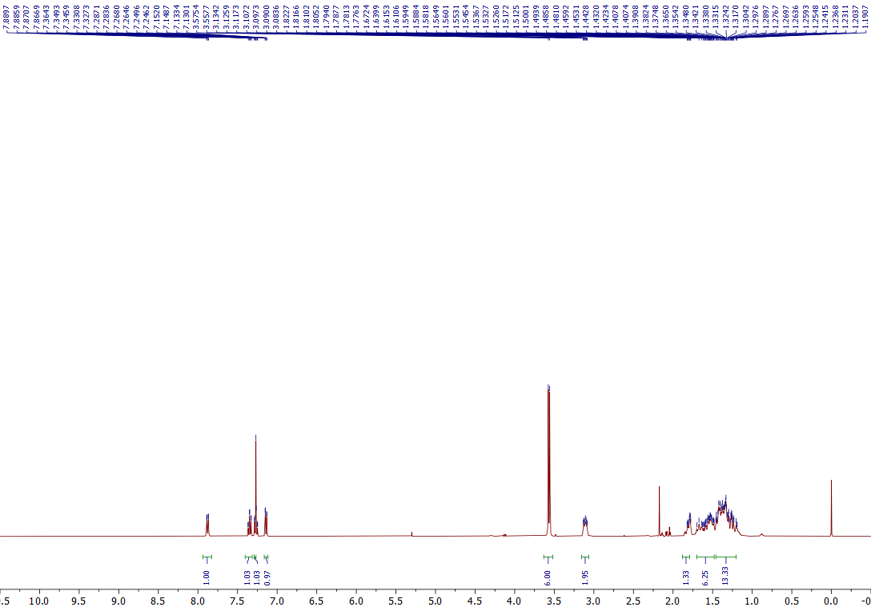
¹H NMR of the 5s (400 MHz, CDCl₃)
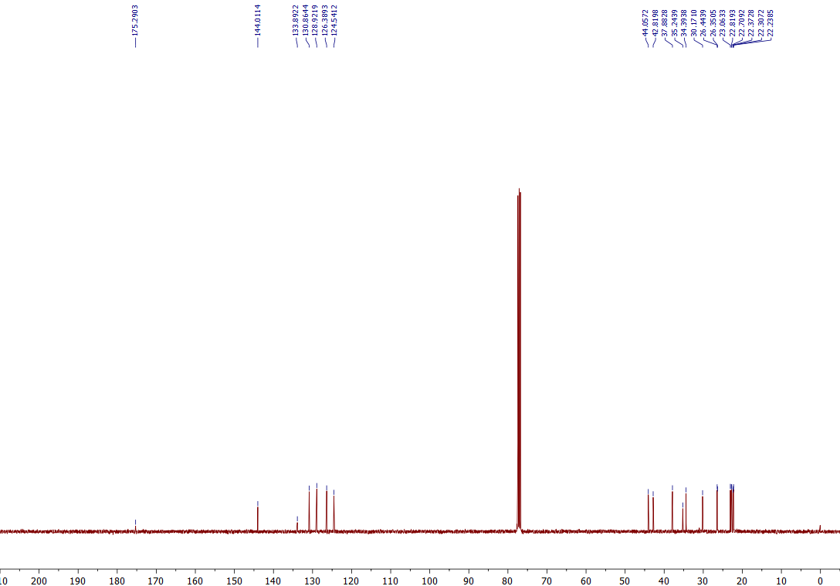
¹³C NMR of the 5s (101 MHz, CDCl₃)
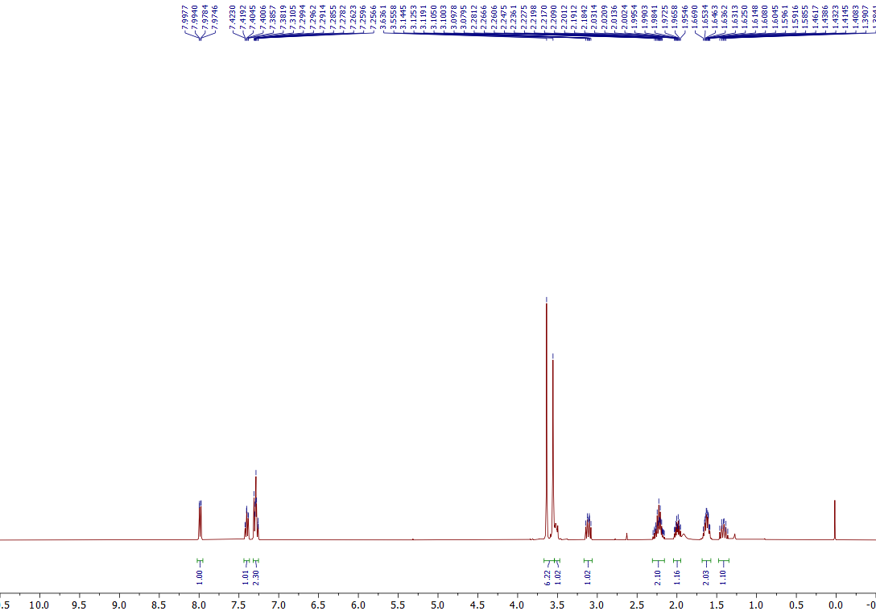
¹H NMR of the 5t (400 MHz, CDCl₃)
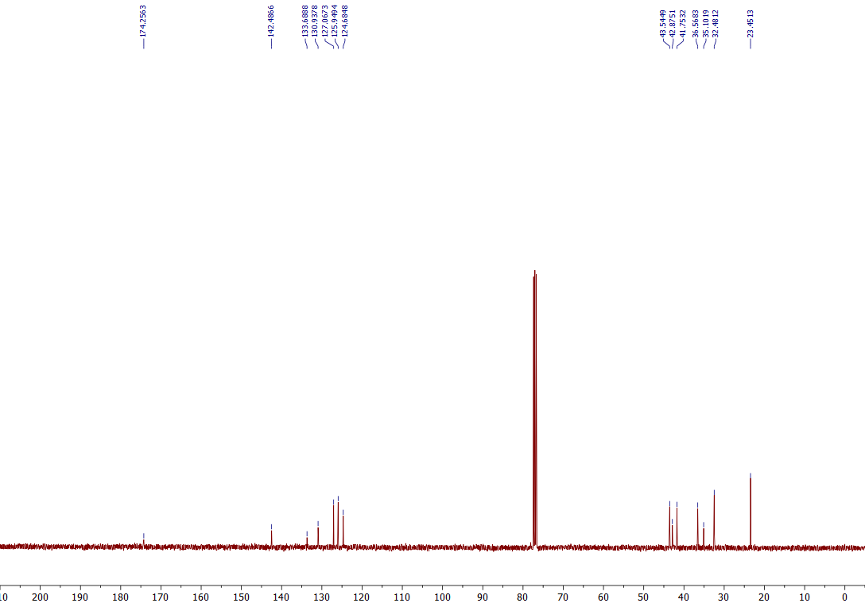
¹³C NMR of the 5t (101 MHz, CDCl₃)
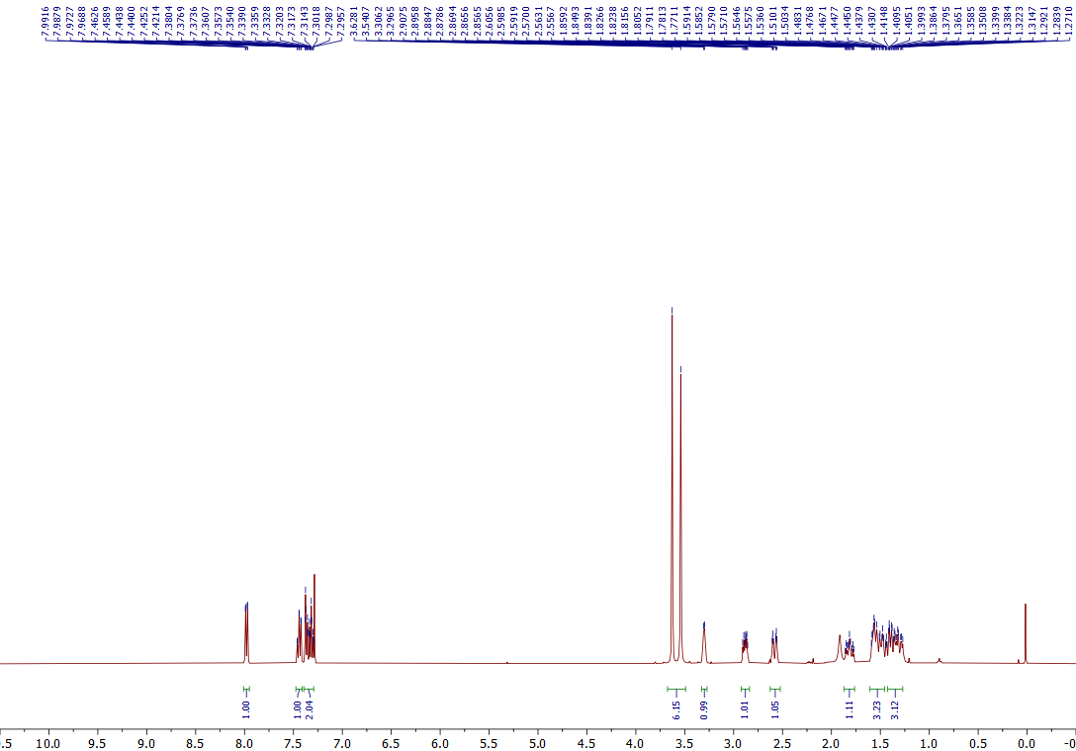
¹H NMR of the 5u (400 MHz, CDCl₃)
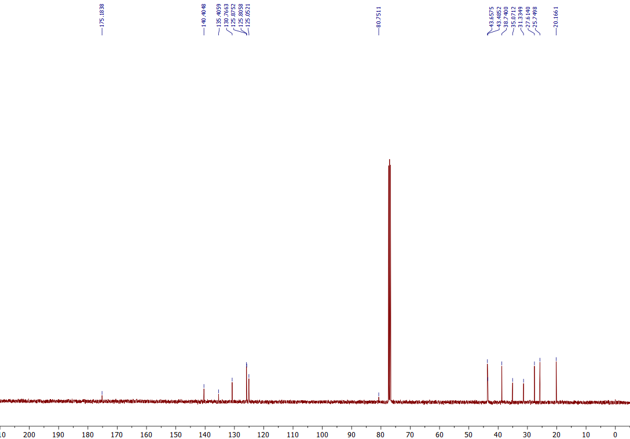
¹³C NMR of the 5u (101 MHz, CDCl₃)

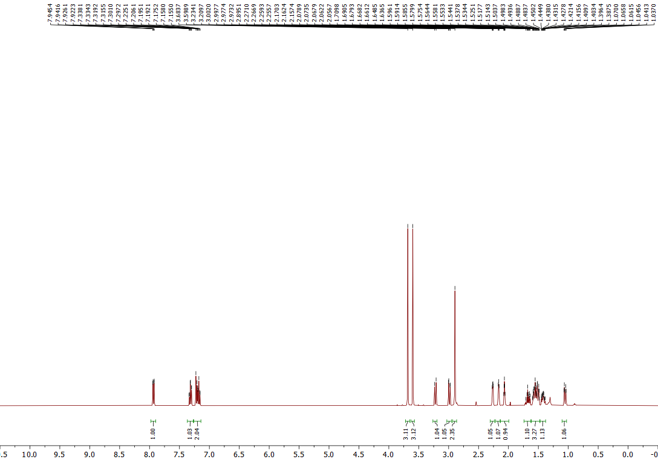
¹H NMR of the 5v (400 MHz, Acetone-d₆)
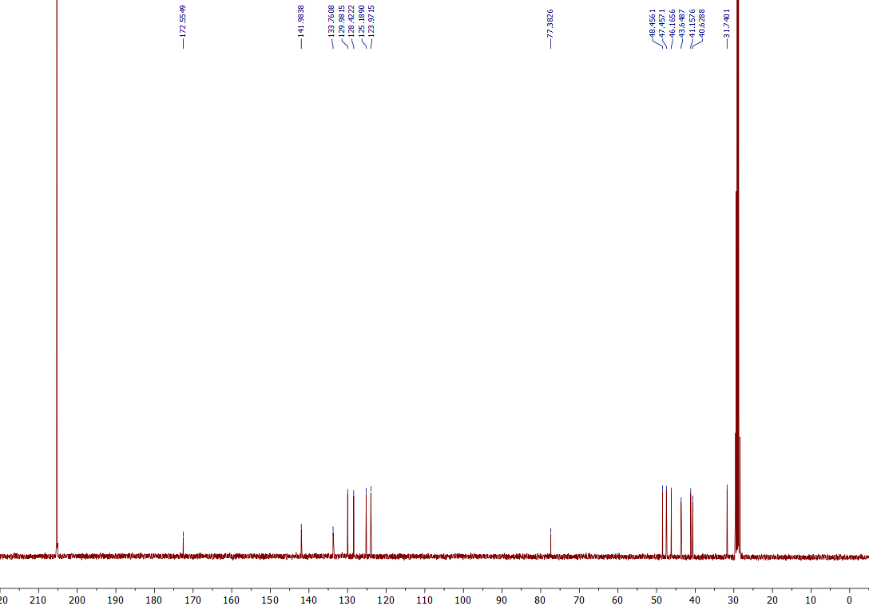
¹³C NMR of the 5v (101 MHz, Acetone-d₆)

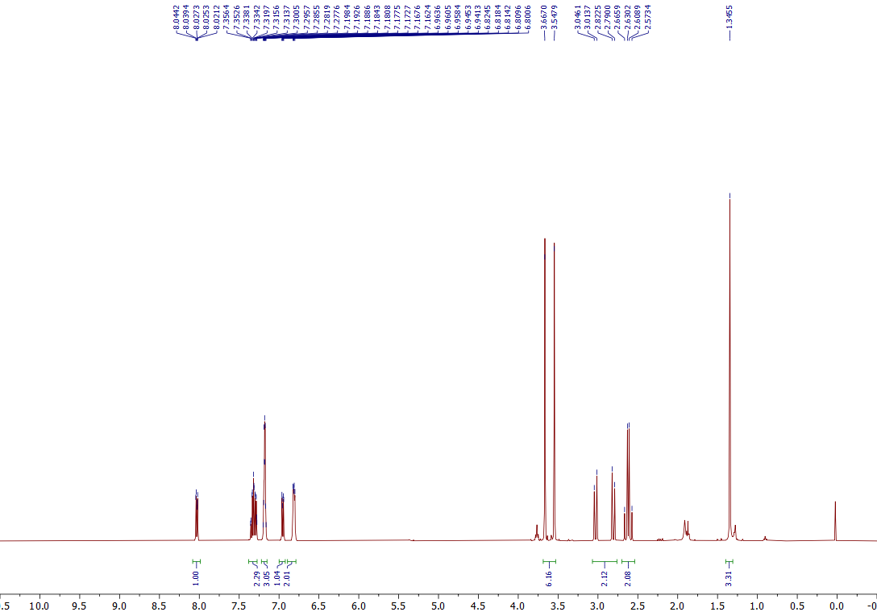
¹H NMR of the 5w (400 MHz, CDCl₃)
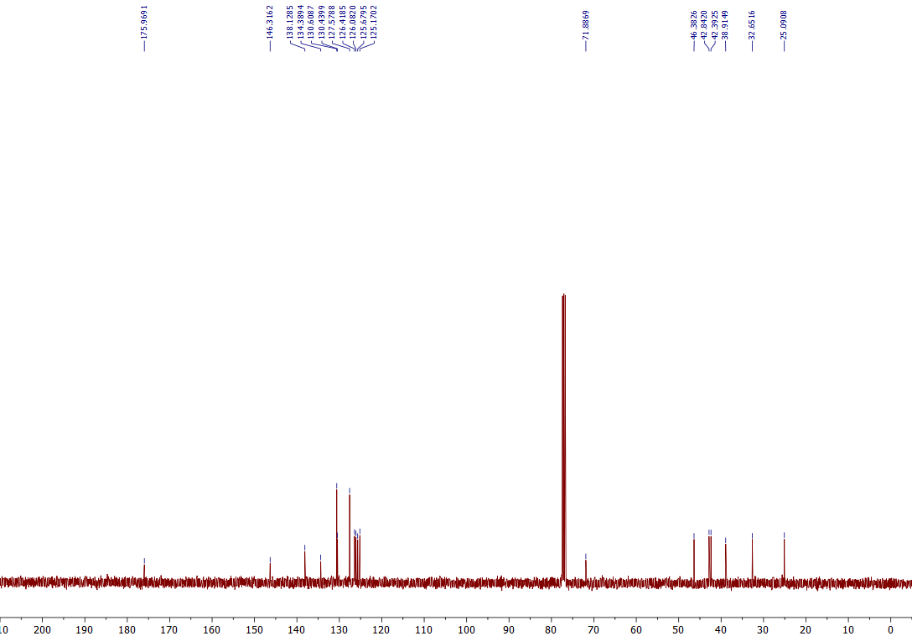
¹³C NMR of the 5w (101 MHz, CDCl₃)

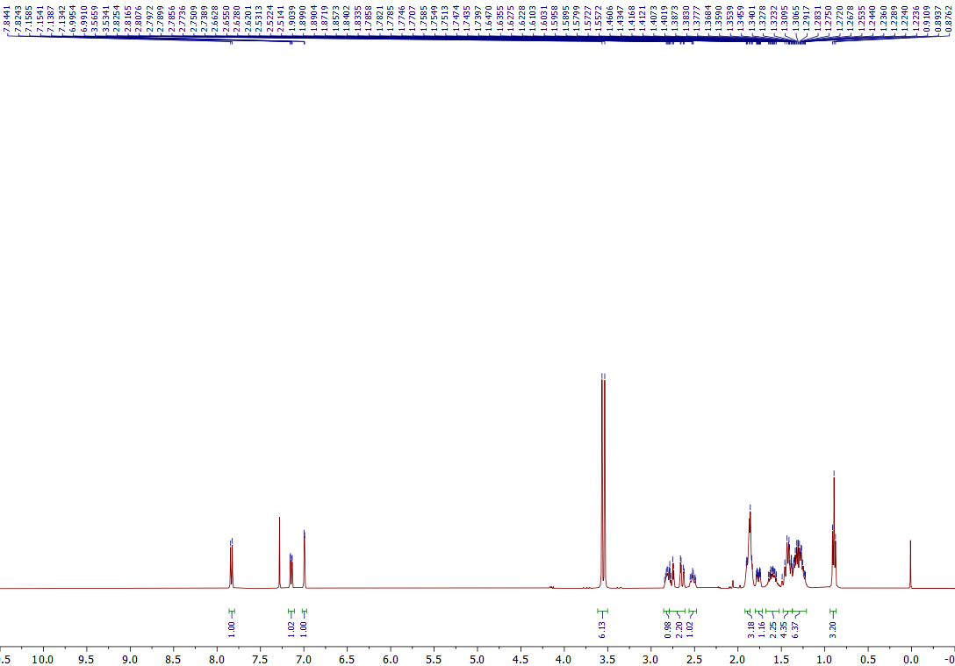
¹H NMR of the 5x (400 MHz, CDCl₃)
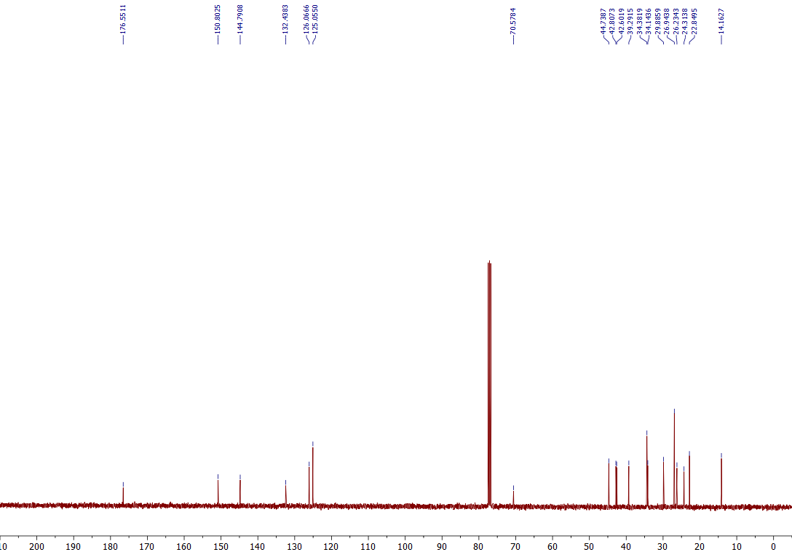
¹³C NMR of the 5x (101 MHz, CDCl₃)

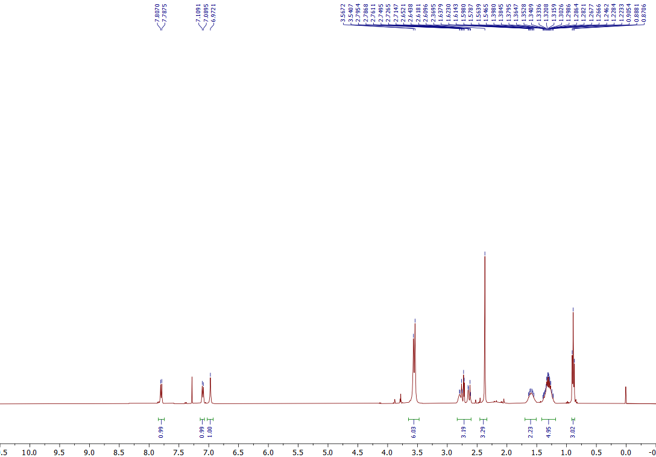
¹H NMR of the 5y (400 MHz, CDCl₃)
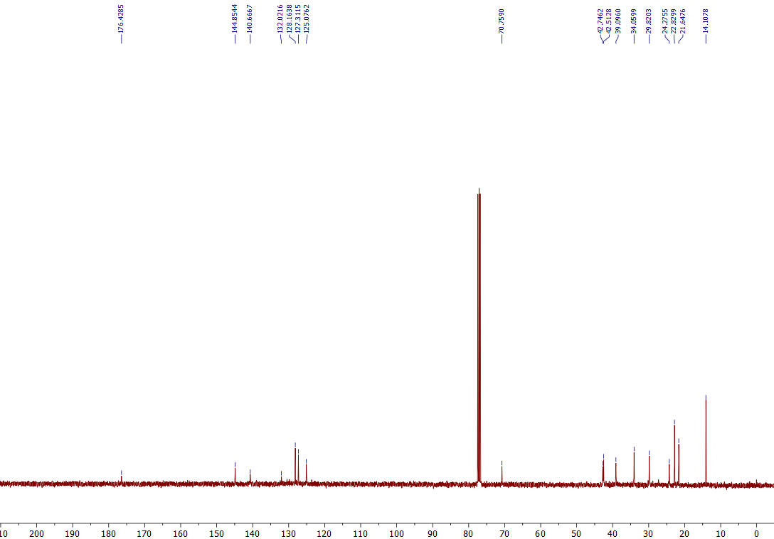
¹³C NMR of the 5y (101 MHz, CDCl₃)

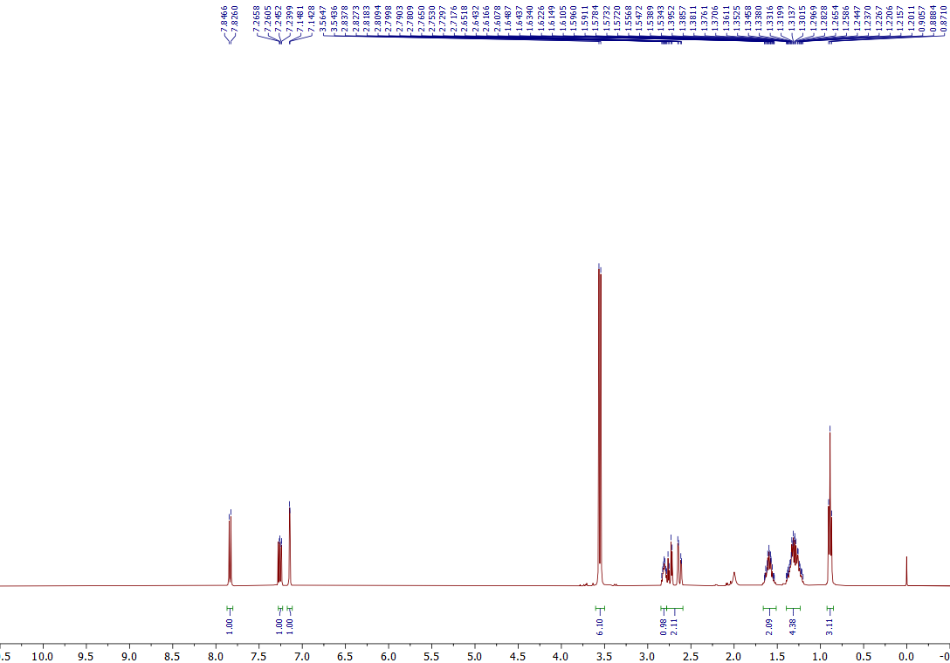
¹H NMR of the 5z (400 MHz, CDCl₃)
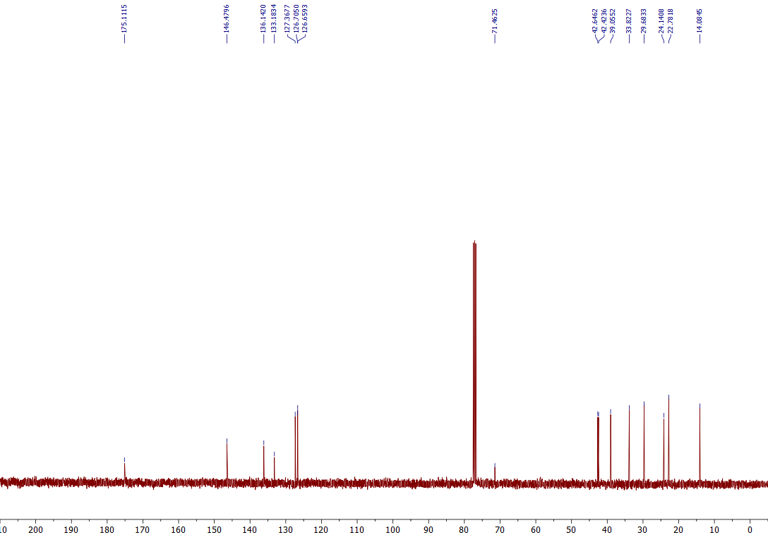
¹³C NMR of the 5z (101 MHz, CDCl₃)

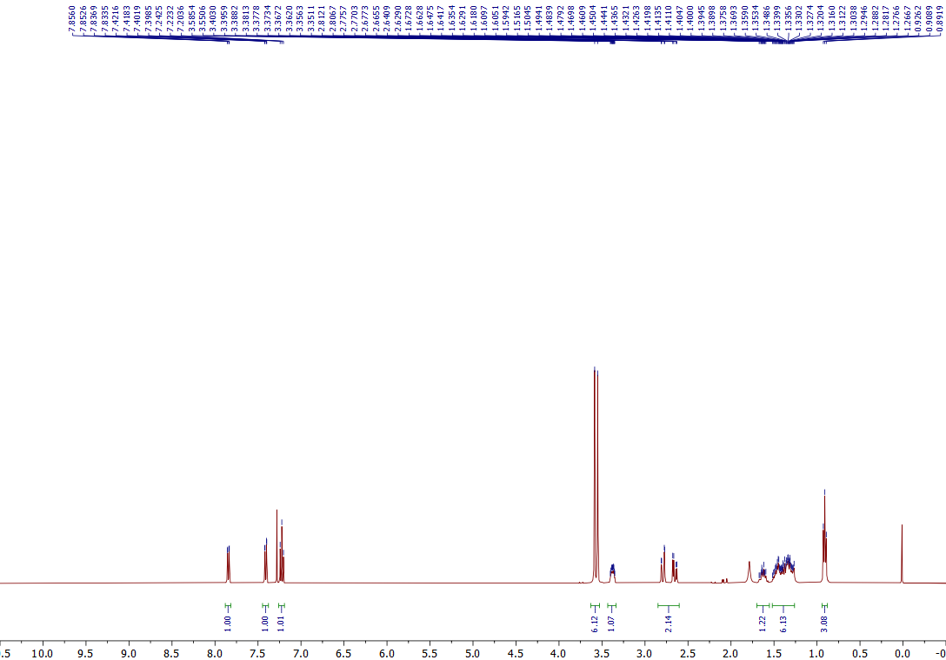
¹H NMR of the 5aa (400 MHz, CDCl₃)
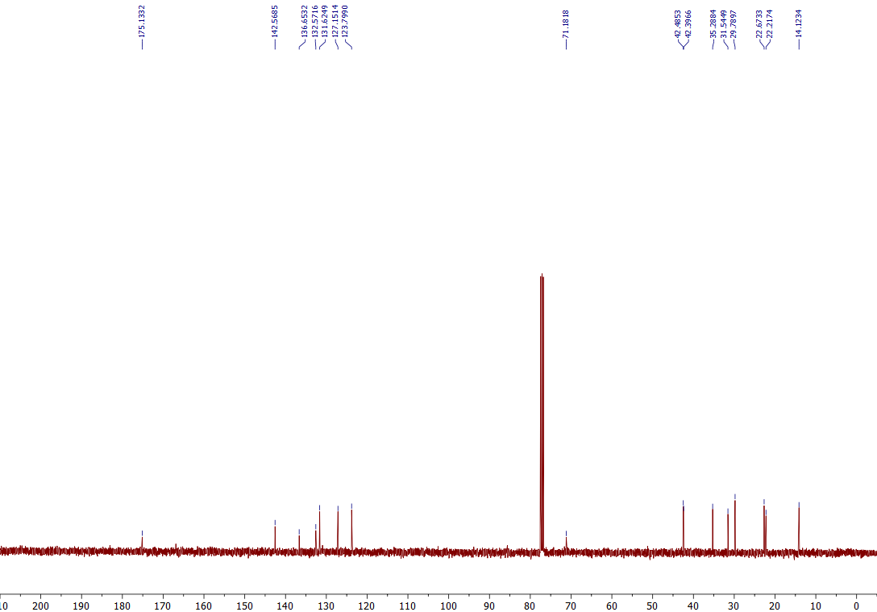
¹³C NMR of the 5aa (101 MHz, CDCl₃)
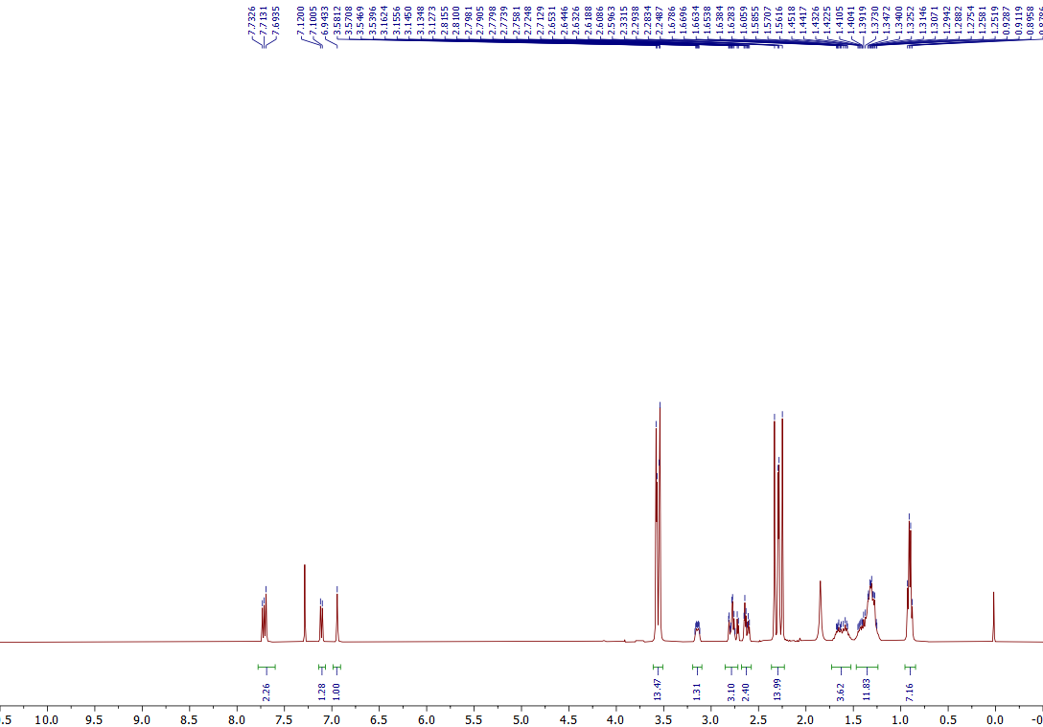
¹H NMR of the 5ab (400 MHz, CDCl₃)
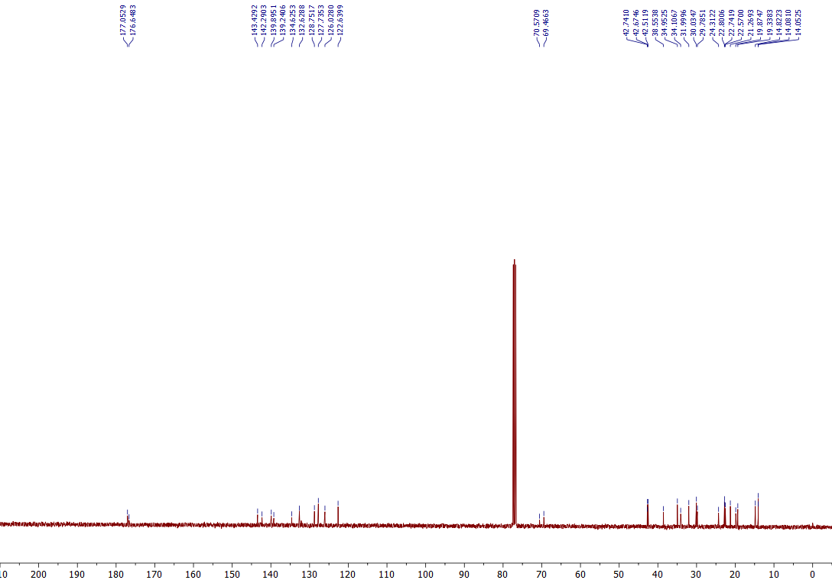
¹³C NMR of the 5ab (101 MHz, CDCl₃)

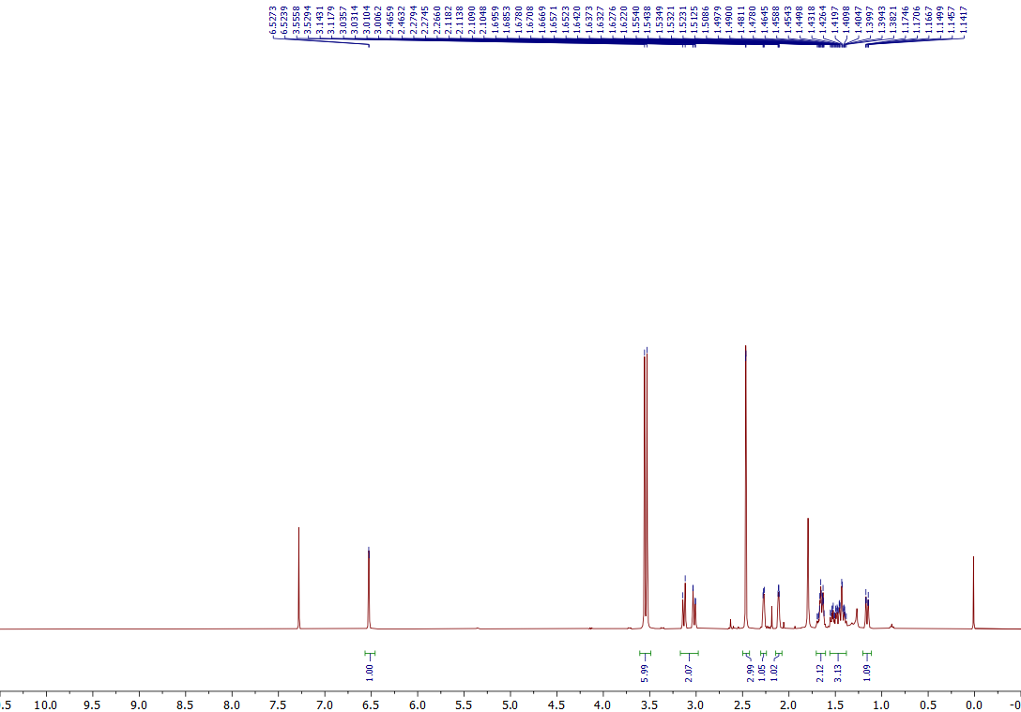
¹H NMR of the 5ac (400 MHz, CDCl₃)
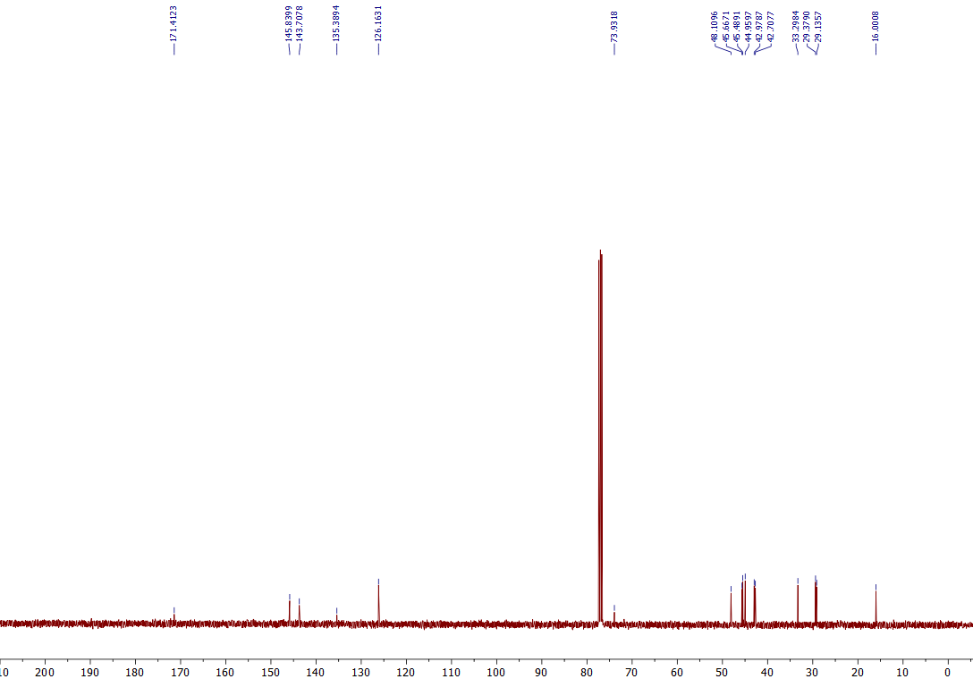
¹³C NMR of the 5ac (101 MHz, CDCl₃)

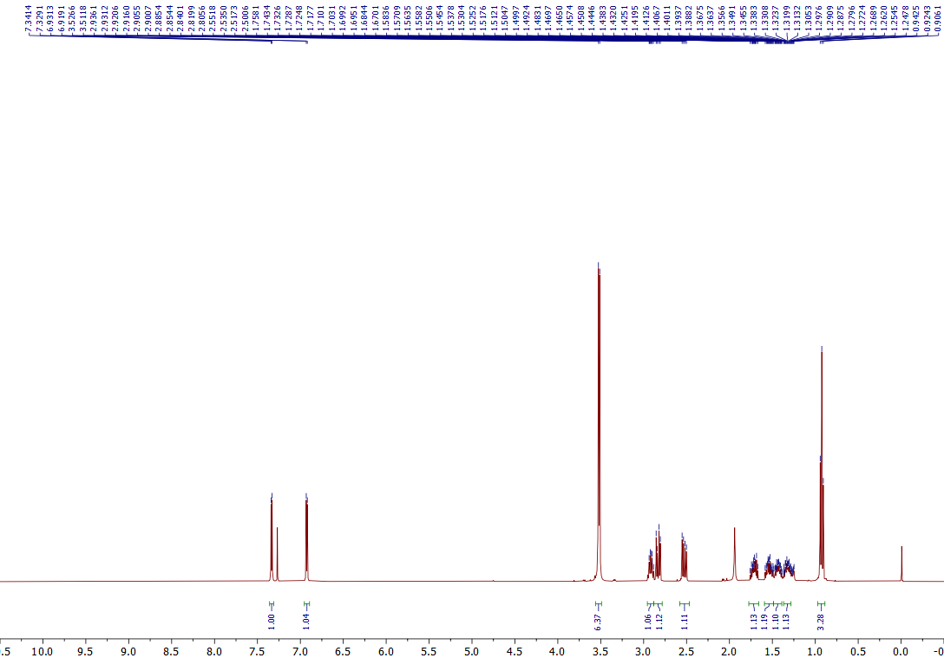
¹H NMR of the 5ad (400 MHz, CDCl₃)

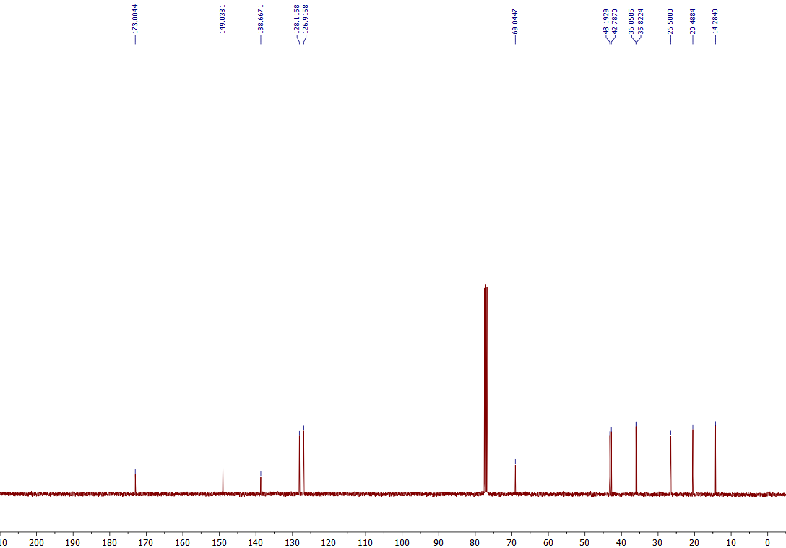
¹³C NMR of the 5ad (101 MHz, CDCl₃)
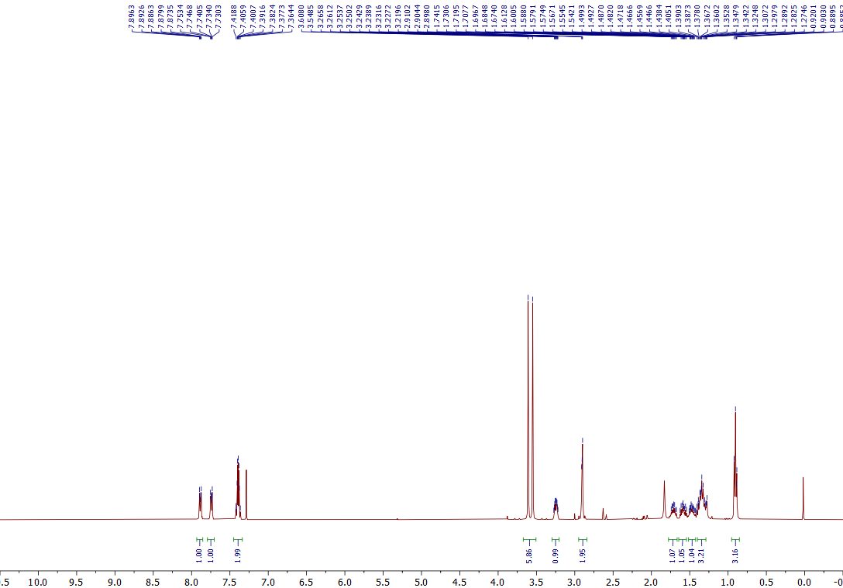
¹H NMR of the 5ae (400 MHz, CDCl₃)
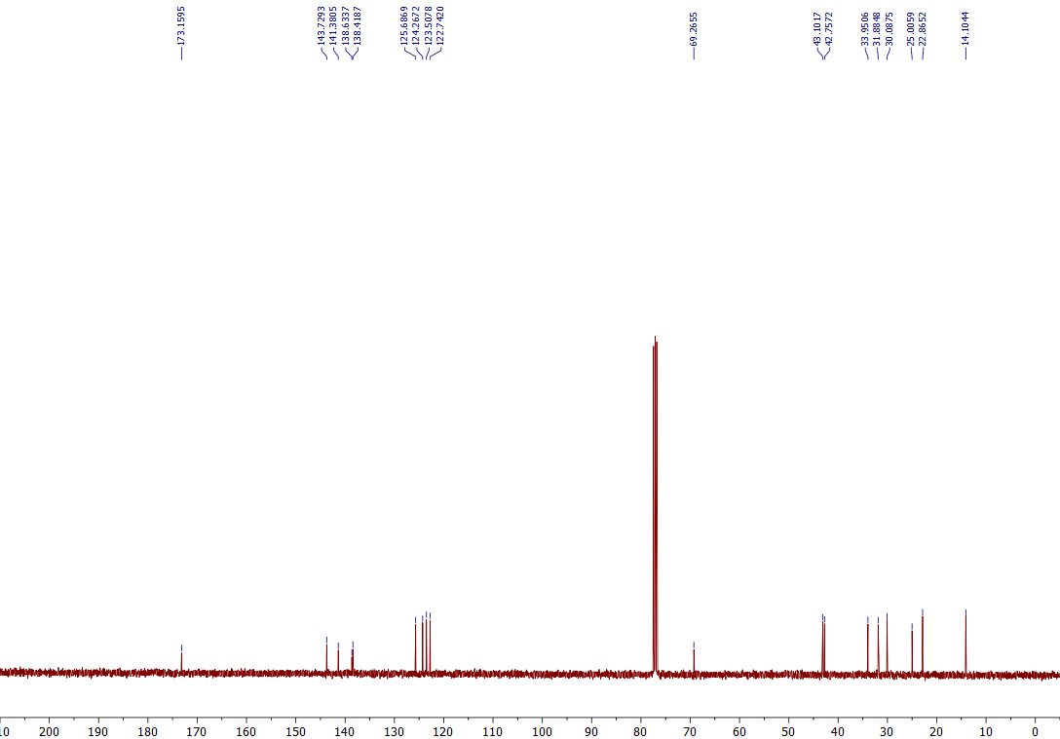
¹³C NMR of the 5ae (101 MHz, CDCl₃)

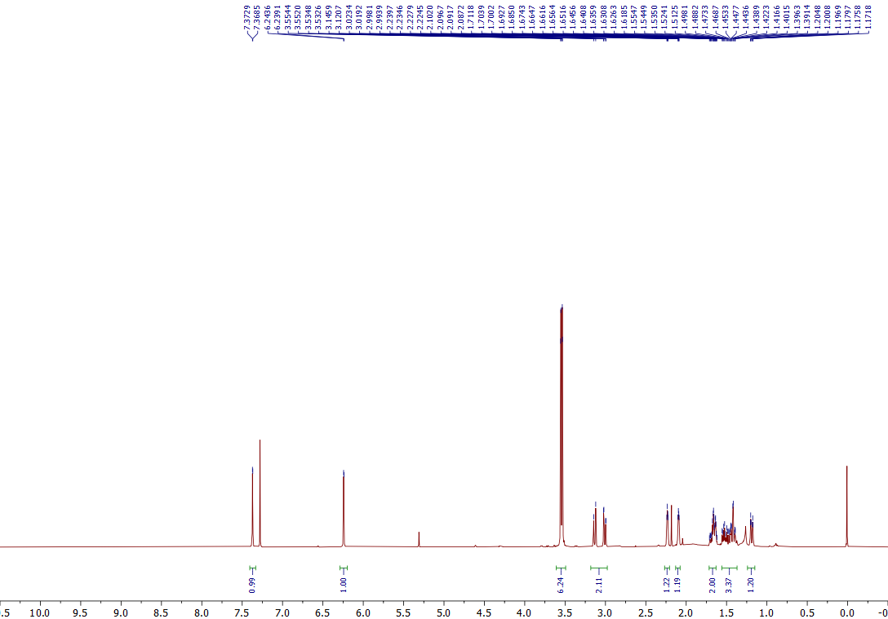
¹H NMR of the 5af (400 MHz, CDCl₃)
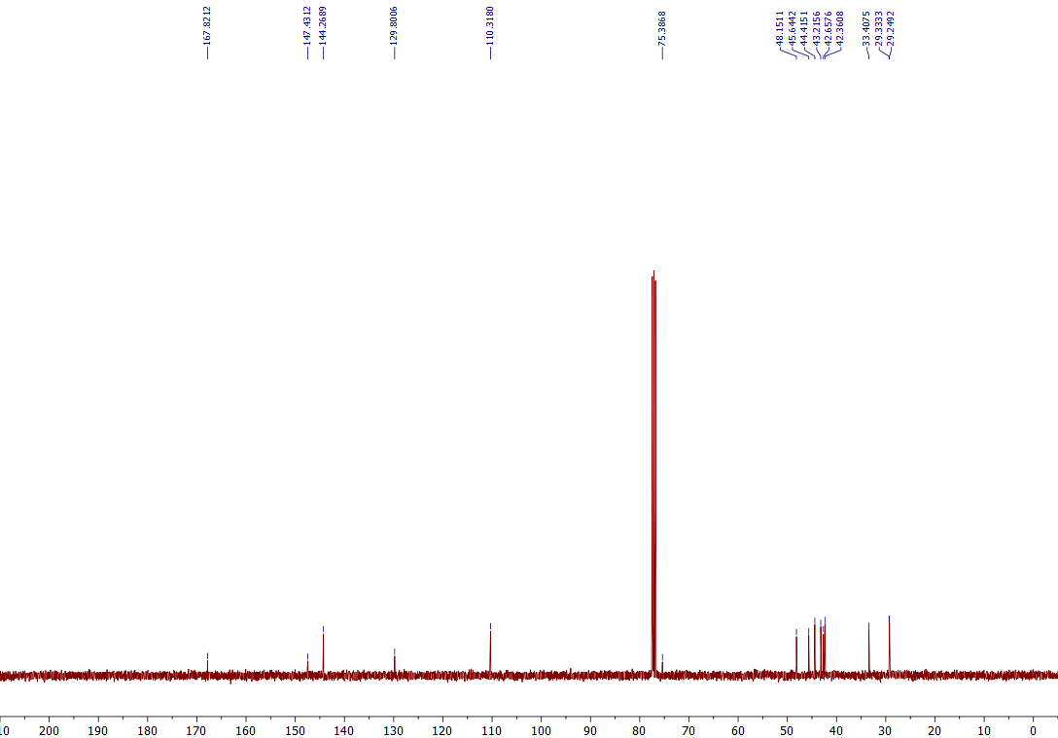
¹³C NMR of the 5af (101 MHz, CDCl₃)

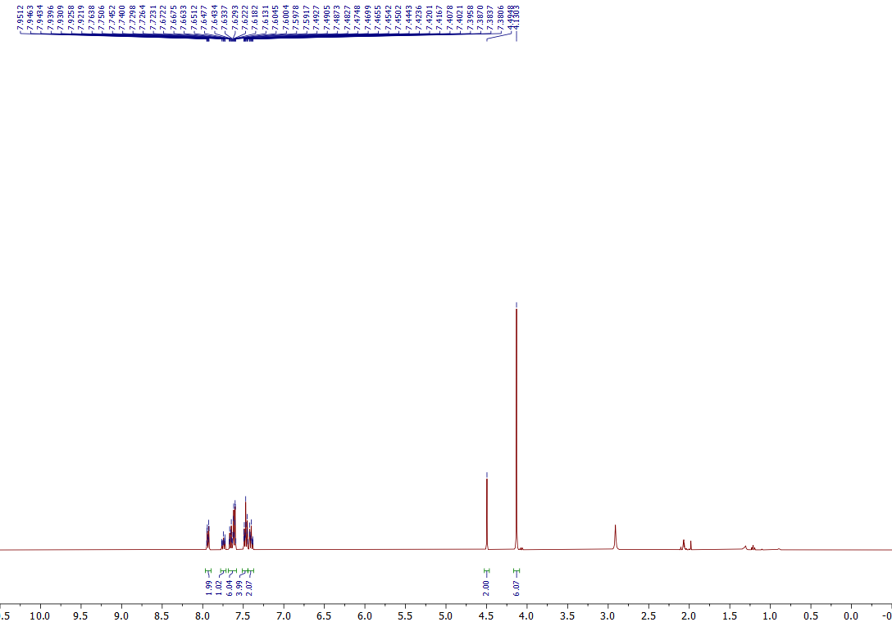
¹H NMR of the 7a (400 MHz, Acetone-d₆)
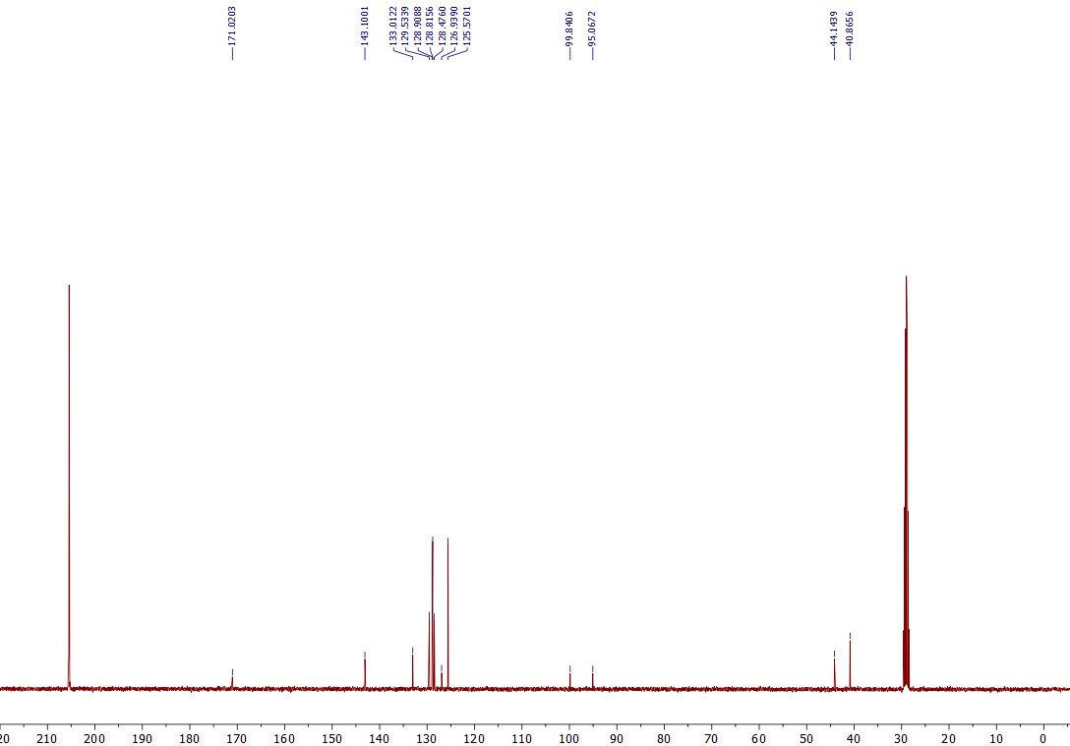
¹³C NMR of the 7a (101 MHz, Acetone-d₆)

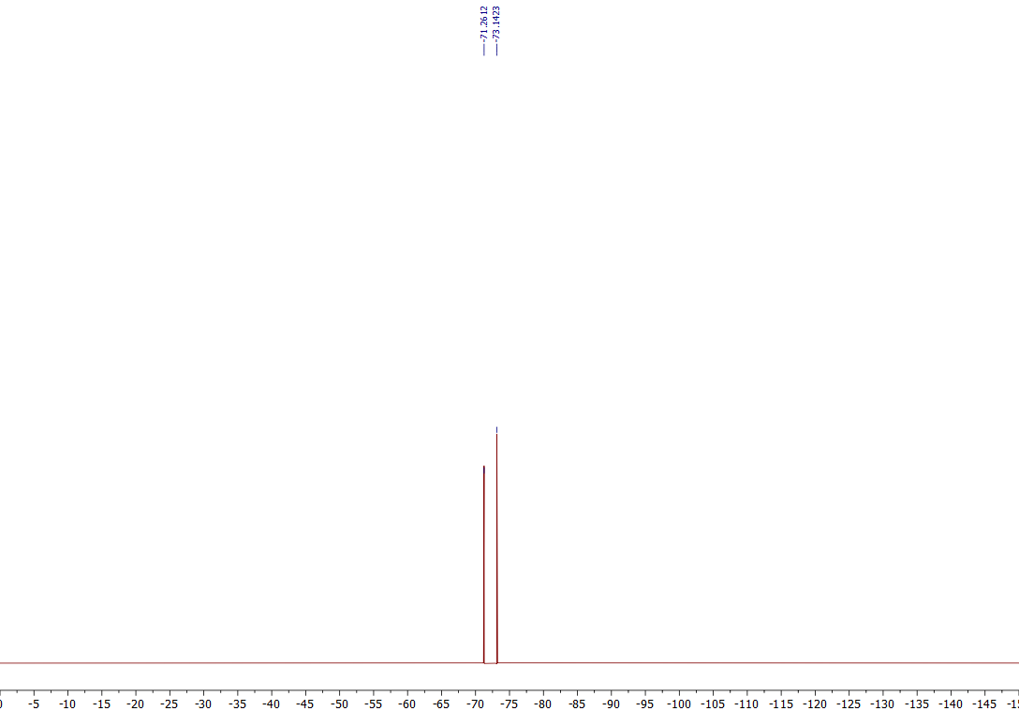
¹⁹F NMR of the 7a (376 MHz, Acetone-d₆)
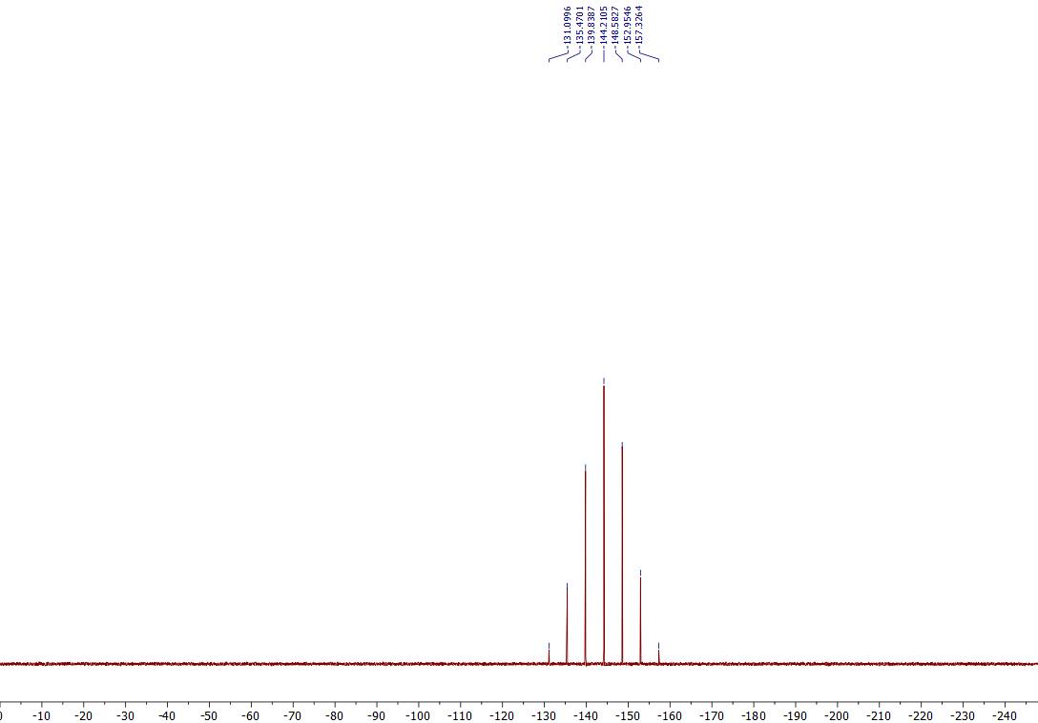
³¹P NMR of the 7a (162 MHz, Acetone-d₆)

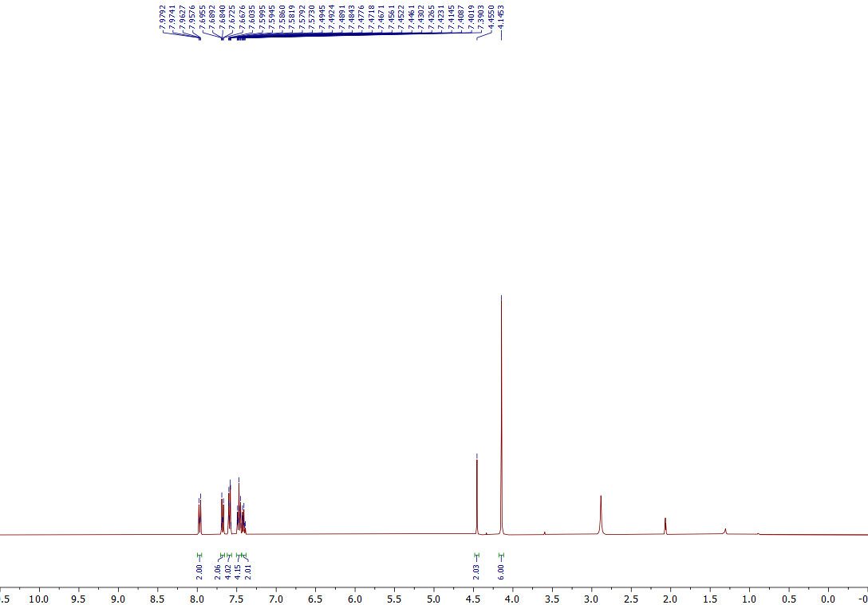
¹H NMR of the 7b (400 MHz, Acetone-d₆)

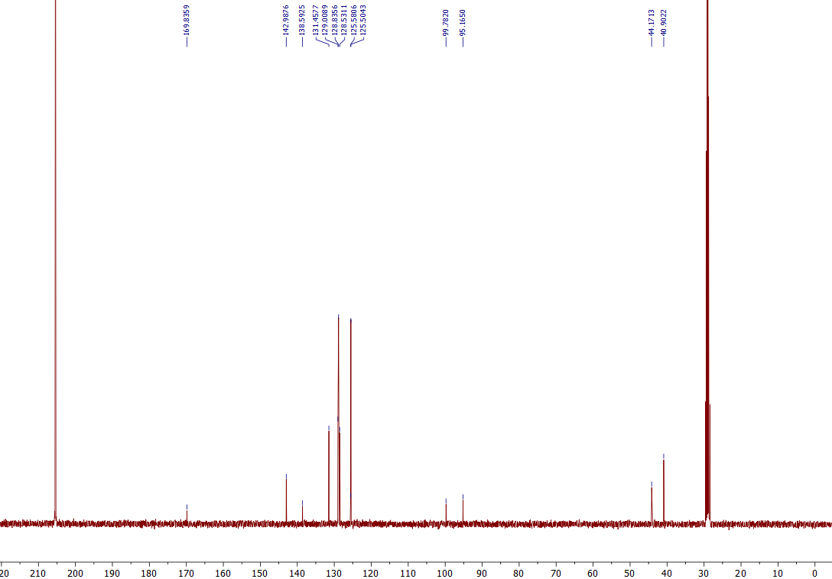
¹³C NMR of the 7b (101 MHz, Acetone-d₆)

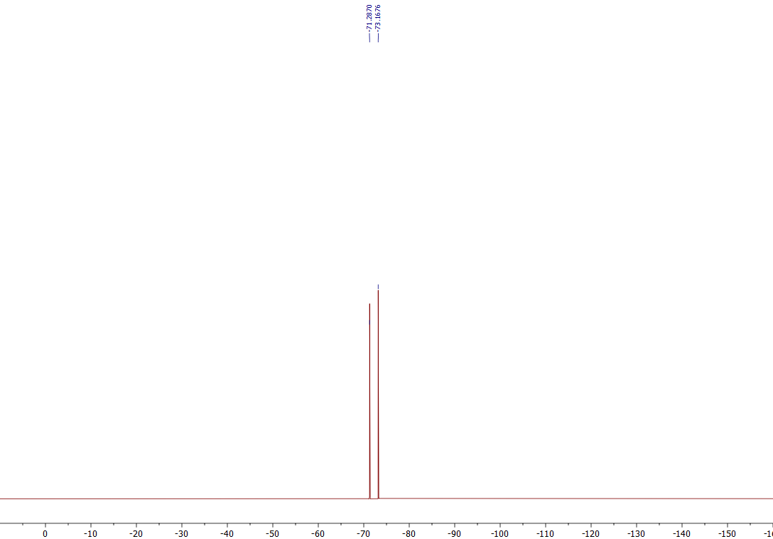
¹⁹F NMR of the 7b (376 MHz, Acetone-d₆)
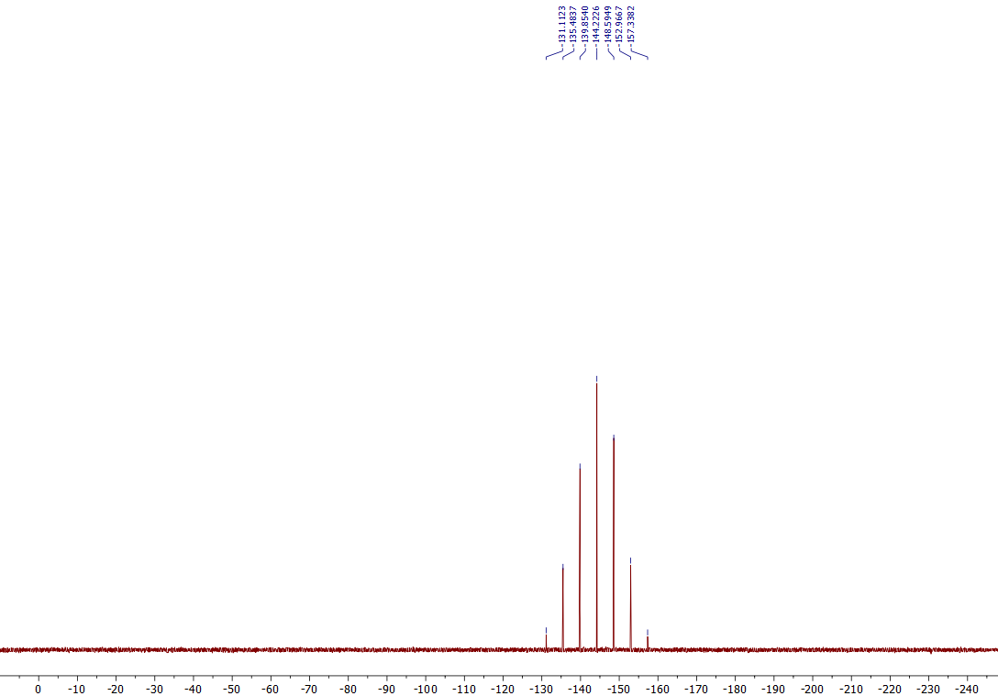
³¹P NMR of the 7b (162 MHz, Acetone-d₆)

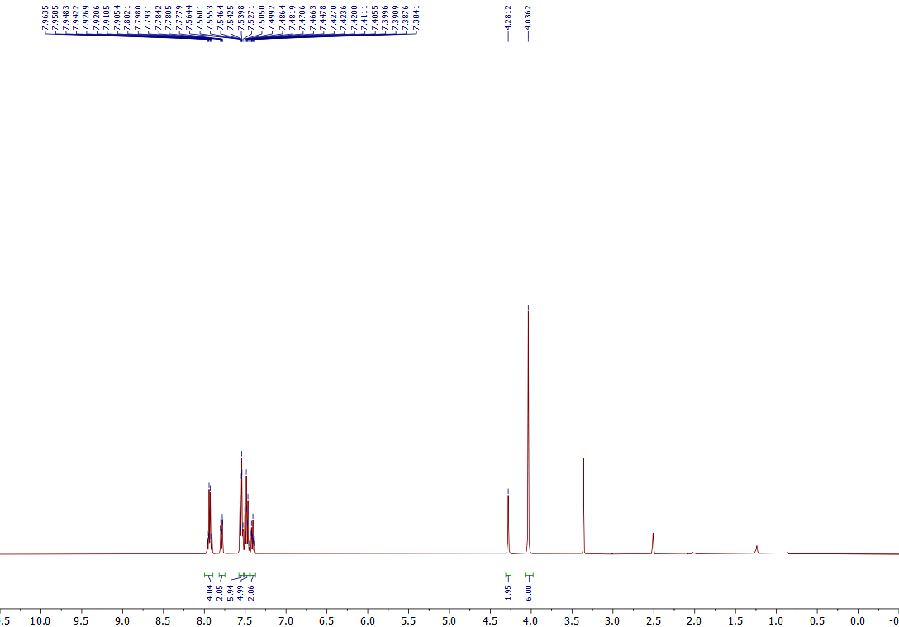
¹H NMR of the 7c (400 MHz, DMSO-d₆)
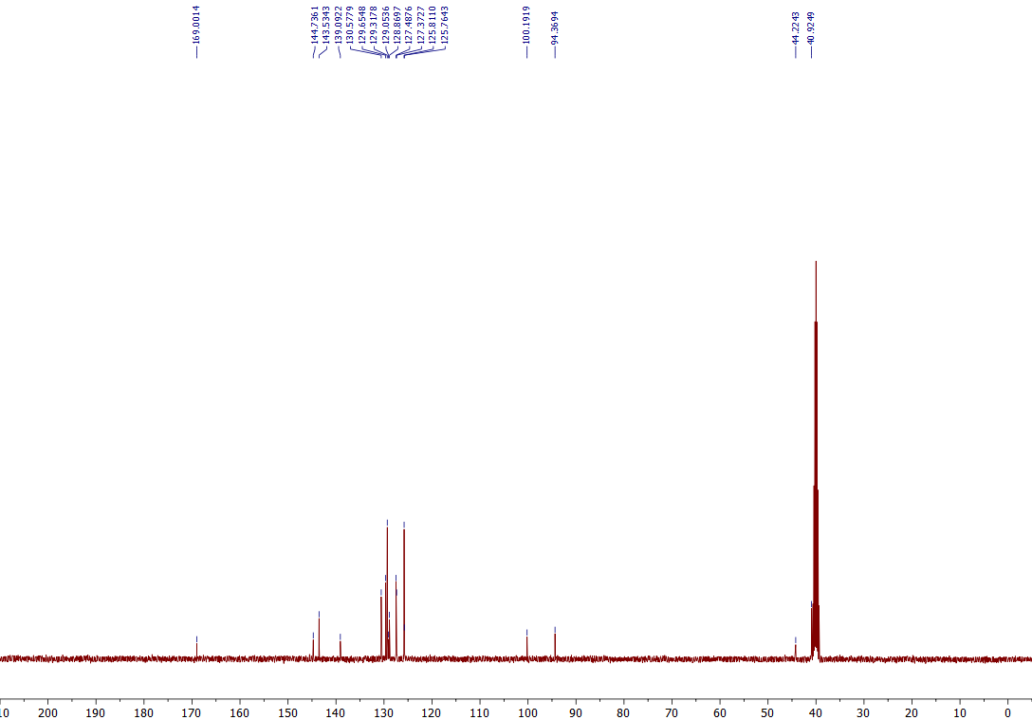
¹³C NMR of the 7c (101 MHz, DMSO-d₆)

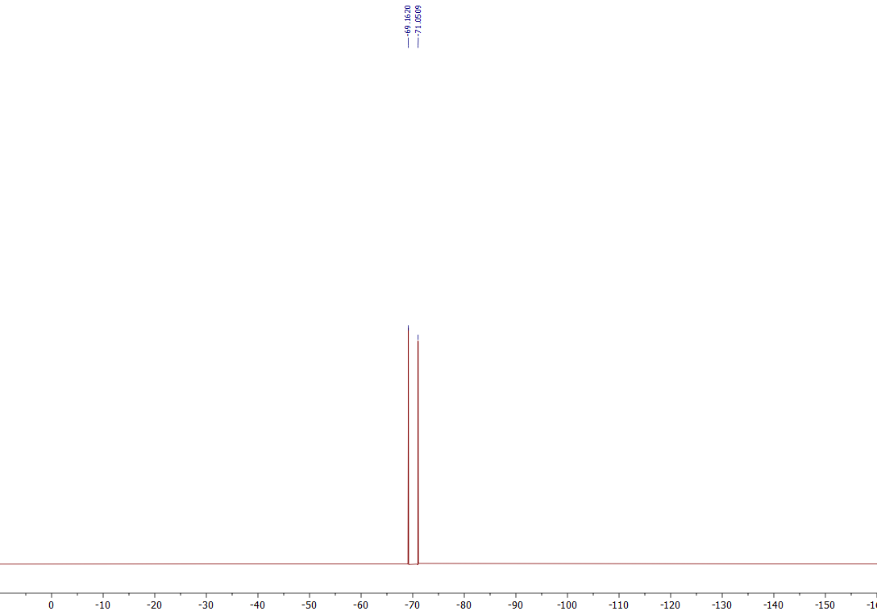
¹⁹F NMR of the 7c (376 MHz, DMSO-d₆)
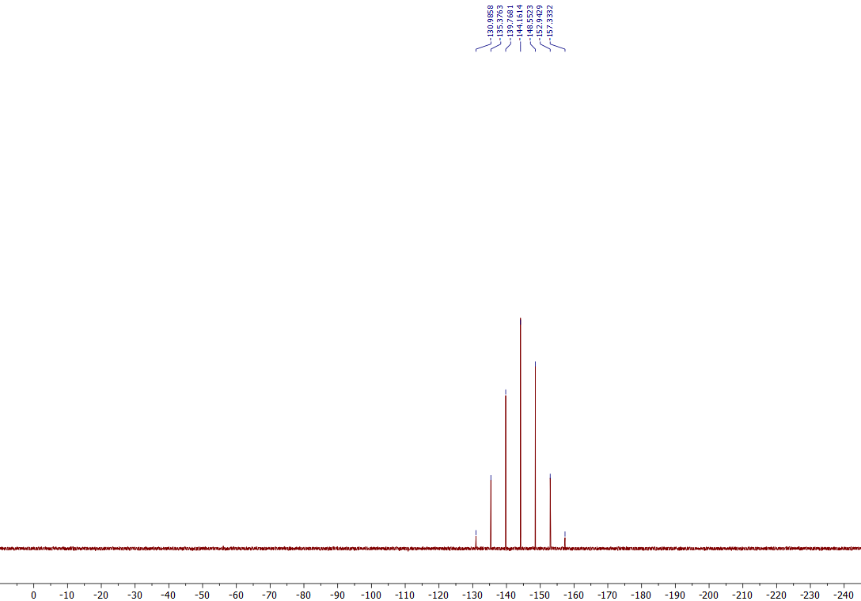

³¹P NMR of the 7c (162 MHz, DMSO-d₆)

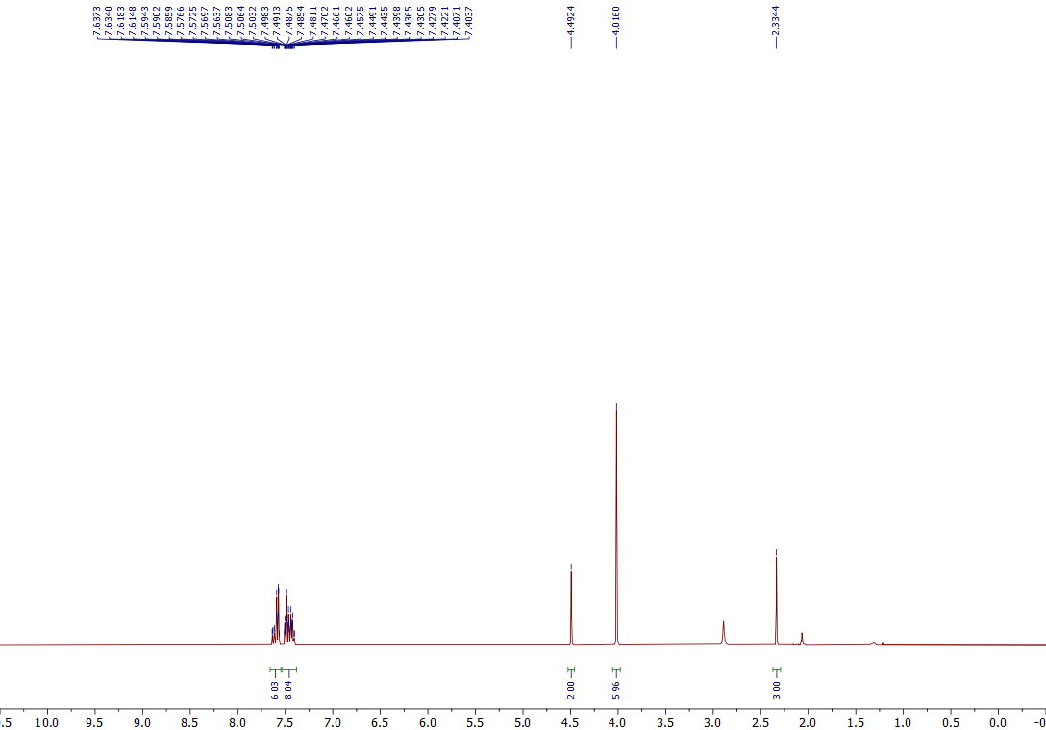
¹H NMR of the 7d (400 MHz, Acetone-d₆)
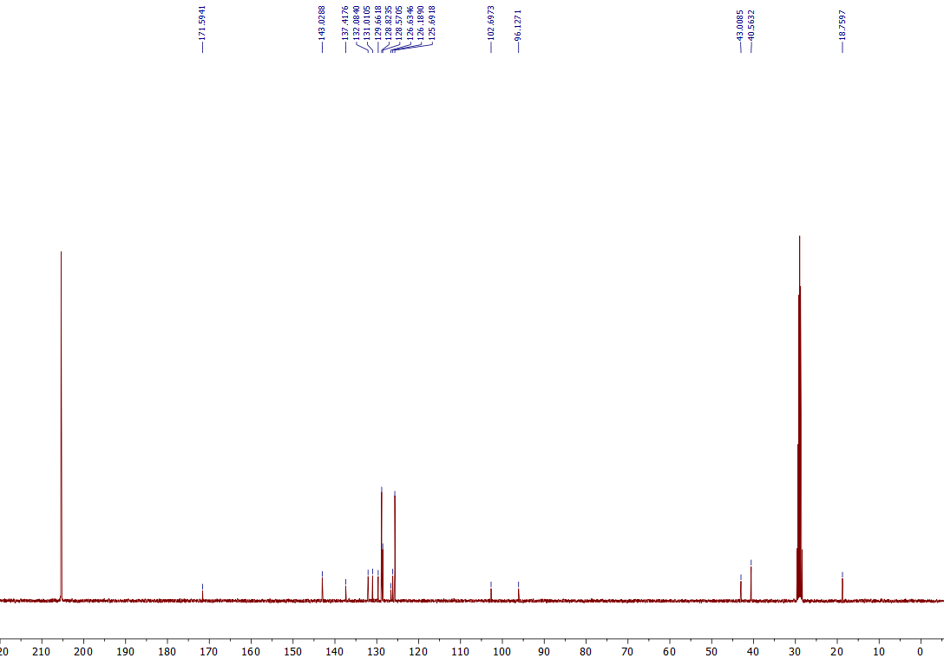
¹³C NMR of the 7d (101 MHz, Acetone-d₆)

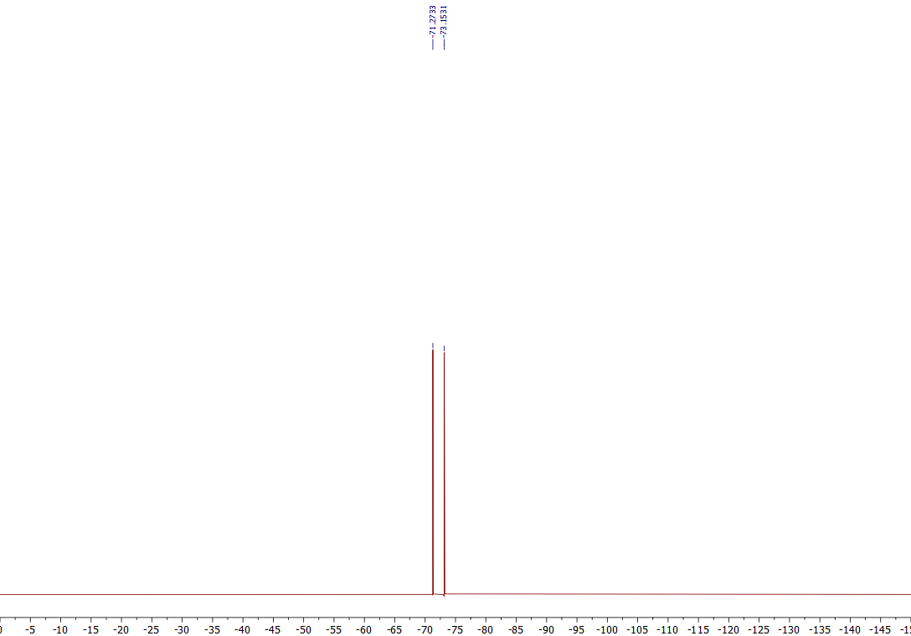
¹⁹F NMR of the 7d (376 MHz, Acetone-d₆)
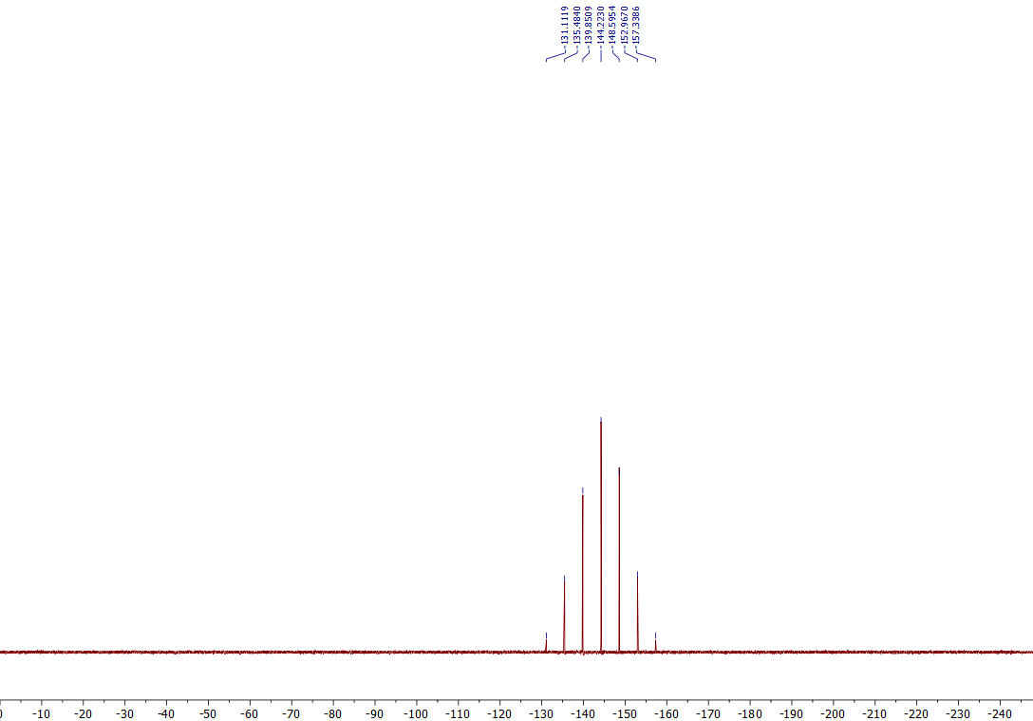
³¹P NMR of the 7d (162 MHz, Acetone-d₆)

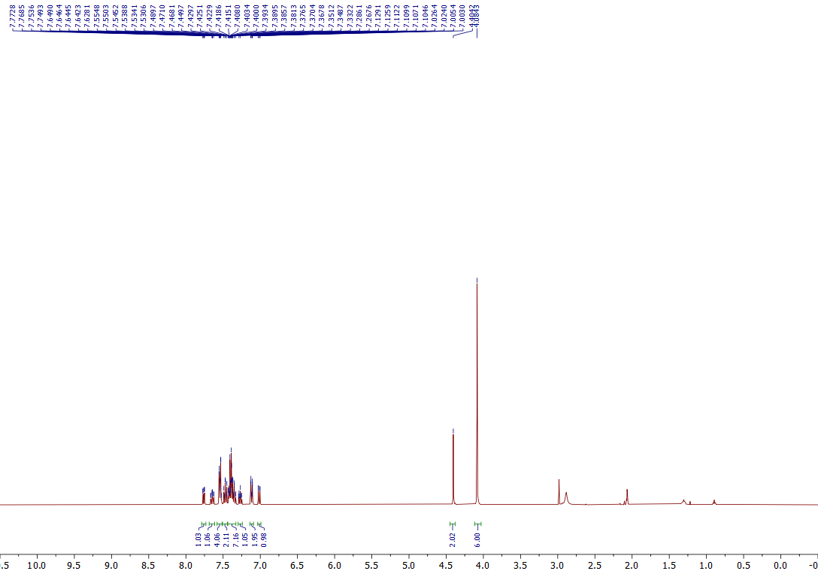
¹H NMR of the 7e (400 MHz, Acetone-d₆)
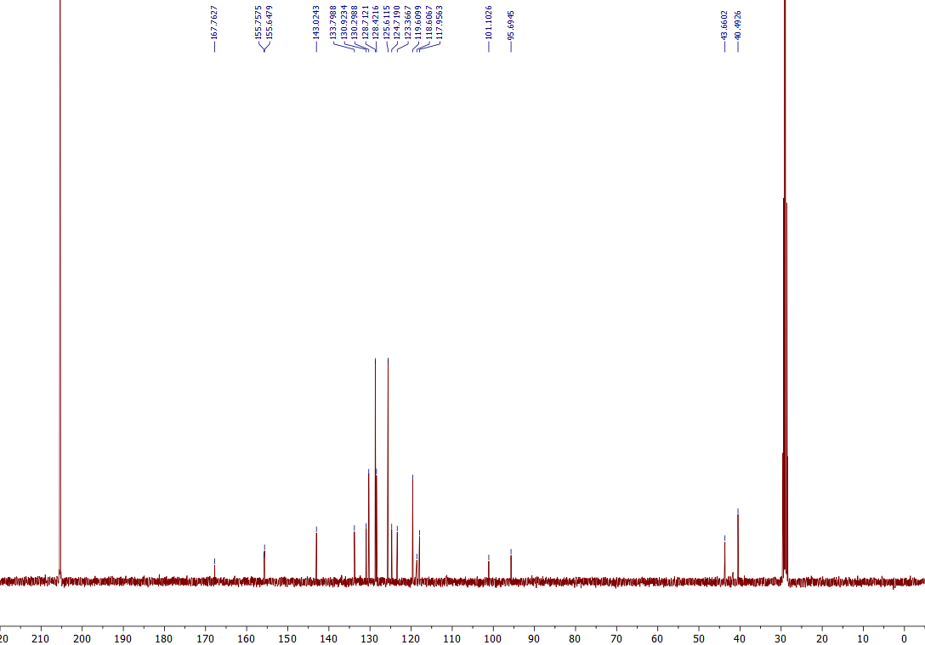
¹³C NMR of the 7e (101 MHz, Acetone-d₆)

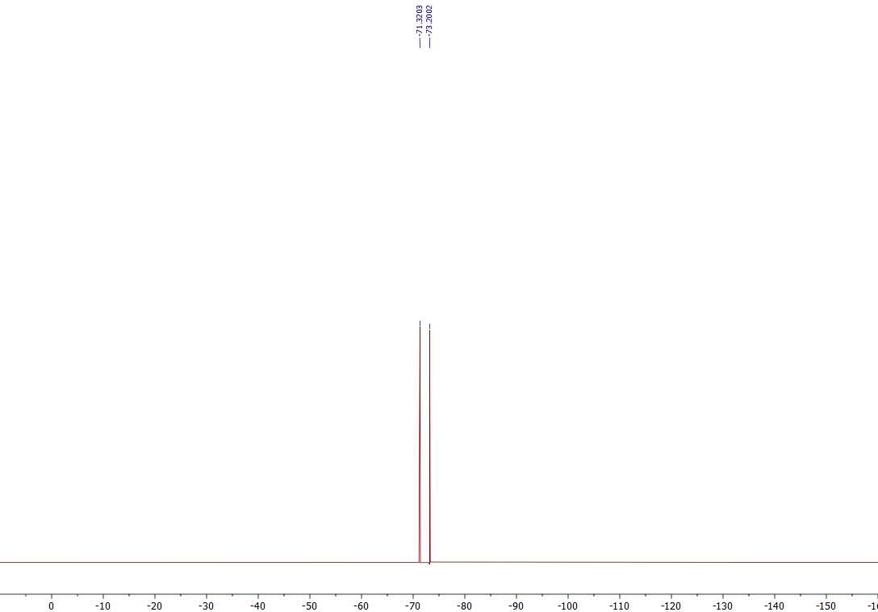
¹⁹F NMR of the 7e (376 MHz, Acetone-d₆)

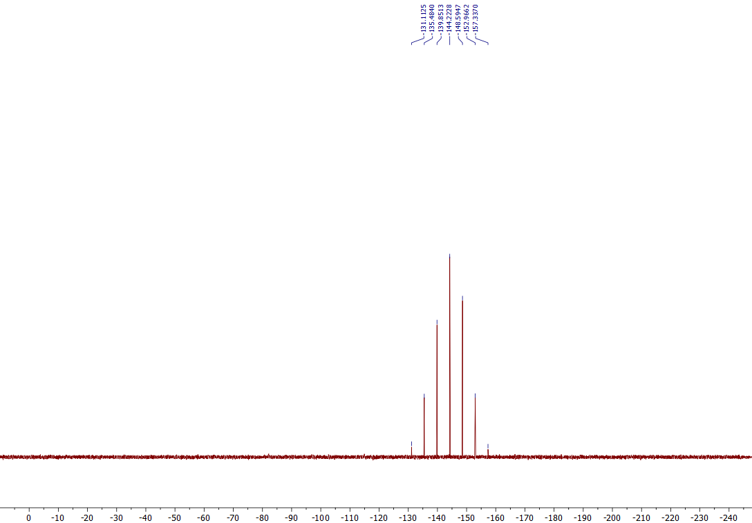
³¹P NMR of the 7e (162 MHz, Acetone-d₆)

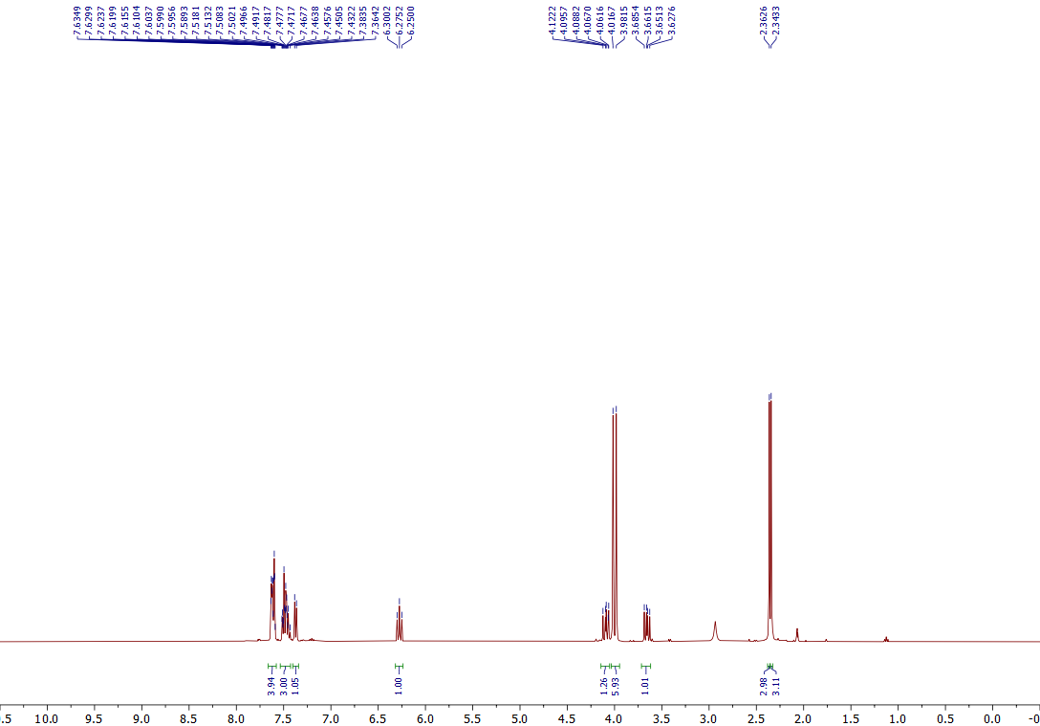
¹H NMR of the 7f (400 MHz, Acetone-d₆)
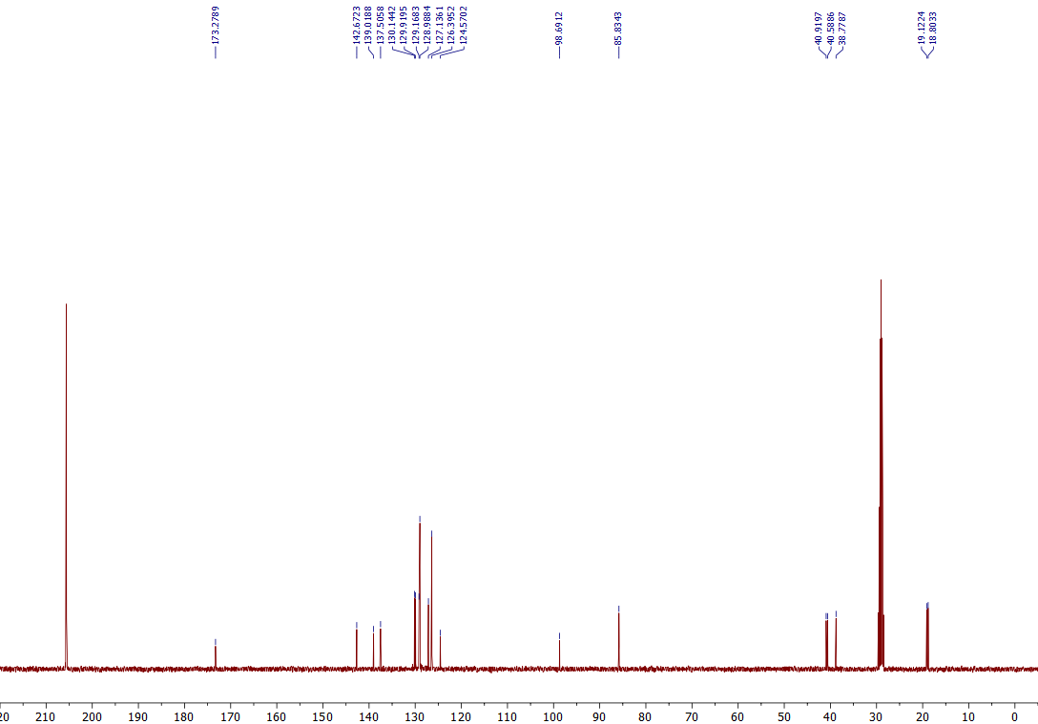
¹³C NMR of the 7f (101 MHz, Acetone-d₆)
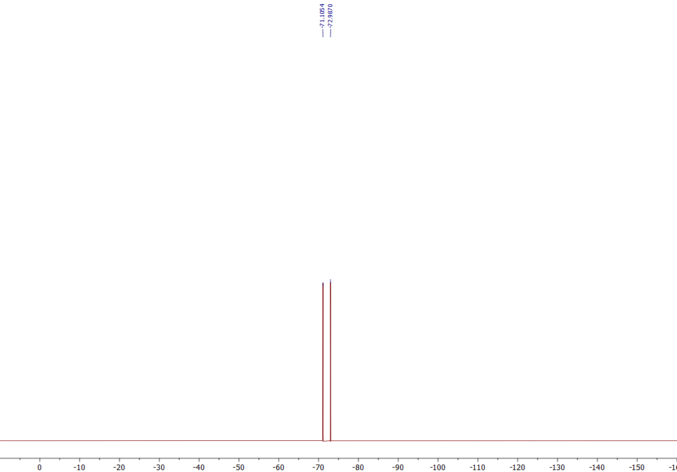
¹⁹F NMR of the 7f (376 MHz, Acetone-d₆)
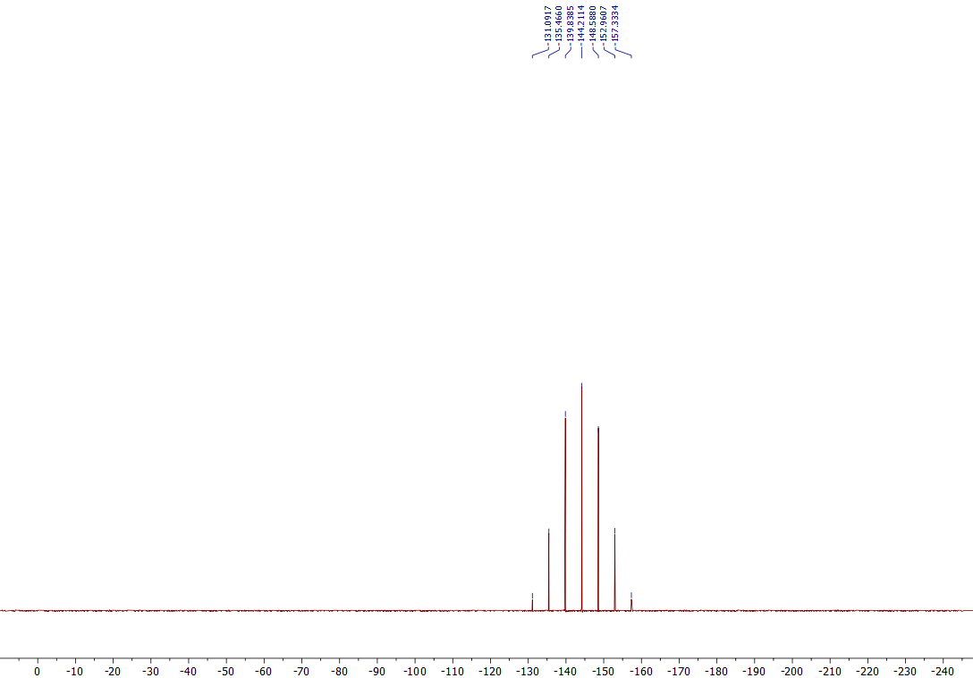
³¹P NMR of the 7f (162 MHz, Acetone-d₆)

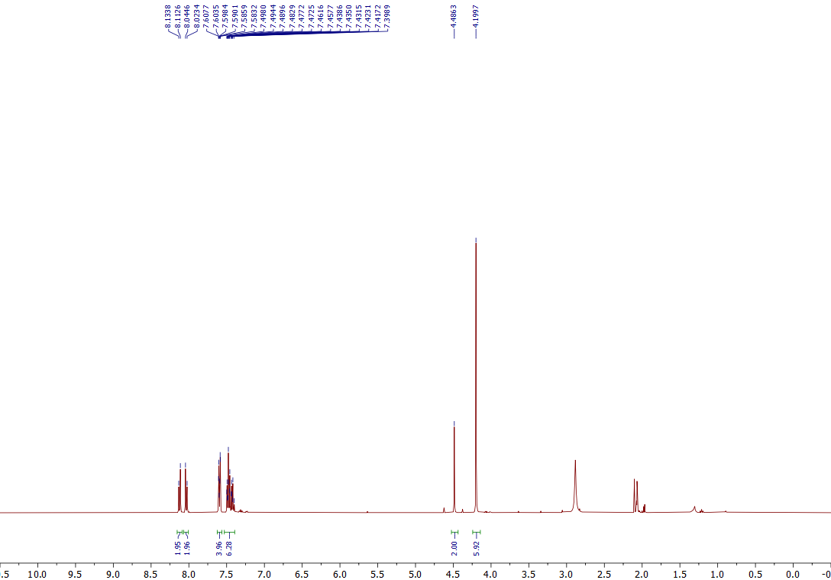
¹H NMR of the 7g (400 MHz, Acetone-d₆)
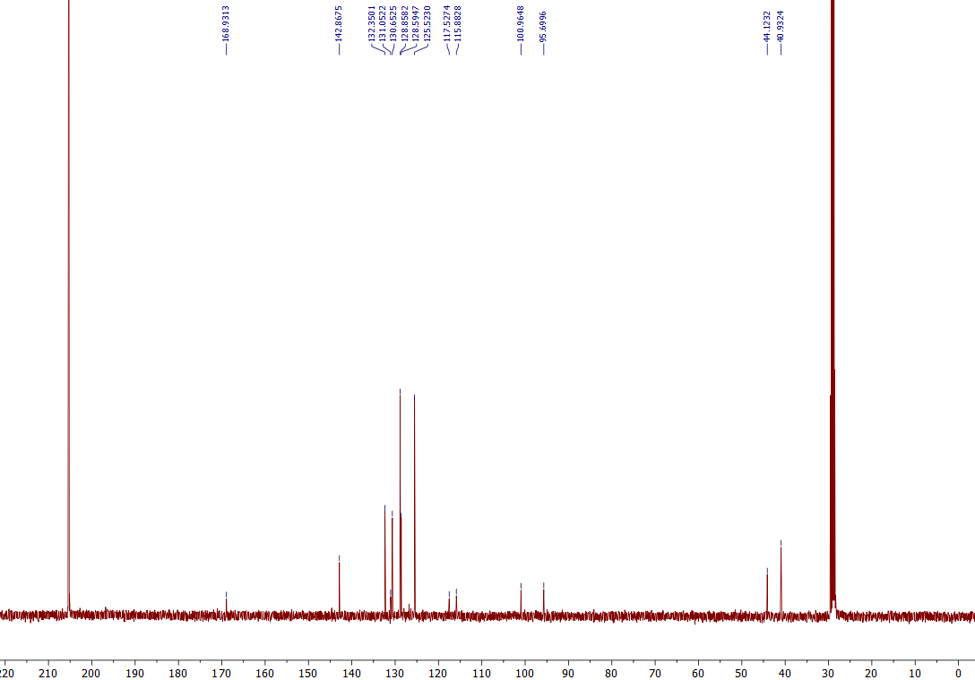
¹³C NMR of the 7g (101 MHz, Acetone-d₆)

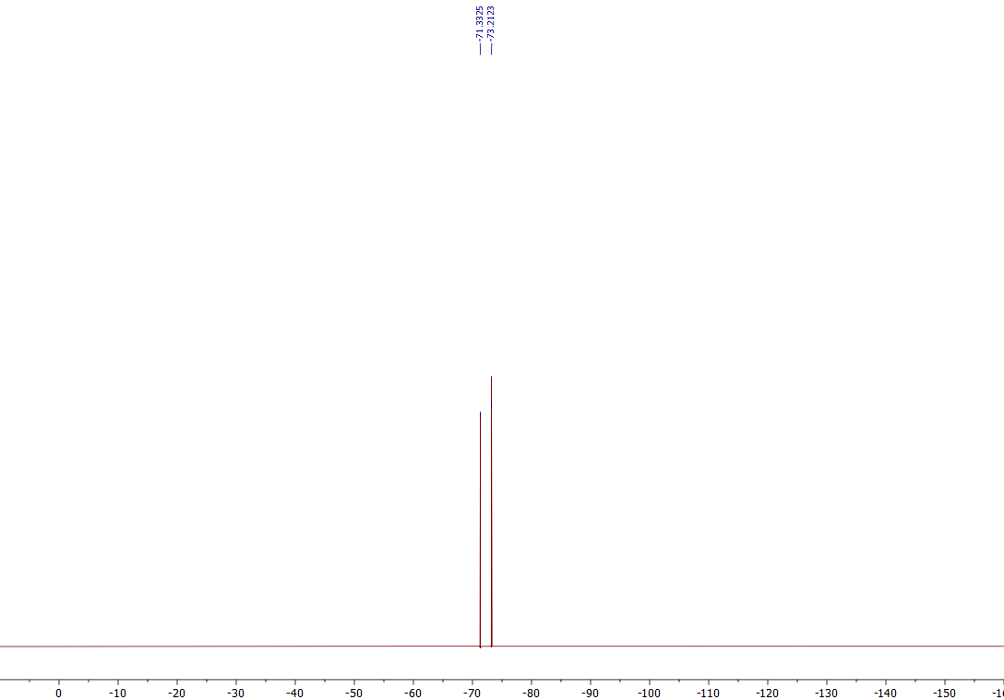
¹⁹F NMR of the 7g (376 MHz, Acetone-d₆)
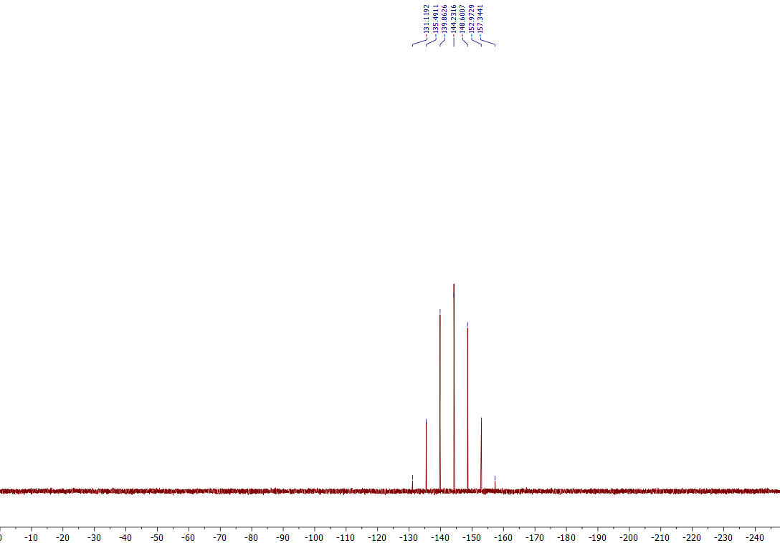
³¹P NMR of the 7g (162 MHz, Acetone-d₆)

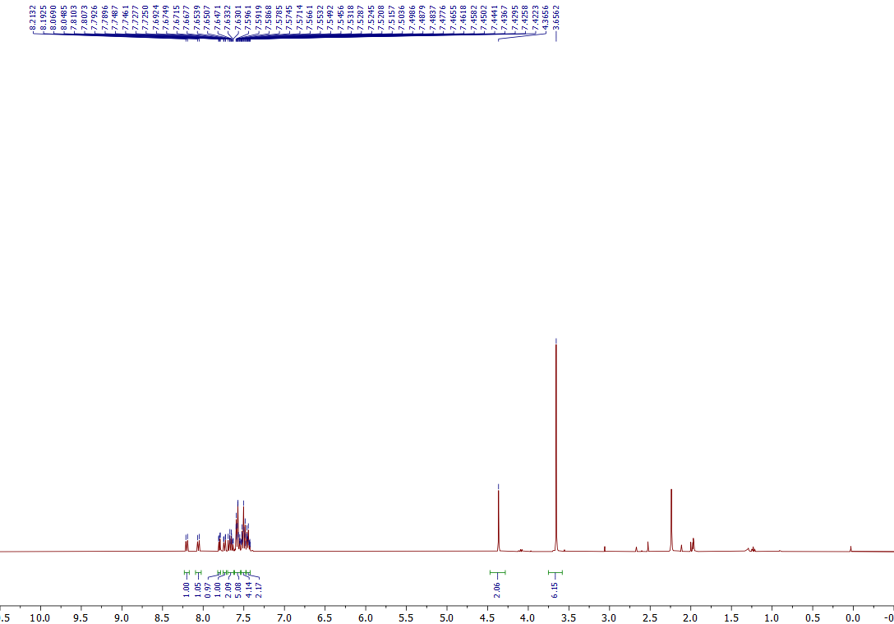
¹H NMR of the 7h (400 MHz, CD₃CN)
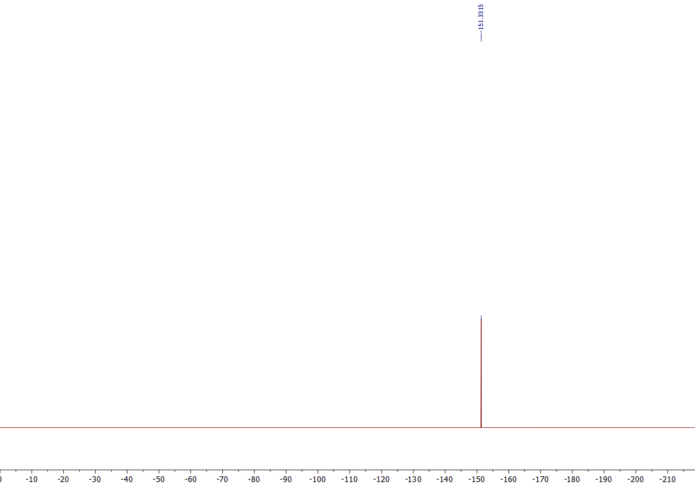
¹⁹F NMR of the 7h (376 MHz, CD₃CN)

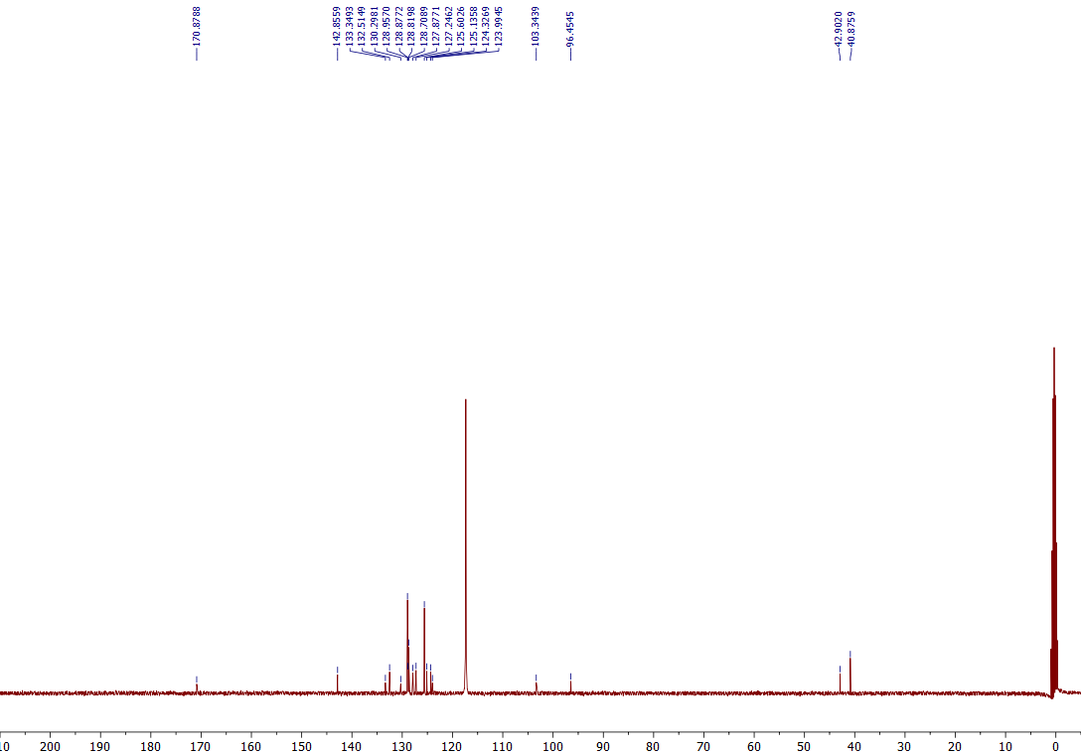
¹³C NMR of the 7h (101 MHz, CD₃CN)

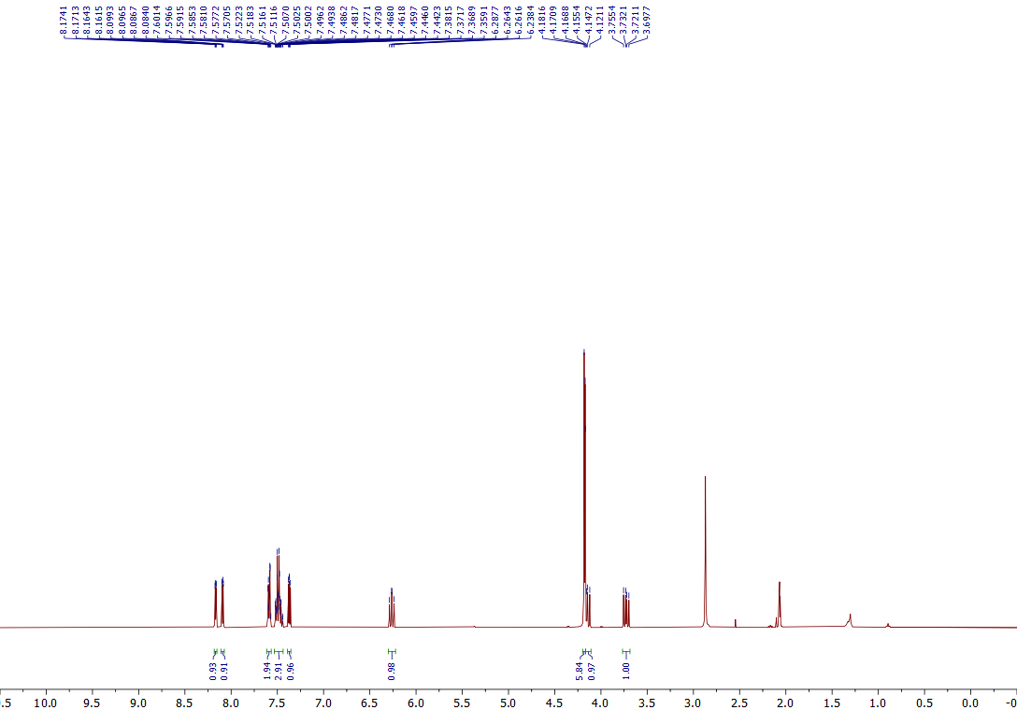
¹H NMR of the 7i (400 MHz, Acetone-d₆)
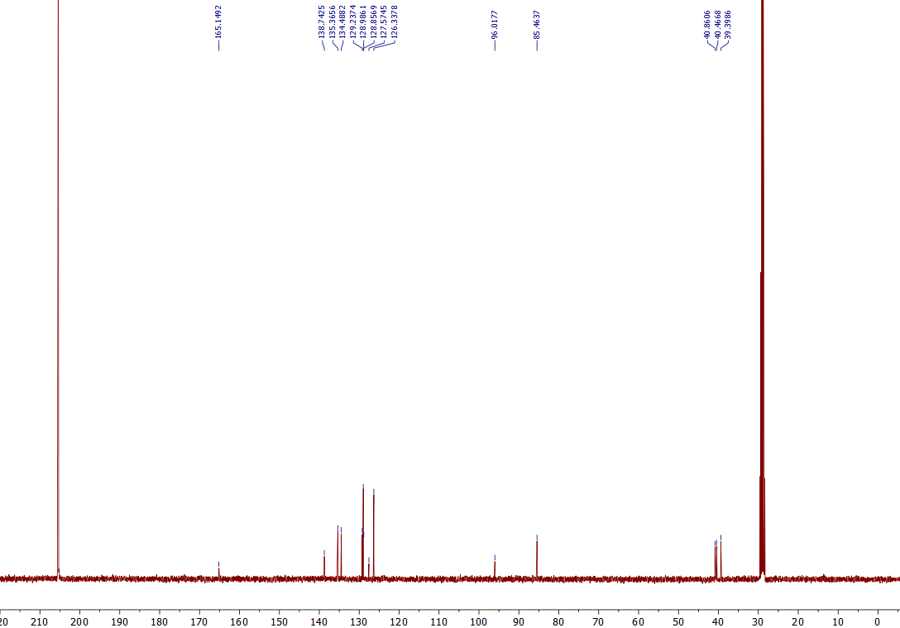
¹³C NMR of the 7i (101 MHz, Acetone-d₆)

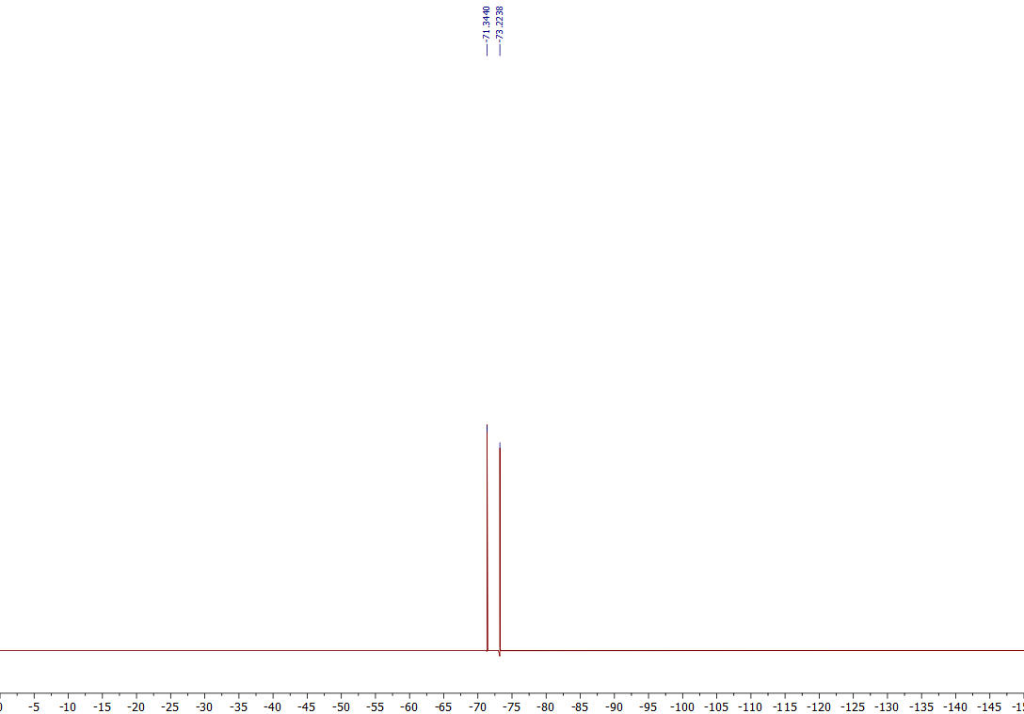
¹⁹F NMR of the 7i (376 MHz, Acetone-d₆)
³¹P NMR of the 7i (162 MHz, Acetone-d₆)

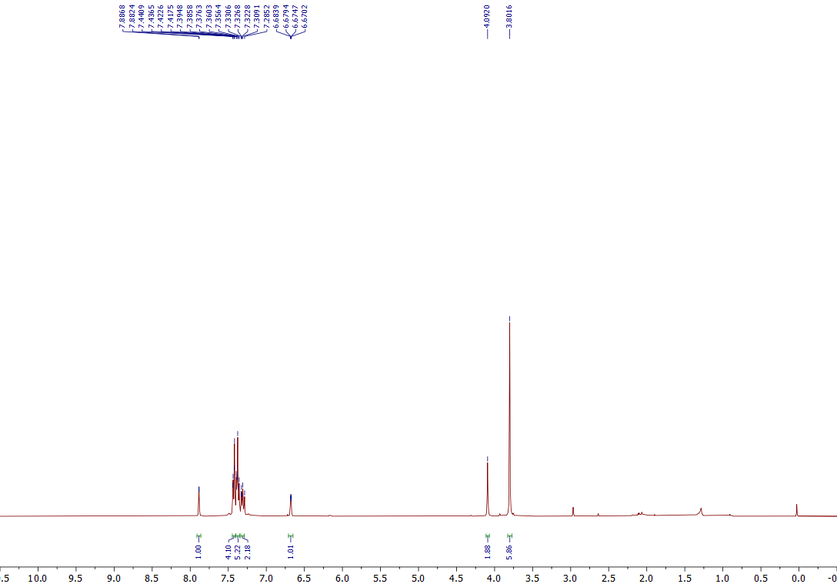
¹H NMR of the 7J (400 MHz, CDCl₃)
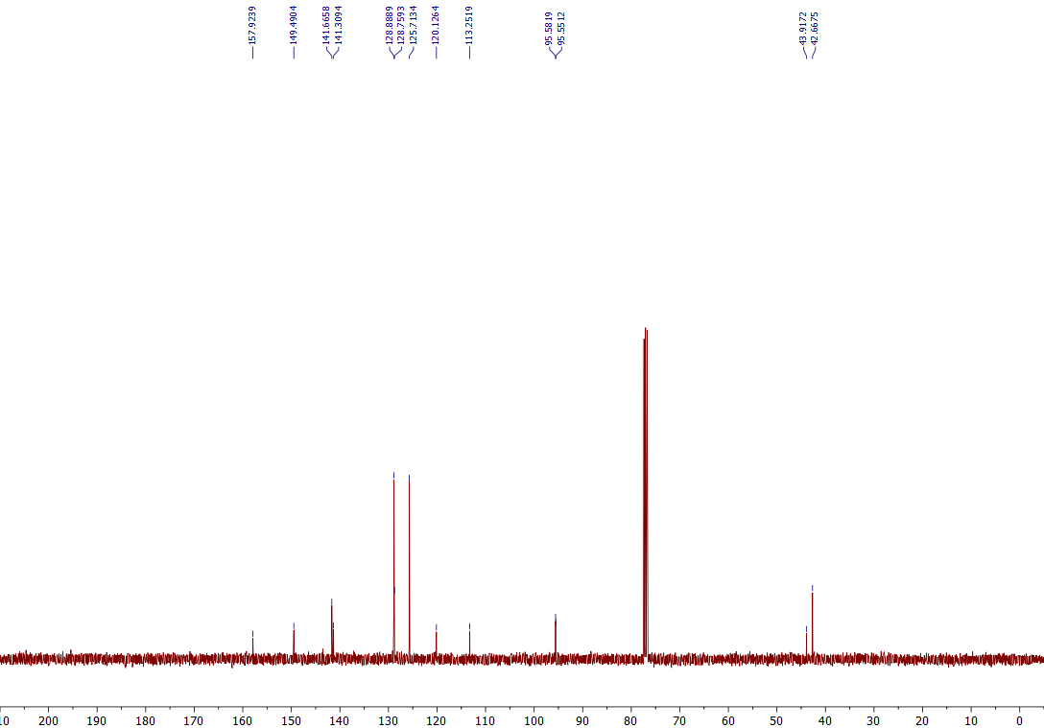
¹³C NMR of the 7J (101 MHz, CDCl₃)

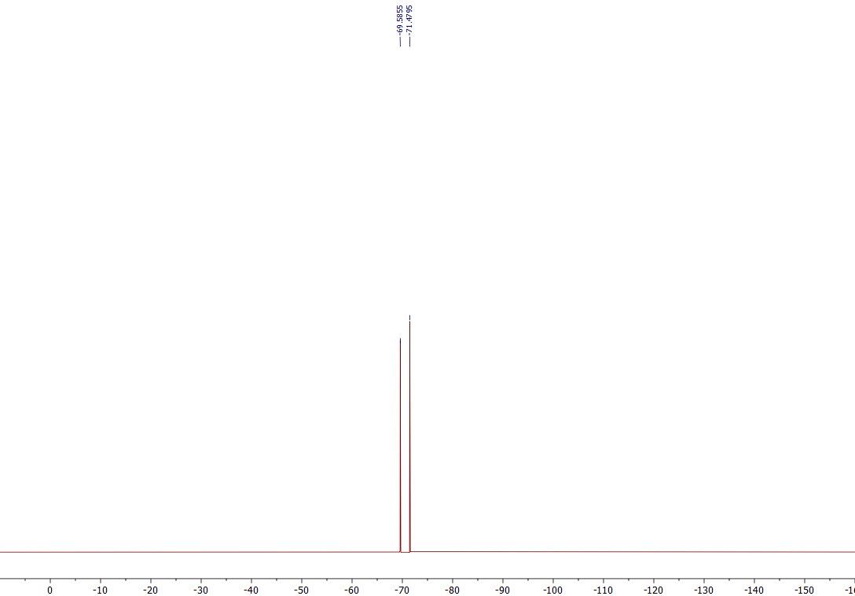
¹⁹F NMR of the 7J (376 MHz, CDCl₃)
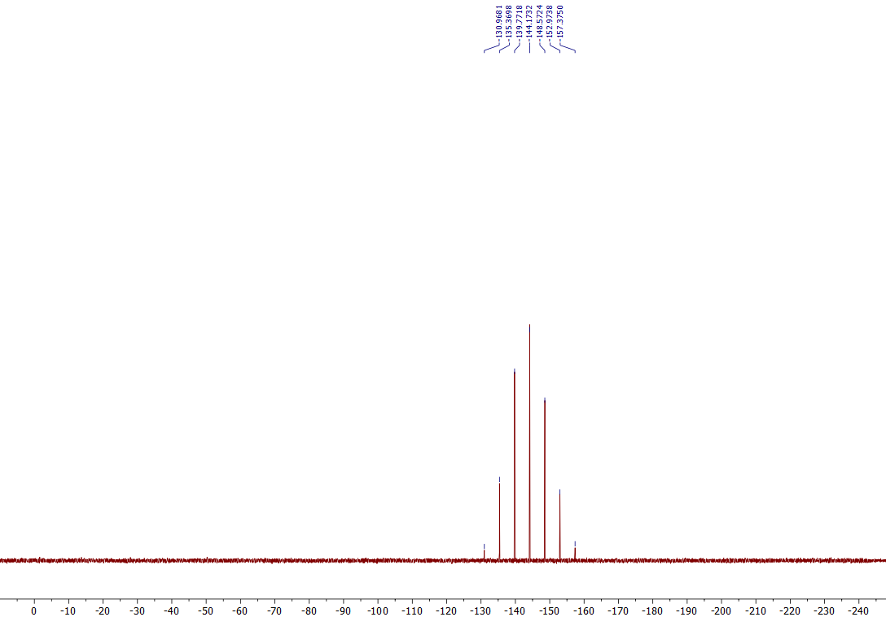
³¹P NMR of the 7J (162 MHz, CDCl₃)

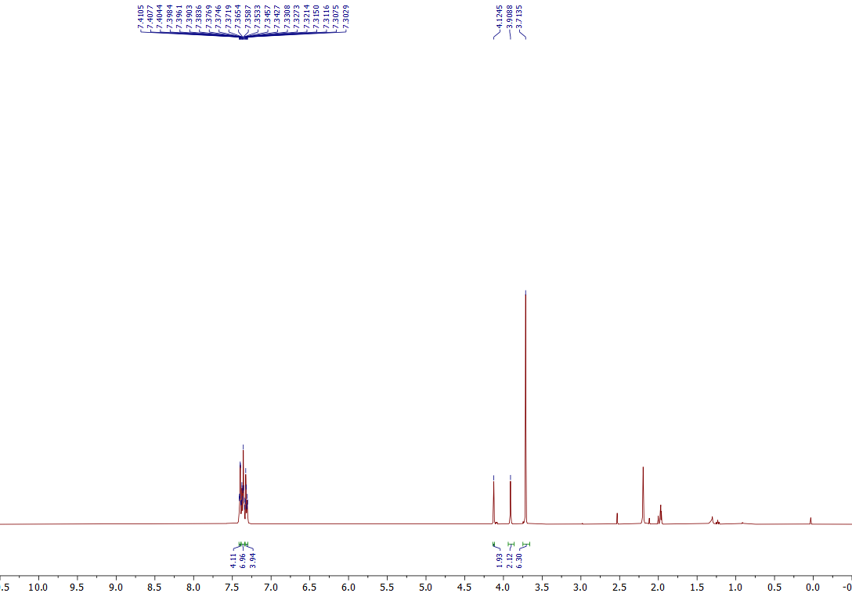
¹H NMR of the 7k (376 MHz, CD₃CN)
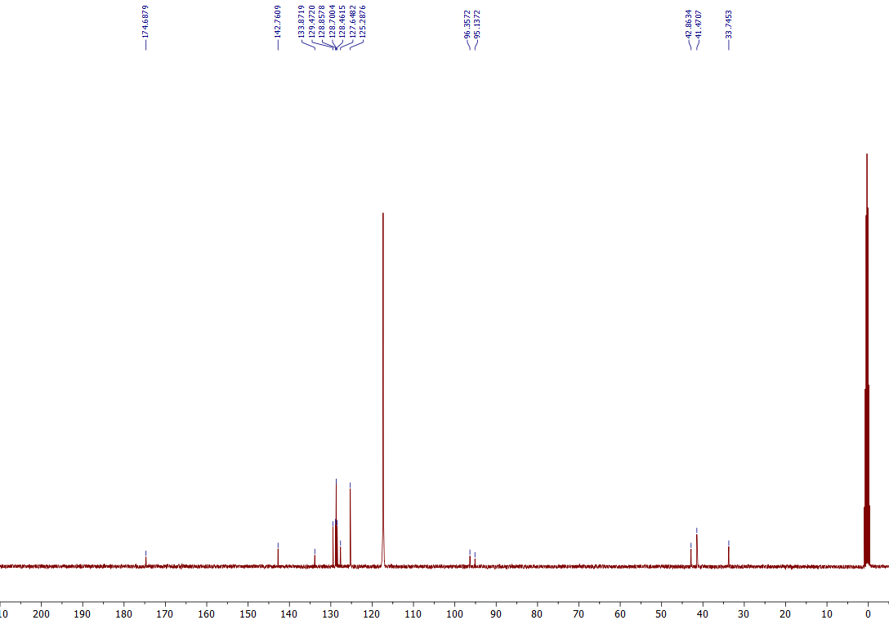
¹³C NMR of the 7k (101 MHz, CD₃CN)

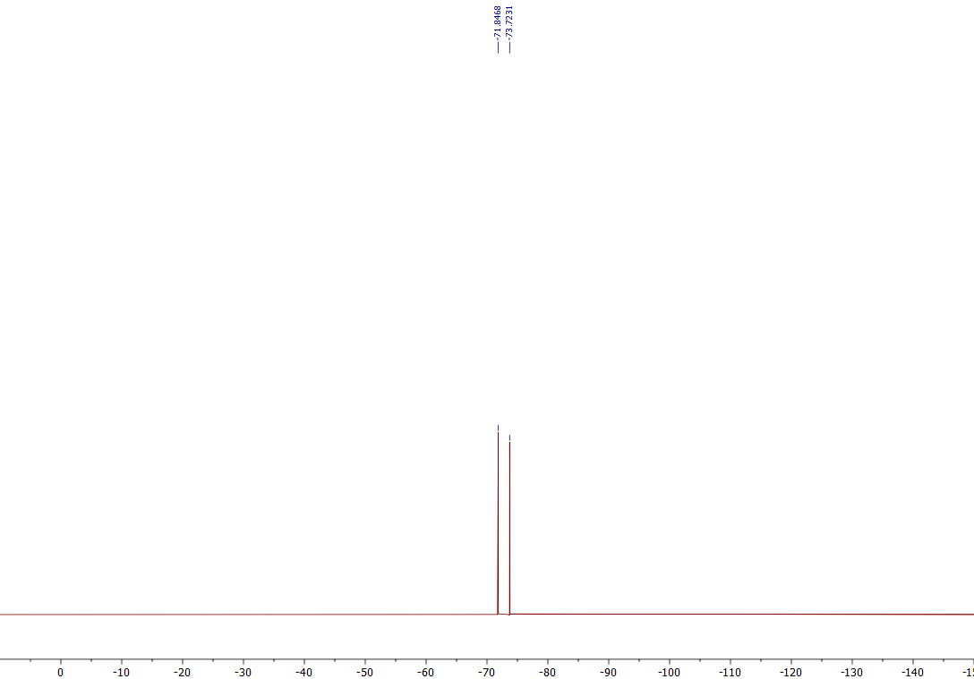
¹⁹F NMR of the 7k (376 MHz, CD₃CN)
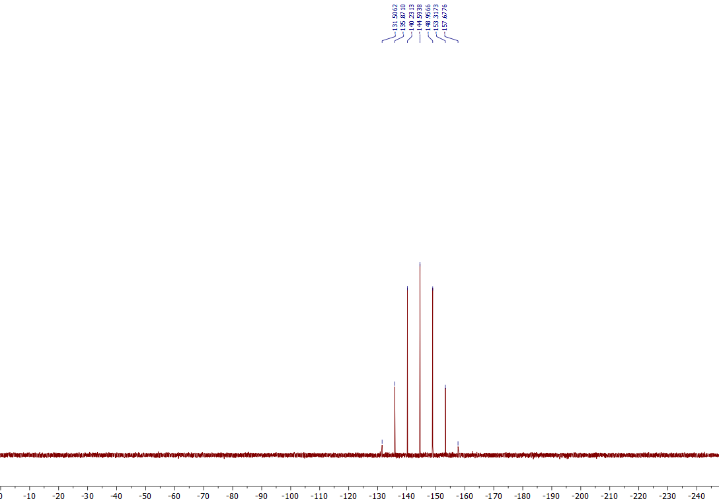
³¹P NMR of the 7k (162 MHz, CD₃CN)

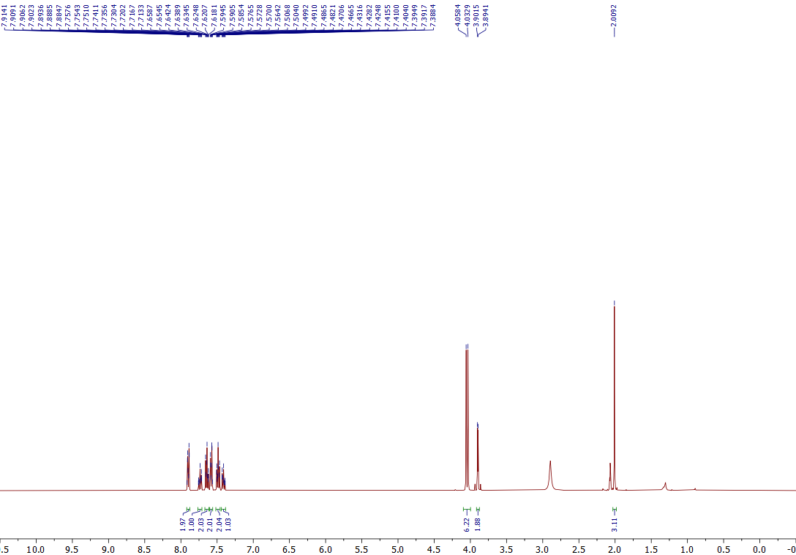
¹H NMR of the 7l (376 MHz, Acetone-d₆)
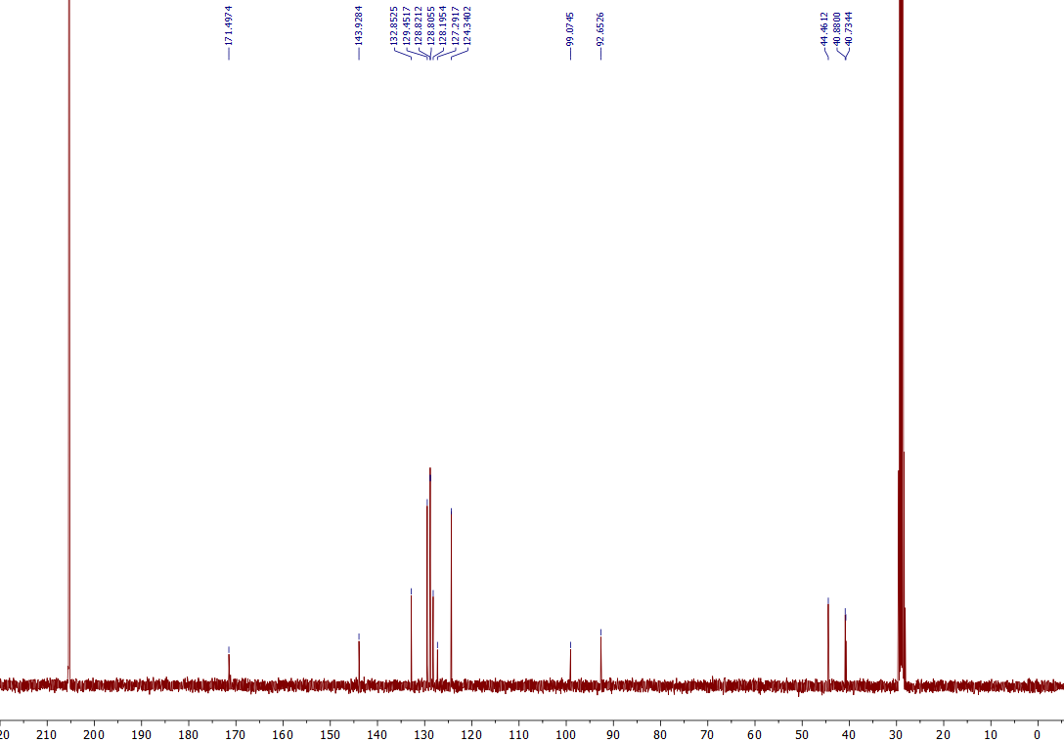
¹³C NMR of the 7l (101 MHz, Acetone-d₆)

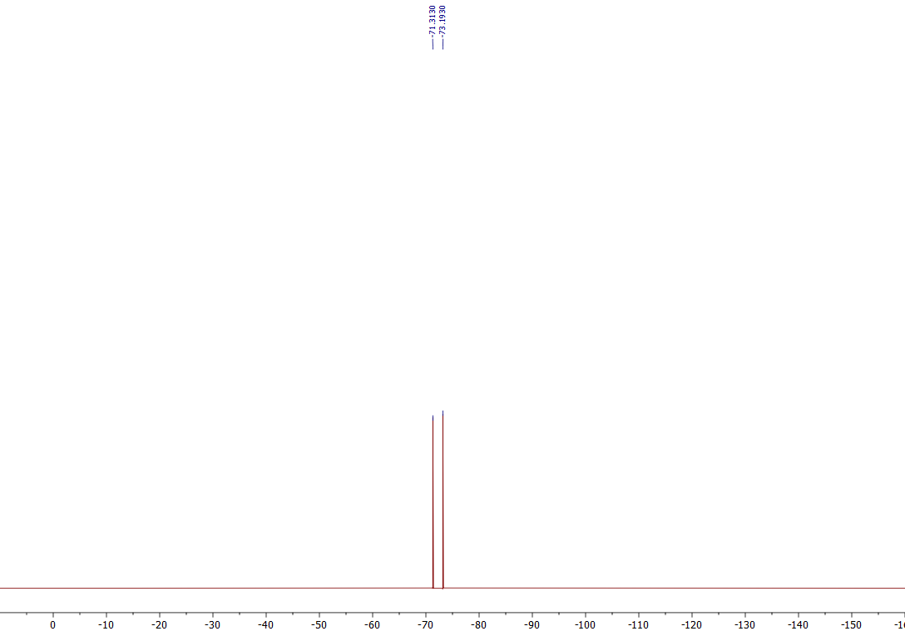
¹⁹F NMR of the 7l (376 MHz, Acetone-d₆)

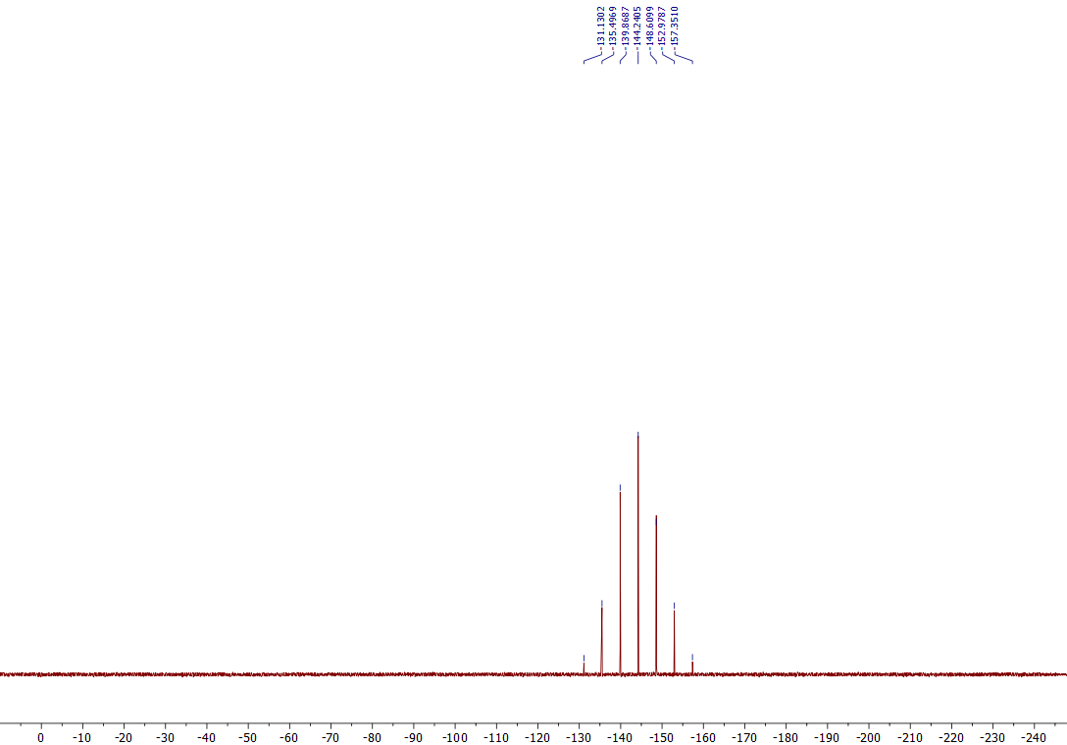
³¹P NMR of the 7l (162 MHz, Acetone-d₆)

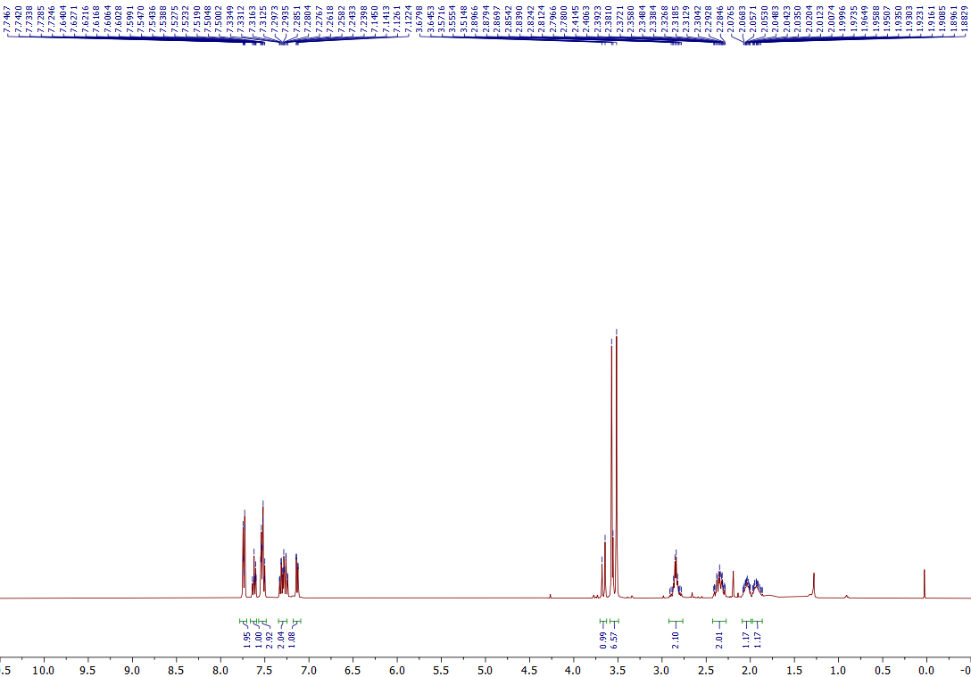
¹H NMR of the 7m (400 MHz, CDCl₃)
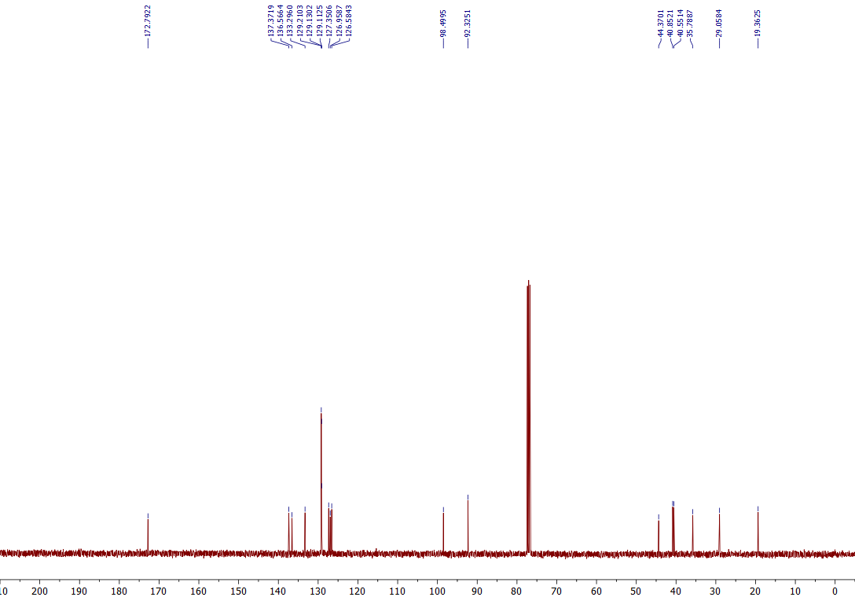
¹³C NMR of the 7m (101 MHz, CDCl₃)

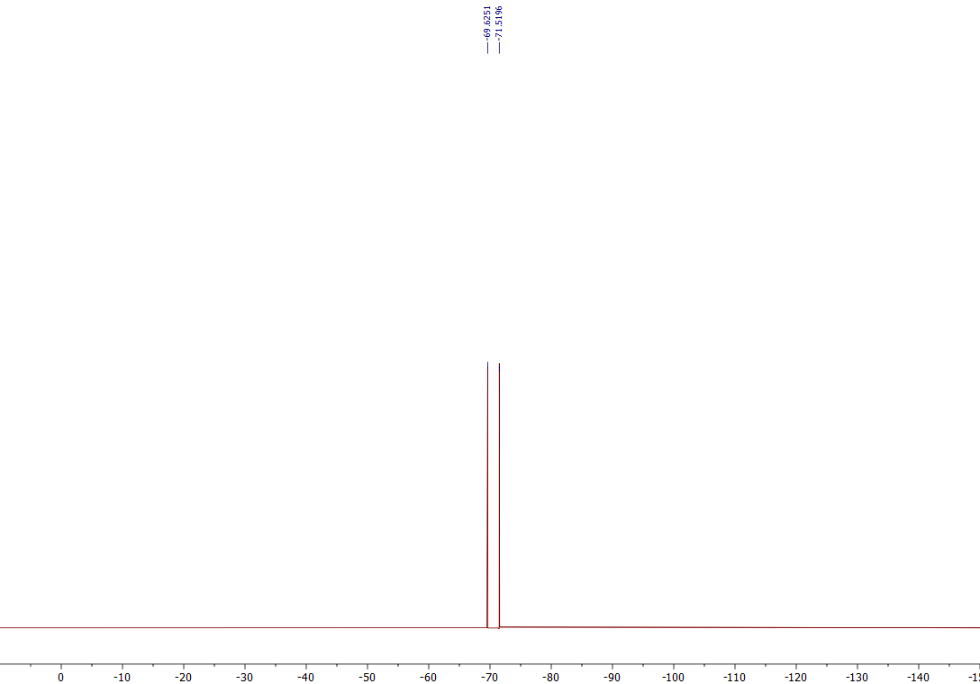
¹⁹F NMR of the 7m (376 MHz, CDCl₃)
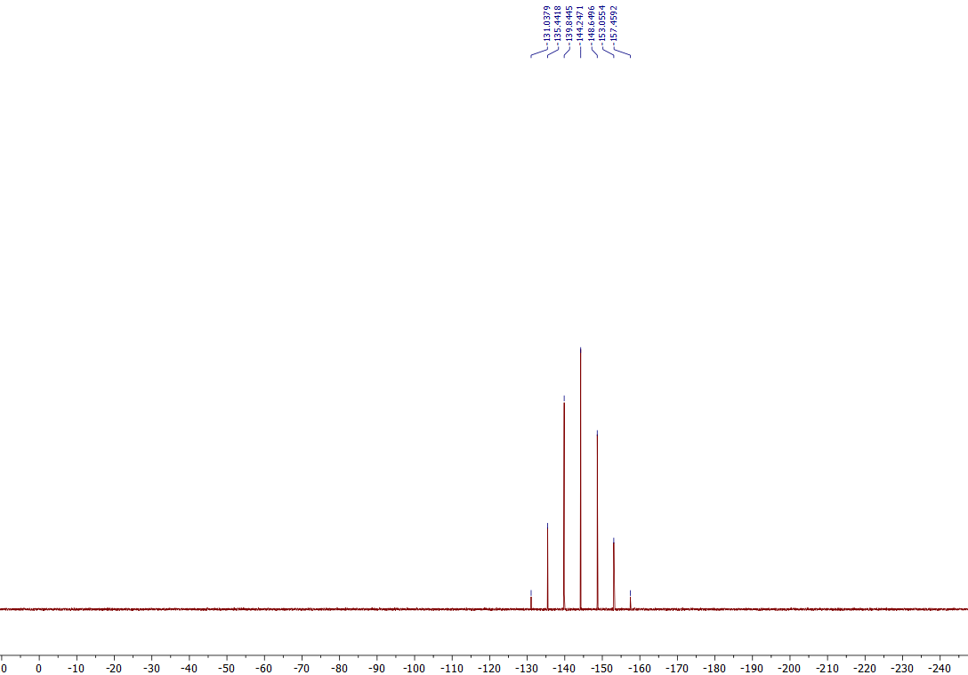
³¹P NMR of the 7m (162 MHz, CDCl₃)

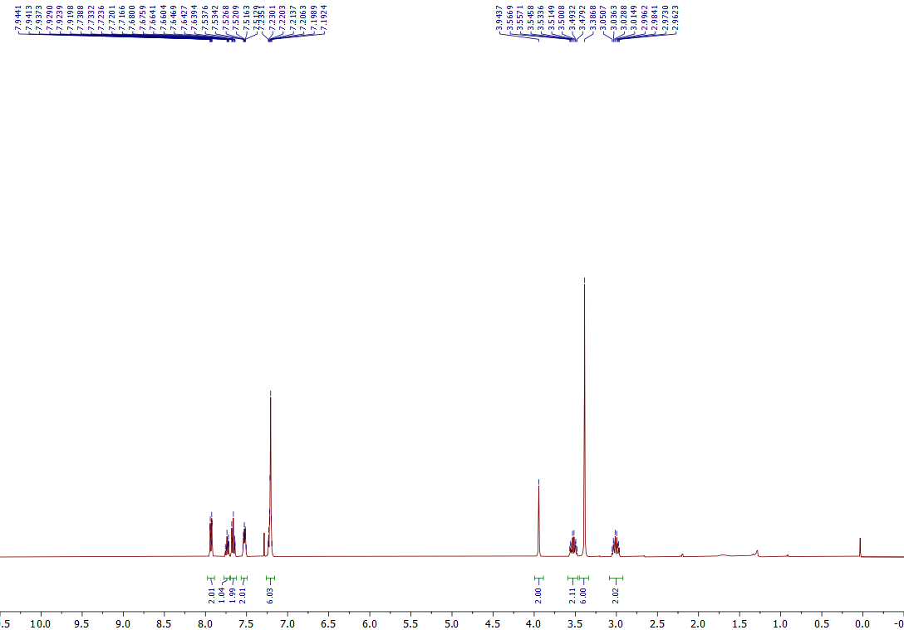
¹H NMR of the 7n (400 MHz, CDCl₃)
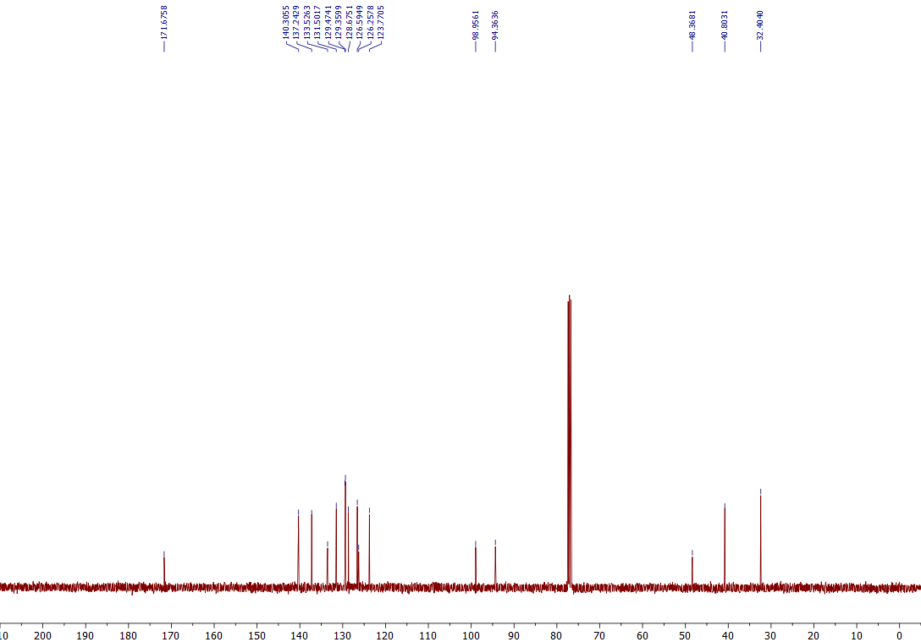
¹³C NMR of the 7n (101 MHz, CDCl₃)

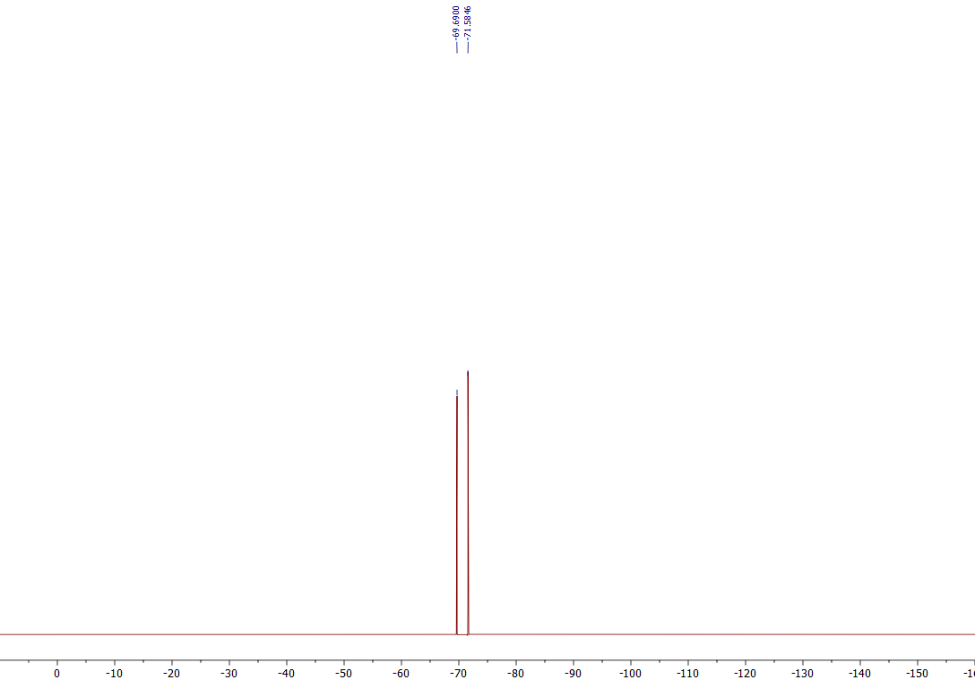
¹⁹F NMR of the 7n (376 MHz, CDCl₃)
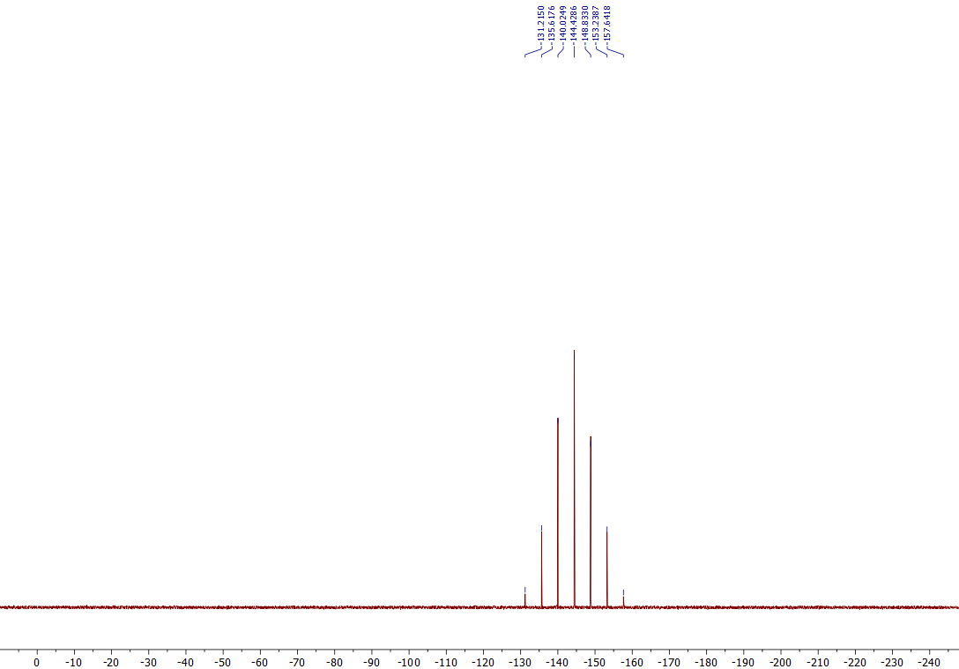
³¹P NMR of the 7n (162 MHz, CDCl₃)

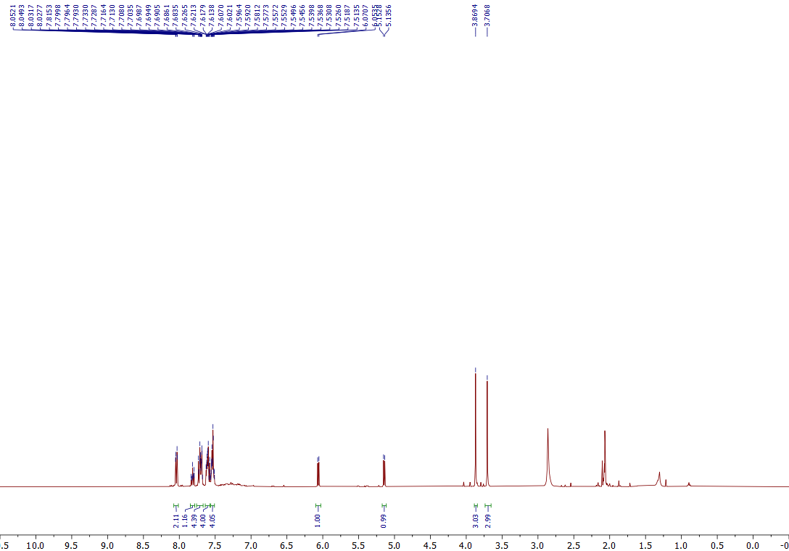
¹H NMR of the 7o (400 MHz, Acetone-d₆)
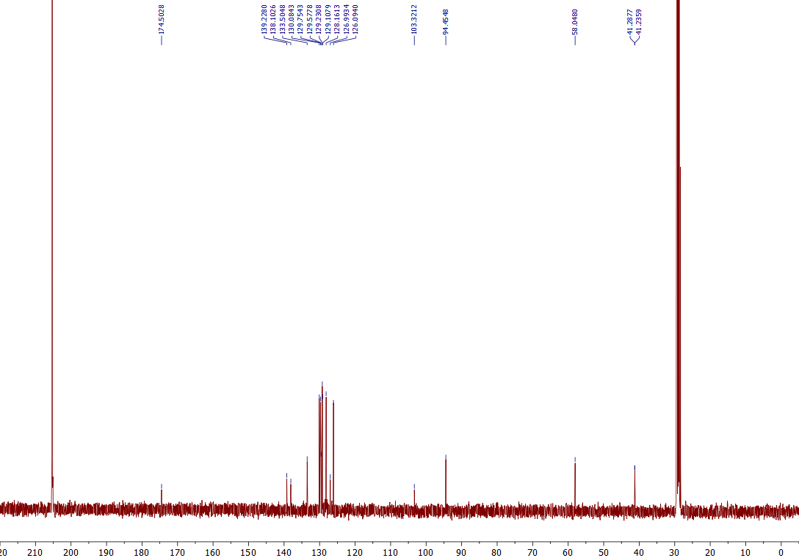
¹³C NMR of the 7o (101 MHz, Acetone-d₆)

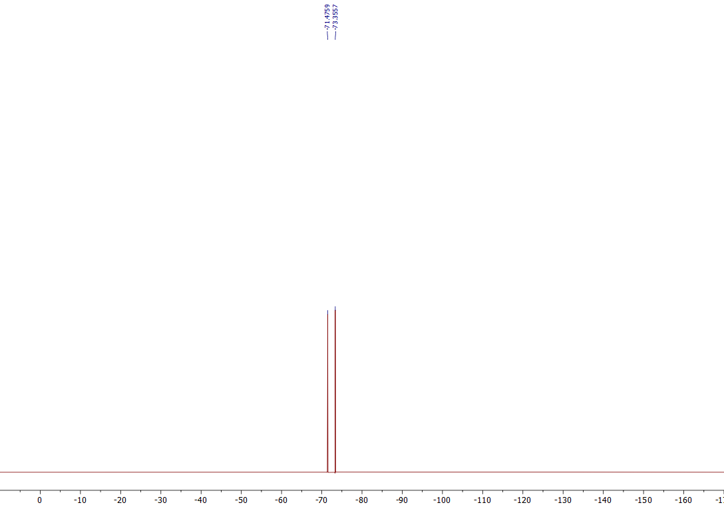
¹⁹F NMR of the 7o (376 MHz, Acetone-d₆)
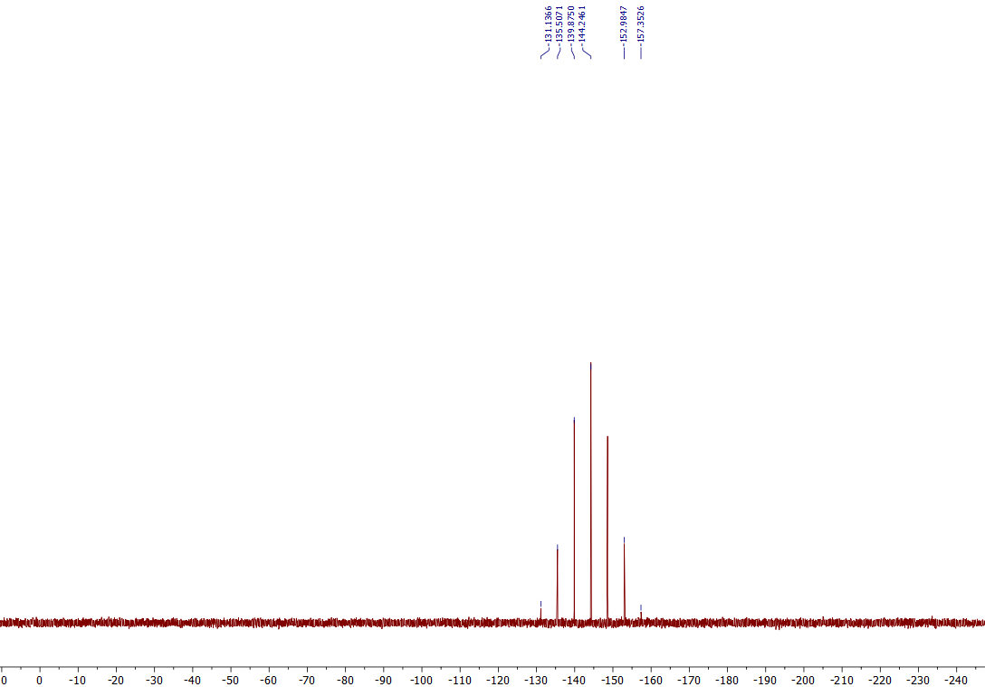
³¹P NMR of the 7o (162 MHz, Acetone-d₆)

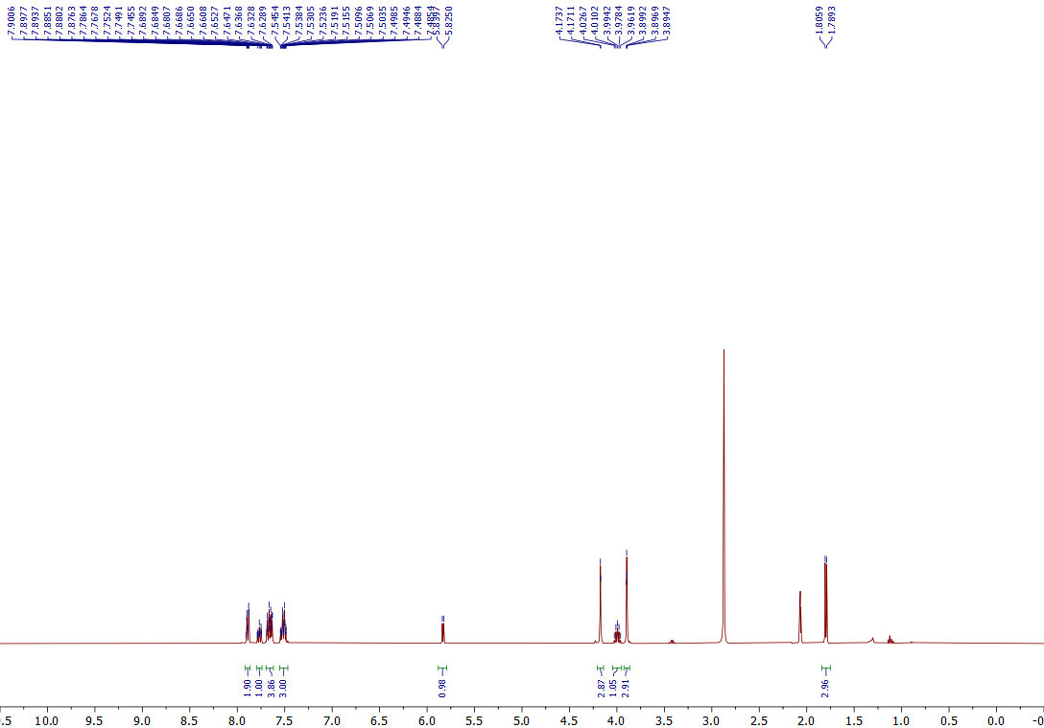
¹H NMR of the 7p (400 MHz, Acetone-d₆)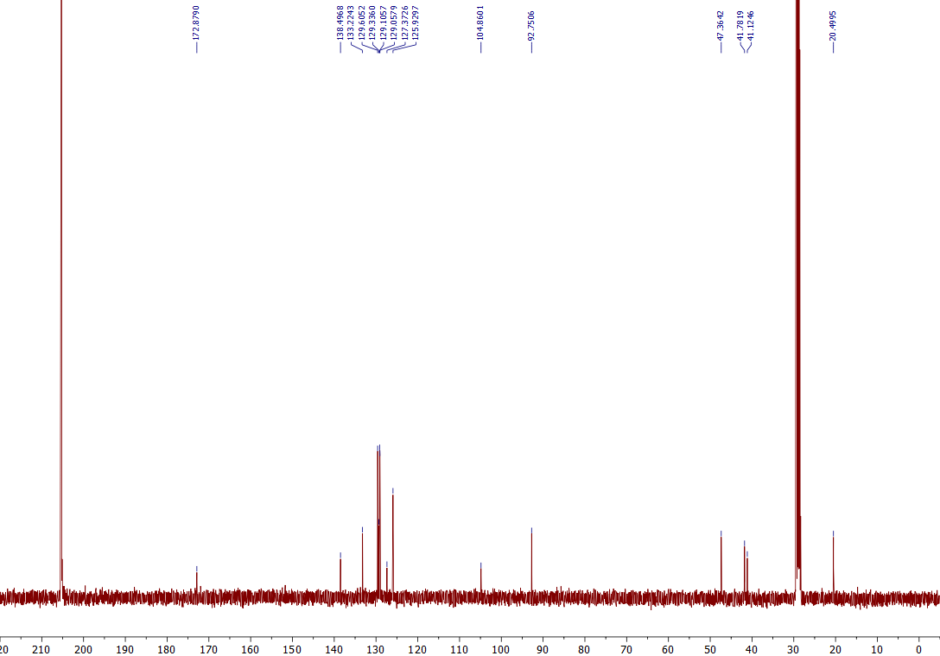
¹³C NMR of the 7p (101 MHz, Acetone-d₆)
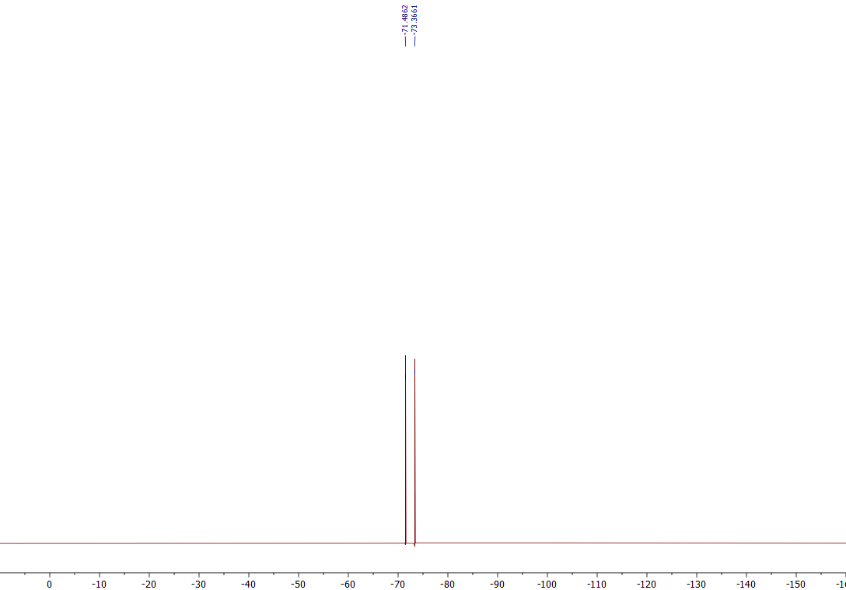
¹⁹F NMR of the 7p (376 MHz, Acetone-d₆)
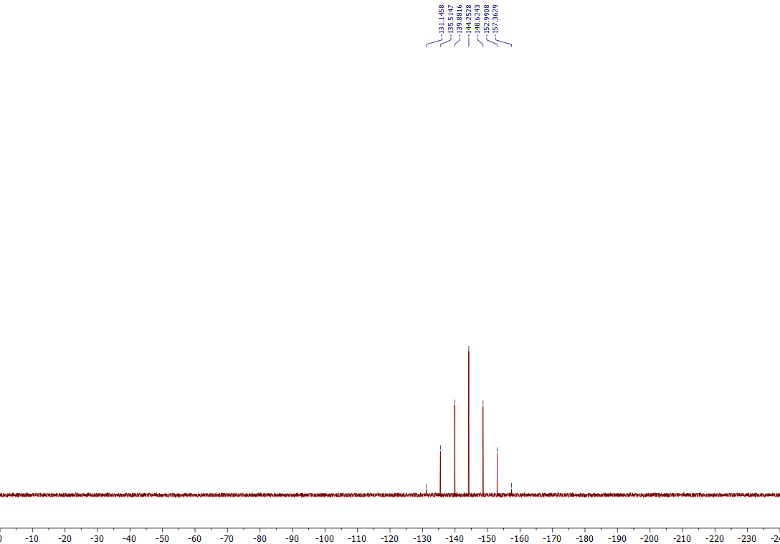
³¹P NMR of the 7p (162 MHz, Acetone-d₆)

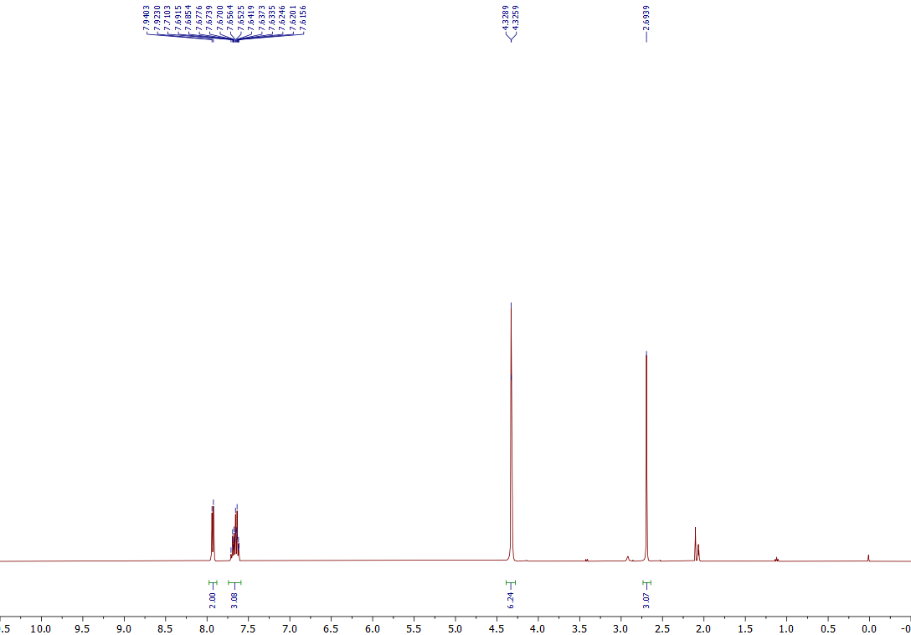
¹H NMR of the 9a (400 MHz, Acetone-d₆)
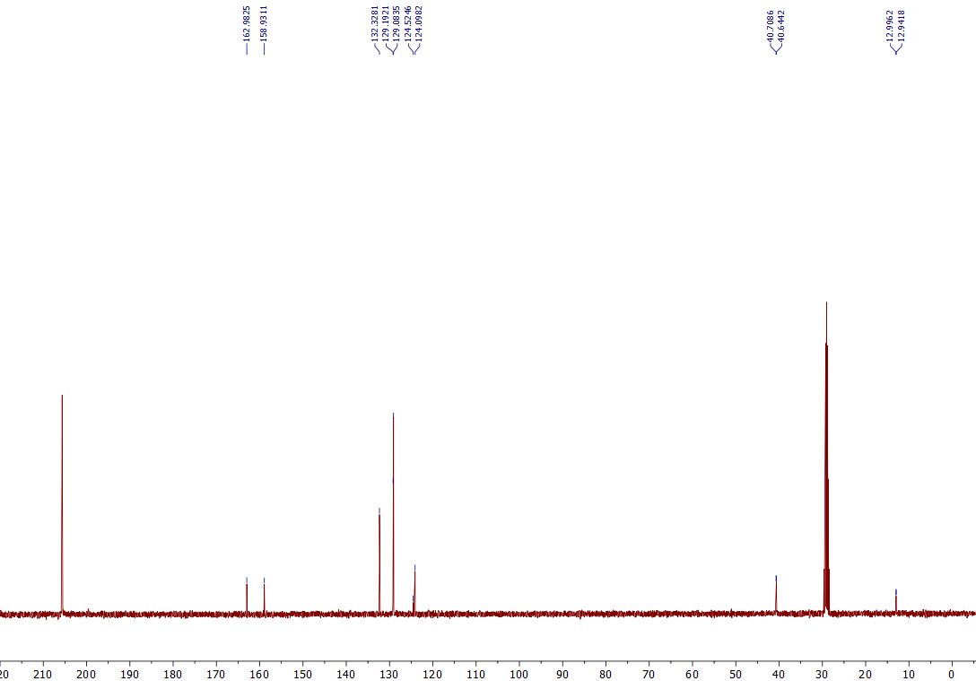
¹³C NMR of the 9a (101 MHz, Acetone-d₆)
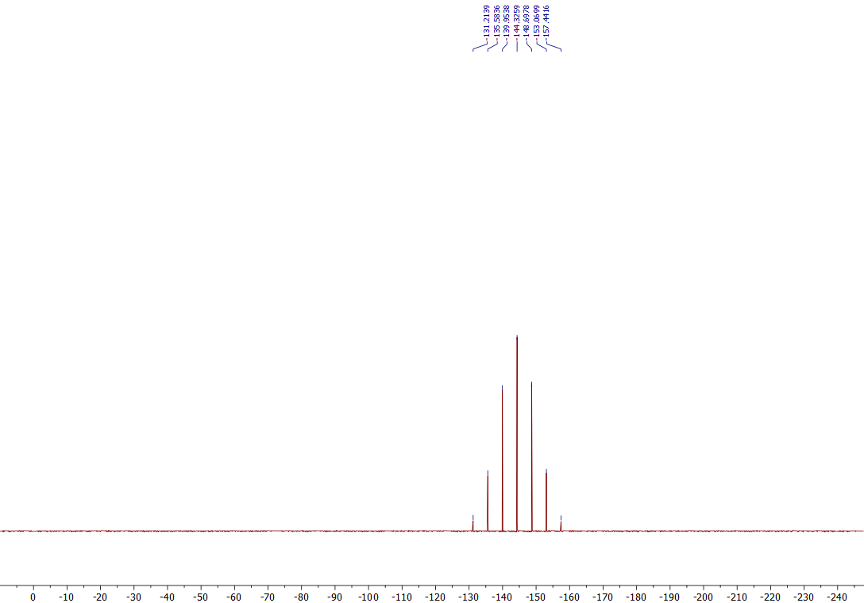
³¹P NMR of the 9a (162 MHz, Acetone-d₆)
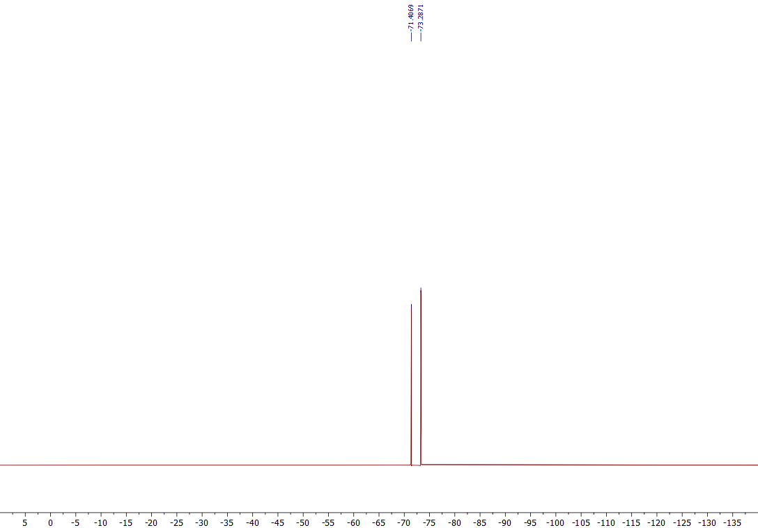
¹⁹F NMR of the 9a (376 MHz, Acetone-d₆)
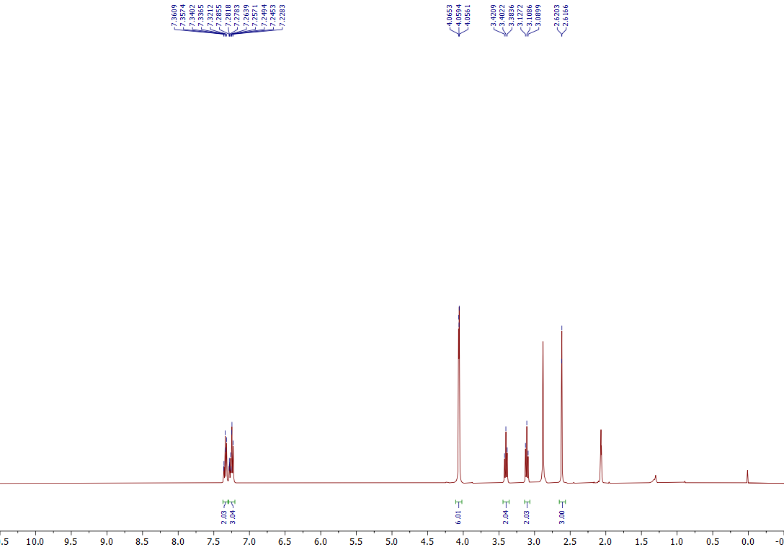
¹H NMR of the 9b (400 MHz, Acetone-d₆)
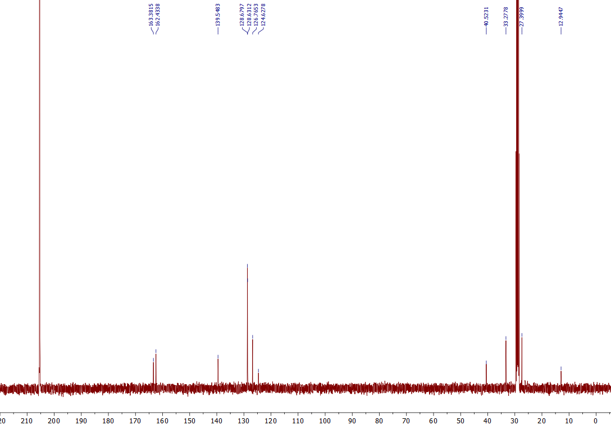
¹³C NMR of the 9b (101 MHz, Acetone-d₆)
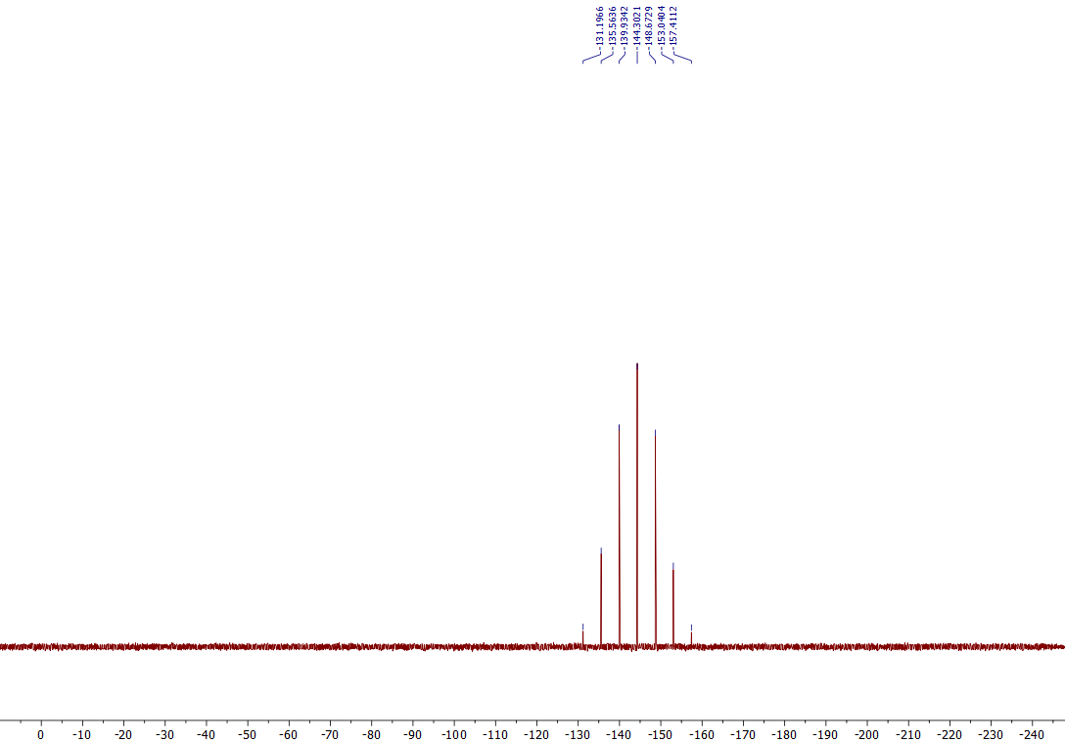
³¹P NMR of the 9b (162 MHz, Acetone-d₆)
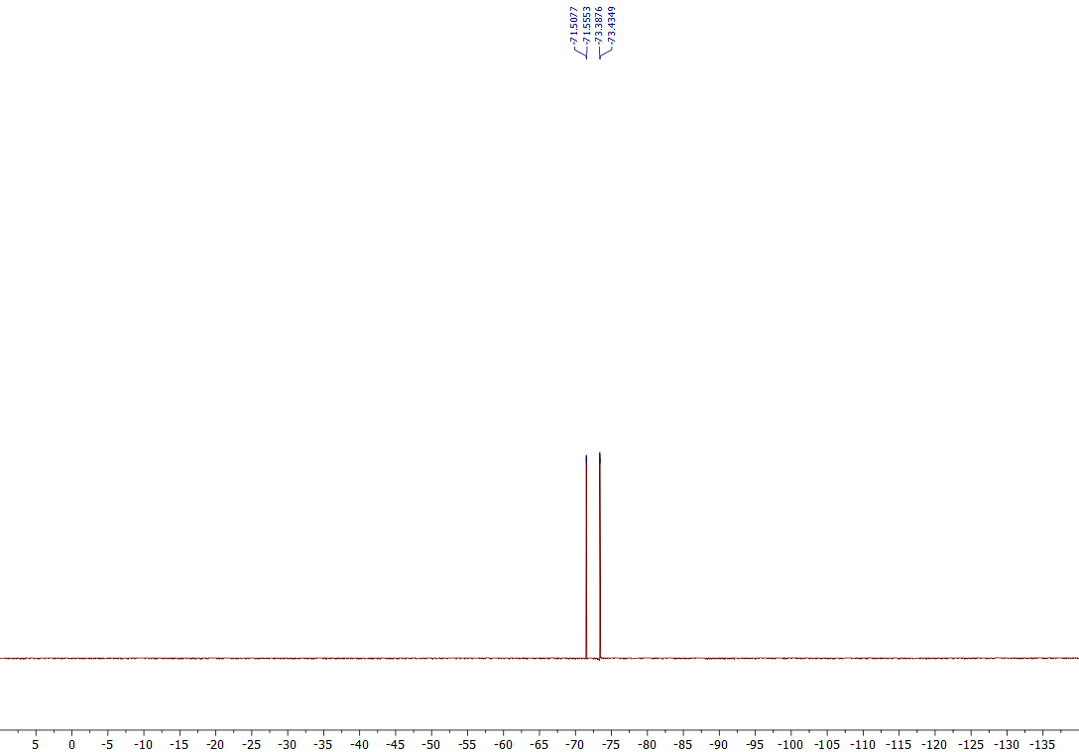
¹⁹F NMR of the 9b (376 MHz, Acetone-d₆)
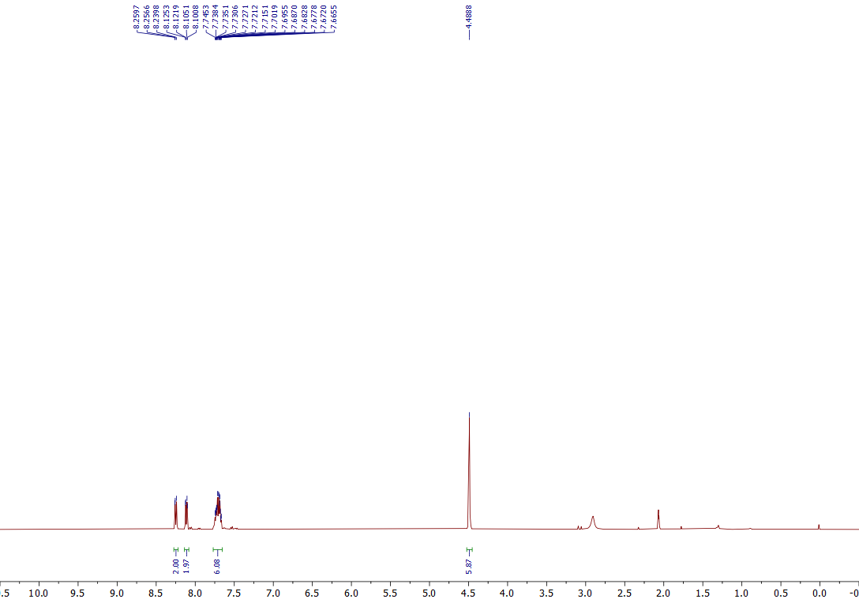
¹H NMR of the 9c (400 MHz, Acetone-d₆)
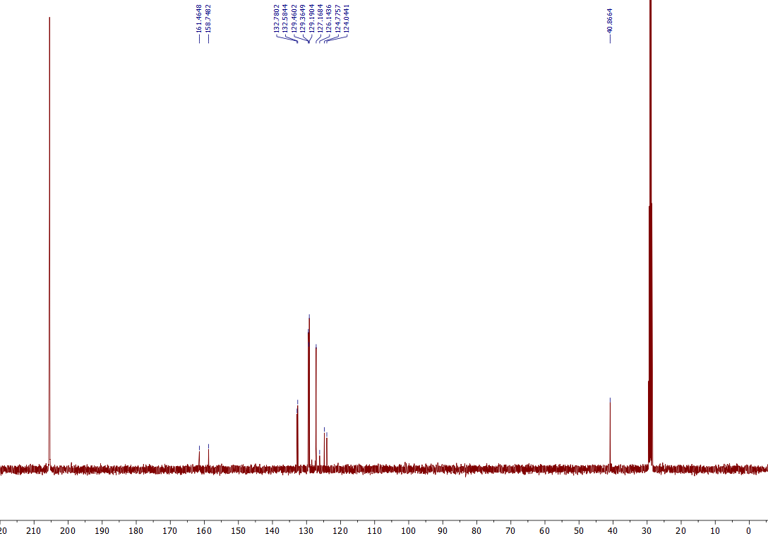
¹³C NMR of the 9c (101 MHz, Acetone-d₆)
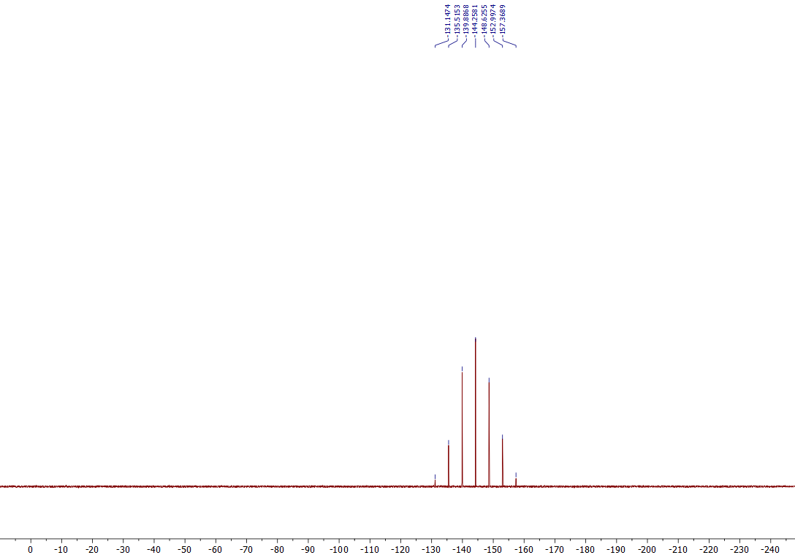
³¹P NMR of the 9c (162 MHz, Acetone-d₆)
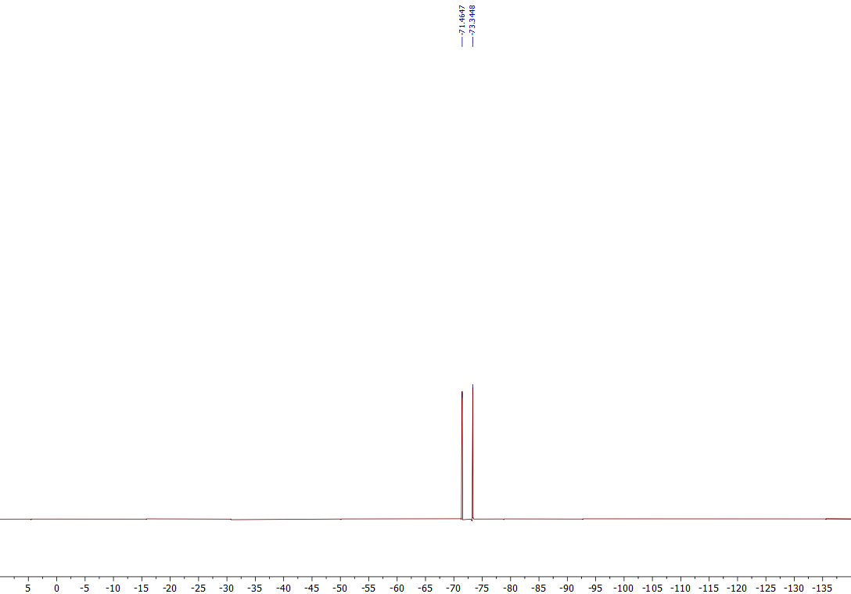
¹⁹F NMR of the 9c (376 MHz, Acetone-d₆)
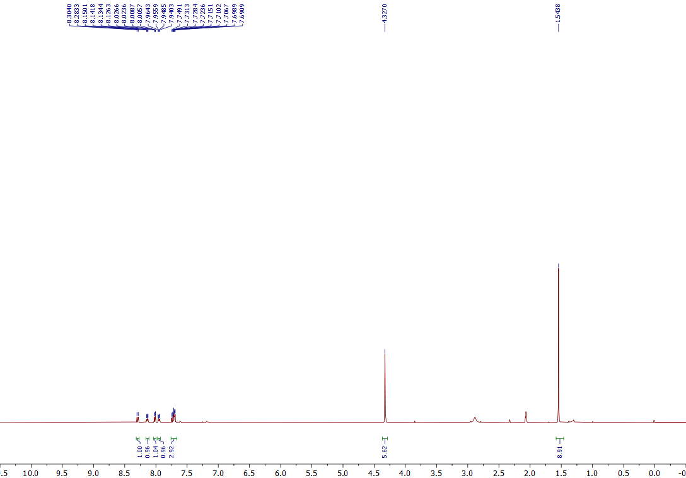
¹H NMR of the 9d (400 MHz, Acetone-d₆)
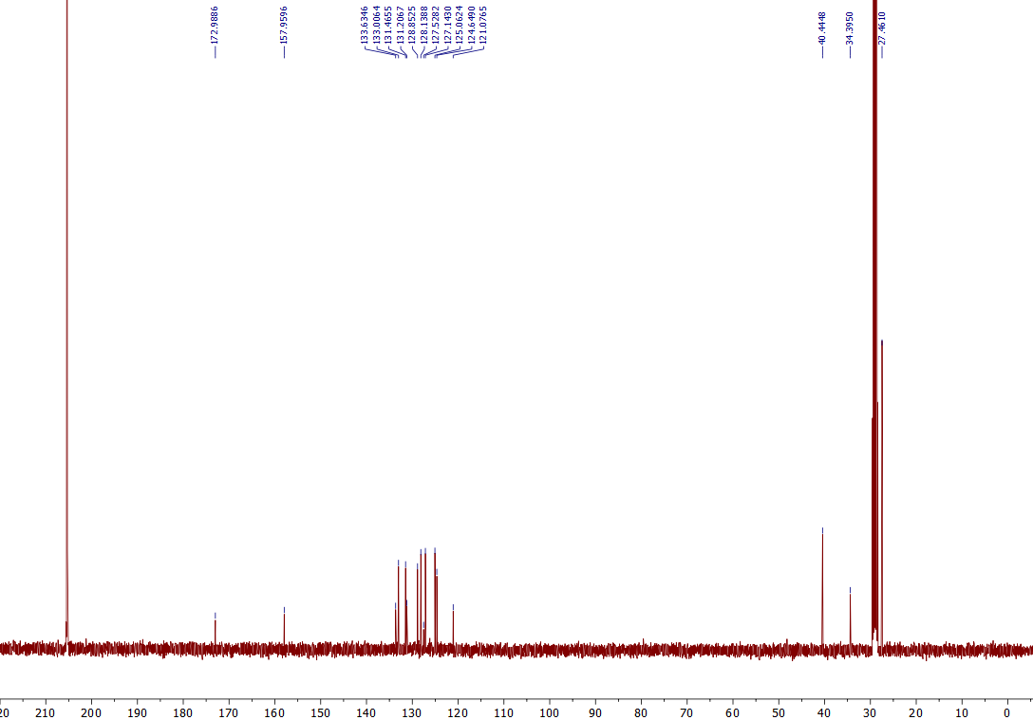
¹³C NMR of the 9d (101 MHz, Acetone-d₆)

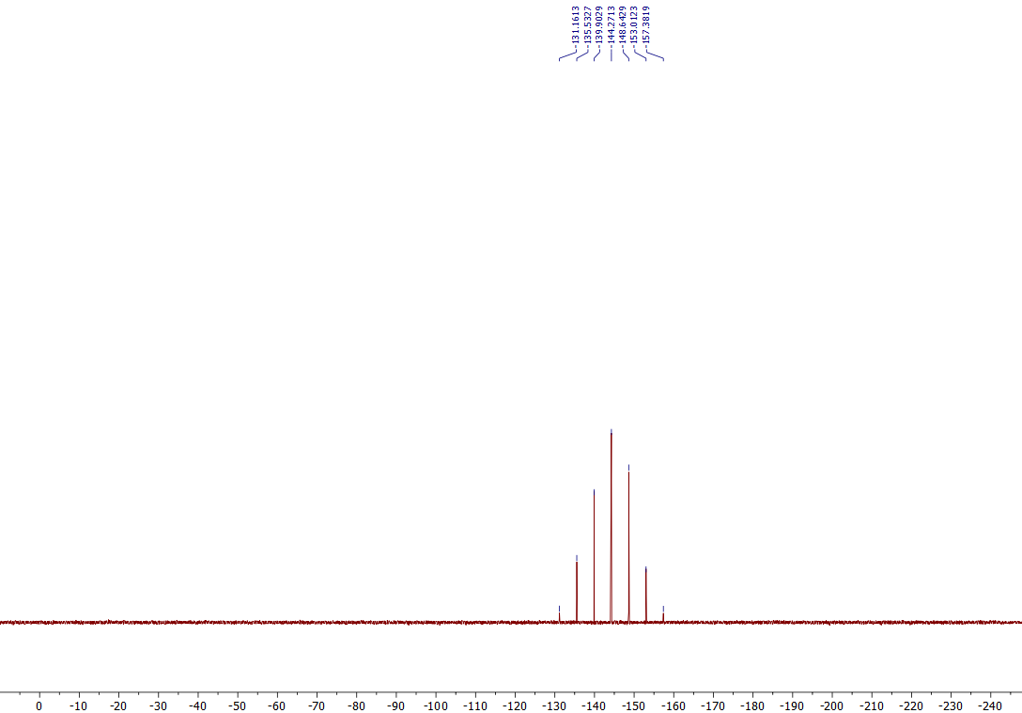
³¹P NMR of the 9d (162 MHz, Acetone-d₆)

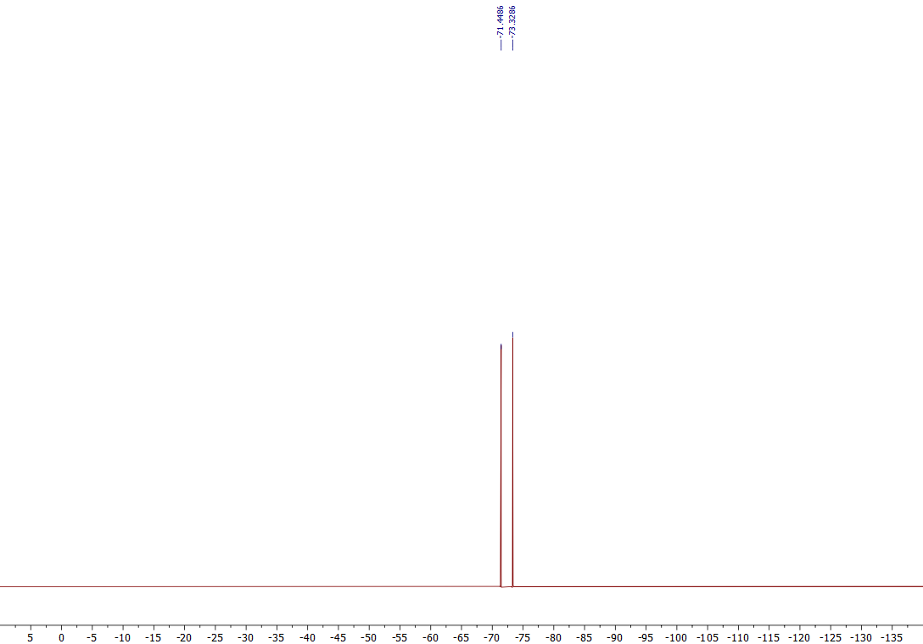
¹⁹F NMR of the 9d (376 MHz, Acetone-d₆)
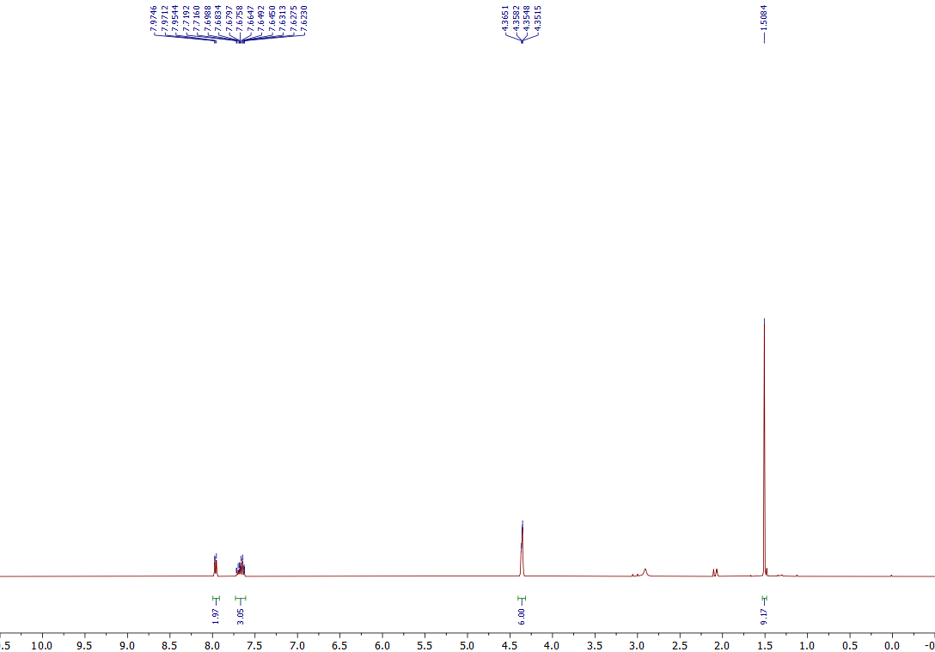
¹H NMR of the 9e (400 MHz, Acetone-d₆)

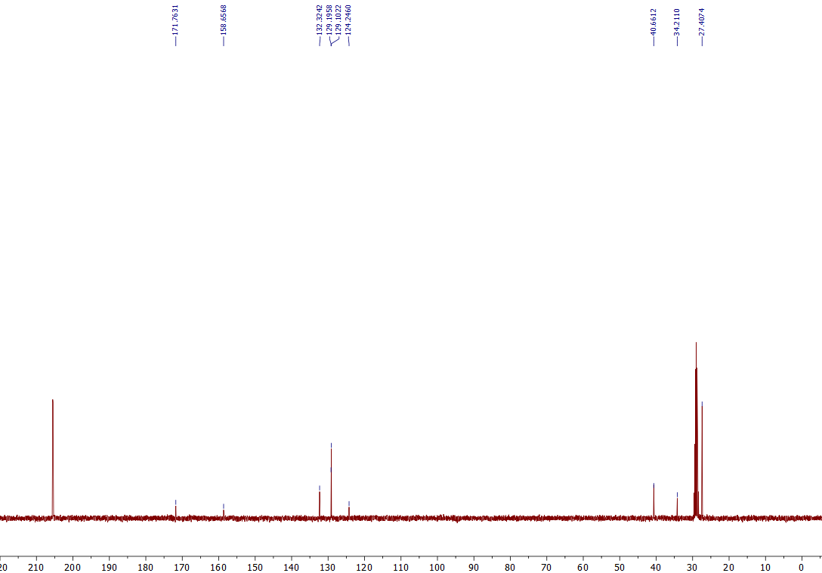
¹³C NMR of the 9e (101 MHz, Acetone-d₆)

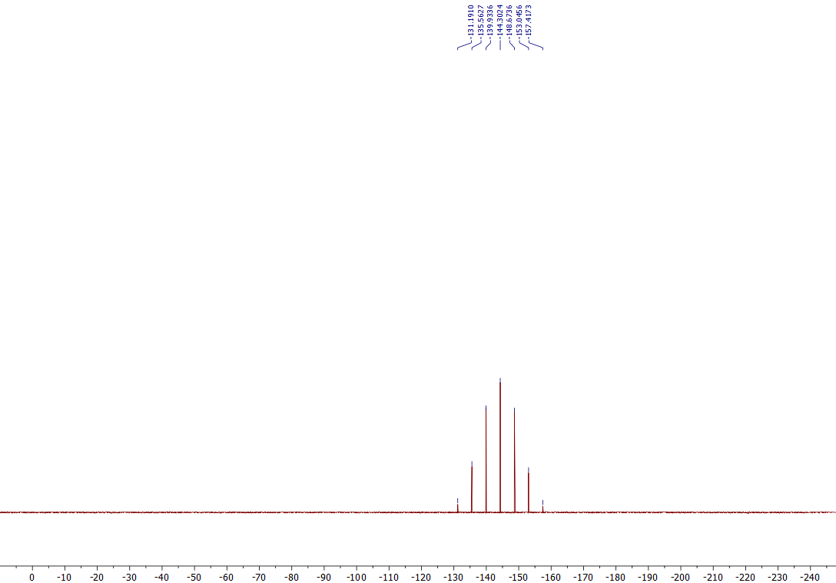
³¹P NMR of the 9e (162 MHz, Acetone-d₆)
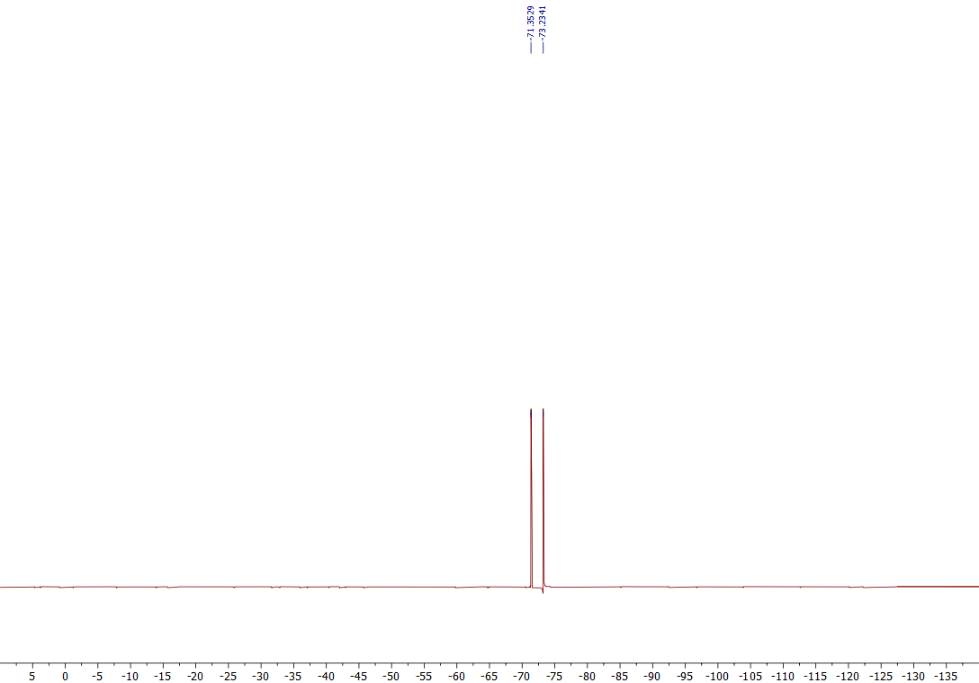
¹⁹F NMR of the 9e (376 MHz, Acetone-d₆)
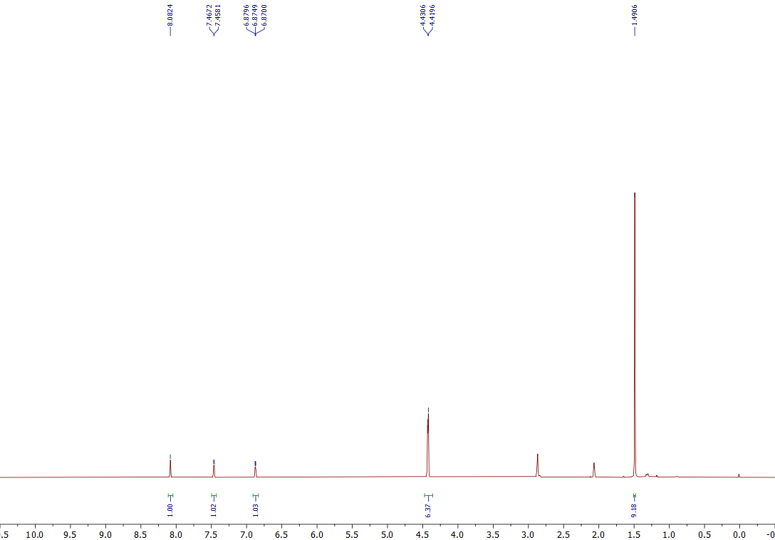
¹H NMR of the 9f (400 MHz, Acetone-d₆)
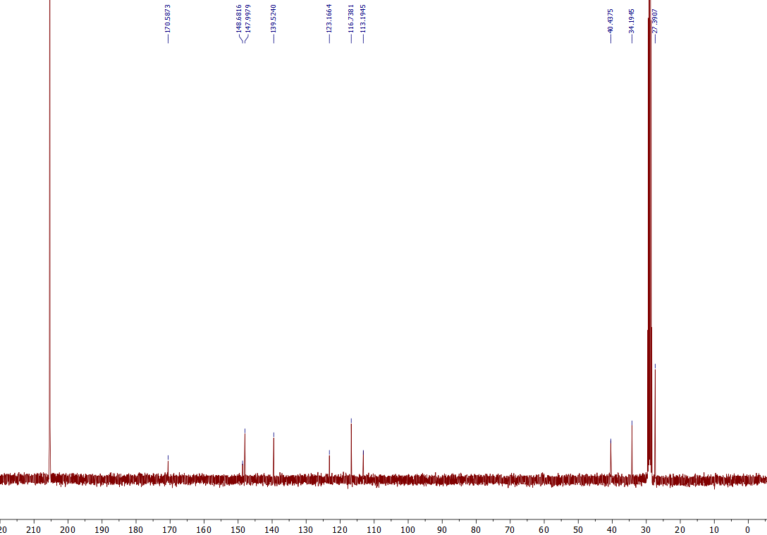
¹³C NMR of the 9f (101 MHz, Acetone-d₆)

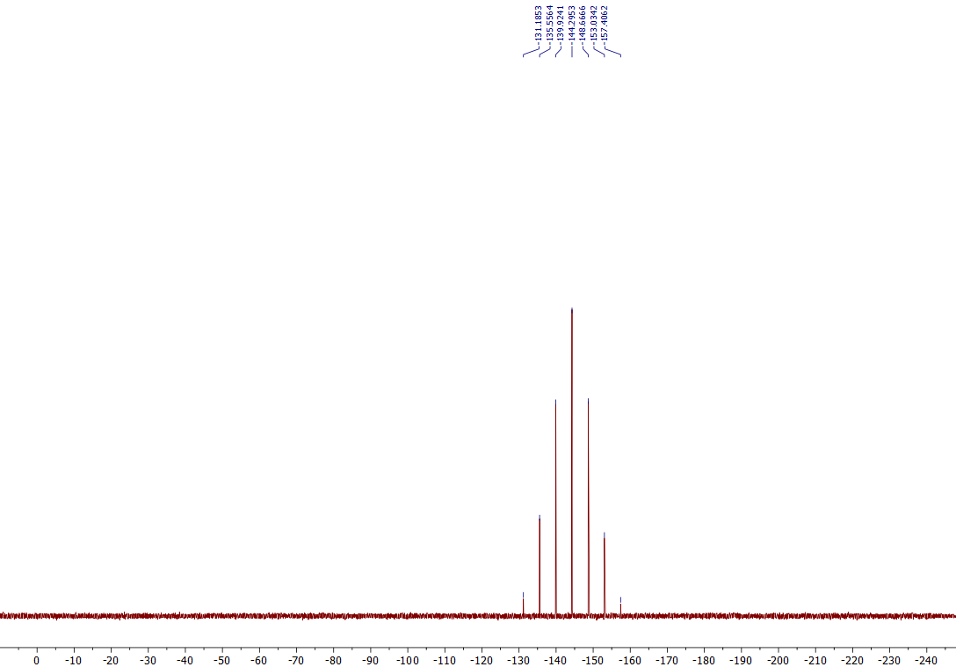
³¹P NMR of the 9f (162 MHz, Acetone-d₆)
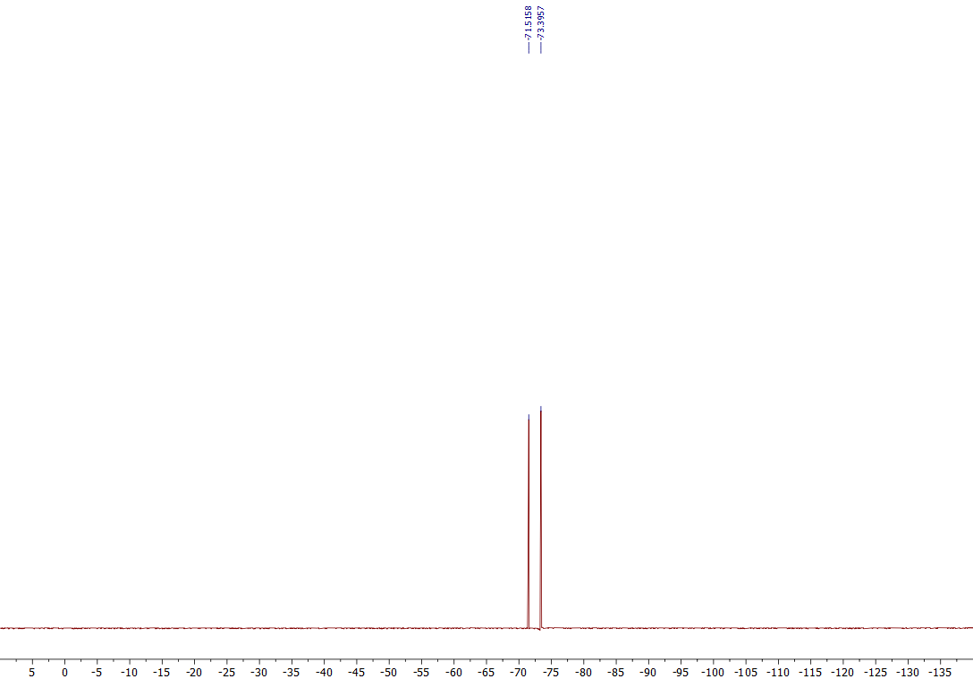
¹⁹F NMR of the 9f (376 MHz, Acetone-d₆)

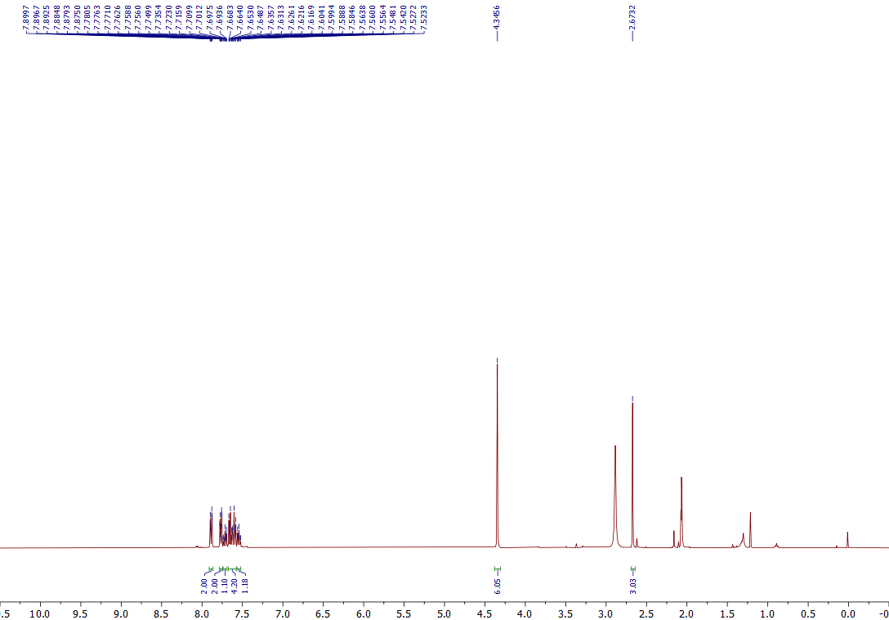
¹H NMR of the 10a (400 MHz, Acetone-d₆)
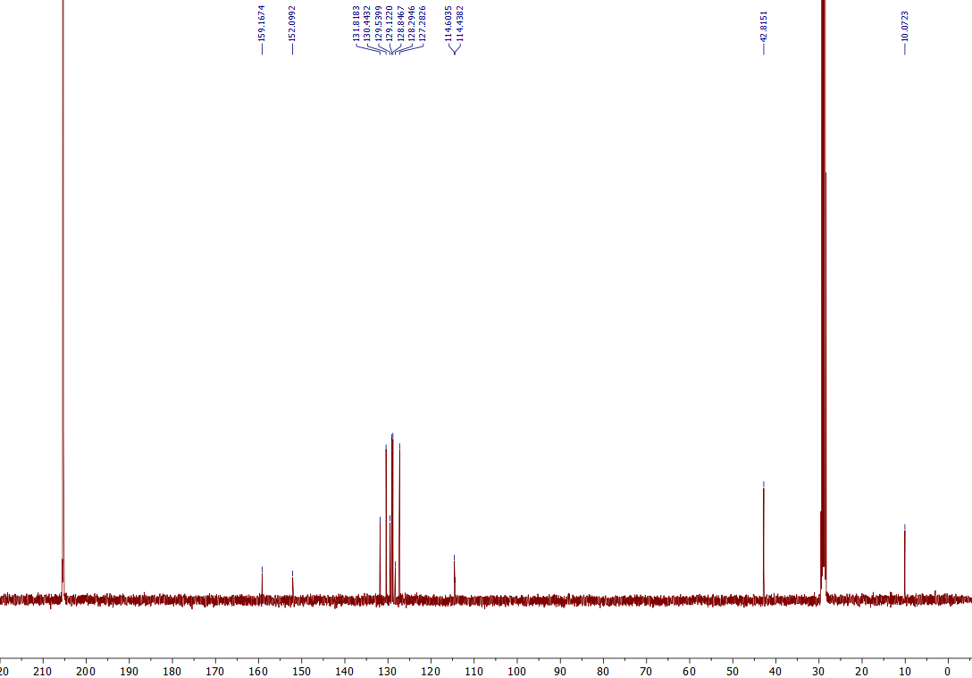
¹³C NMR of the 10a (101 MHz, Acetone-d₆)

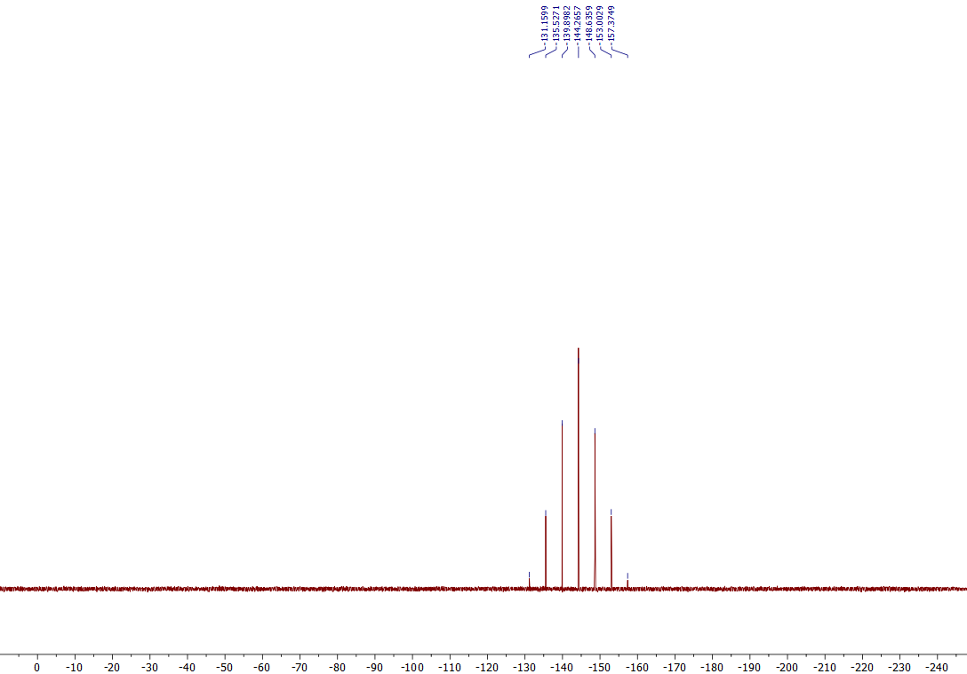
³¹P NMR of the 10a (162 MHz, Acetone-d₆)

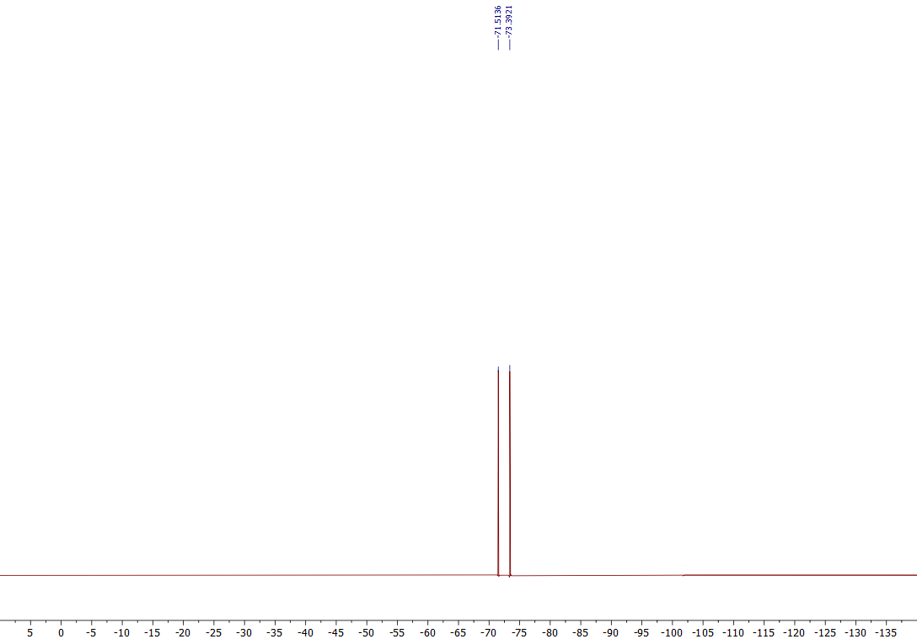
¹⁹F NMR of the 10a (376 MHz, Acetone-d₆)

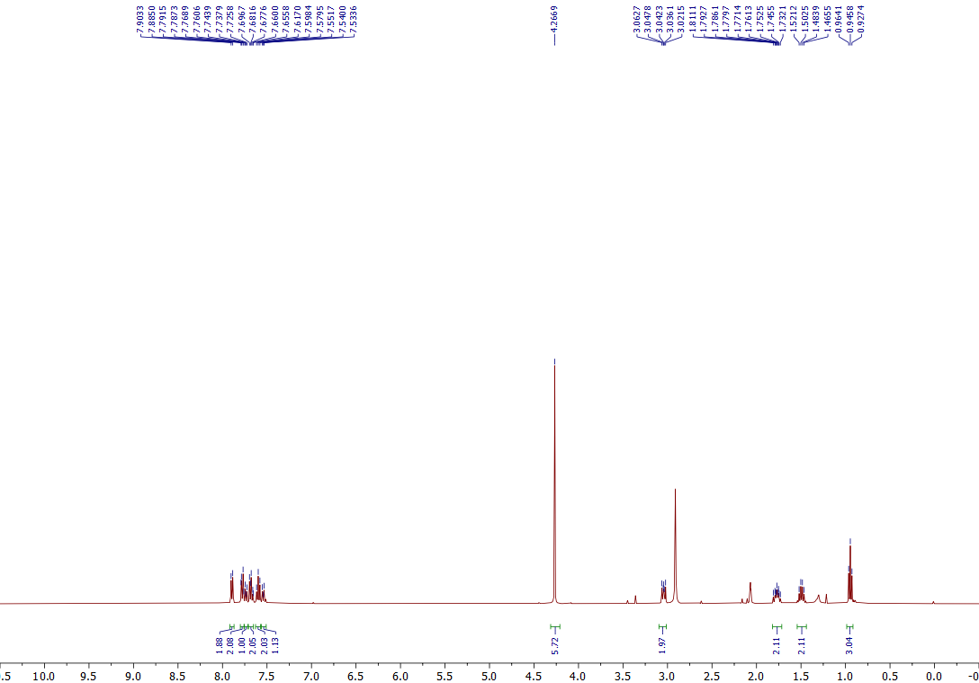
¹H NMR of the 10b (400 MHz, Acetone-d₆)
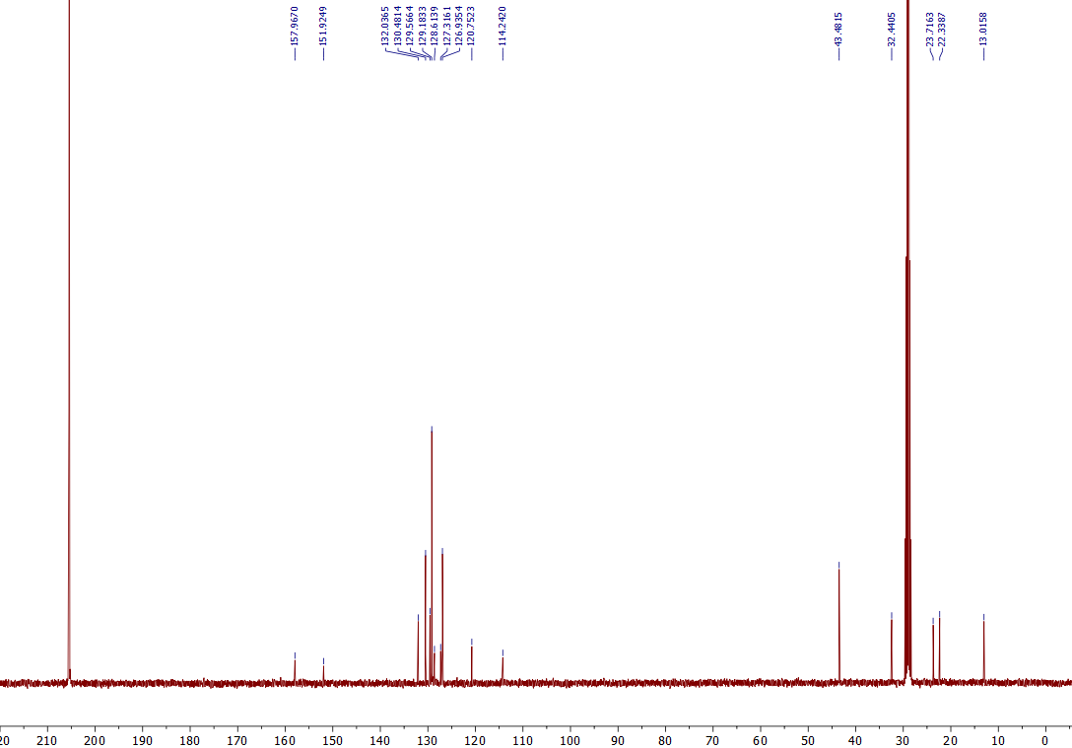
¹³C NMR of the 10b (101 MHz, Acetone-d₆)

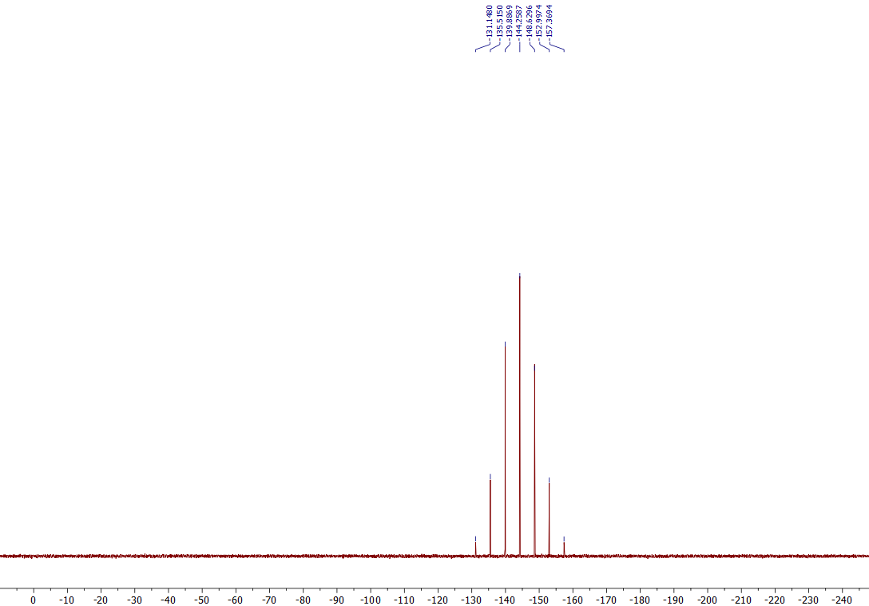
³¹P NMR of the 10b (162 MHz, Acetone-d₆)
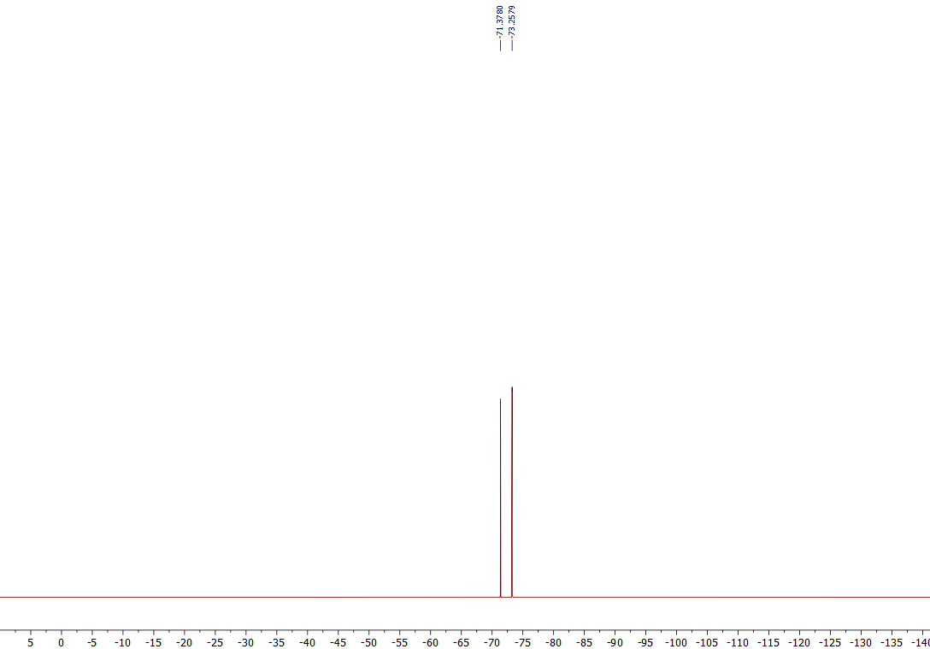
¹⁹F NMR of the 10b (376 MHz, Acetone-d₆)

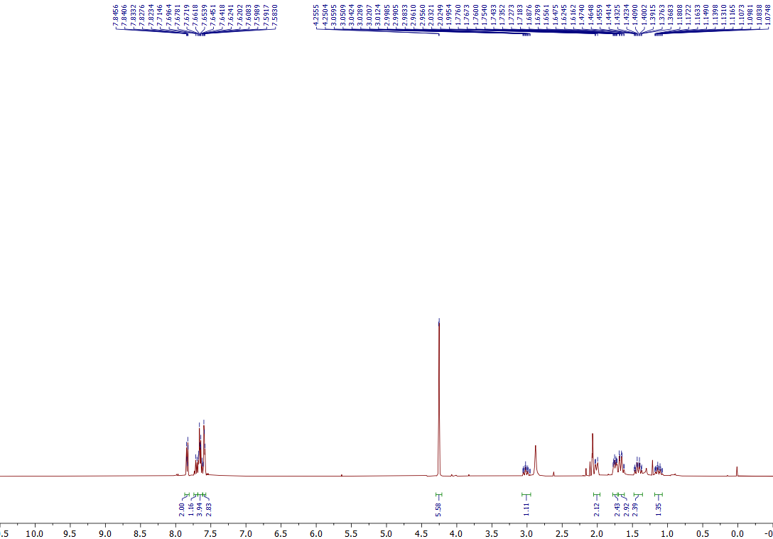
¹H NMR of the 10c (400 MHz, Acetone-d₆)

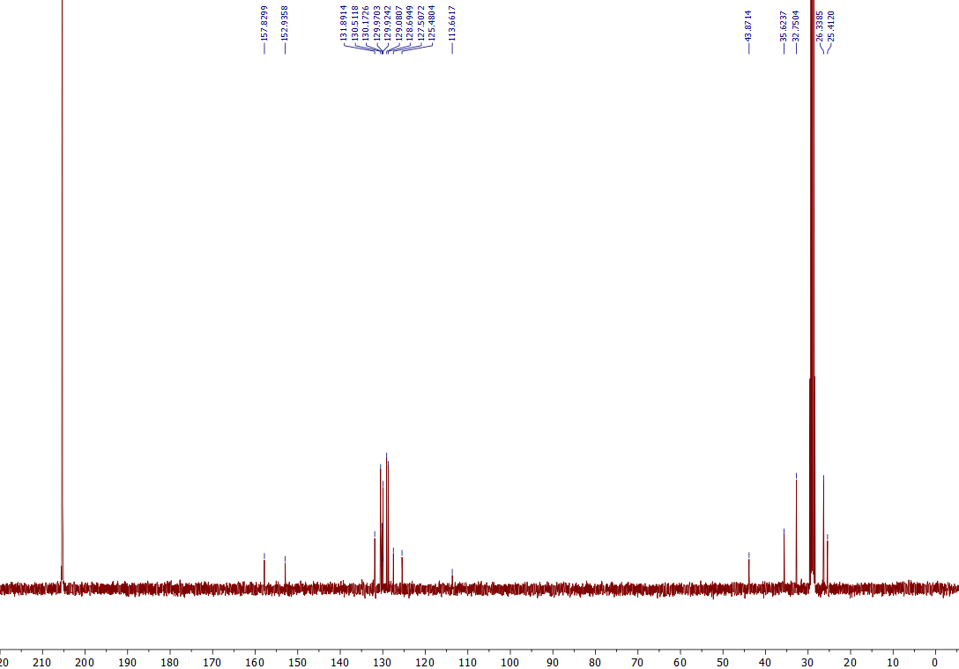
¹³C NMR of the 10c (101 MHz, Acetone-d₆)

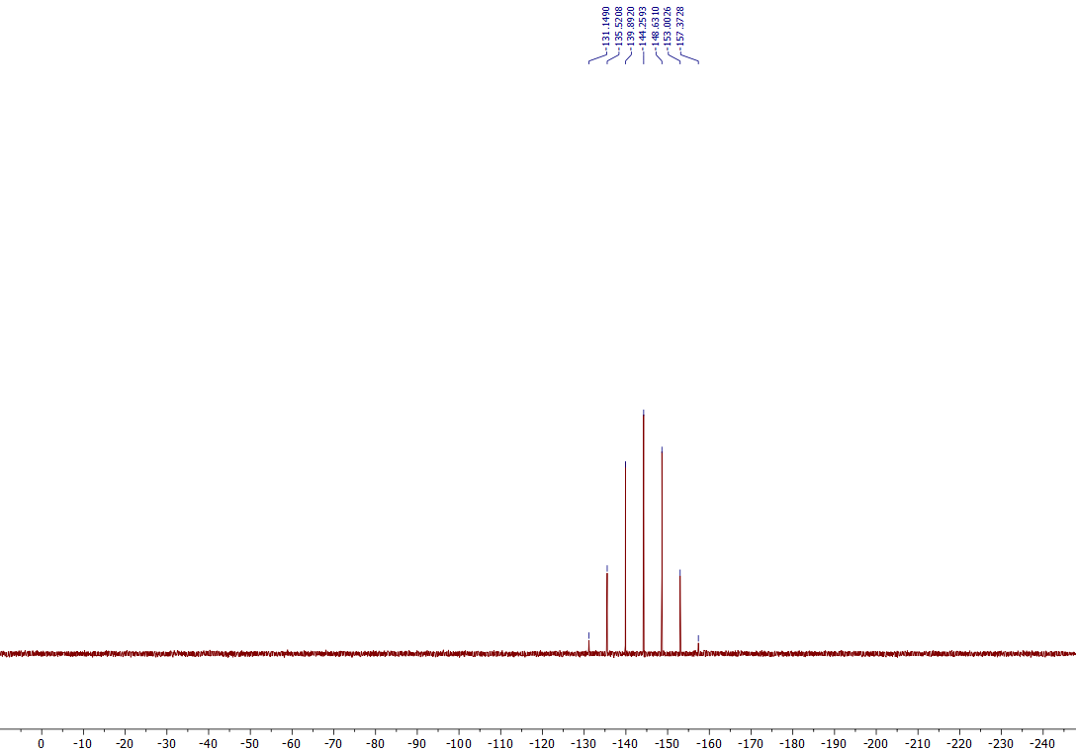
³¹P NMR of the 10c (162 MHz, Acetone-d₆)
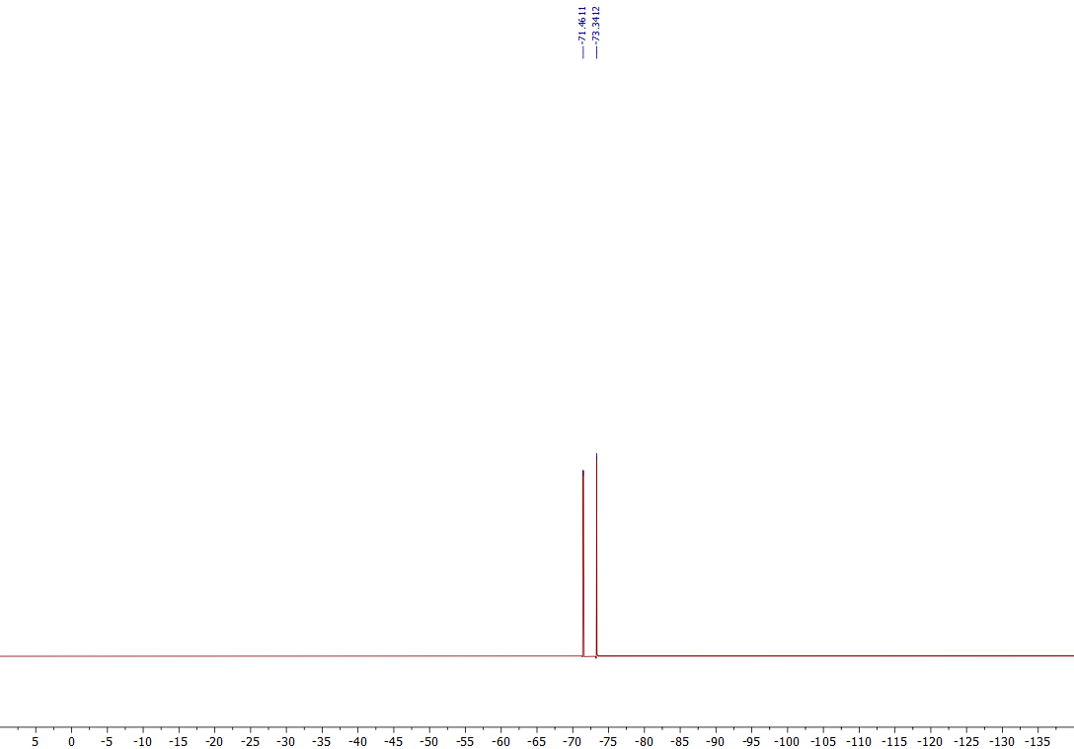
¹⁹F NMR of the 10c (376 MHz, Acetone-d₆)

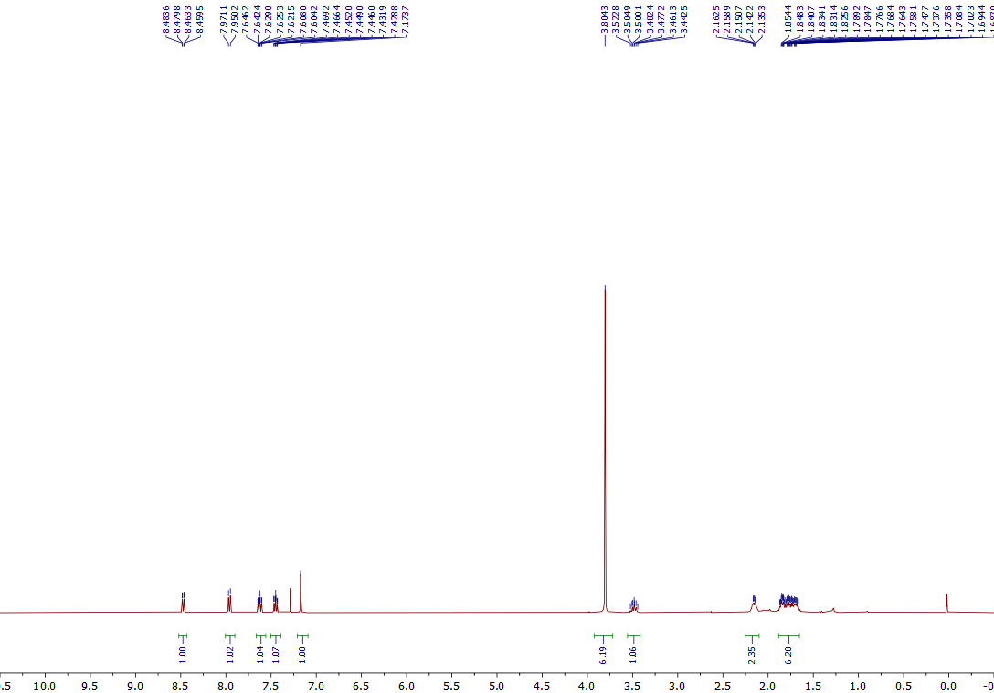
¹H NMR of the 11a (400 MHz, CDCl₃)
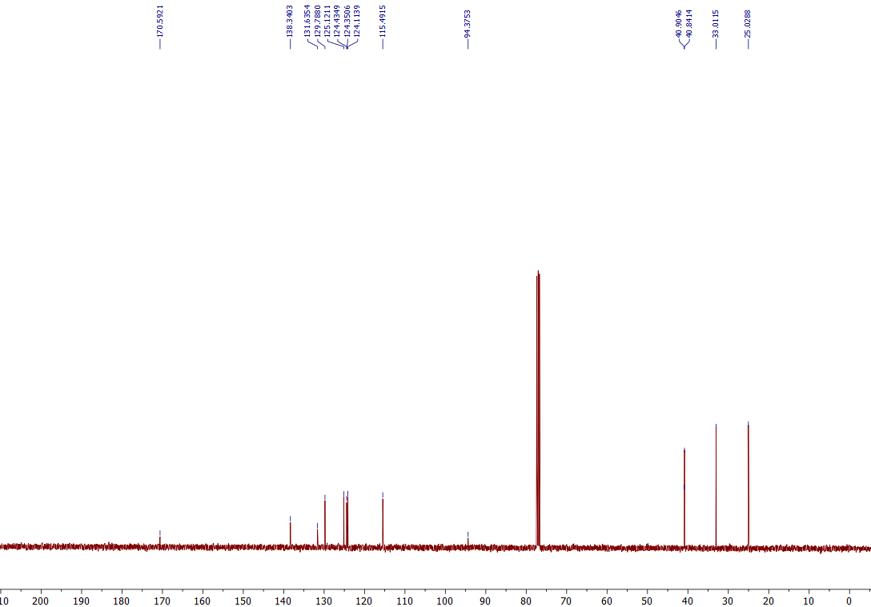
¹³C NMR of the 11a (101 MHz, CDCl₃)
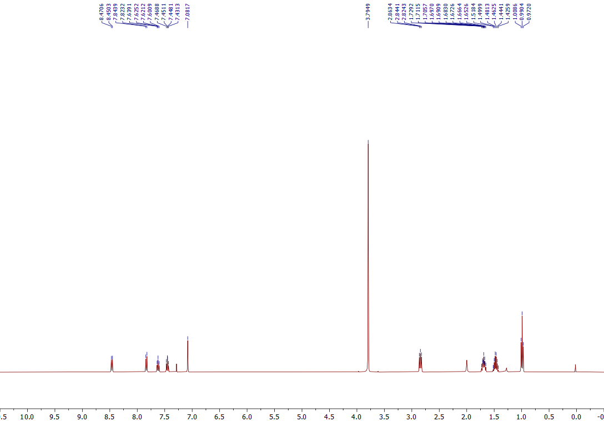
¹H NMR of the 11b (400 MHz, CDCl₃)
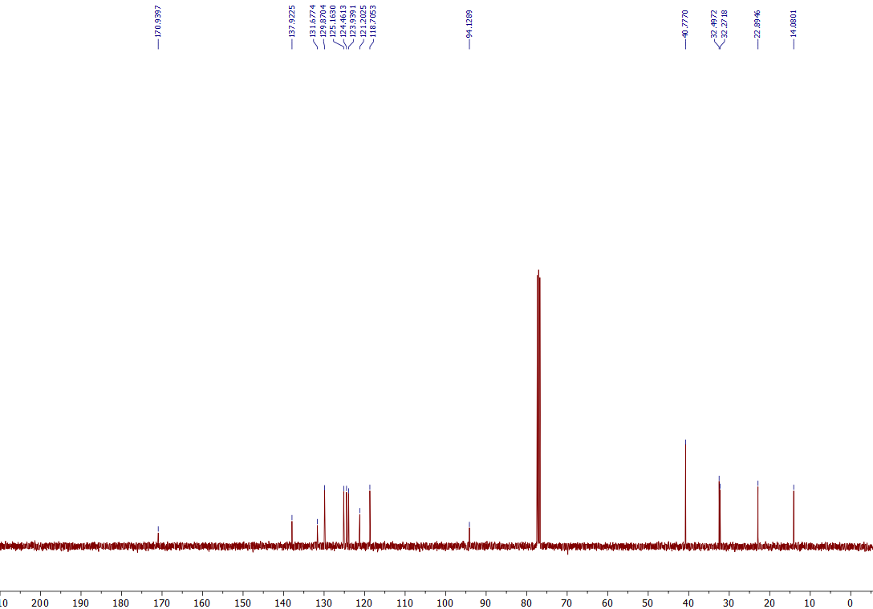
¹³C NMR of the 11b (101 MHz, CDCl₃)
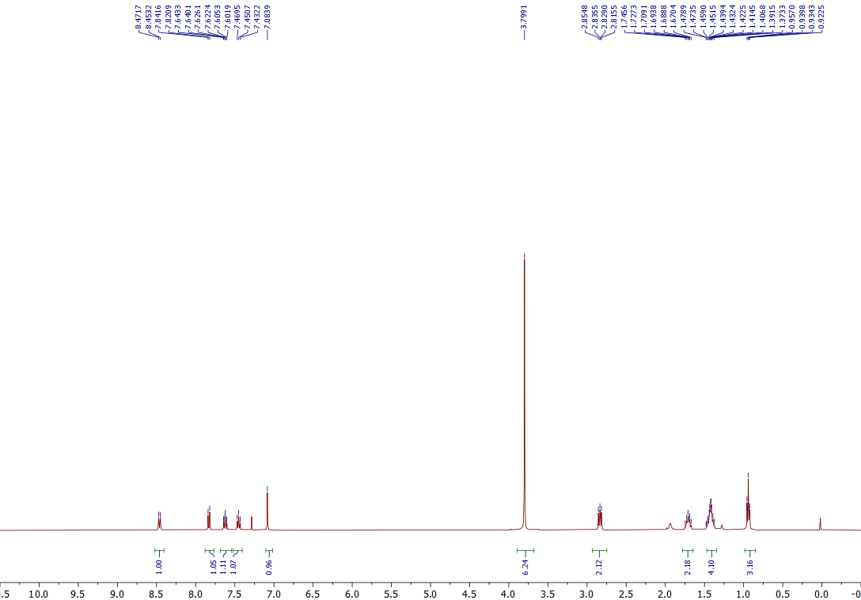
¹H NMR of the 11c (400 MHz, CDCl₃)
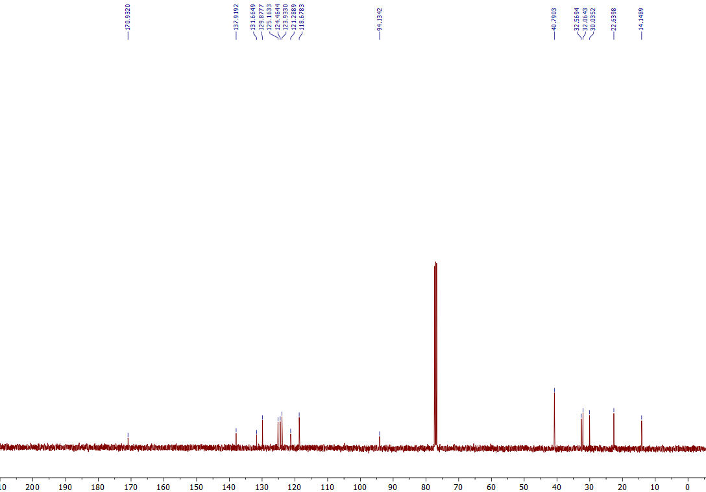
¹³C NMR of the 11c (101 MHz, CDCl₃)
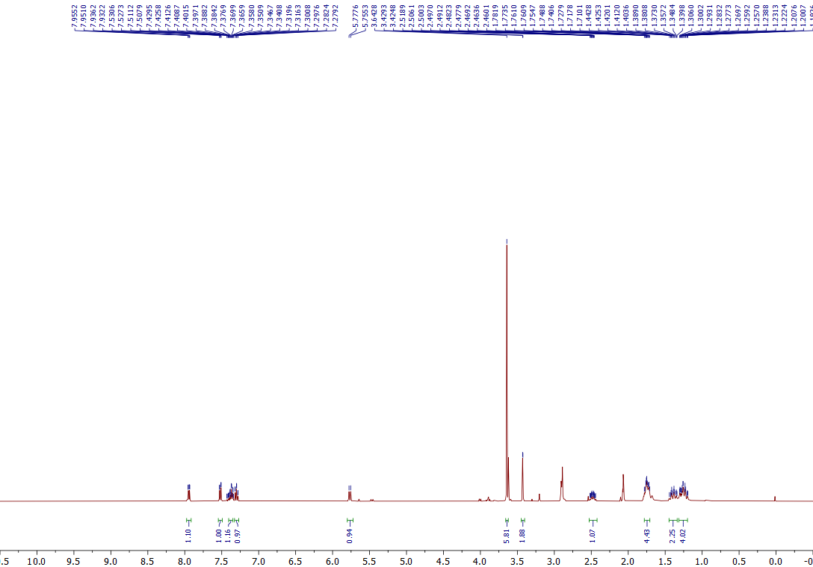
¹H NMR of the 12 (400 MHz, Acetone-d₆)
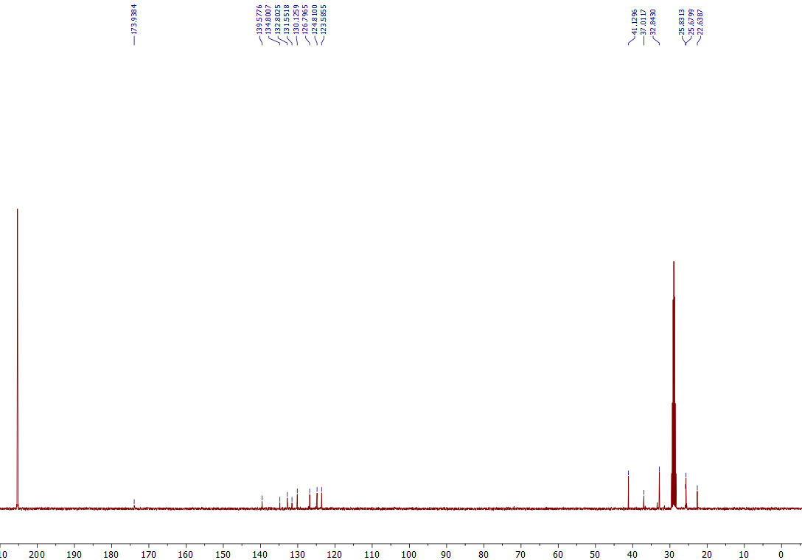
¹³C NMR of the 12 (101 MHz, Acetone-d₆)

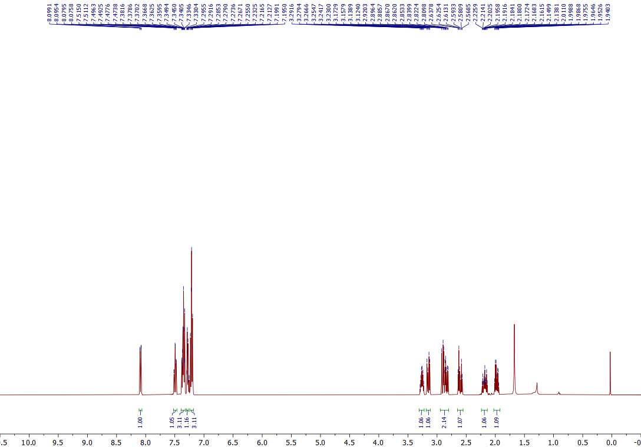
¹H NMR of the 8 (400 MHz, CDCl₃)
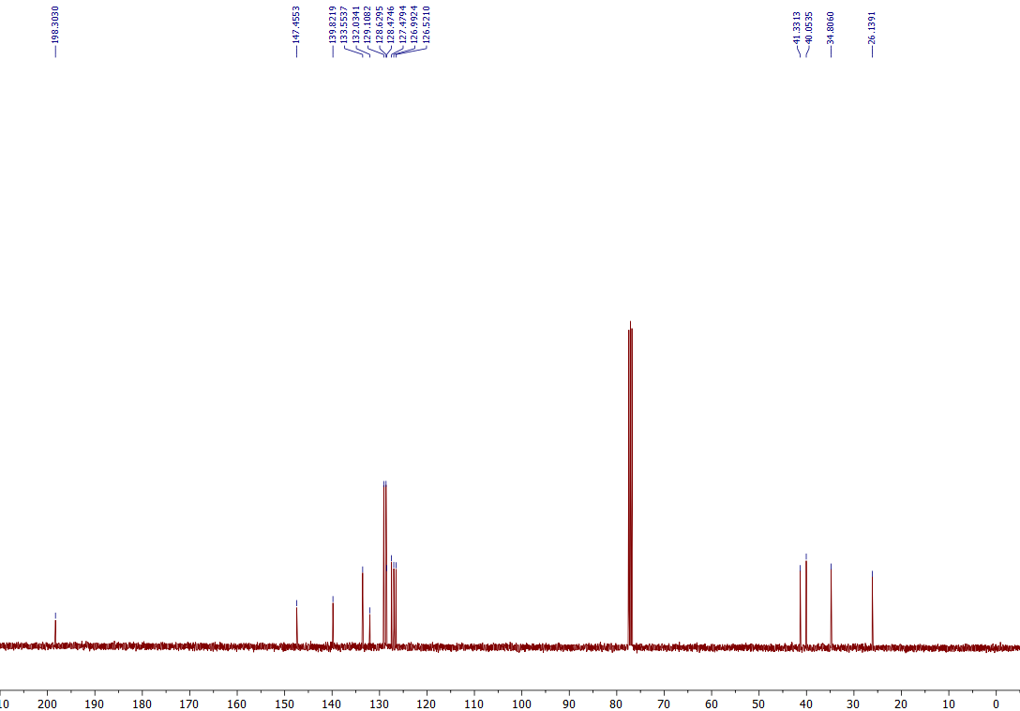
¹³C NMR of the 8 (101 MHz, CDCl₃)
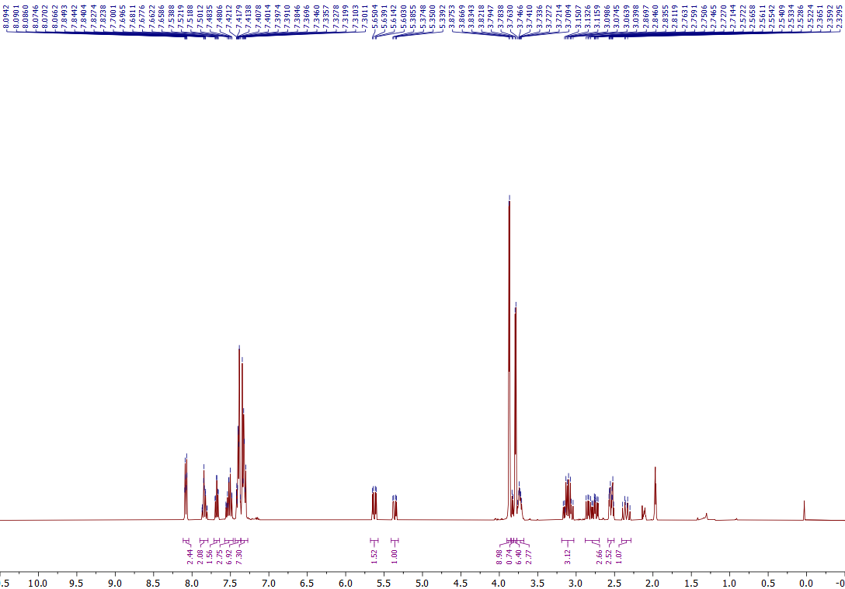
¹H NMR of the 9 (400 MHz, CD₃CN)
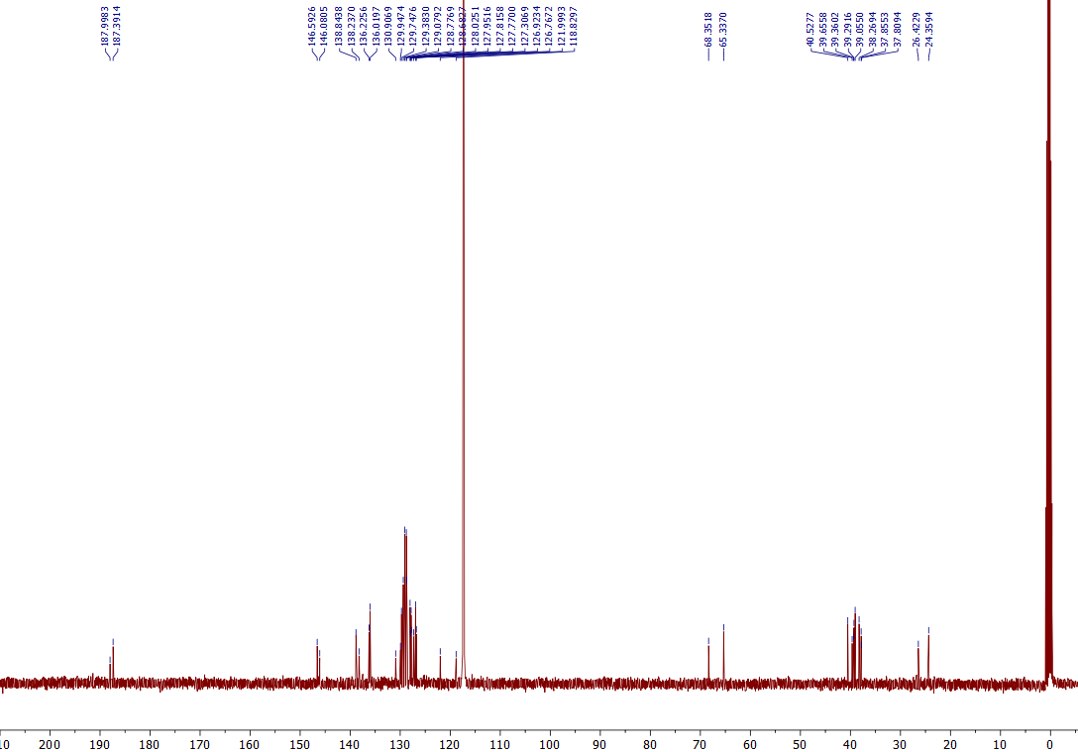
¹³C NMR of the 9 (101 MHz, CD₃CN)

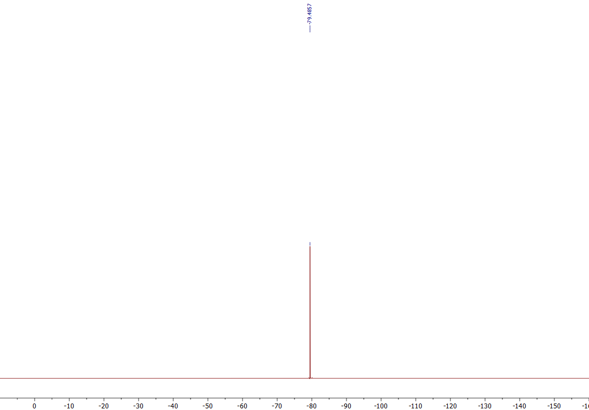

¹⁹F NMR of the 9 (376 MHz, CD₃CN)

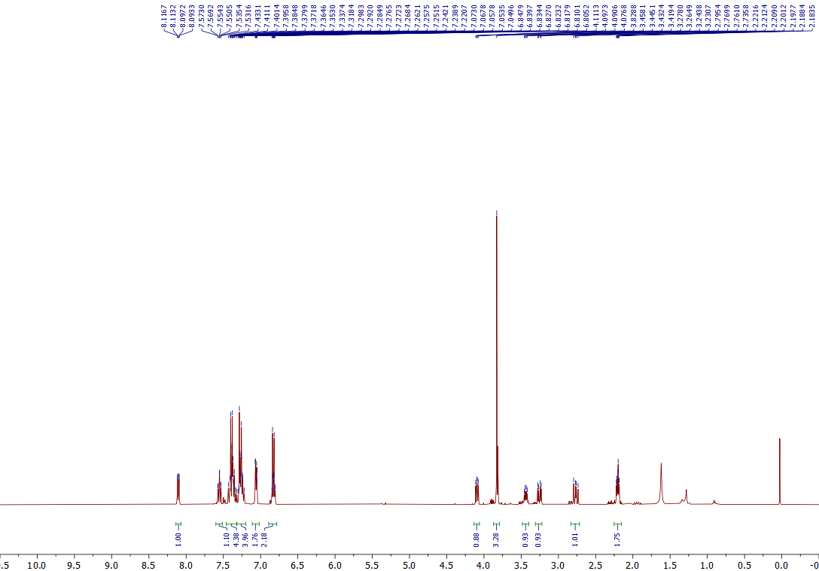
¹H NMR of the 10 (400 MHz, CDCl₃)
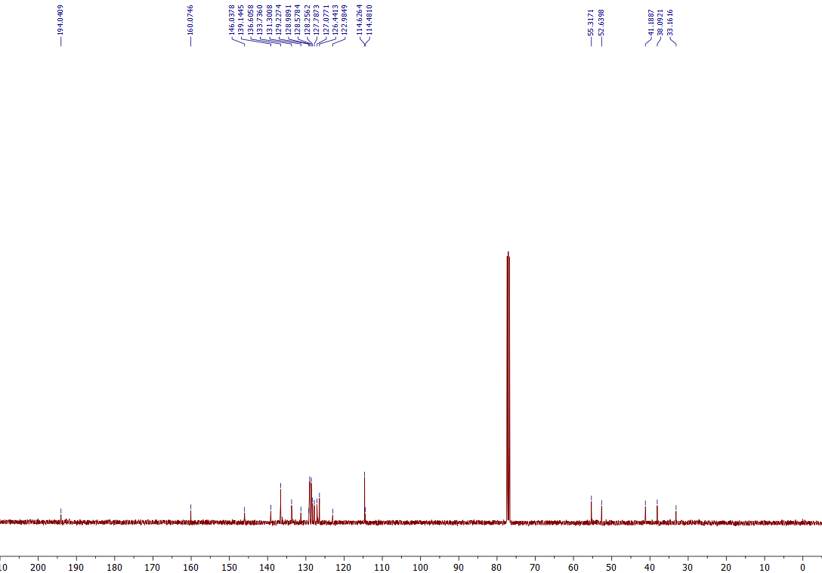
¹³C NMR of the 10 (101 MHz, CDCl₃)

¹H NMR of the 11 (400 MHz, CDCl₃)
¹³C NMR of the 11 (101 MHz, CDCl₃)
¹H NMR of the 12 (400 MHz, CDCl₃)
¹³C NMR of the 12 (101 MHz, CDCl₃)

¹H NMR of the 13 (400 MHz, CDCl₃)
¹³C NMR of the 13 (101 MHz, CDCl₃)

