Table 1 The expression levels of the six lncRNAs
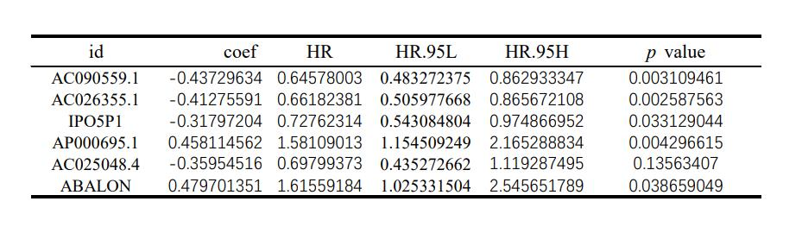

Table 2 Representative results of Gene Set Enrichment Analysis
