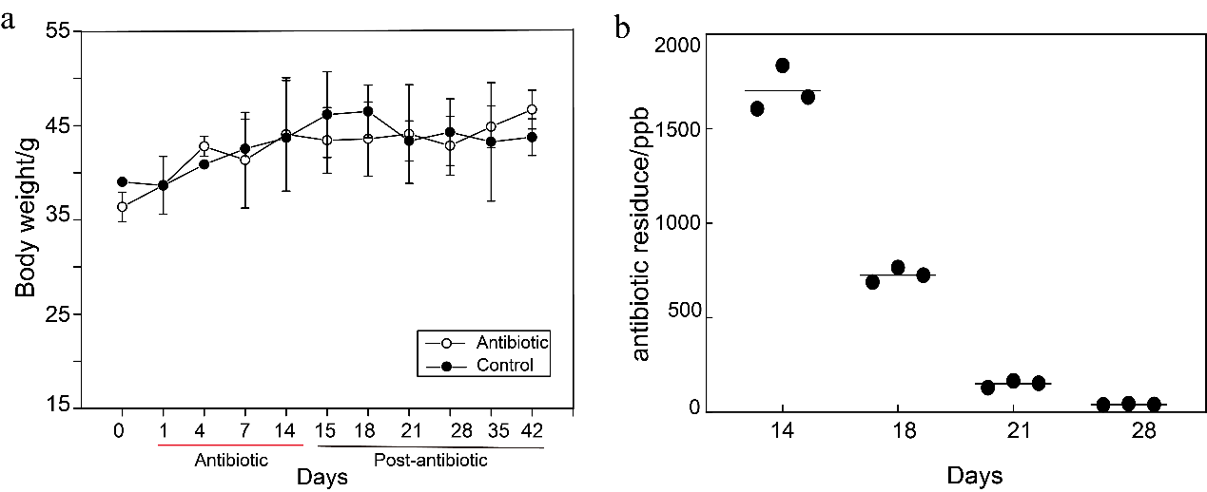 Fig. S1. a Variation of weight of the sampled crayfish before, during and after exposure to enrofloxacin. b Residue of enrofloxacin in muscle of the crayfishes fed with the medicated feed for 14 days.

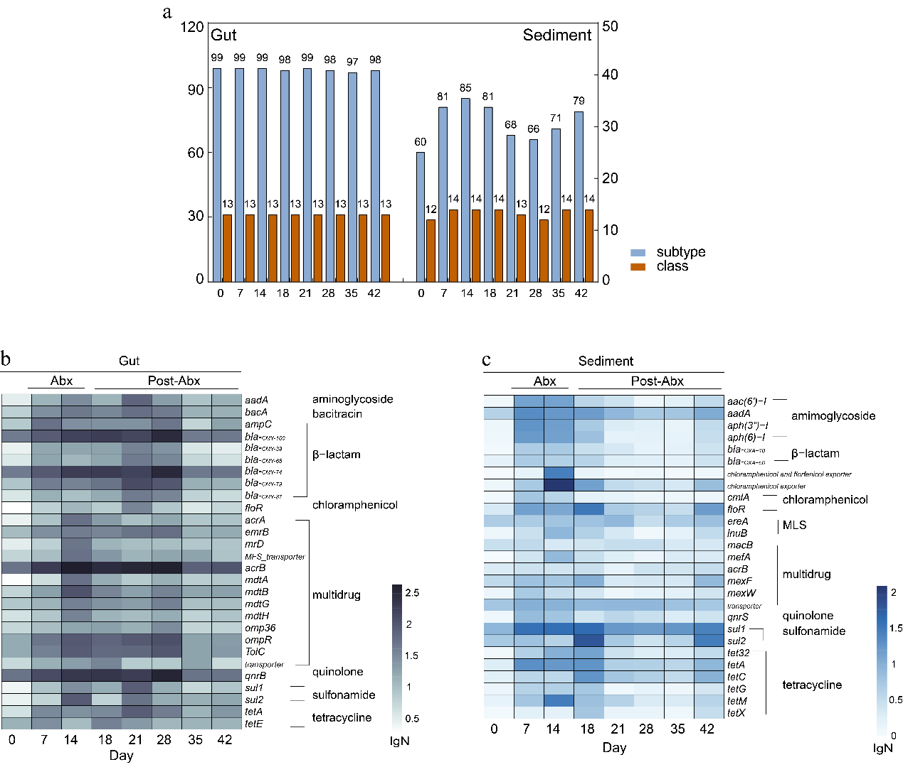
Fig. S2 Effect of the antibiotic Enrofloxacin on the ARGs coding for different antibiotic classes before, during and after enrofloxacin exposure in the gut of crayfish and sediment. a Change of ARGs in the subtype and class in the gut and sediment. The heatmap of the relative abundance of the core ARGs in the gut (b) and sediment (c).

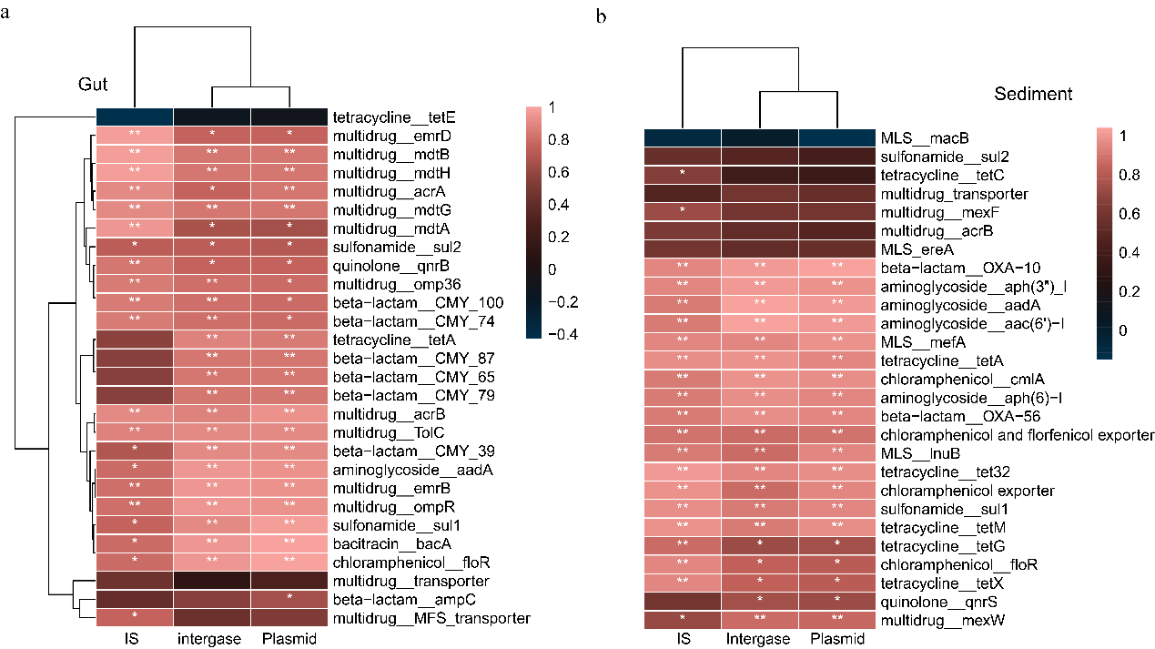
Fig. S3 Correlation between the relative abundance of the core ARGs and groups of MGEs (Plasmid, Intergron, IS) in the guts of crayfish (a) and sediment (b). The color scale shows the spearman’s correlation.
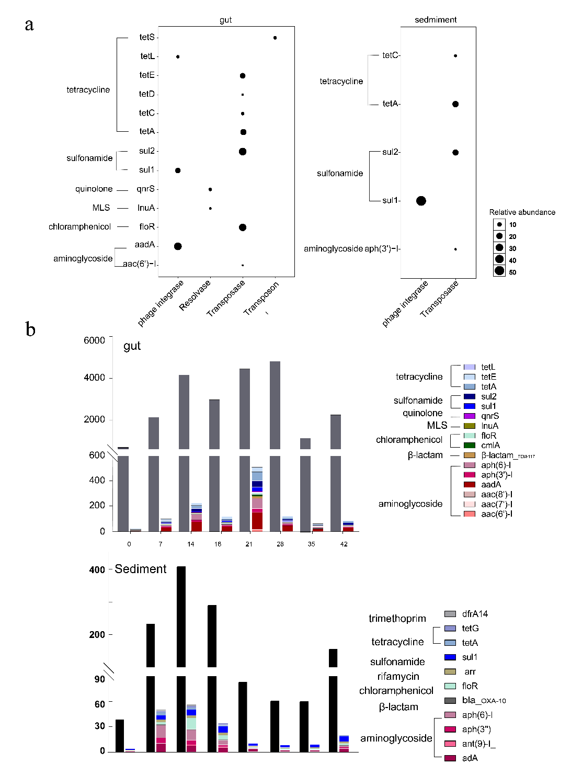
Fig. S4 a The relative abundant of ARGs flanked by MGEs in the gut of crayfish and sediment before, during and after antibiotic exposure. b Antibiotic resistance genes from plasmid origins. Relative abundance of contigs (>1 kb) identified as a plasmid sequence (dark blue) and plasmid sequences carrying ARGs (colours).
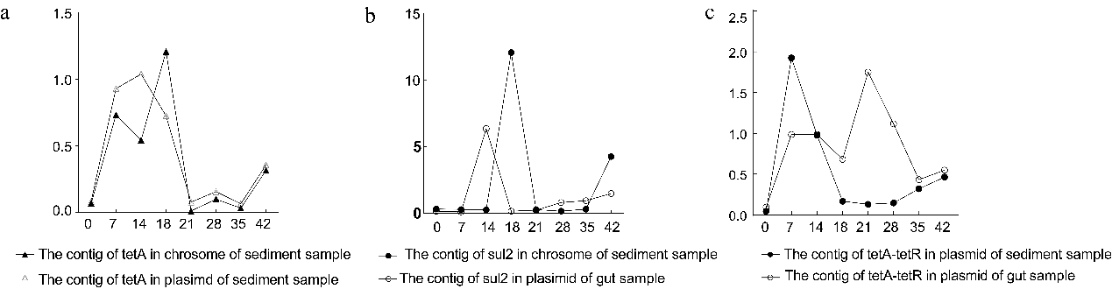
Fig. S5 Change of the relative abundance of contigs included the transposase sequence of different ARGs. a Relative abundance of contigs harboring the ARGs group (tetA, tetR, MFS) and a IS91 transposase gene in Pseudomonas aeruginosa NCGM257; b Relative abundance of contigs harboring the sul2 gene and Tnp_IS 1595 transposase gene; c Relative abundance of contigs harboring tetR and tetA group and a nearby transposon of Tn3 family.

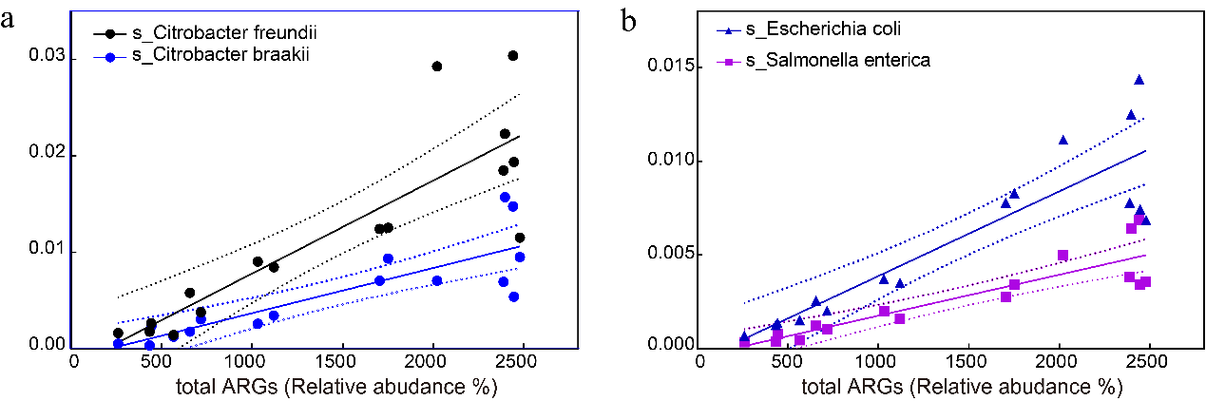
Fig. S6 The correlation analysis between ARGs and microbiome in gut of crayﬁsh. a Correlation of the relative abundance of the total ARGs and the species of Citrobacter freundii and Citrobacter braakii. b Correlation of the relative abundance of the total ARGs and the species of Escherichia coli and Salmonella enterica. The black line indicates the regression model and the grey area correspond to the 95% confidence interval.

Sample | Raw_total_reads | average raw reads/sample | Clean_total_reads | average clean reads/sample | unique OTUs
Gut content | 5068759 | 211198±40578 | 5037129 | 209880 ± 40384 | 4567
sediment | 2430043 | 101252 ± 7102 | 2375097 | 98962±7045 | 1578
Table. S1 List of 16S rRNA sequencing results of gut contents and sediment sample.

Day | phage  integrase | Transposase | transposon | Total  MGE | plasmid
Gut samples
0 | 0.1 | 0.35 | 0.03 | 0.53 | 2.8
7 | 0.23 | 0.48 | 0.01 | 0.753 | 3.88
14 | 0.22 | 1.22 | 0.02 | 1.483 | 5.38
18 | 0.31 | 0.242 | 0.03 | 0.61 | 3.28
21 | 0.91 | 0.592 | 0.002 | 1.54 | 9.48
28 | 0.14 | 0.34 | 0.006 | 0.5 | 2.1
35 | 0.24 | 0.79 | 0.08 | 1.14 | 4.6
42 | 0.25 | 0.38 | 0.03 | 0.69 | 2.36
Sediment samples
0 | 6.02 | 0.95 |  | 6.96 | 11.77
7 | 4.37 | 2 |  | 6.37 | 21.977
14 | 3.04 | 0.87 |  | 3.91 | 147
18 | 5.09 | 4.71 |  | 9.8 | 12.17
21 | 6.1 | 0.83 |  | 6.98 | 13.27
28 | 7.58 | 0.72 |  | 8.3 | 13.77
35 | 7.69 | 0.9 |  | 8.59 | 14.48
42 | 6.27 | 3.26 |  | 9.54 | 13.45

Table. S3 Percentage of ARGs co-occurring with MGEs / total ARGs before, during, and after antibiotic exposure.
*Total MGE includes integrase, transposase, transposon.

