Supplements:

Patient 2
The female child was born in the 29th week of pregnancy (29+6) with weight at birth of 1200 g in our facility. She was acceptor in a fetofetal transfusion syndrome and suffered from neonatal sepsis and supposed hematogenous ventriculitis.
Clinical presentation: Eutroph, no spontaneous breathing, no spontaneous movement upon stimulation. Immediate Intubation and supportive artificial respiration. Tranfser to N-ICU under cardiorespiratoric stable conditions.
Cranial sutures open (sag. 5 mm, lambda 2mm, squamosa 2mm), bulging fontanel. Eyes closed, pupil not examinable, no spontaneous movement of eyelids or bulbus. Spontaneous movement of all 4 limbs, symmetrical.
Course of treatment: Initial ultrasound examination of the brain showed extensive periventricular leukomalacia (not shown). There were no signs of acute hydrocephalus. The cardiorespiratoric state did not allow explorative surgery at that moment. After stabilization of heart and lung function, 4 weeks postnatum, the child developed symptoms of intracranial pressure and a convulsive tendency. An ultrasound confirmed hydrocephalic configuration (suppl. figure 2 A-D). The latter was treated with levetiracetam, an operative procedure was postponed in regard of the still critical cardiorespiratoric state. After stabilization, we performed an MRI of the neurocranium (suppl. figure 2 E-F), which showed a massive hydrocephalus e vacuo with multiple septs and cysts, homoechogenous coagula and approximately 2-3 mm of brain parenchyma left. We indicated a ventricular punction and relieved CSF 7 weeks after birth for further investigation. The CSF drainage had to be repeated at week 10 after birth. There was no sufficient drainage and prolonged increase in the hydrocephalic configuration in ultrasound. Protein levels were constantly elevated (suppl. figure 1). An EVD was implanted 11 weeks after birth. Simultaneously, the child suffered from sepsis with bacillus cereus, supposedly via contamination of breast milk. The sepsis spread to the ventricular system, causing a bacillus cereus-ventriculitis. The infection was treated with vancomycin and meropenem i.v. and vancomycin intrathecal. The drainage clotted after a few days, the child was reconvalescent nonetheless.
Due to further increase in head perimeter, the EVD was revised and we indicated an endoscopic exploration of the ventricular system 13 weeks after birth. The endoscopy showed multiple fibrotic septations and foam-like structures of the remaining brain tissue. The anatomy of the ventricular system was nullified. The foramina of Monro were supposedly presentable. We performed a resection of multiple septs via coagulation and sharp resection, the ventricular system was lavaged extensively. An anti-bacterial drainage was implanted and continuously rinsed with NaCl.
Head perimeter further increased despite continuous drainage of CSF. We performed a MRI of the head at 14 weeks after birth (suppl. figure 3 A-B), which showed further increase in ventricle size and isolation of the right side ventricle. We indicated revision and repeated endoscopic exploration. We saw a fibrinous septation of the enlarged ventricular system. The anatomy of the foramina of Monro was presentable due to extensive resection and preparation. An inter-ventricular stoma could be established. An EVD was implanted at the contralateral side, the residual catheter was explanted.
An ultrasound examination showed repeated enlargement of the rightside ventricle and cystic structure and indicated another endoscopy (suppl. figure 3C). The procedure revealed protein-rich CSF in an enlarged, yet a less septated ventricle system. The connection to the foramina of Monro and between both side ventricles was reestablished. The ventricular system was lavaged once again profusely. The ventricular catheter was explanted and a new BactiSeal™ catheter was implanted.
The ventricular system was rinsed every day for the following weeks. CSF protein levels decreased (suppl. figure 1)) under continuous drainage and rinsing of the EVD. The EVD had to be revised multiple times due to CSF infection with Staph. epidermidis. We performed an MRI of head and skull and saw yet more reduction of brain parenchyma (suppl. figure 3 D). In interdisciplinary consensus and in reconcilement with the child’s parents further treatment was therefore palliative. According to our documentation, the child reached at least an age of 6.

CSF Parameter:
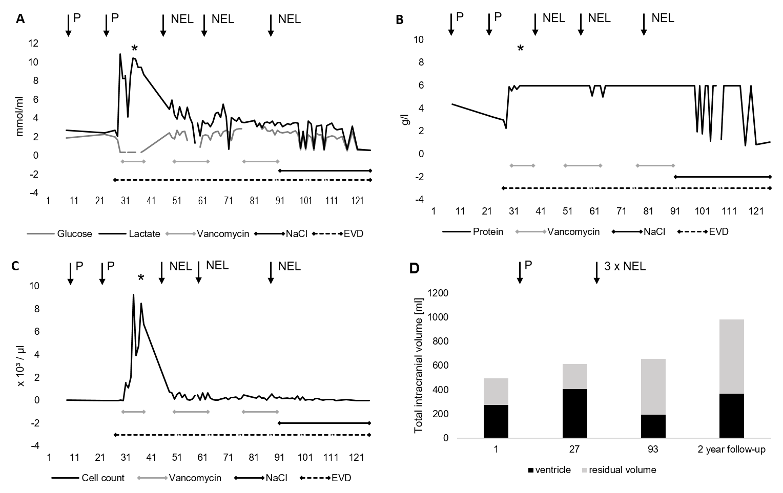
Suppl. Figure 1. CSF (cerebro-spinal fluid) parameter during course of treatment (X-Axis: days of treatment). A: glucose and lactate levels [mmol/ml]. B: protein level [g/ml] and C: cell count [x 10³/µl]. D: volumetry of total intracranial volume and ventricle volume, residual volume [ml]. EVD: external ventricular drainage was in situ. Vancomycin: vancomycin was installed 1 t/d with 5 mg in 5 ml NaCl (sodium chloride). P: punction of the ventricle. NEL: neuro-endoscopic lavage was performed.
*B. cereus has been confirmed in CSF.
Suppl. Figure 2. female preterm neonate (29th week of pregnancy) with past of intracranial hemorrhage and hydrocephalus. Initial ultrasound (adjusted age of 33th +1. week of pregnancy) (A, B): Hydrocephalus (Area A: 3.2 cm² Area B: 6.2 cm²), narrow band of brain parenchyma, periventricular leukoencephalopathy. Follow-up ultrasound (adjusted age 35 + 6. week of pregnancy) (C, D): increased hydrocephalus (Area A: 9.8 cm²Area B: 11,3 cm²). Follow-up MRI (adjusted age 36th + 0. week of pregnancy): 3T MRI scanner T2-weighted image in axial (E) and sagittal (F) orientation: massive hydrocephalus and very thin band of brain parenchyma.
Suppl. Figure 3. Follow-up MRI (adjusted age of one month): 3T MRI scanner T2-weighted image in axial (A) and sagittal (B) orientation, correlating ultrasound (C): massive hydrocephalus with multiple septations, midline shift towards left side, IVD in left ventricle. Follow-up MRI (adjusted age of three month): 3T MRI scanner T2-weighted image in axial orientation (D-F): new isolated dilatation of 4th ventricle (E, F) – suspected blocked aqueduct.

Patient 4
The patient was born in the 24th week of pregnancy (24+3) via c-sectio with a weight at birth of 580 g. She suffered from amnion infection syndrome. Besides typical symptoms of prematurity, the child was intubated and artificially respirated right after birth. Circuclation was always stable. Sonografically, we saw an alteration in plexus choroideus in the initial ultrasound; 14 hours after birth she suffered from IVH II° on the right ventricle (suppl. figure 5).
Course of Treatment: We administered fresh frozen plasma (FFP) and Factor VII; nonetheless the IVH increased to grade IV at day 4 after birth and expanded onto the parenchyma and led to a midline shift. From day 6 to 20 post partum ventricle size (suppl. figure 5) increased further, so EVD implantation was necessary. It occluded at day 26 and was explanted. Due to further hydrocephalic configuration, it had to be re-implanted at day 31. From day 51-59 tPA was installed to resolve blood clots. The EVD was removed at day 59. Due to repeated increase in ventricle size it was once again implanted at day 64. It was regularly rinsed till a VPS was implanted at day 113. The child was released shortly after.
Resubmission occurred 2 weeks later due to signs of intracranial hypertension. A ventricle punction through the anterior fontanel was undertaken and relieved intracranial pressure. We indicated operative VPS revision but further treatment was afterwards denied by the child’s mother and the child once again released.
The child was once again submitted at 7 months after birth with clinical signs of VPS infection. Ultrasound showed unspecific sludge in the ventricle system. We indicated VPS explantation, initiated antibiotic treatment with vancomycin/meropenem and performed NEL of the ventricle system followed by EVD implantation. We started intraventricular vancomycin installation and rinsed the venticular system with NaCl (suppl. figure 4). The EVD had to be revised repeatedly due to dislocation. EVD could be removed, yet ventricle size was increasing in the following ultrasound controls. We performed an MRI (suppl. figure 6) which showed multiple septs and cysts in the ventricular system. We neuroendoscopically implanted an antiseptic side-to-side shunt to the left ventricle that was connected to a Rickham-reservoir inside the right ventricle. The reservoir was regularly used to relieve CSF for at least two weeks. Finally, protein levels and sterile CSF allowed ventriculo-atrial shunt (VAS) implantation as peritoneal resorption was limited due to multiple abdominal surgeries and perforations of the ileum. The VAS implantation was complicated by a major hemorrhage of the jugular vein and had to be terminated mid-procedure. The VA-system was explanted and once again replaced by a rickham reservoir after the child was in stable cardiorespiratoric condition. The reservoir was regularly relieved. In the following course, CSF parameter allowed VAS re-implantation; following the parents wish the child was submitted to another clinic for the procedure.

CSF Parameter:
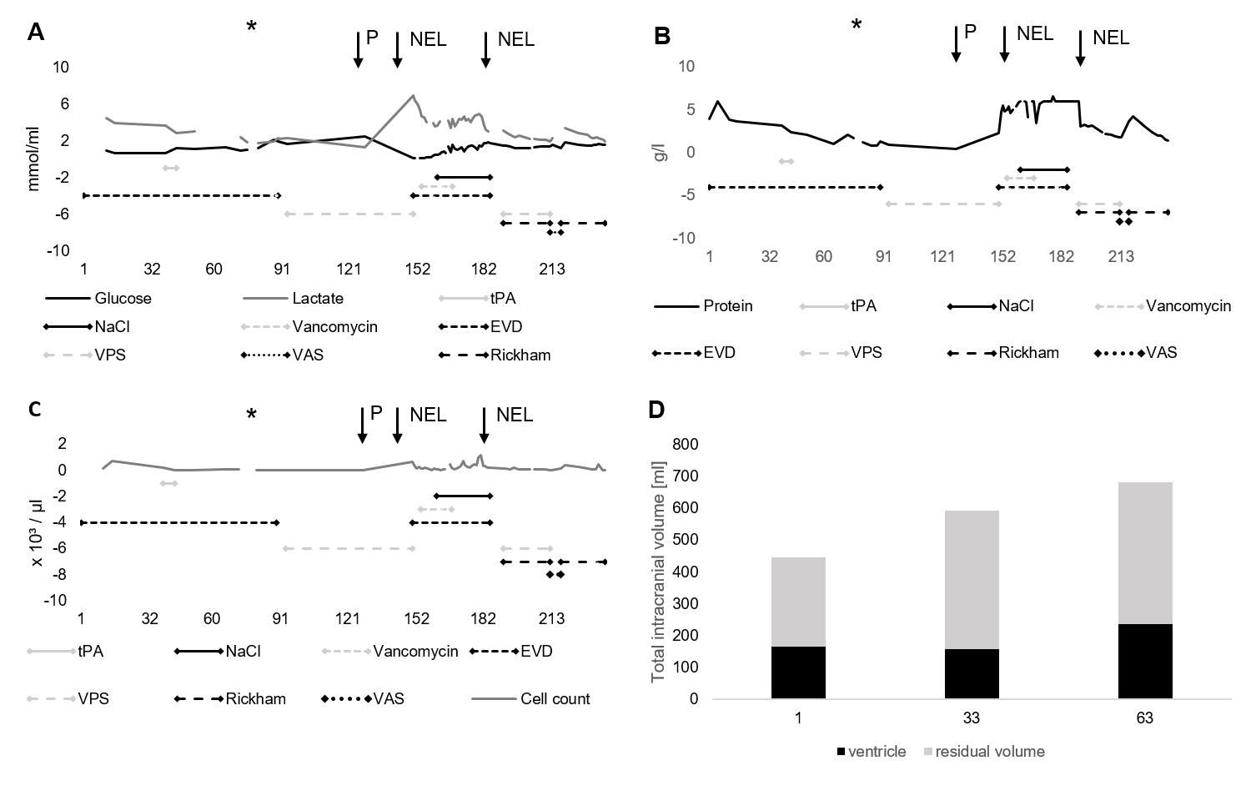
Suppl. Figure 4: CSF (cerebro-spinal fluid) parameter during course of treatment (X-Axis: days of treatment). A: glucose and lactate levels [mmol/ml] during the course of treatment. B: protein level [g/ml] and C: cell count [ x 10³/µl]. D: volumetry of total intracranial volume and ventricle volume, residual volume [ml]. Vancomycin:vancomycin was installed once daily with 5 mg in 5 ml NaCl. NaCl: Sodium chloride was installed with 10 ml 3 times daily. EVD: external ventricular drainage in situ. tPA: time when rtPA (recombinant tissue type plasminogen activator) was installed with 0.5 mg daily. NEL: neuro-endoscopic lavage. VPS: ventriculo-peritoneal shunt in situ. P: punction of ventricle. Rickham: Rickham reservoir in situ. VAS: ventriculo-atrial shunt in situ.
*: detection of S. epidermidis in CSF.
Suppl. Figure 5: Female preterm neonate with past of amnion infection syndrome. Initial ultrasound (corrected age 36 + 2nd week of pregnancy) (A,B): internal hydrocephalus, left sided EVD (A), Left ventricular area: 14.4 cm²; Right ventricular area B: 8.0 cm² in (B). MRI (corrected age 36 + 4th week of pregnancy): 3T MRI scanner, T2 weighted image in axial (C) and sagittal orientation (D): marked parenchymal necrosis and evacuo enlargement of the lateral ventricles.
Suppl. Figure 6. Follow up MRI (corrected age three months): 3T MRI scanner, T2 weighted image in axial (A) and sagittal orientation (B) with left-sided IVD. Follow up MRI (corrected age seven month) 3T MRI scanner, T1 weighted, non-contrast enhanced image in axial (C) orientation and T2 weighted CISS Sequence image in coronal orientation (D): new septations and midline shift towards left side.

Patient 5
The child was born via planned cesarean section after 34th week and five days of pregnancy. Prior, intrauterine ultrasound examinations revealed a hydrocephalic configuration with suspected aqueduct stenosis.
Clinical presentation: Stable cardiorespiratoric state, mild respiratory distress syndrome, weight 2360 g (P 40.0), length 45.0 cm (P 45.0), head perimeter 35.5 cm (P > 97), Apgar score 9 after 10 minutes, symmetric movement of all four extremities, bilateral talipes calcaneus, all cranial sutures open, anterior fontanel 4 × 4 cm, posterior fontanel 3 × 3 cm, no dawn phenomenon.
Course of Treatment: The child was admitted to the intermediate care unit. Ultrasound examinations of the cranium at day of birth presented with massive hydrocephalus and clear CSF so that ventriculo-peritoneal shunting was indicated. The implantation was performed three days after birth (GAV 2.0, 10/30 cm H2O, Miethke, Germany). Ten days later, VPS-ventile revision (peadi GAV, 4/24 cm H2O, Miethke Germany) was performed due to a retro-auricular CSF fistula and consecutive wound infection. Anti-infective therapy was started with vancomycin and cefotaxim. VPS explantation and EVD implantation were performed two weeks after VPS revision due to persistent systemic inflammation. Microbiological examinations revealed ventriculitis with staphylococcus epidermidis. Antibiotic therapy was further escalated with vancomycin, gentamycin, rifampicin and amphotericin B (suppl. figure 7. The child recovered, the external ventricle drainage was removed after 11 days. Repeated ultrasound examination presented decreasing volumes of lateral ventricles (suppl. figure 8 E, F). Child and mother were released home and re-admitted after two days due to growing head size. Ventricle puncture, endoscopic ventricle lavage and re-implantation of an EVD were indicated and performed. Here, ventricle walls appeared with fribrin-like covering that was successfully rinsed out during the procedure. Overall anatomy of inner CSF spaces was regular. EVD weaning failed (suppl. figure 9 E, F), so that a second endoscopic lavage was carried out, accompanied by third-ventriculocisternostomy. Finally, ventricle volumes stabilized and the child could be released from hospital care five days after the last surgical procedure.

CSF Parameter:
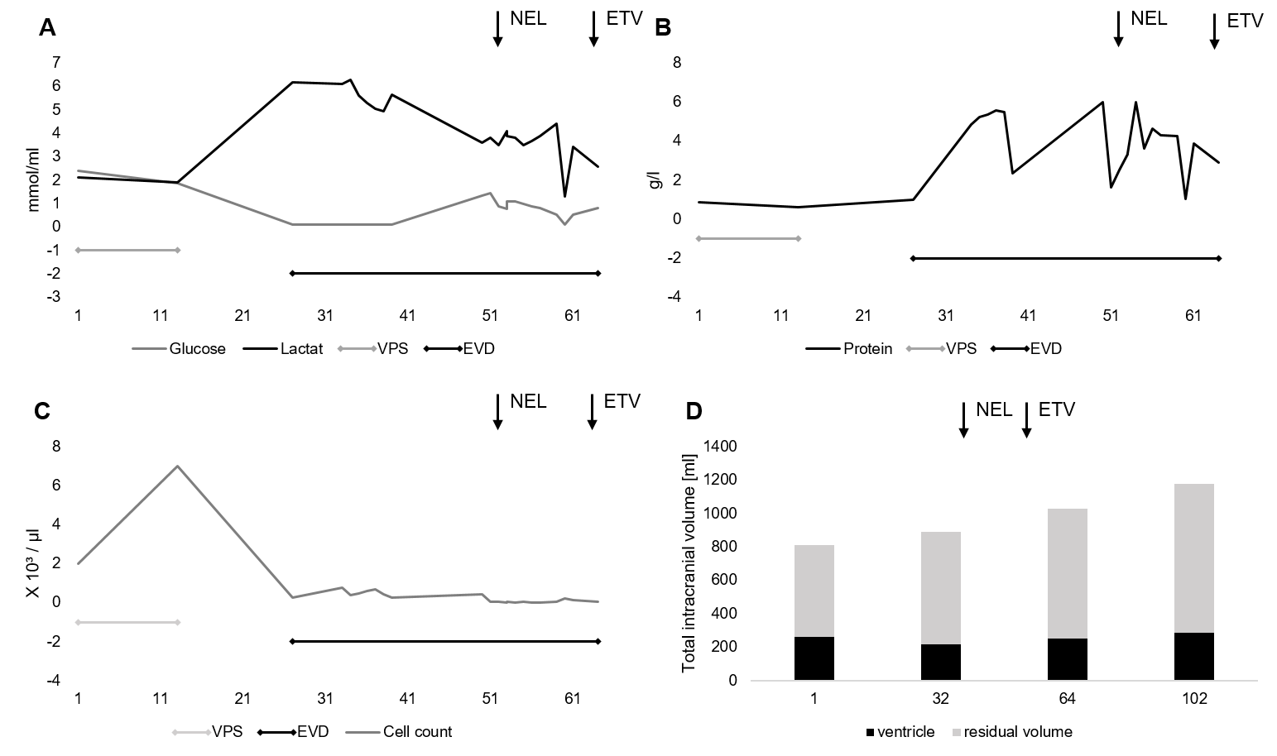
Suppl. Figure 7: CSF (cerebro-spinal fluid) parameter during course of treatment (X-Axis: days of treatment). A: glucose and lactate levels [mmol/ml]. B: protein level [g/ml] and C: cell count [ x 10³/µl]. D: volumetry of total intracranial volume and ventricle volume, residual volume [ml]. Vancomycin: vancomycin was installed once daily with 5 mg in 5 ml NaCl. NaCl: Sodium chloride was installed with 10 ml 3 times daily. EVD: external ventricular drainage in situ. tPA: time when rtPA (recombinant tissue type plasminogen activator) was installed with 0.5 mg daily. NEL: neuro-endoscopic lavage. ETV: endoscopic third ventriculostomy. CSF was sterile through the course of treatment.

Suppl. Figure 8: Female preterm neonate (corrected age 34th + 5. week of pregnancy). Initial ultrasound (A,B): enlarged side ventricles (Area A: 16.8 cm² Area B: 15.6 cm²), bilateral narrowed brain parenchyma. Follow up MRI (corrected age one week, immediately after IVD-implantation): 3T MRI scanner, T2 weighted image in axial (C) and sagittal (D) orientation: internal hydrocephalus, right-sided IVD. Blood sedimentation in dorsal parts of both lateral ventricles. Follow up ultrasound (eight days after IVD implantation) (E, F): decreased internal hydrocephalus, Area A: 12 cm² Area B: 12.2 cm².
Suppl. Figure 9: Follow up ultrasound (corrected age one month): suspected overdrainage because of slit-shaped lateral ventricles (A,B). Follow up ultrasound after revision before release (C,D) Area A: 8.3 cm², Area B: 7.3 cm², decreased width of the lateral ventricles, back to baseline level. E, F: Ultrasound upon re-admission due to growing head circumference. NEL and repeated ETV were performed, which stabilized head perimeter and ventricle size (not shown).

Patient 6
The male child had been operated on a meningomyelocele in utero (24+6) in an external facility. Also, the patient was diagnosed with imperforate anus. Dismembered Colostomy had been performed at day 3 after birth. Additional 3 days later he suffered from severe sepsis caused by S. marcescens, which had been found in bloodstream and CSF. He had been treated with intraventricular application of gentamicin as well as intravenous application of meropenem. An EVD had been implanted 2 weeks after birth and been revised 2 weeks later. He had been treated with anticonvulsants due to ongoing seizures. The child was then admitted to our hospital with acute ventriculitis and increasing ventricle size.
Clinical presentation: Awake, stable cardiorespiratoric state, weak suction. Stomata in sound condition. EVD in situ, drainage sufficient, fontanelle in level. Head perimeter: 50 cm. Weight: 3059 g, length 46 cm.

Course of treatment: Initial ultrasound showed relevant enlargement of ventricles with isolation of the left ventricle with hyper-echogenous material filling ventricular spaces (suppl. figure 11 A, B). There were no signs of intracranial hypertension. We indicated and performed neuro-endoscopic lavage, which showed putrid intraventricular infection. Clots were rinsed and samples taken for further diagnostic. A drainage was placed on sight. Due to initial infection and CSF protein levels (23.5 g/l) we constantly drained CSF through the EVD (suppl. figure 10). VPS-Implantation was undertaken after 23 days of constant drainage at roughly 2 months of age. Ventricle sizes had been stable since (suppl. figure 12).

CSF Parameter:
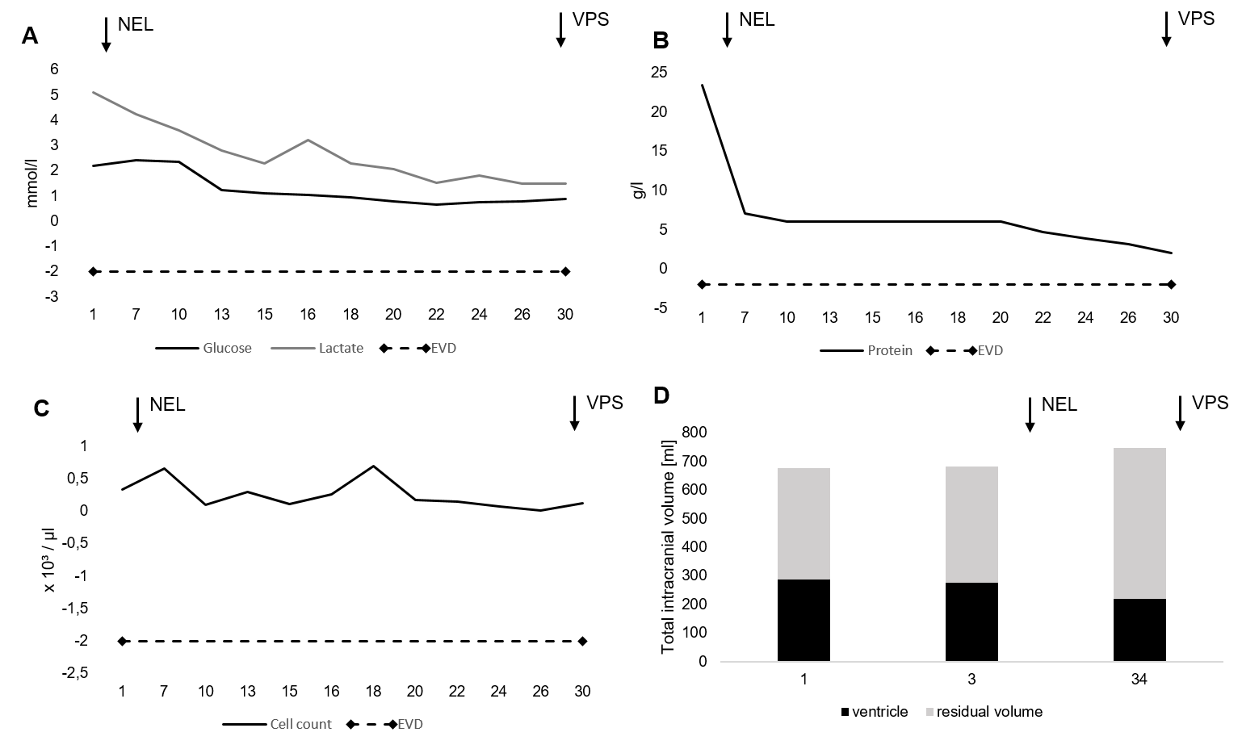
Suppl. Figure 10: CSF (cerebro-spinal fluid) parameter during course of treatment (X-Axis: days of treatment). A: glucose and lactate levels [mmol/ml]. B: protein level [g/ml] and C: cell count [ x 10³/µl]. D: volumetry of total intracranial volume and ventricle volume, residual volume [ml]. EVD: external ventricular drainage in situ. NEL: neuro-endoscopic lavage. VPS: ventriculo-peritoneal shunt implantation. CSF was sterile through the course of treatment.
Suppl. Figure 11: External ultrasound and MRI diagnostics. A: Ultrasound after 3 days post natum. B: Ultrasound 21 days post natum. C+D: 3T scanner, T2 weighted image in axial and sagital orientation 22 days post natum. E+F: 3T scanner, T2 weighted image in axial and sagital orientation 24 days and 2 days post natum.

Suppl. Figure 12: Postoperative imaging. A+B: T2 weighted image in axial and sagittal orientation 3 weeks after NEL and EVD implantation presenting persistent hydrocephalus, a left thalamic cyst and multiple midline cysts (most likely as post-hemorrhagic or post-infectious structural alterations) C+D: Ultrasound 7 days after VPS implantation or 4 weeks after initial NEL, respectively, presenting stable ventricle size. . E+F: Ultrasound 1 month after VPS implantation or 3 months of age, respectively, showing a regular VPS catheter position and a regressive ventricle size.

