Supplementary Material
Supplementary Table S1. Comparison of clinicopathological features between the ANCA-positive LN group and ANCA-positive non-LN group
 | ANCA -positive LN N=25 | ANCA -positive non-LN  N=21 | P-value
Age(years) | 45.64±14.45 | 41.52±13.97 | 0.334
Male，n(%) | 1(4.8%) | 1(4.0%) | 0.710*
Time-gap from diagnosis of SLE to  ANCA positive (months) | 15.00(5.50,96.00) | 12.00(1.00,30.00) | 0.177
White blood cell (109/L) | 3.88(2.71,5.55) | 4.25(2.75,5.99) | 0.808
Hemoglobin (g/L) | 92.21±22.97 | 100.95±14.57 | 0.151
Albumin (g/L) | 36.35±13.27 | 39.21±9.74 | 0.419
C-reaction protein(mg/L) | 9.90(9.90,19.00) | 9.90(9.90,18.18) | 0.631
Erythrocyte sedimentation rate(mm/h) | 56.33±34.55 | 53.35±32.80 | 0.804
Creatinine (umol/L) | 104.90(48.50,245.00) | 43.00(37.51,53.00) | 0.002
eGFR(ml/min/1.73m2) | 69.41±50.07 | 118.70±35.58 | <0.001
24h urine protein (g) | 1.36(0.66,3.39) | 0.10(0.05,0.25) | <0.001
IgE | 85.20(17.63,119.25) | 45.00(16.00,246.00) | 0.781
IgG | 17.92±9.65 | 23.14±10.19 | 0.086
IgM | 0.84 (0.43,1.41) | 1.39(1.10,1.91) | 0.003
IgA | 2.98±1.38 | 3.35±1.59 | 0.410
C3,g/L | 0.55±0.28 | 0.75±0.26 | 0.016
C4,g/L | 0.13±0.09 | 0.13±0.07 | 0.984
Anti-dsDNA, n(%) | 12(52.2%) | 9(60.0%) | 0.635
Anti-dsDNA titer | 6.63(2.29,100.00) | 1.79(0.98,16.41) | 0.185
Anti-SmD1, n(%) | 11(50.0%) | 9(60.0%) | 0.549
Anti-ANA, n(%) | 15(60.0%) | 14(66.7%) | 0.641
Anti-RNP, n(%) | 4(28.6%) | 10(66.7%) | 0.040
Anti-MPO, n(%) | 11(44.0%) | 5(23.8%) | 0.152
Anti-PR3, n(%) | 14(56.0%) | 16(76.2%) | 0.152
Anti-MPO titer | 73.94(67.24,106.30) | 39.90(24.71,122.30) | 0.062
Anti-PR3 titer | 47.88(30.75,71.46) | 71.94(35.90,131.42) | 0.158
*Fisher test;
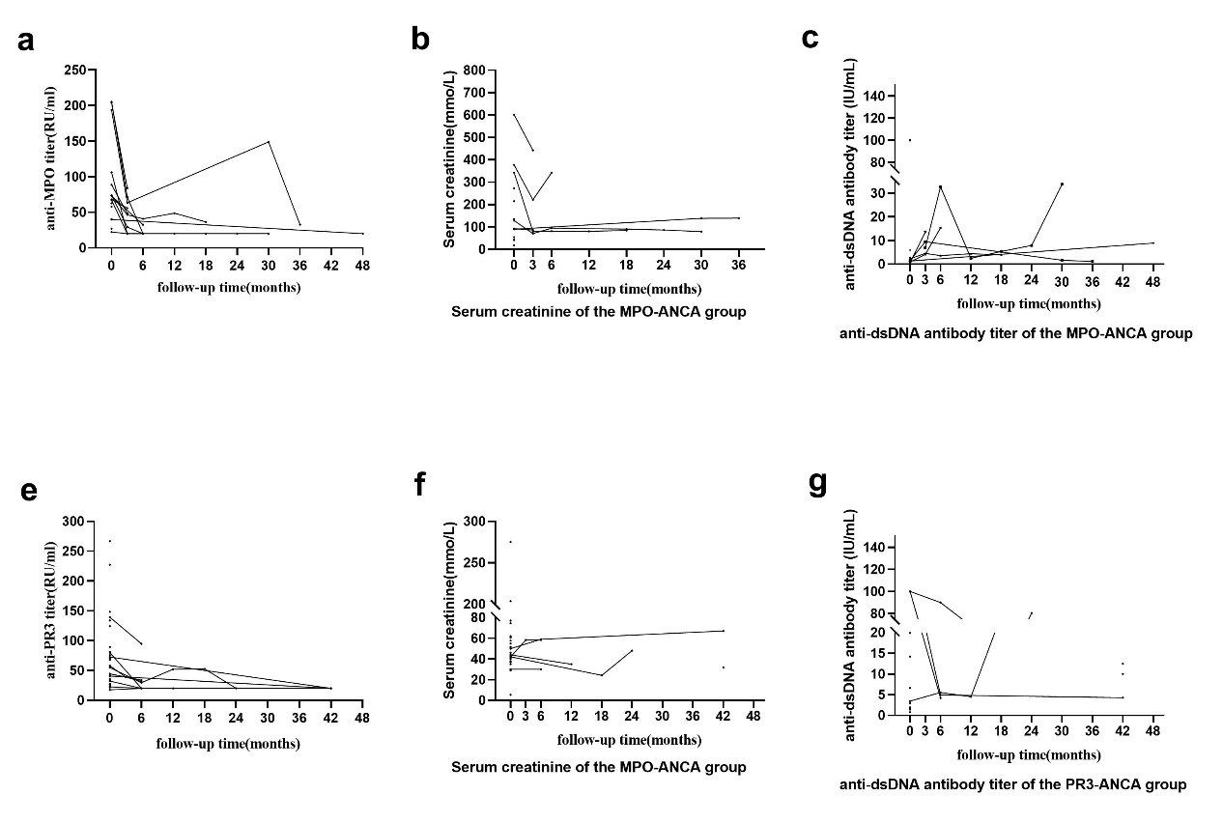
Supplementary Figure S2. Changes in the CREA level and ANCA and dsDNA titers during follow-up (a) changes of anti-MPO titers in SLE with ANCA-positive patients. (b) changes of CREA in MPO-ANCA group. (c) changes of anti-dsDNA titers in MPO-ANCA group. (e) changes of anti-PR3 titers in SLE with ANCA-positive patients. (f) changes of CREA in PR3-ANCA group. (g) changes of anti-dsDNA titers in PR3-ANCA group.
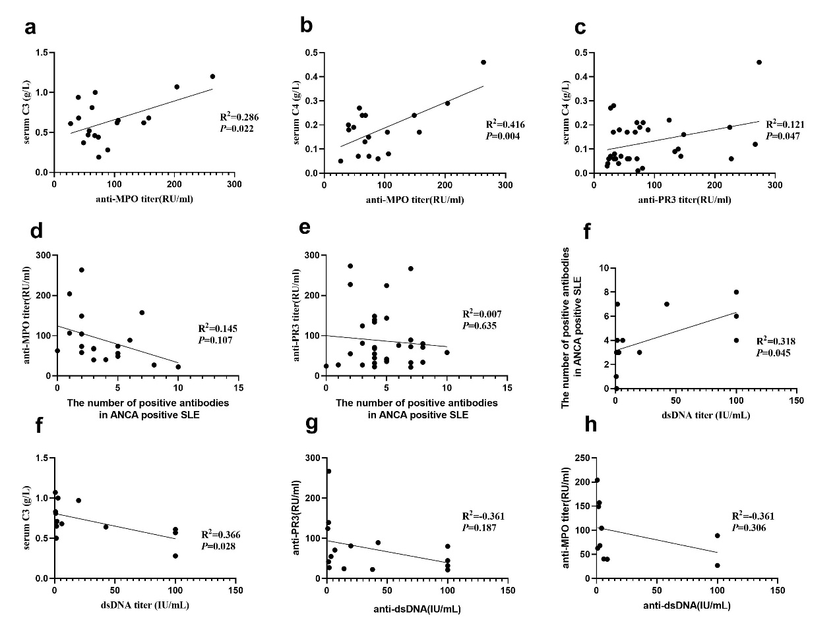
Supplementary Figure S3. Correlation of ANCA titers and clinical characteristics. (a) the correlation of anti-MPO titers with serum C3. (b) the correlation of anti-MPO titers with serum C4. (c) the correlation of anti-PR3 titers with serum C4. (d) the correlation of positive antibodies numbers in SLE with anti-MPO titers. (e) the correlation of positive antibodies numbers in SLE with anti-PR3 titers. (f) the correlation of positive antibodies numbers in ANCA positive SLE group with dsDNA titers. (g) the correlation of dsDNA titers with anti-MPO titers. (h) the correlation of dsDNA titers with anti-PR3 titers.

