Supporting Information
Design, Synthesis, and biological evaluation of pyrazolo-benzothiazole derivatives as a potential therapeutic agent for the treatment of Alzheimer’s disease
Harish Kumar^{1,2}, Navneet Kumar³, Prabha Garg ³, Anju Goyal^{2*}
¹Government. College of Pharmacy, Rohru, Shimla, Himachal Pradesh, 171207, India
²Chitkara College of Pharmacy, Chitkara University, Punjab, 140407, India
³Department of Pharmacoinformatics, National Institute of Pharmaceutical Education and Research (NIPER), Sector 67, SAS. Nagar-160062, Punjab, India

*Corresponding author
Prof. Anju Goyal
Chitkara College of Pharmacy
Chitkara University, Punjab, 140407, India
2nd floor, Cabin No. 240
anju.goyal@chitkara.edu.in

Table of Contents
Page No.

Spectral Data ……………………………………………….…………………………..3-10
¹H, ¹³C NMR and Mass spectra of some intermediate/final compounds.

Supporting figure S1. SAR study of pyrazolo-benzothiazole derivatives.
Supporting figure S2. Free radical scavenging mechanism of 4a.
Supporting figure S3 Protein ligand contact histogram and timeline showing the interaction of DPZ with AChE
Supporting figure S4 Protein ligand contact histogram and timeline showing the interaction of 4a with AChE
Supporting figure S5. Parallel artificial membrane permeation assay (PAMPA-BBB).
Supporting figure S6 (Conclusion). Pyrazolo-benzothiazole as a potential anti-AD agent.

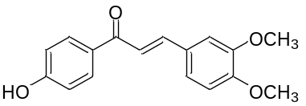¹H-NMR spectra of (E)-3-(3,4-dimethoxyphenyl)-1-(4-hydroxyphenyl)prop-2-en-1-one (3a)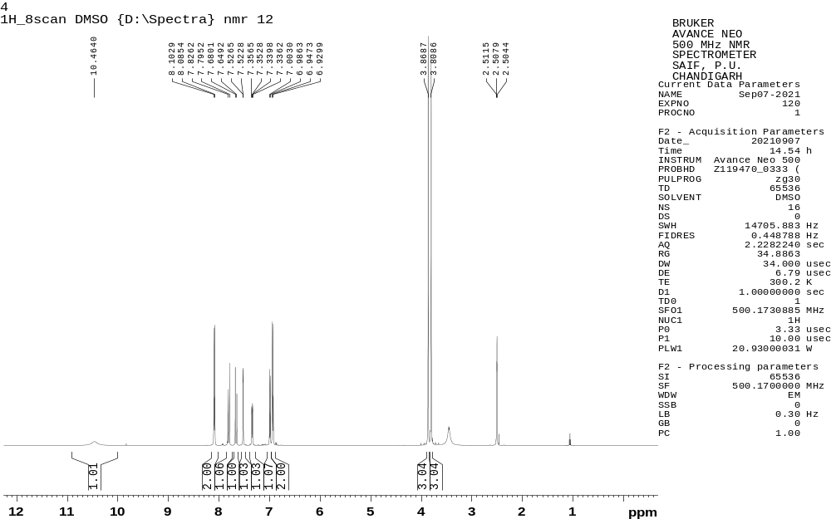

¹H-NMR spectra of (E)-1-(4-hydroxyphenyl)-3-(4-methoxyphenyl)prop-2-en-1-one (3c)
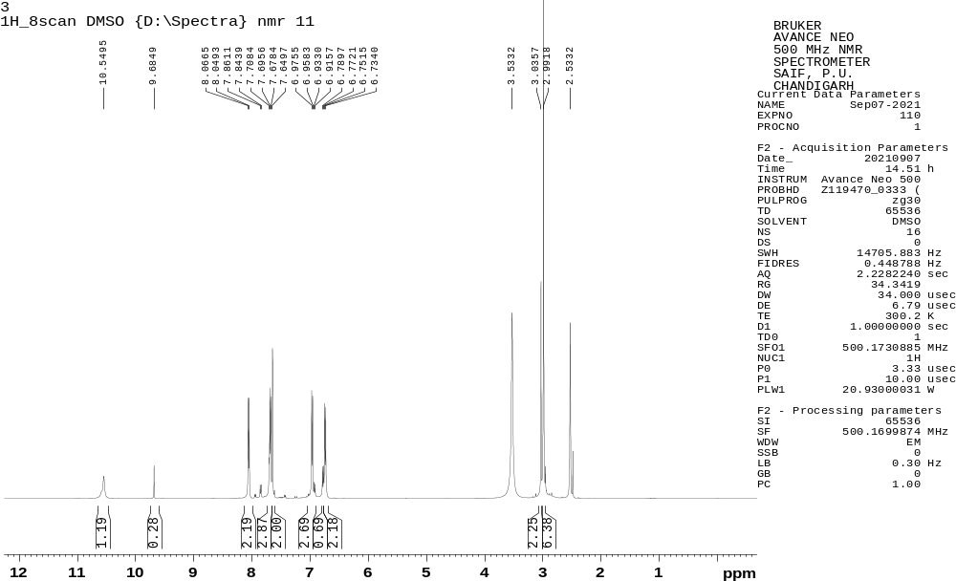

¹H-NMR spectra of 2-hydrazinyl-6-methylbenzo[d]thiazole (6a)
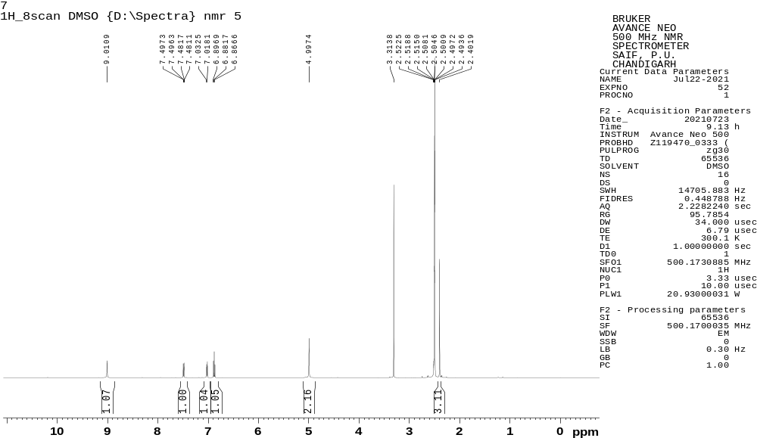

¹H-NMR spectra of 2-hydrazinyl-6-methylbenzo[d]thiazole (6b)
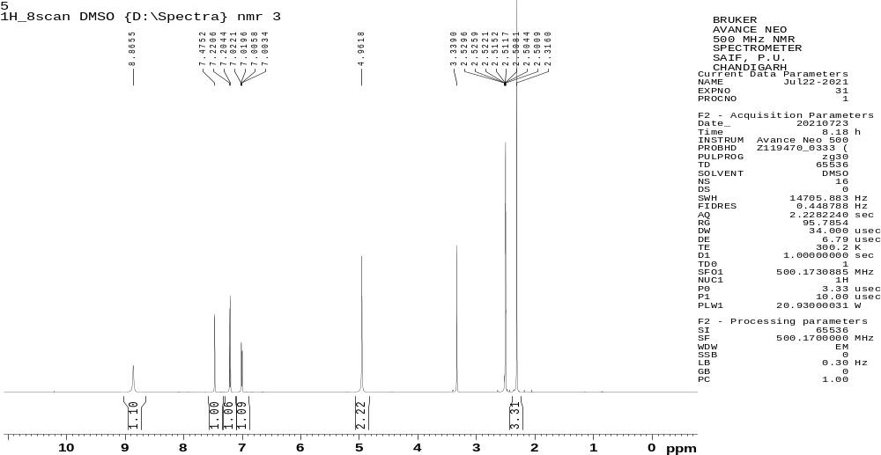

¹H-NMR spectra of 4-(5-(3,4-dimethoxyphenyl)-1-(6-methylbenzo[d]thiazol-2-yl)-4,5-dihydro-1H-pyrazol-3-yl)phenol (4a)

¹³C-NMR spectra of 4-(5-(3,4-dimethoxyphenyl)-1-(6-methylbenzo[d]thiazol-2-yl)-4,5-dihydro-1H-pyrazol-3-yl)phenol (4a)

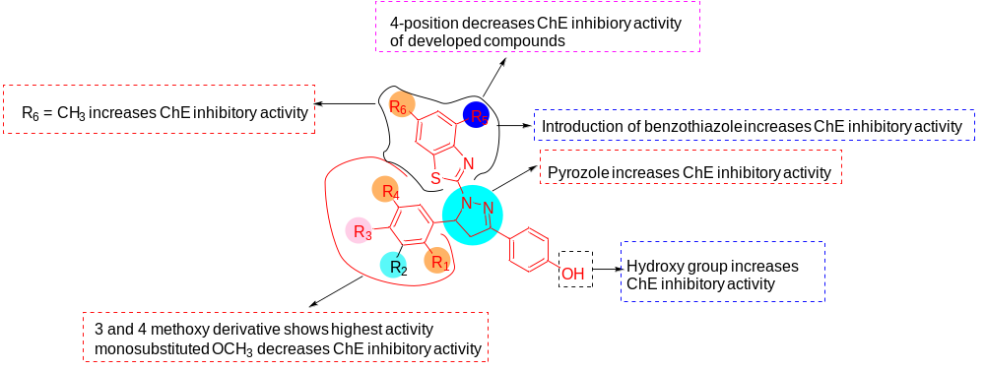
Supporting figure S1. SAR study of pyrazolo-benzothiazole derivatives.

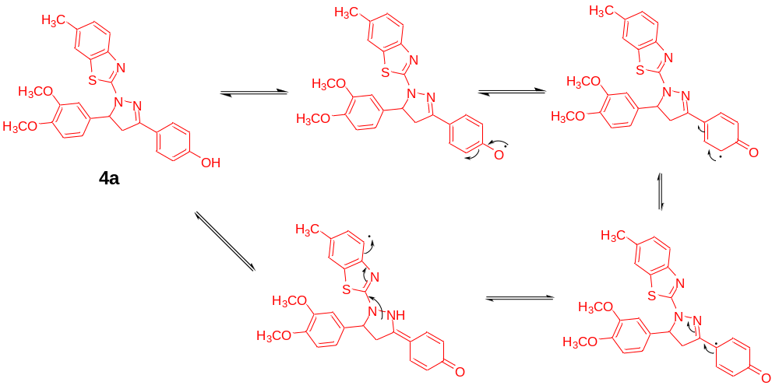
Supporting figure S2. Free radical scavenging mechanism of 4a.

Supporting figure S3 (a) Interactions fraction histogram and (b) protein-ligand contact timeline of of Donepezil with hAChE. Top panel shows the total number of specific contacts the hAChE makes with the Donepezil and the bottom panel shows the interaction of particular residues with the ligands in each trajectory frame

Supporting figure S4 (a) Interactions fraction histogram and (b) protein-ligand contact timeline of 4a with hAChE. Top panel shows the total number of specific contacts the hAChE makes with the 4a and the bottom panel shows the interaction of particular residues with the ligands in each trajectory frame

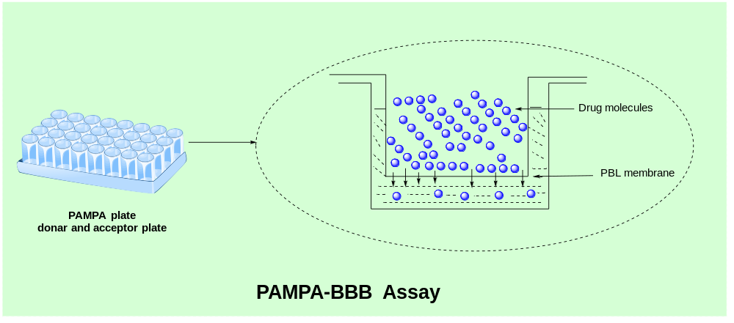
Supporting figure S5. Parallel artificial membrane permeation assay (PAMPA-BBB).

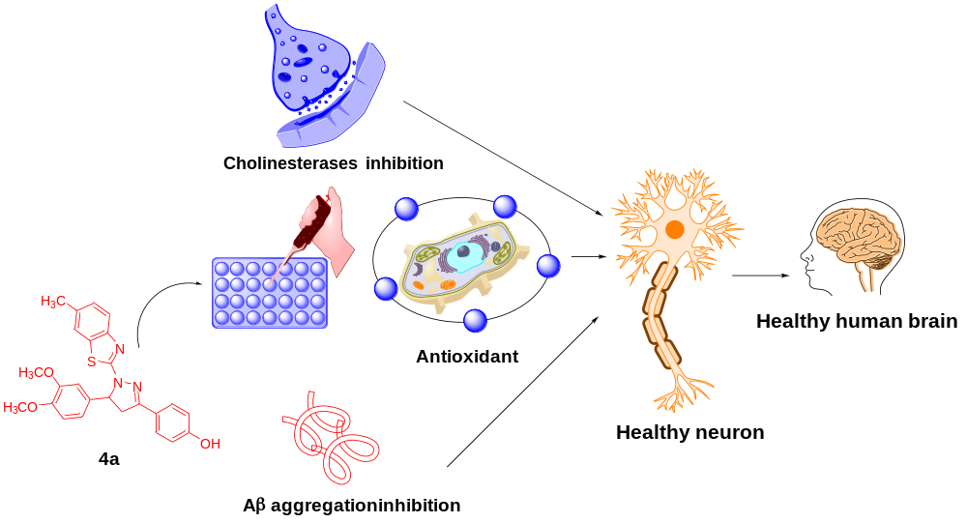
Supporting figure S6 (Conclusion). Pyrazolo-benzothiazole (4a) as a potential anti-AD agent.

