TITLE PAGE
Manuscript title
Estimation of the serial interval of COVID-19 in Ireland using contact tracing data

Author list
Conor G. McAloon^{1*}, Patrick Wall², John Griffin³, Miriam Casey⁴, Ann Barber⁴, Mary Codd², Eamonn Gormley¹, Francis Butler⁵, Locksley L. McV Messam¹, Cathal Walsh⁶, Conor Teljeur⁷, Breda Smyth⁸, Philip Nolan⁹, Martin J. Green¹⁰, Luke O’Grady^{1,10}, Kieran Culhane¹¹, Claire Buckley^{12,13}, Ciara Carroll¹², Sarah Doyle¹², Jennifer Martin¹², Simon J. More^{1,4}

Author affiliations
¹School of Veterinary Medicine, University College Dublin, Belfield, Dublin 4, Ireland
²School of Public Health, Physiotherapy and Sports Science, University College Dublin, Belfield, Dublin 4, Ireland
³Straffan, Kildare, Ireland
⁴Centre for Veterinary Epidemiology and Risk Analysis, School of Veterinary Medicine, University College Dublin, Belfield, Dublin, Ireland
⁵School of Biosystems and Food Engineering, University College Dublin, Belfield, Dublin 4, Ireland
⁶Department of Mathematics and Statistics, University of Limerick, Ireland
⁷Health Information and Quality Authority, George’s Court, Dublin 7, Ireland
⁸Department of Public Health, Health Service Executive West, Galway
⁹National University of Ireland Maynooth, Kildare, Ireland
¹⁰School of Veterinary Medicine and Science, University of Nottingham, Nottingham, UK
¹¹Central Statistics Office, Ardee road, Rathmines, Dublin, Ireland
¹²COVID-19 Contact Management Programme, Health Service Executive, Ireland
¹³School of Public Health, University College Cork, Ireland

*Corresponding author:
Conor McAloon,
conor.mcaloon@ucd.ie,
01 716 6083

Supplementary Material 1
Figure S1
Secondary or tertiary case? Potential to mis-specify the infector when the primary case results in multiple secondary cases (left). The green circle represents the primary case, the blue circle a contact who did not become a case, and orange circles represent contacts who subsequently became cases. Incorrectly identifying two secondary cases as a secondary and tertiary case (right; that is, an intermediate step infector in a close co-contact) would result in a biased estimate of the serial interval.
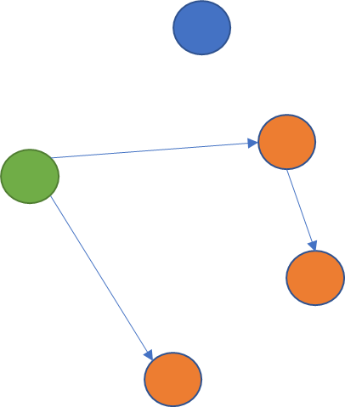
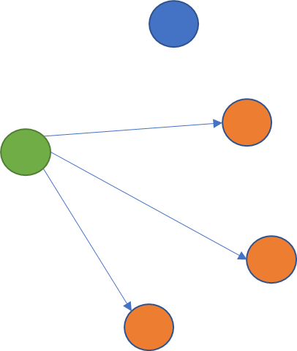

Figure S2
Secondary case or common source? Potential to mis-specify the infector when both the primary case and the case in a recorded contact are acquired from a common unidentified source (ie community transmission). The green circle represents the primary case, the blue circle a contact who did not become a case, and orange circles represent contacts of a case who subsequently became cases.
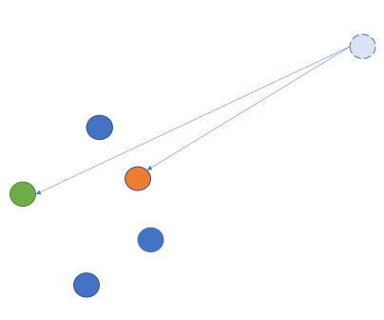
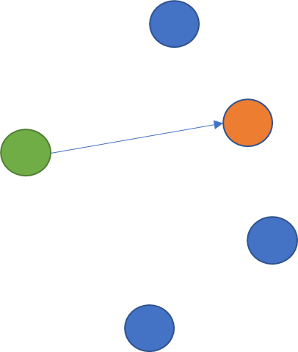
Figure S3 Relationship between serial interval, incubation period and time of infection relative to symptom onset of the infector. Symptom onset is indicated with an ‘X’.

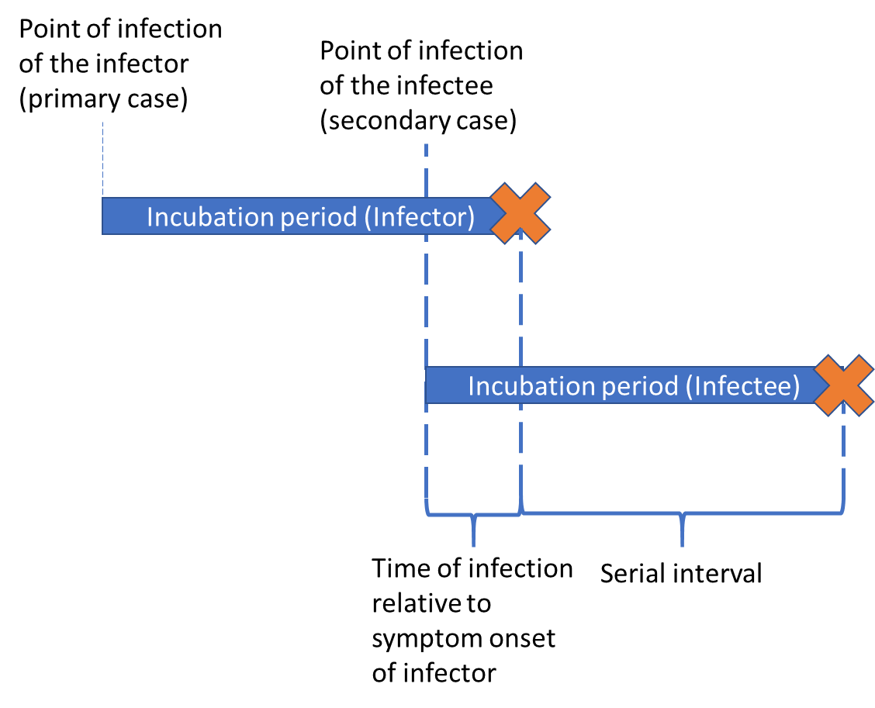
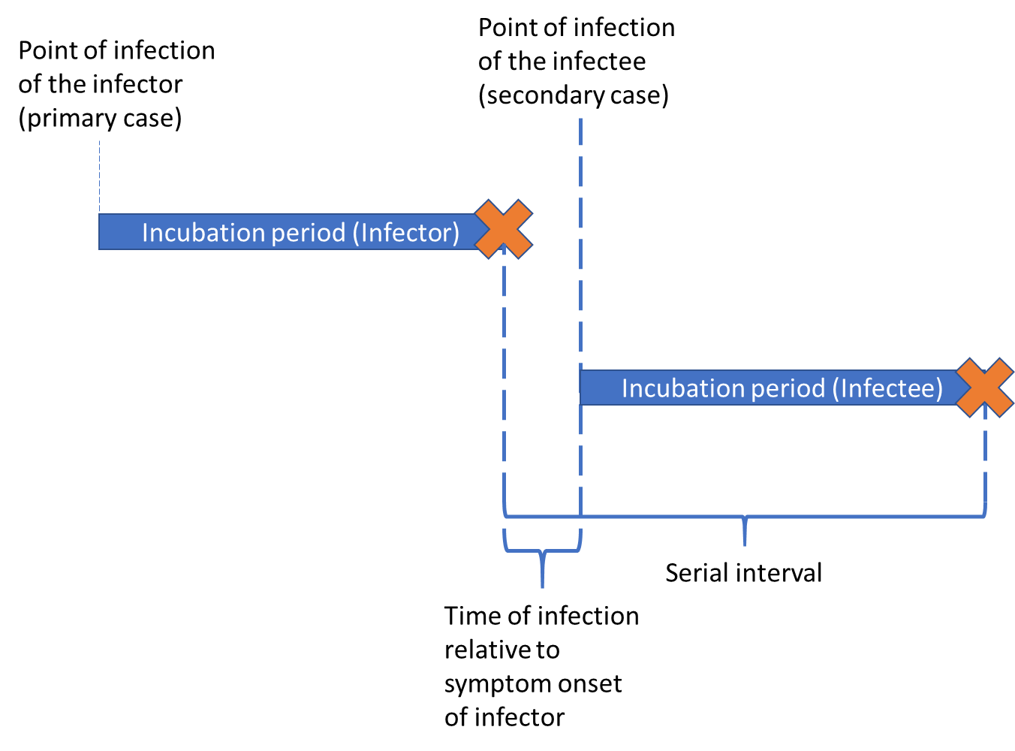
Table S1 Impact of each data cleaning step on number of records
Step | Number of cases | Number of contacts
Initial data read in | 110,408 | 308,305
Restrict to contacts who subsequently became cases | 26,887 | 41,617
Remove duplicate case-contact entries | 26,887 | 41,617
Remove contacts appearing more than once | 23,266 | 41,617
Primary case attributed to community transmission, secondary case to close contact with confirmed case | 6,352 | 11,066
Symptom onset date for both primary and secondary case | 2,465 | 3,650
Remove data within 30 days of last entry | 2,104 | 3,124
Restrict to close contacts | 2,100 | 3,117
Filtering to serial intervals between -10 and 28 days in length | 1,999 | 2, 976
Filter to those where date of date of symptom onset was within 7 days of date of contact tracing phonecall | 1,502 | 2,212
Restrict to individuals who infected only one other person | 471 | 471
Sensitivity analysis dataset – individuals who infected 3 or less other individuals | 1,502 | 2,212

