1-Aryl-1,2,3,4-tetrahydro-isoquinolines inhibit TNFR2-mediated proliferative expansion of CD4⁺Foxp3⁺ regulatory T cells
Feng-Yang Chen^{1,#}, Chang-An Geng^{2,#}, Jing-Bin Zheng¹, Tian-Ze Li², Yang Yang¹, Yi-Fei Wang¹, Ping Li¹, Meng-Meng Jiang¹, Yuan Li¹, Ji-Jun Chen^{2,3,}*, Xin Chen^{1,}*

¹ State Key Laboratory of Quality Research in Chinese Medicine, Institute of Chinese Medical Science, University of Macau, Macau 999078, People's Republic of China.
² State Key Laboratory of Phytochemistry and Plant Resources in West China, Kunming Institute of Botany, Chinese Academy of Sciences; Yunnan Key Laboratory of Natural Medicinal Chemistry, Kunming 650201, People's Republic of China
³ University of Chinese Academy of Sciences, Beijing 100049, People's Republic of China
# These authors contributed equally to this work.
* Corresponding author: xchen@umac.mo (X. Chen); chenjj@mail.kib.ac.cn (J.Chen)

Supplementary Figures
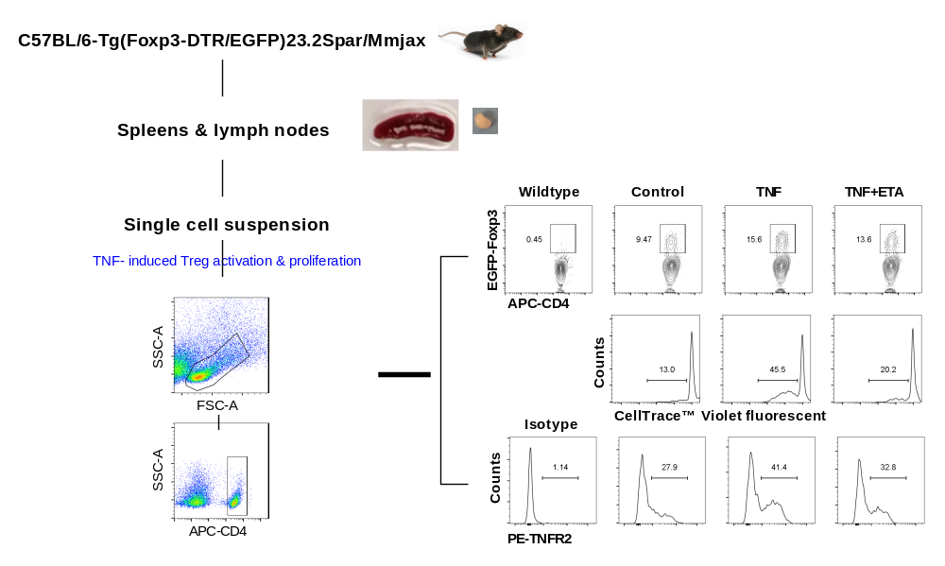
Figure S1. Screening system for inhibitors of TNFR2-mediated proliferation of Treg cells.
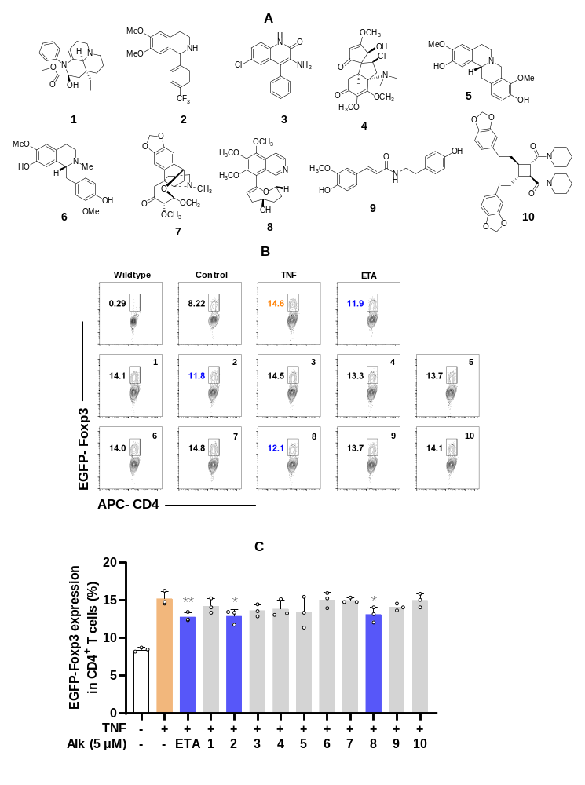
Fig. S2. Representative data of screening of in-house small-molecule library. Lymphocytes from C57BL/6-Tg(Foxp3-DTR/EGFP)23.2Spar/Mmjax mice were stimulated with rmTNF (5 ng/mL), in the presence of compound. After culture for 3 days, the cells were collected and the proportion of EGFP-Foxp3⁺ in CD4⁺T subset was analyzed by flow cytometry. Representative compound are shown in A; representative flow cytometry plots are shown in B. The values in C are presented as means ± S.D. (n=3). ETA was used as the positive control. *p<0.05 and **p<0.01 vs only TNF-treated group.
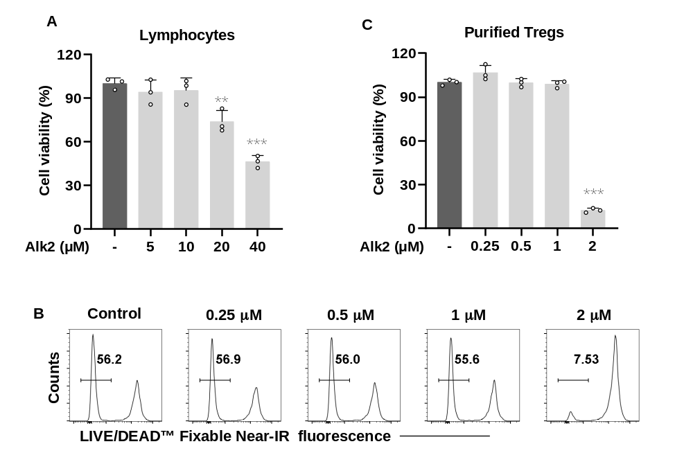
Figure S3. The cytotoxicity of Alk2 on lymphocytes and purified Treg cells. (A) Lymphocytes were cultured with Alk2 for 72 h, the cell viability was detected by an MTT assay. (B&C) CD4⁺CD25⁺ regulatory T cells were cultured with Alk2 in the presence of rmIL-2 (250 pg/mL) plus rmTNF (5 ng/mL). After 3 days, the cell viability was assayed by LIVE/DEAD™ Fixable Near-IR Dead Cell Stain Kit. Representative flow cytometry plots are shown in B. The values in A&C are presented as means ± S.D. (n=3). **p<0.01 and ***p<0.001 vs Control group.

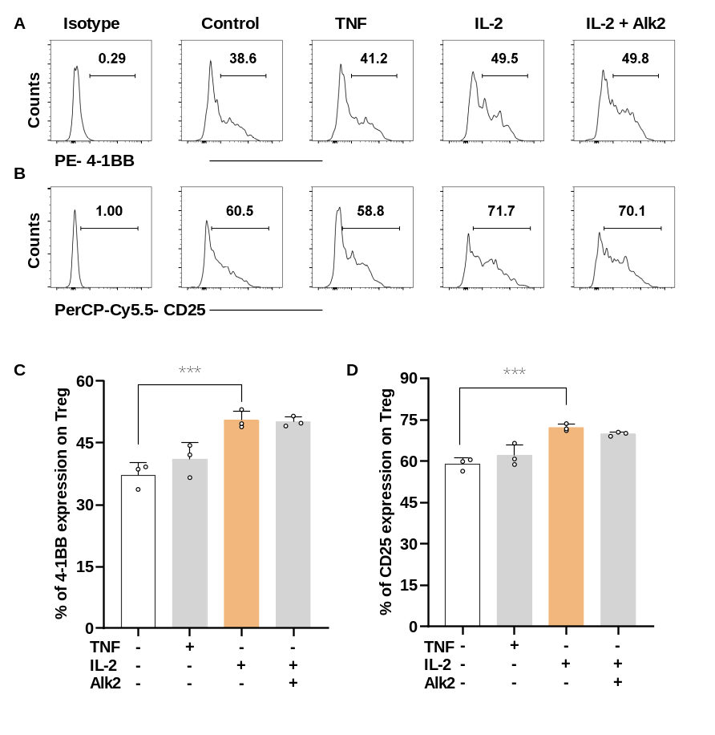
Figure S4. Alk2 couldn’t inhibit IL-2 induced expression of 4-1BB and CD25 on TNFR2 deficient Tregs. Lymphocytes from B6.129S2-Tnfrsf1b^{tm1Mwm}/J (TNFR2 KO) mice were stimulated with rmIL-2 (10 ng/mL) or rmTNF (5 ng/mL), in the presence of Alk2. After culture for 3 days, the cells were collected and the expression of 4-1BB and CD25 on Treg cells were analyzed by flow cytometry. Representative flow cytometry plots are shown in A &B). The values in C& D are presented as means ± S.D. (n=3), ***p<0.001 vs. the indicated groups.

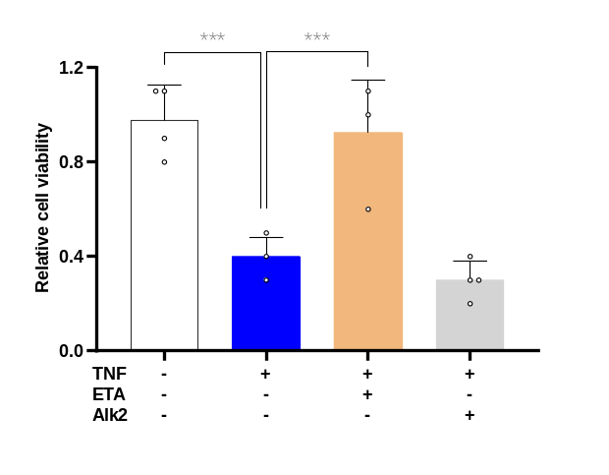
Figure S5. Alk2 couldn’t block the binding of TNF and TNFR2. WEHI-13VAR cells were cultured with TNF (50 pg/ml) and Alk2 or the postive control Etanercept (10μg/ml). After 48 h, the cell viability was detected by MTT assay. The values are presented as means ± S.D. (n=4), ***p<0.001 vs. the indicated groups.

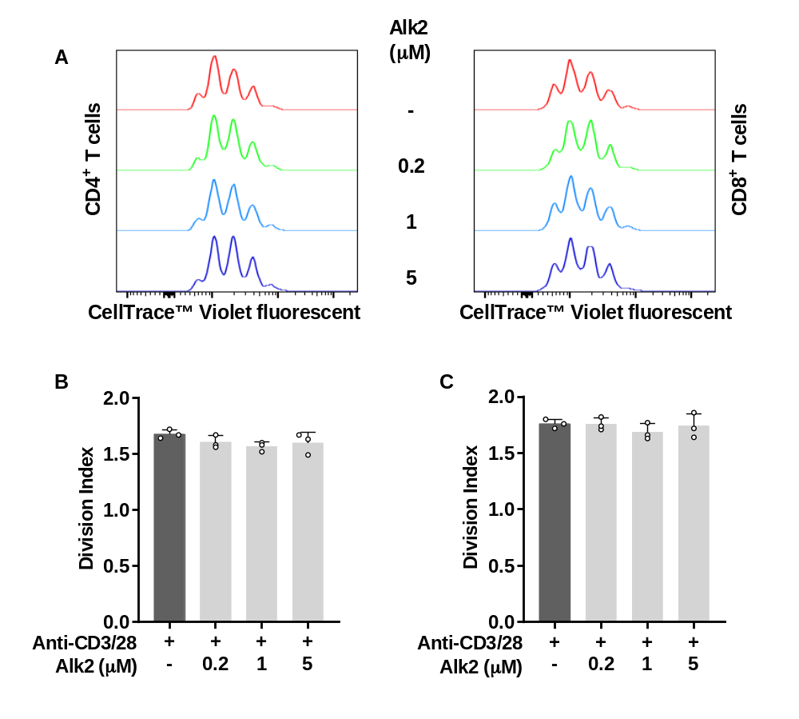
Figure S6. Alk2 couldn’t inhibit Teff proliferation induced by anti-CD3/28 stimulation. CellTrace™ Violet labeled lymphocytes were stimulated with plate-coated anti-CD3e antibody and soluble anti-CD28 Antibodyin the presence or absence of Alk2. After culture for 3 days, the cells were collected. The replicating CD4⁺ and CD8⁺ T cell were analyzed by flow cytometry. Representative flow cytometry plots are shown in A. The values in B are presented as means ± S.D. (n=3).
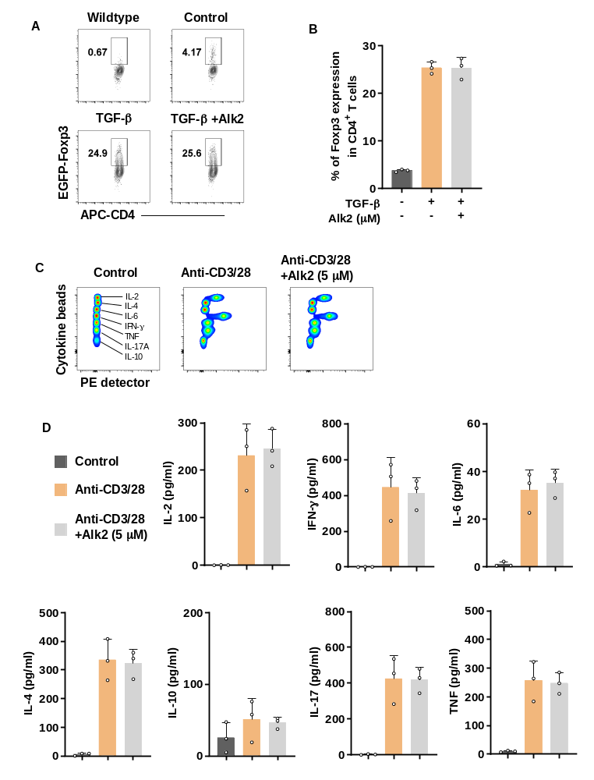
Figure S7. Alk2 couldn’t inhibit Treg differentiation and Th1/2/17 immune response. (A&B) Purified CD4⁺ T cells were activated by anti-CD3/28 in the presence of rmTGF-β and Alk2. After culture for 2 days, the cells were collected and the Foxp3 expression by CD4⁺ cells was determined by flow cytometry. (C&D) Lymphocytes were stimulated with anti-CD3/28 in the presence of Alk2. After culture for 24h, their supernatants were collected and cytokines contents in which were measured by CBA mouse Th1/Th2/Th17 Cytokine Kit. Representative flow cytometry plots are shown in A&C. The values in B&D are presented as means ± S.D. (n=3).
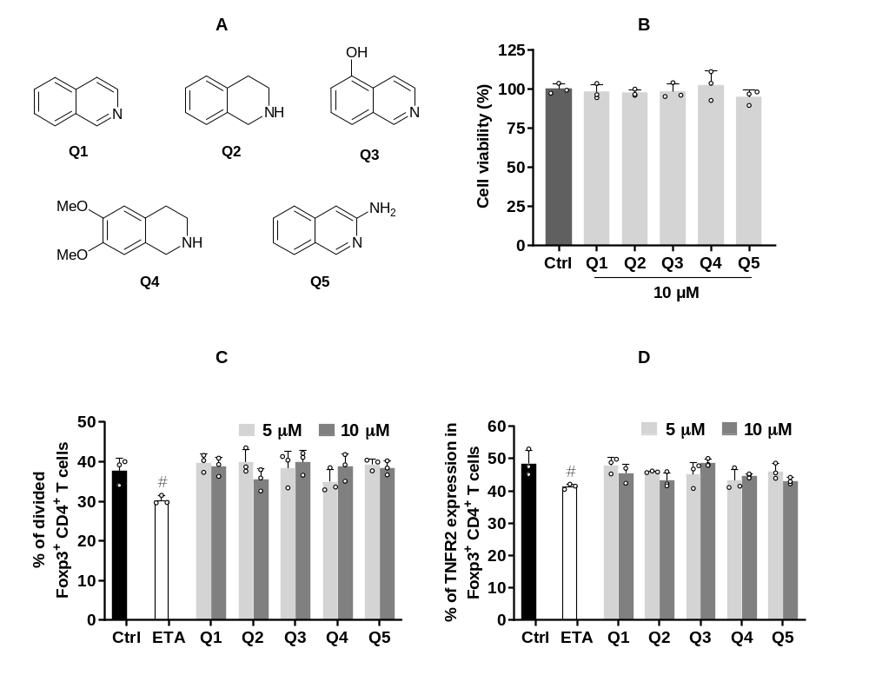
Figure S8. Isoquinolines couldn’t inhibit the proliferation and TNFR2 expression of TNF-stimulated Treg cells. (A) The structures of five Isoquinolines. (B) Lymphocytes were cultured with Isoquinolines for 72 h, the cell viability was detected by an MTT assay. (C&D) CellTrace™ Violet labeled lymphocytes were stimulated with rmIL-2 (250 pg/mL) plus rmTNF (5 ng/mL), in the presence of Isoquinolines. After culture for 3 days, the cells were collected and the replicating Foxp3⁺ cells and the expression of TNFR2 were analyzed by flow cytometry. The values in B, C & D are presented as means ± S.D. (n=3). ETA was used as the positive control. # p<0.05 vs control group.

