Table 1. Inhibitory activities of 1-aryl-1,2,3,4-tetrahydro-isoquinolines on TNF-induced proliferation of Tregs.
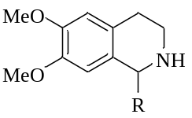 |  |  | 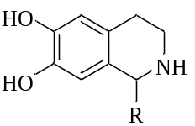
No. | R | Inhibitory rate (%) | No. | R | Inhibitory rate (%)
1 | 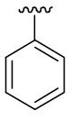 | 36.3 | 23 | 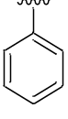 | 27.9
2 | 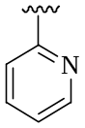 | 25.4 | 24 | 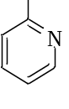 | 30.8
3 | 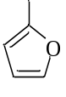 | 25.1 | 25 |  | 22.9
4 | 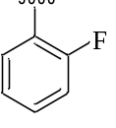 | 24.3 | 26 |  | 25.7
5 | 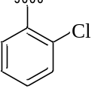 | 24.3 | 27 |  | 22.9
6 | 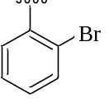 | 25.6 | 28 |  | 24.7
7 | 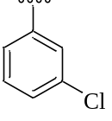 | 32.6 | 29 |  | 25.4
8 | 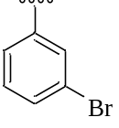 | 20.6 | 30 |  | 28.3
9 | 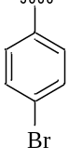 | 40.7 | 31 |  | 24.7
10 | 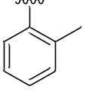 | 26 | 32 |  | 17.2
11 | 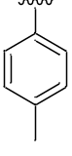 | 33.9 | 33 |  | 31.1
12 | 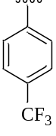 | 39.1 | 34 |  | 33.0
13 | 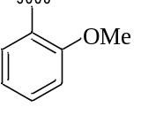 | 29.9 | 35 |  | 28.1
14 | 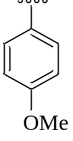 | 19.4 | 36 |  | 9.9
15 | 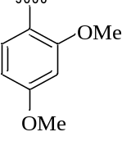 | 26.2 | 37 |  | 25
16 | 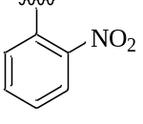 | 28.4 | 38 |  | 24.3
17 | 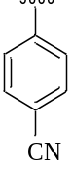 | 24.9 | 39 |  | 17.6
18 | 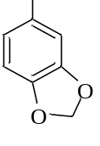 | 27.5 | ‒ | ‒ | ‒
19 | 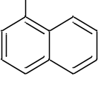 | 39.8 | 40 |  | 30.1
20 | 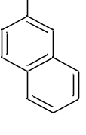 | 41.2 | 41 |  | 25.6
21 | 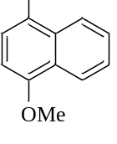 | 49.6 | ‒ | ‒ | ‒
22 | 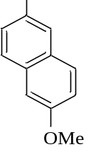 | 42.3 | ‒ | ‒ | ‒

