Supplement 1. Pocock-type stopping boundaries for a true dose-limiting toxicity rate of 40% and a 10% desired probability of early stopping in 10 patients.
Number of patients, n | 1 | 2 | 3 | 4 | 5 | 6 | 7 | 8 | 9 | 10
Boundary, b_{n} | - | - | - | 4 | 5 | 5 | 6 | 6 | 7 | 7

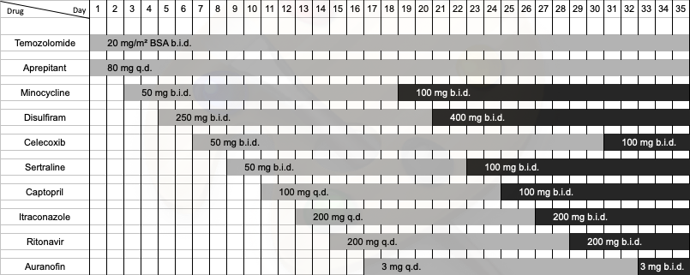
Supplement 2. Progressive addition schedule of the CUSP9v3 drugs. BSA: body surface area; b.i.d.: twice a day; q.d.: once a day.

Dot_CUSP_AEs_15Oct20.html

Supplement 3. Interactive dot chart representing the percentage of suspected association of each CUSP9v3 drug with the 23 most common AEs (frequency ≥ 4). The percentage value ascribed to each drug may be displayed separately by double-clicking on the respective legend symbol (online only). Due to possible overlay because of equal percentage values for different drugs, not all drug-representing dots show-up initially. Sorting of the AEs follows the median number of suspected drugs (MNSD; in square brackets) in descending order. In case of equal MNSD values, second-level sorting was performed according to the frequency of AEs in descending order. Examples on how to read the graph: 1) A median number of 5 suspected drugs was involved in the AE ‘Alanine aminotransferase increased’. Three drugs (i.e., aprepitant, disulfiram, sertraline) were never involved, so on average any combination of 5 drugs from the remaining 7 medications was involved when this AE was observed. 2) Nausea was the only AE which showed a suspected relation to all 10 CUSP9v3 drugs, since no drug had a percentage value of zero. A nausea event was associated with a median number of 2 suspected drugs, i.e., on average any combination of 2 drugs was suspected in a nausea event. In almost 60% of all nausea events, celecoxib was suspected.
Supplement 4. The most frequent adverse events (frequency ≥ 4) and their association (rated as possible or related”) to applied drugs
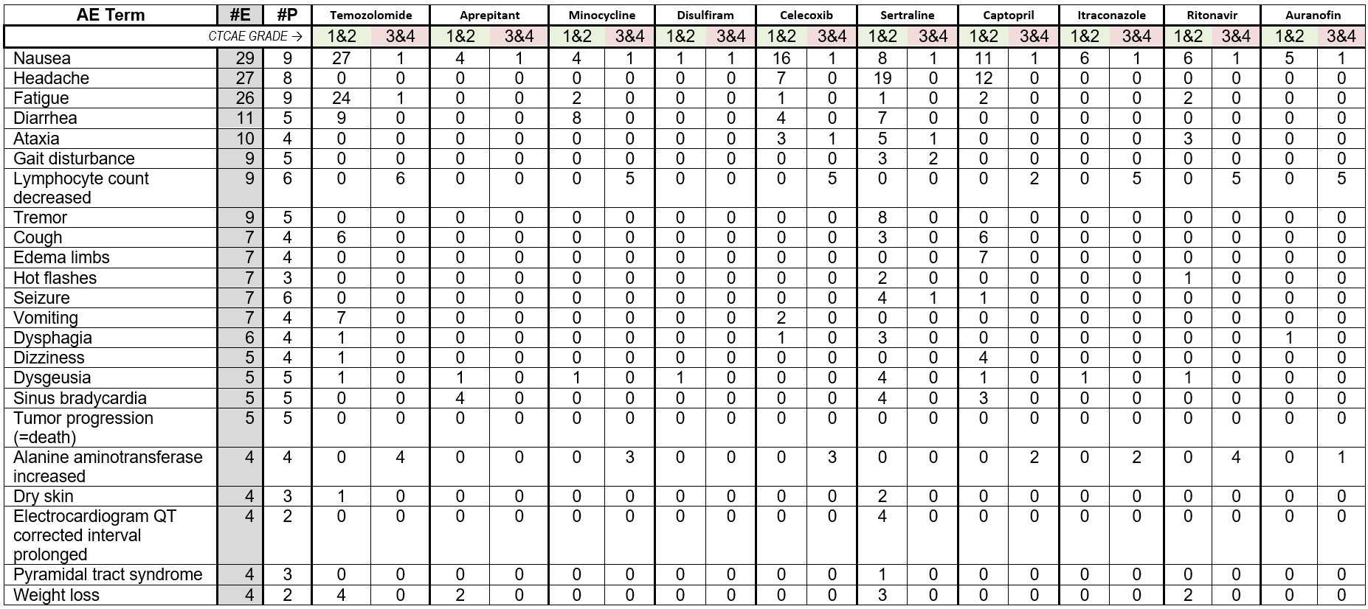
AE: adverse event; CTCAE: common terminology criteria for adverse events; #E: number of discrete events in the entire patient population (includes multiple events per patient); #P: number of patients experiencing the respective AE regardless of multiplicity. The total number of AEs grade 1 and 2 vs. grade 3 and 4 was 178 vs. 28 (p < 0.001)
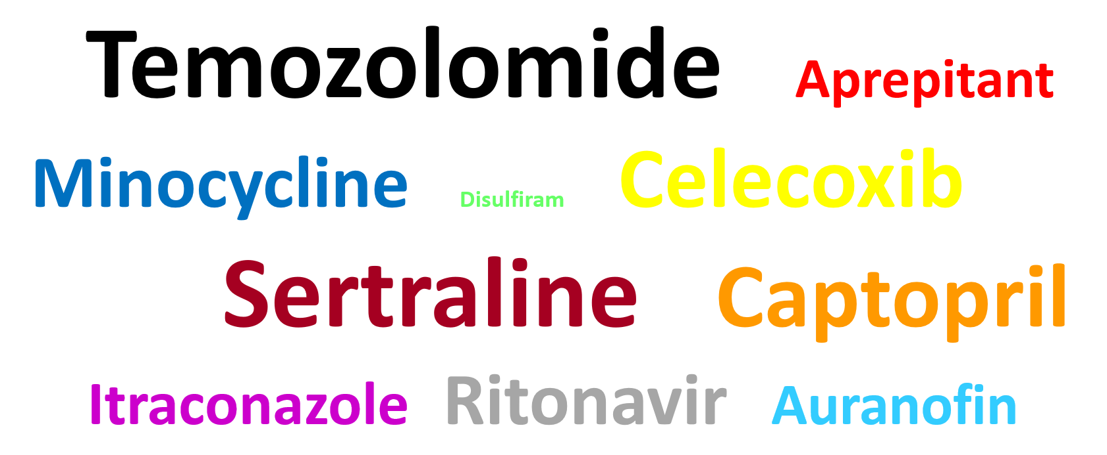

Supplement 5. Cloud representation of the suspected associations of all CUSP9v3 drugs with the frequencies of the 23 most common AEs (CTCAE grade 1-4). The font size is proportional to the cumulative frequency of the specific AEs. Since temozolomide was the drug most commonly related to any AE (n = 93), this number of events was allotted a font size that served as the denominator for all subsequent font size calculations so that the font sizes of all other medication names represent the number of AEs specifically attributed to each respective drug in relation to the number of temozolomide-associated AEs (relative frequencies [rf]). Font size calculations were performed by log(rf) × 30 in order to compensate for the large variation in relative AE frequencies (3-100%).
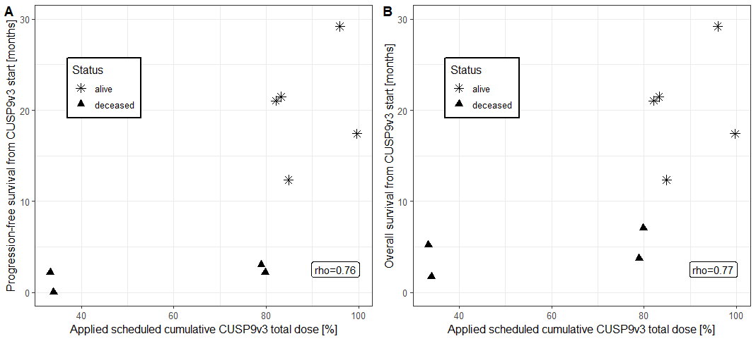
Supplement 6. Spearman correlation (rho) of applied scheduled cumulative CUSP9v3 dose (%) with PFS and OS. One patient who was not evaluable for the primary endpoint (safety) was excluded from this analysis.

