Supplemental Tables and Figures

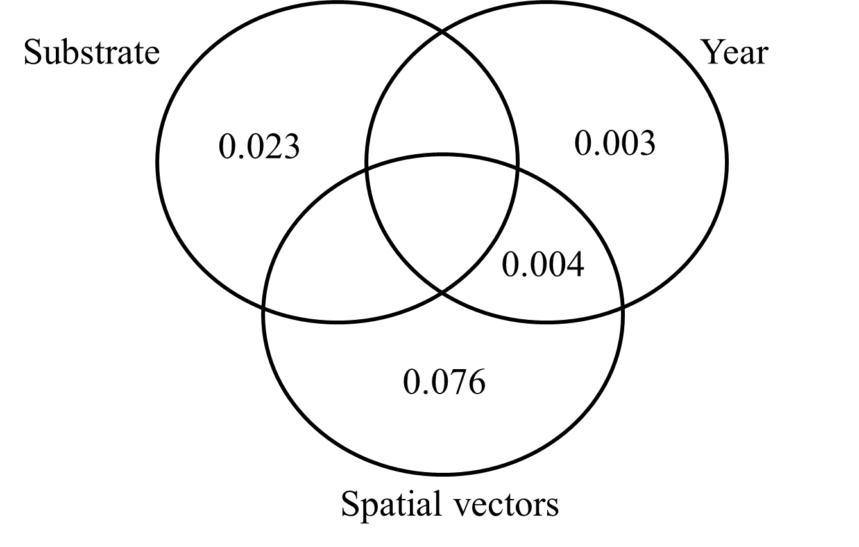
Fig. S1 Venn diagram of variance partitioning analysis using presence-absence data showing effects of substrate type, sampling year, and PCNM spatial vectors on fungal community composition. Residuals=0.900

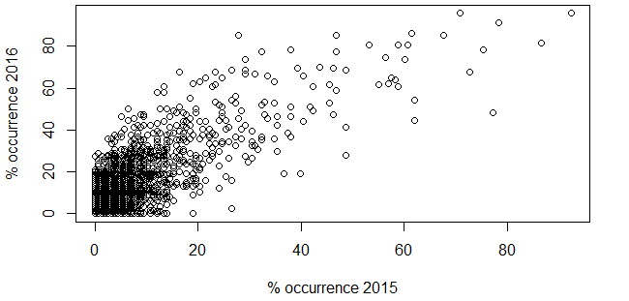
B
A
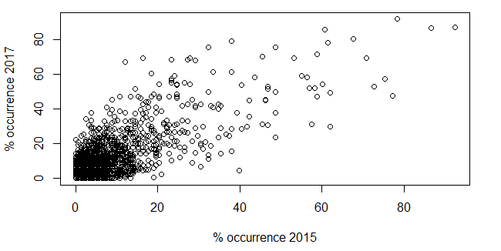
C
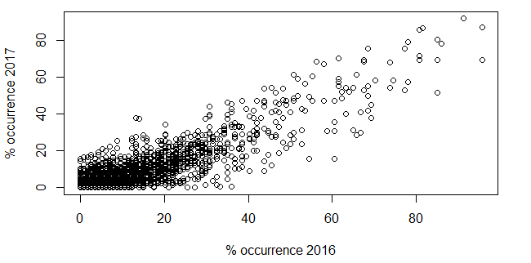
Fig. S2 Scatterplots comparing the percentage of samples an OTU occurs in across years. Each point represents one OTU. OTUs that are common and are found in many samples in one year tend to also be common in other years

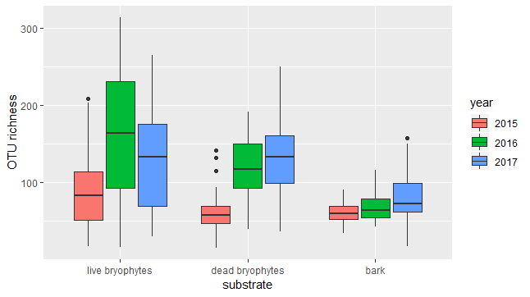
Fig. S3 Boxplots of alpha diversity by substrate and year. Alpha diversity was calculated as the expected OTU richness at 1000 reads of sequencing depth. Average diversity increased from 2015 to 2016

Table S1 Comparison of temporal vs spatial community turnover. Numbers indicate the average temporal dissimilarity by year and substrate type, with numbers in parentheses indicating the spatial distance at which that level of dissimilarity is seen
 | Live Bryophytes | Dead Bryophytes | Bark
Bray Curtis dissimilarity – relative abundance
2015-2016 | 0.854 (6.7 cm) | 0.707 (6.8 cm) | 0.663 (6.3 cm)
2016-2017 | 0.835 (5.7 cm) | 0.744 (8.3 cm) | 0.690 (7.1 cm)
2015-2017 | 0.902 (9.1 cm) | 0.775 (9.5 cm) | 0.721 (8.0 cm)
Jaccard dissimilarity – presence-absence
2015-2016 | 0.984 (56 cm) | 0.888 (79 cm) | 0.815 (30 cm)
2016-2017 | 0.851 (-2 cm) | 0.830 (41 cm) | 0.817 (31 cm)
2015-2017 | 0.909 (77 cm) | 0.901 (94 cm) | 0.841 (45 cm)

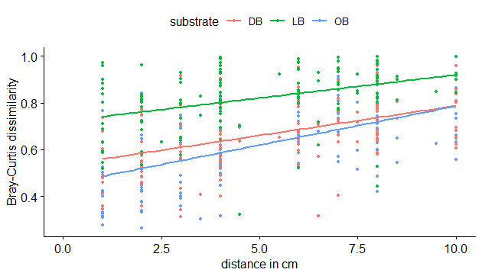
A
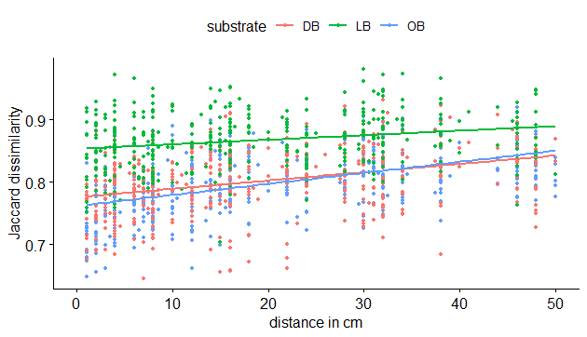
B
Fig. S4 Spatial distance decay by substrate type with Bray-Curtis (A) and Jaccard (B) dissimilarity indices as observed in 2015. Live bryophytes had greater dissimilarities at all distances

Table S2 Percent of the time an OTU is found the subsequent year based on relative abundance in the initial year.
 | ≤ 0.01% | >0.01 – 0.1% | >0.1 – 1% | >1 – 10% | > 10% | total
2015 - 2016
Bark | 21.79% | 32.18% | 42.45% | 77.30% | 90.32% | 38.13%
Dead bryophytes | 34.23% | 46.02% | 58.13% | 78.44% | 88.89% | 49.81%
Live bryophytes | 22.76% | 29.90% | 54.64% | 54.80% | 68.09% | 31.61%
2016 -2017
Bark | 12.24% | 22.87% | 48.12% | 73.16% | 78.08% | 26.33%
Dead bryophytes | 17.20% | 31.53% | 54.61% | 70.05% | 80.70% | 27.22%
Live bryophytes | 16.10% | 27.28% | 40.19% | 43.26% | 63.00% | 26.51%
2015-2017
Bark | 16.05% | 23.51% | 43.79% | 67.79% | 77.06% | 28.73%
Dead bryophytes | 24.42% | 33.13% | 40.77% | 58.88% | 77.65% | 36.38%
Live bryophytes | 13.92% | 16.07% | 32.00% | 38.92% | 55.88% | 21.63%

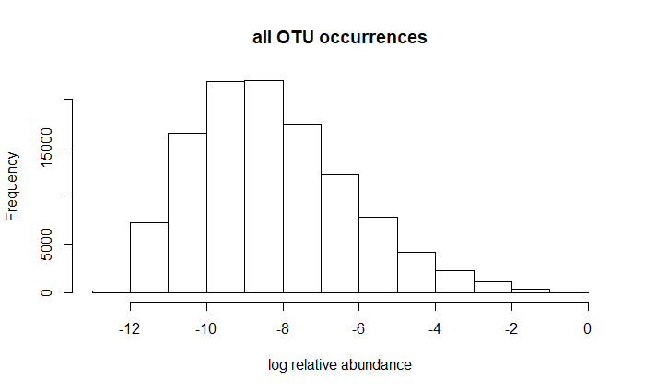
A

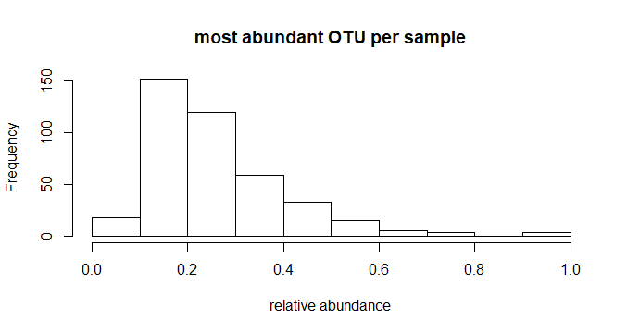
B
Fig. S5 Histograms of relative abundances of all OTU occurrences (A, n=113,494) and of only the most abundant OTU in a given sample (B, n=408). Most OTUs were present only at very low relative abundance most of the time. The most abundance OTU in a sample, however, made up at least 10% of the reads in that sample over 95% of the time.

