Supplementary material
Figure 1

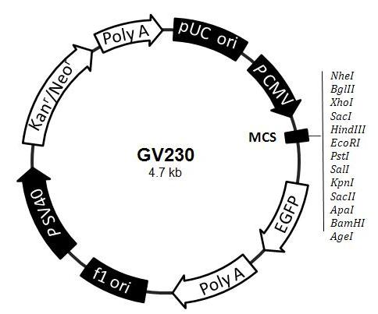
Figure.1 Plasmid map of HPV16 E6

Figure 2
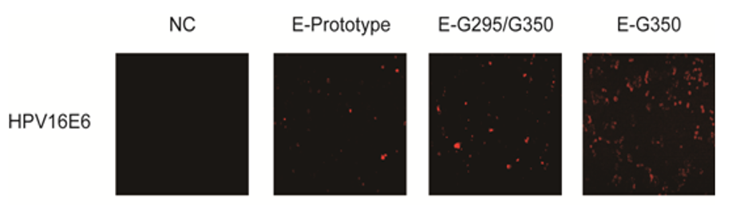
Figure 2. The expression of HPV16 E6 in C33A cells by indirect immunofluorescence (200×). Following the transfection of C33A cells with a GV230 empty vector, HPV16 E6 prototype vector, HPV16 E6-G295/G350 mutation vector, HPV16 E6-T295/G350 mutation vector, the red fluorescence of the vector was measured. The GV230 empty vector group was used as a control group and displayed no red fluorescence, whereas red fluorescence was observed in the other three experimental groups. The HPV16 E6-T295/G350 mutation group contained the highest fluorescence.

Table1. HPV16 E6 gene mutation loci in the non-cervical cancer of Han women
Mutation site | G94A | A95G | C168G | T178G | T178A | A276G | T350G | A442C
Amino acid change | Syn | Syn | T22S | D25E | D25Q | N58S | L83V | E113D
Ep | G | A | C | T | T | A | T | A
AA | G | A | C | T | T | A | G | A
As | G | A | C | G | T | A | T | A
Af | G | A | C | T | T | A | T | A
XinJiang73
XinJiang75 |  |  |  |  |  |  | G | C
XinJiang80 |  |  |  |  |  | G
XinJiang81 |  |  |  | G
XinJiang87 |  |  |  |  |  |  | G
XinJiang88 |  |  |  | G
XinJiang90 |  |  |  | G
XinJiang92
XinJiang95 |  |  |  | G
XinJiang100 |  |  |  | G
XinJiang101 |  |  |  |  |  |  | G
XinJiang112 |  |  | G | G |  |  | G
XinJiang114 |  |  |  | G
XinJiang119 | a | g |  |  | A
XinJiang102 |  |  |  |  |  |  | G
XinJiang49
XinJiang55 |  |  |  |  |  |  | G
XinJiang61 |  |  |  |  |  |  | G
XinJiang69 |  |  |  |  |  |  | G
total | 1 | 1 | 1 | 7 | 1 | 1 | 8 | 1
Table 1. EP = European standard strain; AA = Asian American; AS = Asian type; AF = African type; Syn = Synonymous. Capital letters are missense mutations, and lowercase letters are synonymous mutations.

Table 2. HPV16 E6 gene mutation loci in the non-cervical cancer of Uygur women
Mutation site | T109C | T178G | T183G | T350G
Amino acid change | Syn | D25E | I27R | L83V
Ep | T | T | T | T
AA | T | T | T | G
As | T | G | T | T
Af | T | T | T | T
XinJiang76 |  | G
XinJiang77 |  | G
XinJiang78 |  |  | G
XinJiang84 | c |  |  | G
XinJiang86 |  |  |  | G
XinJiang98 |  |  |  | T/G
XinJiang111
XinJiang113 |  |  |  | G
XinJiang115 |  | G
XinJiang117 |  |  | G
XinJiang118
XinJiang110
XinJiang34 |  |  |  | G
XinJiang44 |  |  |  | T/G
XinJiang46 |  |  |  | G
total | 1 | 3 | 2 | 7
Table 2. EP = European standard strain; AA = Asian American; AS = Asian type; AF = African type; Syn = Synonymous. Capital letters are missense mutations, and lowercase letters are synonymous mutations.
Table 3. HPV16 E6 gene mutation loci in the cervical cancer of Han women
Mutation site | G94A | G96A | T178G | T295G | T350G
Amino acid change | Syn | Syn | D25E | D64E | L83V
Ep | G | G | T | T | T
AA | G | G | T | T | G
As | G | G | G | T | T
Af | G | G | T | T | T
XinJiang96
XinJiang103 |  |  | G
XinJiang104 |  |  |  | G | G
XinJiang106
XinJiang48 |  |  | G
XinJiang56 |  |  |  |  | G
XinJiang57
XinJiang58 |  |  |  |  | G
XinJiang59 |  |  |  |  | G
XinJiang60 |  |  | G
XinJiang62 |  |  |  |  | G
XinJiang63
XinJiang64 | a |  |  |  | G
XinJiang65 |  |  |  |  | G
XinJiang66 |  | a |  |  | G
XinJiang67
XinJiang68 |  |  |  |  | G
XinJiang70
XinJiang71 | a |  |  |  | G
total | 2 | 1 | 3 | 1 | 10
Table 3. EP = European standard strain; AA = Asian American; AS = Asian type; AF = African type; Syn = Synonymous. Capital letters are missense mutations, and lowercase letters are synonymous mutations.
Table 4. HPV16 E6 gene mutation loci in the cervical cancer of Uygur women
Mutation site | A83T | G94A | G96A | A131C | G176A | T178G | T295G | T350G
Amino acid change | Syn | Syn | Syn | Syn | D25N | D25E | D64E | L83V
Ep | A | G | G | A | G | T | T | T
AA | A | G | G | A | G | T | T | G
As | A | G | G | A | G | G | T | T
Af | A | G | G | A | G | T | T | T
XinJiang79 |  | a |  |  |  |  |  | G
XinJiang83 |  |  |  |  |  | T/G |  | T/G
XinJiang82 |  |  |  |  |  | G
XinJiang91 |  |  |  |  | A
XinJiang120 |  |  |  |  |  | G
XinJiang121 |  |  |  |  |  | G
XinJiang122 |  |  |  |  |  | G
XinJiang1 |  |  |  |  |  |  |  | G
XinJiang2 |  |  |  |  |  |  |  | G
XinJiang3 |  |  |  |  |  |  |  | G
XinJiang4
XinJiang5 |  |  |  | c |  | G
XinJiang6 |  |  |  |  |  |  |  | G
XinJiang7 |  |  |  |  |  |  |  | G
XinJiang8 |  |  | a |  |  |  |  | G
XinJiang9 |  |  |  |  |  |  |  | G
XinJiang10 |  |  |  |  |  |  |  | G
XinJiang11 |  |  |  |  |  |  |  | G
XinJiang12 |  |  |  |  |  |  |  | G
XinJiang13 |  |  |  |  |  |  | G | G
XinJiang14 |  |  |  |  |  |  |  | G
XinJiang15 |  |  |  |  |  |  |  | G
XinJiang16 |  |  |  |  |  |  | G | G
XinJiang17 |  |  |  |  |  |  |  | G
XinJiang18
XinJiang19 |  |  |  |  |  |  |  | G
XinJiang20 |  |  |  |  |  |  | G | G
XinJiang21
XinJiang22
XinJiang23 |  |  |  |  |  |  |  | G
XinJiang24 |  |  |  |  |  |  | G | G
XinJiang25
XinJiang26 |  |  |  |  |  |  |  | G
XinJiang27 |  |  |  |  |  |  |  | G
XinJiang28
XinJiang29 |  |  |  |  |  |  |  | G
XinJiang30 |  |  |  |  |  |  | G | G
XinJiang31 |  |  |  |  |  |  |  | G
XinJiang32 |  |  |  |  |  |  |  | G
XinJiang33
XinJiang35 |  |  |  |  |  |  |  | G
XinJiang36
XinJiang37 |  |  |  |  |  |  |  | G
XinJiang38 |  |  |  |  |  |  |  | G
XinJiang39 |  |  |  |  |  |  |  | G
XinJiang40 |  |  |  |  |  |  |  | G
XinJiang41 |  |  |  |  |  |  |  | G
XinJiang42 |  |  |  |  |  |  | G | G
XinJiang43 |  |  |  |  |  |  |  | G
XinJiang45
XinJiang47 | t
XinJiang50 |  |  |  |  |  |  |  | G
XinJiang51 |  |  |  |  |  |  |  | G
XinJiang52 |  |  |  |  |  |  |  | G
XinJiang53 |  |  |  | c |  | G
XinJiang54 |  |  |  |  |  |  |  | G
XinJiang72 |  |  |  |  |  |  |  | G
total | 1 | 1 | 1 | 2 | 1 | 7 | 6 | 40
Table 4. EP = European standard strain; AA = Asian American; AS = Asian type; AF = African type; Syn = Synonymous. Capital letters are missense mutations, and lowercase letters are synonymous mutations.

