Supplementary table 1: Scores of the patients at baseline and on follow-up
Patient ID | 1 | 2 | 3 | 4 | 5 | 6 | 7 | 8 | 9 | 10 | 11 | 12 | 13 | 14 | 15 | 16 | 17 | 18 | 19 | 20 | 21 | 22 | 23 | 24 | Average
At Baseline
Skin thickness/ scaling | 16 | 14 | 17 | 10 | 15 | 20 | 16 | 17 | 15 | 7 | 15 | 7 | 9 | 15 | 7 | 7 | 7 | 20 | 10 | 18 | 12 | 18 | 13 | 16
Pain/ pruritis/ discomfort | 9 | 5 | 6 | 4 | 9 | 10 | 10 | 5 | 5 | 2 | 5 | 4 | 2 | 7 | 3 | 3 | 0 | 15 | 20 | 20 | 7 | 15 | 10 | 15
Erythema | 6 | 7 | 5 | 3 | 7 | 20 | 7 | 10 | 5 | 0 | 5 | 10 | 2 | 5 | 3 | 2 | 4 | 15 | 5 | 15 | 3 | 16 | 7 | 12
Impact of the condition on the ability to perform daily functions | 7 | 7 | 8 | 2 | 6 | 15 | 20 | 6 | 7 | 3 | 8 | 6 | 3 | 5 | 2 | 1 | 0 | 20 | 5 | 17 | 3 | 16 | 10 | 15
Patient severity scoring | 20 | 20 | 15 | 13 | 15 | 20 | 20 | 18 | 20 | 15 | 15 | 15 | 10 | 20 | 8 | 7 | 5 | 20 | 7 | 18 | 16 | 20 | 12 | 20
Total score | 58 | 53 | 51 | 32 | 52 | 85 | 73 | 56 | 52 | 27 | 48 | 42 | 26 | 52 | 23 | 20 | 16 | 90 | 47 | 88 | 41 | 85 | 52 | 78 | 52
At 1 months
Skin thickness/ scaling | 4 | 3 | 7 | 1 | 4 | 15 | 6 | 14 | 15 | 9 | 10 | 5 | 2 | 5 |  |  |  | 15 | 7 | 15 | 7 | 14 | 5
Pain/ pruritis/ discomfort | 2 | 1 | 4 | 1 | 1 | 8 | 4 | 5 | 5 | 2 | 0 | 2 | 1 | 2 |  |  |  | 10 | 10 | 16 | 5 | 12 | 5
Erythema | 2 | 1 | 4 | 1 | 5 | 15 | 3 | 7 | 5 | 0 | 0 | 5 | 1 | 2 |  |  |  | 12 | 4 | 10 | 3 | 14 | 0
Impact of the condition on the ability to perform daily functions | 2 | 1 | 3 | 0 | 3 | 10 | 3 | 4 | 5 | 3 | 0 | 4 | 0 | 2 |  |  |  | 10 | 4 | 14 | 3 | 12 | 0
Patient severity scoring | 7 | 5 | 7 | 5 | 9 | 13 | 6 | 18 | 18 | 10 | 10 | 10 | 1 | 7 |  |  |  | 10 | 5 | 15 | 12 | 15 | 5
Total score | 17 | 11 | 25 | 8 | 22 | 61 | 22 | 48 | 48 | 24 | 20 | 26 | 5 | 18 |  |  |  | 57 | 30 | 70 | 30 | 67 | 15 |  | 31.2
% change | 70.7 | 79.2 | 51 | 75 | 57.7 | 28.2 | 69.9 | 14.3 | 7.7 | 11.1 | 58.3 | 38.1 | 80.8 | 73.1 |  |  |  | 36. 7 | 36.2 | 20.5 | 26.8 | 21.2 | 71.1 |  | 40
Response | VG | E | VG | E | VG | G | VG | F | P | F | VG | G | E | VG |  |  |  | G | G | F | G | F | VG |  | G
At 2 months
Skin thickness/ scaling | 10 | 2 |  |  | 2 | 20 | 4 | 15 | 15 | 10 | 10 | 5 |  |  | 3 | 2 | 4 | 12 | 5 | 12 | 5 | 16
Pain/ pruritis/ discomfort | 6 | 1 |  |  | 1 | 10 | 2 | 5 | 0 | 0 | 0 | 10 |  |  | 0 | 0 | 0 | 8 | 5 | 10 | 2 | 13
Erythema | 4 | 3 |  |  | 8 | 20 | 2 | 0 | 0 | 0 | 0 | 3 |  |  | 1 | 0 | 3 | 10 | 0 | 0 | 2 | 16
Impact of the condition on the ability to perform daily functions | 3 | 0 |  |  | 1 | 15 | 3 | 0 | 0 | 0 | 0 | 6 |  |  | 0 | 0 | 0 | 8 | 2 | 1 | 0 | 14
Patient severity scoring | 13 | 3 |  |  | 3 | 20 | 4 | 18 | 16 | 10 | 10 | 8 |  |  | 3 | 3 | 3 | 8 | 5 | 13 | 9 | 17
Total score | 36 | 9 |  |  | 15 | 85 | 15 | 38 | 31 | 20 | 20 | 32 |  |  | 7 | 5 | 10 | 46 | 17 | 36 | 18 | 76 |  |  | 28.7
% change | 37.9 | 83.0 |  |  | 71.1 | 0 | 79.4 | 32.1 | 40.4 | 25.9 | 58.3 | 23.8 |  |  | 69.6 | 75 | 37.5 | 48.9 | 63.8 | 59.1 | 56.1 | 10.6 |  |  | 44.8
Response | G | E |  |  | E | P | E | G | G | G | VG | F |  |  | VG | E | G | G | VG | VG | VG | F |  |  | G
At 3 months
Skin thickness/ scaling | 7 | 1 |  |  | 2 |  | 4 | 8 | 12 | 6 |  |  |  |  |  |  |  | 7 | 4 |  |  |  |  | 5
Pain/ pruritis/ discomfort | 5 | 0 |  |  | 1 |  | 2 | 1 | 0 | 0 |  |  |  |  |  |  |  | 6 | 5 |  |  |  |  | 4
Erythema | 3 | 3 |  |  | 7 |  | 2 | 2 | 0 | 0 |  |  |  |  |  |  |  | 7 | 0 |  |  |  |  | 10
Impact of the condition on the ability to perform daily functions | 2 | 0 |  |  | 1 |  | 3 | 3 | 0 | 0 |  |  |  |  |  |  |  | 6 | 2 |  |  |  |  | 5
Patient severity scoring | 8 | 1 |  |  | 2 |  | 3 | 14 | 13 | 9 |  |  |  |  |  |  |  | 6 | 5 |  |  |  |  | 9
Total score | 25 | 5 |  |  | 13 |  | 14 | 28 | 25 | 15 |  |  |  |  |  |  |  | 32 | 16 |  |  |  |  | 33 | 20.6
% change | 56.9 | 90.6 |  |  | 75 |  | 80.8 | 50 | 51.9 | 44.4 |  |  |  |  |  |  |  | 64.4 | 66 |  |  |  |  | 57.7 | 60.3
Response | VG | E |  |  | E |  | E | VG | VG | G |  |  |  |  |  |  |  | VG | VG |  |  |  |  | VG | VG
At 4 months
Skin thickness/ scaling | 11 | 1 |  | 1 |  |  | 7 |  | 12 | 8 |  | 3 |  |  |  |  |  |  | 3
Pain/ pruritis/ discomfort | 6 | 1 |  | 1 |  |  | 4 |  | 10 | 0 |  | 1 |  |  |  |  |  |  | 5
Erythema | 4 | 2 |  | 1 |  |  | 4 |  | 4 | 0 |  | 2 |  |  |  |  |  |  | 0
Impact of the condition on the ability to perform daily functions | 5 | 0 |  | 0 |  |  | 4 |  | 0 | 0 |  | 2 |  |  |  |  |  |  | 0
Patient severity scoring | 15 | 0 |  | 3 |  |  | 6 |  | 15 | 11 |  | 8 |  |  |  |  |  |  | 5
Total score | 41 | 4 |  | 6 |  |  | 25 |  | 41 | 19 |  | 16 |  |  |  |  |  |  | 13 |  |  |  |  |  | 20.6
% change | 29.3 | 92.4 |  | 81.2 |  |  | 65.7 |  | 21.1 | 29.6 |  | 61.9 |  |  |  |  |  |  | 72.3 |  |  |  |  |  | 60.3
Response | G | E |  | E |  |  | VG |  | F | G |  | VG |  |  |  |  |  |  | VG |  |  |  |  |  | VG
At 5 months
Skin thickness/ scaling |  | 3 |  |  | 1 |  |  |  |  |  |  |  |  |  | 7 | 4 | 1
Pain/ pruritis/ discomfort |  | 1 |  |  | 1 |  |  |  |  |  |  |  |  |  | 7 | 10 | 1
Erythema |  | 3 |  |  | 5 |  |  |  |  |  |  |  |  |  | 0 | 0 | 0
Impact of the condition on the ability to perform daily functions |  | 0 |  |  | 1 |  |  |  |  |  |  |  |  |  | 0 | 0 | 0
Patient severity scoring |  | 2 |  |  | 1 |  |  |  |  |  |  |  |  |  | 7 | 4 | 2
Total score |  | 9 |  |  | 9 |  |  |  |  |  |  |  |  |  | 21 | 18 | 4 |  |  |  |  |  |  |  | 12.2
% change |  | 83.0 |  |  | 82.7 |  |  |  |  |  |  |  |  |  | 8.7 | 10 | 75 |  |  |  |  |  |  |  | 76.5
Response |  | E |  |  | E |  |  |  |  |  |  |  |  |  | P | F | E |  |  |  |  |  |  |  | E
At 6 months
Skin thickness/ scaling |  |  | 10
Pain/ pruritis/ discomfort |  |  | 5
Erythema |  |  | 0
Impact of the condition on the ability to perform daily functions |  |  | 0
Patient severity scoring |  |  | 10
Total score |  |  | 25
% change |  |  | 51
Response |  |  | VG

P: Poor; F: Fair; G: Good, VG: Very good; E: Excellent

Supplementary figures
Supplementary Figure 1: Patient ID-14, before (A) and 1 month after (B) treatment, with a very good response.
Supplementary Figure 2: Patient ID-23, before (A), 2 weeks after (B), and 1 month after (C) treatment, with a very good response.
Supplementary Figure 3: Patient ID-23, before (A) and 1 month after (B) treatment, with an excellent response.
Supplementary Figure 4: Patient ID-4, before (A) and 4 months after treatment (B)(C), with an excellent response. A clear demarcation line is drawn between the treated and untreated areas on the abdomen (C).
Supplementary Figure 5: Patient ID-3, before (A) and 1 month after treatment (B), with a very good response.
Supplementary Figure 6: Patient ID-1, before (A), 1 month after (B), and 3 months after (C) treatment, with a very good response. At the 3 months follow-up visit, the patient had been suffering from fever and an upper respiratory tract infection which likely contributed to worsening of his condition.
Supplementary Figure 7: Patient ID-8, before (A), 1 month after treatment with a fair response (B), and 3 months after treatment with a very good response (C).

Figure 1
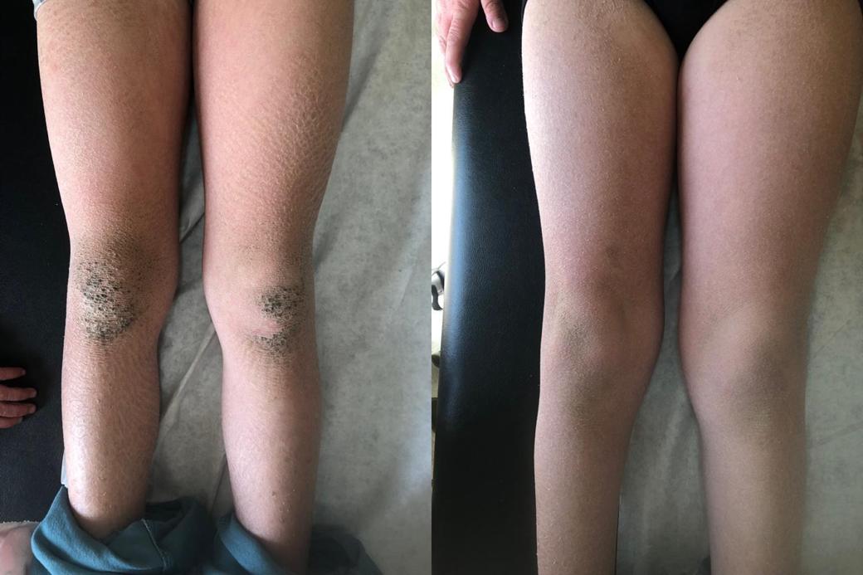
(A) (B)

Figure 2
(A) (B) (C)
Figure 3
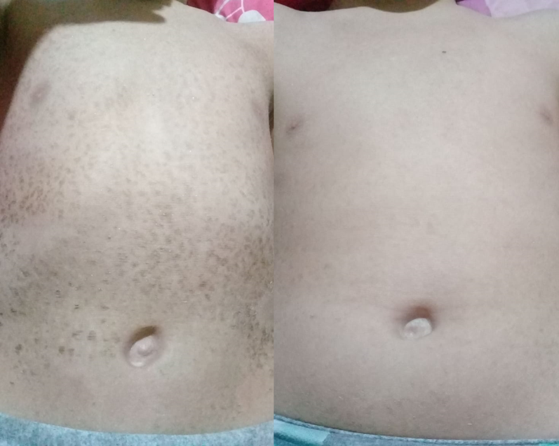
(A) (B)
Figure 4
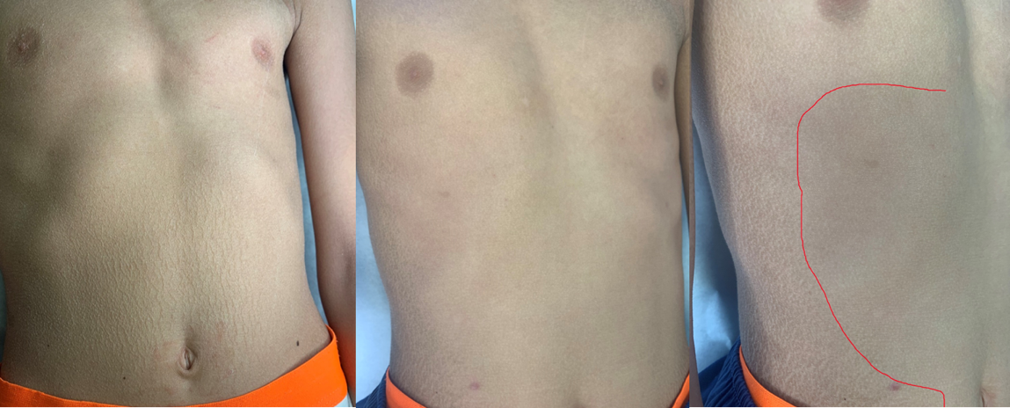
(A) (B) (C)
Figure 5
(A) (B)
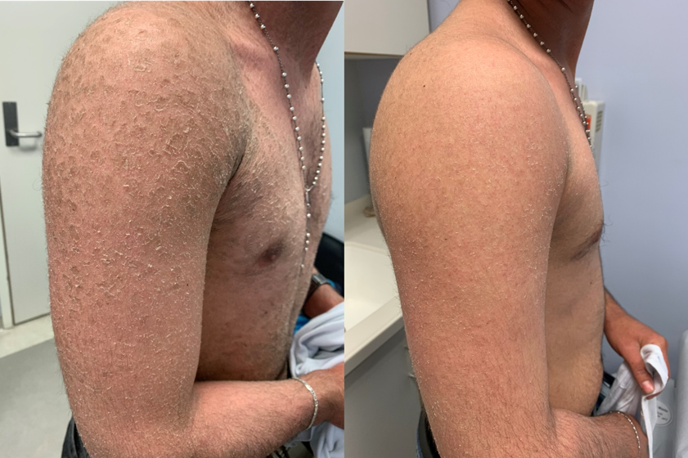

Figure 6
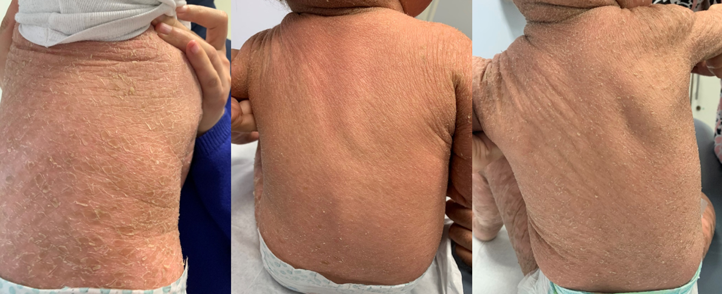
(A) (B) (C)
Figure 7
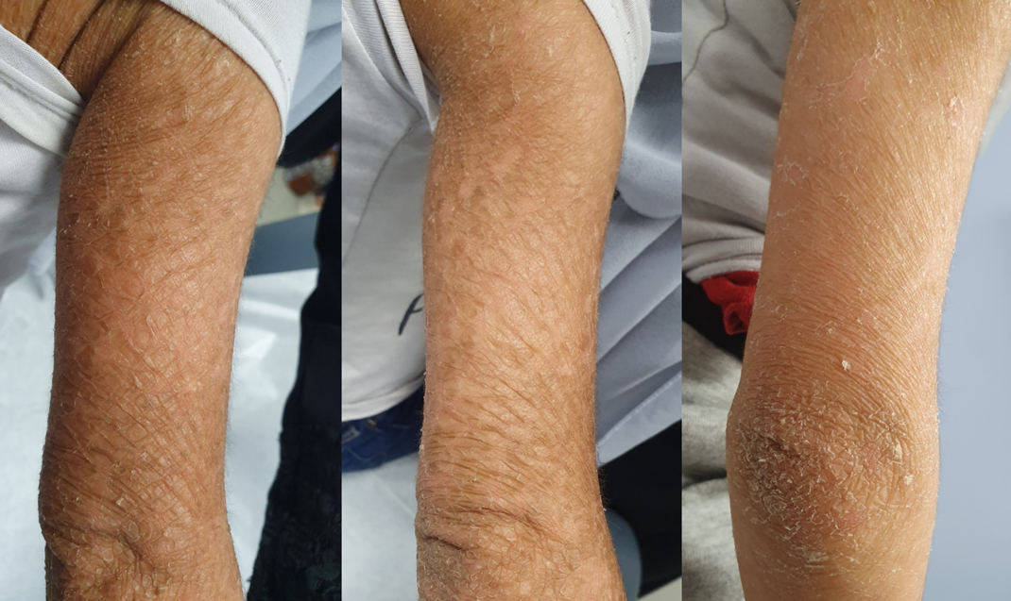
(A) (B) (C)

