SUPPLEMENTAL MATERIAL

Nuclear Smooth Muscle α-actin in Vascular Smooth Muscle Cell Differentiation
Callie S. Kwartler^{1*}, Albert J. Pedroza², Anita Kaw¹, Pujun Guan¹, Shuangtao Ma^{1,3}, Xue-yan Duan¹, Caroline Kernell¹, Charis Wang¹, Jose Emiliano Esparza Pinelo¹, Mikayla S. Borthwick¹, Jiyuan Chen¹, Yuan Zhong⁴, Sanjay Sinha⁵, Xuetong Shen⁴, Michael Fischbein², Dianna M. Milewicz^{1*}
Affiliations: ¹Division of Medical Genetics, Department of Internal Medicine, McGovern Medical School, The University of Texas Health Science Center at Houston, Houston, TX 77030. ²Department of Cardiothoracic Surgery, Stanford University, Stanford, CA 94305. ³Current address: Department of Nanomedicine and Molecular Intervention, Michigan State University, East Lansing, MI 48824. ⁴Department of Epigenetics and Molecular Carcinogenesis, The University of Texas MD Anderson Cancer Center, Smithville, TX 78957. ⁵ Anne McLaren Laboratory, Wellcome Trust-Medical Research Council Cambridge Stem Cell Institute, Department of Medicine, University of Cambridge, Cambridge, United Kingdom.
*Corresponding authors: Dianna M. Milewicz, M.D., Ph.D. and Callie S. Kwartler, Ph.D.

Materials and Methods
Institutional approvals
Human specimens used for this study were obtained with informed consent under the approval of the Institutional Review Board at Stanford University (Protocol #23395) or the Committee for the Protection of Human Subjects at the University of Texas Health Science Center at Houston (Protocol #HSC-MS-06-0564). Animal studies were approved by the Animal Welfare Committee at the University of Texas Health Science Center at Houston (Protocol # AWC-22-0004).

Fractionation into nuclear/cytosolic lysates and SDS-PAGE Western blotting
Confluent 10cm culture dishes of cells were serum starved overnight then (where indicated) treated with 2ng/mL TGFβ1 (Peprotech) for 48 hours or 10ng/mL PDGF-BB (Peprotech) for 24 hours. Cells were harvested with trypsin and washed with PBS, then lysed and fractionated using the CelLytic TM NuCLEAR TM Extraction kit (Sigma, NXTRACT-1KT). Nuclear lysates were sonicated using a Branson sonicator at 60% power for 20 seconds at 4⁰C.
For standard whole cell lysate protein extraction, cells were lysed in RIPA buffer (Millipore Sigma), supplemented with protease inhibitor cocktail (P8340, Millipore Sigma) at 4⁰C for a minimum of 30 minutes. Protein lysates were cleared by centrifugation at top speed at 4⁰C for 15 minutes.
Concentrations of all protein samples were estimated by Bradford assay (Bio-Rad Laboratories). 5ug of protein for each sample (cytosolic, nuclear, or whole cell lysates) were loaded and run on SDS-PAGE gels (Criterion, Bio-Rad), then transferred to PVDF membrane according to standard protocols. Blots were blocked with 5% dry milk in Tris-buffered saline (TBS), containing 0.05% Tween-20 (TBST) and probed with different antibodies listed in the table below. Bands were visualized by chemiluminescent substrate (Clarity ECL, Bio-Rad). Immunoblots were quantitated with ImageJ, with graphs and statistics generated by Prism. Each experiment shown here was performed a minimum of four independent times.

2-dimensional gel electrophoresis
Cultured mouse SMCs were homogenized in urea sample buffer, containing 8M urea, 20mM Tris, 23mM glycine, 0.2mM EDTA, 5% saturated sucrose, and 10mM DTT. Three micrograms of cell lysates were added into 450µL of Rehydration/Sample buffer (Bio-Rad). Samples were loaded onto 24 cm, pH 4–7, immobilized pH gradient strips (Bio-Rad) overnight and focused in a PROTEAN® i12™ IEF System (Bio-Rad) for 60kVh. Then, the strips were equilibrated in Equilibration Buffer I and II (Bio-Rad), the center third parts were cut out and saved, and the strips were gently inserted into a 8-12% SDS-PAGE mini-gel (Bio-Rad). Then, the gel was run, transferred to nitrocellulose membrane, blotted with anti-pan actin antibody (MA5-11869, Sigma) or anti-SMA antibody (A5228, Sigma), and visualized as described in routine immunoblotting. The calculated isoelectric points for α- and β- -actin are 5.24 and 5.29 respectively

Induced pluripotent stem cell (iPSC) reprogramming, Crispr/Cas9 editing, and differentiation
Fibroblasts explanted from two healthy individuals were reprogrammed into iPSCs using the CytoTune Sendai virus reprogramming kit (ThermoFisher) and two additional iPSC lines from healthy individuals were purchased from WiCell. Pluripotency of all lines was confirmed in vitro using a trilineage differentiation array kit (StemCell Technologies) and a global SNP array (Illumina) to confirm no genomic rearrangements in the selected cell lines. All iPSCs were cultured in mTeSR media (StemCell Technologies) on a Matrigel matrix (Corning).
For genetic knockout of ACTA2 using Crispr/Cas9 editing, three pooled sgRNAs targeted against the ACTA2 locus (Synthego, gene knockout kit v2.0), were combined with Cas9 enzyme (Synthego). The combined snRNP complex was electroporated into 1x10⁶ control iPSCs using Nucleofector 4D (Lonza). Cells were replated in standard mTeSR media with addition of CloneR (StemCell Technologies) and allowed to recover for approximately one week. Nucleofected cells were then plated at clonal dilution to allow picking of single cell-derived colonies, which were screened for successful gene editing by PCR, visualization on agarose gel, and Sanger sequencing using primer sequences provided by Synthego. Successfully edited clones were also screened for loss of ACTA2 mRNA expression by qRT-PCR.
All iPSC lines were differentiated into neural crest cells (NCCs) as an intermediate and then smooth muscle cells (SMCs) using a protocol published by Cheung et al.¹ NCCs to SMC differentiation requires twelve consecutive days of treatment with TGFβ1 and platelet-derived growth factor BB (PDGF-BB). For timecourse analysis in Figure 1, samples were taken at days 0 (NCC), 4, 8, and 12 (SMC). For analysis of the resulting SMCs in Figure 5, cells were maintained long term in Smooth Muscle Basal Medium (SmBM, Promo Cell) supplemented with 10% FBS (Gibco), insulin, epidermal growth factor, fibroblast growth factor (Promo Cell), and antibiotic/anti-mycotic (Millipore Sigma). SMCs were serum-starved in SmBM containing 1% FBS and antibiotic/anti-mycotic only for 24 hours, then treated with TGFβ1 (2 ng/mL) for 48 hours where indicated.

Immunostaining and Confocal microscopy
Cells were seeded on 22mm cover slips and attached overnight, then serum starved and treated with TGFβ1 where indicated. Cells were fixed in 4% paraformaldehyde in 0.1M phosphate-buffer saline (PBS). Nuclei were isolated according to the published protocol of Neely and Bao, 2019.² Isolated nuclei were spun onto coverslips pre-coated with 0.1% gelatin and immediately fixed in 4% paraformaldehyde in PBS. The SMCs or nuclei were permeabilized with 0.3% Triton X-100 for 10 minutes, blocked in 3% bovine serum albumin (BSA) in PBS with Tween-20 for 1 hour, and then incubated with primary antibody at 4⁰C overnight. Cells stained for αSMA were incubated with AlexaFluor 488 Goat-anti-mouse at room temperature for 1 hour and Texas Red™-X Phalloidin for 40 minutes, then mounted in Prolong Diamond with Dapi (ThermoFisher). Other cells and nuclei were incubated with AlexaFluor 488 Goat-anti-mouse and AlexaFluor594 donkey-anti rabbit secondary antibodies for 1 hour followed by mounting in Prolong Diamond with Dapi (ThermoFisher). Immunofluorescent images were obtained using the Nikon A1-R confocal microscope. All imaging was performed at the Center for Advanced Microscopy, Department of Integrative Biology and Pharmacology at McGovern Medical School, UTHealth.
Quantification of corrected total nuclear fluorescence (CTNF) was performed in ImageJ according to protocols for corrected total cell fluorescence available via The Open Lab Book at https://theolb.readthedocs.io/en/latest/imaging/measuring-cell-fluorescence-using-imagej.html. Briefly, regions of interest were designated by outlining each nucleus along with three background regions of any size surrounding the nucleus. Intensity readings for the nucleus were normalized to background intensity according to this formula: CTNF=Integrated Density-(Area of Selected Nucleus*Mean Fluorescence of 3 background readings). Co-localization analysis was performed in NIS-Elements software. For each analyzed nucleus, sixteen individual regions of interest were distributed throughout the nucleus, with each drawn around <10 pixels with high intensity of HP1a. The Pearson correlation coefficient for each region of interest was calculated by the software, then the sixteen area coefficients were averaged and reported as a single value for each nucleus.

Quantitative real time PCR (qRT-PCR)
Total RNA was isolated from cultured immortalized SMCs (Purelink RNA kit, ThermoFisher), quantified by Nanodrop (Thermo Fisher Scientific), and used for cDNA synthesis using QScript reagent (Quantabio). mRNA expression was assessed using SYBR green chemistry (primers listed in Table 2 below, reaction master mix from Quantabio) or Taqman probes (Taqman probes were purchased from Applied Biosystems and qPCR master mix obtained from Takara Biosciences). Reactions were performed in triplicate and 18S rRNA and Gapdh were used as endogenous controls for SYBR and Taqman reactions in mouse respectively. For human, GAPDH was used as an endogenous control, and all reactions were SYBR green.

Co-immunoprecipitation (CoIP)
Nuclear enriched lysates were prepared by lysing cell pellets in 10X volume of hypotonic buffer (10mM Tris pH7.4, 10mM KCl, 1.5mM MgCl2, 1mM DTT) for 10 minutes on ice, homogenizing by passing cells through a 21G syringe needle 5X, then centrifuging at low speed to pellet the nuclear fraction. Pellets were washed a second time in hypotonic buffer, then resuspended in 150uL low salt buffer per prep (20mM Tris pH7.4, 20mM KCl, 1.5mM MgCl2, 1mM DTT, 25% glycerol, 0.2mM EDTA) and homogenized by passing through a 21G syringe needle 15X. 150uL High salt buffer (20mM Tris pH7.4, 1.2M KCl, 1.5mM MgCl2, 1mM DTT, 25% glycerol, 0.2mM EDTA) was slowly added, and lysates were rotated at 4°C overnight. Lysates were cleared by high speed centrifugation and stored at -20°C until use.
Lysates were quantified by Bradford assay. 20ug lysates were set aside as input and 300ug lysates used for each pulldown (IgG or test antibody). For pulldowns, nuclear lysates were incubated in IP buffer (10mM Tris (pH 8), 150mM NaCl, 0.1mM EGTA, 20% glycerol, and 0.2% NP-40) and primary antibody or species-matched IgG overnight at 4°C. 25uL aliquots of Protein G magnetic beads (SureBeads, Bio-Rad) were washed in IP wash buffer (10mM Tris pH 8, 300mM NaCl, 1% NP40) three times, then added to pulldown samples which were then rotated at 4°C for 4 hours. Protein-bound beads were washed 3 times 5 minutes at 4°C in IP wash buffer. Protein was eluted in 2x Laemmli buffer (Bio-Rad) by heating the beads at 70°C for 10 minutes and collecting the eluate using magnetic separation.

Chromatin immunoprecipitation (ChIP)
Cells were crosslinked with formaldehyde for 10 minutes at room temperature, then quenched with glycine for 5 minutes and washed twice with ice cold PBS. Cells were pelleted and stored at -80°C until use. ChIP pulldowns were performed using the Simple ChIP magnetic separation kit (Cell Signaling Technologies) according to the manufacturer’s specifications. Briefly, lysates were incubated in 1X ChIP buffer with antibody or species-matched IgG control overnight at 4°C. Magnetic protein A/G beads from the Simple ChIP kit were added, and samples were rotated for 4 hours at 4°C. Protein-bound beads were washed 3 times 5 minutes at 4°C in low salt wash buffer and once in high salt wash buffer, then proteins were eluted in ChIP elution buffer from the kit at 65°C in a thermomixer for 30 minutes. Crosslinks were reversed at 65°C with excess salt and proteinase K, and the resulting DNA was purified and quantified by quantitative RT-PCR. A 2% input sample was saved for each lysate used in each batch of pulldowns, and analysis of the RT-PCR results was performed by normalizing to this input for each sample.
For sequential ChIP reactions, sample preparation was the same, and the first pulldown proceeded as described above until the high salt buffer wash. Proteins were eluted by incubating in 10mM DTT for 30 minutes at 37°C twice and combining the eluates, then the samples were diluted in 1X ChIP buffer and the second antibody or IgG was added and incubated overnight at 4°C, followed by resuming the typical ChIP protocol described above with the addition of the beads. For each repeat of the sequential ChIP experiment, the following controls were performed: 1) single pulldowns for each antibody or species-matched IgG used in the experiment, 2) double pulldowns with the antibody against protein A followed by species-matched IgG for the antibody against protein B, 3) double pulldowns with the antibody against protein A followed by the antibody against protein B, 4) double pulldowns with the antibody against protein B followed by species-matched IgG for the antibody against protein A, 5) double pulldowns with the antibody against protein B followed by the antibody against protein A. For a list of primers used for ChIP, please see Table 2.

Mouse SMC isolation and culture
SMCs were explanted from the ascending aortas of age and gender matched Acta2^{SMC-R179C/+} and WT littermates or Acta2-/- and WT littermates as previously described.³ SMCs were maintained in Smooth Muscle Basal Medium (SmBM, Promo Cell) supplemented with 20% FBS (Gibco), insulin, epidermal growth factor, fibroblast growth factor (Promo Cell), HEPES (Millipore Sigma), sodium pyruvate (Millipore Sigma), L-glutamine (Millipore Sigma), and antibiotic/anti-mycotic (Millipore Sigma). SMCs were serum-starved in SmBM containing 1% FBS and antibiotic/anti-mycotic only for 24 hours and treated with TGFβ1 (2 ng/mL) for 48 hours where indicated.

BrdU incorporation ELISA
SMCs were seeded at a density of 5000 cells/well in 96-well plates and allowed to attach overnight. Cells were serum starved for 24 hours in SMC media containing 1% FBS before addition of BrdU with or without PDGF-BB stimulation (Peprotech, 10ng/mL final concentration), and incubated with BrdU for 24 h. BrdU ELISAS were performed according to the manufacturer's instructions (Cell Signaling Technologies). Assays were performed in triplicate, and graphs are representative of at least three independent experiments.

Transwell migration assay
A modified Boyden chamber assay was used to quantify cell migration. A total of 25,000 SMCs were seeded in duplicate into polycarbonate filters (Corning) fitted into 24-well plates, with a pore size of 8 × 10⁻³ mm. The bottom chamber contained 10ng/ml PDGF-B as a chemoattractant where indicated. Cells were incubated for 24 h before gently scraping any unmigrated cells from the upper surface of the porous membrane and visualizing migrated cells with 0.5% Crystal Violet (for human cells) or Dapi (for mouse cells). Crystal violet stained membranes were then destained in a well containing methanol, and OD450 was read on the methanol to quantify. Dapi stained membranes were mounted onto slides and a blinded observer photographed five random 400x fields from each membrane followed by counting of nuclei, and results were expressed as mean ± SD. Experiments were performed in duplicate chambers and results shown are representative of at least three independent experiments.

Actin disrupting peptide treatments
WT mouse SMCs were seeded onto cover slips or 10cm dishes as previously described. After incubation of cells in SMBM containing 1% FBS for 24 hours, cells were treated with 2 ng/ml TGF-β1 for 48 hours. Cells were incubated with indicated doses (1 µg/ml or 5 µg/ml) of either αSKA-fp or αSMA-fp for 24 hours in Owens media with media and peptide replenished every 12 hours. Both peptides have been previously characterized by Hinz et al.⁴ No peptide controls were treated with Owens media alone.

Ultracentrifugation assay for F/G actin
The fraction of F-to-G actin was assayed using the G-actin/F-actin In Vivo Assay Kit (Cytoskeleton) according to the manufacturer’s protocol. Resulting samples were run on SDS-PAGE for Western blot.

Cloning and lentivirus infection for NLS-actins
Prior to infection, SMCs were immortalized by human telomerase reverse transcriptase (hTERT) overexpression using conditioned medium containing retrovirus from pBabe.hTERTpuro-pA317 packaging cell line. Infected cells were selected using 0.5µg/mL puromycin for one week, then switched back to regular SMC maintenance medium.

Assay for transposase-accessible chromatic (ATAC) sequencing and analysis
Duplicate wells of explanted mouse aortic SMCs from WT and Acta2^{SMC-R179C/+} mice were plated at a density of 100,000 cells per 6 well plate, allowed to attach overnight, then serum starved for 24 hours. Cells were harvested, counted, then frozen and sent to be processed for ATAC sequencing (cell lysis, nuclear permeabilization, transposase reaction, indexed library amplification and sequencing on Illumina platform) through a commercial third party (Active Motif, Carlsbad, CA). Sequenced libraries were jointly analyzed. Peaks with >50% ([log2FC]>0.58) were selected for peak-gene association and pathway analysis using GREAT version 4.0.4⁵ and applying default genomic region-gene association settings, assigning genes a basal regulatory domain 5kb upstream, 1kb downstream, and extended in either direction to the nearest gene’s basal regulatory domain. Accordingly, peaks may be associated with multiple genes. Peak regions with increased or decreased accessibility were analyzed separately using the entire mm10 genome as background region input. Pathway analysis for gene ontology (GO) biological processes was conducted within GREAT via binomial fold enrichment testing and resulting pathways ranked by statistical significance. All reported pathways had false discovery rate (FDR) corrected q value <0.05. Chromatin accessibility data visualizations were generated using the Integrative Genomics Viewer version 2.12.3 (https://software.broadinstitute.org/software/igv/).⁶

Mouse single cell RNA Sequencing and analysis
Data files from previously reported single-cell RNA sequencing (scRNAseq) data (Kaw et al, in revision) from ascending aortic/transverse arch tissue from 8-week-old female Acta2^{SMC-R179C/+} were analyzed using the Seurat package (v.4.1.0) in R and merged into a single object for analysis. Following standard quality control metrics to remove doublets and debris, data were normalized, scaled, and regressed to read depth. Principal component analysis, nonlinear dimensional reduction, and unsupervised clustering at a pre-set resolution of 0.3 was performed. SMC subsets were selected manually for downstream analyses. Differential gene expression (DEG) testing was performed in Seurat using the “FindMarkers” function to perform Wilcoxon rank-sum testing. Genes with average [log2FC] > 0.25 and adjusted p value <0.05 were considered significant. Gene set enrichment analysis was performed using the clusterProfiler (v4.2.2) package in R using differentially expressed genes ranked by fold change as input genes and applying Benjamini-Hochberg . Gene ontology pathways with correction for multiple comparisons. Pathways with adjusted p values <0.05 were considered significant. For proliferation pathways scores, the complete gene list were extracted from the GO:0008283 and a composite expression score was calculated for all SMCs in the dataset using the “AddModuleScore” function in Seurat. Proliferation pathways scores between the SMC clusters were analyzed via Wilcoxon rank-sum testing.

Combined analysis of ATAC-seq and scRNA-seq
We considered genes with an absolute value log2 fold change > 0.25 in expression between SMC1 and SMC2 clusters from the scRNA-seq analysis and accessibility peaks with an absolute value log2 fold change > 0.25 between WT and Acta2^{SMC-R179C/+} in the ATAC-seq analysis, which were assigned to the genes within 100kb. Genes were binned into quadrants with increased or decreased accessibility and increased or decreased expression. Then we used hypergeometric test to determine whether a pathway from GO annotations is enriched for genes in the quadrants with increased accessibility and increased expression or decreased accessibility and decreased expression.

Human single cell RNA Sequencing
Human studies were approved by IRB and prospective informed consent was obtained from the patient’s parents. Discarded aortic aneurysm tissue (ACTA2^{R179H/+} patient) was recovered immediately upon resection from the operating room and maintained in cold saline. Tissues were then rinsed and 50mg of transmural aortic tissue were finely minced in an enzyme buffer containing collagenase cocktail (Liberase TM 10.4 U/mL, Roche) and elastase (8 U/mL, Sigma). Tissues were enzymatically digested for 60 minutes to obtain cell suspensions which were subsequently filtered through a 70µm strainer. Samples were sorted via FACS employing Calcein green (ThermoFisher) to select live cells. Cell suspensions were then counted and processed for single cell 3’ mRNA library preparation using commercially available kits and protocol (10X Genomics) at the Stanford Genome Sequencing Service Center. Discarded distal ascending aortic tissue from a pediatric heart donor was separately processed using the same protocol. Completed libraries were sequenced on a NovaSeq6000 device (Illumina) and resulting raw data were processed into gene expression matrices using the Cell Ranger Single-cell software suite 3.1.0. In brief, base-call files were demultiplexed to generate FASTQ files and reads were aligned to the human (GRCh38) genome. Expression matrices were then built into single cell RNA objects using the Seurat package in R and samples were merged into a single object. Standard quality control metrics were used to exclude debris and doublets. Dataset integration, cell clustering and cluster marker identification were performed using standard analysis pipelines within the Seurat package. Differentially expressed genes were ranked by fold change and input into GSEA v.4.1.0 using default settings to identify differentially activated pathways.
ACTA2 p.R179H human tissue scRNAseq data was merged with published Marfan syndrome (MFS) aortic scRNAseq data⁷ (hosted on Gene Expression Omnibus accession GSE153534) using reciprocal PCA data integration under default conditions within the Seurat package in R.⁸ This dataset includes aortic root/ascending aortic cells from a young male MFS patient taken at the time of aortic aneurysm repair surgery. The resulting integrated dataset was subjected to unsupervised clustering analysis at low resolution. The core SMC cluster was identified via highest expression of canonical SMC markers (MYH11, CNN1) and sub-selected for direct comparison between patients. Expression of genes of interest identified within the ACTA2 p.R179H dataset were then plotted in UMAP space.

Statistical analysis and reproducibility
For all experiments except single cell RNA sequencing, a minimum of three biological replicates, often more, was performed. Human cell data was validated with multiple independent patient and control lines (n=3). Transfections and lentiviral infections were done independently for each biological replicate. Major conclusions presented in this paper were validated by reproducing experimental results by two different scientists. Data representation and statistical analysis were perfomed using GraphPad Prism software. All data is graphed as mean with error bars delineating standard deviation. For each dataset, statistical tests were selected based on the number of samples being compared, and confirmatory tests for normality of the data were performed prior to selection of the correct statistical test. RT-PCR data are represented with technical replicates from one experiment on the graph, although a minimum of three biological replicates showed the same trend in all cases. Blot quantiation data is represented with each individual experiment shown as one dot. Imaging quantitation is presented as each dot representing one cell, with a minimum of two staining rounds represented in the quantitation. All data is graphed as mean ± standard deviation with individual data points visible. RT-PCR results, blot quantitation results, and imaging quantitation results with two groups were analyzed by student’s t-test. Welch’s correction was used where variances were significantly different between groups. RT-PCR results, blot quantitation results, and imaging quantitation with three or more groups were analyzed by one-way ANOVA followed by multiple comparisons test for pairwise comparisons. All data were tested for normality and in cases where normality was not passed, a nonparametric test was used.
References:
- Cheung C, Bernardo AS, Pedersen RA, Sinha S. Directed differentiation of embryonic origin-specific vascular smooth muscle subtypes from human pluripotent stem cells. Nat Protoc. 2014 Apr; 9:929-38.
- Neely A and Bao X. Nuclei Isolation Staining (NIS) Method for Imaging Chromatin-Associated Proteins in Difficult Cell Types. Curr Protoc Cell Biol. 2019 September; 84(1): e94.
- Kwartler, C.S., Zhou, P., Kuang, S., Duan, X., Gong, L., and Milewicz, D.M. Vascular Smooth Muscle Cell Isolation and Culture from Mouse Aorta. Bio-Protocol. 2016; 6(23):e2045.
- Hinz, B., Gabbiani, G. and Chaponnier, C. The NH2-terminal peptide of alpha-smooth muscle actin inhibits force generation by the myofibroblast in vitro and in vivo. J. Cell Biol. 2002; 157, 657-663.
- McLean, C.Y., Brisor, D., Hiller, M., Clarke, S.L., Schaar, B.T., Lowe, C.B., Wenger, A.M., and Bejerano, G. GREAT improves functional interpretation of cis-regulatory regions. Nat Biotechnol. 2010; 28, 495-501.
- Robinson, J.T., Thorvaldsdottir, H., Winckler, W., Guttman, M., Lander, E.S., Getz, G., and Mesirov, J.P. Integrative Genomics Viewer. Nat Biotechnol. 2011; 29, 24-26.
- Pedroza, A.J., Tashima, Y., Shad, R., Cheng, P., Wirka, R., Churovich, S., Nakamura, K., Yokoyama, N., Cui, J.Z., Iosef, C., et al. (2020). Single-Cell Transcriptomic Profiling of Vascular Smooth Muscle Cell Phenotype Modulation in Marfan Syndrome Aortic Aneurysm. Arterioscler Throm Vasc Biol. 40, 2195–2211.
- Butler, A., Hoffman, P., Smibert, P., Papalexi, E., and Satija, R. (2018). Integrating single-cell transcriptomic data across different conditions, technologies, and species. Nat Biotechnol. 36, 411–420.

Table 1. Antibodies used in this study
Antigen | Company, Product # | Use in paper
αSMA | Sigma A5228 | WB, IP, ChIP, IF
αSMA | CST 19245 | WB after IP
Gapdh | CST 2118 | WB
Histone H3 | CST 14269 | WB
β-actin | CST 4970 | WB after IP, ChIP
β-actin | Proteintech 66009-1-Ig | WB, IF
Pan actin | Cytoskeleton AAN01-A | WB (2D)
SMMHC | Abcam ab53219 | WB
SM22α (Transgelin) | Abcam ab14106 | WB
Calponin | Abcam ab46794 | WB
BAF250 | CST 12354 | WB
BAF155 | CST 11956 | WB
BAF170 | CST 12760 | WB
BAF57 | CST 33360 | WB
TIP49 | CST 74775 | WB
INO80C | Abcam ab151046 | WB
YY1 | CST 46395 | WB
BRG1 | CST 49360 | WB
BRG1 | CST 52251 | IP, ChIP
INO80 | Novus NBP1-78758 | WB, IP, ChIP
MKL1 | Proteintech 21166-1-AP | WB, IF
INO80E | Abcam ab122837 | WB
Lamin A/C | CST 4777 | WB
Flag | CST 14793 | WB
SMMHC | Abcam ab124679 | WB
HP1a | CST 2616 | IF
H3K4me3 | CST 9751 | ChIP
H3K27me3 | CST 9733 | ChIP
CST= Cell Signaling Technologies, WB=Western blot, IP=Co-immunoprecipitation, ChIP= chromatin immunoprecipitation, IF=immunofluorescence staining

Table 2. Primers used in this study.
Target (qRT-PCR) | Primers
Nanog (mouse) | fwd: 5'-AGGGTCTGCTACTGAGATGCTCTG-3'  rvs: 5'-CAACCACTGGTTTTTCTGCCACCG-3'
Sox2 (mouse) | fwd: 5'-GGCAGCTACAGCATGATGCAGGAGC-3'  rvs: 5'-CTGGTCATGGAGTTGTACTGCAGG-3'
Oct4 (mouse) | fwd: 5'-CTGTAGGGAGGGCTTCGGGCACTT-3'  rvs: 5'-CTGAGGGCCAGGCAGGAGCACGAG-3'
Klf4 (mouse) | fwd: 5’- CTGAACAGCAGGGACTGTCA-3’  rvs: 5’- GTGTGGGTGGCTGTTCTTTT-3’
18s (mouse) | fwd: 5’- GTAACCCGTTGAACCCCATT-3’  rvs: 5’- CCATCCAATCGGTAGTAGCG-3’
ACTA2 (human) | fwd: 5’-CACTGTCAGGAATCCTGTGA-3’  rvs: 5’-CAAAGCCGGCCTTACAGA-3’
CNN1 (human) | fwd: 5’-GTCCACCCTCCTGGCTTT-3’  rvs: 5’-AAACTTGTTGGTGCCCATCT-3’
TAGLN (human) | fwd: 5’-TCTTTGAAGGCAAAGACATGG-3’  rvs: 5’-TTATGCTCCTGCGCTTTCTT-3’
MYH11 (human) | fwd: 5’-AGATGGTTCTGAGGAGGAAACG-3’  rvs: 5’-AAAACTGTAGAAAGTTGCTTATTCACT-3’
GAPDH (human) | fwd: 5'- TGAAGGTCGGAGTCAACGGA -3'  rvs: 5'- GGTCAGGTCCACCACTGACAC -3'
SOX2 (human) | fwd: 5’- GGGAAATGGGAGGGGTGCAAAAGAGG-3’  rvs: 5’-TTGCGTGAGTGTGGATGGGATTGGTG-3’
OCT4 (human) | fwd: 5’-GACAGGGGGAGGGGAGGAGCTAGG-3’  rvs: 5’-CTTCCCTCCAACCAGTTGCCCCAAAC-3’
KLF4 (human) | fwd: 5’-ACGATCGTGGCCCCGGAAAAGGACC-3’  rvs: 5’-CAACAACCGAAAATGCACCAGCCCCAG-3’
Target (ChIP) | Primers
Acta2 (mouse) | fwd: 5’-AGAGTGAACGGCCAGCTTCA-3’  rvs: 5’-AGGCTGAACGCTGAAGGGTT-3’
Cnn1 (mouse) | fwd: 5’- CCAGATGAGAGCTGTCTAGATCT-3’  rvs: 5’- GCCAGGTTAACAGGTCTTGG-3’
Tagln (mouse) | fwd: 5’- CCAAGTCCGGGTAACAAGGAA-3’  rvs: 5’-GCATGCTTTGGAGATGCTGC-3’
Myh11 (mouse) | fwd: 5’- GGCCTTTTTGGGTTGTCTCC-3’  rvs: 5’- CCTTGCACACACACCACTCA-3’
Klf4 (mouse) | fwd: 5’-TGGGGAATGGGAAAAGGAGTAATA-3’  rvs: 5’-CTGCGCTGGGAAGAGGAG-3’
Actb (mouse) | Active Motif catalog #71017

Supplemental Figures and Legends
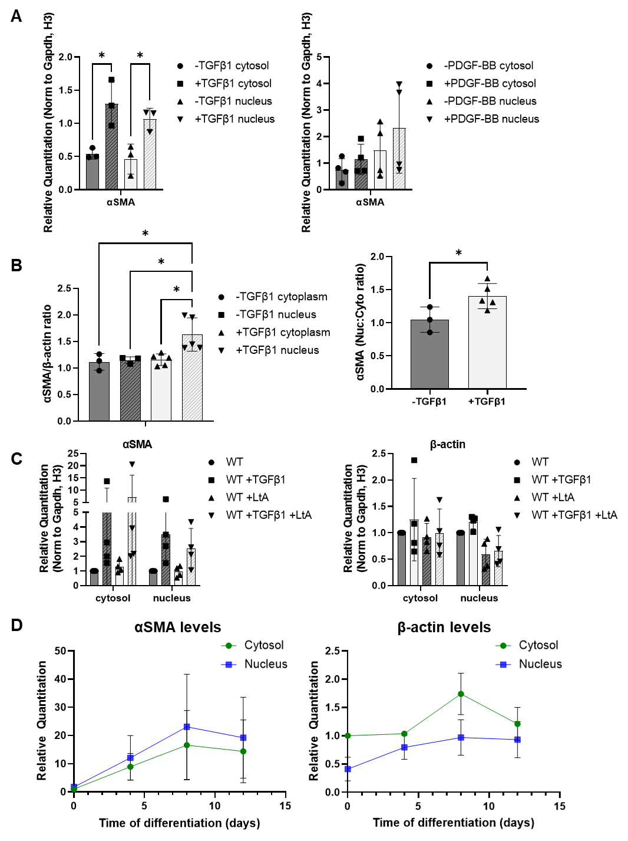
Supplemental Figure I. A) Quantitation of immunoblot in Figure 1A shows that TGFβ1 stimulation for 48 hours increases protein levels of αSMA in both the nucleus and cytosol, while PDGF-BB treatment for 24 hours does not affect αSMA nuclear localization (n=3independent experiments). B) Quantitation of the 2D gel immunoblot in Figure 1B shows that the ratio of αSMA to β-actin is consistent between the cytosol and the nucleus in serum starved cells, but TGFβ1 stimulation for 48 hours increases the αSMA to β-actin ratio only in the nucleus. The right graph shows the same data but illustrates quantitation of the ratio of αSMA in the nucleus vs. cytosol which increases significantly after TGFβ1 stimulation (n=3 independent experiments for unstimulated, n=5 for TGFβ1 stimulation). C) Quantitation of the latrunculin (LtA) treatment immunoblot shown in Figure 1C shows that depolymerization of actins by LtA treatment does not affect nuclear localization of actin, supporting that the observed nuclear localization is accurate (n=4 independent experiments). D) Quantitation of the NCC to SMC differentiation timecourse immunoblot shown in Figure 1G shows that αSMA levels in both the nucleus and cytosol increase around 15-20 fold during the differentiation, which nuclear levels accumulating faster than cytosolic. Over the same timecourse, β-actin levels do not dramatically change, and nuclear accumulation is lower than cytosolic (n=4 independent experiments using 2 different control cell lines). *p<0.05
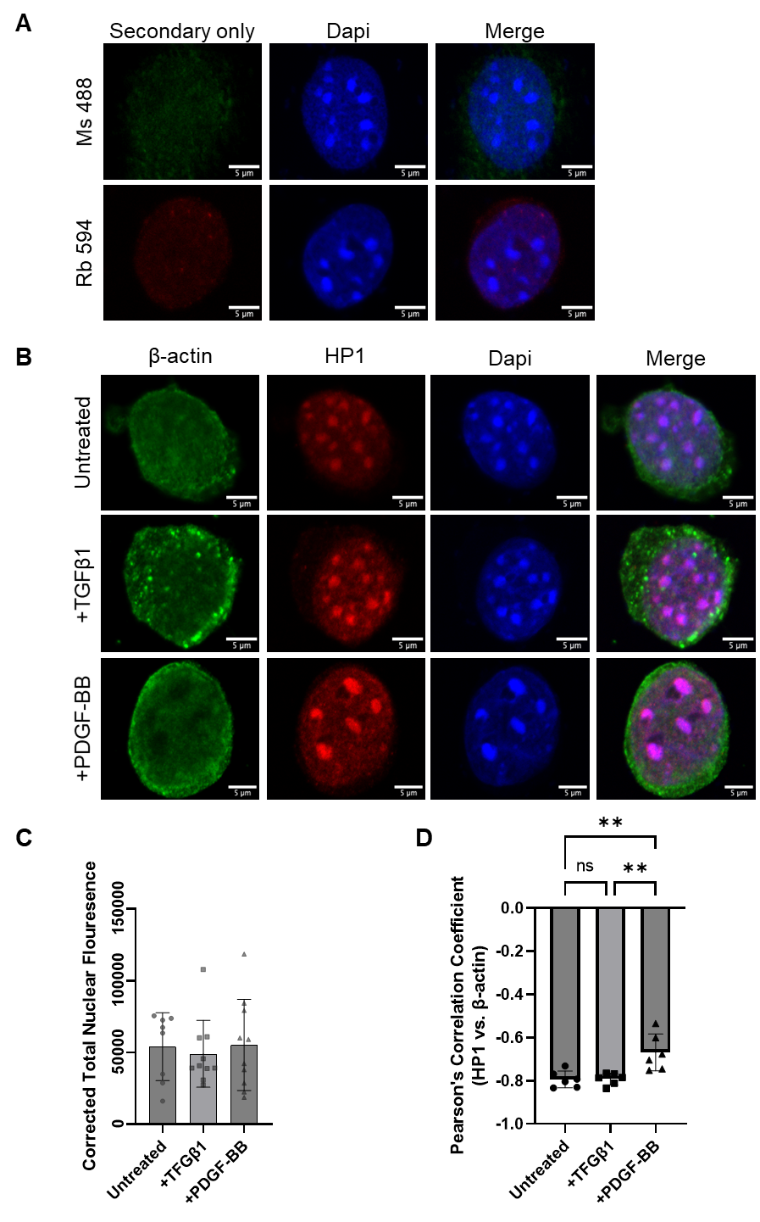
Supplemental Figure II. A) Secondary only control stains for the two secondary antibodies used in this paper: AlexaFluor 488 Goat anti-Mouse (top) and AlexaFluor 594 Donkey anti-Rabbit (bottom). B-D) Immunostaining of isolated nuclei shows no change in nuclear β-actin after treatment with TGFβ1 or PDGF-BB, quantified in (C) and confirms absence of αSMA signal in areas of heterochromatin by colocalization analysis between HP1 (red) and β-actin (green), quantified in (D).
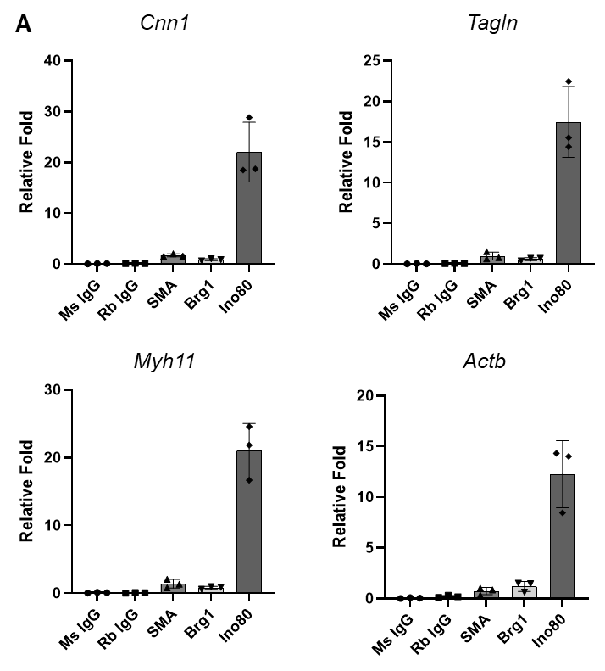
Supplemental Figure III. A) Single pulldown controls for the sequential ChIP experiment shown in Figure 2E. Single and double pulldowns were performed and analyzed as one experiment. Results are representative of three independent experiments.
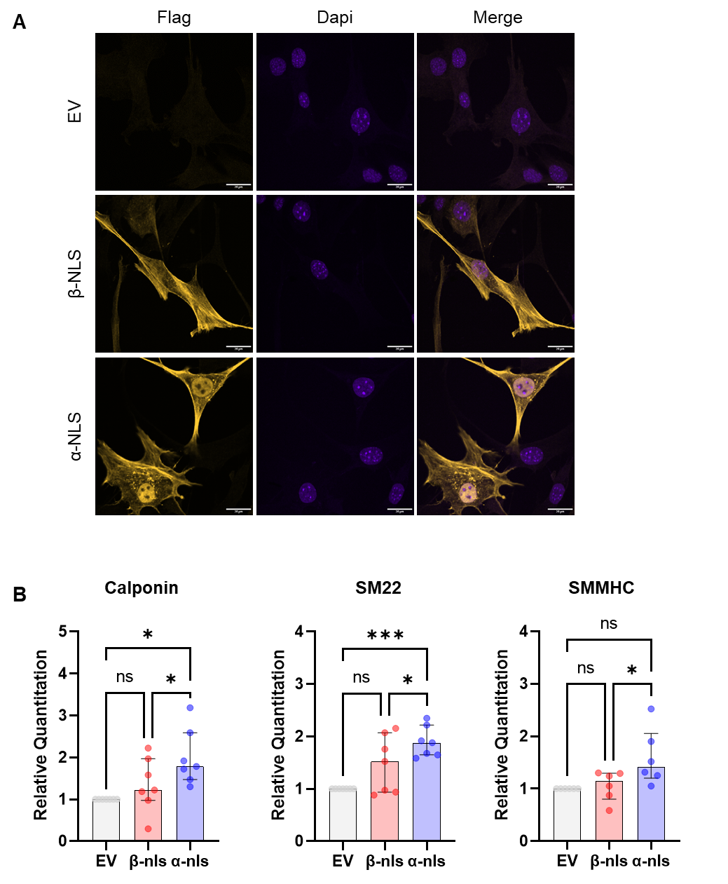
Supplemental Figure IV. A) Immunostaining of infected cells with the Flag antibody shows the efficiency of infection and the nuclear accumulation of the tagged actins. B) Quantitation of immunoblot in Figure 2G shows small but reproducible increases in contractile protein levels in WT SMC infected with a lentivirus expressing α-NLS but not β-NLS (n=7 independent experiments). *p<0.05, ***p<0.001
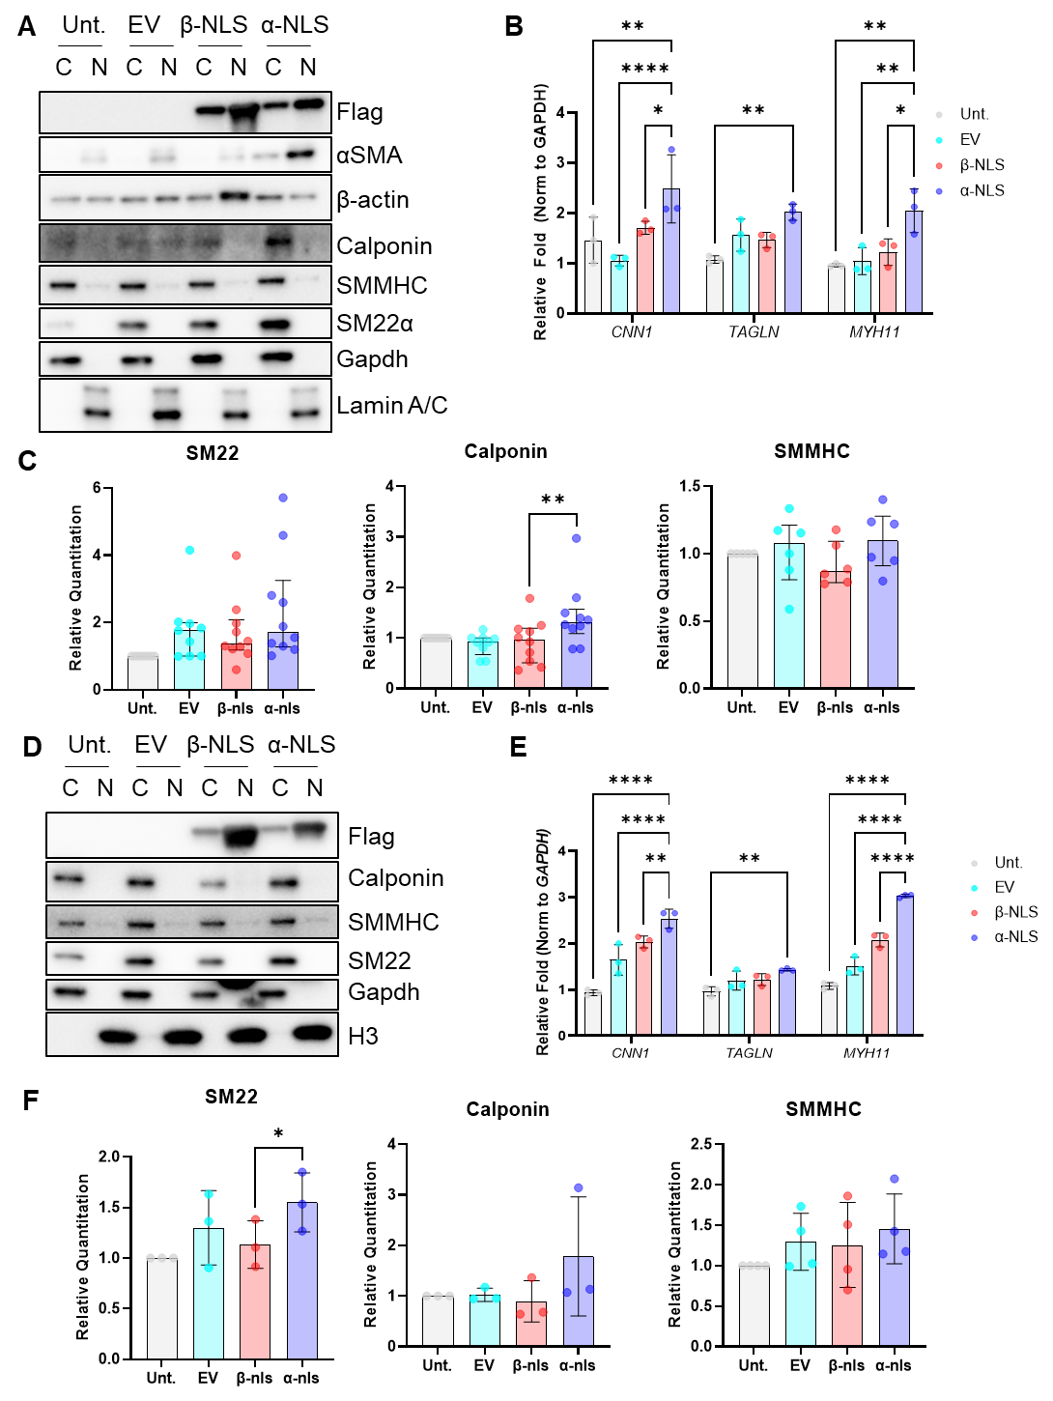
Supplemental Figure V. A) Transfection of 293T cells with empty vector or β-actin or αSMA tagged with a nuclear localization sequence (EV, β-NLS, and α-NLS labels, respectively) shows that only α-NLS increases levels of SMC contractile proteins including Calponin, SM22α, and SMMHC after 48 hours. B) Quantitative RT-PCR 24 hours after transfection confirms increased expression of SMC contractile genes in α-NLS transfected 293T cells. D) Transfection of HeLa cells with EV, β-NLS, and α-NLS shows that only α-NLS increases levels of SMC contractile proteins including Calponin, SM22α, and SMMHC after 48 hours. E) Quantitative RT-PCR 24 hours after transfection confirms increased expression of SMC contractile genes in α-NLS transfected HeLa cells. F) Quantitation of immunoblot in D shows small but reproducible increases in contractile protein levels in HeLa cells transfected with α-NLS but not β-NLS (n=3 independent experiments). *p<0.05, **p<0.01, ***p<0.001, ****p<0.0001
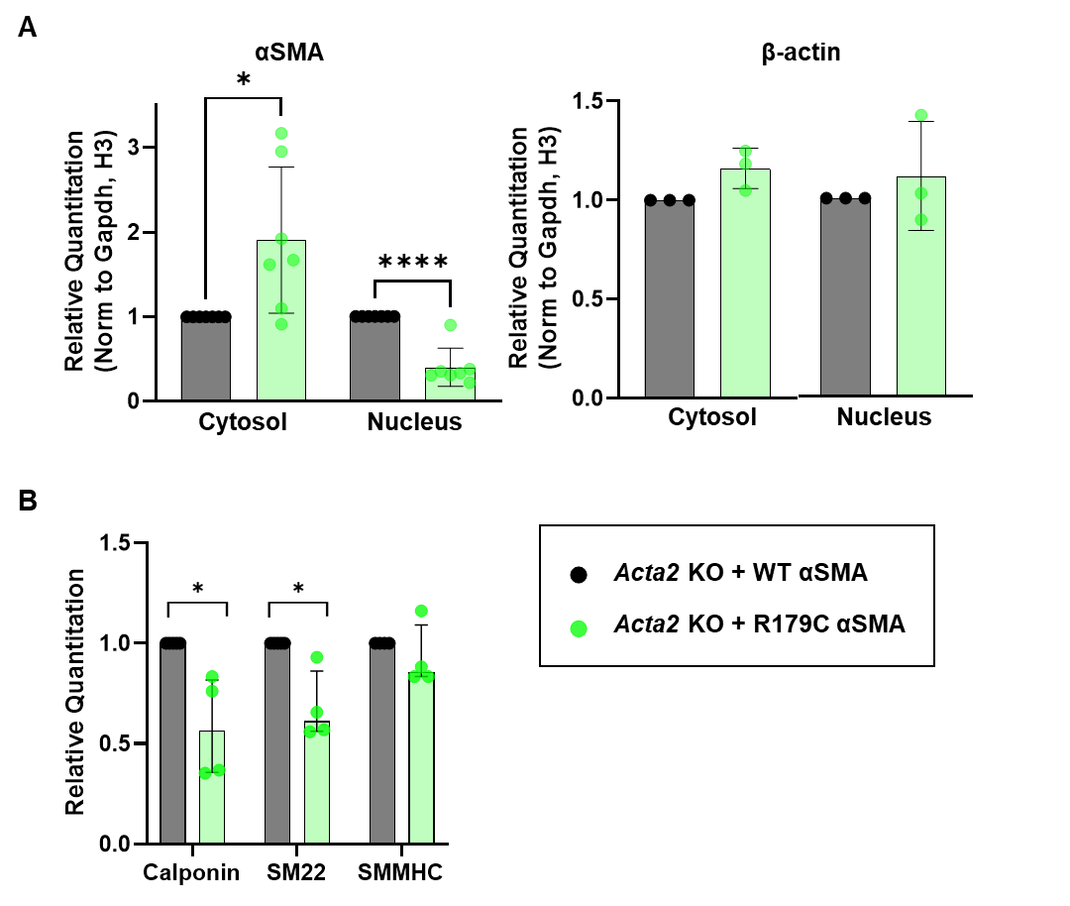
Supplemental Figure VI. A) Quantitation of immunoblot shown in Figure 3A where the cytosolic accumulation of αSMA is significantly increased and nuclear accumulation is decreased in Acta2 KO cells expressing R179C mutant αSMA compared with WT SMC. β-actin accumulation to the nucleus is not affected. B) Quantitation of immunoblot shown in Figure 3A reveals reproducible decreases in contractile protein accumulation in Acta2 KO cells expressing R179C mutant αSMA compared with WT SMC (n=4 independent lentiviral infections). *p<0.05, ***p<0.001
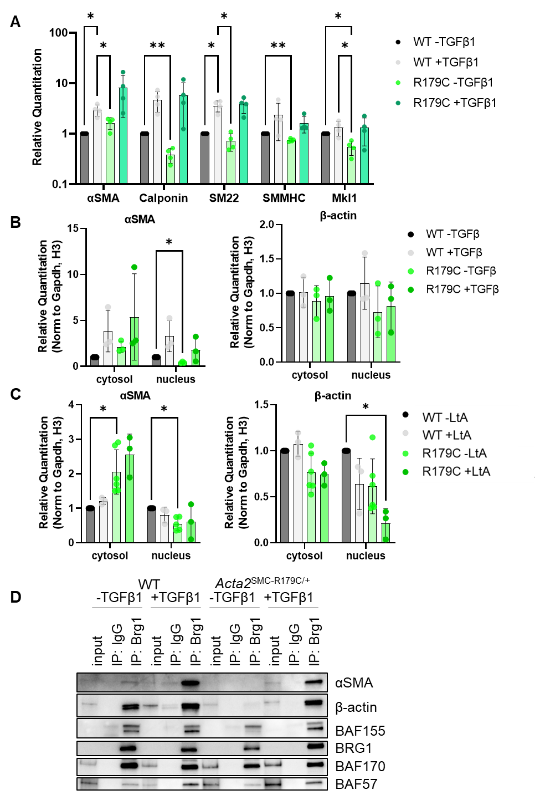
Supplemental Figure VII. A) Quantitation of immunoblot in Figure 4E shows significant and reproducible decreases in accumulation of contractile proteins in the Acta2^{SMC-R179C/+} cells compared with WT (n=4 independent experiments). B) Quantitation of immunoblot in Figure 4F shows decreased nuclear accumulation, of αSMA in the Acta2^{SMC-R179C/+} cells compared with WT. β-actin accumulation to the nucleus was variable across experiments (n=4 independent experiments). C) Quantitation of immunoblot in Figure 4G shows that LtA treatment further does moderately decrease nuclear accumulation of β-actin in Acta2^{SMC-R179C/+} cells but does not significantly affect αSMA nuclear accumulation (n=3 independent experiments). D) Co-immunoprecipitation with BRG1 antibody confirms decreased association of both αSMA and β-actin with the BAF chromatin remodeling complex in in Acta2^{SMC-R179C/+} SMCs which is partially rescued by TGFβ1 treatment (n=3 independent experiments). *p<0.05, **p<0.01
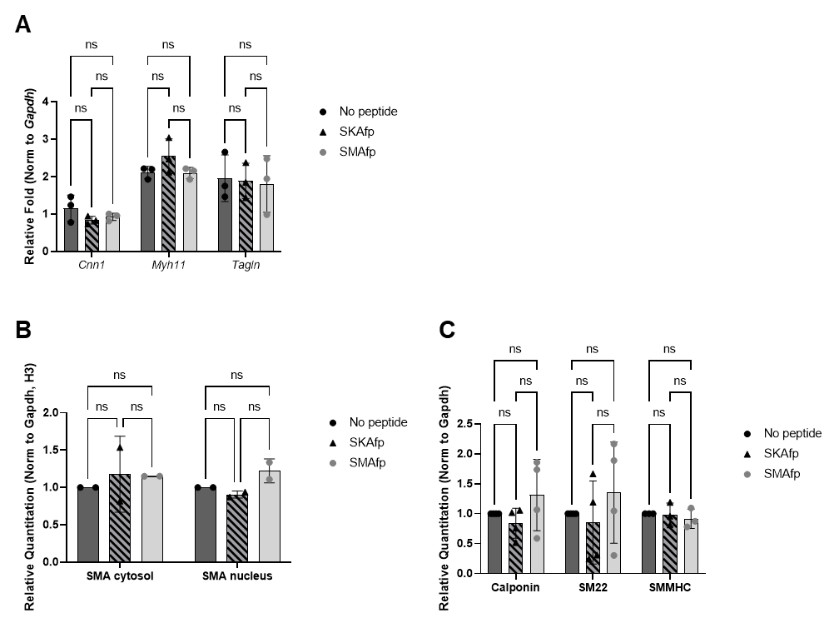
Supplemental Figure VIII. A) Quantitative RT-PCR after 24 hours of treatment with 5 µg/mL actin disrupting peptides indicates that complete disruption of αSMA filaments does not lead to decreased expression of SMC contractile genes (n=3 independent experiments). B) Quantitation of immunoblot in Figure 4L shows that 5 µg/mL actin disrupting peptide treatment does not affect nuclear accumulation of αSMA (n=3 independent experiments). C) Quantitation of immunoblot in Figure 4L shows that 5 µg/mL actin disrupting peptide treatment does not affect levels of SMC contractile proteins (n=3 independent experiments).
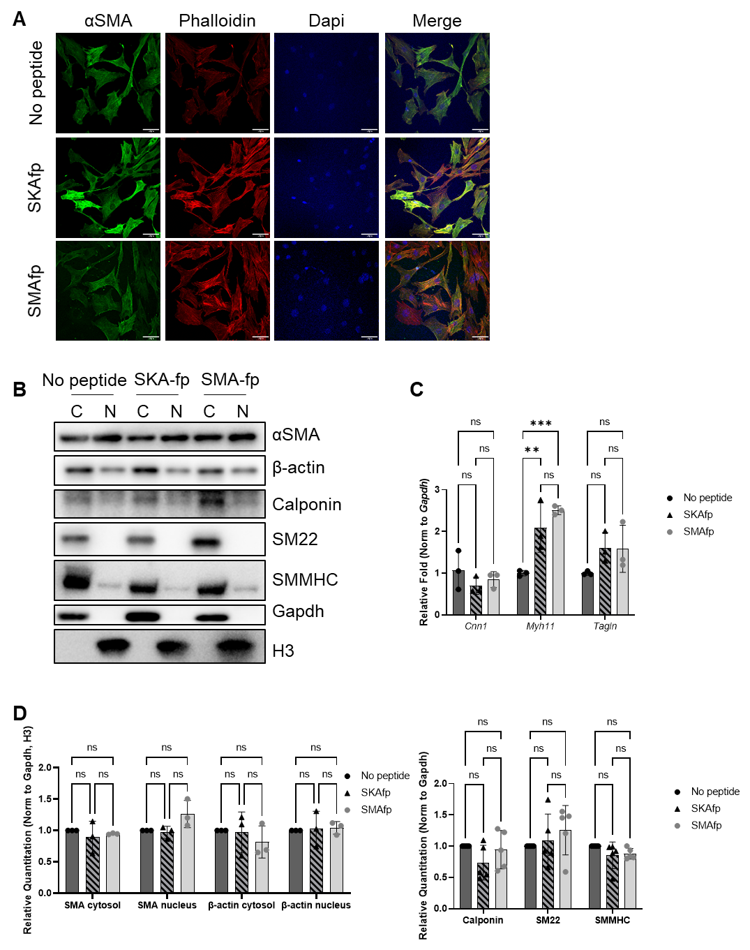
Supplemental Figure IX. A) Immunostaining for αSMA shows partial disruption of αSMA filaments with 1 µg/mL SMAfp actin disrupting peptide treatment but not with 1 µg/mL SKAfp actin disrupting peptide treatment. B, D) Treatment of WT SMCs with 1 µg/mL actin disrupting peptide does not impact nuclear accumulation of actins or contractile protein levels (quantified in D). C) Quantitative RT-PCR after 24 hours of treatment with 1 µg/mL actin disrupting peptides indicates that partial disruption of αSMA filaments does not lead to decreased expression of SMC contractile genes (n=3 independent experiments). **p<0.01, ***p<0.001
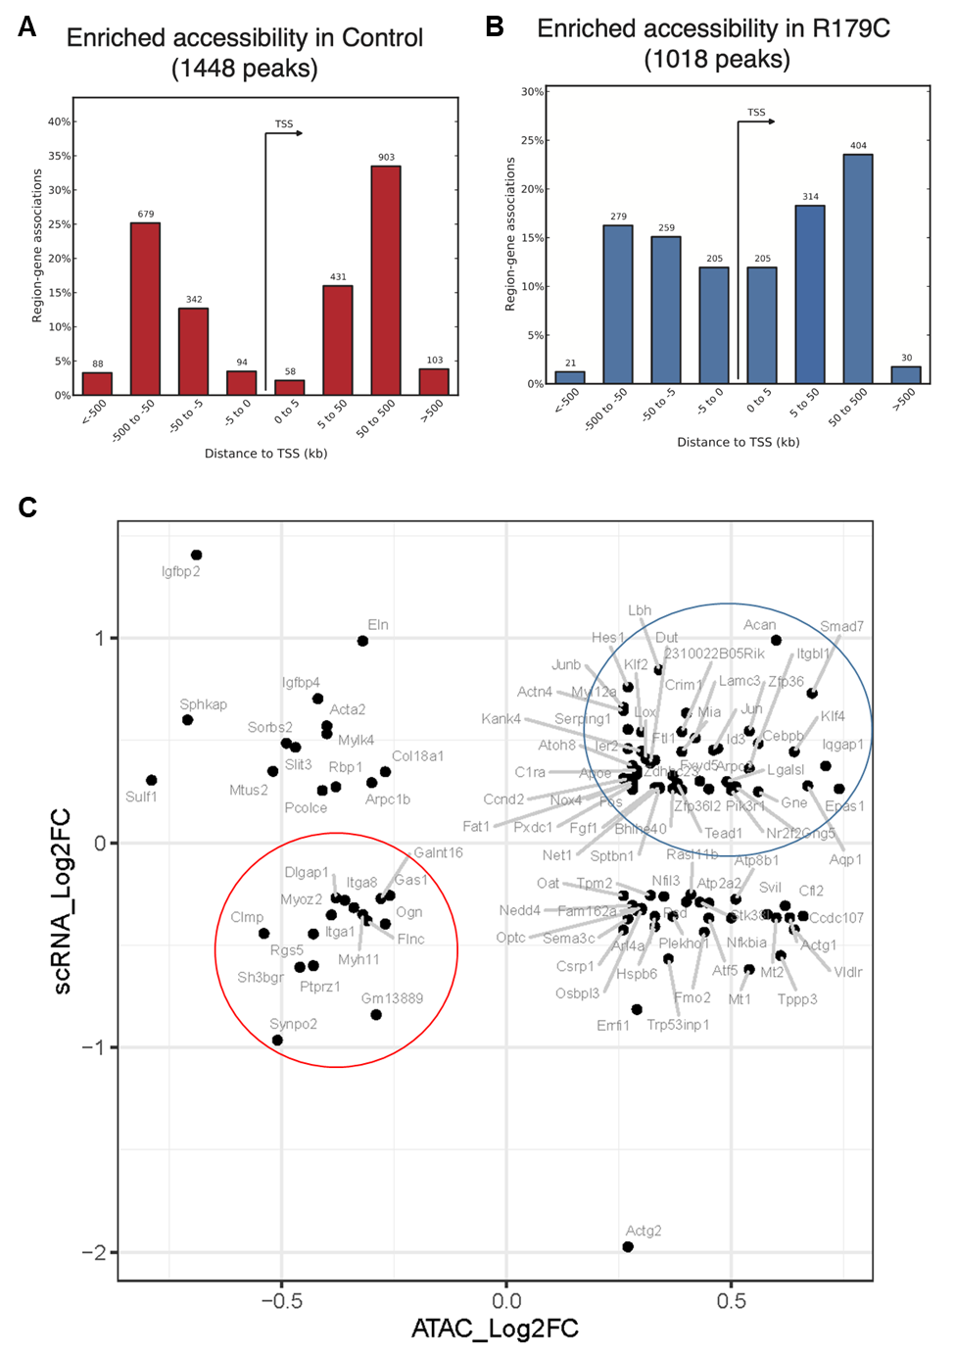
Supplemental Figure X. A) Distribution of chromatin accessibility peaks around the transcription start sites of nearby genes for peaks with increased accessibility in WT SMCs. B) Distribution of chromatin accessibility peaks around the transcription start sites of nearby genes for peaks with increased accessibility in Acta2^{SMC-R179C/+} SMCs. C) Visualization of integrated scRNA-seq and ATAC-seq datasets plots the log2FC in gene expression in vivo on the y-axis and the log2FC in chromatin accessibility in vitro on the x-axis. Genes indicated by dots inside the red circle have decreased accessibility and decreased expression in Acta2^{SMC-R179C/+} SMCs and were analyzed by GO enrichment analysis in Figure 5A. Genes indicated by dots inside the blue circle have increased accessibility and increased expression in Acta2^{SMC-R179C/+} SMCs and were analyzed by GO enrichment analysis in Figure 5B.
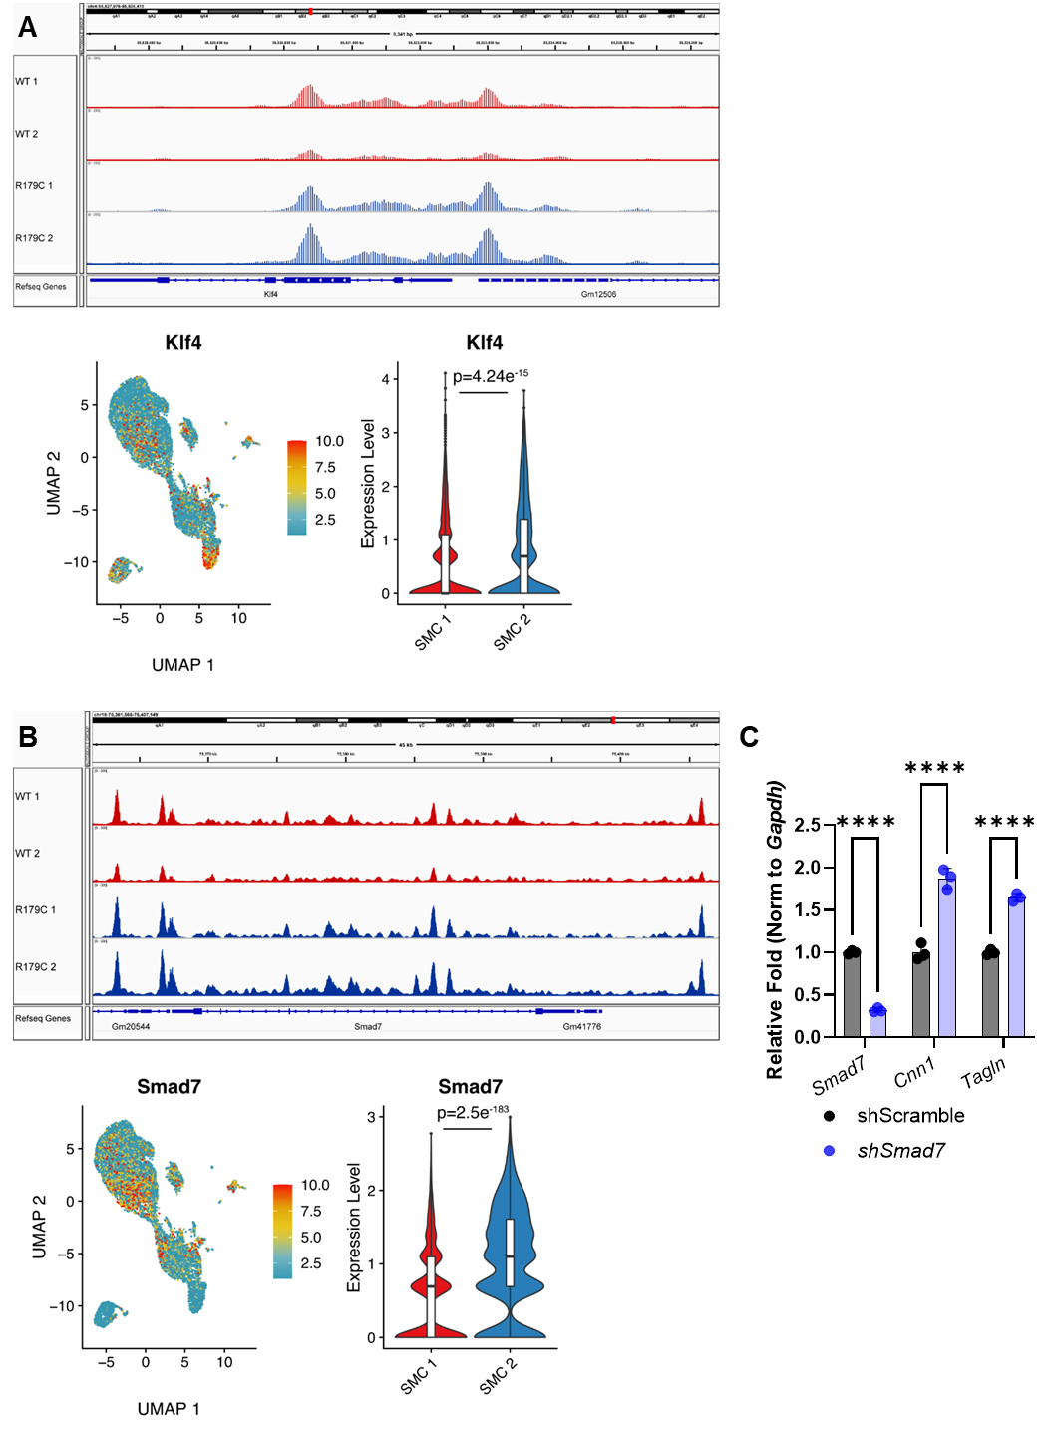
Supplemental Figure XI. A) Genome browser view for the Klf4 gene shows chromatin accessibility increased in Acta2^{SMC-R179C/+} SMCs in vitro and transcript levels visualized in UMAP space and quantified shows increased expression in Acta2^{SMC-R179C/+} SMCs in vivo. B) Genome browser view for the Smad7 gene shows chromatin accessibility increased in Acta2^{SMC-R179C/+} SMCs in vitro and transcript levels visualized in UMAP space and quantified shows increased expression in Acta2^{SMC-R179C/+} SMCs in vivo. C) Quantitative RT-PCR validates shRNA-mediated knockdown of Smad7 in WT SMCs and shows knockdown of Smad7 increases expression of SMC contractile genes. ****p<0.0001
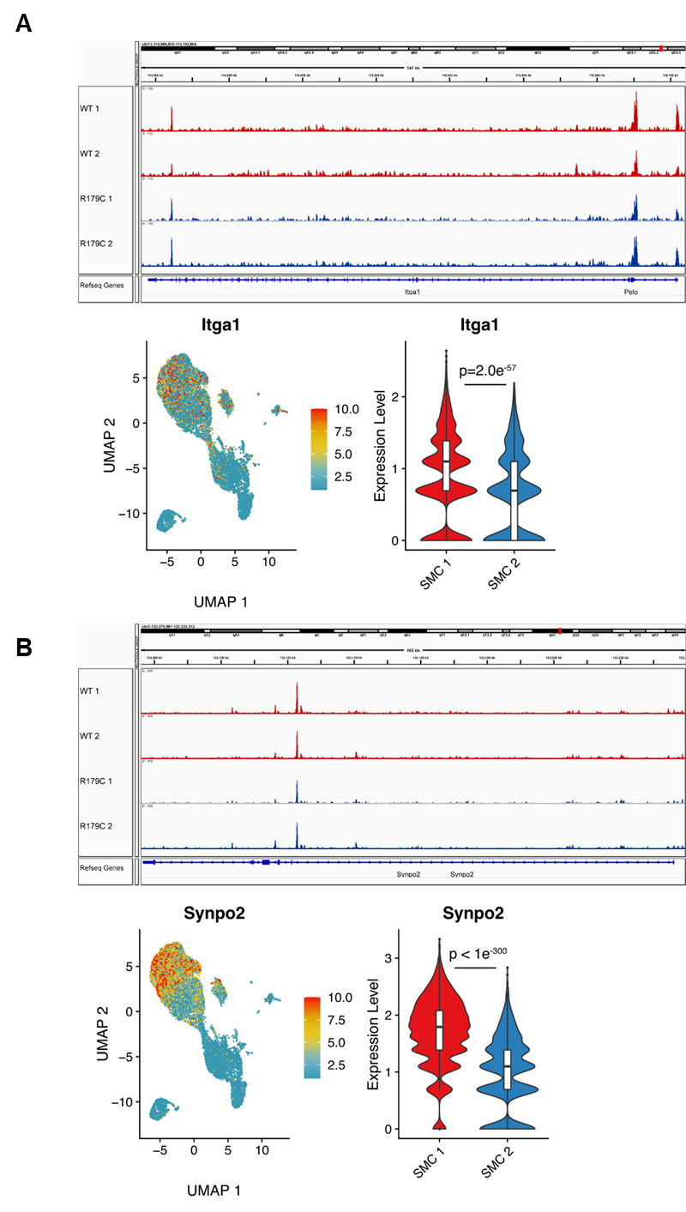
Supplemental Figure XII. A) Genome browser view for the Itga1 gene shows chromatin accessibility decreased in Acta2^{SMC-R179C/+} SMCs in vitro and transcript levels visualized in UMAP space and quantified shows decreased expression in Acta2^{SMC-R179C/+} SMCs in vivo. B) Genome browser view for the Synpo2 gene shows chromatin accessibility decreased in Acta2^{SMC-R179C/+} SMCs in vitro and transcript levels visualized in UMAP space and quantified shows decreased expression in Acta2^{SMC-R179C/+} SMCs in vivo.
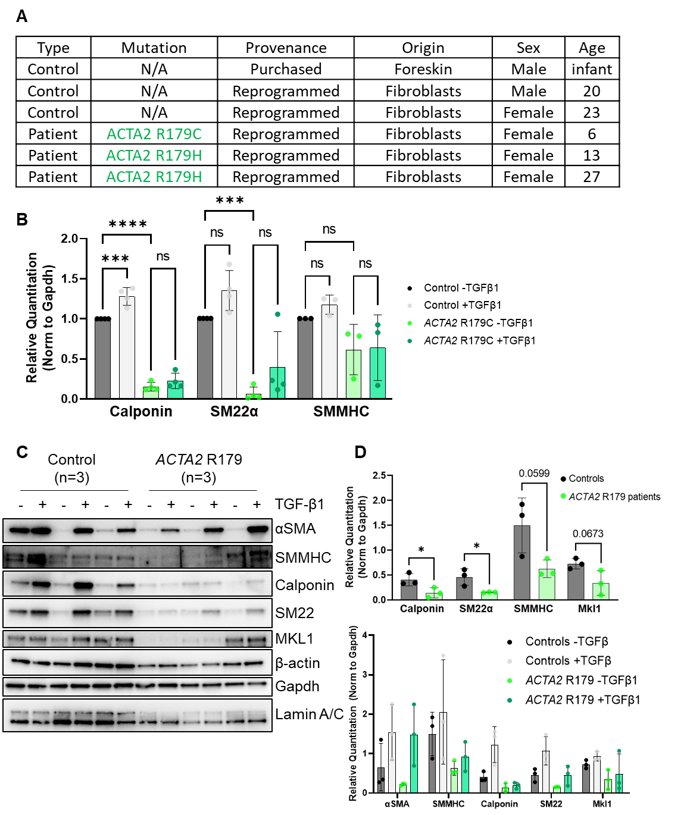
Supplemental Figure XIII. A) Demographic and genotype information for patient and control lines used in this study. B) Quantitation of immunoblot from Figure 6A reveals significant decreases in contractile protein accumulation in ACTA2 p.R179C patient SMCs compared with control SMCs (n=4 independent experiments). C, D) Immunoblot showing decreased contractile protein accumulation is a consistent finding across three ACTA2 p.R179 patient lines (C), quantified in (D). *p<0.05, **p<0.01, ***p<0.001
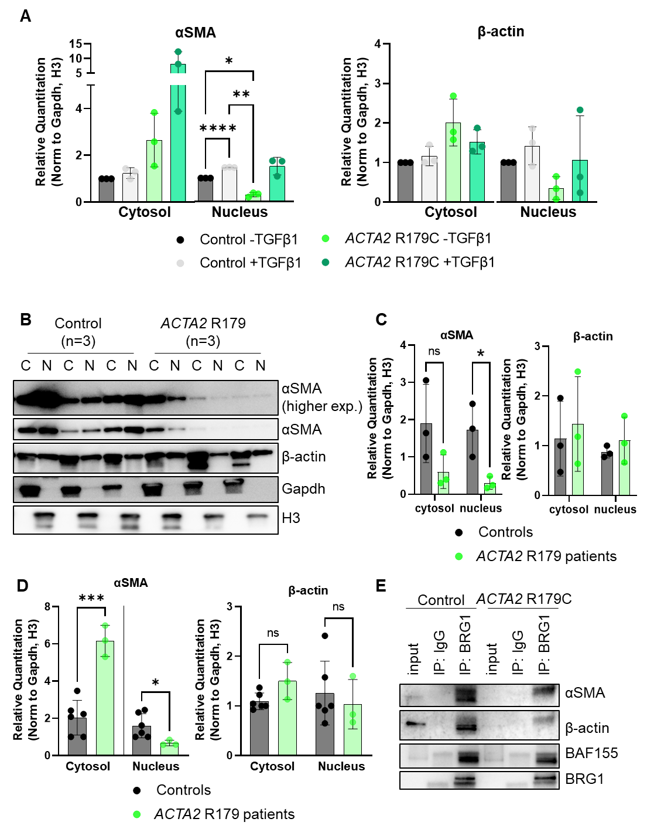
Supplemental Figure XIV. A) Quantitation of immunoblot from Figure 6C shows a significant decrease in αSMA nuclear accumulation in patient-derived ACTA2 p.R179C SMCs compared with controls. β-actin accumulation to the nucleus was variable and not significantly altered (n=3 independent experiments). B,C) Immunoblot showing decreased nuclear accumulation of αSMA is a consistent phenotype across three ACTA2 p.R179 patient lines (B), quantified in (C). D) Quantitation of immunoblot from Figure 6D shows a significant increase in cytosolic αSMA and decrease in αSMA nuclear accumulation in patient-derived ACTA2 p.R179 NCCs compared with controls. β-actin accumulation to the nucleus was not significantly altered (n=3 independent experiments). E) Co-immunoprecipitation with BRG1 antibody confirms decreased association of both αSMA and β-actin with the BAF chromatin remodeling complex in ACTA2 p.R179C SMCs. *p<0.05, **p<0.01, ***p<0.001, ****p<0.0001

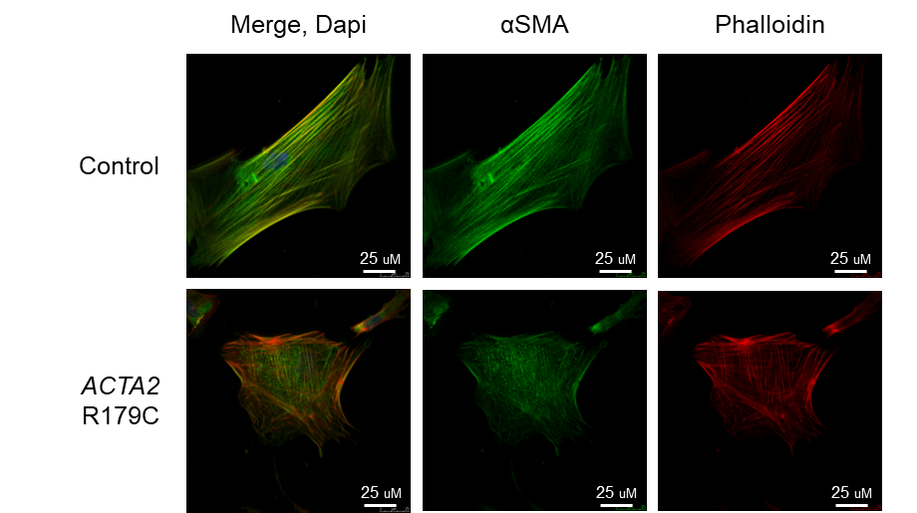
Supplemental Figure XV. Immunostaining for αSMA shows partial disruption of αSMA filaments in SMCs with the ACTA2 p.R179C pathogenic variant.

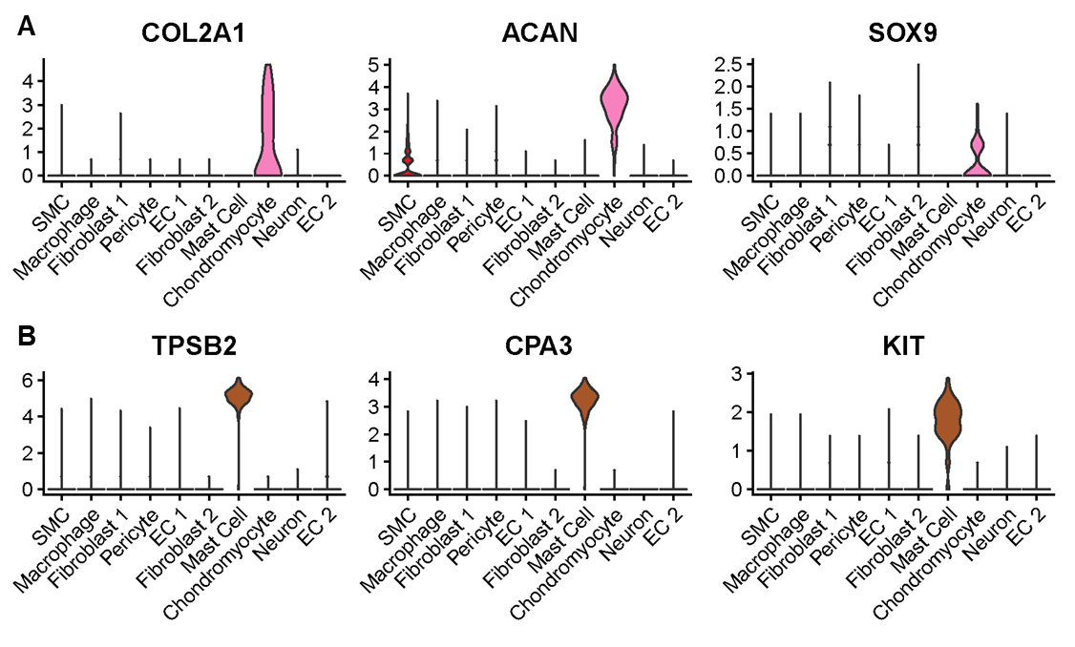
Supplemental Figure XVI. Violin plots for marker genes of the mast cell and chondromyocyte clusters from the single cell RNA sequencing. These two cell clusters are unique to the ACTA2 p.R179H patient compared with the donor. Pink plots (COL2A1, ACAN, SOX9) are markers of chondromyocytes and brown plots (TPSB2, CPA3, KIT) are markers of mast cells.
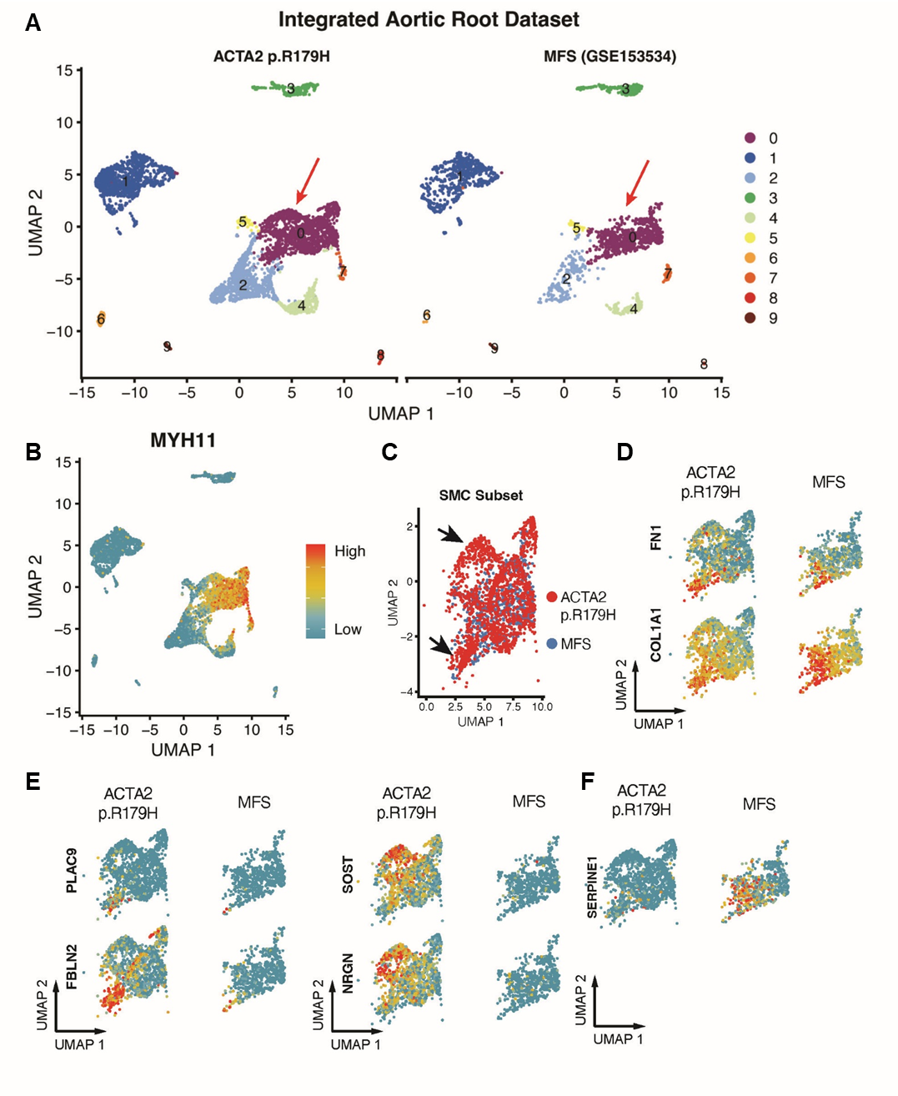
Supplemental Figure XVII. Integrated ACTA2 p.R179H and Marfan syndrome (MFS) aortic scRNAseq data. A) Complete dataset following reciprocal PCA data integration demonstrating representation of all major cell clusters in both datasets. Red arrow indicates SMC cluster selected for downstream analysis. B) Expression plot of MYH11 confirming SMC identity for selected cluster. C) Overlaid UMAP plot for ACTA2 p.R179H and MFS SMCs demonstrating overrepresented sub-populations in ACTA2 patient (black arrows). D) Expression of ‘typical’ SMC modulation markers (FN1, COL1A1) with gradient of expression in both patients. E) Expression of representative altered SMC phenotypic trajectory markers in ACTA2 patient (see Figure 7I) not activated in MFS SMCs. F) Activation of TGFβ1-responsive gene SERPINE1 is not observed in ACTA2 p.R179H SMCs as compared to MFS.

