Supplementary materials
Novel insights into the Thaumarchaeota in the deepest oceans: their metabolism and potential adaptation mechanisms

Haohui Zhong^{1,2}, Laura Lehtovirta-Morley³, Jiwen Liu^{1,2}, Yanfen Zheng¹, Heyu Lin¹, Delei Song¹, Jonathan D. Todd³, Jiwei Tian⁴, Xiao-Hua Zhang^{1,2,5}*

¹College of Marine Life Sciences, Ocean University of China, Qingdao 266003, China.
²Laboratory for Marine Ecology and Environmental Science, Qingdao National Laboratory for Marine Science and Technology, Qingdao 266237, China. ³School of Biological Sciences, University of East Anglia, Norwich Research Park, Norwich, Norfolk NR4 7TJ, UK. ⁴Key Laboratory of Physical Oceanography, Ministry of Education, Ocean University of China, Qingdao 266100, China. ⁵Frontiers Science Center for Deep Ocean Multispheres and Earth System, Ocean University of China, Qingdao 266100, China.

* Corresponding author: xhzhang@ouc.edu.cn

a
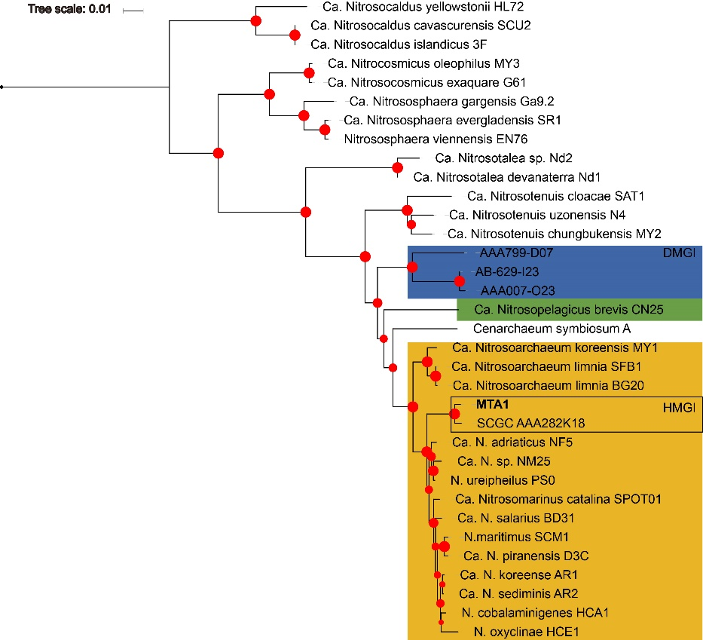
b
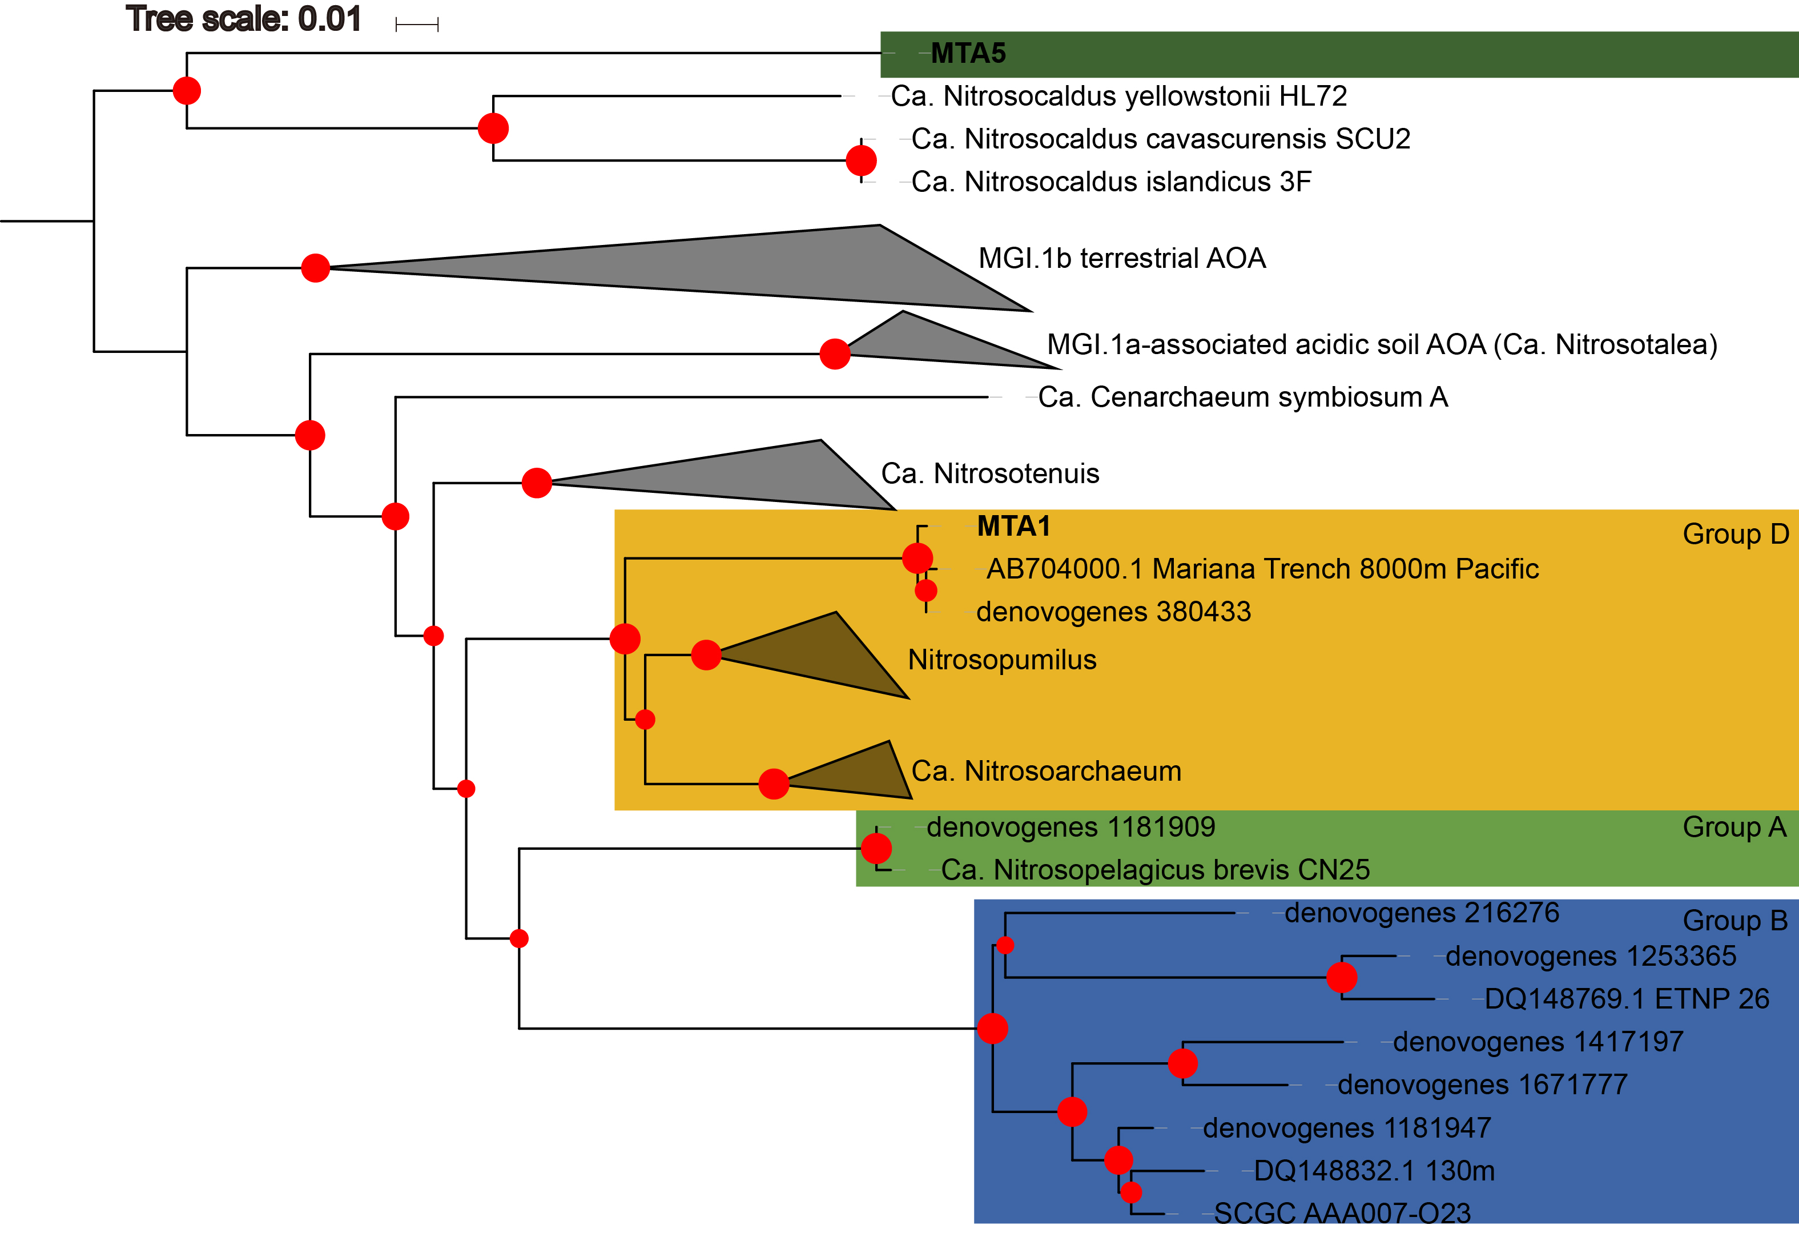

Figure S1 Phylogenetic tree based on 16S rRNA (a) and amoA (b) genes (nucleotide trees). Neighbor-joining, 100 bootstraps. Size of the red dot shows the bootstrap value of the branch. Genes started with “denovogenes” were from metagenomic data directly. Colors of clades follow those in Figure 1.

a
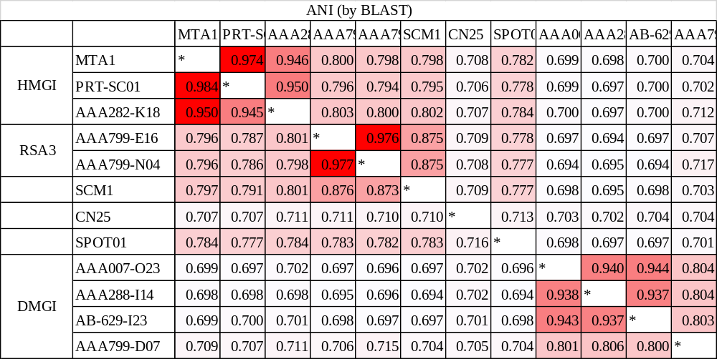
b
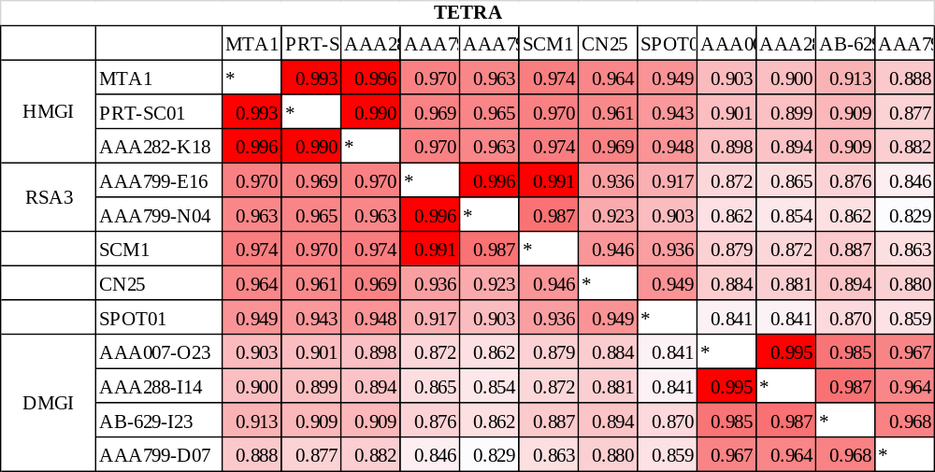

Figure S2 ANI and TETRA between HMGI, DMGI and other representative assemblages. If ANI > 0.95 or TETRA > 0.99 (shown in red) between two genomes then they could be considered to be the same phylotype.

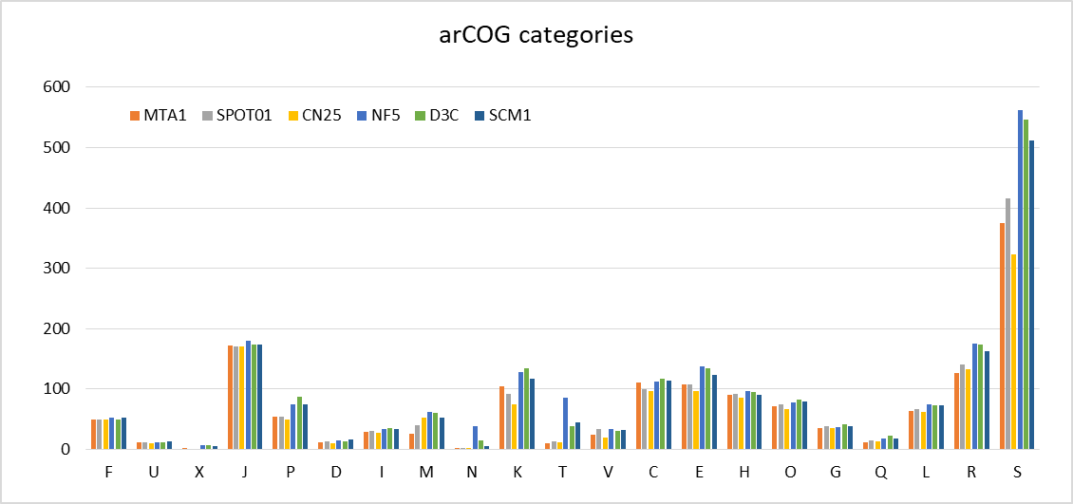
Figure S3 arCOG categories graph of several other high completeness AOA from water samples including MTA1 (DMGI SAGs are not complete enough thus not suited for this analysis). Meanings of these categories are listed below.
F Nucleotide transport and metabolism
U Intracellular trafficking, secretion, and vesicular transport
X Mobilome: prophages, transposons
J Translation, ribosomal structure and biogenesis
P Inorganic ion transport and metabolism
D Cell cycle control, cell division, chromosome partitioning
I Lipid transport and metabolism
M Cell wall/membrane/envelope biogenesis
N Cell motility
K Transcription
T Signal transduction mechanisms
V Defense mechanisms
C Energy production and conversion
E Amino acid transport and metabolism
H Coenzyme transport and metabolism
O Posttranslational modification, protein turnover, chaperones
G Carbohydrate transport and metabolism
Q Secondary metabolites biosynthesis, transport and catabolism
L Replication, recombination and repair
R General function prediction only
S Function unknown
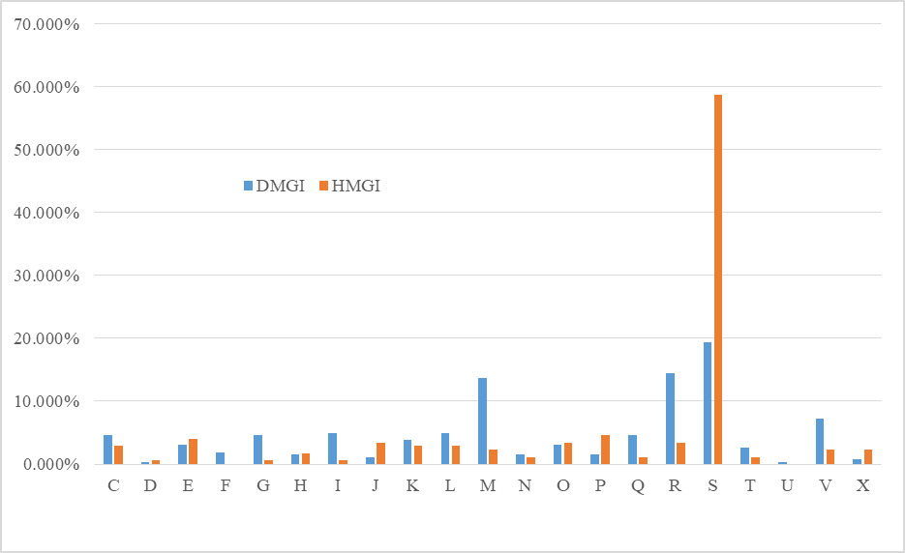
Figure S4 Comparisons of unique gene proportions in arCOG categories between the DMGI and the HMGI. Categories follow figure S3.
a
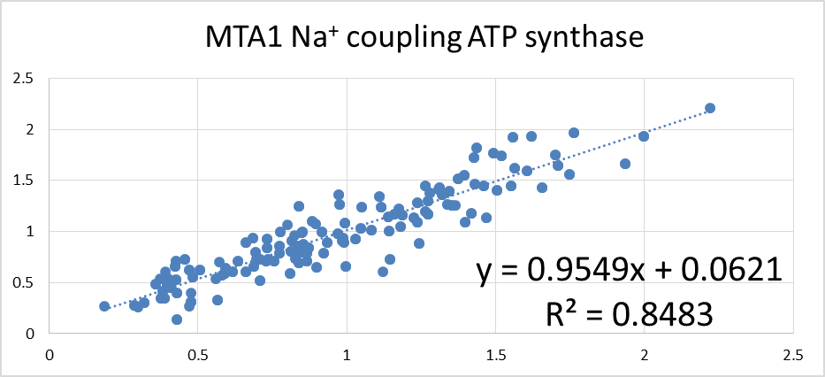
b
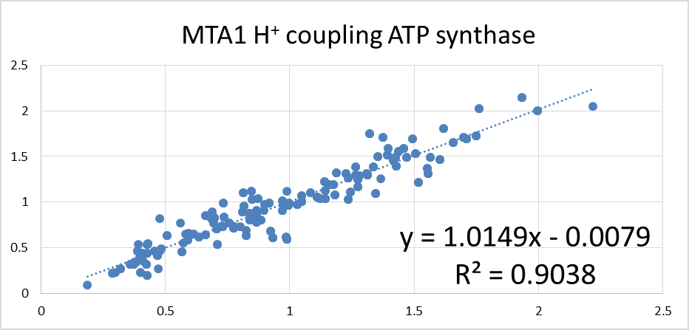
Figure S5 Tetranucleotide frequencies divergence linear regression of two ATP synthase gene islands based on zero-order Markov method frequency expectations (Pride et al., 2003). Since the R² of the Na⁺ coupling ATP synthase gene island is smaller, it is more likely from HGT.

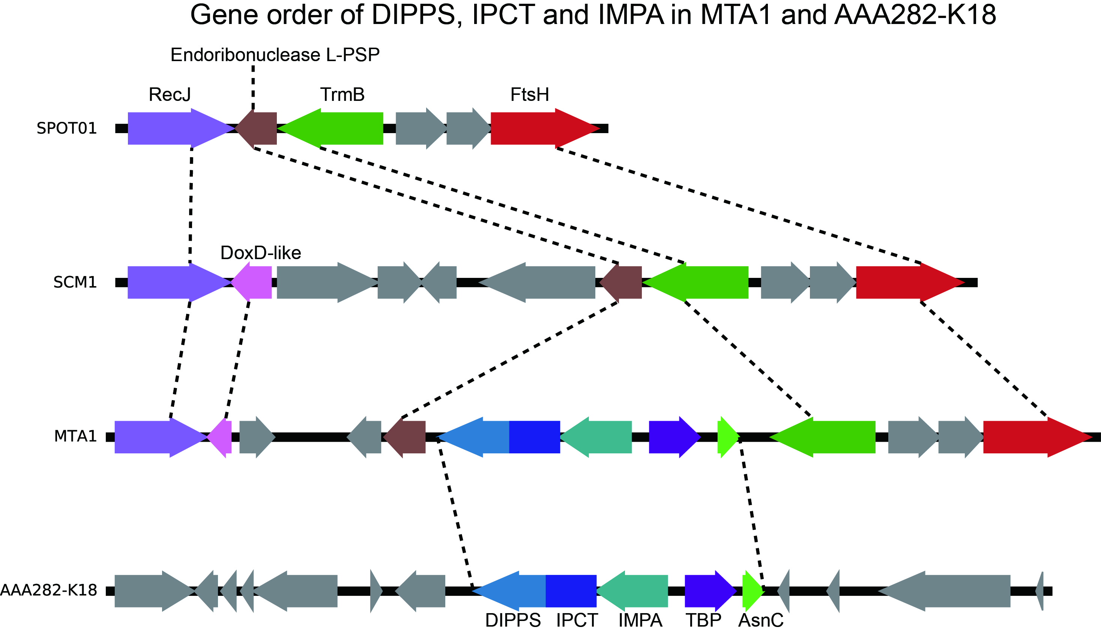
Figure S6 DIPPS+IPCT gene order. DIPPS: di-myo-inositol phosphate phosphate synthase; IPCT: inositol-1-phosphate cytidylyltransferase.

a
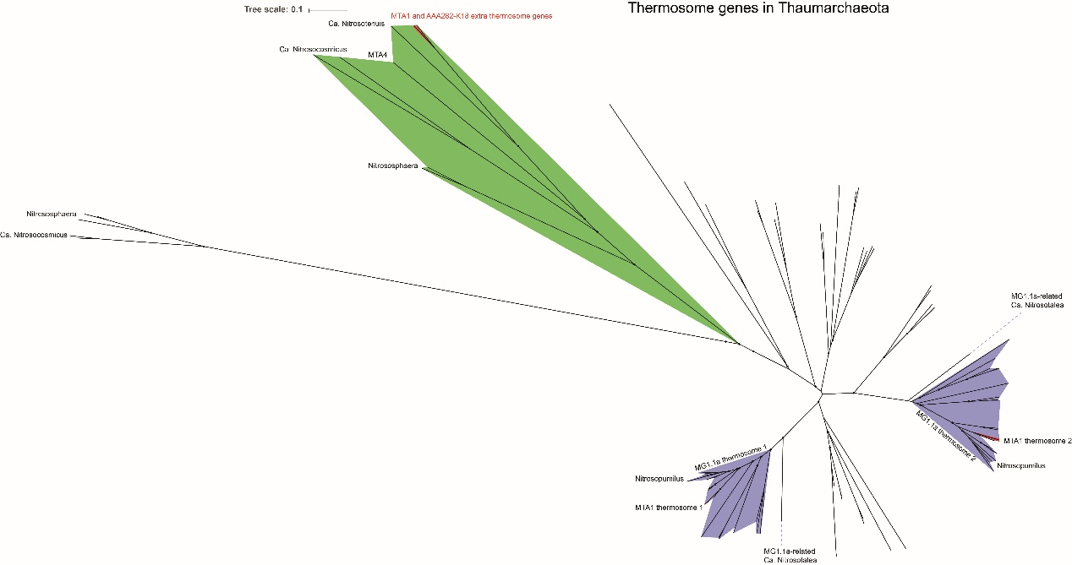
b
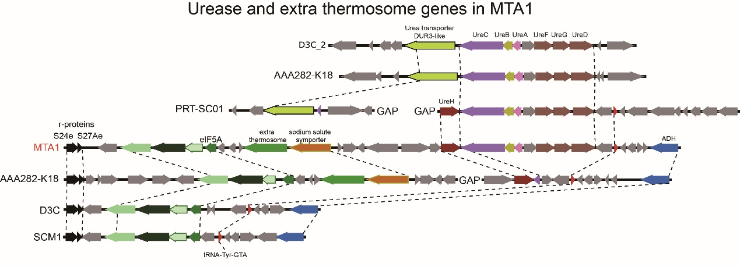

Figure S7 Phylogenetic tree (a) (Neighbor joining, amino acids, 100 bootstraps) and gene order of the urease and extra thermosome genes (b)

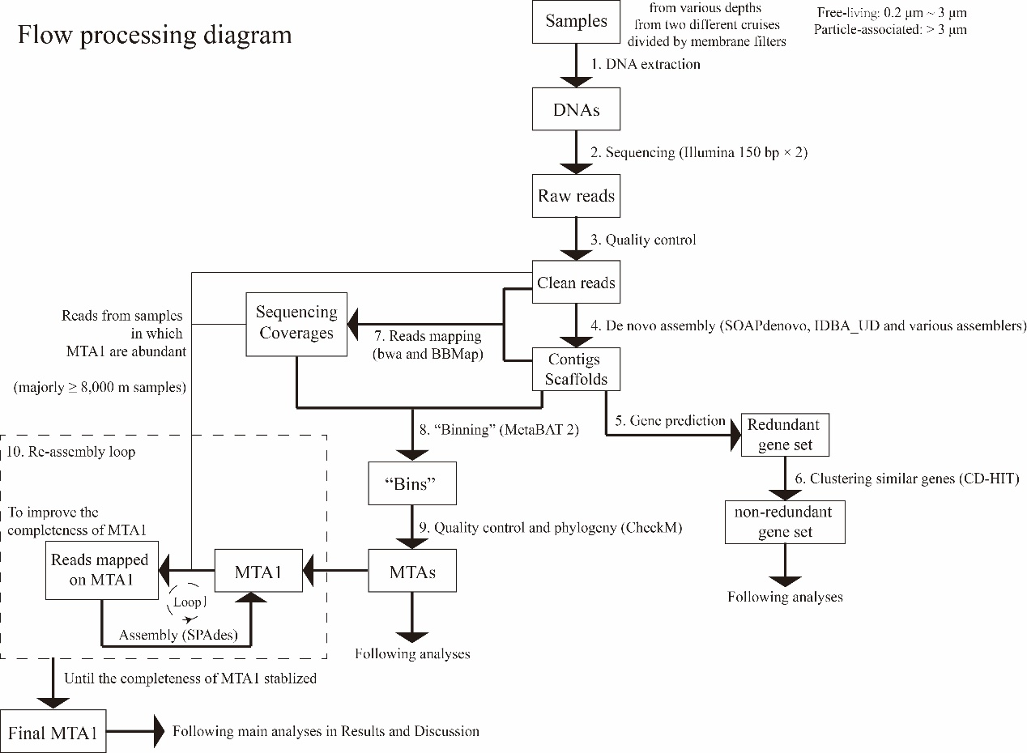
Figure S8 A whole pipeline graph of material and method

Table S1 Environmental factors in trenches at various depths (especially the NH4⁺)
Sampling Depth (m) | Temperature (°C) | Salinity | DO (mg/L) | pH | NOx- (μmol/L) | NO2- (μmol/L) | NH4 (nmol/L) | SiO42- (μmol/L) | PO43- (μmol/L)
4a | 29.82 | 34.06 | 193.64 | 8.24 | 0.1 | 0.02 | 18.9 | 0.55 | 0.02
50a | 29.82 | 34.06 | 193.6 | 8.24 | 0.02 | 0.02 | 24.9 | 0.42 | 0.02
100a | 28.62 | 34.05 | 197.5 | 8.26 | 0.03 | 0.02 | 26.7 | 0.56 | 0.1
125a | 26 | 34.8 | 198.6 | 8.24 | 0.32 | 0.07 | 24.6 | 2.34 | 0.36
150a | 12.95 | 34.47 | 131.3 | 7.93 | 5.12 | 0.11 | 20.6 | 5.05 | 1.12
200a | 18.85 | 34.83 | 164.8 | 8.11 | 18.06 | 0.03 | 18.2 | 2.34 | 1.13
500a | 11.47 | 34.7 | 89.67 | 7.74 | 32.76 | 0.02 | 21 | 19.66 | 2.19
800a | 5.77 | 34.59 | 87.3 | 7.7 | 35.89 | 0.008 | 18.2 | 72.32 | 2.43
1000a | 4.91 | 34.57 | 84.92 | 7.7 | 37.86 | 0.002 | 20.7 | 89.29 | 2.62
1500a | 3.24 | 34.62 | 100.4 | 7.77 | 39.36 | 0.006 | 17.6 | 123.18 | 2.7
2000a | 2.31 | 34.67 | 117.1 | 7.82 | 38.78 | 0.01 | 24.6 | 140.52 | 2.62
3000a | 1.61 | 34.68 | 136.4 | 7.8 | 36.6 | 0.005 | 19.2 | 149.61 | 2.41
4000a | 1.46 | 34.7 | 157.7 | 7.8 | 35.18 | 0.01 | 20.4 | 144.08 | 2.3
6050a | 1.6 | 34.71 | 174.4 | 7.83 | 34.17 | 0.02 | 17.5 | 136.31 | 2.25
8320a | 1.96 | 34.72 | 174.8 | 7.75 | 34.02 | 0.02 | 18.9 | 134.31 | 2.28
10257b | ~1.00 | ~34.70 | 156 | ~7.80 | 36.43 | 0.03 | NA | NA | ~2.40
Note: a, from Mar. 2017 cruise [1]; b, from Nunoura et al. [2]
1. Liu J, Zheng Y, Lin H, Wang X, Li M, Liu Y, et al. Proliferation of hydrocarbon-degrading microbes at the bottom of the Mariana Trench. Microbiome. 2019; 7:47.
2. Nunoura T, Takaki Y, Hirai M, Shimamura S, Makabe A, Koide O, et al. Hadal biosphere: insight into the microbial ecosystem in the deepest ocean on Earth. Proc Nat Acad Sci USA. 2015; 112:E1230-E1236.

Table S2 Genes of major metabolic pathways and key functions in MTA1
 | Short Name | Name | locus tag
GNG/EMP
 |  | fructose-bisphosphate aldolase / 2-amino-3,7-dideoxy-D-threo-hept-6-ulosonate synthase [EC:4.1.2.13 2.2.1.10] | Nhad_95
 | apgM | 2,3-bisphosphoglycerate-independent phosphoglycerate mutase [EC:5.4.2.12] | Nhad_115
 | adhP | alcohol dehydrogenase, propanol-preferring [EC:1.1.1.1] | Nhad_148, Nhad_508
 | PGK | phosphoglycerate kinase [EC:2.7.2.3] | Nhad_172
 | ENO | enolase [EC:4.2.1.11] | Nhad_299
 | pmm-pgm | phosphomannomutase / phosphoglucomutase [EC:5.4.2.8 5.4.2.2] | Nhad_395
 | gpmB | probable phosphoglycerate mutase [EC:5.4.2.12] | Nhad_441
 | korB | 2-oxoglutarate/2-oxoacid ferredoxin oxidoreductase subunit beta [EC:1.2.7.3 1.2.7.11] | Nhad_583
 | korA | 2-oxoglutarate/2-oxoacid ferredoxin oxidoreductase subunit alpha [EC:1.2.7.3 1.2.7.11] | Nhad_584
 |  | phosphoenolpyruvate carboxykinase (ATP) [EC:4.1.1.49] | Nhad_605
 | ACSS | acetyl-CoA synthetase [EC:6.2.1.1] | Nhad_1123, Nhad_1457
 | TPI | triosephosphate isomerase (TIM) [EC:5.3.1.1] | Nhad_1209
 |  | fructose 1,6-bisphosphate aldolase/phosphatase | Nhad_1281
 | gap2 | glyceraldehyde-3-phosphate dehydrogenase (NAD(P)) [EC:1.2.1.59] | Nhad_1418
 | pgi-pmi | glucose/mannose-6-phosphate isomerase [EC:5.3.1.9 5.3.1.8] | Nhad_1505
TCA cycle
 | mdh | malate dehydrogenase [EC:1.1.1.37] | Nhad_277
 | sucC | succinyl-CoA synthetase beta subunit [EC:6.2.1.5] | Nhad_471
 | sucD | succinyl-CoA synthetase alpha subunit [EC:6.2.1.5] | Nhad_472
 | korB | 2-oxoglutarate/2-oxoacid ferredoxin oxidoreductase subunit beta [EC:1.2.7.3 1.2.7.11] | Nhad_583
 | korA | 2-oxoglutarate/2-oxoacid ferredoxin oxidoreductase subunit alpha [EC:1.2.7.3 1.2.7.11] | Nhad_584
 |  | phosphoenolpyruvate carboxykinase (ATP) [EC:4.1.1.49] | Nhad_605
 | IDH1 | isocitrate dehydrogenase [EC:1.1.1.42] | Nhad_663
 | ACO | aconitate hydratase [EC:4.2.1.3] | Nhad_741
 | CS | citrate synthase [EC:2.3.3.1] | Nhad_1601
PPP
 |  | transketolase [EC:2.2.1.1] | Nhad_315, Nhad_316
 |  | transaldolase [EC:2.2.1.2] | Nhad_314
 | PRPS | ribose-phosphate pyrophosphokinase [EC:2.7.6.1] | Nhad_903
 |  | fructose 1,6-bisphosphate aldolase/phosphatase | Nhad_1281
 | rpiA | ribose 5-phosphate isomerase A [EC:5.3.1.6] | Nhad_401
 | gck | glycerate 2-kinase [EC:2.7.1.165] | Nhad_460
 | pmm-pgm | phosphomannomutase / phosphoglucomutase [EC:5.4.2.8 5.4.2.2] | Nhad_395
 | pgi-pmi | glucose/mannose-6-phosphate isomerase [EC:5.3.1.9 5.3.1.8] | Nhad_1505
 |  | fructose-bisphosphate aldolase / 2-amino-3,7-dideoxy-D-threo-hept-6-ulosonate synthase [EC:4.1.2.13 2.2.1.10] | Nhad_95
3-HP/4-HB
 | ACC/PCC | Acetyl-CoA carboxylase (EC 6.4.1.2); Propionyl-CoA carboxylase (EC 6.4.1.3) | Nhad_341, Nhad_342, Nhad_343
 |  | 3-hydroxypropionyl-CoA synthetase (ADP-forming) [EC:6.2.1.-] | Nhad_243
 | MCEE | Methylmalonyl-CoA epimerase (EC 5.1.99.1) | Nhad_1212
 | MCM | Methylmalonyl-CoA mutase (EC 5.4.99.2) | Nhad_1213
 | MCM | B12 binding domain of Methylmalonyl-CoA mutase (EC 5.4.99.2) | Nhad_1217
 | SSADH | Succinate-semialdehyde dehydrogenase [NAD] (EC 1.2.1.24); Succinate-semialdehyde dehydrogenase [NAD(P)+] (EC 1.2.1.16) | Nhad_1569
 |  | Succinate semialdehyde reductase (EC 1.1.1.-) | Nhad_459
 |  | 4-hydroxybutyryl-CoA synthetase (EC 6.2.1.-) | Nhad_410
 | abfD | 4-hydroxybutyryl-CoA dehydratase (EC:4.2.1.120) | Nhad_409
 |  | Crotonyl-CoA hydratase (EC:4.2.1.17) | Nhad_242
 |  | 3-Hydroxybutyryl-CoA dehydrogenase (EC 1.1.1.35) | Nhad_1270
 |  | Acetoacetyl-CoA beta-ketothiolase (EC 2.3.1.9) | Nhad_1428, Nhad_1589
ammonia monooxygenase (AMO) [EC:1.14.99.39]
 | amoA | ammonia monooxygenase subunit A | Nhad_760
 | amoB | ammonia monooxygenase subunit B | Nhad_763
 | amoC | ammonia monooxygenase subunit C | Nhad_762
 | "amoX" | ammonia monooxygenase subunit "X" / conserved protein near other subunits | Nhad_761
inositol phosphate related
 | IMPA | myo-inositol-1(or 4)-monophosphatase [EC:3.1.3.25] | Nhad_347, Nhad_1609
 | INO1 | myo-inositol-1-phosphate synthase [EC:5.5.1.4] | Nhad_1064
 | DIPPS | CDP-L-myo-inositol myo-inositolphosphotransferase [EC:2.7.8.34] | Nhad_1608
 | IPCT | 1L-myo-inositol 1-phosphate cytidylyltransferase [EC:2.7.7.74] | Nhad_1608
GCS and lipoate associated (unique gene island in HMGI)
 | DLD | GCS L-protein / dihydrolipoyl dehydrogenase [EC:1.8.1.4] | Nhad_623
 | gcvH | GCS H-protein | Nhad_618
 | gcvT | GCS T-protein [EC:2.1.2.10] | Nhad_617
 | gcvPA | GCS PA-protein [EC:1.4.4.2] | Nhad_619
 | gcvPB | GCS PB-protein [EC:1.4.4.2] | Nhad_620
 | LipA | Lipoate synthase | Nhad_616
 | lplA | Lipoate-protein ligase A | Nhad_622
 |  | N5,N10-methylenetetrahydromethanopterin reductase-related protein | Nhad_624
Urease
 | UreC | Urease alpha subunit (EC 3.5.1.5) | Nhad_136
 | UreB | Urease beta subunit (EC 3.5.1.5) | Nhad_137
 | UreA | Urease gamma subunit (EC 3.5.1.5) | Nhad_138
 | UreF | Urease accessory protein UreF | Nhad_140
 | UreG | Urease accessory protein UreG | Nhad_141
 | UreD | Urease accessory protein UreD | Nhad_142
 |  | Urea transporter (found in PRT-SC01) | absent
ETC complex I / NADH dehydrogenase
 | nuoN | NADH-ubiquinone oxidoreductase chain N (EC 1.6.5.3) | Nhad_329
 | nuoL | NADH-ubiquinone oxidoreductase chain L (EC 1.6.5.3) | Nhad_330
 | nuoM | NADH-ubiquinone oxidoreductase chain M (EC 1.6.5.3) | Nhad_331
 | nuoK | NADH-ubiquinone oxidoreductase chain K (EC 1.6.5.3) | Nhad_332
 | nuoJ | NADH-ubiquinone oxidoreductase chain J (EC 1.6.5.3) | Nhad_333
 | nuoI | NADH-ubiquinone oxidoreductase chain I (EC 1.6.5.3) | Nhad_334
 | nuoH | NADH-ubiquinone oxidoreductase chain H (EC 1.6.5.3) | Nhad_335
 | nuoD | NADH-ubiquinone oxidoreductase chain D (EC 1.6.5.3) | Nhad_336
 | nuoC | NADH-ubiquinone oxidoreductase chain C (EC 1.6.5.3) | Nhad_337
 | nuoB | NADH-ubiquinone oxidoreductase chain B (EC 1.6.5.3) | Nhad_338
 | nuoA | NADH ubiquinone oxidoreductase chain A (EC 1.6.5.3) | Nhad_339
ETC complex II / succinate dehydrogenase
 | sdhB | succinate dehydrogenase / fumarate reductase, iron-sulfur subunit [EC:1.3.5.1 1.3.5.4] | Nhad_354
 | sdhD | succinate dehydrogenase / fumarate reductase, membrane anchor subunit | Nhad_355
 | sdhC | succinate dehydrogenase / fumarate reductase, cytochrome b subunit | Nhad_356
 | sdhA | succinate dehydrogenase / fumarate reductase, flavoprotein subunit [EC:1.3.5.1 1.3.5.4] | Nhad_357
ETC complex III / cytochrome bc1 complex
 | cytb | Cytochrome b/b6, N-terminal | Nhad_801
ETC complex IV / cytochrome c oxidase
 | ctaB, COX10, cyoE | heme o synthase [EC:2.5.1.141] | Nhad_526, Nhad_1550
 | ctaA, COX15 | cytochrome c oxidase assembly protein subunit 15 | Nhad_436
 | ctaD, coxA | cytochrome c oxidase subunit I [EC:1.9.3.1] | Nhad_438
 | ctaC, coxB | cytochrome c oxidase subunit II [EC:1.9.3.1] | Nhad_439
ETC complex V / A-type ATP synthase sodium coupling / horizontal gene transfer set
 | atpI | A-type ATP synthase subunit a/I (EC 3.6.3.14) | Nhad_478
 | atpH | A-type ATP synthase subunit H (EC 3.6.3.14) | Nhad_479
 | atpD | A-type ATP synthase subunit D (EC 3.6.3.14) | Nhad_480
 | atpB | A-type ATP synthase subunit B (EC 3.6.3.14) | Nhad_481
 | atpA | A-type ATP synthase subunit A (EC 3.6.3.14) | Nhad_482
 | atpF | A-type ATP synthase subunit F (EC 3.6.3.14) | Nhad_483
 | atpC | A-type ATP synthase subunit d/C (EC 3.6.3.14) | Nhad_484
 | atpE | A-type ATP synthase subunit E (EC 3.6.3.14) | Nhad_485
 | atpK | A-type ATP synthase subunit c/K (EC 3.6.3.14) | Nhad_486
ETC complex V / A-type ATP synthase proton coupling / original set
 | atpK | A-type ATP synthase subunit c/K (EC 3.6.3.14) | Nhad_820
 | atpD | A-type ATP synthase subunit D (EC 3.6.3.14) | Nhad_822
 | atpB | A-type ATP synthase subunit B (EC 3.6.3.14) | Nhad_823
 | atpA | A-type ATP synthase subunit A (EC 3.6.3.14) | Nhad_824
 | atpE | A-type ATP synthase subunit E (EC 3.6.3.14) | Nhad_825
 | atpI | A-type ATP synthase subunit a/I (EC 3.6.3.14) | Nhad_826
 | atpC | A-type ATP synthase subunit d/C (EC 3.6.3.14) | Nhad_830
 | atpH | A-type ATP synthase subunit H (EC 3.6.3.14) | Nhad_1562
 | atpF | A-type ATP synthase subunit F (EC 3.6.3.14) | Nhad_1622

Table S3 Transporter genes associated with Na⁺ bioenergetics in MTA1
Short name | Name | locus tag in MTA1 | In other epipelagic marine AOA
NCX | Sodium/calcium exchanger | Nhad_61 | no
nhaD | Na+/H+ antiporter NhaD type | Nhad_65 | yes
nhaP | Na+/H+ antiporter NhaP type | Nhad_948 | no
 | putative sodium-dependent bicarbonate transporter | Nhad_188 | no
 | sodium-solute symporter, putative | Nhad_128 | yes

Table S4 Unique genes in HMGI and several other shown in the Venn diagram
arCOG No. | Categories | Function | Other annotations | In MTA1
Proteins only in HMGI :
arCOG01794 | Q | SAM-dependent methyltransferase |  | yes
arCOG00298 | Q | McbC-like oxidoreductase, duplicated domains (non-ribosomal peptide synthetase component) |  | no
arCOG00674 | I | Phosphatidylglycerophosphate synthase | IPCT and DIPPS | yes
arCOG03500 | M | Cell surface protein, contains right handed beta helix region |  | no
arCOG01319 | E | Na+/proline symporter | Na+/solute symporter | yes
arCOG14289 | S | Uncharacterized protein |  | no
arCOG11507 | S | Uncharacterized protein |  | yes
arCOG03088 | V | Toxic component of toxin-antitoxin system, dsRBD-like fold, HicA family |  | yes
arCOG10846 | L | PD-(DE)xK superfamily endonuclease |  | yes
arCOG02129 | X | Transposase |  | no
Proteins both in HMGI and DMGI :
arCOG00880 | V | Type I site-specific restriction-modification system, R (restriction) subunit or related helicase |  | no
arCOG00756 | E | Glycine cleavage system T protein (aminomethyltransferase) |  | yes
arCOG01303 | E | Glycine cleavage system H protein (lipoate-binding) |  | yes
arCOG00077 | E | Glycine cleavage system protein P (pyridoxal-binding), N-terminal domain |  | yes
arCOG00076 | E | Glycine cleavage system protein P (pyridoxal-binding), C-terminal domain |  | yes
arCOG03837 | H | Lipoate-protein ligase A associated domain |  | yes
arCOG01939 | H | Lipoate-protein ligase A |  | yes
arCOG01068 | C | Pyruvate/2-oxoglutarate dehydrogenase complex, dihydrolipoamide dehydrogenase (E3) component or related enzyme | Glycine cleavage system protein L | yes
arCOG00660 | H | Lipoate synthase |  | yes
arCOG03611 | E | Peptidase C1A subfamily |  | no
Common proteins in HMGI DMGI RSA3 :
arCOG03005 | F | Nucleoside triphosphate pyrophosphohydrolase, MazG superfamily |  | no
Proteins both in HMGI and epipelagic species :
arCOG14073 | S | Uncharacterized protein
arCOG06192 | T | Signal transduction histidine kinase, contains PAS domain |  | no
arCOG11939 | N | Surface protein, associated with type IV pili like system |  | no
arCOG05183 | T | Signal transduction histidine kinase, contains PocR-like and PAS domains |  | yes
arCOG14320 | S | Uncharacterized protein |  | yes
arCOG11612 | S | Uncharacterized protein |  | yes
arCOG10856 | S | Uncharacterized membrane protein |  | yes
arCOG10556 | S | Uncharacterized protein |  | yes
arCOG10555 | S | Uncharacterized protein |  | yes
arCOG10554 | S | Uncharacterized protein |  | yes
arCOG00489 | H | Cob(I)alamin adenosyltransferase |  | yes
arCOG01475 | P | Predicted Co/Zn/Cd cation transporter |  | yes
arCOG11931 | S | Uncharacterized protein |  | yes
arCOG00795 | L | UvrD/REP helicase |  | yes
arCOG03118 | S | Membrane protein DegA family |  | yes
arCOG07264 | S | Predicted membrane protein with C-terminal Zn ribbon domain |  | yes
arCOG10580 | S | Uncharacterized protein |  | yes
arCOG14078 | R | Predicted kinase or ATPase |  | yes
arCOG01273 | E | ABC-type branched-chain amino acid transport system, permease component |  | yes
arCOG04936 | M | Glycosyl transferase family 2 |  | no
arCOG14096 | S | Uncharacterized protein |  | yes
arCOG04920 | S | Uncharacterized protein |  | yes
arCOG08821 | S | Uncharacterized protein (expansion in Thaumarchaeota) |  | yes
arCOG08658 | S | Uncharacterized protein |  | yes
arCOG15271 | X | Casposon associated protein-primed PolB family polymerase |  | yes
arCOG01452 | V | CRISPR-associated protein Cas1 |  | yes

Table S5 Unique genes associated with amino acids and their transportations in MTA1.
Short name | Name | locus tag in MTA1
LysE | lysine transporter | Nhad_1061
putP | Na+/proline symporter | Nhad_128
MetH | Methionine synthase I (cobalamin-dependent), methyltransferase domain | Nhad_562
 | glyoxalase family protein, putative | Nhad_380
 | Proline dehydrogenase | Nhad_205
LivM | ABC-type branched-chain amino acid transport system, permease component | Nhad_295
 | Leucyl aminopeptidase | Nhad_318

Table S6 Primers used in this study.

Target genes | Gene short name | Primer names | Sequence 5' to 3' | PCR condition
ammonia monooxygenase subunit A | amoA | MTA1_amoA_453F | CAGTAGCAGACCCGCTTGAA | 95℃ 3.5 min, 40 × (96℃ 20 s, 56℃ 20 s, 72℃ 30 s), 72℃ 10 min
ammonia monooxygenase subunit A | amoA | MTA1_amoA_617R | CCAAGCGGCCATCCATCTAT | 95℃ 3.5 min, 40 × (96℃ 20 s, 56℃ 20 s, 72℃ 30 s), 72℃ 10 min
4-hydroxybutyryl-CoA dehydratase | hcd | MTA1_hcd_775F | GCTGGGCAAGAAGCCTTGAT | 95℃ 5 min; 30 × (95℃ 30 s, 52℃ 45 s, 72℃ 45 s); 72℃ 10 min
4-hydroxybutyryl-CoA dehydratase | hcd | MTA1_hcd_1073R | AGCTTGTGTGCCAAGTGAGA | 95℃ 5 min; 30 × (95℃ 30 s, 52℃ 45 s, 72℃ 45 s); 72℃ 10 min
di-myo-inositol phosphate phosphate synthase and inositol-1-phosphate cytidylyltransferase | DIPPS +IPCT | MTA1_D_I_744F | CCGATGGGCCAGTATCAAGA | 95℃ 5 min, 30 × (95℃ 30 s, 55℃ 45 s, 72℃ 30 s), 72℃ 10 min
 | DIPPS +IPCT | MTA1_D_I_922R | TCCCCATCACATCCATCCAC | 95℃ 5 min, 30 × (95℃ 30 s, 55℃ 45 s, 72℃ 30 s), 72℃ 10 min
16S rRNA gene | 16S rRNA | 341F  802R [3] | CCTAYGGGRBGCASCAG  TACNVGGGTATCTAATCC | 98℃ 10 min, 30 × (98℃ 10 s, 50℃ 15 s, 72℃ 30 s), 72℃ 5 min
16S rRNA gene | 16S rRNA | 515F (modified)  806R (modified) [4] | GTGYCAGCMGCCGCGGTAA  GGACTACNVGGGTWTCTAAT | 94℃ 3 min, 35 × (94℃ 45 s, 50℃ 60 s, 72℃ 90 s), 72℃ 10 min
3. Wang Y, Huang JM, Cui GJ, Nunoura T, Takaki Y, Li WL, et al. Genomics insights into ecotype formation of ammonia-oxidizing archaea in the deep ocean. Environ Microbiol. 2019; 21:716-729.
4. Walters W, Hyde ER, Berg-Lyons D Ackermann G, Humphrey G, Parada A, et al. Improved bacterial 16S rRNA gene (V4 and V4-5) and fungal internal transcribed spacer marker gene primers for microbial community surveys. Msystems. 2016;1:e00009-15.

Table S7 60 ribosomal genes chosen in the phylogenetic trees. Multi-copies are marked in red and not used in the phylogenetic tree. The last five ribosome proteins are not ubiquitous in AOA, so they were not chosen while building the tree.
