Supplemental Table 1. Demographic and clinical characteristics of the patients enrolled in this study
Variables | Training set  (TCGA) | Validation set  （GSE39582） | Validation set  （GSE17536）
N | 365 | 518 | 138
Age | 66.76±12.67 | 67.54±13.00 | 65.69±13.64
Gender
Female | 172(47.1) | 233(45.0) | 67(48.6)
Male | 193(52.9) | 285(55.0) | 71(51.4)
TNM classification
Stage Ⅰ | 75(20.5) | 377(7.1) | 24(17.4)
Stage Ⅱ | 166(45.5) | 271(52.3) | 57(41.3)
Stage Ⅲ | 124(34.0) | 210(40.4) | 57(41.3)

Supplemental Table 2. ERGs identified by Limma
Genes | Log FC | p Value | Groups
MTHFD1L | 2.0267 | <0.001 | up
IL6R | -2.2235 | <0.001 | down
TRIP13 | 1.8758 | <0.001 | up
ABI3BP | -1.7183 | <0.001 | down
GTF2IRD1 | 1.8035 | <0.001 | up
NAAA | -1.8317 | <0.001 | down
PDE9A | -2.2693 | <0.001 | down
FABP2 | -2.7831 | <0.001 | down
MYC | 1.9318 | <0.001 | up
PLAC8 | -3.1313 | <0.001 | down
RHPN1 | 2.0036 | <0.001 | up
HIGD1A | -1.6099 | <0.001 | down
SNCG | -1.5223 | <0.001 | down
MSX2 | 2.2553 | <0.001 | up
PRKACB | -1.9820 | <0.001 | down
MYO1A | -2.0148 | <0.001 | down
RECQL4 | 1.6935 | <0.001 | up
FGFRL1 | 1.7754 | <0.001 | up
MLXIPL | 2.0506 | <0.001 | up
ASCL2 | 3.1091 | <0.001 | up
RNF43 | 1.9903 | <0.001 | up
PIGZ | -1.7948 | <0.001 | down
NKD2 | 2.1978 | <0.001 | up
SLC12A2 | 1.5275 | <0.001 | up
B3GNT6 | -2.6165 | <0.001 | down
PTP4A3 | 1.7910 | <0.001 | up
AXIN2 | 1.9293 | <0.001 | up
PPP1R14D | -1.7182 | <0.001 | down
NKD1 | 2.0226 | <0.001 | up
HOXB8 | 1.8847 | <0.001 | up
PHGR1 | -2.1725 | <0.001 | down
C10orf99 | -2.7400 | <0.001 | down
AREG | 1.7759 | <0.001 | up
ST6GALNAC1 | -1.6567 | <0.001 | down
SLC39A5 | -1.6626 | <0.001 | down
EREG | 1.7046 | <0.001 | up

Supplemental Table 3. Characteristics of the ERGs related to diagnosis and their coefficients
Variables | 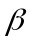 | 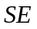 | 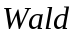 | 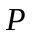 | 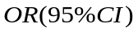
Intercept | -6.5112 | 1.2498 | 27.1437 | <.0001 | -
SLC12A2 | 1.3003 | 0.2660 | 23.9027 | <.0001 | 3.670(2.179-6.181)
AXIN2 | 0.7520 | 0.1952 | 14.8351 | 0.0001 | 2.121(1.447-3.110)

Supplemental Table 4 The correlation between enhancers and candidate ERGs
Genes | Univariate Cox analysis |  |  | Spearman’s correlation test
Genes | HR | 95%CI | value | eRNAs | Cor | Tissue | Gene type
DCST2 | 2.661 | 1.166-6.076 | 0.020 | ENSR00000014087 | 0.552* | multi-tumors | seRNA-regulated
 |  |  |  | 1:155003728-155009728 | 0.367* | multi-tumors
DNAJC15 | 0.695 | 0.503–0.961 | 0.028 | ENSR00000061967 | 0.398* | multi-tumors | seRNA-regulated
 |  |  |  | ENSR00000061968 | 0.401* | multi-tumors
 |  |  |  | 13:43058818-43064818 | 0.393* | multi-tumors
PCCA | 0.752 | 0.573-0.988 | 0.040 | ENSR00000065185 | 0.740* | COAD  READ | Specific eRNA-regulated
ZNF160 | 1.782 | 1.130-2.812 | 0.013 | ENSR00000111307 | 0.477* | multi-tumors | seRNA-regulated
 |  |  |  | 19:52622405-52628405 | 0.509* | multi-tumors
 |  |  |  | 19:52623389-52629389 | 0.490* | multi-tumors
PLCB4 | 0.840 | 0.714-0.990 | 0.037 | ENSR00000134462 | 0.920* | COAD  READ | seRNA-regulated
 |  |  |  | ENSR00000134475 | 0.907* | COAD  READ | specfic eRNA-regulated
ZMIZ2 | 1.582 | 1.015-2.465 | 0.043 | ENSR00000211831 | 0.408* | multi-tumors | seRNA-regulated
 |  |  |  | ENSR00000211832 | 0.400* | multi-tumors
SMARCD3 | 2.028 | 1.112-3.698 | 0.021 | ENSR00000329061 | 0.443* | multi-tumors | other
ZNF467 | 1.937 | 1.257-2.984 | 0.003 | ENSR00000329061 | 0.451* | multi-tumors | other
EPPK1 | 0.647 | 0.430-0.975 | 0.037 | ENSR00000333971 | 0.449* | multi-tumors | other
ATP2A1 | 2.711 | 1.522-4.829 | 0.001 | ENSR00000085043 | 0.406* | multi-tumors | other
ABCG1 | 1.485 | 1.042-2.115 | 0.029 | ENSR00000142710 | 0.800* | multi-tumors | other

Supplemental Table 5. Univariate and multivariate analysis of clinical information and prognosis score
Variables | Univariate analysis |  | Multivariate analysis
Variables |  | 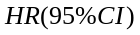
Gender | 0.14810 | 1.160(0.687-1.957) | - | -
Age | 0.02375 | 1.024(1.000-1.048) | 0.01758 | 1.018(0.995-1.041)
TNM classification | 0.73530 | 2.086(1.364-3.192) | 0.60521 | 1.832(1.174-2.857)
Prognostic score | 1.12730 | 3.087(2.250-4.237) | 1.00360 | 2.728(1.948-3.821)

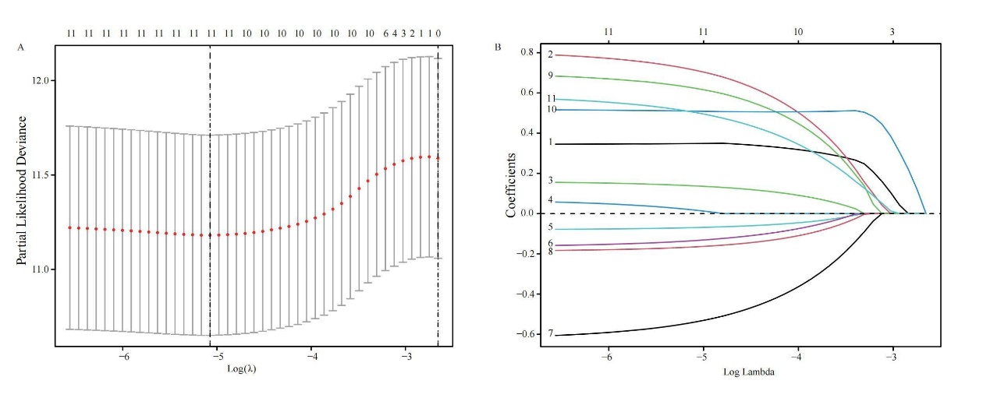
Figure S1. Lasso variables screening process.

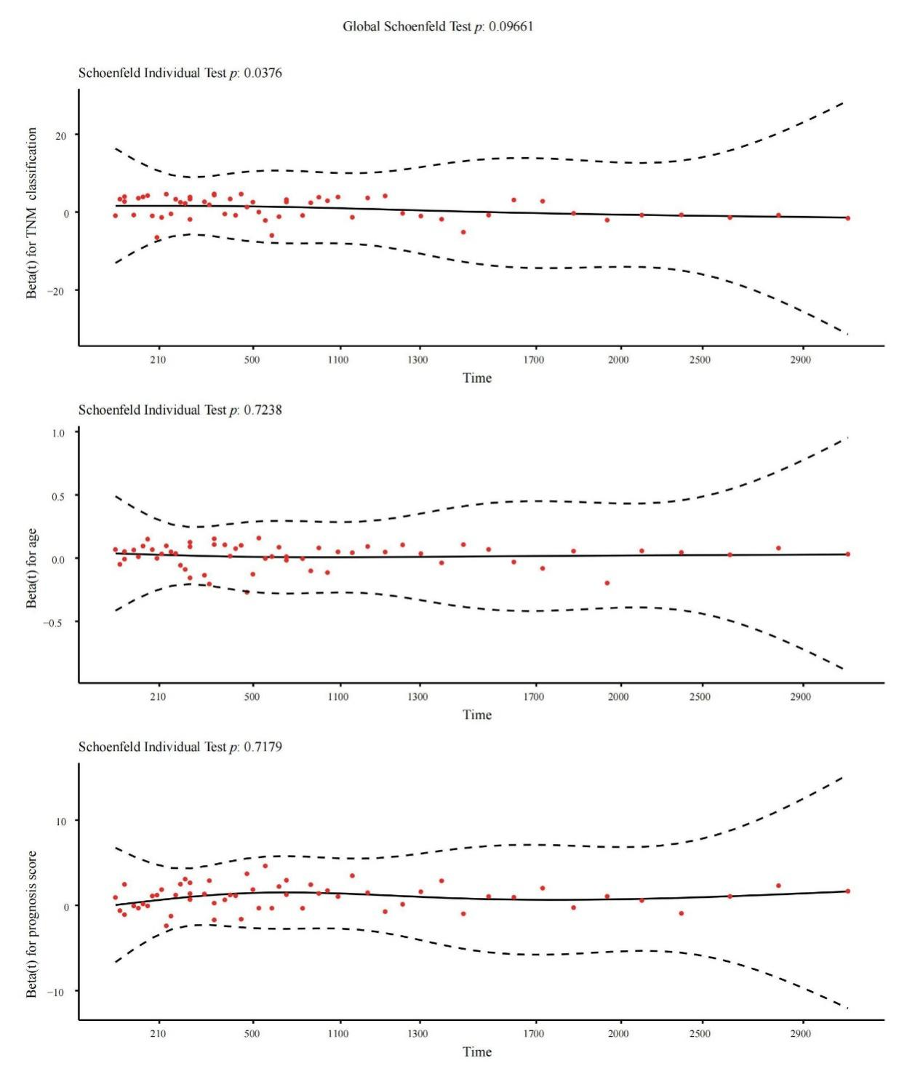
Figure S2. Plot of the global PH assumption tests.

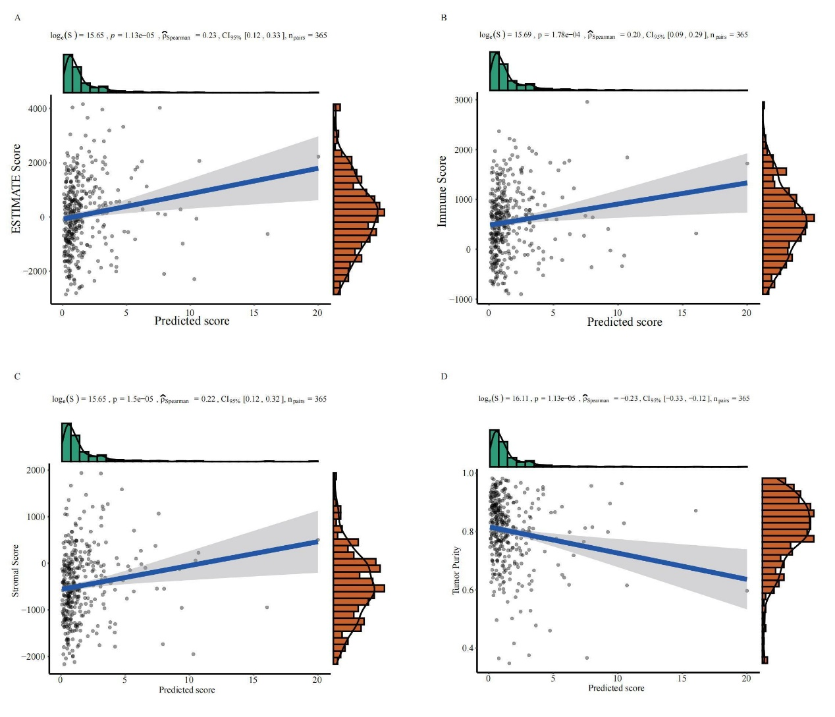
Figure S3. Correlation plots of immune infiltration and prognostic model.

