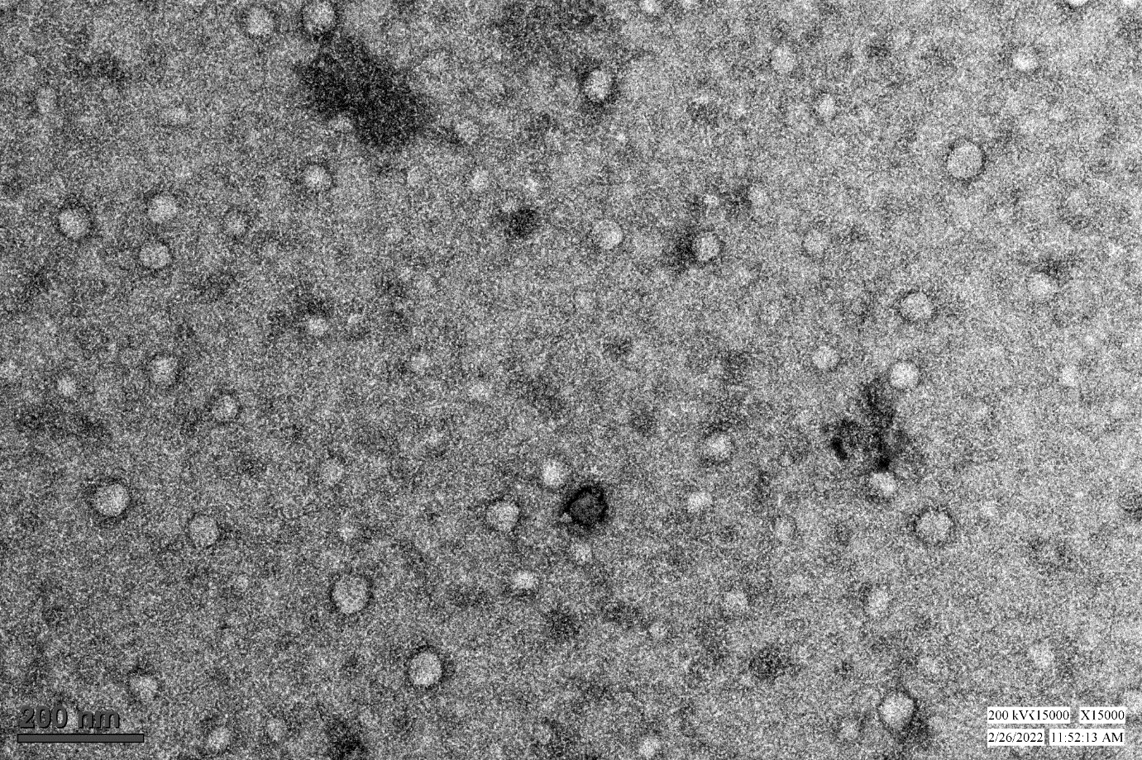
Figure S1: TEM image of the isolated salivary exosomes at the scale of 200nm

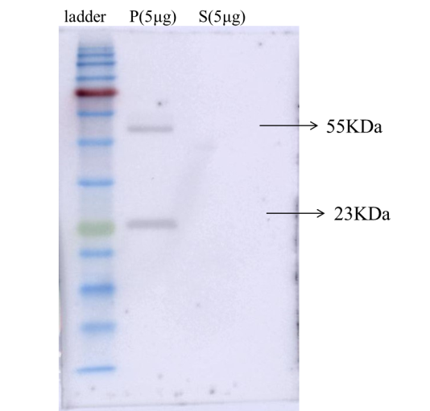
Figure S2: Western blot of anti-CD63. In this blot, the pellet obtained during sEV isolation method and the supernatant. P= Pellet obtained by the PEG-based precipitation combined with ultrafiltration. S= Supernatant obtained during the isolation process.

Figure S3: Western blot of anti-CD63 (A), L1CAM (B) and anti-phospho-alpha-synuclein (C) (refer Fig 2B, 2H & 2J).

