Supplementary figures
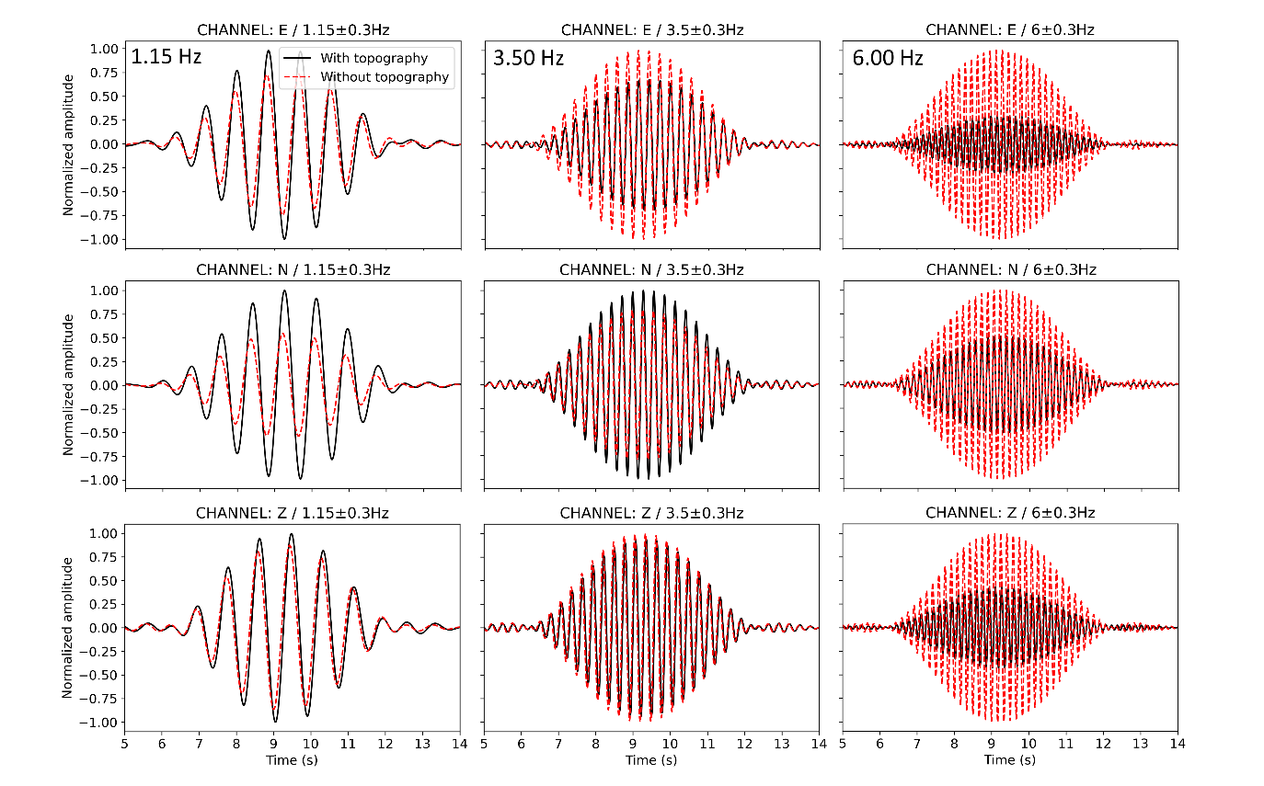
Figure S1: Synthetic waveforms of the E (top), N (middle) and Z (bottom) components simulated at the permanent seismic station (TNS) and filtered within frequency bands of 0.85–1.45 Hz (left), 3.2–3.8 Hz (middle) and 5.7–6.3 Hz (right). The low-frequency signal components are clearly amplified due to topography in comparison with the high-frequency signals.

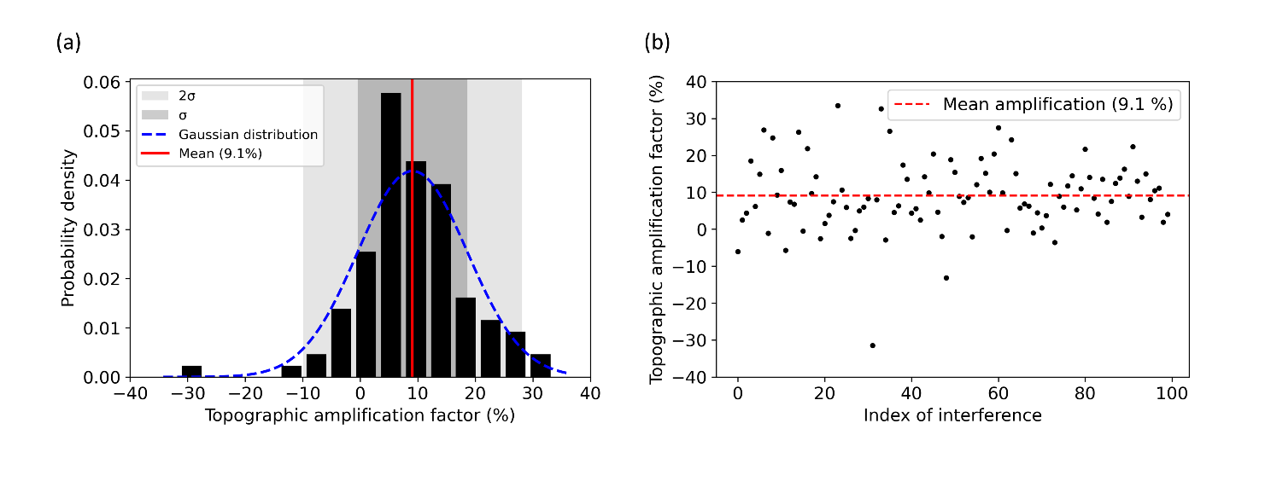
Figure S2: (a) The distribution of 1.15 Hz signal amplification at TNS due to topography for the 100 scenarios of interferences. The mean amplification is 9.1 %. The range is from -31 % to 34 %. However, -31 % is an outlier and an amplification is likelier than a reduction of amplitude (b).

