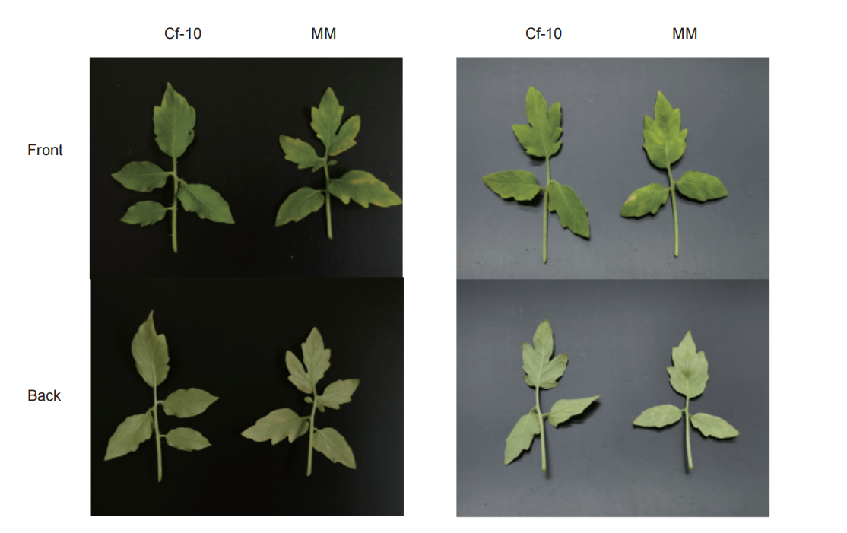
Fig. S1. Phenotype of the Cf-10-carrying line and susceptible line at 10 (left) and 16 (right) days after inoculation

