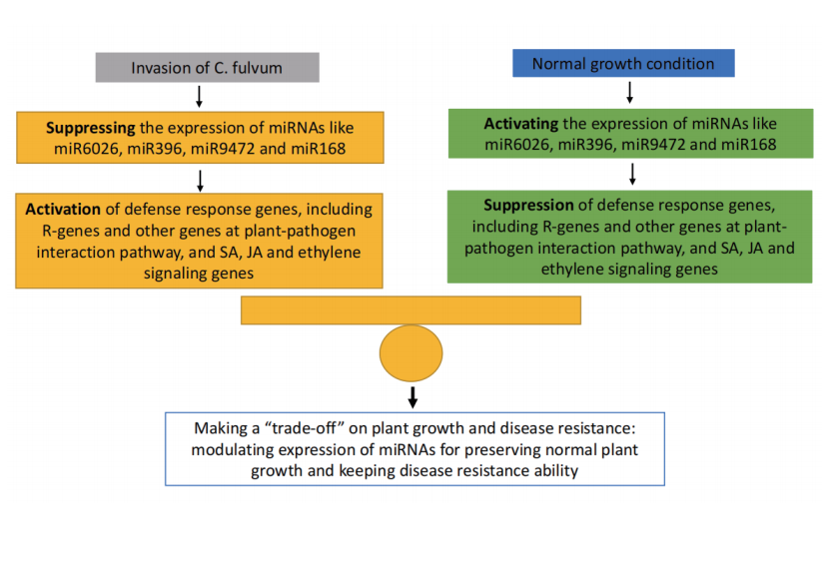
Fig. S4. Resistant lines carrying the Cf-10 gene potentially employ a “trade-off” strategy to ensure normal plant growth while preserving strong disease resistance.

