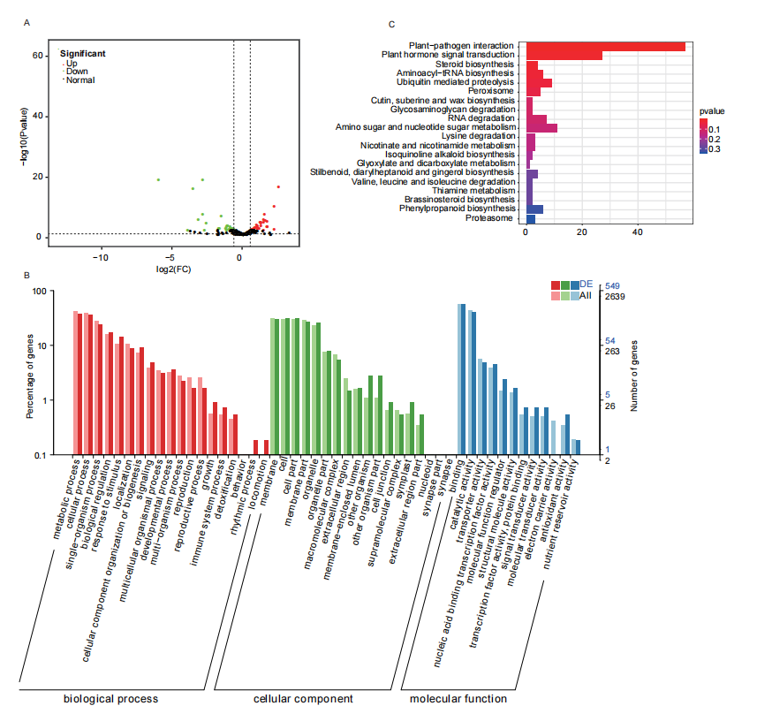
Fig. S2. miRNA profiling of the susceptible line without any Cf gene for the control and 3 dpi of C. fulvum. (A) Volcano plot of differentially expressed miRNAs between the control and 3 dpi susceptible lines. Red dots are upregulated, while green dots are downregulated genes in the 3 dpi resistant line. Black points are insignificant genes. (B) GO and KEGG pathway (C) enrichment analysis of predicted target genes of differentially expressed miRNAs between the control and 3 dpi susceptible lines.

