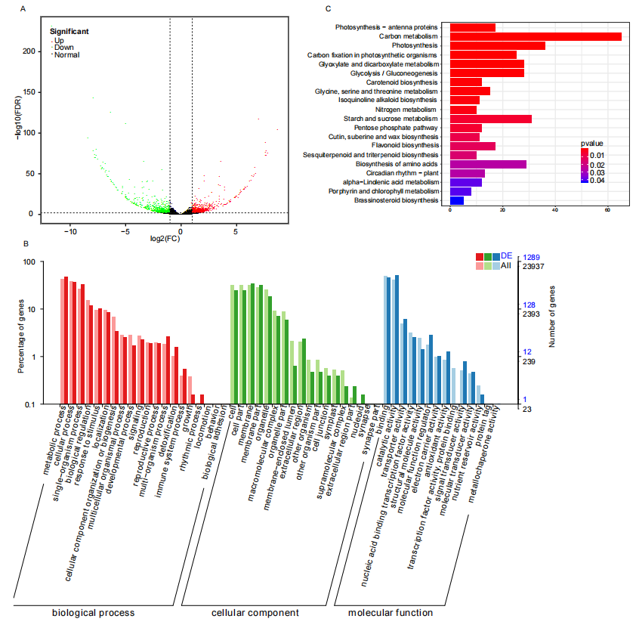
Fig. S3. Comparing the transcriptome between resistant and susceptible lines revealed that they have different expression patterns in defense response pathways. (A) Volcano plot comparing gene expression levels between resistant and susceptible lines at 3 dpi. Red dots are upregulated, while green dots are downregulated genes in the 3 dpi resistant line. Black points are insignificant genes. (B) GO and KEGG pathway (C) enrichment analysis of differentially expressed genes between resistant and susceptible lines at 3 dpi.

