Table 1: Univariate and multivariate logistic regression analysis to determine the effect of baseline characteristics on outcomes among patients with septic shock
Markers | Univariate |  | Multivariate
Markers | OR (95% CI) | P-value | OR (95% CI) | P-value
Mortality (yes vs. no)
Age | 0.996 (0.939-1.055) | 0.881 | 0.993 (0.901-1.094) | 0.881
Gender | 0.947 (0.412-2.178) | 0.889 | 0.794 (0.261-2.419) | 0.685
Comorbidity | 1.289 (0.414-4.017) | 0.662 | 0.247 (0.037-1.657) | 0.151
APACHE IV | 1.640 (1.339-2.008) | <0.001* | 1.282 (0.756-2.175) | 0.357
SOFA | 2.798 (1.812-4.321) | <0.001* | 1.933 (0.614-6.088) | 0.261
RRT (yes vs. no)
Age | 0.984 (0.926-1.046) | 0.611 | 0.977 (0.902-1.059) | 0.577
Gender | 0.639 (0.258-1.58) | 0.332 | 0.594 (0.234-1.509) | 0.273
Comorbidity | 1.155 (0.365-3.654) | 0.806 | 0.724 (0.157-3.346) | 0.679
APACHE IV | 1.092 (0.973-1.225) | 0.135 | 0.897 (0.572-1.405) | 0.634
SOFA | 1.216 (0.96-1.54) | 0.105 | 1.516 (0.601-3.822) | 0.378
ICU length of stay (≥13 days vs. <13 days)
Age | 0.991 (0.934-1.052) | 0.776 | 0.999 (0.925-1.079) | 0.986
Gender | 1.407 (0.603-3.281) | 0.431 | 1.471 (0.618-3.496) | 0.384
Comorbidity | 0.818 (0.262-2.554) | 0.731 | 1.449 (0.333-6.368) | 0.623
APACHE IV | 0.935 (0.84-1.041) | 0.221 | 1.094 (0.722-1.659) | 0.671
SOFA | 0.859 (0.691-1.07) | 0.176 | 0.709 (0.301-1.666) | 0.431
MV duration (≥10 days vs. <10 days)
Age | 0.991 (0.938-1.048) | 0.754 | 0.979 (0.907-1.057) | 0.592
Gender | 2.393 (1.319-6.823) | 0.058* | 2.334 (0.973-5.595) | 0.058
Comorbidity | 0.788 (0.277-2.241) | 0.655 | 0.418 (0.100-1.749) | 0.232
APACHE IV | 1.063 (0.962-1.175) | 0.231 | 0.995 (0.657-1.505) | 0.979
SOFA | 1.121 (0.914-1.375) | 0.273 | 1.046 (0.449-2.437) | 0.917
Vasopressors (1 vs. >1)
Age | 1.000 (0.941-1.062) | 0.995 | 1.018 (0.938-1.106) | 0.669
Gender | 2.471 (0.994-6.142) | 0.052 | 2.858 (1.075-7.599) | 0.035*
Comorbidity | 0.675 (0.201-2.269) | 0.525 | 2.567 (0.505-13.05) | 0.256
APACHE IV | 0.847 (0.751-0.956) | 0.007* | 0.844 (0.532-1.34) | 0.473
SOFA | 0.731 (0.572-0.932) | 0.012* | 0.971 (0.378-2.492) | 0.951
*P<0.05 considered as significant, Abbreviations: Odds ratio (OR), Acute Physiology and Chronic Health Evaluation (APACHE), Sequential Organ Failure Assessment (SOFA); Renal replacement therapy (RRT), Mechanical ventilator (MV).

Markers | Univariate |  | Multivariate
Markers | OR (95% CI) | P-value | OR (95% CI) | P-value
Mortality (Yes vs. No)
HR 0h | 1.014 (0.953-1.078) | 0.671 | 0.944 (0.756-1.179) | 0.611
HR 6h | 1.118 (1.041-1.202) | 0.002* | 1.366 (0.962-1.940) | 0.082
HR 24h | 1.101 (1.023-1.186) | 0.011* | 0.933 (0.695-1.254) | 0.647
MAP 0h | 0.755 (0.642-0.882) | <0.001* | 0.944 (0.551-1.618) | 0.835
MAP 6h | 0.743 (0.633-0.872) | <0.001* | 0.619 (0.329-1.176) | 0.143
MAP 24h | 1.165 (1.040-1.305) | 0.008* | 2.880 (1.020-8.132) | 0.046*
CVP 0h | 0.640 (0.481-0.851) | 0.002* | 1.726 (0.501-5.946) | 0.387
CVP 6h | 1.046 (0.842-1.299) | 0.685 | 0.959 (0.114-8.070) | 0.969
CVP 24h | 1.141 (0.860-1.513) | 0.360 | 3.071 (0.192-49.099) | 0.428
RRT (Yes vs. No)
HR 0h | 1.032 (0.966-1.103) | 0.349 | 1.025 (0.948-1.108) | 0.538
HR 6h | 1.053 (0.988-1.123) | 0.111 | 1.104 (1.007-1.212) | 0.036*
HR 24h | 1.038 (0.968-1.112) | 0.299 | 0.999 (0.921-1.084) | 0.988
MAP 0h | 1.034 (0.894-1.197) | 0.652 | 1.122 (0.921-1.367) | 0.253
MAP 6h | 0.975 (0.845-1.125) | 0.728 | 0.935 (0.757-1.156) | 0.536
MAP 24h | 0.999 (0.899-1.101) | 0.849 | 0.916 (0.795-1.055) | 0.221
CVP 0h | 1.078 (0.836-1.39) | 0.564 | 1.348 (0.861-2.110) | 0.192
CVP 6h | 1.055 (0.836-1.332) | 0.653 | 1.009 (0.714-1.424) | 0.961
CVP 24h | 0.996 (0.736-1.347) | 0.978 | 0.860 (0.579-1.277) | 0.454
Vasopressors (1 vs. >1)
HR 0h | 0.944 (0.884-1.009) | 0.088 | 0.959 (0.892-1.03) | 0.251
HR 6h | 0.941 (0.882-1.002) | 0.058 | 0.966 (0.895-1.041) | 0.363
HR 24h | 0.943 (0.879-1.01) | 0.095 | 0.963 (0.894-1.036) | 0.311
MAP 0h | 1.114 (0.969-1.282) | 0.131 | 1.061 (0.899-1.25) | 0.485
MAP 6h | 1.053 (0.916-1.21) | 0.467 | 0.983 (0.813-1.189) | 0.862
MAP 24h | 0.965 (0.875-1.065) | 0.481 | 1.017 (0.897-1.152) | 0.796
CVP 0h | 1.108 (0.862-1.424) | 0.422 | 1.025 (0.698-1.505) | 0.899
CVP 6h | 0.906 (0.72-1.139) | 0.397 | 0.834 (0.593-1.172) | 0.295
CVP 24h | 0.961 (0.72-1.283) | 0.789 | 1.061 (0.733-1.532) | 0.758
ICU length of stay (≥13 days vs. <13 days)
HR 0h | 0.99 (0.931-1.054) | 0.755 | 1.004 (0.926-1.088) | 0.931
HR 6h | 0.968 (0.912-1.027) | 0.283 | 0.93 (0.854-1.013) | 0.097
HR 24h | 1.051 (0.979-1.128) | 0.172 | 1.123 (1.027-1.229) | 0.011*
MAP 0h | 1.134 (0.988-1.303) | 0.074 | 1.271 (1.044-1.545) | 0.017*
MAP 6h | 0.939 (0.818-1.077) | 0.366 | 0.824 (0.656-1.036) | 0.097
MAP 24h | 0.968 (0.879-1.066) | 0.511 | 1.033 (0.900-1.185) | 0.647
CVP 0h | 0.89 (0.699-1.133) | 0.343 | 0.635 (0.392-1.031) | 0.066
CVP 6h | 0.974 (0.783-1.211) | 0.812 | 1.178 (0.824-1.684) | 0.371
CVP 24h | 0.869 (0.654-1.154) | 0.332 | 0.754 (0.504-1.129) | 0.171
MV duration (≥10 days vs. <10 days)
HR 0h | 1.037 (0.977-1.101) | 0.229 | 1.098 (1.004-1.201) | 0.040*
HR 6h | 1.024 (0.967-1.085) | 0.411 | 0.94 (0.856-1.033) | 0.198
HR 24h | 1.078 (1.006-1.156) | 0.034* | 1.22 (1.081-1.377) | 0.001*
MAP 0h | 0.873 (0.761-0.991) | 0.050* | 0.917 (0.748-1.123) | 0.400
MAP 6h | 0.821 (0.713-0.946) | 0.006* | 0.896 (0.708-1.133) | 0.359
MAP 24h | 0.998 (0.909-1.095) | 0.959 | 1.052 (0.88-1.257) | 0.579
CVP 0h | 0.762 (0.599-0.969) | 0.027* | 0.912 (0.571-1.456) | 0.699
CVP 6h | 0.843 (0.682-1.042) | 0.114 | 0.598 (0.382-0.936) | 0.024*
CVP 24h | 1.085 (0.826-1.426) | 0.557 | 1.404 (0.849-2.321) | 0.186
Table 2: Univariate and multivariate logistic regression analysis to determine the effect of macrocirculation markers on outcomes
A  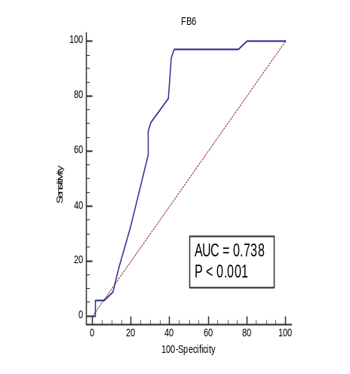 | B  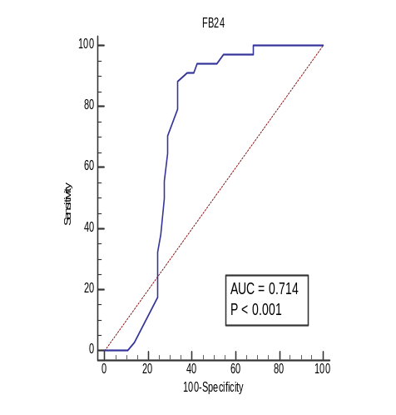 | C  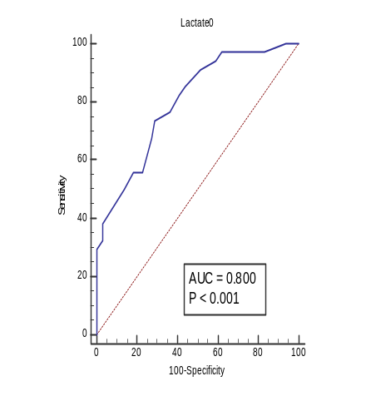
D  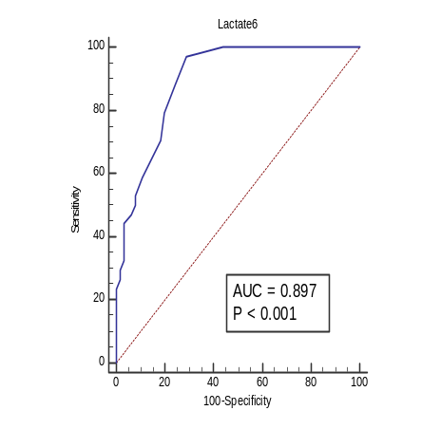 | E  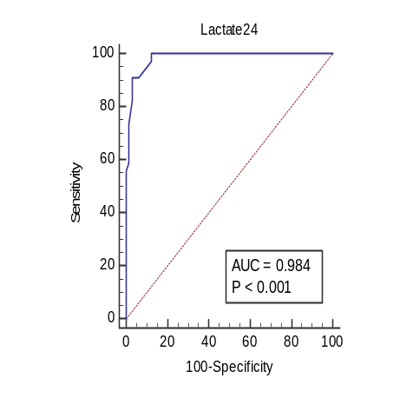 | F  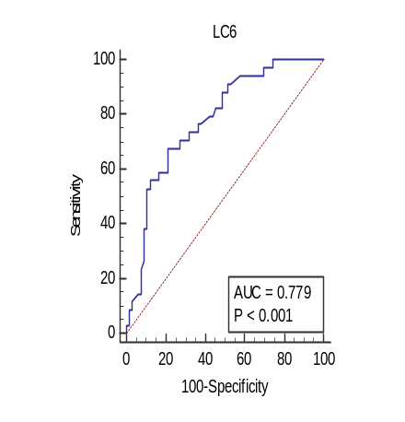
G
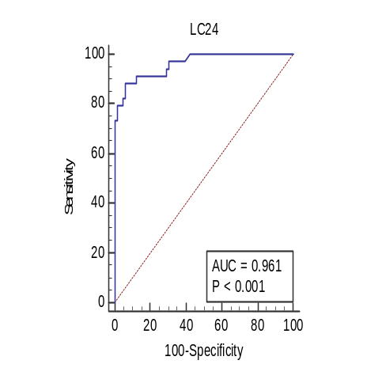
Figure 1: ROC curves of fluid balance (A) at 6h, (B) at 24h, lactate (C) at baseline, (D) at 6h, (E) at 24h, and clearance lactate (F) at 6h, (G) at 24h to predict mortality
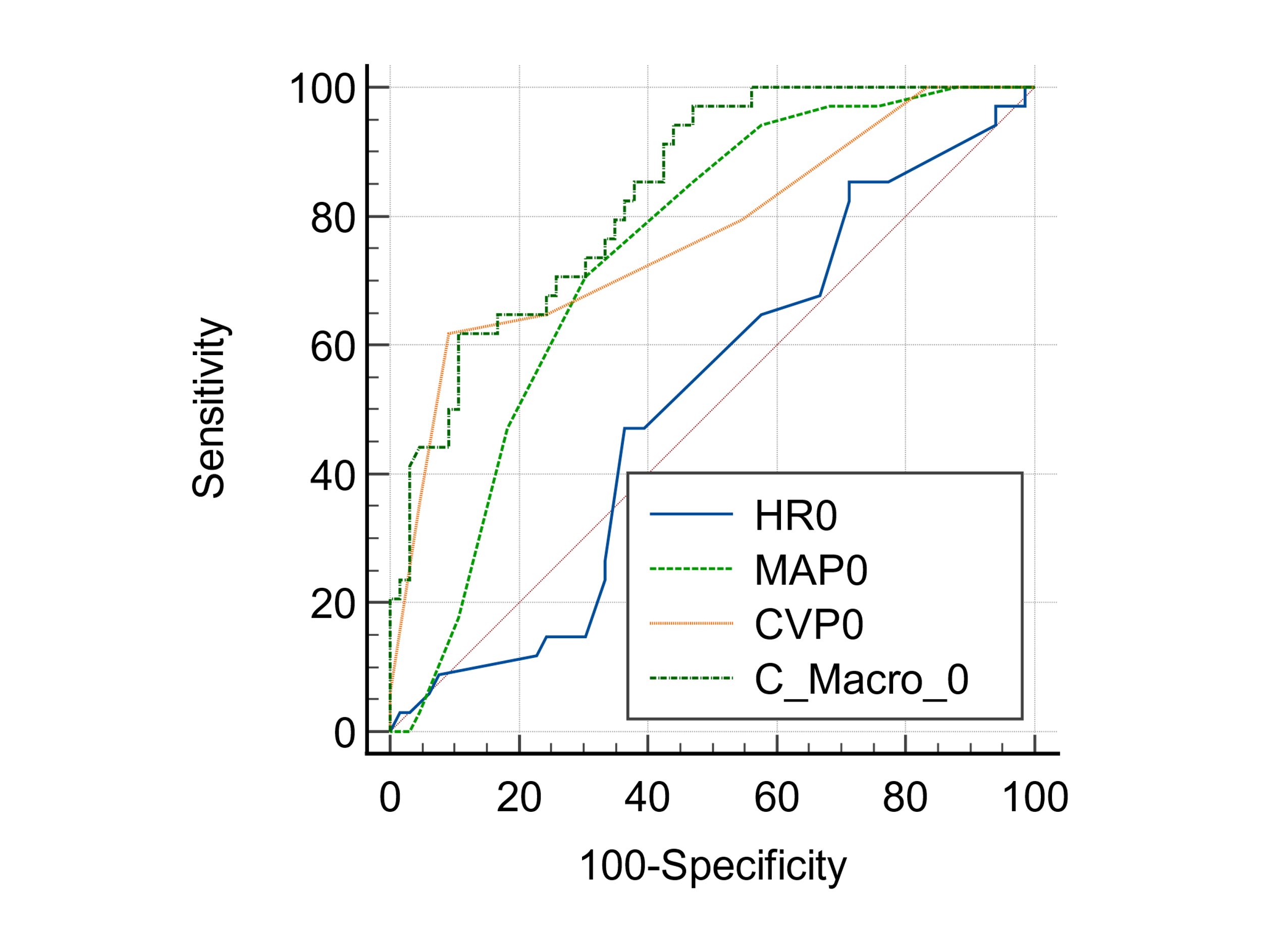
  HR0 vs. MAP0
  Difference between areas | 0.226
  Significance level | P = 0.0009
  HR0 vs. CVP0
  Difference between areas | 0.253
  Significance level | P = 0.0017
  HR0 vs. Combined marker at 0h
  Difference between areas | 0.320
  Significance level | P < 0.0001
  MAP0 vs. CVP0
  Difference between areas | 0.0276
  Significance level | P = 0.6906
  MAP0 vs. Combined marker at 0h
  Difference between areas | 0.0938
  Significance level | P = 0.0193
  CVP0 vs. Combined marker at 0h
  Difference between areas | 0.0662
  Significance level | P = 0.0449
Figure 2: Pairwise comparison of AUCs between macrocirculation markers and combine marker of macrocirculation to predict mortality at baseline

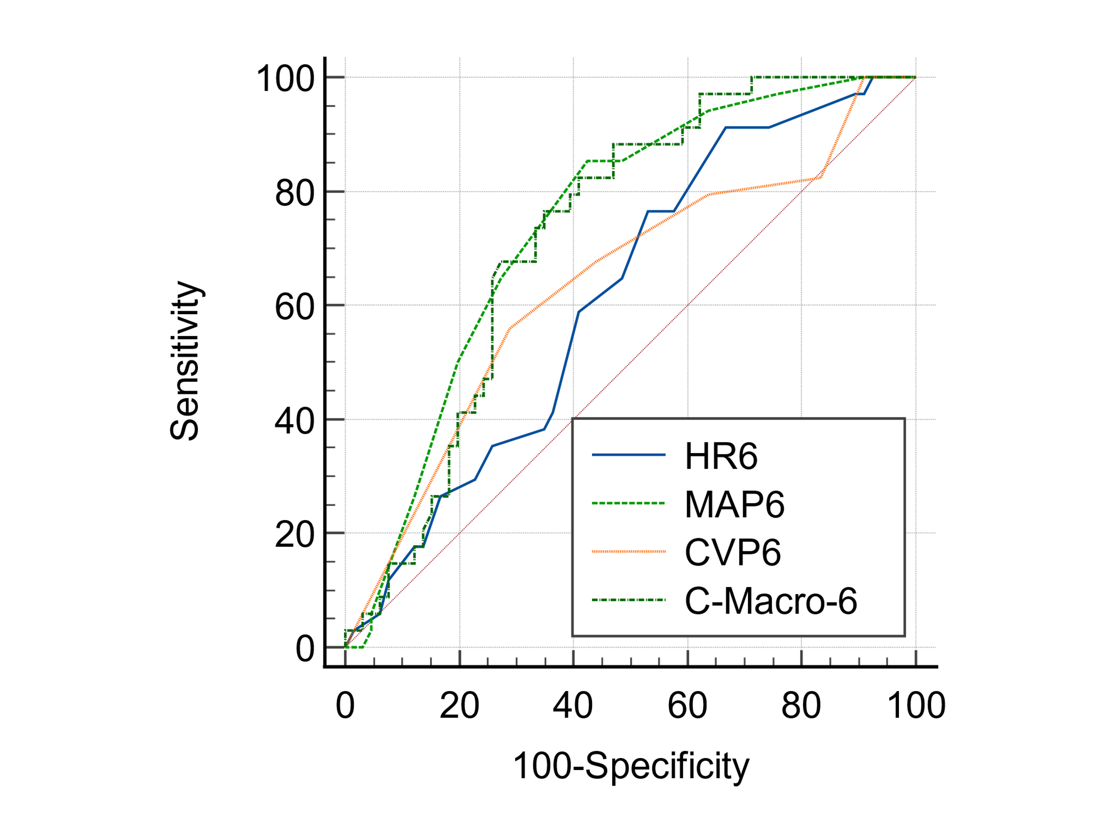
  HR6 vs. MAP6
  Difference between areas | 0.127
  Significance level | P = 0.1260
  HR6 vs. CVP6
  Difference between areas | 0.0227
  Significance level | P = 0.7679
  HR6 vs. Combined marker at 6h
  Difference between areas | 0.111
  Significance level | P = 0.0433
  MAP6 vs. CVP6
  Difference between areas | 0.104
  Significance level | P = 0.1738
  MAP6 vs. Combined marker at 6h
  Difference between areas | 0.0163
  Significance level | P = 0.7136
  CVP6 vs. Combined marker at 6h
  Difference between areas | 0.0878
  Significance level | P = 0.2967
Figure 3: Pairwise comparison of AUCs between macrocirculation markers and combine marker of macrocirculation to predict mortality at 6h

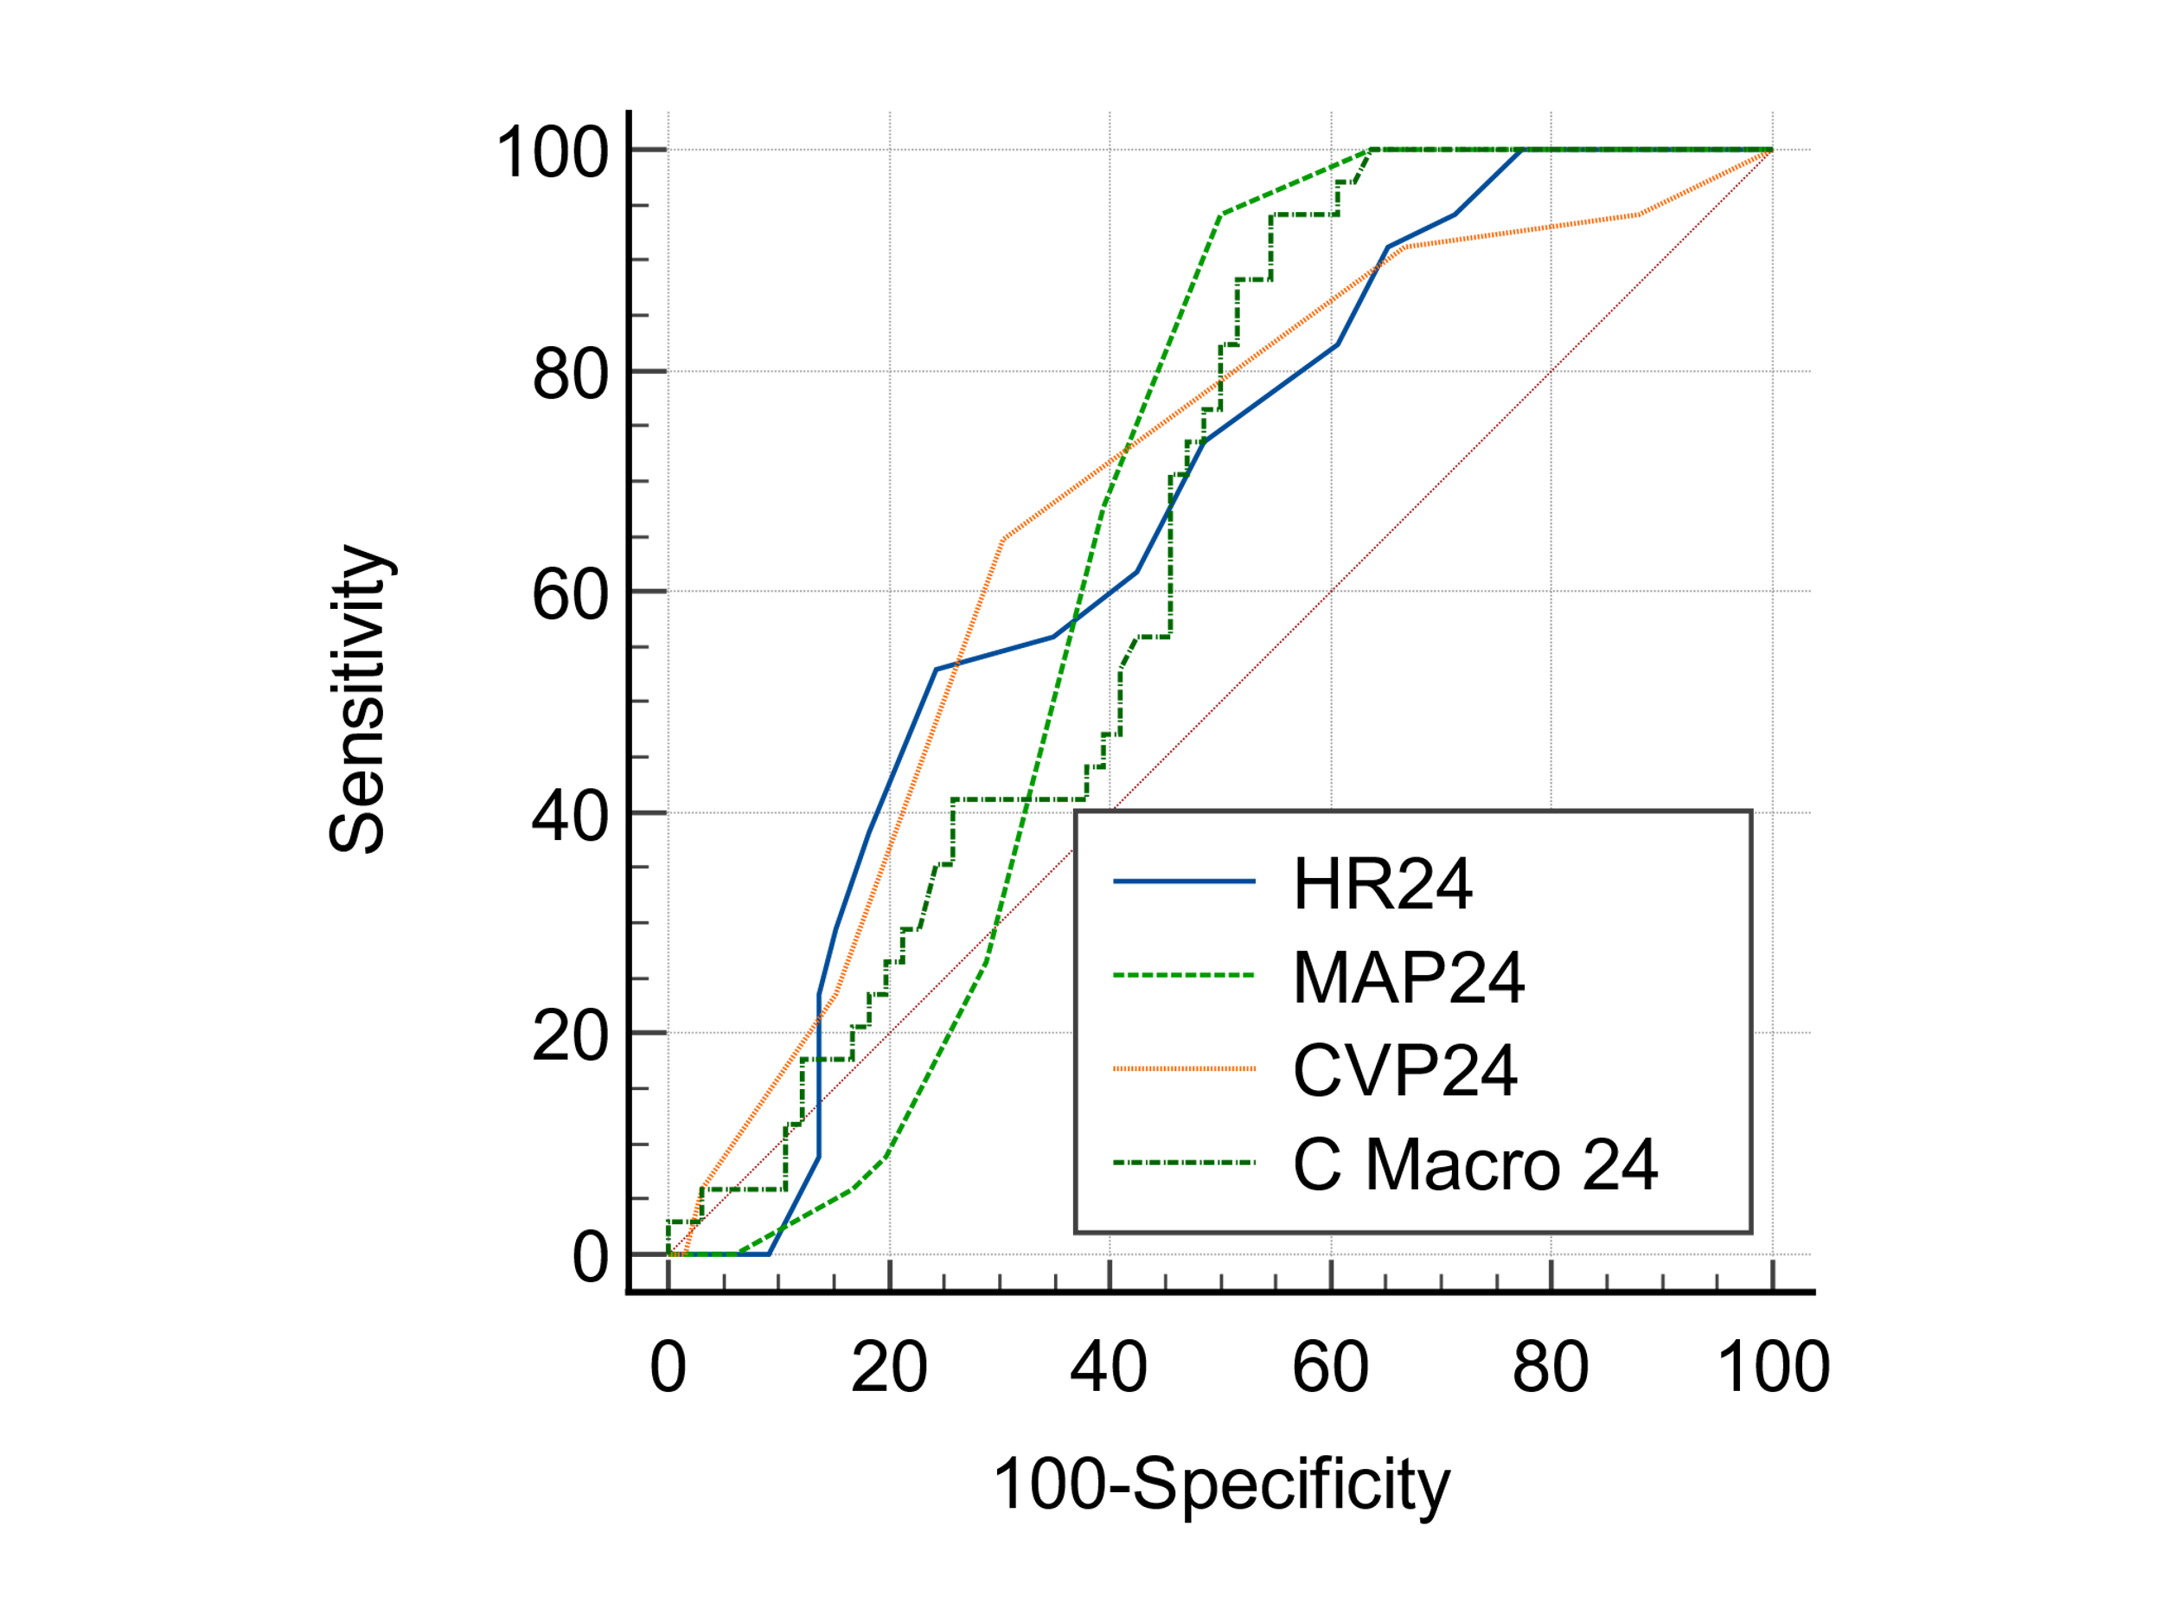
  HR24 vs. MAP24
  Difference between areas | 0.0102
  Significance level | P = 0.9003
  HR24 vs. CVP24
  Difference between areas | 0.0194
  Significance level | P = 0.7966
  HR24 vs. combined marker at 24h
  Difference between areas | 0.0109
  Significance level | P = 0.8257
  MAP24 vs. CVP24
  Difference between areas | 0.0296
  Significance level | P = 0.6966
  MAP24 vs. combined marker at 24h
  Difference between areas | 0.000668
  Significance level | P = 0.9904
  CVP24 vs. combined marker at 24h
  Difference between areas | 0.0303
  Significance level | P = 0.7339
Figure 4: Pairwise comparison of AUCs between microcirculation markers and combine marker of microcirculation to predict mortality at 24h

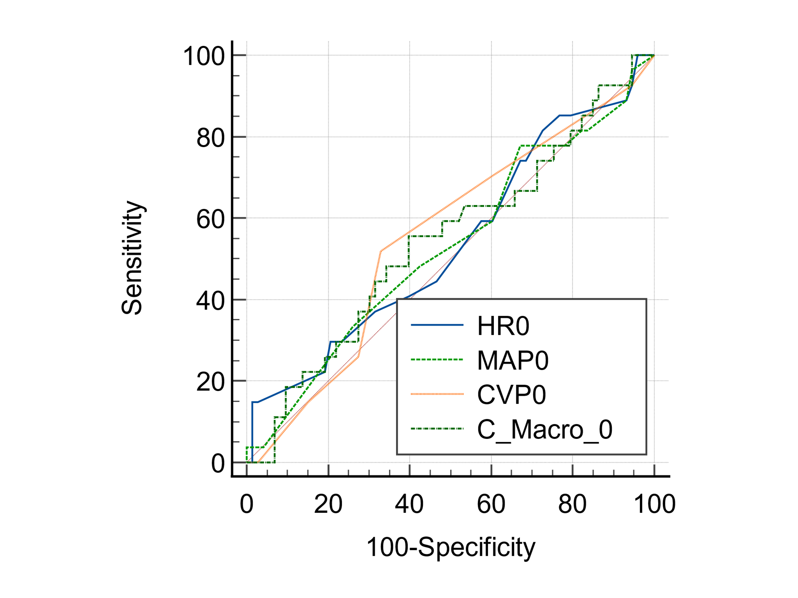
  HR0 vs. MAP0
  Difference between areas | 0.00812
  Significance level | P = 0.9327
  HR0 vs. CVP0
  Difference between areas | 0.0175
  Significance level | P = 0.8586
  HR0 vs. combined marker at 0h
  Difference between areas | 0.00710
  Significance level | P = 0.9425
  MAP0 vs. CVP0
  Difference between areas | 0.0256
  Significance level | P = 0.7533
  MAP0 vs. combined marker at 0h
  Difference between areas | 0.0152
  Significance level | P = 0.7044
  CVP0 vs. combined marker at 0h
  Difference between areas | 0.0104
  Significance level | P = 0.8418
Figure 5: Pairwise comparison of AUCs between macrocirculation markers and combine marker of macrocirculation to predict RRT at baseline

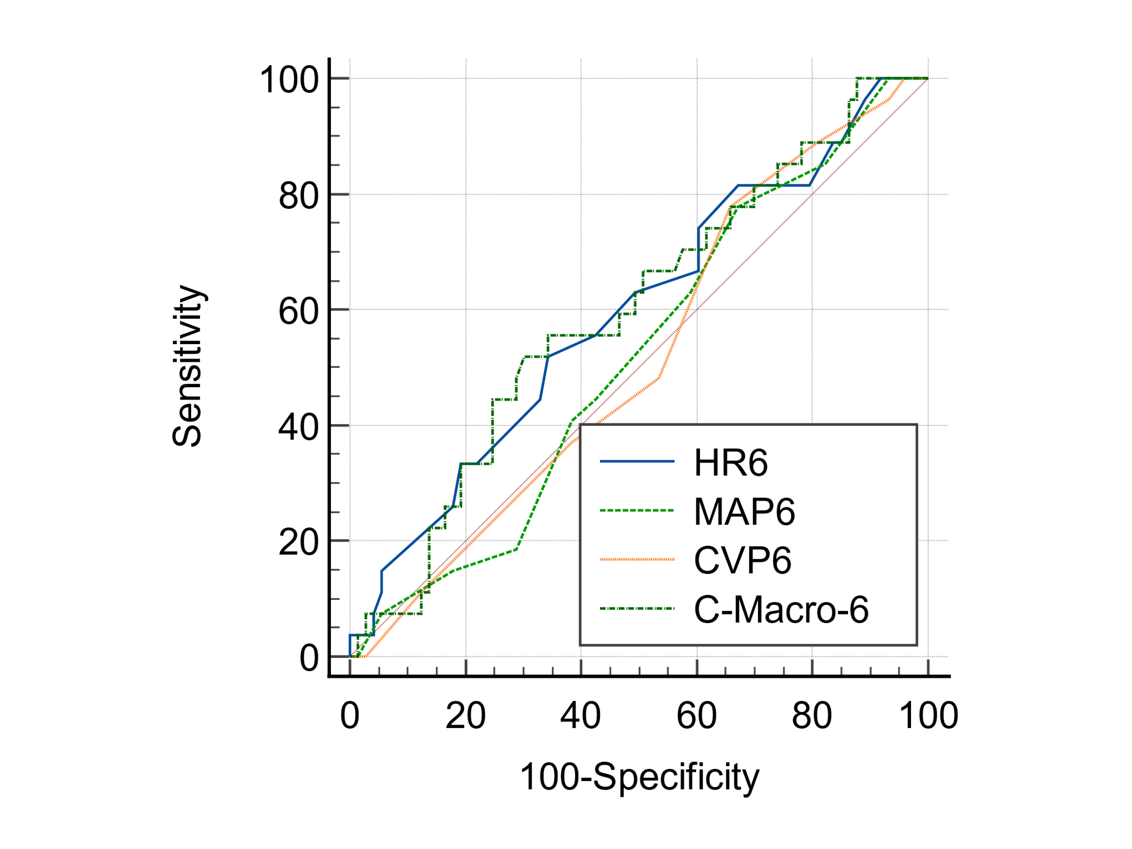
  HR6 vs. MAP6
  Difference between areas | 0.0758
  Significance level | P = 0.4329
  HR6 vs. CVP6
  Difference between areas | 0.0766
  Significance level | P = 0.4019
  HR6 vs. combined marker at 6h
  Difference between areas | 0.00152
  Significance level | P = 0.9794
  MAP6 vs. CVP6
  Difference between areas | 0.000761
  Significance level | P = 0.9935
  MAP6 vs. combined marker at 6h
  Difference between areas | 0.0774
  Significance level | P = 0.1566
  CVP6 vs. combined marker at 6h
  Difference between areas | 0.0781
  Significance level | P = 0.3450
Figure 6: Pairwise comparison of AUCs between macrocirculation markers and combine marker of macrocirculation to predict RRT at 6h

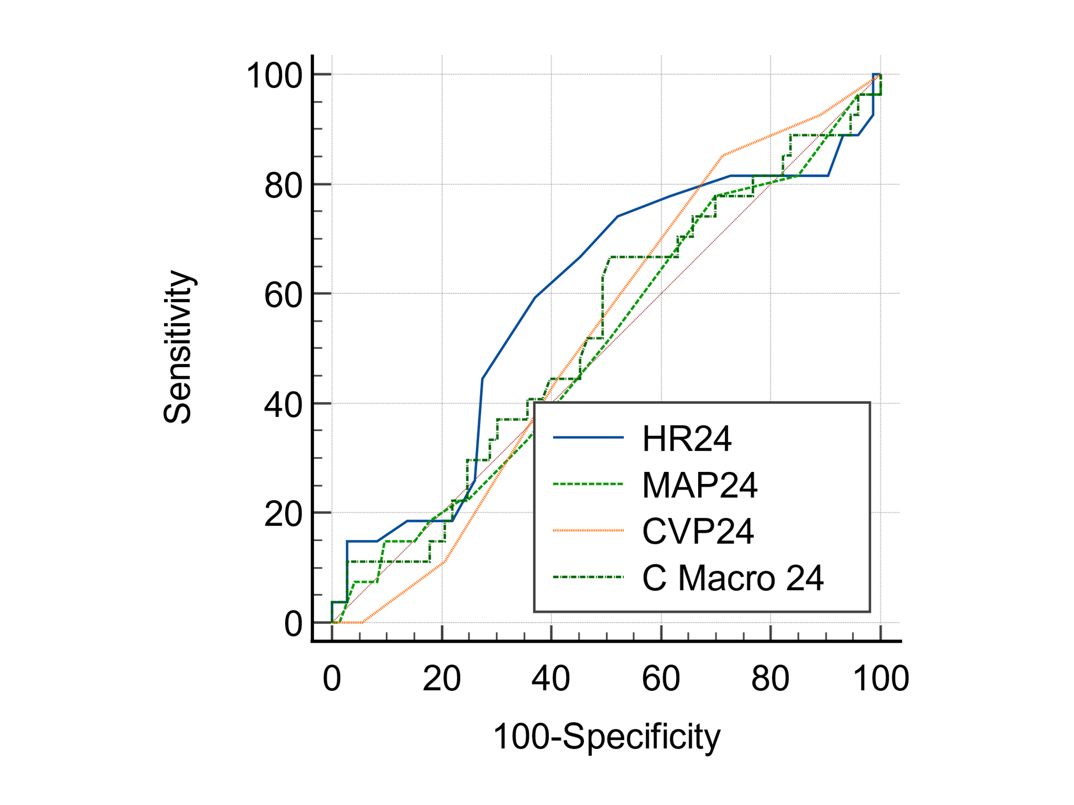
  HR24 vs. MAP24
  Difference between areas | 0.0802
  Significance level | P = 0.3805
  HR24 vs. CVP24
  Difference between areas | 0.0639
  Significance level | P = 0.5313
  HR24 vs. combined marker at 24h
  Difference between areas | 0.0586
  Significance level | P = 0.2991
  MAP24 vs. CVP24
  Difference between areas | 0.0162
  Significance level | P = 0.8560
  MAP24 vs. combined marker at 24h
  Difference between areas | 0.0216
  Significance level | P = 0.6976
  CVP24 vs. combined marker at 24h
  Difference between areas | 0.00533
  Significance level | P = 0.9501
Figure 7: Pairwise comparison of AUCs between macrocirculation markers and combine marker of macrocirculation to predict RRT at 24h

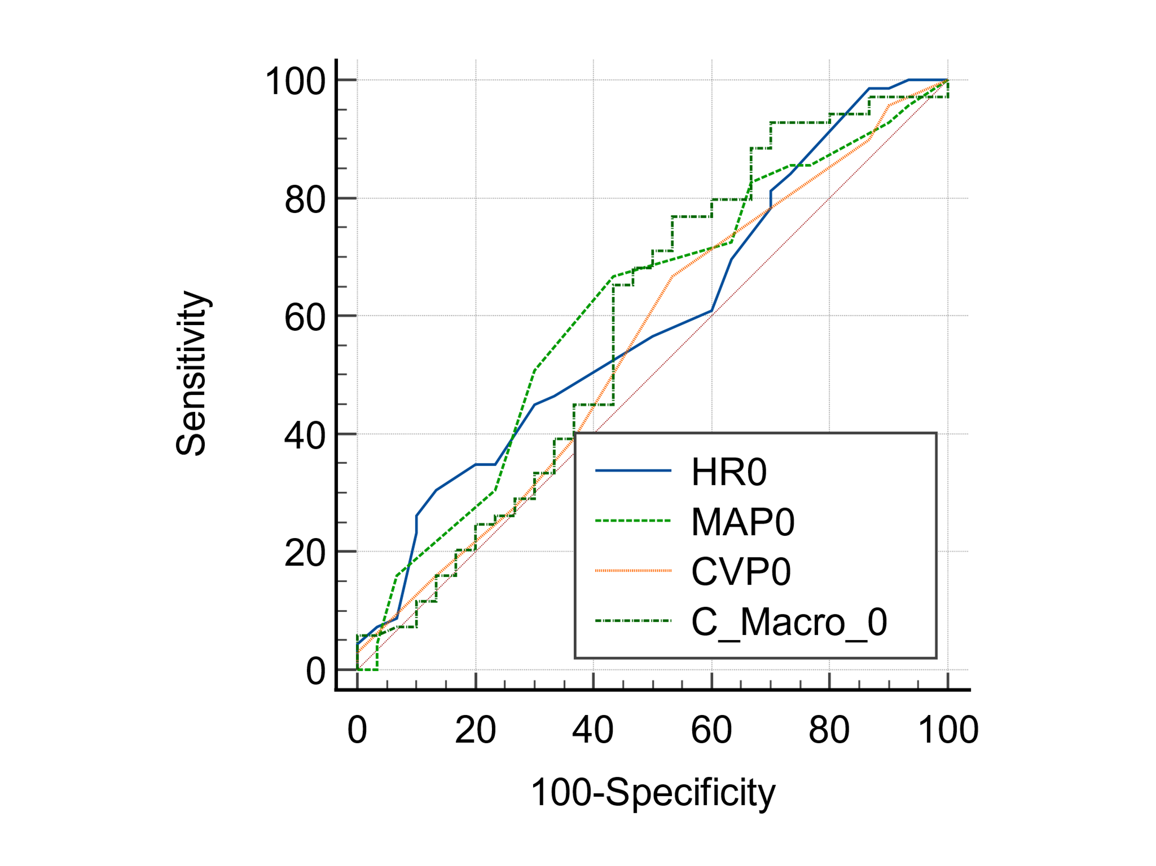
  HR0 vs. MAP0
  Difference between areas | 0.0205
  Significance level | P = 0.8128
  HR0 vs. CVP0
  Difference between areas | 0.0391
  Significance level | P = 0.6497
  HR0 vs. combined marker at 0h
  Difference between areas | 0.00169
  Significance level | P = 0.9850
  MAP0 vs. CVP0
  Difference between areas | 0.0597
  Significance level | P = 0.4049
  MAP0 vs. combined marker at 0h
  Difference between areas | 0.0222
  Significance level | P = 0.5634
  CVP0 vs. combined marker at 0h
  Difference between areas | 0.0374
  Significance level | P = 0.3994
Figure 8: Pairwise comparison of AUCs between macrocirculation markers and combine marker of macrocirculation to predict vasopressors at baseline

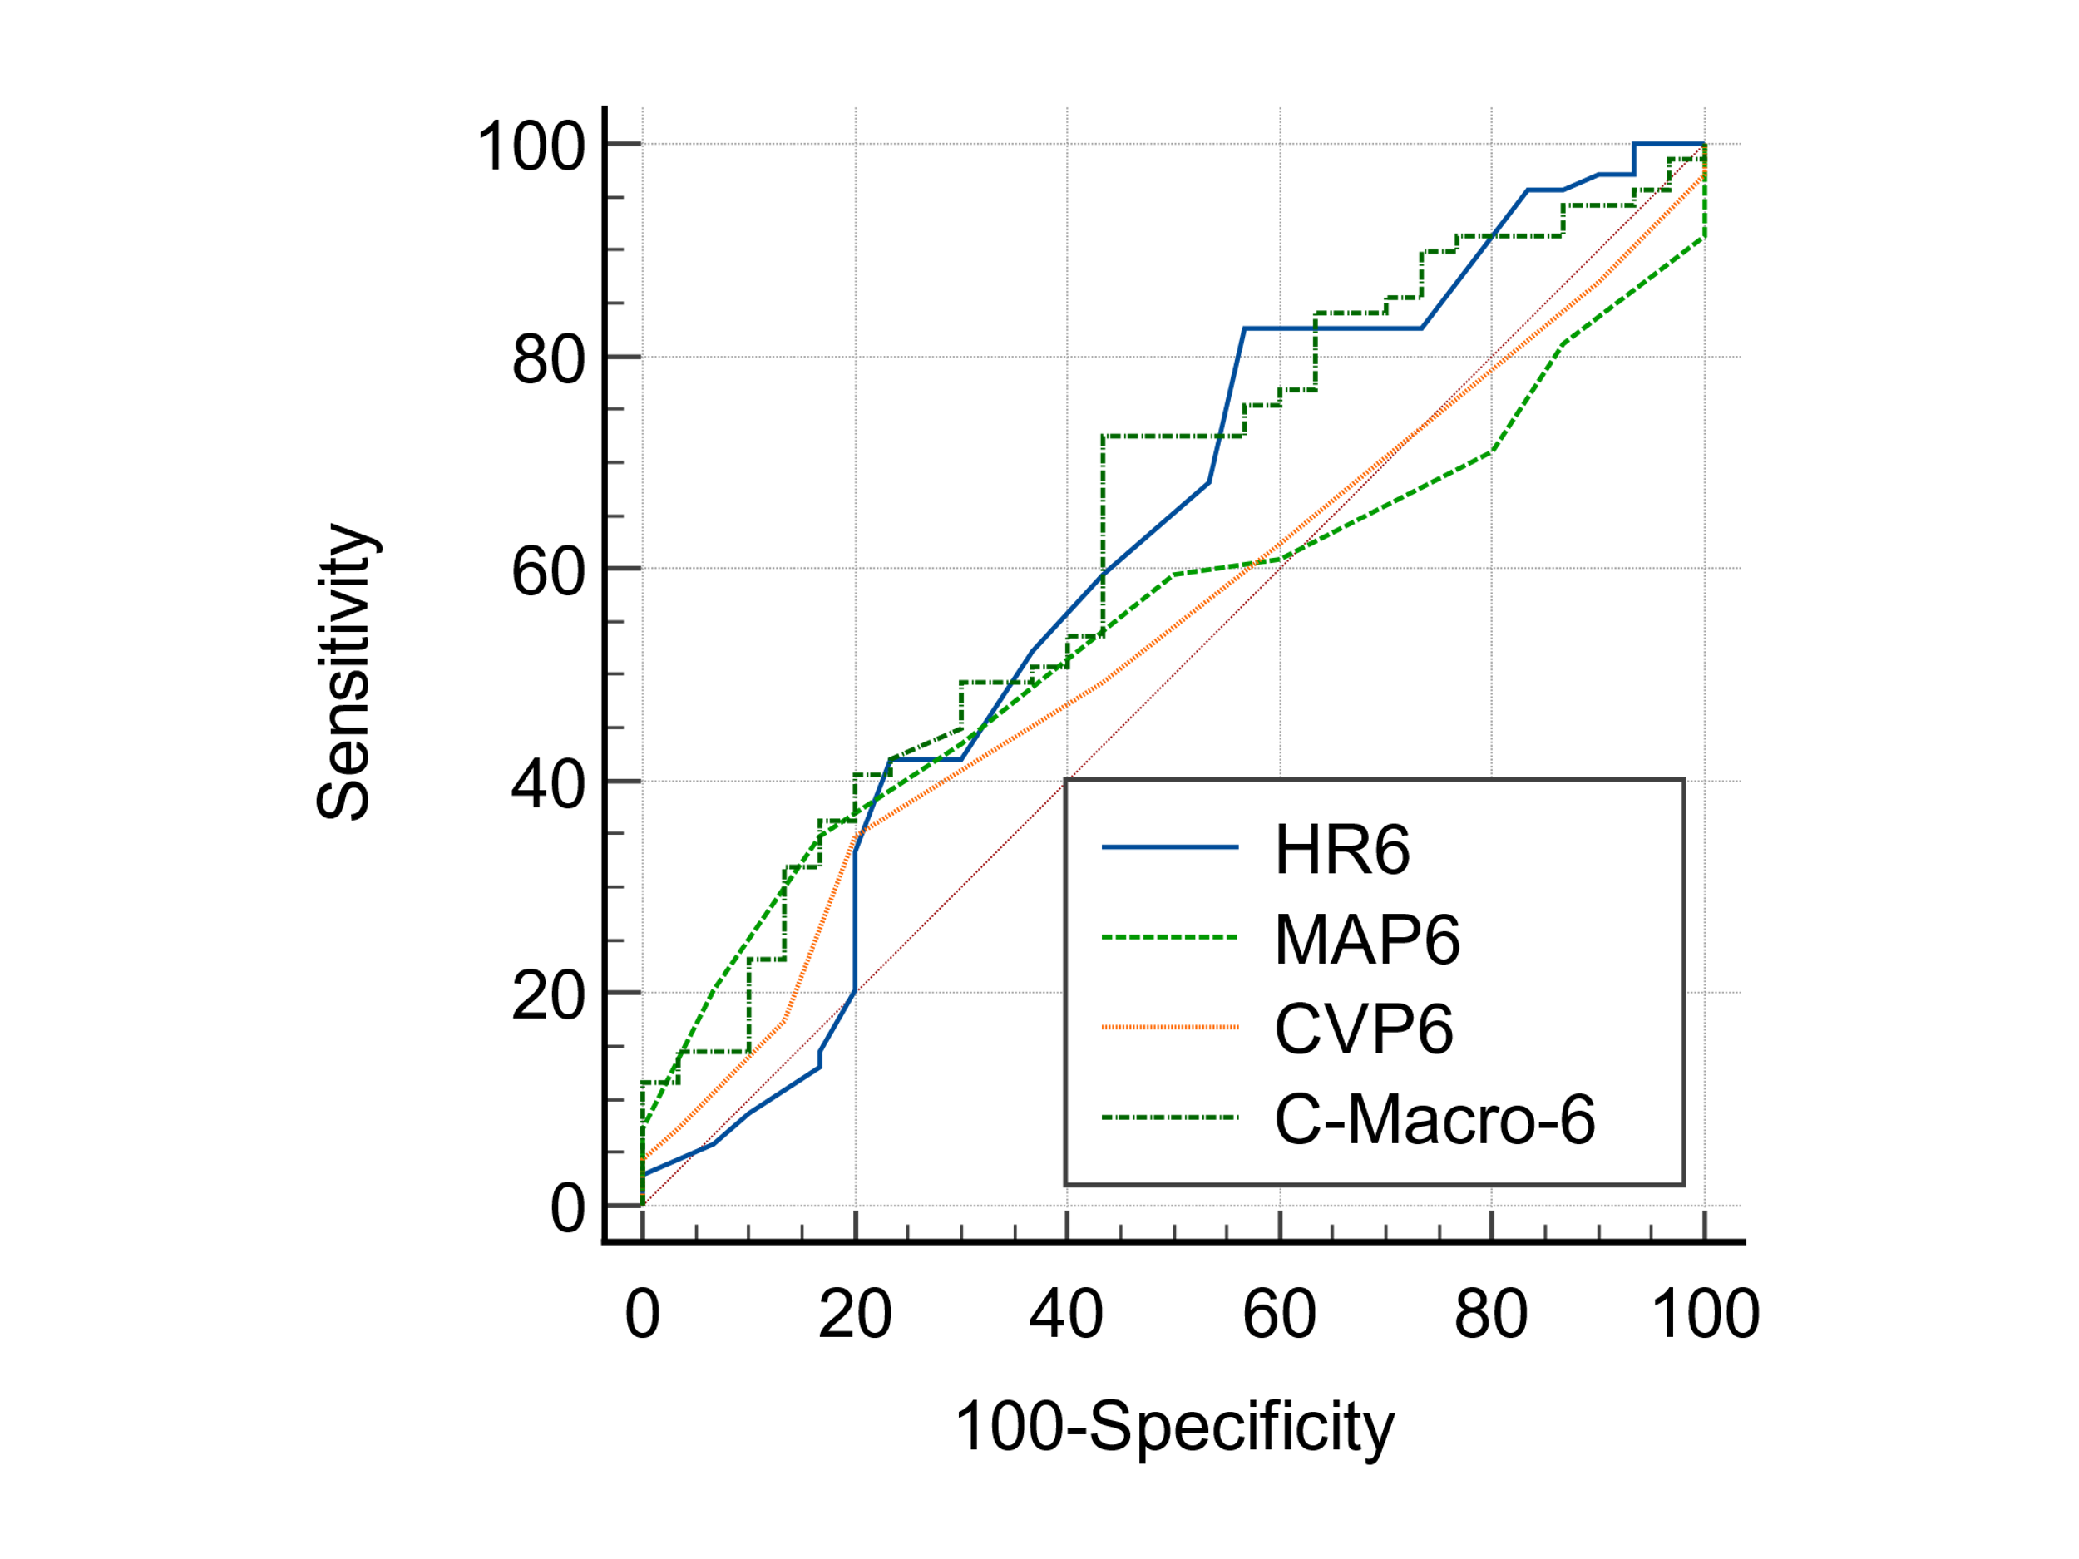
  HR6 vs. MAP6
  Difference between areas | 0.0568
  Significance level | P = 0.5331
  HR6 vs. CVP6
  Difference between areas | 0.0676
  Significance level | P = 0.4904
  HR6 vs. combined marker at 6h
  Difference between areas | 0.0285
  Significance level | P = 0.5745
  MAP6 vs. CVP6
  Difference between areas | 0.0109
  Significance level | P = 0.9049
  MAP6 vs. combined marker at 6h
  Difference between areas | 0.0853
  Significance level | P = 0.1215
  CVP6 vs. combined marker at 6h
  Difference between areas | 0.0961
  Significance level | P = 0.2713
Figure 9: Pairwise comparison of AUCs between macrocirculation markers and combine marker of macrocirculation to predict vasopressors at 6h

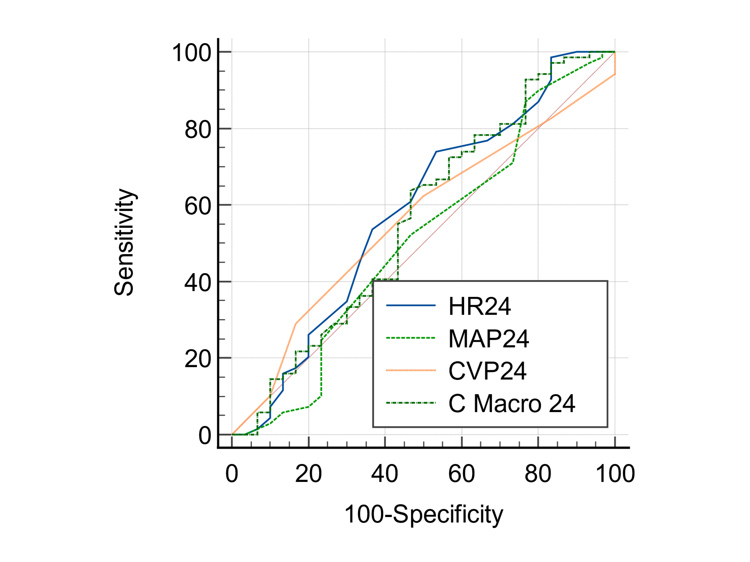
  HR24 vs. MAP24
  Difference between areas | 0.0742
  Significance level | P = 0.4489
  HR24 vs. CVP24
  Difference between areas | 0.0246
  Significance level | P = 0.7999
  HR24 vs. combined marker at 24h
  Difference between areas | 0.0215
  Significance level | P = 0.6901
  MAP24 vs. CVP24
  Difference between areas | 0.0495
  Significance level | P = 0.5580
  MAP24 vs. combined marker at 24h
  Difference between areas | 0.0527
  Significance level | P = 0.6596
  CVP24 vs. combined marker at 24h
  Difference between areas | 0.00314
  Significance level | P = 0.9700
Figure 10: Pairwise comparison of AUCs between macrocirculation markers and combine marker of macrocirculation to predict vasopressors at 24h

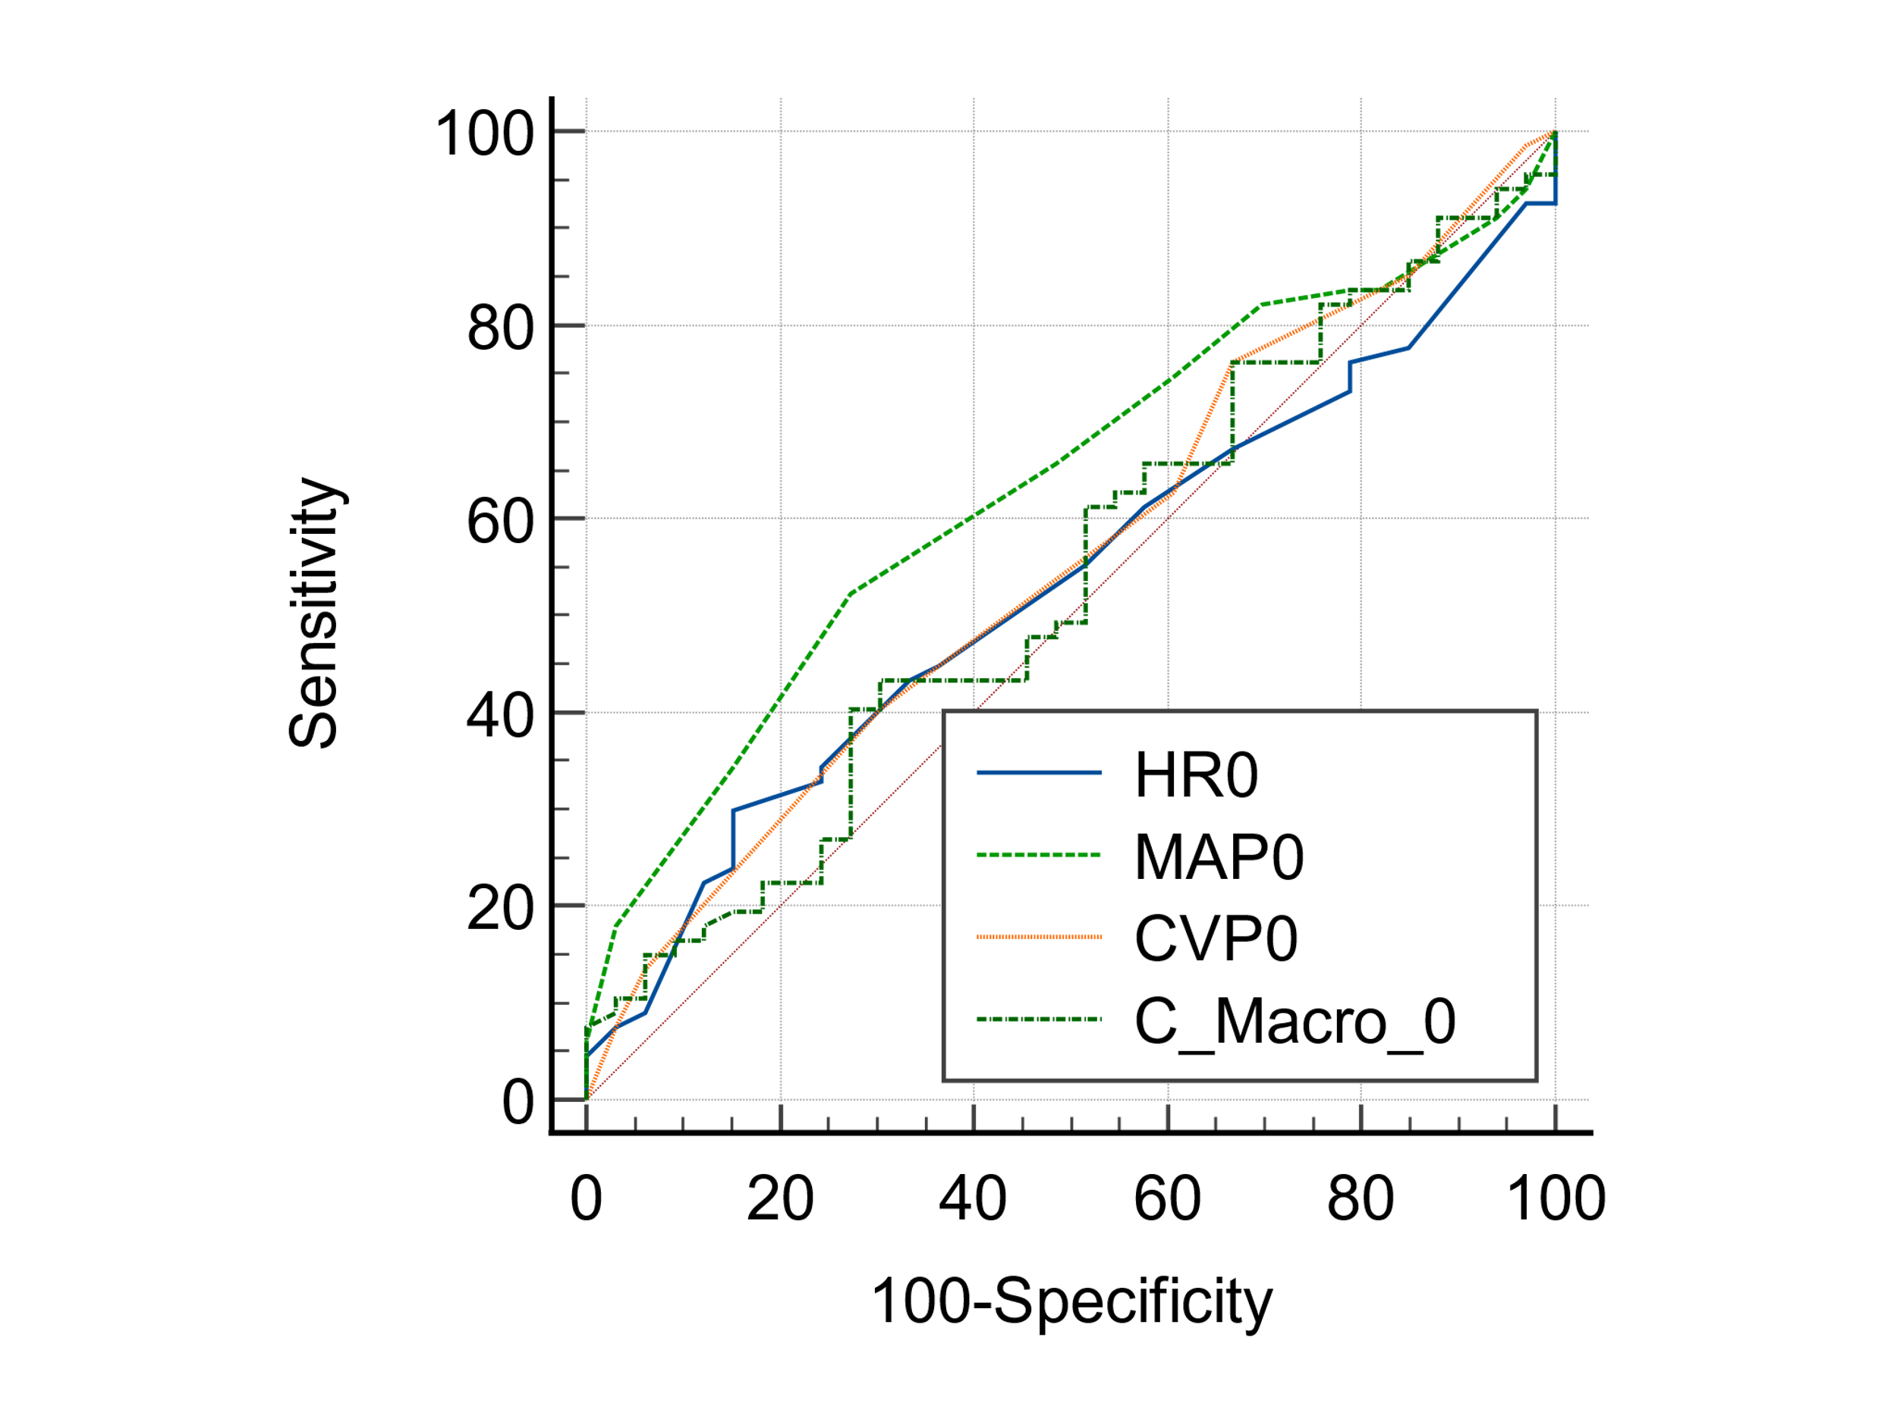
  HR0 vs. MAP0
  Difference between areas | 0.103
  Significance level | P = 0.1599
  HR0 vs. CVP0
  Difference between areas | 0.0253
  Significance level | P = 0.7665
  HR0 vs. combined marker at 0h
  Difference between areas | 0.00633
  Significance level | P = 0.9354
  MAP0 vs. CVP0
  Difference between areas | 0.0776
  Significance level | P = 0.4027
  MAP0 vs. combined marker at 0h
  Difference between areas | 0.0966
  Significance level | P = 0.0140
  CVP0 vs. combined marker at 0h
  Difference between areas | 0.0190
  Significance level | P = 0.8672
Figure 11: Pairwise comparison of AUCs between macrocirculation markers and combine marker of macrocirculation to predict ICU LOS at baseline

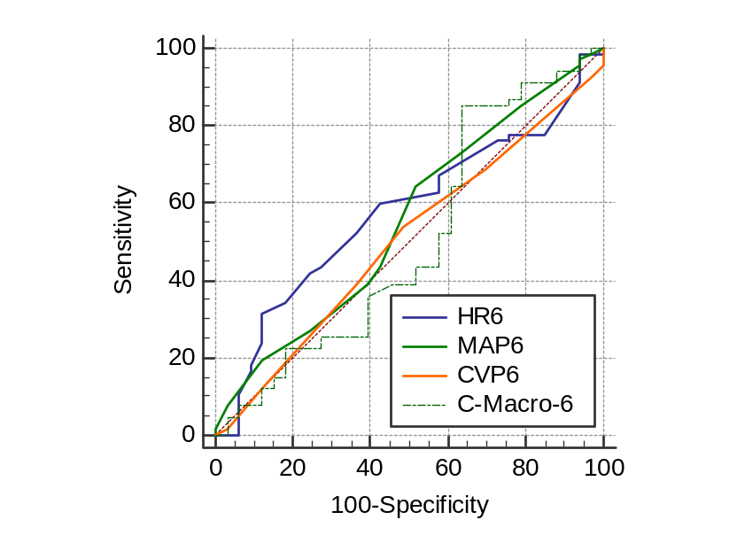
  HR6 vs. MAP6
  Difference between areas | 0.0226
  Significance level | P = 0.7976
  HR6 vs. CVP6
  Difference between areas | 0.0726
  Significance level | P = 0.3940
  HR6 vs. combined marker at 6h
  Difference between areas | 0.0728
  Significance level | P = 0.2040
  MAP6 vs. CVP6
  Difference between areas | 0.0500
  Significance level | P = 0.5839
  MAP6 vs. combined marker at 6h
  Difference between areas | 0.0502
  Significance level | P = 0.6756
  CVP6 vs. combined marker at 6h
  Difference between areas | 0.000226
  Significance level | P = 0.9981
Figure 12: Pairwise comparison of AUCs between macrocirculation markers and combine marker of macrocirculation to predict ICU LOS at 6h

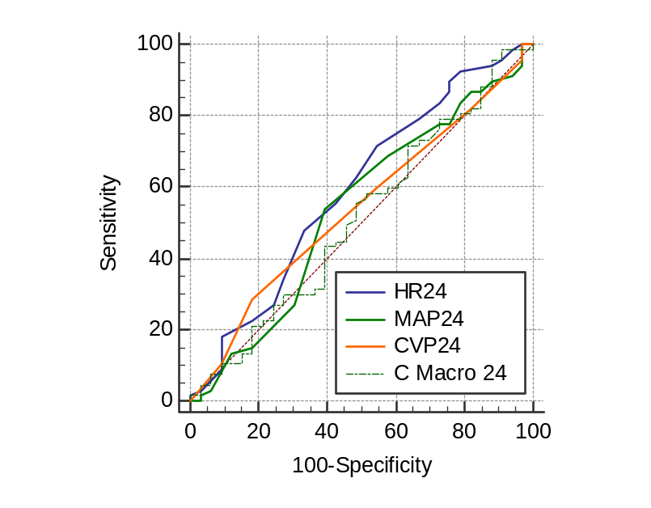
  HR24 vs. MAP24
  Difference between areas | 0.0543
  Significance level | P = 0.5081
  HR24 vs. CVP24
  Difference between areas | 0.0516
  Significance level | P = 0.5120
  HR24 vs. combined marker at 24h
  Difference between areas | 0.0801
  Significance level | P = 0.1662
  MAP24 vs. CVP24
  Difference between areas | 0.00271
  Significance level | P = 0.9765
  MAP24 vs. combined marker at 24h
  Difference between areas | 0.0258
  Significance level | P = 0.8132
  CVP24 vs. combined marker at 24h
  Difference between areas | 0.0285
  Significance level | P = 0.7632
Figure 13: Pairwise comparison of AUCs between macrocirculation markers and combine marker of macrocirculation to predict ICU LOS at 24h
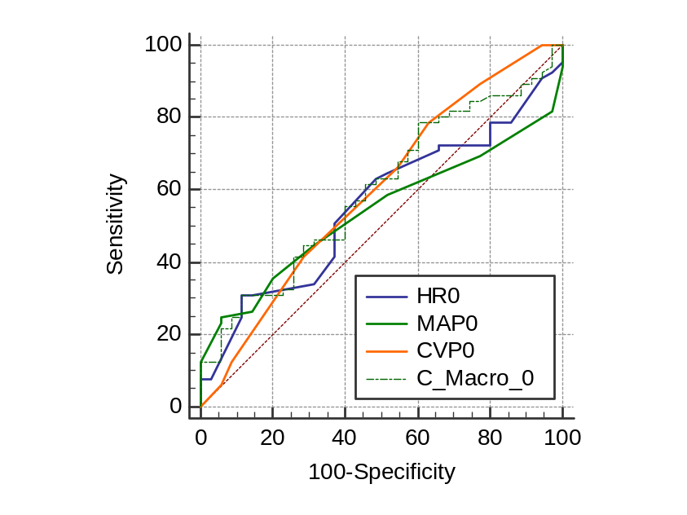
  HR0 vs. MAP0
  Difference between areas | 0.0171
  Significance level | P = 0.8113
  HR0 vs. CVP0
  Difference between areas | 0.0424
  Significance level | P = 0.6098
  HR0 vs. combined marker at 0h
  Difference between areas | 0.0420
  Significance level | P = 0.5855
  MAP0 vs. CVP0
  Difference between areas | 0.0596
  Significance level | P = 0.4095
  MAP0 vs. combined marker at 0h
  Difference between areas | 0.0591
  Significance level | P = 0.1605
  CVP0 vs. combined marker at 0h
  Difference between areas | 0.000440
  Significance level | P = 0.9908
Figure 14: Pairwise comparison of AUCs between macrocirculation markers and combine marker of macrocirculation to predict MV duration at baseline

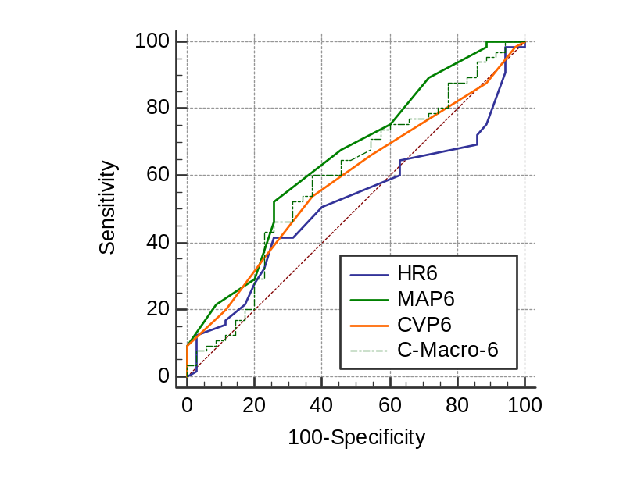
  HR6 vs. MAP6
  Difference between areas | 0.138
  Significance level | P = 0.0892
  HR6 vs. CVP6
  Difference between areas | 0.0699
  Significance level | P = 0.4132
  HR6 vs. combined marker at 6h
  Difference between areas | 0.0791
  Significance level | P = 0.4520
  MAP6 vs. CVP6
  Difference between areas | 0.0684
  Significance level | P = 0.3721
  MAP6 vs. combined marker at 6h
  Difference between areas | 0.0591
  Significance level | P = 0.1804
  CVP6 vs. combined marker at 6h
  Difference between areas | 0.00923
  Significance level | P = 0.9168
Figure 15: Pairwise comparison of AUCs between macrocirculation markers and combine marker of macrocirculation to predict MV duration at 6h

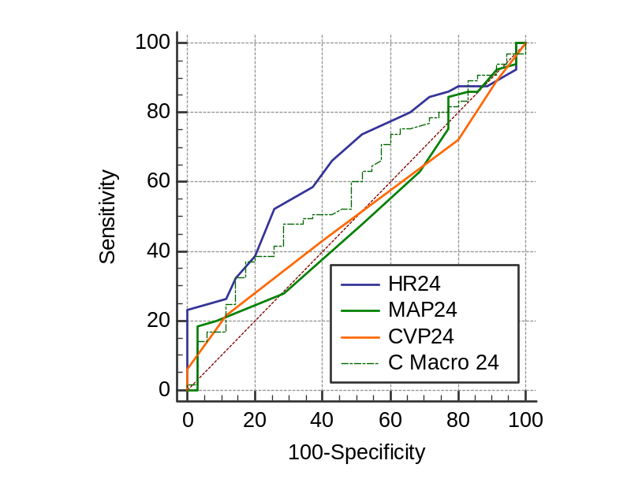
  HR24 vs. MAP24
  Difference between areas | 0.148
  Significance level | P = 0.0520
  HR24 vs. CVP24
  Difference between areas | 0.141
  Significance level | P = 0.1042
  HR24 vs. combined marker at 24h
  Difference between areas | 0.0662
  Significance level | P = 0.2435
  MAP24 vs. combined marker at 24h
  Difference between areas | 0.00703
  Significance level | P = 0.9272
  MAP24 vs. combined marker at 24h
  Difference between areas | 0.0815
  Significance level | P = 0.4390
  CVP24 vs. combined marker at 24h
  Difference between areas | 0.0745
  Significance level | P = 0.3177
Figure 16: Pairwise comparison of AUCs between macrocirculation markers and combine marker of macrocirculation to predict MV duration at 24h

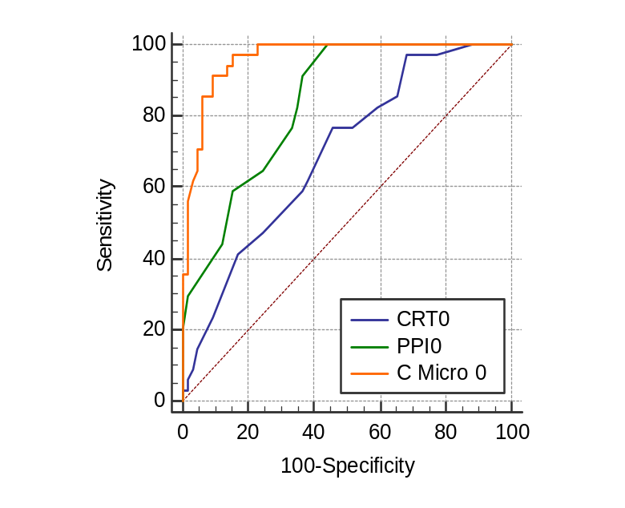
  CRT0 vs. PPI0
  Difference between areas | 0.142
  Standard Error | 0.0471
  z statistic | 3.024
  Significance level | P = 0.0025
  CRT0 vs. Combined marker at 0h
  Difference between areas | 0.268
  Standard Error | 0.0530
  z statistic | 5.052
  Significance level | P < 0.0001
  PPI0 vs. Combined marker at 0h
  Difference between areas | 0.125
  Standard Error | 0.0368
  z statistic | 3.407
  Significance level | P = 0.0007
Figure 17: Pairwise comparison of AUCs between microcirculation markers and combine marker of microcirculation to predict mortality at baseline

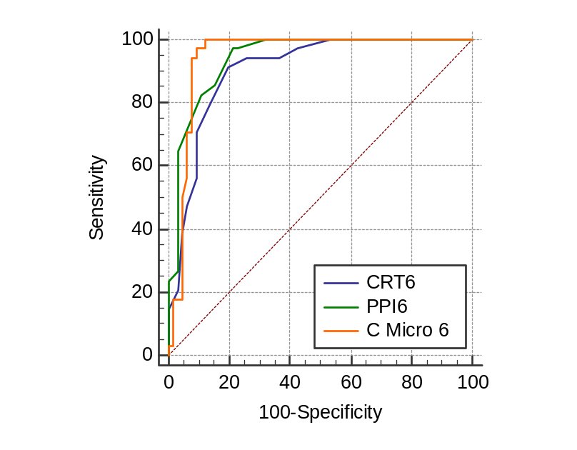
  CRT6 vs. PPI6
  Difference between areas | 0.0370
  Standard Error | 0.0319
  z statistic | 1.161
  Significance level | P = 0.2456
  CRT6 vs. Combined marker at 6h
  Difference between areas | 0.0412
  Standard Error | 0.0375
  z statistic | 1.099
  Significance level | P = 0.2719
  PPI6 vs. Combined marker at 6h
  Difference between areas | 0.00423
  Standard Error | 0.0313
  z statistic | 0.135
  Significance level | P = 0.8925
Figure 18: Pairwise comparison of AUCs between microcirculation markers and combine marker of microcirculation to predict mortality at 6h

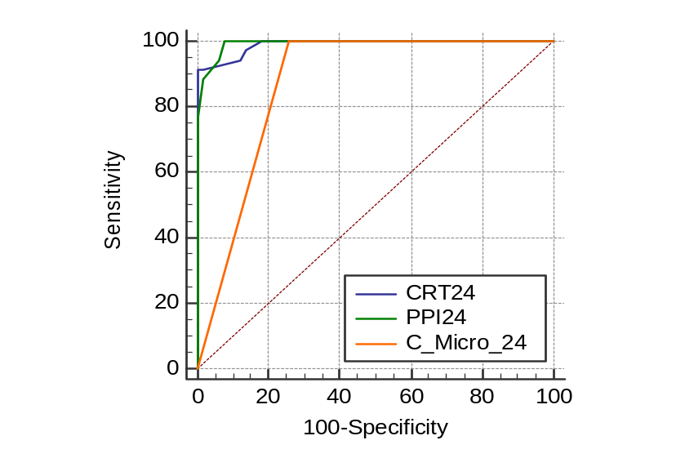
  CRT24 vs. PPI24
  Difference between areas | 0.00334
  Standard Error | 0.00827
  z statistic | 0.404
  Significance level | P = 0.6863
  CRT24 vs. Combined marker at 24h
  Difference between areas | 0.118
  Standard Error | 0.0269
  z statistic | 4.404
  Significance level | P < 0.0001
  PPI24 vs. Combined marker at 24h
  Difference between areas | 0.122
  Standard Error | 0.0260
  z statistic | 4.680
  Significance level | P < 0.0001
Figure 19: Pairwise comparison of AUCs between microcirculation markers and combine marker of microcirculation to predict mortality at 24h

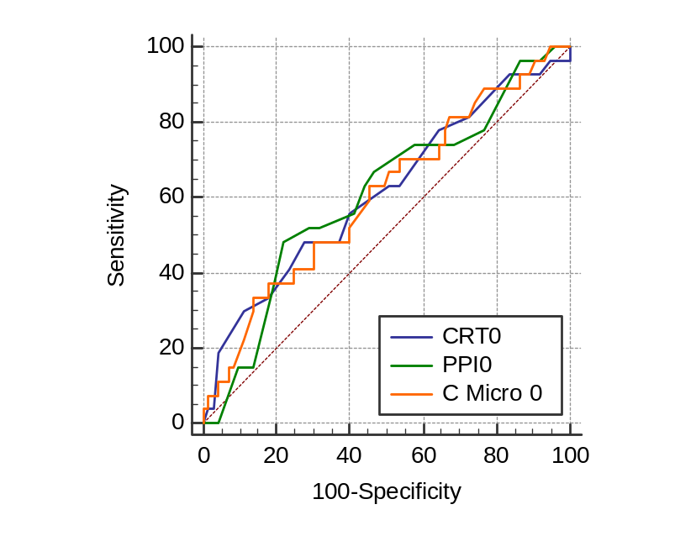
  CRT0 vs. PPI0
  Difference between areas | 0.00583
  Standard Error ª | 0.0540
  z statistic | 0.108
  Significance level | P = 0.9139
  CRT0 vs. Combined marker at 0h
  Difference between areas | 0.00710
  Standard Error ª | 0.0708
  z statistic | 0.100
  Significance level | P = 0.9200
  PPI0 vs. Combined marker at 0h
  Difference between areas | 0.00127
  Standard Error ª | 0.0530
  z statistic | 0.0239
  Significance level | P = 0.9809
Figure 20: Pairwise comparison of AUCs between microcirculation markers and combine marker of microcirculation to predict RRT at baseline

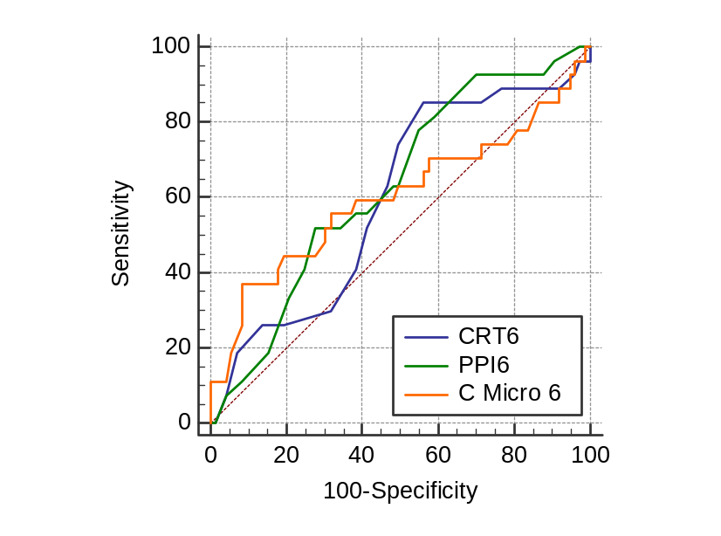
  CRT6 vs. PPI6
  Difference between areas | 0.0348
  Standard Error ª | 0.0501
  z statistic | 0.693
  Significance level | P = 0.4881
  CRT6 vs. Combined marker at 6h
  Difference between areas | 0.00507
  Standard Error ª | 0.0623
  z statistic | 0.0814
  Significance level | P = 0.9351
  PPI6 vs. Combined marker at 6h
  Difference between areas | 0.0297
  Standard Error ª | 0.0445
  z statistic | 0.666
  Significance level | P = 0.5052
Figure 21: Pairwise comparison of AUCs between microcirculation markers and combine marker of microcirculation to predict RRT at 6h

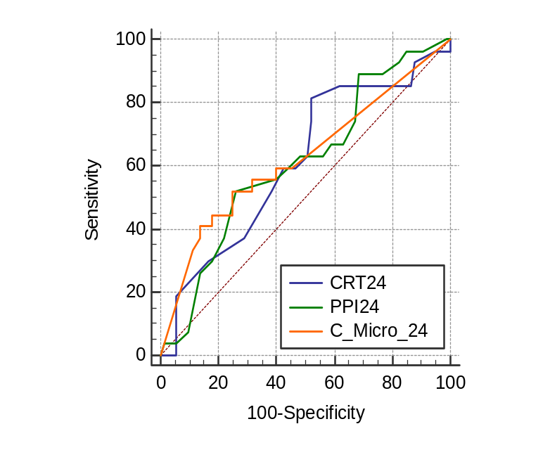
  CRT24 vs. PPI24
  Difference between areas | 0.00203
  Standard Error ª | 0.0406
  z statistic | 0.0500
  Significance level | P = 0.9601
  CRT24 vs. Combined marker at 24h
  Difference between areas | 0.0137
  Standard Error ª | 0.0467
  z statistic | 0.294
  Significance level | P = 0.7691
  PPI24 vs. Combined marker at 24h
  Difference between areas | 0.0157
  Standard Error ª | 0.0301
  z statistic | 0.523
  Significance level | P = 0.6008
Figure 22: Pairwise comparison of AUCs between microcirculation markers and combine marker of microcirculation to predict RRT at 24h

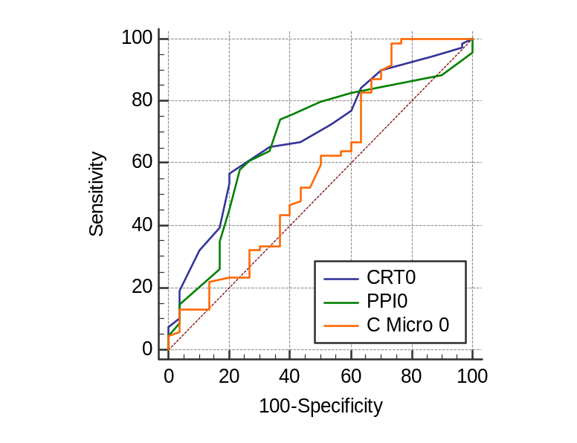
  CRT0 vs. PPI0
  Difference between areas | 0.0164
  Standard Error ª | 0.0483
  z statistic | 0.340
  Significance level | P = 0.7337
  CRT0 vs. Combined marker at 0h
  Difference between areas | 0.110
  Standard Error ª | 0.0632
  z statistic | 1.742
  Significance level | P = 0.0814
  PPI0 vs. Combined marker at 0h
  Difference between areas | 0.0937
  Standard Error ª | 0.0544
  z statistic | 1.723
  Significance level | P = 0.0848
Figure 23: Pairwise comparison of AUCs between microcirculation markers and combine marker of microcirculation to predict vasopressor at baseline

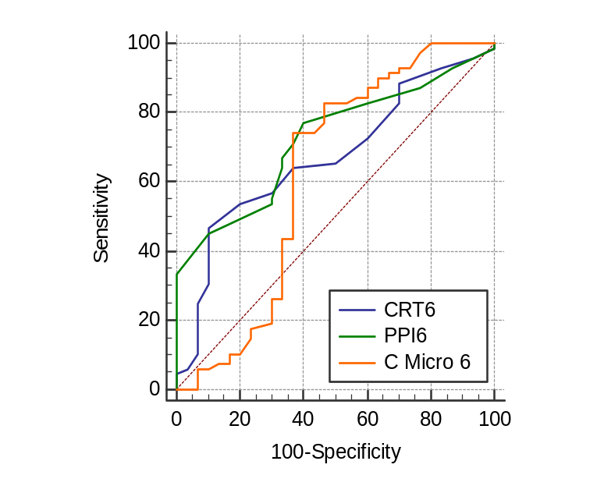
  CRT6 vs. PPI6
  Difference between areas | 0.0524
  Standard Error ª | 0.0465
  z statistic | 1.128
  Significance level | P = 0.2595
  CRT6 vs. Combined marker at 6h
  Difference between areas | 0.0514
  Standard Error ª | 0.0678
  z statistic | 0.759
  Significance level | P = 0.4481
  PPI6 vs. Combined marker at 6h
  Difference between areas | 0.104
  Standard Error ª | 0.0515
  z statistic | 2.016
  Significance level | P = 0.0438
Figure 24: Pairwise comparison of AUCs between microcirculation markers and combine marker of microcirculation to predict vasopressor at 6h

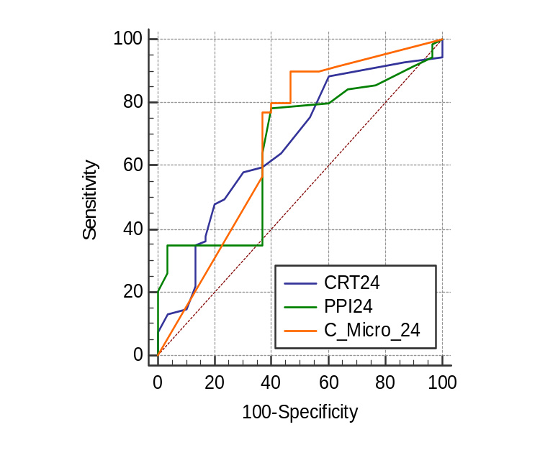
  CRT24 vs. PPI24
  Difference between areas | 0.00966
  Standard Error ª | 0.0472
  z statistic | 0.205
  Significance level | P = 0.8379
  CRT24 vs. Combined marker at 24h
  Difference between areas | 0.0162
  Standard Error ª | 0.0526
  z statistic | 0.308
  Significance level | P = 0.7584
  PPI24 vs. Combined marker at 24h
  Difference between areas | 0.0258
  Standard Error ª | 0.0297
  z statistic | 0.872
  Significance level | P = 0.3834
Figure 25: Pairwise comparison of AUCs between microcirculation markers and combine marker of microcirculation to predict vasopressor at 24h

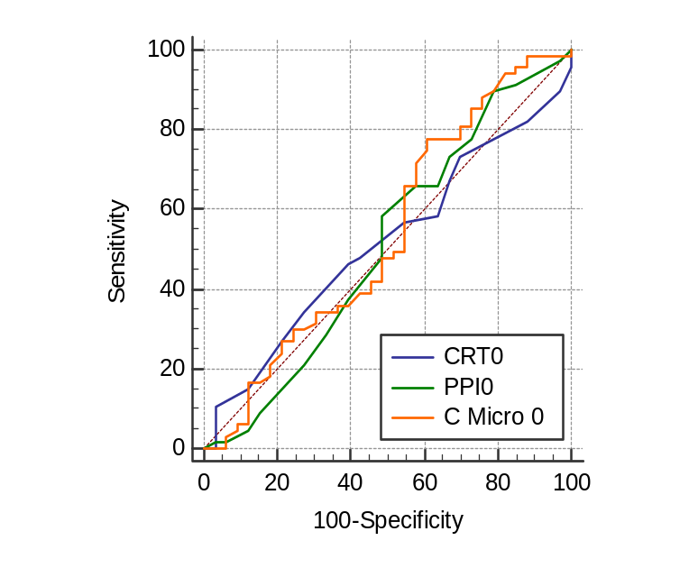
  CRT0 vs. PPI0
  Difference between areas | 0.00701
  Standard Error ª | 0.0506
  z statistic | 0.139
  Significance level | P = 0.8897
  CRT0 vs. Combined marker at 0h
  Difference between areas | 0.0224
  Standard Error ª | 0.0639
  z statistic | 0.350
  Significance level | P = 0.7261
  PPI0 vs. Combined marker at 0h
  Difference between areas | 0.0294
  Standard Error ª | 0.0545
  z statistic | 0.539
  Significance level | P = 0.5897
Figure 26: Pairwise comparison of AUCs between microcirculation markers and combine marker of microcirculation to predict ICU LOS at baseline
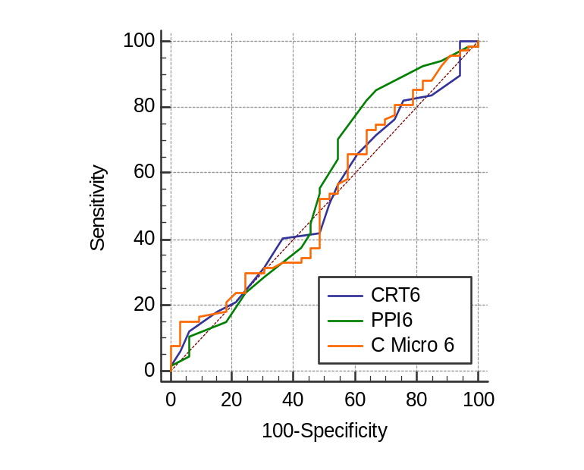
  CRT6 vs. PPI6
  Difference between areas | 0.0339
  Standard Error ª | 0.0478
  z statistic | 0.710
  Significance level | P = 0.4775
  CRT6 vs. Combined marker at 6h
  Difference between areas | 0.00588
  Standard Error ª | 0.116
  z statistic | 0.0509
  Significance level | P = 0.9594
  PPI6 vs. Combined marker at 6h
  Difference between areas | 0.0280
  Standard Error ª | 0.122
  z statistic | 0.230
  Significance level | P = 0.8181
Figure 27: Pairwise comparison of AUCs between microcirculation markers and combine marker of microcirculation to predict ICU LOS at 6h

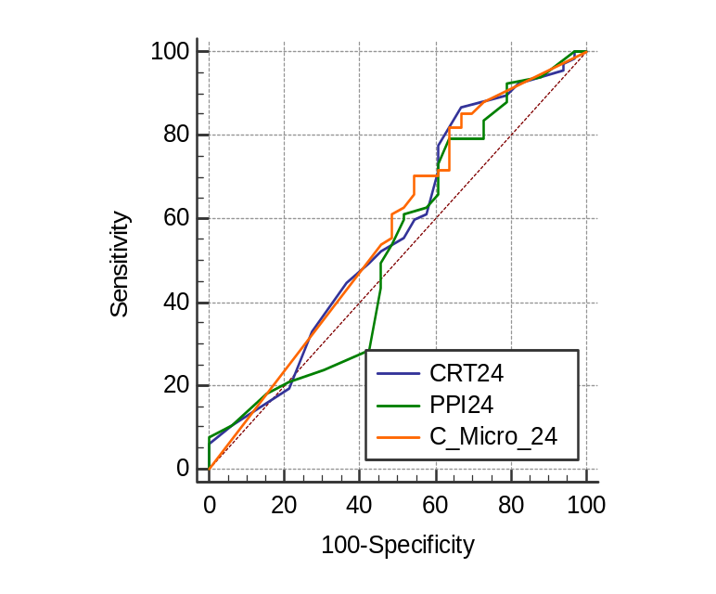
  CRT24 vs. PPI24
  Difference between areas | 0.0360
  Standard Error ª | 0.0379
  z statistic | 0.949
  Significance level | P = 0.3425
  CRT24 vs. Combined marker at 24h
  Difference between areas | 0.00543
  Standard Error ª | 0.118
  z statistic | 0.0461
  Significance level | P = 0.9632
  PPI24 vs. Combined marker at 24h
  Difference between areas | 0.0414
  Standard Error ª | 0.122
  z statistic | 0.339
  Significance level | P = 0.7343
Figure 28: Pairwise comparison of AUCs between microcirculation markers and combine marker of microcirculation to predict ICU LOS at 24h
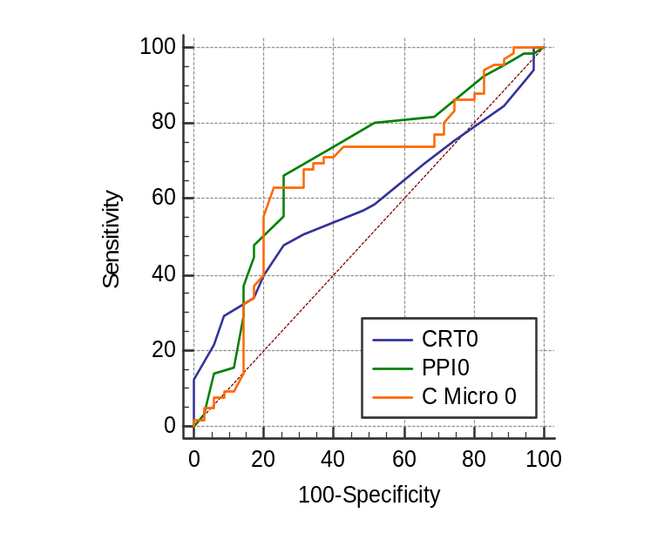
  CRT0 vs. PPI0
  Difference between areas | 0.100
  Standard Error ª | 0.0513
  z statistic | 1.960
  Significance level | P = 0.0500
  CRT0 vs. Combined marker at 0h
  Difference between areas | 0.0697
  Standard Error ª | 0.0627
  z statistic | 1.111
  Significance level | P = 0.2667
  PPI0 vs. Combined marker at 0h
  Difference between areas | 0.0308
  Standard Error ª | 0.0499
  z statistic | 0.617
  Significance level | P = 0.5372
Figure 29: Pairwise comparison of AUCs between microcirculation markers and combine marker of microcirculation to predict MV duration at baseline

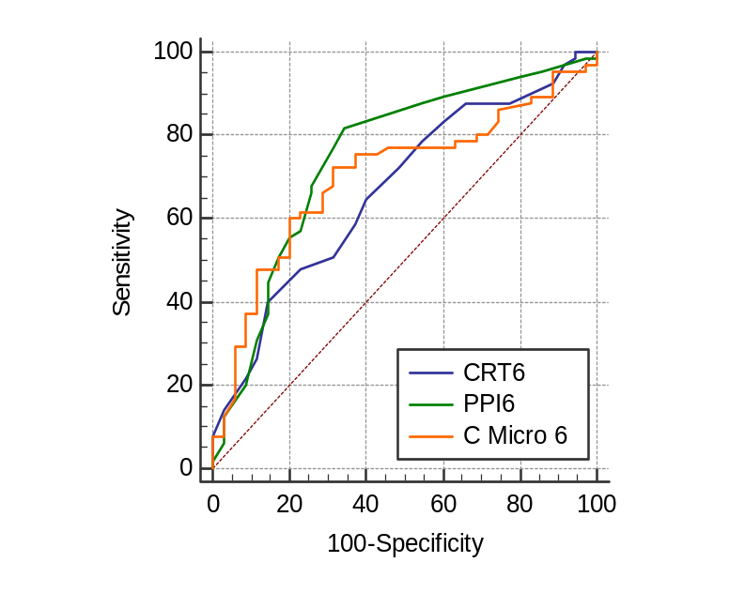
  CRT6 vs. PPI6
  Difference between areas | 0.0796
  Standard Error | 0.0464
  z statistic | 1.716
  Significance level | P = 0.0862
  CRT6 vs. Combined marker at 6h
  Difference between areas | 0.0325
  Standard Error | 0.0489
  z statistic | 0.665
  Significance level | P = 0.5059
  PPI6 vs. Combined marker at 6h
  Difference between areas | 0.0470
  Standard Error | 0.0416
  z statistic | 1.129
  Significance level | P = 0.2587
Figure 30: Pairwise comparison of AUCs between microcirculation markers and combine marker of microcirculation to predict MV duration at 6h
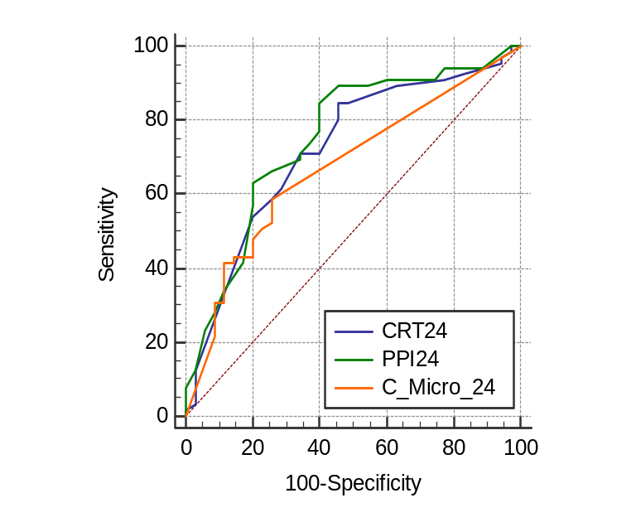
  CRT24 vs. PPI24
  Difference between areas | 0.0284
  Standard Error ª | 0.0393
  z statistic | 0.722
  Significance level | P = 0.4702
  CRT24 vs. Combined marker at 24h
  Difference between areas | 0.0492
  Standard Error ª | 0.0451
  z statistic | 1.091
  Significance level | P = 0.2751
  PPI24 vs. Combined marker at 24h
  Difference between areas | 0.0776
  Standard Error ª | 0.0305
  z statistic | 2.546
  Significance level | P = 0.0109
Figure 31: Pairwise comparison of AUCs between microcirculation markers and combine marker of microcirculation to predict MV duration at 24h

