SUPPLEMENTAL MATERIAL

Dynamics of Human Milk Oligosaccharides in early lactation and relation with growth and appetitive traits of Filipino breastfed infants

Tinu M. Samuel¹; Mickaël Hartweg²; Jowena D. Lebumfacil³, Katherine. B. Buluran⁴, Rachel. B. Lawenko⁴; Elvira M. Estorninos⁴; Aristea Binia⁵; Norbert Sprenger^{5*}

Affiliations :
1 Nestlé Product Technology Center-Nutrition, Société des Produits Nestlé S.A., 1800 Vevey, Switzerland.
2 Clinical Research Unit, Société des Produits Nestlé SA, 1000 Lausanne, Switzerland
3 Clinical Research Operations, Wyeth Philippines, Inc., Makati City, 1200, Philippines,
4 Asian Hospital & Medical Center, Muntinlupa City, 1780, Philippines
5 Nestlé Institute of Health Sciences, Société des Produits Nestlé SA, 1000 Lausanne, Switzerland

Supplemental Table 1. Demographic, maternal, and infant characteristics by milk groups, N=41.
 | Se+/Le+ (N=25) |  | Se+/Le- (N=5) |  | Se-/Le+ (N=10) |  | Se-/Le- (N=1)
 | Mean [SD] or N (%) | Median  [25th, 75th percentiles] | Mean [SD] or N (%) | Median  [25th, 75th percentiles] | Mean [SD] or N (%) | Median  [25th, 75th percentiles] | Mean [SD] or N (%) | Median  [25th, 75th percentiles]
Infant Characteristics
Sex
Female | 12 (48%) |  | 4 (80%) |  | 4 (40%) |  | 1 (100%)
Male | 13 (52%) |  | 1 (20%) |  | 6 (60%) |  | 0 (0%)
Gestational age at birth (weeks) | 38.6 [1.2] | 39 [38, 40] | 38.8 [1.6] | 38 [38, 40] | 39.3 [1.8] | 38 [38, 40] | 37.0 [-] | 37 [37, 37]
Age at enrollment (days) | 23.6 [1.7] | 24 [22, 25] | 24.4 [2.3] | 26 [23, 26] | 24.0 [2.2] | 25 [21, 26] | 26.0 [-] | 26 [26, 26]
Birth weight, grams | 3106.0 [297.4] | 3000  [2900, 3330] | 3106.0 [382.5] | 3070  [2800, 3300] | 3015.0 [347.7] | 3100  [2680, 3360] | 3040.0  [-] | 3040  [3040, 3040]
Birth length, cm | 50.3 [2.1] | 50 [49, 52] | 49.2 [0.8] | 49 [49, 50] | 49.7 [2.4] | 49.5 [48, 52] | 48 [-] | 48 [48, 48]
Weight at enrollment [21-26 days], grams | 3929.6 [425.6] | 3848  [3580, 4145] | 3733.0 [502.0] | 3990  [3625, 4040] | 3875.5 [310.4] | 3986  [3760, 4068] | 3592.5  [-] | 3593  [3593, 3593]
Length at enrollment [21-26 days], cm | 51.0 [1.4] | 50.7  [50.0, 51.8] | 50.1 [1.4] | 49.5  [49.4, 50.2] | 51.0 [2.0] | 50.7  [49.0, 52.9] | 49.2 [-] | 49.2  [49.2, 49.2]
BMI at enrollment [21-26 days], kg/m² | 15.1 [1.2] | 15.5  [14.1, 15.8] | 14.9 [1.8] | 15.1  [14.7, 16.3] | 14.9 [1.0] | 15.1  [13.9, 15.4] | 14.8 [-] | 14.8  [14.8, 14.8]
Head circumference at enrollment [21-26 days], grams | 36.0 [1.0] | 35.9  [35.3, 36.6] | 35.8 [1.2] | 36.0  [35.4, 36.7] | 35.8 [0.8] | 36.0  [34.8, 36.5] | 35.5 [-] | 35.5  [35.5, 35.5]
Maternal characteristics
Delivery type
Vaginal | 23 (92%) |  | 4 (80%) |  | 9 (90%) |  | 0 (0%)
Caesarean | 2 (8%) |  | 1 (20%) |  | 1 (10%) |  | 1 (100%)
Maternal age at birth, years | 26.3 [5.1] | 27  [21, 28] | 26.8 [6.2] | 26  [23, 27] | 26.3 [6.7] | 26.5  [22, 28] | 25.0 [-] | 25  [25, 25]
Parity | 2.5 [1.3] | 2 [2, 3] | 3.0 [1.6] | 3 [2, 4] | 2.9 [1.6] | 2.5 [2, 4] | 2.0 [-] | 2 [2, 2]

Supplemental Table 2. Descriptive statistics for quantified HMOs independent of milk group and by time of lactation, N=41.
 |  | Time of Lactation
 |  | 21-26 days | 42-47 days | 2.75 months | 4 months
2’FL (mg/L) | n/nmiss/nblq  Mean (SD)  Median  25th, 75th percentiles  Min, max | 41 / 0 / 3  1839 (1553)  1795  6.5, 3018  0.0, 4992 | 41 / 0 / 5  1985 (1671)  1909  32, 3121  7, 5684 | 40 / 0 / 3  1195 (975)  1222  23, 1814  0.0, 3205 | 39 / 1 / 6  1091(944)  928  16, 1805  0.0, 2978
3FL (mg/L) | n/nmiss/nblq  Mean (SD)  Median  25th, 75th percentiles  Min, max | 41 / 0 / 0  788 (740)  608  297, 998  0.0, 2829 | 41 / 0 / 0  1120 (943)  875  477, 1273  0.0, 3896 | 40 / 0 / 0  1108 (775)  961  532, 1546  70, 3085 | 39 / 1 / 0  1274 (916)  1160  636, 1839  5.7, 3701
3’GL (mg/L) | n/nmiss/nblq  Mean (SD)  Median  25th, 75th percentiles  Min, max | 41 / 0 / 25  8.5 (9.7)  4.0  4.0, 9.8  4.0, 60 | 41 / 0 / 25  8.3 (8.2)  4.0  4.0, 10.0  0.0, 40 | 40 / 0 / 33  6.1 (5.6)  4.0  4.0, 4.0  4.0, 32 | 39 / 1 / 28  4.4 (4.6)  4.0  4.0, 4.0  0.0, 28
3’SL (mg/L) | n/nmiss/nblq  Mean (SD)  Median  25th, 75th percentiles  Min, max | 41 / 0 / 0  164 (58)  158  128, 196  90, 353 | 41 / 0 / 0  169 (51)  157  132, 200  99, 311 | 40 / 0 / 0  122 (28)  121  100, 136  71, 216 | 39 / 1 / 0  118 (31)  117  94, 135  69, 187
6’GL (mg/L) | n/nmiss/nblq  Mean (SD)  Median  25th, 75th percentiles  Min, max | 41 / 0 / 0  42 (21)  36  30, 52  19, 125 | 41 / 0 / 0  36 (19)  32  23, 44  10, 93 | 40 / 0 / 0  21 (12)  18  13, 25  8.3, 70 | 39 / 1 / 2  16 (10)  14  11, 17  0.0, 60
6’SL (mg/L) | n/nmiss/nblq  Mean (SD)  Median  25th, 75th percentiles  Min, max | 41 / 0 / 0  546 (164)  543  437, 626  232, 1017 | 41 / 0 / 0  321 (122)  285  234, 406  141, 676 | 40 / 0 / 0  143 (68)  129  93, 176  64, 369 | 39 / 1 / 0  86 (41)  84  57, 111  22, 207
A-Tetra (mg/L) | n/nmiss/nblq  Mean (SD)  Median  25th, 75th percentiles  Min, max | 41 / 0 / 5  6.2 (23)  0.0  0.0, 0.0  0.0, 136 | 41 / 0 / 3  5.2 (19)  0.0  0.0, 0.0  0.0, 118 | 40 / 0 / 2  3.5 (13x)  0.0  0.0, 0.0  0.0, 71 | 39 / 1 / 1  2.2 (9.2)  0.0  0.0, 0.0  0.0, 52
DFLNHa (mg/L) | n/nmiss/nblq  Mean (SD)  Median  25th, 75th percentiles  Min, max | 41 / 0 / 5  148 (160)  116  17, 189  0.0, 617 | 41 / 0 / 4  92 (120)  58  17, 112  0.0, 538 | 40 / 0 / 18  36 (48)  17  17, 44  0.0, 187 | 39 / 1 / 19  16 (23)  17  0.0, 17  0.0, 112
DSLNT (mg/L) | n/nmiss/nblq  Mean (SD)  Median  25th, 75th percentiles  Min, max | 41 / 0 / 0  385 (145)  346  290, 471  125, 834 | 41 / 0 / 0  263 (80)  261  202, 303  108, 497 | 40 / 0 / 0  146 (66)  121  98, 193  59, 343 | 39 / 1 / 0  120 (45)  113  88, 146  38, 224
Hex4 HexNAC2 (2) (mg/L) | n/nmiss/nblq  Mean (SD)  Median  25th, 75th percentiles  Min, max | 41 / 0 / 11  45 (50)  28  8.0, 58  0.0, 215 | 41 / 0 / 7  42 (48)  29  8.0, 53  0.0, 25 | 40 / 0 / 18  24 (34)  8.0  8.0, 32  0.0, 179 | 39 / 1 / 13  24 (33)  8.0  8.0, 25  0.0, 160
Hex4 HexNAc2 (1) (mg/L) | n/nmiss/nblq  Mean (SD)  Median  25th, 75th percentiles  Min, max | 41 / 0 / 0  126 (95)  97  60, 154  24, 447 | 41 / 0 / 0  81 (50)  71  48, 88  31, 266 | 40 / 0 / 5  37 (27)  28  20, 48  0.0, 140 | 39 / 1 / 8  28 (26)  22  8.0, 36  0.0, 135
LDFT (mg/L) | n/nmiss/nblq  Mean (SD)  Median  25th, 75th percentiles  Min, max | 41 / 0 / 12  149 (154)  119  23, 255  0.0, 689 | 41 / 0 / 9  260 (404)  208  23, 363  0.0, 2551 | 40 / 0 / 10  203 (189)  182  23, 315  0.0, 880 | 39 / 1 / 11  215 (233)  186  23, 318  0.0, 993
LNDFH-I (mg/L) | n/nmiss/nblq  Mean (SD)  Median  25th, 75th percentiles  Min, max | 41 / 0 / 2  758 (732)  888  20, 1297  0.0, 2592 | 41 / 0 / 4  715 (645)  843  18, 1220  0.0, 2133 | 40 / 0 / 6  500 (431)  503  7.8, 823  0.0, 1457 | 39 / 1 / 6  396 (386)  350  5.0, 722  0.0, 1256
LNFP-I (mg/L) | n/nmiss/nblq  Mean (SD)  Median  25th, 75th percentiles  Min, max | 41 / 0 / 4  981 (1108)  691  14, 1334  0.0, 4433 | 41 / 0 / 2  649 (758)  426  14, 803  0.0, 2981 | 40 / 0 / 0  336 (397)  247  0.0, 510  0.0, 1665 | 39 / 1 / 2  225 (290)  160  0.0, 262  0.0, 1143
LNFP-II (mg/L) | n/nmiss/nblq  Mean (SD)  Median  25th, 75th percentiles  Min, max | 41 / 0 / 0  664 (599)  544  191, 910  0.0, 2081 | 41 / 0 / 0  610 (514)  543  158, 870  0.0, 1763 | 40 / 0 / 1  404 (267)  399  200, 505  0.0, 1029 | 39 / 1 / 1  371 (282)  347  135, 509  0.0, 1145
LNFP-III (mg/L) | n/nmiss/nblq  Mean (SD)  Median  25th, 75th percentiles  Min, max | 41 / 0 / 2  277 (142)  255  204, 347  0.0, 766 | 41 / 0 / 2  355 (139)  365  261, 443  18, 629 | 40 / 0 / 1  279 (104)  281  218, 339  18, 499 | 39 / 1 / 2  267 (108)  266  217, 346  0.0, 463
LNFP-V (mg/L) | n/nmiss/nblq  Mean (SD)  Median  25th, 75th percentiles  Min, max | 41 / 0 / 6  927 (69)  69  43, 141  12, 242 | 41 / 0 / 9  83 (63)  67  35, 111  12, 257 | 40 / 0 / 11  46 (32)  42  12, 65  0.0, 126 | 39 / 1 / 9  40 (31)  40  12, 55  0.0, 125
LNT (mg/L) | n/nmiss/nblq  Mean (SD)  Median  25th, 75th percentiles  Min, max | 41 / 0 / 0  1303 (613)  1243  865, 1504  335, 3637 | 41 / 0 / 0  968 (441)  948  721, 1200  210, 2585 | 40 / 0 / 0  548 (348)  462  327, 659  144, 1828 | 39 / 1 / 0  460 (430)  363  204, 578  104, 2388
LNnDFH (mg/L) | n/nmiss/nblq  Mean (SD)  Median  25th, 75th percentiles  Min, max | 41 / 0 / 24  17 (33)  14  0.0, 14  0.0, 212 | 41 / 0 / 22  16 (28)  14  0.0, 14  0.0, 174 | 40 / 0 / 26  14 (15)  14  7, 14  0.0, 87 | 39 / 1 / 20  12 (19)  14  0.0, 14  0.0, 113
LNnFP-V (mg/L) | n/nmiss/nblq  Mean (SD)  Median  25th, 75th percentiles  Min, max | 41 / 0 / 24  14 (12)  10  10, 19  0.0, 59 | 41 / 0 / 22  19 (12)  10  10, 28  0.0, 51 | 40 / 0 / 28  14 (12)  10  10, 15  0.0, 59 | 39 / 1 / 26  14 (15)  10  10, 10  0.0, 77
LNnT (mg/L) | n/nmiss/nblq  Mean (SD)  Median  25th, 75th percentiles  Min, max | 41 / 0 / 0  226 (157)  191  111, 296  33, 670 | 41 / 0 / 0  243 (153)  211  116, 360  37, 631 | 40 / 0 / 4  153 (125)  107  68, 214  12, 542 | 39 / 1 / 5  128 (118)  82  53, 175  12, 534
LSTb (mg/L) | n/nmiss/nblq  Mean (SD)  Median  25th, 75th percentiles  Min, max | 41 / 0 / 0  86 (33)  76  60, 101  21, 165 | 41 / 0 / 0  81 (26)  85  59, 96  17, 143 | 40 / 0 / 0  53 (22)  48  35, 69  17, 108 | 39 / 1 / 0  41 (18)  40  26, 53  15, 95
LSTc (mg/L) | n/nmiss/nblq  Mean (SD)  Median  25th, 75th percentiles  Min, max | 41 / 0 / 0  211 (107)  185  150, 242  52, 508 | 41 / 0 / 0  123 (74)  103  67, 159  28, 351 | 40 / 0 / 0  54 (40)  44  22, 74  8.1, 206 | 39 / 1 / 0  31 (23)  24  13, 38  8.9, 110
MFLNH-III (mg/L) | n/nmiss/nblq  Mean (SD)  Median  25th, 75th percentiles  Min, max | 41 / 0 / 0  477 (165)  460  376, 555  202, 1017 | 41 / 0 / 0  337 (156)  319  214, 403  89, 662 | 40 / 0 / 0  133 (74)  117  72, 172  39, 332 | 39 / 1 / 9  84 (59)  75  35, 131  18, 246

Supplemental Table 3. Descriptive statistics for anthropometric measures, by study visit and sex, N=41.
Mean [SD]
Median
25th, 75th percentiles
Infant age at study visit | 21-26 days | 42-47 days | 2.5 months | 2.75 months | 4 months | 6 months
 |  | BOYS (N=20)
Weight, g | 3914.4 (487.28)  3971.3  3467.5, 4208.8 | 4881.6 (530.26)  4908.8  4383.8, 5262.5 | 5720.6 (550.67)  5705.0  5297.5, 6170.0 | 5840.5 (531.53)  5853.8  5498.8, 6290.0 | 6566.6 (641.23)  6727.5  6035.0, 7012.5 | 7521.5 (828.94)  7540.0  6995.0, 7932.5
Length, cm | 51.263 (1.773)  50.900  49.650, 53.050 | 53.588 (1.920)  53.250  51.975, 55.150 | 56.920 (2.172)  56.600  55.100, 58.500 | 57.710 (1.903)  57.750  56.550, 58.850 | 60.435 (1.842)  60.650  59.200, 61.500 | 64.320 (2.056)  64.550  62.800, 65.500
Head circumference, cm | 36.085 (1.087)  36.100  35.250, 36.750 | 37.510 (1.074)  37.400  36.725, 38.400 | 39.033 (1.117)  38.900  38.100, 39.900 | 39.353 (1.027)  39.250  38.650, 40.150 | 40.633 (1.076)  40.550  39.775, 41.500 | 42.520 (1.087)  42.400  41.650, 43.400
BMI, kg/m² | 14.855 (1.300)  14.890  13.944, 15.594 | 16.972 (1.306)  16.688  15.922, 18.079 | 17.642 (1.223)  17.581  16.861, 18.144 | 17.518 (1.135)  17.438  16.906, 18.066 | 17.956 (1.328)  17.996  17.333, 18.684 | 18.168 (1.677)  17.971  17.040, 18.833
Weight-for-age z-score | -0.523 (0.872)  -0.550  -1.180, 0.075 | -0.280 (0.802)  -0.200  -0.965, 0.255 | -0.307 (0.796)  -0.300  -0.865, 0.345 | -0.399 (0.760)  -0.365  -0.840, 0.245 | -0.435 (0.8878  -0.155  -1.080, 0.155 | -0.457 (0.979)  -0.385  -1.075, 0.060
Weight-for-length z-score | 0.842 (0.965)  0.880  0.375, 1.450 | 1.726 (0.928)  1.525  1.110, 2.635 | 1.333 (0.926)  1.290  0.450, 1.790 | 1.066 (0.812)  1.065  0.520, 1.250 | 0.853 (0.846)  0.855  0.500, 1.280 | 0.650 (1.064)  0.525  -0.065, 1.075
Length-for-age z-score | -1.309 (0.900)  -1.375  -2.075, -0.460 | -1.529 (0.946)  -1.655  -2.335, -0.605 | -1.372 (1.038)  -1.430  -2.325, -0.540 | -1.325 (0.908)  -1.390  -1.885, -0.710 | -1.418 (0.891)  -1.290  -2.020, -0.800 | -1.426 (0.967)  -1.300  -2.155, -0.865
BMI-for-age z-score | 0.277 (0.941)  0.315  -0.395, 0.895 | 0.831 (0.858)  0.680  0.205, 1.550 | 0.679 (0.806)  0.695  0.125, 1.040 | 0.509 (0.754)  0.450  0.105, 0.910 | 0.540 (0.885)  0.605  0.160, 1.050 | 0.509 (1.073)  0.430  -0.215, 0.995
Head circumference-for-age z-score | -0.574 (0.931)  -0.525  -1.200, 0.045 | -0.627 (0.904)  -0.670  -1.300, 0.075 | -0.585 (0.958)  -0.670  -1.320, 0.170 | -0.587 (0.872)  -0.685  -1.175, 0.075 | -0.643 (0.911)  -0.690  -1.425, 0.100 | -0.571 (0.892)  -0.665  -1.260, 0.160
Weight gain/day | n/a | 45.594 (10.331)  47.030  40.089, 50.595 | 36.691 (6.697)  37.347  35.026, 41.046 | 34.131 (6.116)  34.728  30.938, 38.181 | 29.105 (6.957)  28.530  24.794, 33.915 | 23.423 (5.666)  21.826  20.154, 26.583
Length gain/week | n/a | 0.766 (0.330)  0.758  0.517, 0.969 | 0.803 (0.217)  0.861  0.721, 0.938 | 0.799 (0.177)  0.838  0.756, 0.919 | 0.705 (0.138)  0.719  0.677, 0.773 | 0.594 (0.091)  0.598  0.566, 0.643
 |  | GIRLS (N=21)
Weight, g | 3855.5 (310.37)  3847.5  3625.0, 4072.5 | 4668.6 (402.64)  4655.0  4437.5, 4970.0 | 5349.8 (564.42)  5235.0  4895.0, 5555.0 | 5503.9 (598.71)  5395.0  5117.5, 6010.0 | 6108.4 (758.33)  6075.0  5550.0, 6705.0 | 6762.4 (812.4)  6570.0  6060.0, 7350.0
Length, cm | 50.448 (1.267)  50.350  49.400, 51.300 | 52.638 (1.095)  52.500  52.100, 53.150 | 55.581 (1.336)  55.900  54.800, 56.500 | 56.118 (1.372)  56.100  55.625, 56.950 | 59.032 (1.656)  59.400  57.800, 60.400 | 62.205 (1.894)  62.700  60.900, 63.500
Head circumference, cm | 35.690 (0.7409)  35.800  35.000, 36.100 | 36.893 (0.705)  37.000  36.400, 37.450 | 37.983 (0.692)  38.100  37.700, 38.500 | 38.420 (0.499)  38.500  38.050, 38.900 | 39.705 (0.721)  39.800  39.200, 40.100 | 41.468 (0.783)  41.500  40.800, 42.100
BMI, kg/m² | 15.152 (1.126)  15.098  14.658, 15.953 | 16.849 (1.368)  16.918  16.017, 17.778 | 17.302 (1.543)  16.995  16.369, 18.297 | 17.465 (1.655)  17.374  16.149, 18.743 | 17.510 (1.882)  17.248  16.296, 19.170 | 17.453 (1.7262)  17.441  15.790, 19.103
Weight-for-age z-score | -0.183 (0.579)  -0.060  -0.430, 0.150 | -0.036 (0.655)  0.120  -0.370, 0.410 | -0.177 (0.837)  -0.300  -0.740, 0.240 | -0.187 (0.845)  -0.280  -0.690, 0.545 | -0.315 (1.006)  -0.280  -0.980, 0.490 | -0.623 (0.988)  -0.760  -1.440, 0.110
Weight-for-length z-score | 1.162 (0.916)  1.240  0.650, 2.020 | 1.750 (0.925)  1.920  1.200, 2.200 | 1.330 (0.947)  1.200  0.650, 2.000 | 1.308 (1.046)  1.285  0.365, 2.090 | 0.833 (1.156)  0.790  -0.060, 1.800 | 0.509 (1.046)  0.430  -0.520, 1.590
Length-for-age z-score | -1.242 (0.677)  -1.300  -1.800, -0.830 | -1.389 (0.548)  -1.400  -1.660, -1.090 | -1.297 (0.720)  -1.250  -1.570, -0.700 | -1.325 (0.689)  -1.265  -1.610, -0.875 | -1.203 (0.793)  -1.010  -1.820, -0.500 | -1.452 (0.855)  -1.280  -2.070, -0.900
BMI-for-age z-score | 0.703 (0.792)  0.830  0.260, 1.220 | 1.035 (0.885)  1.090  0.580, 1.570 | 0.768 (0.954)  0.580  0.180, 1.400 | 0.779 (1.028)  0.805  -0.030, 1.565 | 0.511 (1.168)  0.400  -0.210, 1.550 | 0.296 (1.079)  0.350  -0.760, 1.340
Head circumference-for-age z-score | -0.327 (0.651)  -0.220  -0.800, 0.140 | -0.462 (0.602)  -0.420  -0.780, -0.040 | -0.681 (0.583)  -0.720  -0.830, -0.210 | -0.556 (0.423)  -0.495  -0.880, -0.190 | -0.525 (0.575)  -0.520  -0.950, -0.240 | -0.482 (0.608)  -0.470  -1.010, 0.040
Weight gain/day | n/a | 38.109 (11.811)  37.738  34.524, 48.333 | 30.293 (10.347)  29.133  23.775, 37.989 | 29.324 (8.860)  28.036  22.835, 37.254 | 24.741 (7.1001  23.187  18.462, 29.753 | 18.867 (4.683)  18.003  15.422, 21.477
Length gain/week | n/a | 0.721 (0.403)  0.800  0.365, 1.013 | 0.728 (0.183)  0.743  0.586, 0.892 | 0.701 (0.166)  0.659  0.581, 0.837 | 0.653 (0.120)  0.646  0.546, 0.754 | 0.530 (0.073)  0.545  0.464, 0.573
g = gram; cm = centimeter

Supplemental Table 4. Descriptive statistics for growth parameters by tertiles of HMO area under the curve (AUC), N=41.
HMO (mg/L) / Growth Measure | HMO AUC: Lowest Tertile | HMO AUC: Medium Tertile | HMO AUC: Highest Tertile | p-value
LDFT (mean [SD] concentration) | 1,939 [1,361] | 17,633 [6,424] | 40,859 [16,550]
Head circumference | 41.692 [1.000]  41.500 (40.800; 42.600] | 42.400 [1.069]  42.100 (41.600; 43.000) | 41.931 [1.125]  41.900 (41.100; 42.300) | 0.204
Head circ-for-age z-score | -0.878 [0.693]  -0.780 (-1.180; -0.470) | -0.249 [0.817]  -0.270 (-0.960; 0.270) | -0.456 [0.372]  -0.460 (-1.040; 0.040) | 0.160
LNDFH-I (mean [SD] concentration) | 779 [720] | 57,059 [16,314] | 105,627 [21,280]
Head circumference | 41.682 [1.000]  41.500 (40.800; 42.600) | 41.808 [1.152]  41.700 (41.100; 42.100) | 42.523 [0.960]  42.300 (41.700; 43.400) | 0.075
Head circ-for-age z-score | -0.878 [0.693]  -0.780 (-1.180; -0.470) | -0.488 [0.784]  -0.780 (-1.000; 0.040) | -0.217 [0.698]  0.000 (-0.780; 0.230) | 0.097
LNnDFH (mean [SD] concentration) | 303 [378] | 1,255 [68] | 2,359 [1,249]
Length | 62.477 [2.517]  62.000 (60.900; 63.600) | 64.085 [1.909]  64.200 (62.900; 65.000) | 63.308 [2.079]  63.200 (61.900; 64.700) | 0.274
Length-for-age z-score | -1.914 [0.937]  -2.070 (-2.680; -0.900) | -1.045 [0.866]  -1.140 (-1.300; -0.570) | -1.356 [0.728]  -1.300 (-1.540; -1.070) | 0.089
Head circumference | 41.846 [0.945]  41.500 (41.400; 42.800) | 41.854 [1.068]  42.000 (40.800; 42.300) | 42.323 [1.222]  42.100 (41.500; 43.400) | 0.558
Head circ-for-age z-score | -0.770 [0.795]  -0.490 (-1.290; -0.350) | -0.610 [0.703]  -0.96 (-1.04; 0.11) | -0.204 [0.714]  -0.100 (-0.780; 0.210) | 0.153
2’FL (mean [SD] concentration) | 9,800 [21,700] | 127,767 [32,021] | 250,799 [55,567]
Length gain/week | 0.54 [0.085]  0.57 (0.47; 0.59) | 0.57 [0.076]  0.57 (0.54, 0.61) | 0.58 [0.10]  0.56 (0.52; 0.64) | 0.740
Length-for-age z-score gain/week | -0.02 [0.039]  -0.012 (-0.034; -0.001) | -0.00 [0.031]  -0.011 [-0.015; 0.026] | -0.002 [0.043]  0.003 (-0.034; 0.020) | 0.414
MFLNH-3 (mean [SD] concentration) | 12,616 [2,212] | 18,624 [2,193] | 29,959 [4,149]
Weight | 7628.1 [879.76]  7460.0 (7265.0; 8155.0) | 6853.1 [787.66]  6570.0 (6335.0; 7685.0) | 6973.8 [880.27]  6995.0 (6570.0; 7585.0) | 0.070
Weight-for-age z-score | -0.048 [0.945]  0.070 (-0.760; 0.320) | -0.791 [0.771]  -0.970 (-1.360; -0.220) | -0.774 [1.062]  -0.300 (-1.580; -0.140) | 0.093
Length | 64.446 [2.118]  64.600 (63.000; 65.500) | 62.946 [2.052]  63.200 (62.200; 64.500) | 62.477 [2.172]  61.900 (60.900; 63.600) | 0.081
Length-for-age z-score | -1.014 [0.956]  -0.950 (-1.300; -0.570) | -1.484 [0.806]  -1.280 (-1.910; -0.940) | -1.818 [0.813]  -1.740 (-2.410; -1.460) | 0.063
Head circumference | 42.485 [1.031]  42.600 (41.700; 43.400) | 41.792 [1.156]  41.700 (40.800; 42.200) | 41.746 [0.959]  41.500 (41.400; 42.200) | 0.144
Head circ-for-age z-score | -0.238 [0.524]  -0.270 (-0.550; 0.110) | -0.587 [0.820]  -0.960 (-1.180; -0.100) | -0.758 [0.850]  -0.490 (-1.420; -0.280) | 0.140
Length gain/week | 0.604 [0.0878]  0.573 (0.559; 0.645) | 0.569 [0.055]  0.573 (0.541; 0.609) | 0.515 [0.096]  0.518 (0.450; 0.591) | 0.095
Length-for-age z-score gain/week | 0.008 (0.0379)  0.003 (-0.013; 0.025 | -0.001 [0.0228]  0.001 (-0.015; 0.015) | -0.032 [0.041]  -0.023 (-0.047; -0.003) | 0.042
3 FL (mean [SD] concentration) | 35,227 [17,492] | 85,693 [13,739] | 189,698 [58,298]
Length gain/week | 0.586 [0.105]  0.605 (0.541; 0.645) | 0.571 [0.076]  0.573 (0.491, 0.632) | 0.531 [0.076]  0.559 (0.473; 0.573) | 0.304
Length-for-age z-score gain/week | 0.004 [0.0417]  0.004 (-0.023; 0.025) | -0.0003 [0.0319]  -0.011 (-0.020; 0.015) | -0.025 [0.0369]  -0.013 (-0.034; -0.003) | 0.150
6’GL (mean [SD] concentration) | 1,462 [321] | 2,186 [214] | 3,661 [1,303]
Weight-for-length z-score | -0.005 (0.792)  -0.140 (-0.780; 0.430) | 0.7020 [0.826]  0.760 (0.260; 1.270) | 1.029 [1.236]  1.150 (0.090; 2.180) | 0.048
Weight gain/day | 18.661 [3.760]  19.334 (15.422; 20.568) | 22.309 [3.054]  21.477 (20.682; 24.562) | 22.640 [8.1585]  21.023 (16.769; 28.328) | 0.086
Weight-for-age z-score gain/day | -0.004 [0.0045]  -0.004 (-0.006; -0.002) | -0.000363 [0.0041]  -0.000130 (-0.002; 0.003) | 0.001 [0.0093]  -0.002 (-0.004; 0.009] | 0.071
Data shown as Mean [Standard Deviation]. Median (25th percentile; 75th percentile). P-value compares mean values of growth measure over tertiles of HMO. Associations presented are those with a significant overall association between the HMO AUC and growth overall.

Supplemental Table 5. Descriptive statistics with linear regression model for anthropometric measures by sex and milk group Se+/Le+ (reference) versus other milk groups at 6 months of age, N=41.

 | Male |  |  |  | Female |  |  |  | Linear regression
 | Se+/Le+ (N=13) |  | Others (N=7) |  | Se+/Le+ (N=12) |  | Others (N=9)
 | Mean [SD] | Median  [25th, 75th percentiles]  Min, max | Mean [SD] | Median  [25th, 75th percentiles]  Min, max | Mean [SD] | Median  [25th, 75th percentiles]  Min, max | Mean [SD] | Median  [25th, 75th percentiles]  Min, max | Beta estimate  95% CI  p-value
Weight, g | 7753.5 [850.00] | 7685.0  [7075.0, 8155.0 ]  6705, 9780 | 7090.7 [630.78] | 7010.0  [6570.0, 7640.0]  6060, 7790 | 6898.8 [793.81] | 6827.5  [6237.5, 7405.0]  5700, 8215 | 6528.6 [850.85] | 6460.0  [5835.0, 7085.0]  5515, 7910 | -440.416  -980.108; 99.276  P=0.1063
Length, cm | 64.915 [2.0078] | 64.700  [63.600, 65.800 ]  61.50, 68.40 | 63.214 [1.7686] | 63.600  [61.500, 64.900 ]  60.90, 65.50 | 62.908 [1.6763] | 63.100  [61.900, 63.850]  59.30, 65.40 | 61.000 [1.7098] | 61.000 [1.7098]  [59.100, 62.700]  59.10, 63.50 | -1.408  -2.527; -0.289  P=0.015
Head circumference, cm | 42.808 [1.0120] | 42.900  [42.000, 43.500]  41.60, 44.70 | 41.986 [1.0869] | 42.200  [41.300, 42.800]  40.20, 43.40 | 41.525 [0.8148] | 41.600  [40.950, 42.100]  40.20, 43.00 | 41.371 [0.7783] | 41.500  [40.800, 41.500]  40.60, 42.90 | -0.460  -1.006; 0.086  P=0.0958
BMI, kg/m2 | 18.415 [1.9894] | 18.134  [16.823, 19.542]  16.02, 22.09 | 17.709 [0.7815] | 17.808  [17.256, 18.460]  16.34, 18.49 | 17.420 [1.7727] | 17.583  [15.671, 18.388]  15.22, 20.70 | 17.509 [1.7812] | 16.706  [15.790, 19.366]  15.55, 19.62 | -0.326  -1.534; 0.881  P=0.5861
Weight-for-age z-score | -0.185 [0.9696] | -0.220  [-0.950, 0.320]  -1.42, 2.05 | -0.960 [0.8347] | -1.070  [-1.580, -0.270]  -2.38, -0.05 | -0.439 [0.9384] | -0.450  [-1.235, 0.190]  -1.95, 1.03 | -0.937 [1.0643] | -0.970  [-1.810, -0.210]  -2.28, 0.71 | -0.530  -1.164; 0.104  P=0.0985
Length-for-age z-score | -1.156 [0.9439] | -1.300  [-1.720, -0.790]  -2.80, 0.43 | -1.926 [0.8528] | -1.740  [-2.680, -1.080]  -3.08, -0.88 | -1.121 [0.7455] | -1.025  [-1.530, -0.735]  -2.76, 0.01 | -2.020 [0.7616] | -2.070  [-2.870, -1.280]  -2.87, -0.90 | -0.650  -1.168; -0.132  P=0.0154
Weight-for-length z-score | 0.764 [1.2815] | 0.640  [-0.220, 1.530]  -0.89, 3.08 | 0.439 [0.4670] | 0.410  [0.090, 0.870]  -0.35, 0.88 | 0.439 [1.0833] | 0.525  [-0.655, 1.165]  -0.89, 2.28 | 0.629 [1.0494] | 0.370  [-0.250, 1.710]  -0.68, 1.80 | -0.094  -0.845; 0.658  P=0.8017
Head circumference-for-age z-score | -0.342 [0.8339] | -0.280  [-1.040, 0.230]  -1.37, 1.21 | -0.997 [0.8977] | -0.780  [-1.610, -0.350]  -2.46, 0.21 | -0.424 [0.6332] | -0.365  [-0.890, 0.050]  -1.42, 0.71 | -0.581 [0.5952] | -0.490  -1.030, -0.470  -1.18, 0.58 | -0.376  -0.821; 0.068  P=0.0941
BMI-for-age z-score | 0.652 [1.2690] | 0.540  [-0.370, 1.440]  -0.97, 2.87 | 0.243 [0.5454] | 0.320  [-0.060, 0.760]  -0.73, 0.78 | 0.274 [1.1068] | 0.435  [-0.840, 0.925]  -1.17, 2.21 | 0.333 [1.1145] | -0.130  -0.760, 1.490  -0.93, 1.63 | -0.180  -0.942; 0.583  P=0.6349
Weight gain/day | 24.421 [6.3015] | 21.786  [20.049, 26.802]  19.19, 41.56 | 21.570 [4.0110] | 21.867  [20.568, 24.172]  13.70, 26.49 | 19.697 [4.7717] | 18.701  [15.820, 23.303]  14.06, 29.01 | 17.444 [4.5068] | 16.380  [12.484, 20.682]  12.19, 24.56 | -2.456  -6.105; 1.193  P=0.1802
Length gain/week | 0.623 [0.0748] | 0.632  [0.582, 0.645]  0.49, 0.80 | 0.539 [0.0986] | 0.573  [0.473, 0.591]  0.35, 0.64 | 0.550 [0.0616] | 0.550  [0.505, 0.568]  0.46, 0.70 | 0.495 [0.0821] | 0.459  [0.443, 0.573]  0.38, 0.60 | -0.065  -0.117; -0.013  P=0.0154
Head circumference gain/week | 0.296 [0.0296] | 0.293  [0.280, 0.305]  0.26, 0.37 | 0.287 [0.0416] | 0.286  [0.264, 0.309]  0.22, 0.35 | 0.269 [0.0277] | 0.264  [0.245, 0.290]  0.23, 0.31 | 0.260 [0.0232] | 0.266  [0.245, 0.273]  0.22, 0.30 | -0.010  -0.032; 0.011  P=0.3429
BMI gain/day | 0.021 [0.0159] | 0.016  [0.010, 0.028]  0.00, 0.05 | 0.022 [0.0076] | 0.020  [0.016, 0.031]  0.02, 0.04 | 0.016 [0.0120] | 0.016  [0.008, 0.021]  -0.00, 0.05 | 0.014 [0.0147] | 0.019  [0.001, 0.028]  -0.01, 0.03 | -0.001  -0.010; 0.009  P=0.8984
Weight for age z-score gain | 0.001 [0.0081] | -0.001  [-0.005, 0.006]  -0.01, 0.02 | -0.001 [0.0061] | -0.002  [-0.003, 0.000]  -0.01, 0.01 | -0.002 [0.0059] | -0.003  [-0.007, 0.002]  -0.01, 0.01 | -0.004 [0.0052] | -0.003  [-0.010, 0.000]  -0.01, 0.00 | -0.002  -0.007; 0.002  P=0.2724
Length for age z-score gain | 0.009 [0.0345] | 0.010  [-0.011, 0.025]  -0.05, 0.09 | -0.032 [0.0481] | -0.013  -[0.075, -0.006]  -0.12, 0.02 | -0.005 [0.0282] | -0.008  [-0.021, 0.003]  -0.05, 0.06 | -0.022 [0.0382] | -0.034  [-0.047, 0.015]  -0.08, 0.03 | -0.028  -0.053; -0.004  P=0.0215
Weight for length z-score gain | -0.016 [0.0692] | -0.035  [-0.074, 0.038]  -0.09, 0.11 | 0.004 [0.0479] | -0.018  [-0.031, 0.060]  -0.04, 0.08 | -0.023 [0.0550] | -0.017  [-0.055, -0.008]  -0.10, 0.12 | -0.033 [0.0761] | -0.007  [-0.108, 0.030]  -0.15, 0.06 | 0.005  -0.040; 0.051  P=0.8167
Head circumference for age z-score gain | 0.003 [0.0245] | 0.000  [-0.013, 0.013]  -0.02, 0.06 | -0.006 [0.0351] | -0.003  [-0.031, 0.006]  -0.05, 0.06 | -0.004 [0.0222] | -0.007  [-0.019, 0.014]  -0.04, 0.03 | -0.005 [0.0193] | -0.005  [-0.015, 0.006]  -0.04, 0.02 | -0.006  -0.024; 0.011  P=0.4625
BMI for age z-score gain | 0.001 [0.0105] | -0.002  [-0.007, 0.008]  -0.01, 0.02 | 0.002 [0.0057] | -0.001  [-0.001, 0.008]  -0.00, 0.01 | -0.002 [0.0078] | -0.001  [-0.007, 0.001]  -0.01, 0.02 | -0.003 [0.0095] | 0.002  [-0.011, 0.006]  -0.02, 0.01 | 0.000  -0.006; 0.006  P=0.9529

Beta estimate for ‘Other’ milk group compared to Se+/Le+ (reference) group from linear regression model further adjusted for maternal age at birth, infant sex, birth weight, and mode of delivery.
Supplemental Figure 1. Pearson Correlation plot for all HMOs.

Supplemental figure 2. Infant growth over the first 6 months of life, by gender (N=41) shown as a) infant weight plotted against WHO percentiles, b) infant length plotted against WHO percentiles, c) infant head circumference plotted against WHO percentiles, d) z-scores for weight-for-age, e) z-scores for weight-for-length, f) z-scores for length-for-age, and g) z-scores for head circumference-for-age. Box plots show median with 25th to 75th percentile and whiskers indicate 5th and 95th percentiles.
a.
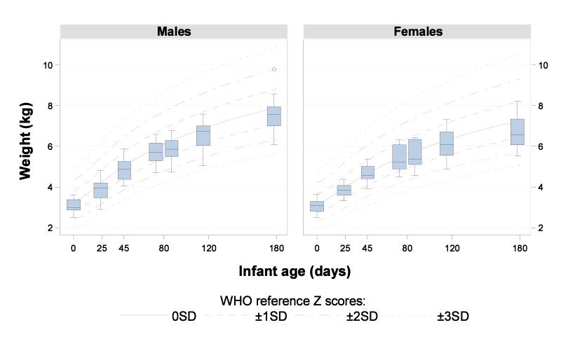
b.
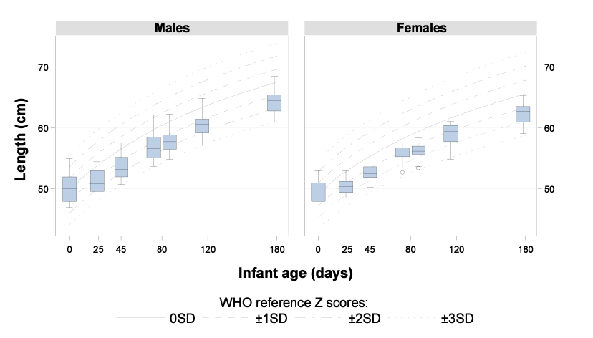
c.
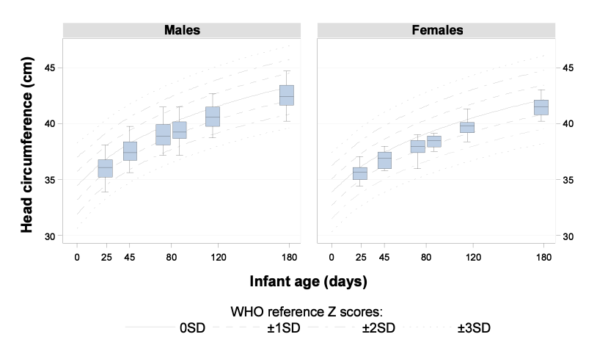
d.
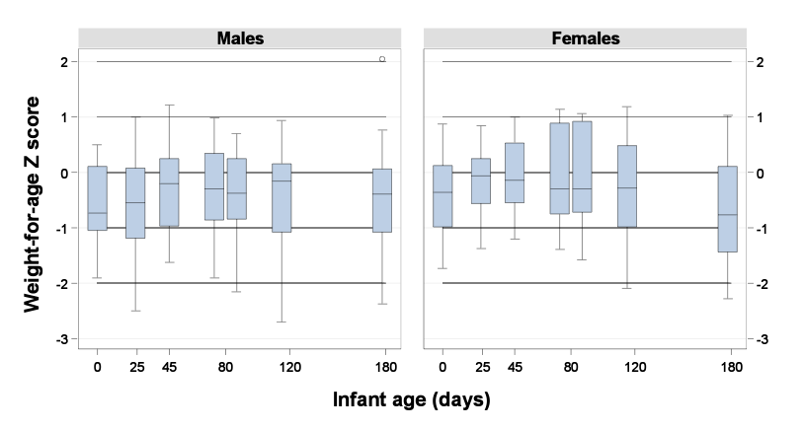

e.
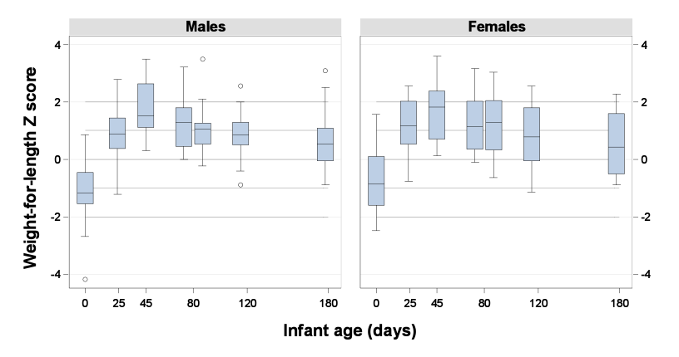
f.
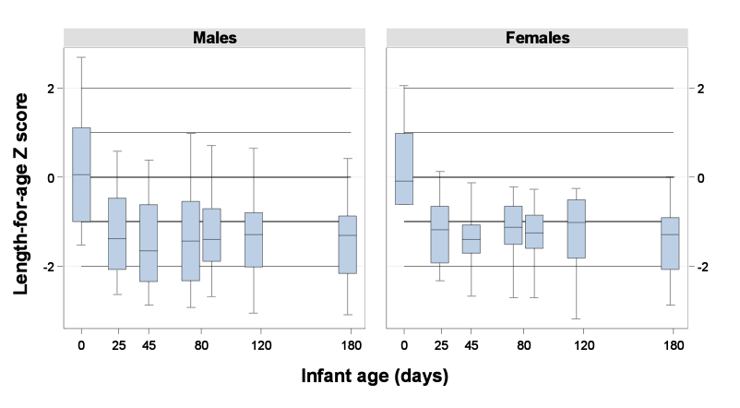

g.
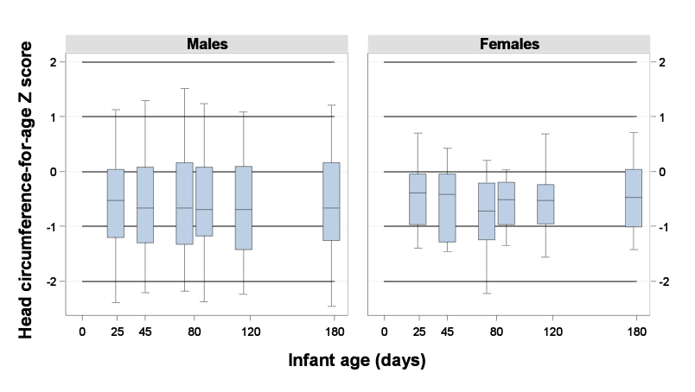
Supplemental Figure 3. Infant growth across the first 6 months (N=41), stratified by gender, shown as a) weight gain/day, b) length gain/week, c) head circumference gain/week, d) BMI, e) BMI-for-age z-score, f) BMI gain/day, g) weight z-score gain/day, h) length z-score gain/week, i) weight-for-length z-score gain/week, j) head circumference z-score gain/week, and k) BMI z-score gain/day.

a.
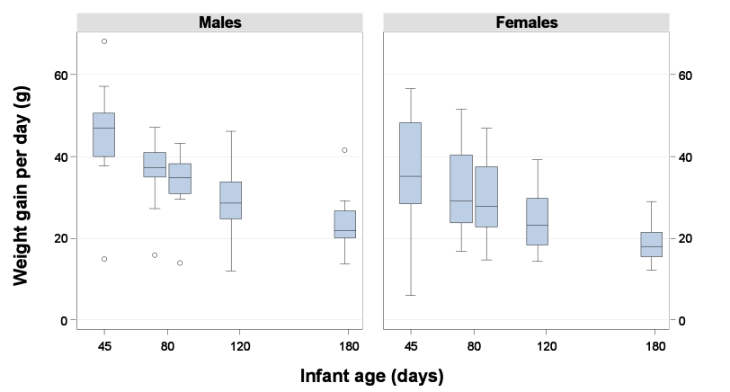
b.
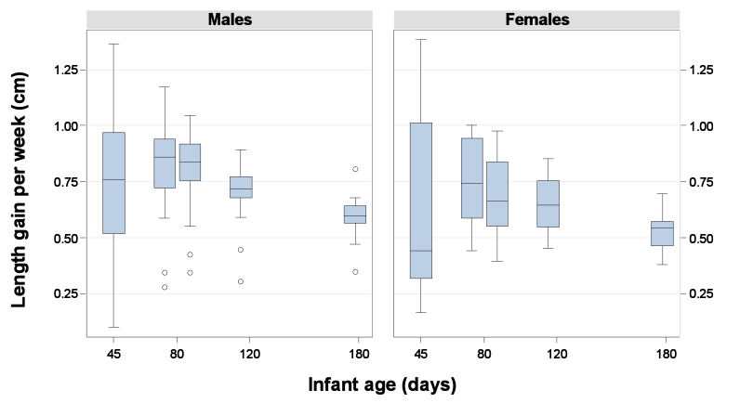

c.
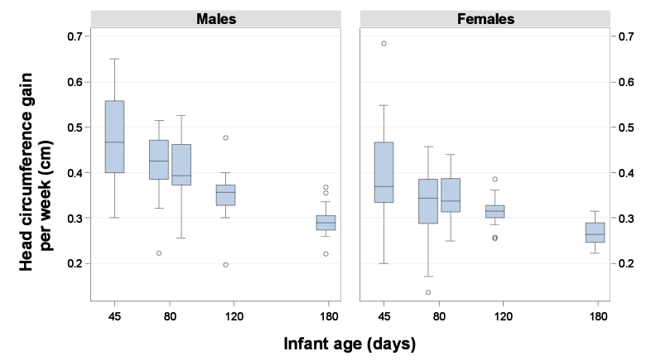
d.
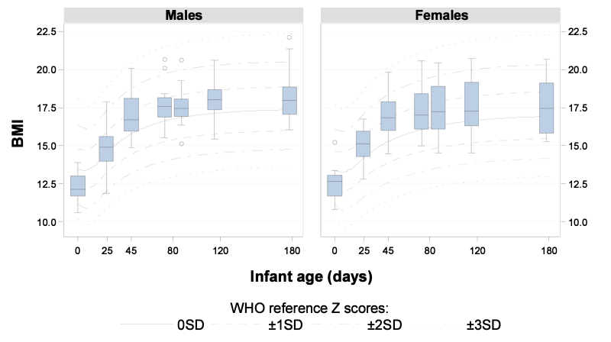

e.
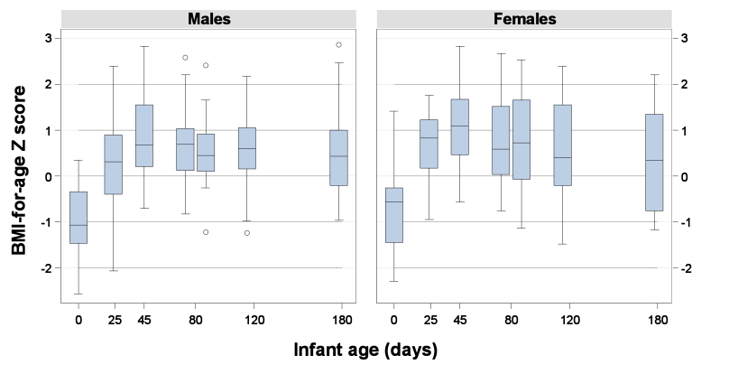
f.
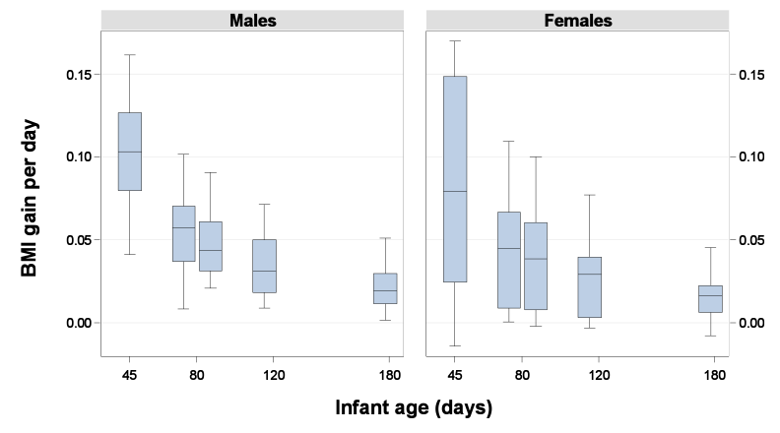

g.
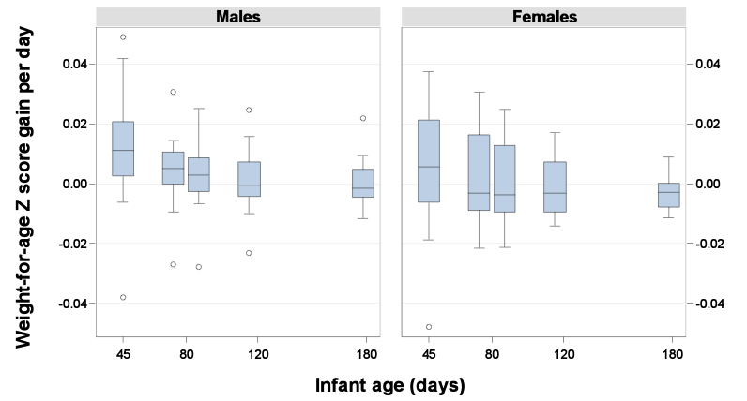
h.
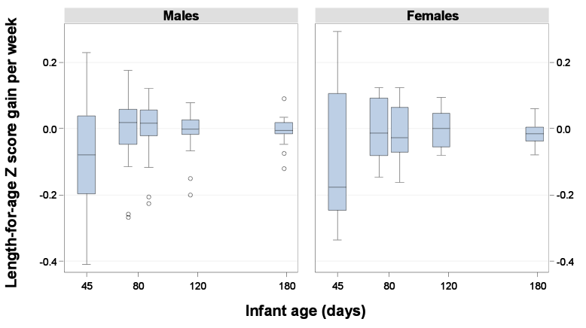

i.
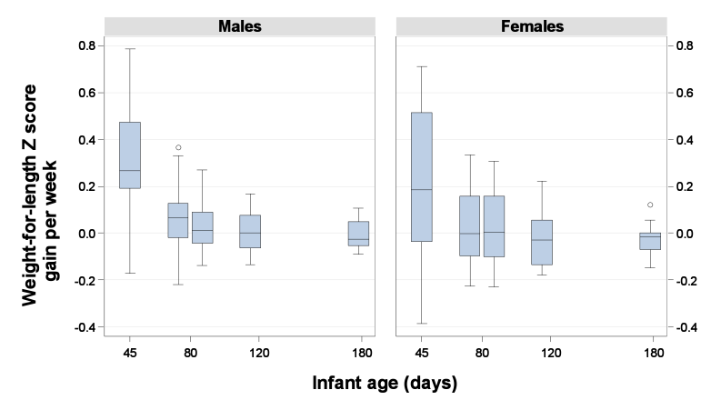
j.
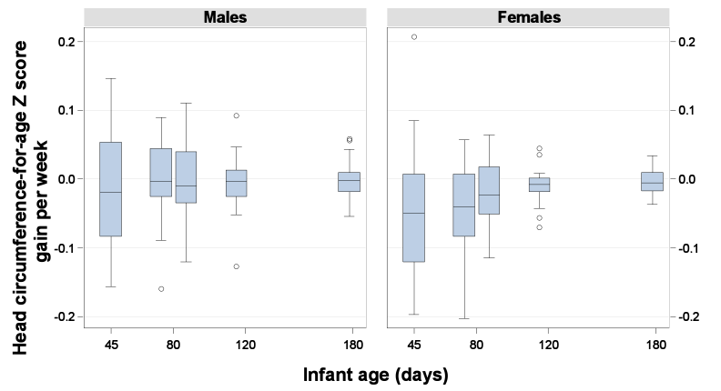

k.
