Electronic Supplementary Information

3D printed scaffold for repairing bone defects in apical periodontitis
Cong Li^{1,}‡, Xiaoyin Xu^{2,}‡, Jing Gao¹, Xiaoyan Zhang¹, Yao Chen¹, Ruixin Li^{1,} *, Jing Shen^{1,} *

Experimental
Materials and characterization
All chemical and biological supplies were purchased from Sigma-Aldrich. The peptide KSL-W was purchased from GL Biochem Co.,Ltd. (Shanghai, China), UV-vis absorption spectra were recorded on a Agilent Cary 60 spectrometer. Morphology study was performed by Scanning electron microscope (SEM, SU8100, HITACHI, Japan), laser particle scanning analyzer (MalvernZetasizerNanoZS90, Malvern Instruments Ltd., UK) and confocal laser scanning microscope (CLSM, Leica TCS SP8, Germany). The 3D scaffold model was designed using Solidworks 2010 (SolidWorks Corporation, Waltham, MA, USA), and printed with the 3D printer(OrganP 1800, Shangxian minimal invasive inc, China). Radiographic results were evaluated using 3DX550 Veraviewepocs (J. Morita Mfg Corp., Kyoto, Japan) and micro-CT(Skyscan, Germany). The Bio-Oss® particles and Bio-Gide® membrane were purchased from Geistlich Pharma AG (Wolhusen, Switzerland).
The orthogonal test of the elements effecting KSL-W@PLGA microspheres
The effects of the following four factors: (A) the concentration of PLGA, (B) the concentration of KSL-W, (C) the concentration of PVA emulsion and (D) the volume ratio of inner water phase to organic phase on the encapsulation efficiency of KSL-W@PLGA microspheres were investigated. The experiment was adopted orthogonal design and chosen L9 (34) orthogonal tables to repeat 3 times (Tab. S1).
Fabrication of KSL-W@PLGA microspheres/collagen/silk fibroin/nano-hydroxyapatite scaffold
The 3D scaffold model was printed with the 3D printer. Set the printing parameters as shown in the Tab. S2.
Construction of bone defect model
The steps of making bone defect models were as follows:
(1) The Japanese white rabbits were injected intraperitoneally with 10% chloral hydrate (3.5mL/kg), and then the mandible of the rabbits were depilated with an electric shaver, disinfection the operation area with iodine followed deiodination with 75% ethanol.
(2) A 2-3cm horizontal incision was made at a distance of 2-3cm from the inferior margin of the rabbit's mandible. The scalpel touched the surface of the bone and cut the periosteum. The skin, connective tissue, muscle and periosteum were bluntly separated in sequence to expose the surgical field. Then, a 5mm×5mm square bone defect was made with a dental laboratory lathe.
(3) After 20 μL of the mixture of bacterial suspension of E. faecalis and P. gingivalis (1×10⁶ CFUs/mL) were placed in the bone defect for 5 minutes, they were sucked out with cotton swabs, and then implanted with different experimental materials, the muscle tissue and skin were sutured successively, and the surgical area was disinfected with iodophor. After the operation, all the Japanese white rabbits received the powder soft diet for one week. During the follow-up period, the bone infections in all groups were localized and no antibiotics were given after surgery.

Tables
Tab. S1 Factors and levels that influence the encapsulation rate
Factors |  | Experimental Parameters
 |  | 1 | 2 | 3
A | the concentration of PLGA（mg/mL） | 25 | 50 | 100
B | the concentration of KSL-W（mg/mL） | 2.5 | 5 | 10
C | the concentration of PVA emulsion（%） | 0.25 | 0.5 | 1
D | the volume ratio of inner water phase to organic phase | 2/1 | 1/1 | 1/2

Tab. S2 The printing parameters
printing parameters | value
Given pressure (Pa) | 1
General feed speed (mm/s) | 6
Ordinary extrusion speed (mm/s) | 2.2
first layer print height correction (mm) | 0.65
print layer thickness(mm) | 0.42
print layer | 7
print needle diameter(nm) | 600
bottom plate molding temperature(℃) | -20

Tab. S3 Absorbance values corresponding to different KSL-W concentrations
Concentrations（mg/mL） | Absorbance values
1.0 | 10.1983
0.8 | 8.1850
0.6 | 6.3976
0.5 | 5.6159
0.4 | 4.7457
0.2 | 2.6459
0.1 | 1.4763

Tab. S4 The result of orth gonal experiment of KSL-W@PLGA sustained release microsphere
 | Factors |  |  |  | encapsulation efficiency（%）
 | A | B | C | D | encapsulation efficiency（%）
1 | 1 | 1 | 1 | 1 | 35
2 | 1 | 2 | 2 | 2 | 72
3 | 1 | 3 | 3 | 3 | 41
4 | 2 | 1 | 2 | 3 | 44
5 | 2 | 2 | 3 | 1 | 39.5
6 | 2 | 3 | 1 | 2 | 38.4
7 | 3 | 1 | 3 | 2 | 25.6
8 | 3 | 2 | 1 | 3 | 22.6
9 | 3 | 3 | 2 | 1 | 68
K1 | 148 | 104.6 | 96 | 142.5
K2 | 121.9 | 134.1 | 184 | 136
K3 | 116.2 | 147.4 | 106.1 | 107.6
‾K1 | 49.33 | 34.87 | 32 | 47.5
‾K2 | 40.63 | 44.7 | 61.33 | 45.33
‾K3 | 38.73 | 49.13 | 35.37 | 35.87
R | 10.6 | 14.26 | 29.33 | 11.63
The sequence of the factors | C>B>D>A
Optimal Level | A₁ | B₃ | C₂ | D₁
Optimal combination | A₁B₃C₂D₁

Figures
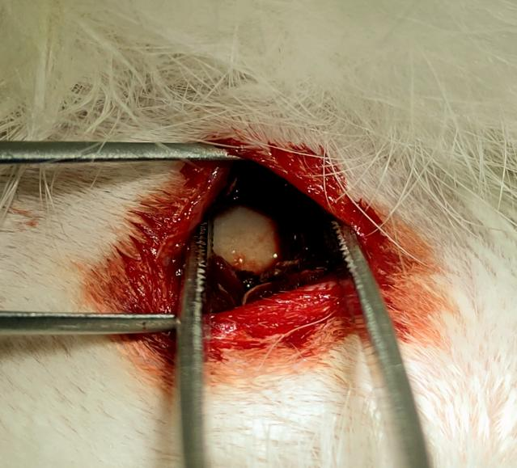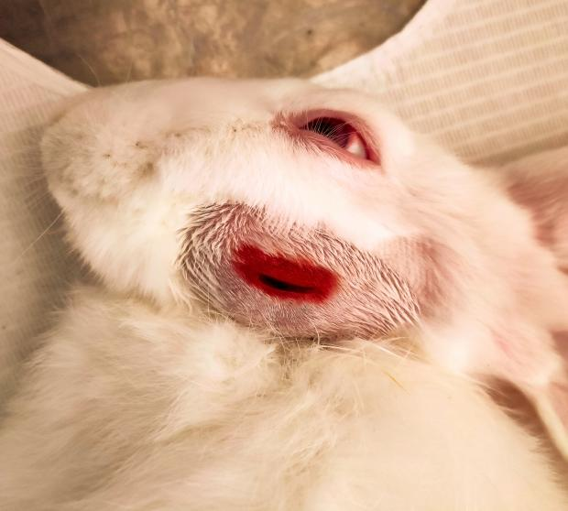
- A
- B
Fig. S1 (A) A horizontal incision parallel to the lower margin of the mandible was made 2-3cm above the lower margin of the mandible (B) The exposed surgical field

