Supplementary Materials for

Rapid Vertical Exchange at Fronts in the Northern Gulf of Mexico

Lixin Qu*, Leif N. Thomas*, Aaron F. Wienkers, Robert D. Hetland, Daijiro Kobashi, John R. Taylor, Fucent Hsuan Wei Hsu, Jennifer A. MacKinnon, R. Kipp Shearman, and Jonathan D. Nash

*Corresponding authors. Email: lixinqu123@gmail.com and leift@stanford.edu

This PDF file includes:

Supplementary Methods
Supplementary Figures: Figs. S1 to S7

Supplementary Methods
Oxygen model
The dissolved oxygen is simulated as a tracer in the triple-nested simulations. The vertical mixing of oxygen is parameterized using the GLS turbulence closure model (31). The riverine water is saturated in oxygen. The oxygen at the lateral open boundaries is relaxed to the parent models. The gas exchange at the sea surface is assumed to be instantaneous, and the surface values of oxygen are set to saturated values based on temperature and salinity (32). The effects of photosynthesis on the concentration of dissolved oxygen are not included. A benthic respiration formulation, as the sink of oxygen, is applied at the bottom to provide the bottom oxygen flux. According to (25), the respiration function is formulated as

$Bottom O_{2} flux=6.0 \left[O_{2}m^{-2}{days}^{-1}\right]×2^{\frac{T}{10.0{}_{}^{o}C}}×\left[1-\exp\left(-\frac{O_{2}}{30.0 μM}\right)\right]$.

Slab mixed layer model
A slab mixed layer model is used to calculate the inertial oscillations generated by winds in the surface mixed layer. The inertial oscillations shown in the left panel of Fig. 5F are calculated using the model:

$\left\{\begin{aligned}\frac{∂u_{ML}}{∂t}-fv_{ML}=\frac{τ_{x}}{ρ_{o}H_{ML}} \\ \frac{∂v_{ML}}{∂t}+fu_{ML}=\frac{τ_{y}}{ρ_{o}H_{ML}}\end{aligned}\right.$,

where ${(u}_{ML},v_{ML})$ is the mixed layer velocity, $f$is the Coriolis parameter, ${(τ}_{x},τ_{y})$ is the surface wind stress, $ρ_{0}=1025 kg/m^{3}$is the reference density, and $H_{ML}=5 m$ is the mixed layer thickness. The model is initialized with the ageostrophic velocity from TXLA-L3 at June 12, 2010 12:00 UTC, which is obtained by subtracting the geostrophic velocity from the total velocity and then spatially averaged over a section on the dense side of the front (i.e., the blue section in Fig. 5E) and within the top 5 m. The wind stress is the same stress used to force TXLA-L3 but spatially averaged over the frontal region. The model is integrated for 3 days to get a time series of ${(u}_{ML},v_{ML})$, and $u_{ML}$ during the last inertial cycle is shown in the left panel of Fig. 5F.

Reduced physics model
A reduced physics model is used to illustrate how the front influences the wind-driven inertial oscillations. The model is linear and constructed as

$\left\{\begin{aligned}\frac{∂u}{∂t}-fv=\overline{-\frac{1}{ρ}\frac{∂P}{∂x}}+\overline{\frac{∂}{∂z}(ν\frac{∂u}{∂z})} \\ \frac{∂v}{∂t}+fu=\overline{-\frac{1}{ρ}\frac{∂P}{∂y}}+\overline{\frac{∂}{∂z}(ν\frac{∂v}{∂z})}\end{aligned}\right.$,

where $(u,v)$ is the mixed layer velocity, $f$is the Coriolis parameter, $(\overline{-\frac{1}{ρ_{o}}\frac{∂P}{∂x}},\overline{-\frac{1}{ρ_{o}}\frac{∂P}{∂y}})$ is the pressure gradient force vertically averaged in the mixed layer, $(\overline{\frac{∂}{∂z}(ν\frac{∂u}{∂z})},\overline{\frac{∂}{∂z}(ν\frac{∂v}{∂z})})$ is the frictional body force vertically averaged in the mixed layer, and $ν$ is the turbulent viscosity. The reduced physics model is forced by the terms on the right-hand side of the equations and solves for $\left(u,v\right).$ The reduced physics model is initialized with the velocity from TXLA-L3 along a section across the front (i.e., the magenta section in Fig. 5E) at June 12, 2010 12:00 UTC. The model outputs the mixed layer velocity as a function of across-front distance (in the x direction) and time. The pressure gradient force and frictional body force are extracted along the across-front section using the diagnostics of the momentum equation from the TXLA-L3 solution, vertically averaged within the top 5 m, and implemented as the forcing terms of the reduced physics model. The model is integrated for 3 days to get $(u,v)$, and then the ageostrophic velocity $(u_{ag},v_{ag})$ is calculated by subtracting the geostrophic velocity (calculated using the vertically averaged pressure gradient force) from $(u,v)$. The evolution of the ageostrophic velocity $u_{ag}$at the light side of the front during the last inertial cycle is shown in the right panel of Fig. 5G. $u_{ag}$ is denoted with a prime to distinguish from the ageostrophic velocity from the L3 simulation.

The frictional forcing term in the reduced physics model can be interpreted in a form with stresses. The vertically averaged frictional force can be expressed as

$\overline{\frac{∂}{∂z}(ν\frac{∂\vec{u}}{∂z})}=\frac{1}{H_{ML}}\int_{{-H}_{ML}}^{0}{\frac{∂}{∂z}\left(ν\frac{∂\vec{u}}{∂z}\right)dz}=\frac{1}{H_{ML}}\left[{\left.\left(ν\frac{∂\vec{u}}{∂z}\right)\right|}_{z=0}-{\left.\left(ν\frac{∂\vec{u}}{∂z}\right)\right|}_{z={-H}_{ML}}\right]$,

where $H_{ML}$ is the thickness of the surface mixed layer. At the surface, the shear stress is equal to the wind stress,

${\left.\left(ν\frac{∂\vec{u}}{∂z}\right)\right|}_{z=0}=\frac{\vec{τ^{w}}}{ρ}$.

At the bottom of the mixed layer, the shear has a component associated with the thermal wind shear $\frac{∂\vec{u_{g}}}{∂z}$, yielding a geostrophic stress $\vec{τ^{g}}≡-ρν\frac{∂\vec{u_{g}}}{∂z}$. Similarly, the ageostrophic shear $\frac{∂\vec{u_{ag}}}{∂z}$ is corresponding to an ageostrophic stress $\vec{τ^{ag}}≡-ρν\frac{∂\vec{u_{ag}}}{∂z}$. With these definitions, the shear stress at the bottom is
$${\left.\left(ν\frac{∂\vec{u}}{∂z}\right)\right|}_{z={-H}_{ML}}={{\left.\left(ν\frac{∂\vec{u_{g}}}{∂z}\right)\right|}_{z={-H}_{ML}}+\left.\left(ν\frac{∂\vec{u_{ag}}}{∂z}\right)\right|}_{z={-H}_{ML}}=-\frac{\vec{τ^{g}}}{ρ}- \frac{\vec{τ^{ag}}}{ρ} .$$

Consequently, the vertically averaged frictional force can be expressed as

$$\overline{\frac{∂}{∂z}\left(ν\frac{∂\vec{u}}{∂z}\right)}=\frac{1}{H_{ML}}\left(\frac{\vec{τ^{w}}}{ρ} +\frac{\vec{τ^{g}}}{ρ}+\frac{\vec{τ^{ag}}}{ρ}\right) .$$

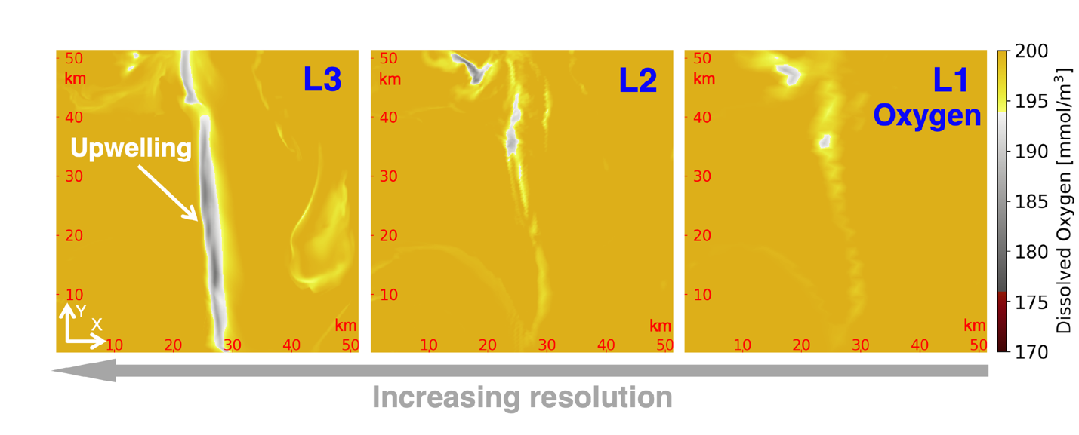
Fig. S1. Horizontal slices of dissolved oxygen. These slices are made over the L3 domain from the L1, L2, and L3 simulations. The horizontal resolutions of L1-3 are O(1 km), O(300 m), and 100 m. The L1 and L2 simulations are interpolated to the L3 grid for comparison. The slices are made at the subsurface (z = -4.7 m). Upwelling of low-oxygen water near the front is most prominent in L3 but less obvious in L1 and L2. The poor representation is due to the relatively low resolutions of L1 and L2 simulations. All the model snapshots are taken on June 15, 2010 00:00 UTC.
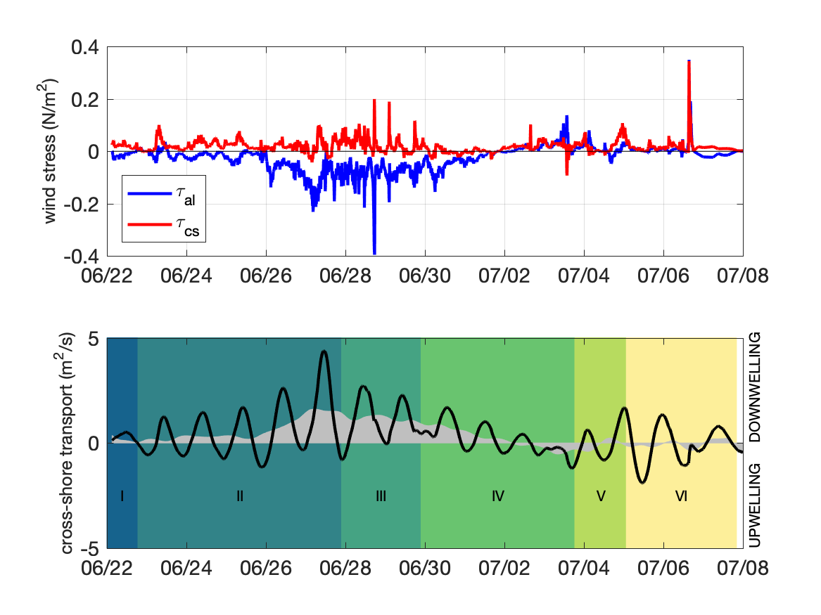

Fig. S2. Overview of the wind-forcing experienced on the cruise and the different flow regimes that were observed. Upper panel: along-shore (blue) and cross-shore (red) components of the wind-stress as inferred from the winds measured on the RV Walton Smith. Lower panel: the cross-shore transport of water (black) as estimated using a slab mixed layer model forced by the observed winds. The low-pass filtered transport is shaded in gray, where a positive (negative) cross-shore transport would drive downwelling (upwelling). The six flow regimes that were experienced are indicated in color: I) well mixed ocean following Tropical Storm Claudette, II) slumping isopycnals and inertial freshwater bore, III) downwelling winds mix ocean, push freshwater onshore, IV) bottom-attached shallow freshwater front and instabilities, V) winds relax and reverse, offshore propagation and detachment of shallow freshwater front, VI) interaction of shallow freshwater front with inertial motions.

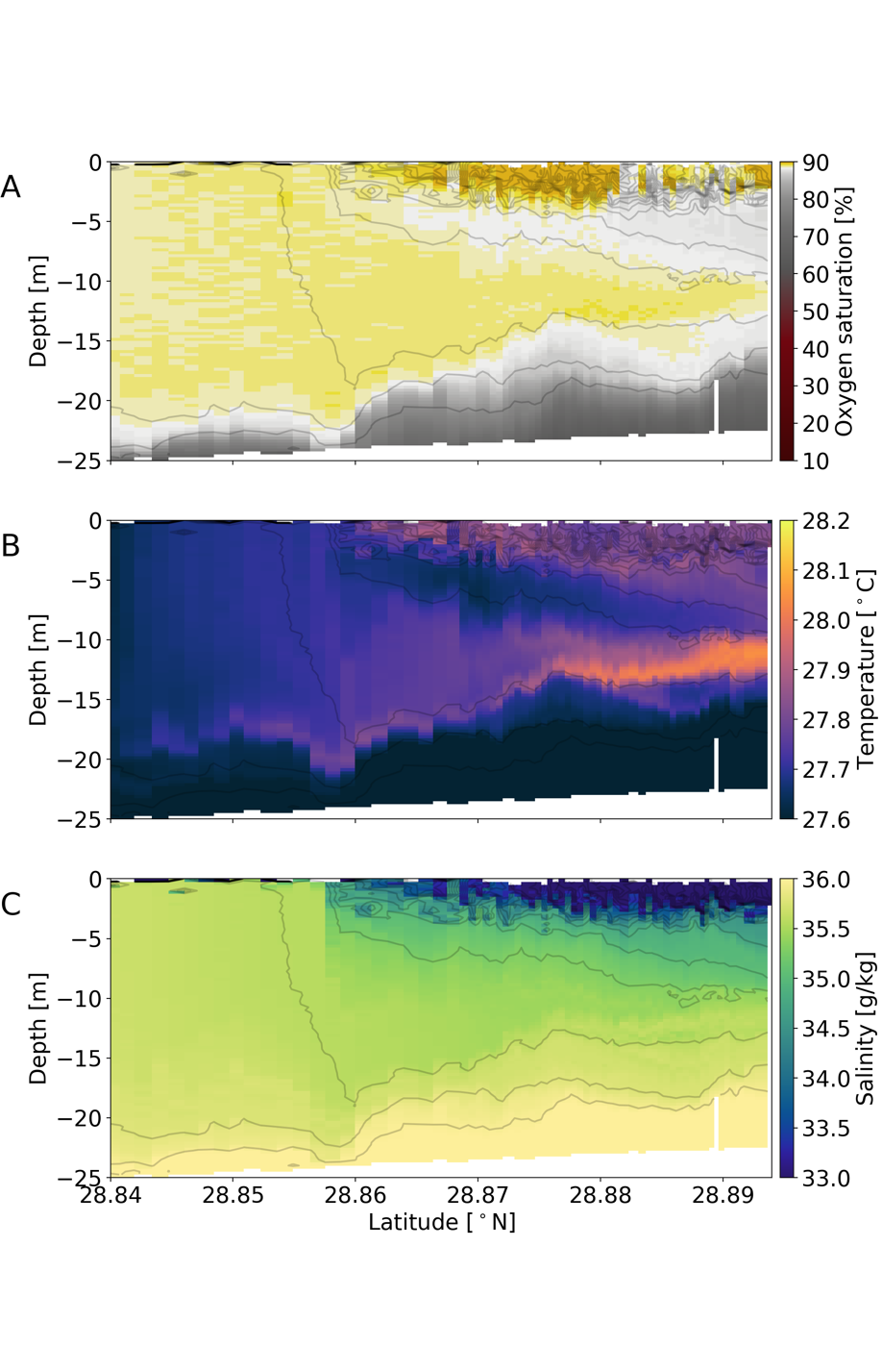

Fig. S3. SUNRISE Campaign transects on June 23, 2021. Vertical sections of oxygen saturation (A), temperature (B), and salinity (C) observed with R/V Pelican between 10:00 and 14:00 UTC on June 23, 2021. To illustrate the frontal processes, the offshore fraction of the transect with the depth deeper than 25 m is not shown. Grey contours are isopycnals drawn every 0.2 kg/m³. The ship track of R/V Pelican associated with these transects is shown in Fig. 2.

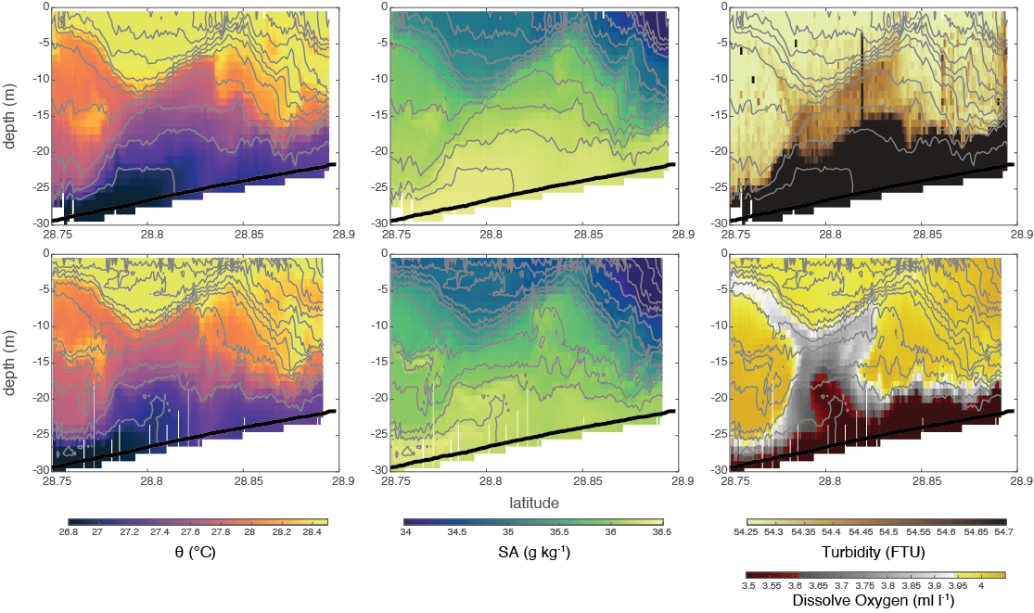

Fig. S4. SUNRISE Campaign transect on June 25, 2021. Vertical sections of temperature (left), salinity (middle), and turbidity/dissolved oxygen (right) observed with R/Vs Pelican (upper) and Walton Smith (lower) between 17:00 and 21:00 UTC on June 25, 2021. Grey contours are isopycnals drawn every 0.2 kg/m³. Black lines show the bottom located by the ADCPs in the bottom track mode. The ship tracks of R/Vs Walton Smith and Pelican associated with these transects are shown in Fig. 2.

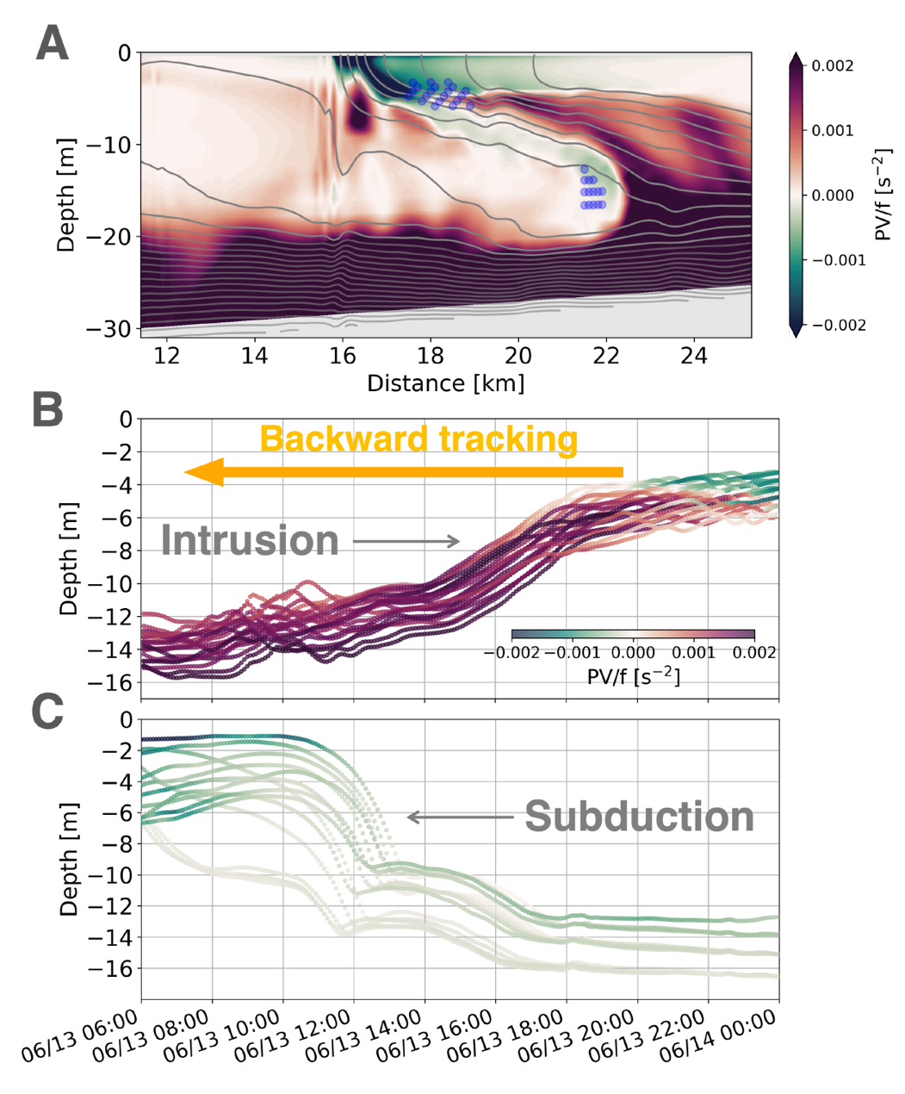

Fig. S5. Lagrangian float tracking. (A) Across-front section of PV. The section is made at June 14, 2010 00:00 UTC along the orange line marked in Fig. 3E. Isopycnals are contoured every 0.2 kg/m³ in gray. (B) Time series of float depth colored by PV. The floats are initially released at the positions marked by the upper group of dots in (A) and backward tracked in time. (C) Same as B but for the floats marked by the lower dots in (A). The results are made from the TXLA-L3 solution.
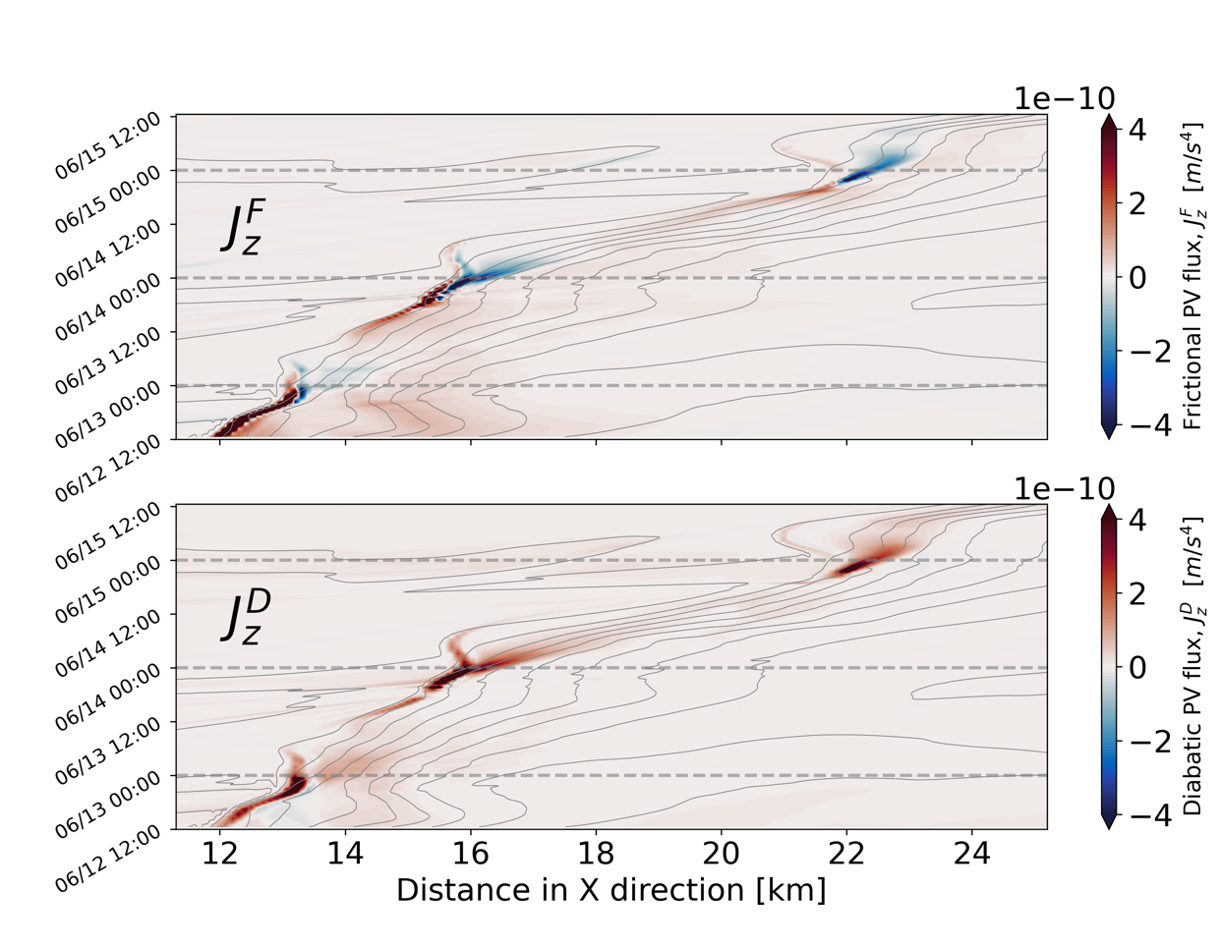

Fig. S6. Hovmöller diagrams of surface PV flux. The frictional PV flux $J_{z}^{F}={(∇}_{h}b×F_{h})∙\hat{z}$ and the diabatic PV flux $J_{z}^{D}=-(f+ζ)D$ are shown as a function of distance in the x direction and time ($b$ is the buoyancy, $F_{h}$ is the horizontal frictional body force, $ζ$ is the relative vorticity, and $D$ represents the diabatic processes). $F_{h}$ and $D$ are obtained using the diagnostics from the TXLA-L3 solution. The diagrams are made along the across-front section marked by the orange line in Fig. 5B. The gray contours are isopycnals made every 0.2 kg/m³. The calculations are made from the TXLA-L3 solution.
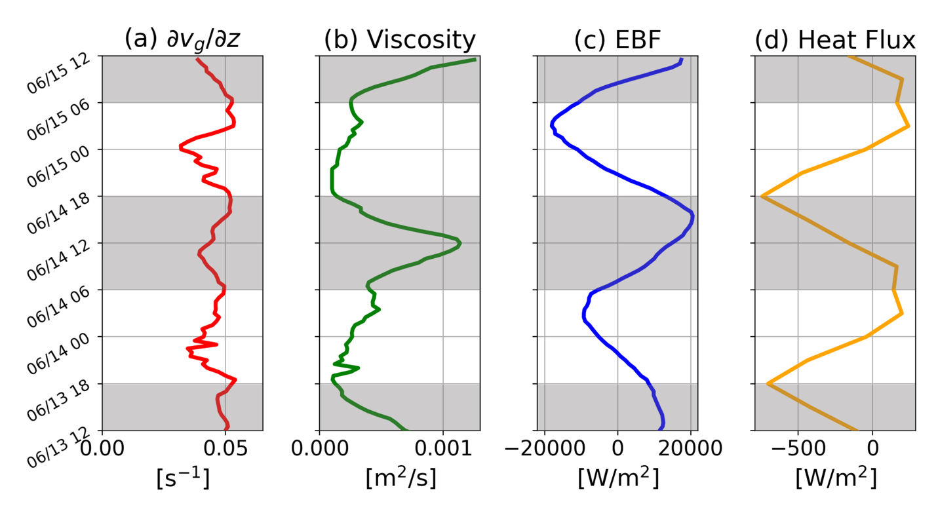
Fig. S7. Evolution of frontal properties on the light side of the front over two inertial periods. (a) Time-series of the geostrophic shear in the y direction at z=-5 m. (b) Time-series of the viscosity at z=-5 m. (c) Time series of the time-dependent EBF. The Ekman transport in the EBF is calculated via multiplying the slab mixed layer model solution for the velocity by the mixed layer thickness H=5m, i.e., $\vec{M_{e}}=(u_{ML}\hat{x}+v_{ML}\hat{y})H$. Positive values indicate a tendency of destabilizing the front. (d) Time series of surface heat flux. Positive values mean buoyancy loss. All the properties are averaged over a 2 km-long section at the light side of the front (i.e., the first 2 km of the magenta section in Fig. 5E). The shaded areas mark the periods when the viscosity is enhanced. The calculations are made from the TXLA-L3 solution.

