3D Printing and Processing of Miniaturized Transducers with Near-pristine Piezoelectric Ceramics for Localized Cavitation

Author: Haotian Lu^{1*}, Huachen Cui^{1*}, Ryan Hensleigh¹, Laiming Jiang², Gengxi Lu², Felix Wu⁵, Jose Morale⁴, Seth Putterman³, Qifa Zhou², Xiaoyu (Rayne) Zheng^{1#}

Author address:

¹Department of Civil and Environmental Engineering and Mechanical and Aerospace Engineering, University of California, Los Angeles, California 90095, USA

²Department of Biomedical Engineering, University of Southern California, Los Angeles, California 90089, USA

³Department of Physics and Astronomy, University of California, Los Angeles, California 90095, USA
⁴Ronald Reagan UCLA Medical Center, University of California, Los Angeles, California 90095, USA

⁵Materials Technology R&D, Vehicle Technologies Office, Energy Efficiency and Renewable Energy, U.S. Department of Energy, Forrestal Building, 1000 Independence Avenue, SW, Washington, DC, 20585 USA

*These authors contributed equally to this work

#Corresponding author: Xiaoyu (Rayne) Zheng Email: rayne@seas.ucla.edu

Supplementary information

SI. 1. Fabrication resolution of the 3D piezoelectric nanocomposites
During the curing process, the resolution of the custom PμSL fabrication system in x-y plane (20 um$×20um)$ is determined by the pixel size of the projector. The resolution along z-axis is determined by the curing depth of colloid. The curing depth of the solid layer is given as¹:
$$Z_{ct}=\frac{1}{α}\ln\left(\frac{E}{E_{c}}\right) S1.1$$
where, $α$ is the resin absorption coefficient, $E$ and $E_{c}$ are the actual and critical exposure, respectively. In our fabrication process, the layer thickness was set as 15 um, which is smaller than half of the cure depth to ensure tight bonding between two consecutive layer². This optimized cure depth for each layer was modulated by tuning the exposure time³. A reductive lens was utilized to increase the fabrication resolution of the printed structure³.

SI. 2. Acoustic properties of as-fabricated material

Measurement of acoustic impedance
The schematic of the setup that was used to measure sound speeds is shown in Fig. S4a. The sound speed in the material $V_{material}$ is calculated using the phase change $Δϕ$ of the received signal after inserting the material in between the two standard transducers (Fig. S4c):
$$V_{material}=\frac{tV_{water}}{t-ΔϕV_{water}} S3.1$$
where, t indicates the thickness of the material to be tested, $V_{water}$ is the sound speed in water. The acoustic impedance is calculated using the following formula⁴:
$Z=ρV_{material} S3.2$
where, $ρ$ is the density of the material.

Measurement of attenuation coefficients
The transmission ratio, $t_{p}$, between the transmitted wave acoustic pressure and the incident wave acoustic pressure on the interface⁵.
$t_{p}=\frac{2Z_{2}}{Z_{1}+ Z_{2}} S3.3$
Where the $Z_{1}$ and $Z_{2}$ indicates the acoustic impedance of the two materials. Thus, the acoustic pressure in the material near the interface I and interface II (Fig. S4b) are represented using the transmission ratio $t_{p12}$ at interface I and $t_{p34}$ at interface II:
$$p_{2}=t_{p12}p1 S3.4$$
$$p_{3}=t_{p34}p4 S3.5$$
Since the acoustic pressure $p$ has a linear relationship with the voltage $V$ generated by the transducer for measuring, the acoustic pressure ratio between top and bottom side within material can be represented using the voltage amplitude V:
$$\frac{p_{3}}{p_{2}}=\frac{{(z_{1}+z_{2})}^{2}V_{4}}{4Z_{1}Z_{2}V_{1}} S3.6$$
where, $Z_{1}$and $Z_{2}$ are the acoustic impedance of the medium (water) and the material to be tested. V₁ and V₄ are the measured voltage generated by ultrasound transducer placed at the top and bottom side of the material. For a given frequency, converting the unit of S3.6 into (dB/mm) can yield the attenuation coefficient of the material:
$$α=\frac{20}{d}log\frac{{(z_{1}+z_{2})}^{2}V_{4}}{4Z_{1}Z_{2}V_{1}} S3.7$$
where, d is the thickness of the material.

SI. 3. 3D printable packaging material
The matching material was formed by mixing carbon fiber (CF) with RIGID resin (Formlab, USA). RIGID resin is the mixture of urethane dimethacrylate and isobornyl Methacrylate. The acoustic impedance of the matching material reached the values from 3 Mrayl to 6.7 Mrayl by tuning the matching layer’s CF loading from 25wt% to 45wt%. The CF could increase the composite density and sound speed with a little increment of attenuation coefficient⁶. The thickness of the fabricated matching layer was designed as the one-quarter of the wavelengths of the transmitted ultrasound to reduce the acoustic loss⁷.

The backing material is the Fe magnetic particle-loaded Flexible resin (Formlab, USA). Flexible is the mixture of acrylated oligomers and acrylated monomers. By tuning the Fe magnetic particle loading in the backing layer from 3wt% to 20wt%, the attenuation coefficient of the backing materials can range from -4.3 dB/mm to -10 dB/mm for 10-MHz sound waves damping. The Fe magnetic particle loading can increase sound dissipation by increase the thermal loss caused by the friction of particles⁸. The acoustic impedance of the backing material ranged from 2.6 Mrayl to 8 Mrayl, making it suitable for many transducer applications mentioned in the main text.

SI. 4. Dye diffusion coefficient and microbubble concentration
In cavitation-enabled dye diffusion, the container was divided into six sections. The change of their pixel value standard deviation was used to evaluate the diffusion uniformity (Fig. S7). The ultrasound radiation force-assisted diffusion and cavitation-assisted diffusion can be calculated based on the methylene blue diffusion coefficient in the water⁹.

In localized cavitation experiment, microbubble solution with different concentrations was injected into the transparent blood vessel phantom. The pixel value - microbubble concentration digital imaging correlation (DIC) curve was plotted in Fig. S8. The microbubble opening speeds were achieved by correlating frames of experiment videos at different times and the DIC curve.

References
1. Walker, D. A., Hedrick, J. L. & Mirkin, C. A. Rapid, large-volume, thermally controlled 3D printing using a mobile liquid interface. Science 366, 360–364 (2019).
2. Cui, H. et al. Three-dimensional printing of piezoelectric materials with designed anisotropy and directional response. Nature Mater 18, 234–241 (2019).
3. Yao, D. et al. Achieving the Upper Bound of Piezoelectric Response in Tunable, Wearable 3D Printed Nanocomposites. Advanced Functional Materials 29, 1903866 (2019).
4. Dukhin, A. S. & Goetz, P. J. Chapter 7 - Acoustic and Electroacoustic Measurement Techniques. in Studies in Interface Science (eds. Dukhin, A. S. & Goetz, P. J.) vol. 24 261–301 (Elsevier, 2010).
5. Dukhin, A. S. & Goetz, P. J. Chapter 3 - Fundamentals of Acoustics in Homogeneous Liquids: Longitudinal Rheology. in Studies in Interface Science (eds. Dukhin, A. S. & Goetz, P. J.) vol. 24 91–125 (Elsevier, 2010).
6. Yan, Z., Pu, Z., Haijun, F. & Yi, Z. Experiment Study on Sound Properties of Carbon Fiber Composite Material. IOP Conference Series: Materials Science and Engineering 542, 012001 (2019).
7. Shung, K. K. & Zippuro, M. Ultrasonic transducers and arrays. IEEE Engineering in Medicine and Biology Magazine 15, 20–30 (1996).
8. Cao, L., Fu, Q., Si, Y., Ding, B. & Yu, J. Porous materials for sound absorption. Composites Communications 10, 25–35 (2018).
9. Selifonov, A. A., Shapoval, O. G., Mikerov, A. N. & Tuchin, V. V. Determination of the Diffusion Coefficient of Methylene Blue Solutions in Dentin of a Human Tooth using Reflectance Spectroscopy and Their Antibacterial Activity during Laser Exposure. Optics and Spectroscopy 126, 758–768 (2019).

Supplementary Figures

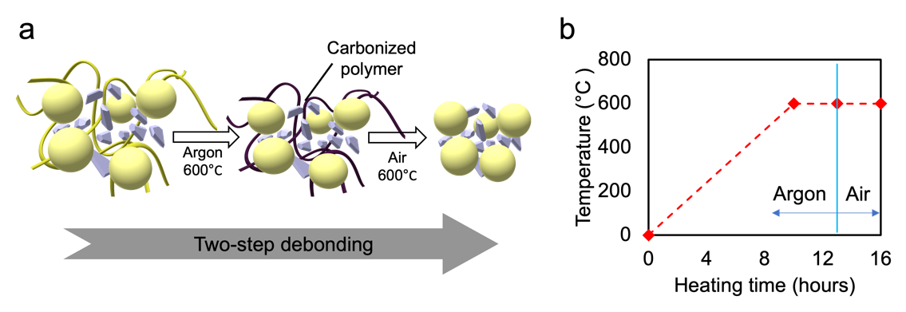
Figure S1. (a) Two-step debonding process. (b) Debonding time-temperature curve.

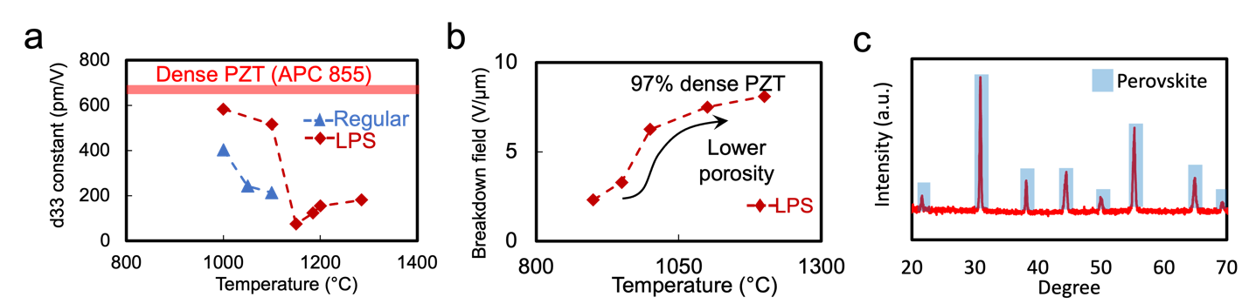Figure S2. Peak sintering temperature optimized by (a) d₃₃ constant and (b) Breakdown electrical field of the samples. (c) XRD image of the sintered PZT sample.

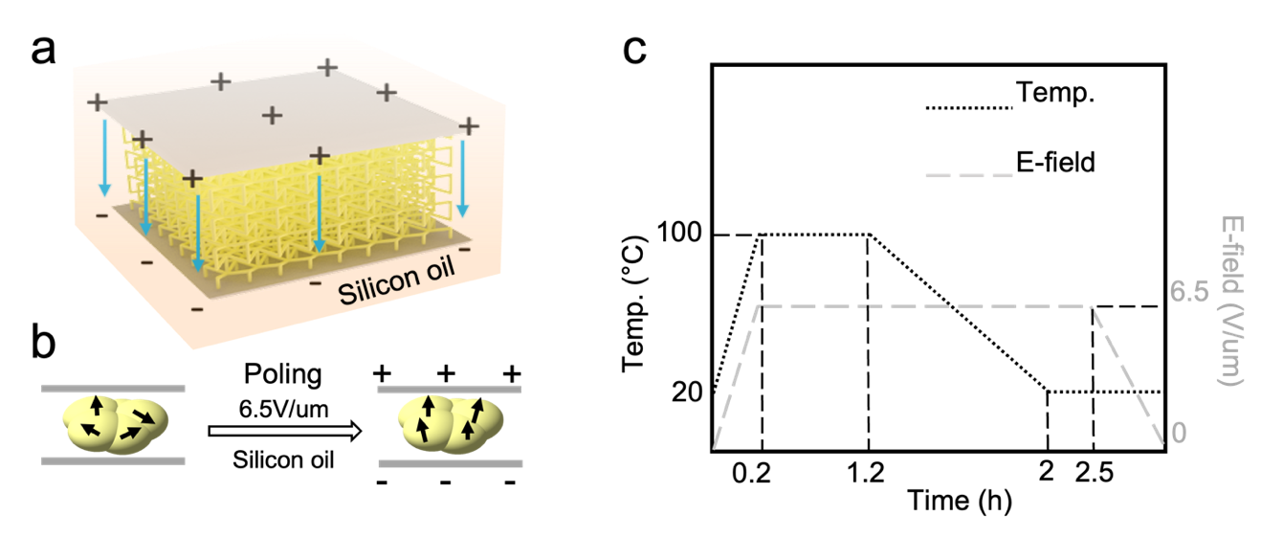
Figure S3. (a) Schematic of polarization setup. (b) Schematic of the dipole alignment along the applied electrical field. (c) Polarization time and electrical field profile.

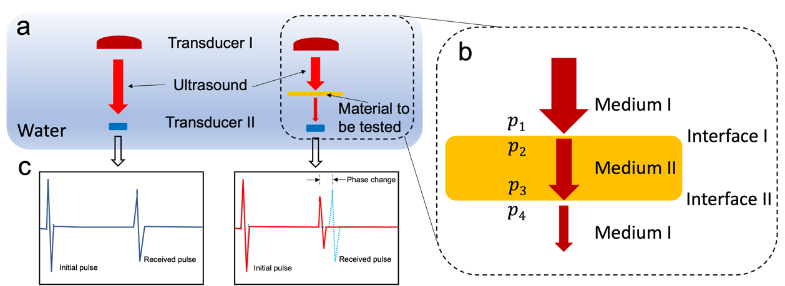
Figure S4. (a) Experiment set up for sound speed and acoustic attenuation measurement. (b) Acoustic pressures near and within the sample to be tested (p: acoustic pressure) (c) Schematics of the received signals with and without sample in between transducers.

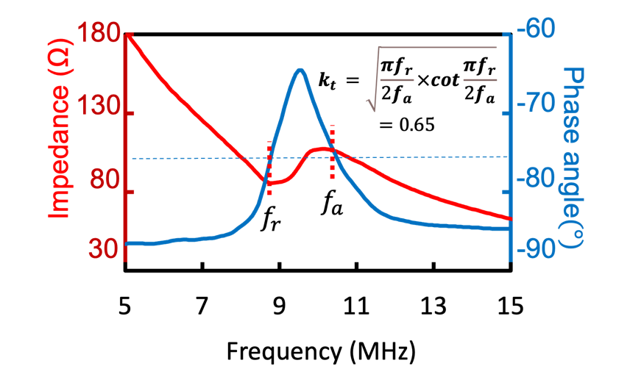
Figure S5. Impedance and phase angle plots of the fabricated PZT sample

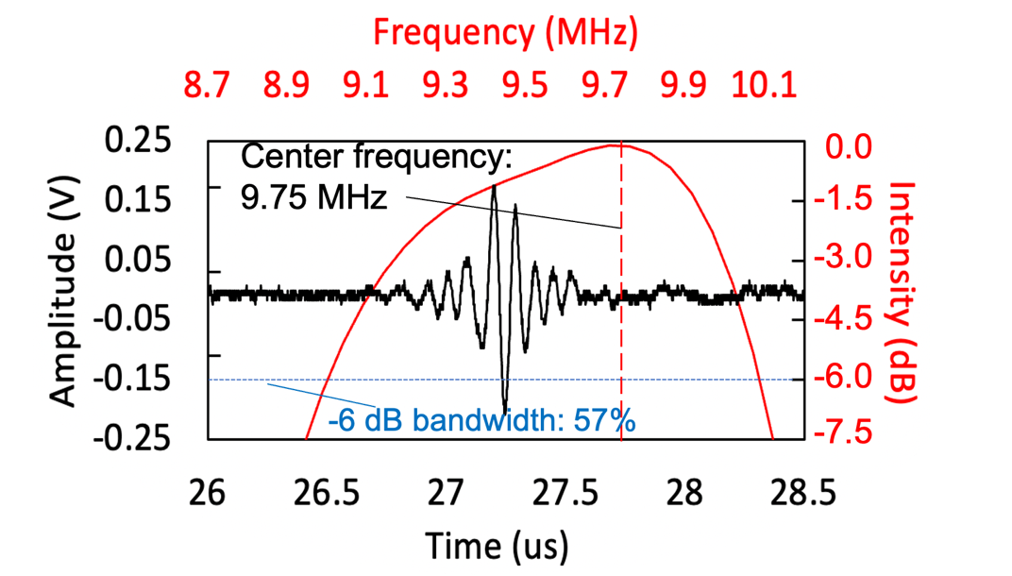
Figure S6. 3D printed miniatured ultrasound transducer pulse-echo signal and its frequency spectrum.

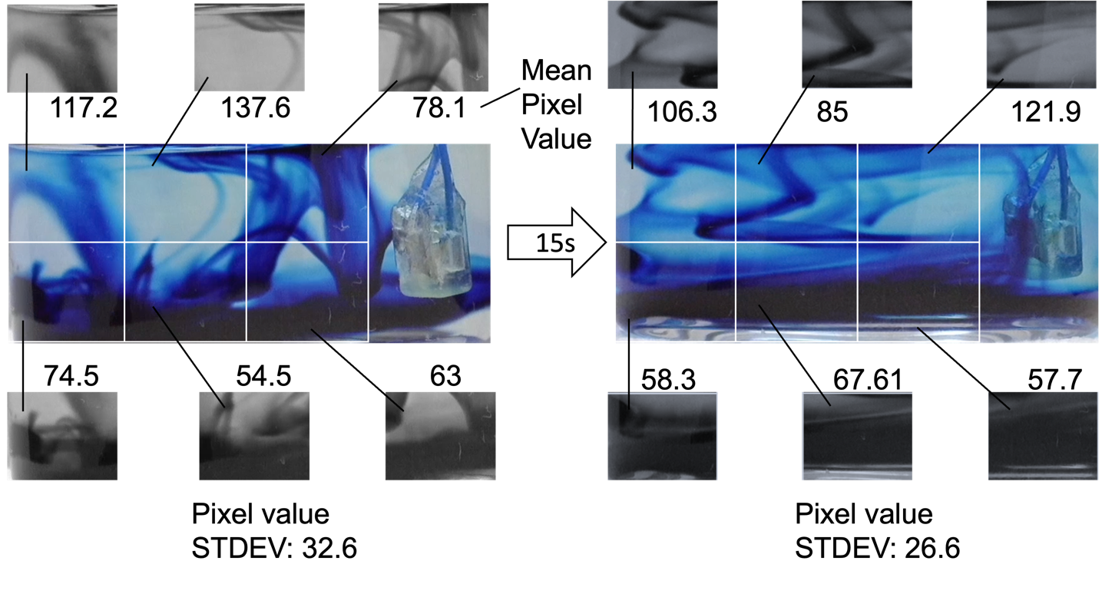 Figure S7. Dye diffusion speed and uniformity calculation based on the pixel value of grayscale images.

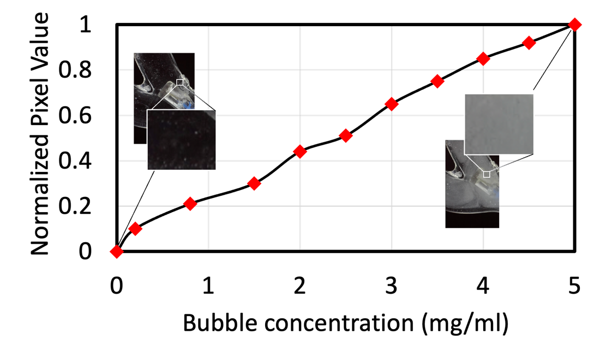
Figure S8. Digital image correlation curve of microbubble concentration in the blood vessel phantom vs. image mean pixel value.

