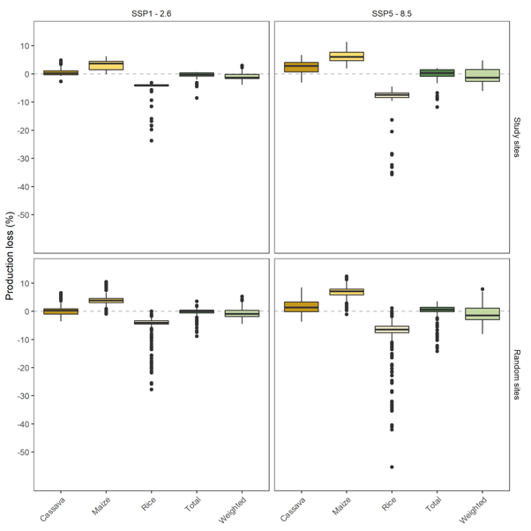

Figure S1. Projected agricultural changes by crop for SSP1-2.6 and 8.5. Top row are projections for our study sites, while the bottom row examines projected changes for 4,746 randomly selected sites from our study region. Weighted average is based on agricultural projections weighted by current yields/production area.

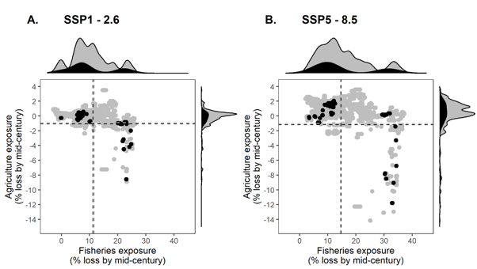
Figure S2. A comparison of expected fisheries and agriculture losses (exposure). A) SSP1-2.6, B) SSP5-8.5. Black dots/histograms are our study sites. Grey dots/histograms are a random selection of 4,746 (10% of) coastal cells with population densities >25 people/km². Dotted lines represent the mean exposure. Differences between expected losses in our sites and the randomly selected sites are generally small to negligible (Cohen’s D for agricultural losses SSP5-8.5=0.31, SSP1-2.6= 0.35, fisheries losses SSP5-8.5 =-0.02, RCP2.6=-0.03), indicating that our sites are not particularly biased.

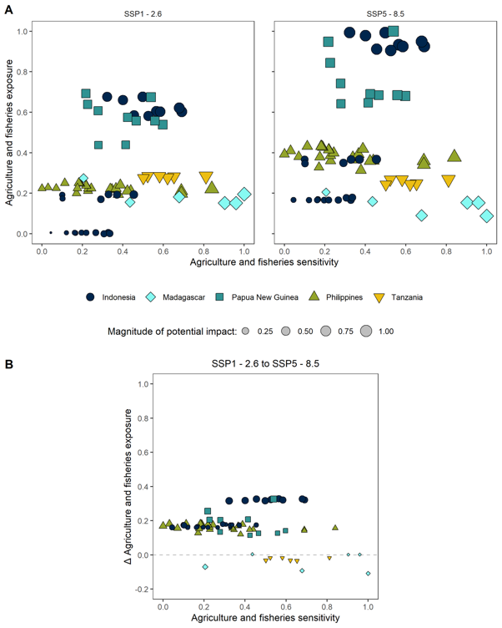

Fig S3. Potential impacts of changes to agriculture and fisheries by scenario. A) SSP1-2.6, B) SSP5-8.5. Both exposure and sensitivity to fisheries and agriculture are integrated. The potential impact is calculated as the Euclidian distance to the origin. C) The change in potential impact from mitigation (i.e. the difference between SSP5-8.5 and SSP1-2.6).

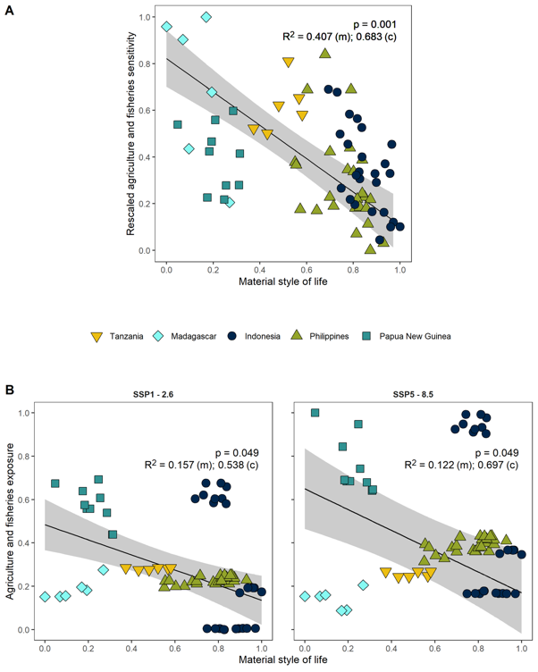

Fig S4. Relationships between MSL and (A) Ag-Fish sensitivity, (B) Ag-Fish exposure under SSP1-2.6 and (C) SSP5-8.5. (m)=marginal R², (c)=conditional R²

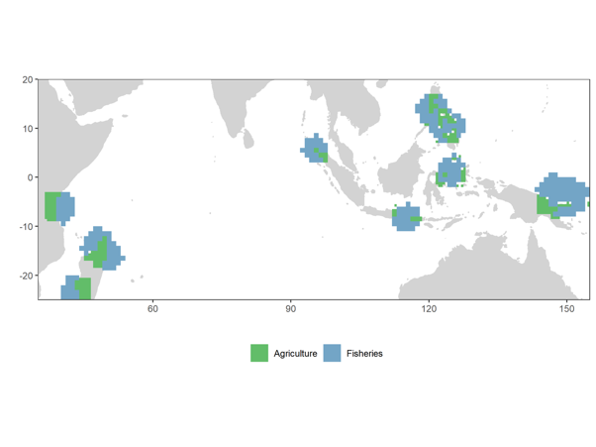

Fig. S5. The cells used in determining fisheries and agriculture exposure.

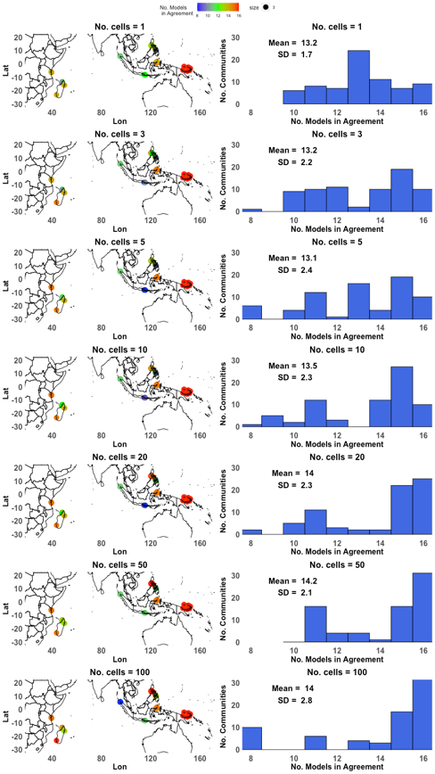
Figure S6. Trade-off between model agreement and number of cells used for fisheries SSP1-2.6. A model run agreement of 50%, the lowest possible value, indicates that half of model runs indicate one direction of change, and half the opposite; conversely, a value of 100% indicates that all model runs agree on the direction of change.
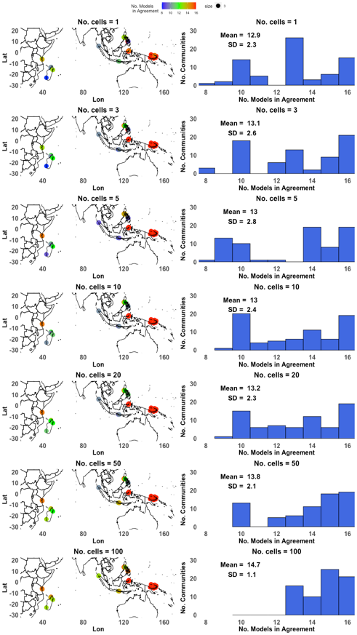
Fig S7. Trade-off between model agreement and number of cells used for fisheries SSP5-8.5. A model run agreement of 50%, the lowest possible value, indicates that half of model runs indicate one direction of change, and half the opposite; conversely, a value of 100% indicates that all model runs agree on the direction of change.

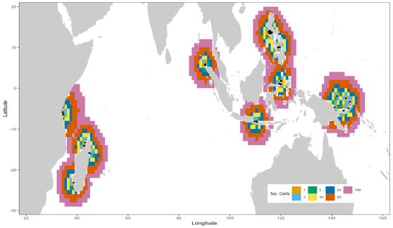
Figure S8. Spatial extent covered by using different numbers of grid cells to determine fisheries exposure. Black dots are coastal study sites associated with each?

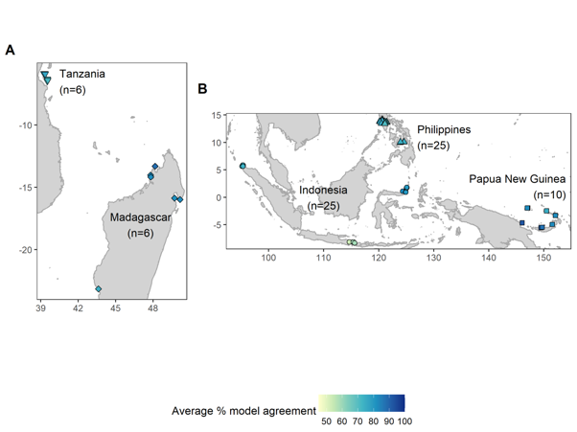

Fig. S9. Inset map of study sites and average agriculture-fisheries model run agreement at each site. A model run agreement of 50% means that half of model runs indicate one direction of change, and half the opposite; conversely, a value of 100% indicates that all model runs agree on the direction of change.

Table S1. Sample size and proportion of social surveys

Community | country | Number  Households  Surveyed | Number  Households  Total | Sampling  Proportion | Sampling  Strategy
anoi itam | indonesia | 29 | 158 | 0.18 | Systematic
bahoi | indonesia | 22 | 100 | 0.22 | Systematic
balohanvillage | indonesia | 47 | 577 | 0.08 | Systematic
bentanan | indonesia | 40 | 355 | 0.11 | Systematic
blongko | indonesia | 56 | 1827 | 0.03 | Systematic
bondalem | indonesia | 48 | 333 | 0.14 | Systematic
boyong pante | indonesia | 18 | 2505 | 0.01 | Systematic
buerawang | indonesia | 51 | 344 | 0.15 | Systematic
iboih | indonesia | 21 | 92 | 0.23 | Systematic
ieu meulee | indonesia | 30 | 228 | 0.13 | Systematic
jaboi | indonesia | 50 | 1269 | 0.04 | Systematic
kahuku | indonesia | 27 | 180 | 0.15 | Systematic
keuneukai | indonesia | 44 | 196 | 0.22 | Systematic
lampuyang | indonesia | 36 | 241 | 0.15 | Systematic
minanga | indonesia | 27 | 203 | 0.13 | Systematic
pasiran | indonesia | 58 | 480 | 0.12 | Systematic
pemuteran | indonesia | 49 | 1651 | 0.03 | Systematic
penuktukan | indonesia | 26 | 133 | 0.20 | Systematic
pria laot | indonesia | 22 | 1986 | 0.01 | Systematic
rumbia | indonesia | 20 | 902 | 0.02 | Systematic
sambirenteng | indonesia | 61 | 278 | 0.22 | Systematic
talise | indonesia | 30 | 1024 | 0.03 | Systematic
tejakula | indonesia | 52 | 630 | 0.08 | Systematic
tulamben | indonesia | 24 | 2366 | 0.01 | Systematic
tumbak | indonesia | 21 | 1799 | 0.01 | Systematic
ambodipaka | madagascar | 115 | 835 | 0.14 | Systematic
dauphin | madagascar | 55 | 90 | 0.61 | Systematic
fimihara | madagascar | 43 | 900 | 0.05 | Systematic
masoala | madagascar | 63 | 142 | 0.44 | Systematic
nosy valiha | madagascar | 29 | 41 | 0.71 | Systematic
rasis | madagascar | 34 | 58 | 0.59 | Systematic
ahus | papua new guinea | 38 | 122 | 0.31 | Systematic
andra | papua new guinea | 23 | 95 | 0.24 | Systematic
baia | papua new guinea | 35 | 35 | 1 | Census
dabanot | papua new guinea | 19 | 25 | 0.76 | Systematic
kavulik | papua new guinea | 24 | 51 | 0.47 | Systematic
muluk | papua new guinea | 20 | 66 | 0.30 | Systematic
silom 1 | papua new guinea | 13 | 23 | 0.57 | Systematic
somalani | papua new guinea | 67 | 67 | 1 | Census
ungakum | papua new guinea | 24 | 56 | 0.43 | Systematic
vesse | papua new guinea | 55 | 55 | 1 | Census
MATABAO | philippines | 40 | 999 | 0.04 | Random
MOCABAC ISLAND | philippines | 40 | 119 | 0.34 | Random
TIPOLO | philippines | 28 | 585 | 0.05 | Random
AGUINING | philippines | 30 | 480 | 0.06 | Random
CALUBCUB II | philippines | 40 | 912 | 0.04 | Random
BATAAN | philippines | 41 | 435 | 0.09 | Random
LAIYA APLAYA | philippines | 41 | 1,202 | 0.03 | Random
SAWANG | philippines | 40 | 438 | 0.09 | Random
LAGADLARIN | philippines | 40 | 753 | 0.05 | Random
BALIBAGO | philippines | 40 | 635 | 0.06 | Random
ANILAO PROPER | philippines | 40 | 600 | 0.07 | Random
SAN AGUAPITO IV | philippines | 40 | 352 | 0.11 | Random
PAPAYA | philippines | 40 | 508 | 0.08 | Random
PANTALAN | philippines | 40 | 643 | 0.06 | Random
WAWA | philippines | 40 | 4,662 | 0.01 | Random
BUCAL | philippines | 40 | 212 | 0.19 | Random
BAHA | philippines | 40 | 200 | 0.20 | Random
TALIBAYOG | philippines | 40 | 411 | 0.10 | Random
NINIKAT NG PAG-ASA | philippines | 39 | 133 | 0.29 | Random
MALIGAYA | philippines | 40 | 207 | 0.19 | Random
KANLURAN | philippines | 40 | 133 | 0.30 | Random
BRGY 6 | philippines | 40 | 151 | 0.26 | Random
BRGY 4 | philippines | 40 | 110 | 0.36 | Random
POBLACION | philippines | 40 | 404 | 0.10 | Random
PUTICAN | philippines | 34 | 102 | 0.33 | Random
jambiani | tanzania | 40 | 600 | 0.07 | Systematic
matemwe | tanzania | 39 | 378 | 0.10 | Systematic
mkokotoni | tanzania | 39 | 500 | 0.08 | Systematic
mtende | tanzania | 39 | 400 | 0.10 | Systematic
mzuri | tanzania | 40 | 217 | 0.18 | Systematic
pwani mchangani | tanzania | 41 | 200 | 0.21 | Systematic

