Supplementary Information for

New globally distributed bacteria with high proportions of novel protein families involved in sulfur and nitrogen cycling
Xianzhe Gong, Álvaro Rodríguez del Río, Le Xu, Marguerite Langwig, Lei Su, Mingxue Sun, Jaime Huerta-Cepas, Valerie De Anda and Brett J. Baker

This PDF file includes:
Extended Data Figs. 1-5
Supplementary Results and Discussion

Other Supplementary Information for this manuscript includes the following:
Description of Supplementary Tables 1-15
Supplementary References

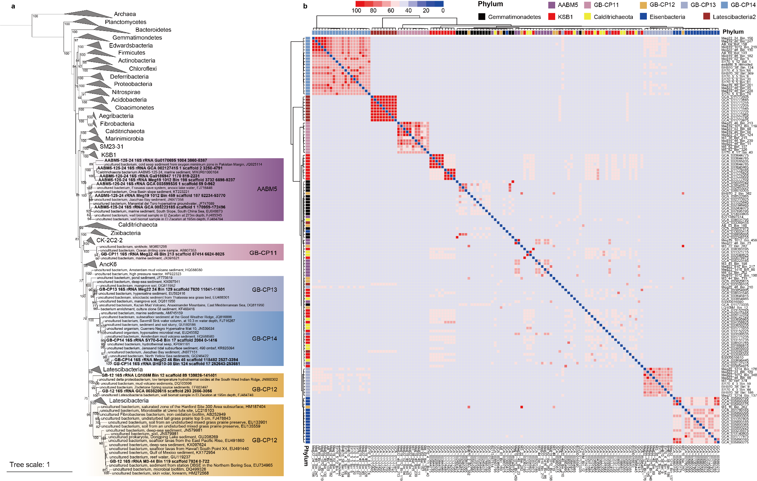Extended Data Fig. 1 Genomic uniqueness of the five phyla. (a) Maximum likelihood phylogenetic tree of 16S rRNA gene in six phyla. Sequences recovered from the genomes in this study are in bold. (b) Hierarchical clustering heatmap using pheatmap package in R based on average amino acids identity (AAI) for each genome pair. The neighboring phyla in the phylogenetic tree (as shown in Fig. 1) based on ribosomal protein marker genes were used as reference genomes in the heatmap to show the distinct AAI of five phyla compared to other genomes. Genome self-comparisons are presented in blue.
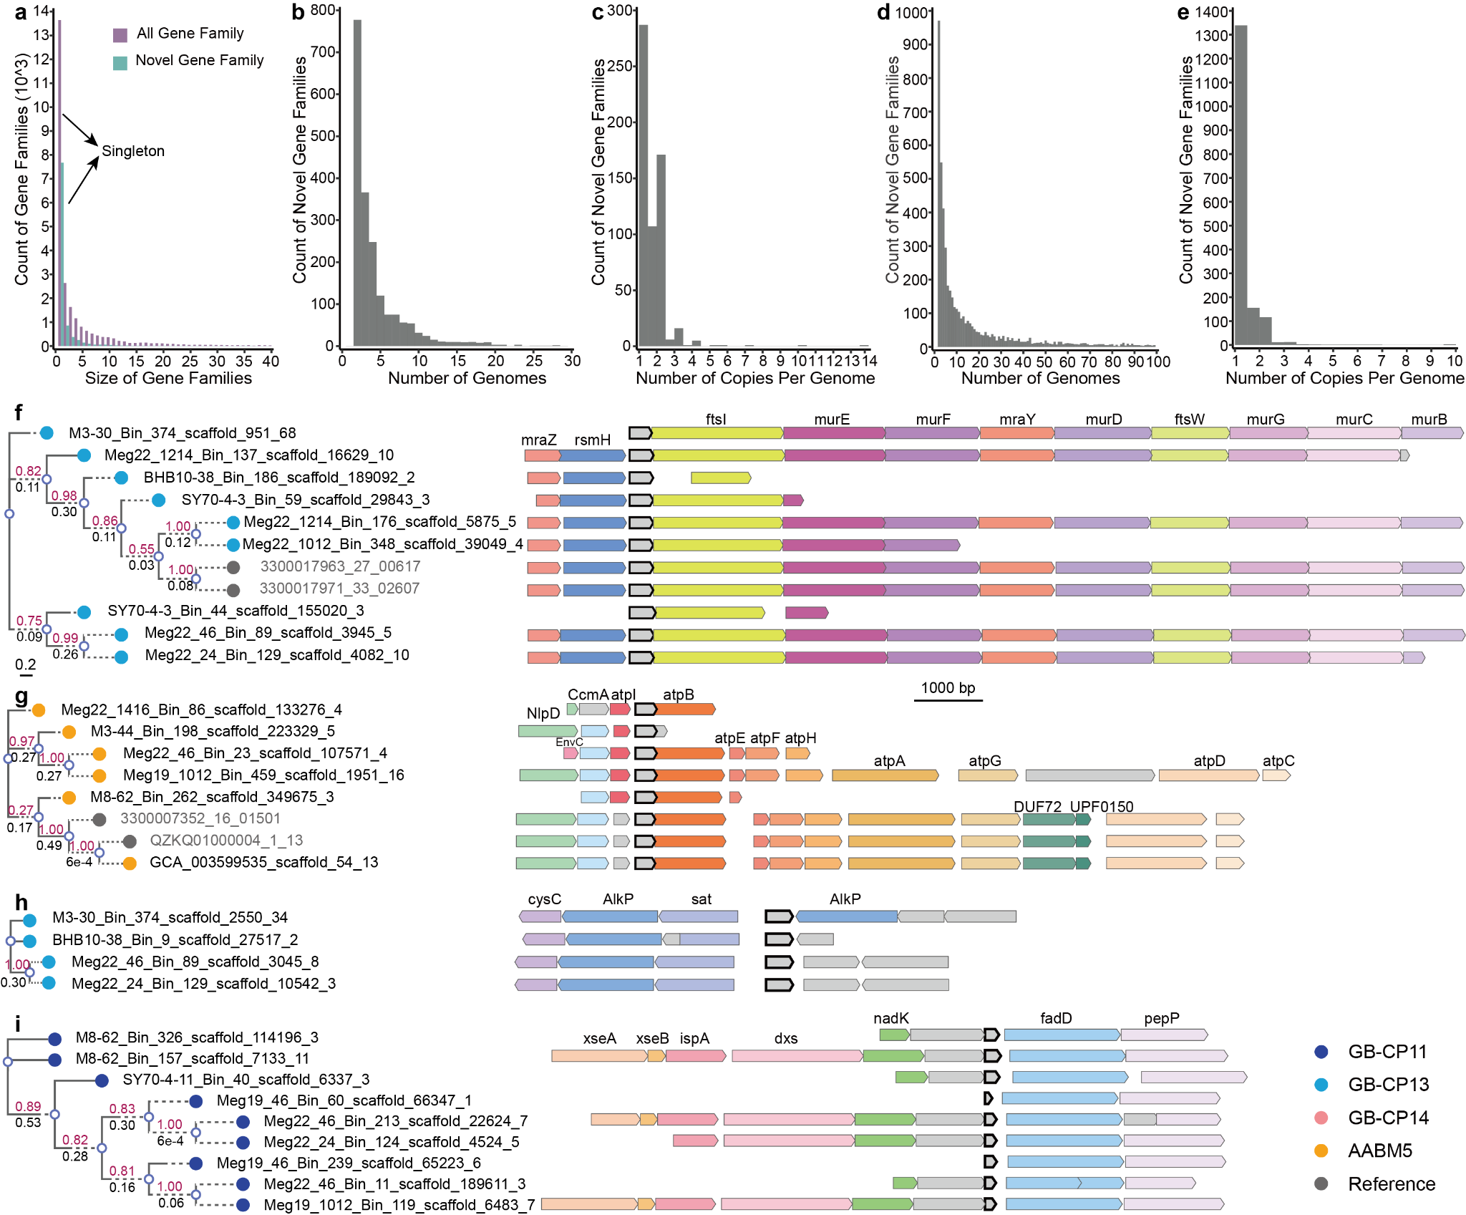Extended Data Fig. 2 Characteristics of gene families and novel gene family clusters (marked in grey with a black outline) neighboring conserved known proteins. (a) Most of the clustered gene families are singleton in these 5 phyla. Novel families represent an important fraction of the gene clusters but show a limited number of genes (b) Distribution of the number of genomes in which the novel gene families are detected shows most of the gene families are shared by less than 10 genomes, but could be up to 33 genomes. Singletons are not shown for data visualization. (c) Average number of copies of the novel gene families in the 61 bacterial genomes shows most of the gene families had less than 3 copies per genome, and the singletons are excluded for data visualization. (d) Among the collection of 169,642 genomes, most of the novel families are shared in less than 50 genomes, but could be over 4000 genomes. Singletons are not shown for data visualization. (e) Average number of copies of the novel gene families in the 169,642 bacterial genomes shows most of the gene families had less than 3 copies per genome, and the singletons are excluded for data visualization. (f) A novel gene family mainly detected in GB-CP13 and with conserved 16S rRNA methyltransferase (rsmH; K03438) and transcriptional regulator (mraZ; K03925) downstream, and a gene cluster related to peptidoglycan biosynthesis (ftsI; K03587, murE; K01928, murF; K01929, mraY; K01000, murD; K01925, ftsW; K03588, murG; K02563, murC; K01924, and murB; K00075) upstream. (g) A novel gene family mainly detected in AABM5 associated with F-type ATPase (atpI; K02116, atpB; K02108, atpE; K02110, atpF; K02109, atpH; K02113, atpA; K02111, atpG; K02115, atpD; K02112, and atpC; K02114). (h) A novel gene family only detected in GB-CP13 and associated with proteins related to sulfur assimilation (sat; K00958, AlkP; COG3379, and cysC; K00860). (i) A novel gene cluster only detected in GB-CP11, neighboring another novel gene, a NAD⁺ kinase (nadK; K00858), dxs (K01662), ispA (K13789), xseB (K03602), and xseA (K03601) downstream, and genes for fatty acid degradation (fadD; K01897) and pepP (K01262) upstream. Grey color denotes the protein without homologues in the current database. The phylogeny was constructed using FastTree2 and numbers on the top and bottom of the branch represent the bootstrap and branch length, respectively.
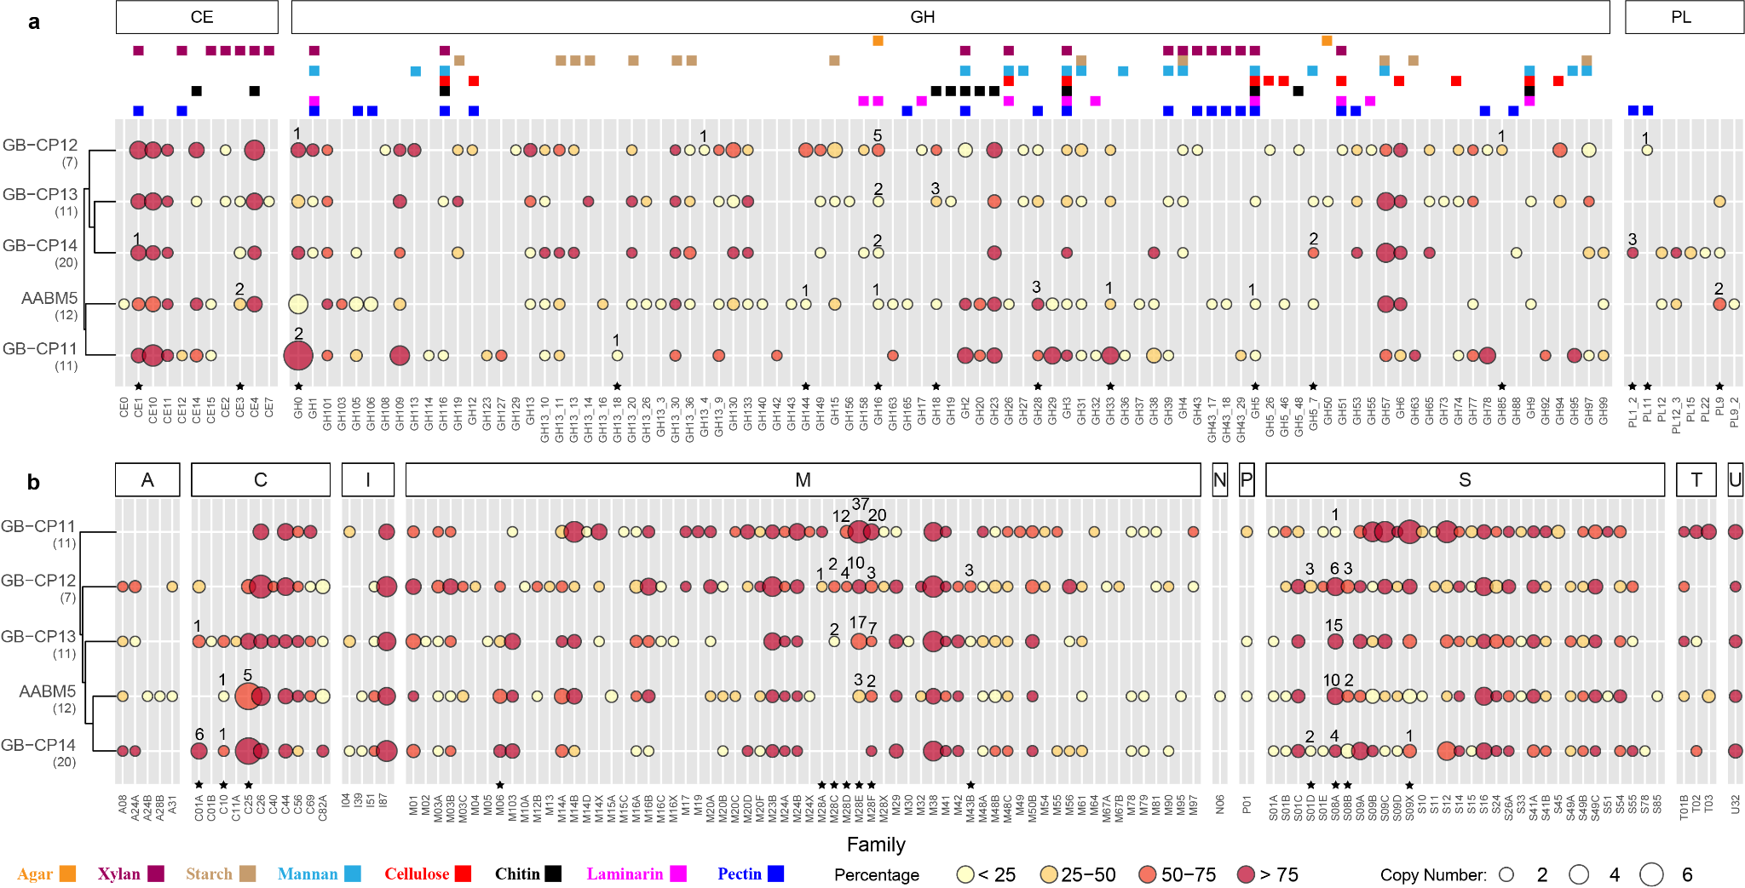
Extended Data Fig. 3 Carbohydrate-active enzymes (CAZyme) and peptidase encoded by genomes in this study. (a) CAZymes, including carbohydrate esterase (CE), glycoside hydrolase (GH), and polysaccharide lyase (PL), identified in the five phyla. Substrates for each family are stacked on top. (b) Peptidases, classified as family aspartic (A), cysteine (C), unassigned inhibitors (I), metallo (M), asparagine (N), mixed (P), serine (S), threonine (T), and unknown (U) by the MEROPS database identified in six phyla. Colors filled in the circle denote the percentage of genomes within one phylum encode the gene. Sizes of the circle denote the average number of gene copies identified in the genome within one phylum. Asterisk denotes the family identified with potential secretion signal, with a number on top of the circle representing the number of sequences identified with potential secretion signal using PSORTb v3.0. Numbers in brackets denote the total number of genomes in each phylum. The cluster using pheatmap package in R is based on the normalized data considering the equal contribution by the percentage of genome containing the enzyme and the average copy number per genome in the phylum.

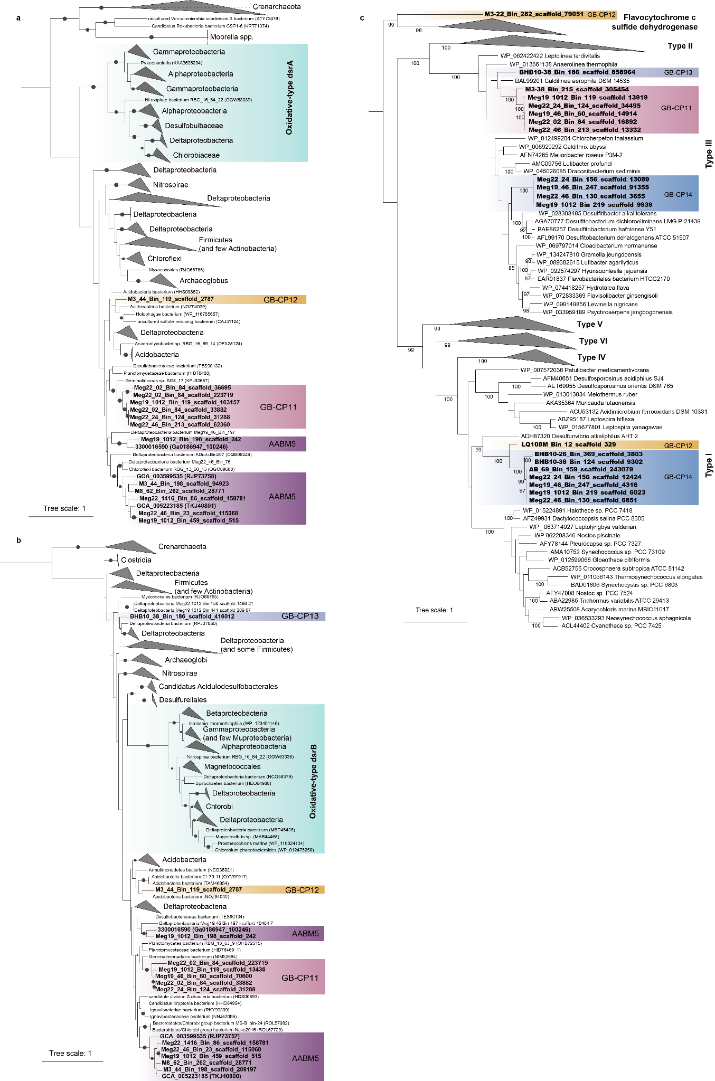
Extended Data Fig. 4 Maximum likelihood phylogenetic tree of genes associated with sulfur cycling. (a) A phylogenetic tree of the gene encoding for alpha subunit of dissimilatory sulfite reductase (DsrA). (b) A phylogenetic tree of the gene encoding for beta subunit of dissimilatory sulfite reductase (DsrB). (c) A phylogenetic tree of the gene encoding for sulfide-quinone reductase (SQR). One sequence recovered from genome M3-22_Bin_282 was annotated as sulfide-quinone reductase by Hidden Markov Model (HMM) profile-based annotation, but is phylogenetically close to flavocytochrome c sulfide dehydrogenase. Sequences recovered from the genomes in this study are in bold.

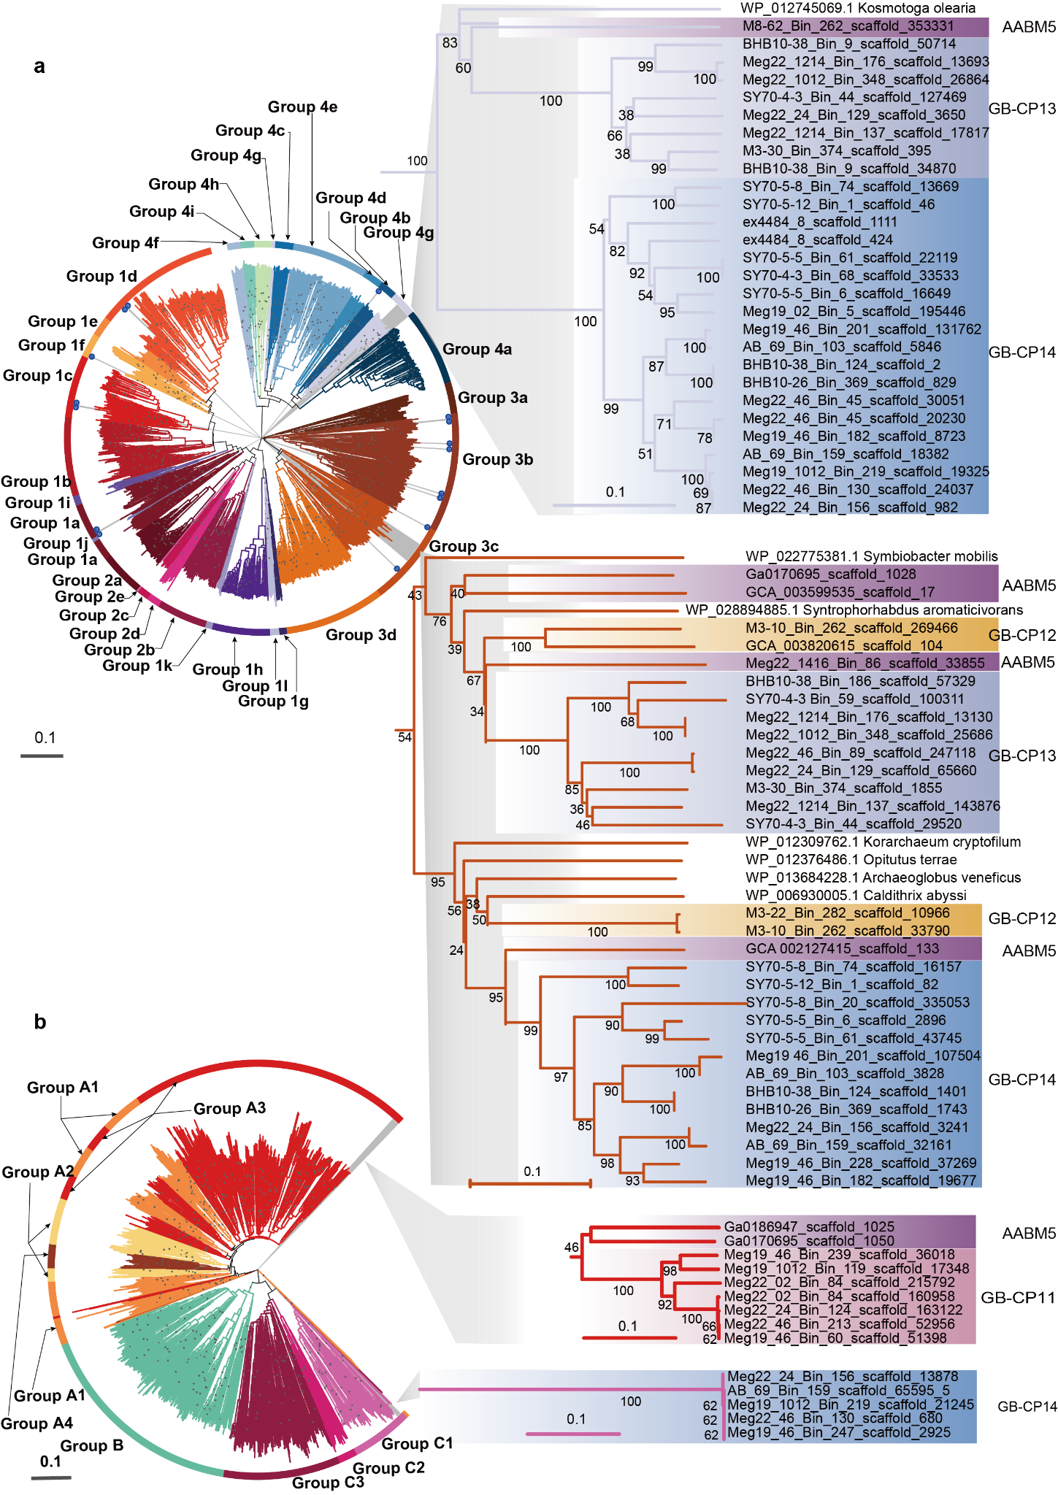Extended Data Fig. 5 Maximum likelihood phylogenetic tree of hydrogenases. (a) Phylogenetic tree of NiFe hydrogenases. The majority of NiFe hydrogenase identified from the five phyla in this study is highlighted in grey background, which belong to Group 4g and Group 3c. Branches with a star in the end denote the minor NiFe hydrogenases identified in this study. (b) Phylogenetic tree of FeFe hydrogenases. FeFe hydrogenases identified in this study belong to Group A3 and C1 as highlighted with a grey background. Bootstrap values ≥ 80 are shown in circles.

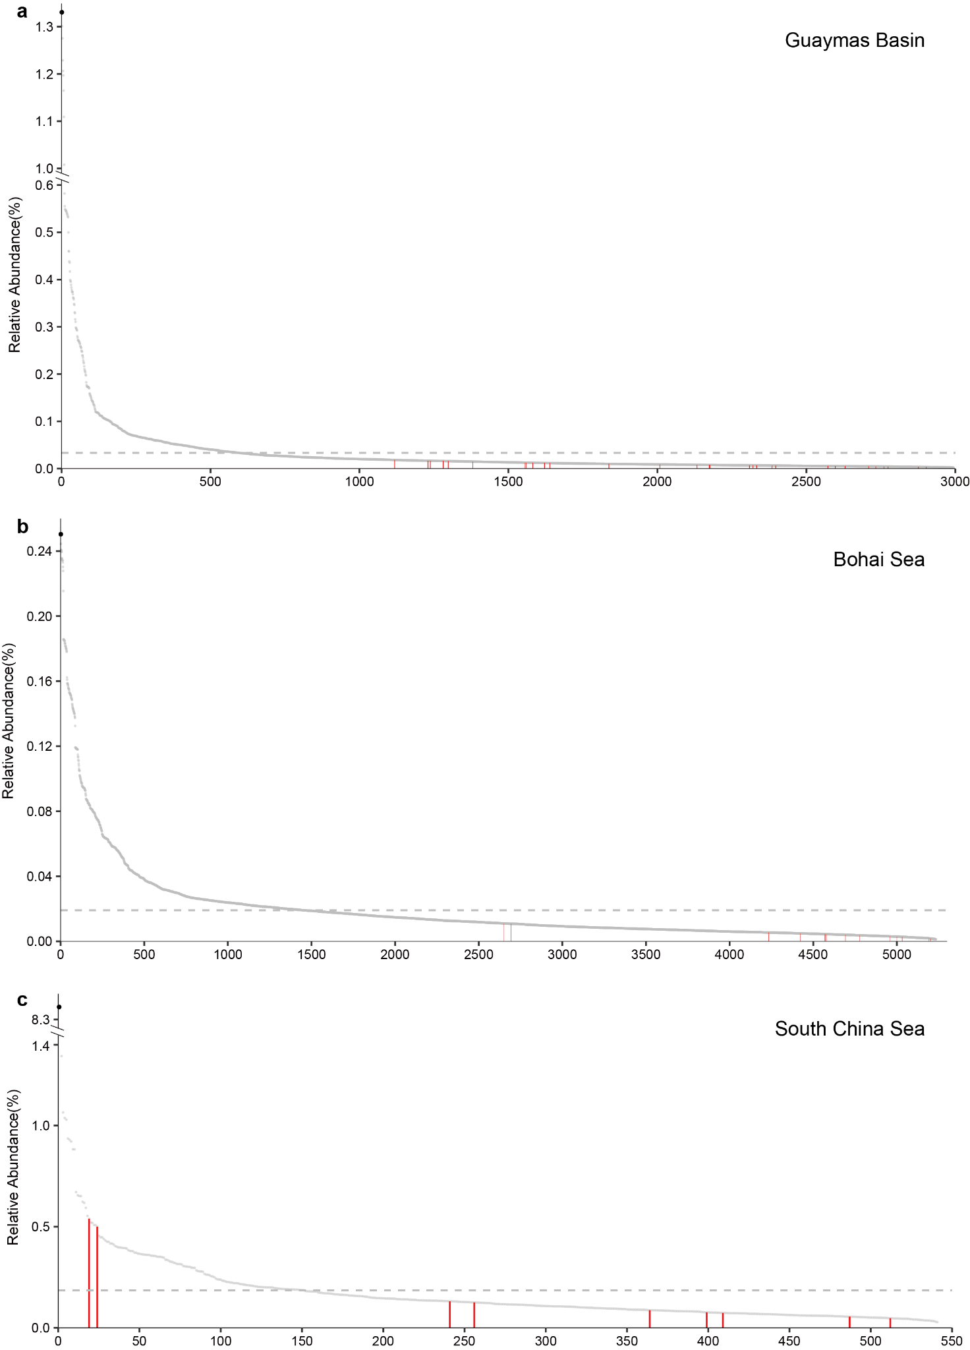Extended Data Fig. 6 Normalized relative abundance of each genome recovered from three different sites. (a) Normalized relative abundance of 2994 genomes recovered from Guaymas Basin samples. (b) Normalized relative abundance of 5233 genomes recovered from Bohai Sea samples. (c) Normalized relative abundance of 541 genomes recovered from cold seep samples in South China Sea. Red lines are the normalized relative abundance of 30, 14, and 9 genomes in this study. Dash line is the average relative abundance of all genomes. Black dot represents the highest genome abundance in the sampling site.

Supplementary Results and Discussion
Phylogeny of five phyla and novel protein identification
Based on the 37 concatenated marker genes, the 55 genomes recovered in this study formed 5 groups. We included all the publicly available genomes, belonging to the phyla identified by GTDB-Tk, from NCBI by May, 2020. We further included the genomes which were reported previously¹. Our phylogenetic results indicate that the 55 newly reconstructed genomes together with 6 genomes from NCBI and IMG/M databases belong to 4 new phyla, which are designated Guaymas Basin Candidate Phylum (GB-CP) GB-CP11, GB-CP12, GB-CP13, and GB-CP14, and one poorly described phylum, Candidate division AABM5-125-24 (AABM5 hereafter) (Fig. 1). The metabolic analyses were based on the 61 genomes. When we analyzed the genomic context to search for novel proteins, we only used the 55 genomes we recovered in this study. When we expanded the search against the collection of 169,642 bacterial and archaeal genomes, we further identified 19 genomes phylogenetically related to AABM5. Thus, the two novel protein families which are widely present in more than 70% of the AABM5 genomes (31 curated AABM5 genomes) and rarely detected in the collection of 169,642 prokaryotic genomes

Carbohydrate-active enzymes (CAZymes)
All genomes within these 5 phyla have genes encoding for potential diverse CAZymes (Extended Data Fig. 3), enzymes related to breaking down different carbohydrates, which are further divided into 5 categories: Carbohydrate Esterases (CE), Glycoside Hydrolases (GH), Polysaccharide Lyases (PL), Glycoside Transferases (GT), and Carbohydrate-binding Modules (CBM). These CAZymes are significant for the degradation of different types of carbohydrates, e.g., agar, xylan, starch, mannan, cellulose, chitin, laminarin, and pectin. Among ~5400 genes classified as CAZymes in these 5 phyla, over 3200 are classified as GT and CBM, 11, 91, and 8 are identified as CE, GH, and PL families/subfamilies, respectively (Supplementary Tables 10 and 11). AABM5 has a wider range of diverse CAZymes with 59 families/subfamilies in CE, PL, and GH, while GB-CP14 has the least diversity of CAZymes with only 41 families/subfamilies. These 5 phyla share 3 and 8 families of CE and GH, respectively. The types of CAZymes that are present in > 50% MAGs within a single phylum are similar across the 5 phyla, and mostly appear to be in more than one copy in the MAGs. All 5 phyla have phylum-specific CAZyme families/subfamilies, compromising 49 out of 110. However, most of those phylum-specific families/subfamilies are only present in less than half of MAGs within that phylum, and with few copies. Specifically, for those types of CAZymes widely distributed only in the single group (> 50% MAGs), GH113 (β-mannanase) is only found in GB-CP12; GH127 (β-L-arabinofuranosidase) and GH142 (β-L-arabinofuranosidase) are only present in GB-CP11; and PL1_2 (pectate and pectin lyase) is only found in GB-CP14. Notably, CB-CP11 does not have genes encoding for PL.
Based on the predicted localization of enzymes, 15 families/subfamily of CE, GH, and PL are predicted to be extracellular within the 5 phyla suggesting that complex substrates are degraded outside the cell and later taken up for consumption. The generated monosaccharide, e.g., glucose, could further support the metabolism of the cell through glycolysis and the tricarboxylic acid (TCA) cycle. These secreted CAZymes might contribute to the degradation of complex substrates, e.g., pectin, laminarin, agar, chitin, and xylan in the surrounding environments. The types of CAZymes with secretion signals in each group are different, even for the same substrate. Interestingly, none of the 5 phyla encodes the entire set of enzymes for the complete degradation of the complex substrate (Supplementary Tables 9 and 10) suggesting handoffs of the degradation of complex substrates outside of the cell. However, only 36 sequences have the signal of extracellular potential among those identified ~2200 CE, GH, and PL genes.

Detrital proteins
There are ~4600 different peptidase-related sequences, including ~4250 classified peptidase-like genes, ~250 peptidase inhibitor genes, and ~100 unclassified genes identified within these 5 phyla (Supplementary Tables 12 and 13). Metallo and serine peptides are the most two diverse families in all the 5 phyla. Among the 117 classified families/subfamilies, 31 of them are found in all phyla, and many of them are present in more than 75% of MAGs in all the 5 phyla. Examples of conserved peptidases are: C26 (gamma-glutamyl hydrolase), that acts as an endopeptidase for substrates with gamma-linked glutamate bonds, such as folyl penta-gamma-glutamate; C44 (amidophosphoribosyltransferase precursor), of which mature enzymes catalyzing the formation of phosphoribosylamine from phosphoribosylpyrophosphate (PRPP) and glutamine; M23B (lysostaphin), an endopeptidase that lyse bacterial cell wall peptidoglycans; M38 (isoaspartyl dipeptidase); M41 (FtsH peptidase) and S16 (Lon-A peptidase), mostly are ATP-dependent endopeptidases; I87, inhibiting FtsH and modulating the degradation of mistranslation products that disrupt membranes², is encoded in more than 4 copies per MAG in all these 5 phyla (Extended Data Fig. 3). GB-CP12 has 87 families of peptidases as the most diverse phylum, while GB-CP14 has 71 families which is the least diverse phylum. 24 out of 122 classified families/subfamilies were exclusively found in a single phylum, and those unique families/subfamilies are mostly present in less than 50% MAGs in that phylum with fewer gene copy number than the rest of types of peptidases. In addition, none of genes in those unique families/subfamilies has the signal of secretion.
A total of 185 genes, distributed in 14 families/subfamilies, appear to be potentially extracellular. The only extracellular family/subfamily consistently found in the 5 phyla is the serine endopeptidase subtilisin (S08A), widely distributed in eukaryotes and prokaryotes^{3,4}. GB-CP11, GB-CP12, and GB-CP13 have many potential genes identified as extracellular peptidases belonging to family M28 (subfamilies M28C, M28E, and M28F). These three subfamilies are mainly Streptomyces-type aminopeptidases and carboxypeptidases, releasing basic amino acids and C-terminal glutamates, respectively. GB-CP14 has different types of potential extracellular peptidase compared with other phyla. GB-CP14 has 6 sequences with signals of potential secretion belonging to family C01A (papain), a heat-resistant enzyme with an optimal temperature range of 60 to 70 °C⁵. This may highlight the significant role of GB-CP14 in the extracellular degradation of proteins in the hydrothermal vent area.

Central metabolism
Glycolysis: MAGs from the 5 phyla encode most of the key genes for glycolysis (Fig. 3). Interestingly, the gene encoding for pyruvate kinase was not found in AABM5 and GB-CP11, suggesting that these groups may not be capable of forming pyruvate. In addition, less than half of MAGs in GB-CP11 and GB-CP13 have genes encoding for triosephosphate isomerase, transforming dihydroxyacetone phosphate to glyceraldehyde 3-phosphate (GADP) for further glycolysis. None of the MAGs has genes encoding for glyceraldehyde-3-phosphate dehydrogenase, which suggests that the transformation of glyceraldehyde 3-phosphate to 3-phosphoglycerate has to be a two-step process via 1,3-bisphosphoglycerate. Moreover, all phyla have the fructose-1,6-bisphosphatase and the phosphoenolpyruvate carboxykinase, a rate-limiting enzyme in gluconeogenesis and catalyzing the oxydecarboxylation and phosphorylation of oxaloacetate⁶. However, none of the MAGs has the glucose-6-phosphatase suggesting a glycolytic route rather than gluconeogenic one (Supplementary Tables 7 and 8).

Pyruvate metabolism: Pyruvate could be converted to acetyl-CoA by different pathways (Fig. 3). AABM-5, GB-CP11, and GB-CP12 encode the pyruvate dehydrogenase complex. Except for GB-CP11, the other 4 phyla have pyruvate ferredoxin oxidoreductase, catalyzing the oxidative decarboxylation of pyruvate to acetyl-CoA and CO₂⁷. In addition, all MAGs encode the gene for 2-oxoglutarate/2-oxoacid ferredoxin oxidoreductase, which exhibits a broad substrate specificity toward 2-oxoacids, and accepts multiple substrates, including 2-oxoglutarate, 2-oxobutanoate, and pyruvate to form acetyl-CoA^{8,9}, which could be further utilized for the oxidative TCA cycle. GB-CP14 MAGs encode genes for the cytochrome D-lactate dehydrogenase converting lactate to pyruvate suggesting the ability of fermentation in this group. The direct formation of acetate from pyruvate through pyruvate dehydrogenase is missing in all the 5 phyla. Acetate still could be produced through acetyl-CoA or acetyl-phosphate. None of the MAGs encode genes for pyruvate decarboxylase and bacterial alcohol dehydrogenase (ADH1), thus they could not ferment pyruvate to ethanol through acetaldehyde. However, the presence of other types of alcohol dehydrogenases and acetaldehyde dehydrogenases (Supplementary Tables 7 and 8), suggests that they may be able to convert ethanol into acetaldehyde, and further incorporate into acetyl-CoA.

Pentose phosphate pathway (PPP): This pathway generates NADH, pentose, and ribose 5-phosphate for nucleotide and amino acid biosynthesis, and reduced molecules for anabolism (Fig. 3). MAGs in GB-CP11, and few MAGs in AABM5, GB-CP12, GB-CP13, and GB-CP14 display both oxidative and non-oxidative PPP, while the rest of MAGs only encodes the non-oxidative PPP. Few MAGs have the gene encoding for ribokinase, catalyzing the phosphorylation of ribose, while they are not those MAGs with the ribose ABC transporter. None of the MAGs has the entire pathway for galactose metabolism for galactose degradation, or ribulose monophosphate pathway for formaldehyde fixation and detoxification.

Wood-Ljungdahl pathway (WLP): All 5 phyla have the partial WLP (Fig. 3), one of the most ancient carbon fixation pathways¹⁰. Genes encoding formate dehydrogenase, transforming CO₂ to formate, are not present in any of the 5 phylum MAGs. One MAG from each phylum (AABM5, GB-CP11, GB-CP13, and GB-CP14) encode formyl-tetrahydrofolate (HCO-THF) synthase activating formate to formyl-H4F. All the 5 phyla are capable of further reducing formyl-THF to methyl-THF by the presence of folD and metF genes. GB-CP14 MAGs encode ccoF gene which is potentially involved in anaerobic CO oxidation^{11,12}. AABM5, and CB-CP13 have most of the CO-dehydrogenase−acetyl-CoA-synthase complex CODH/ACS, the key enzyme for the carbonyl branch for the WLP. However, all MAGs lack the enzyme CODH/ACS methyltransferase subunit, which is responsible for the transfer of the methyl moiety from methyl-THF to the corrinoid iron–sulfur protein (CFeSP) for acetyl-CoA synthesis.
The synthetic pathway for formate assimilation¹³, the reductive glycine pathway (rGlyP)¹³ is found across MAGs from the 5 phyla. The glycine cleavage system (GCS), catalyzing the reversible conversion of CO₂, methenyl-THF, and ammonia to glycine and tetrahydrofolate (THF), is annotated in all the 5 phyla. We explore the possibility of CO oxidation in these bacterial genomes, yet none of the MAG encode the three subunits of the coxLMS complex and only one MAG in GB-CP11 has the large subunit of aerobic CO dehydrogenase (coxL).

TCA cycle: All the 5 phyla have the complete set of genes for the TCA cycle (Fig. 3), though some MAGs lack few genes (Supplementary Tables 7 and 8). Interestingly, none of the MAGs encode ATP-citrate lyase, and only very few genes encoding for fumarate reductase are annotated in the MAG suggesting that they could not fix carbon through the reductive TCA cycle. Previously described 2-oxoglutarate synthase, one of the three key enzymes for reductive direction of the TCA cycle¹⁴, in Helicobacteraceae¹⁵ participated in the oxidative TCA cycle. Thus the 2-oxoglutarate synthase in these 5 phyla may also participate in the oxidative TCA cycle as well.

Electron transport chain (ETC): All the 5 phyla encode most of the components of the ETC (Supplementary Tables 7 and 8). They all have the subunits for complex I and II. AABM5 and GB-CP12 have F-type ATPase, while GB-CP13 and GB-CP14 have the V/A-type ATPase. Notably, GB-CP11 only has some subunit for either F-type ATPase or V/A-type ATPase. GB-CP13 and GB-CP14 appear to lack cytochrome oxidase suggesting an anaerobic lifestyle. GB-CP12, some GB-CP11 and AABM5 MAGs encode more than one type of cytochrome oxidase with different affinities for oxygen, e.g., cytochrome c oxidase, cytochrome cbb₃ type oxidase and cytochrome bd ubiquinol oxidase, which indicates that they are aerobes and able to utilize oxygen at different concentrations efficiently. AABM5 and most MAGs in GB-CP11 only have the oxygen high-affinity ones, mainly cytochrome bd ubiquinol oxidase, suggesting that they may only use the oxygen as the electron acceptor efficiently when the oxygen concentration is low to scavenge oxygen as a way of protection rather than for energy production.
Additionally, we identified the acetogenic type Rhodobacter nitrogen fixation (Rnf) electron transport complex in 4 among these 5 phyla (GB-CP11, GB-CP12, GB-CP13, and GB-CP14) (Fig. 3). This complex could serve as a respiratory enzyme that couples the reduction of NAD⁺ to oxidize reduced ferredoxin. The free energy of this exergonic reaction could be used to pump sodium ions or protons out of cells, thereby generating a potential gradient, which is further used for ATP synthesis.

Lipids: Genes encoding for enzymes which are responsible for the transport, activation, and cleavage of fatty acids through beta oxidation¹⁶ are found in all phyla (e.g., genes encoding for acyl-CoA dehydrogenase and enoyl-CoA hydratase are commonly found in these 5 phyla). However, only 2 GB-CP12 MAGs appear to have the complete pathway for beta oxidation (i.e., they encode for the 3-hydroxyacyl-CoA dehydrogenase and acetyl-CoA acyltransferase). This suggests a limited ability of fatty acid degradation in these 5 phyla.

Amino acids: Different types of amino acids, including alanine, serine, asparagine, histidine, and lysine could be degraded via central metabolism (i.e., TCA cycle and pyruvate metabolism) which are also the key pathways for energy production in most phyla (Fig. 3). In addition, genes encoding for glutamine synthetase, glutamate synthase, and glutamate dehydrogenase are commonly annotated in these 5 phyla suggesting active anabolic and catabolic metabolisms through glutamate, glutamine, and ammonium. However, all phyla lack the genes encoding key enzymes for the degradation of branched-chain amino acids and aromatic amino acids, e.g., valine, leucine, isoleucine, and tyrosine.

Sulfur metabolism
Marine sediments are active sites for sulfur and nitrogen cycling. Detailed genome-specific metabolic potential reveals that all these 5 phyla are capable of using different sulfur and nitrogen compounds as energy source (Fig. 4). Most AABM5 MAGs and one GB-CP11 MAG encode sulfate adenylyltransferase (SAT), reversibly reducing sulfate to adenylyl sulfate (APS), and adenylylsulfate reductase (AprAB), reversibly reducing APS to sulfite. In addition, they also encode the quinone-modifying oxidoreductase gene (QmoABC) for the efficient electron delivery to adenylylsulfate reductase¹⁷. Most of the MAGs from GB-CP11, GB-CP12, and GB-CP13 only have one copy of the sat gene, which reversibly reduces sulfate to APS. Most AABM5 MAGs, and some GB-CP11, GB-CP12, and GB-CP13 MAGs encode dissimilatory sulfite reductase (DsrAB) (Supplementary Table 14). Based on their phylogenetic position, they are reductive type sulfite reductase (Extended Data Fig. 4). Based on their metabolic repertoire, only AABM5 MAGs encode the entire pathway for dissimilatory sulfate reduction to H₂S. Most MAGs in GB-CP11, and only few GB-CP12 and GB-CP13 MAGs display a partial pathway for dissimilatory sulfate reduction. Interestingly, it seems that these bacteria from Guaymas Basin have more tendency to reduce sulfate than those from the Bohai Sea, e.g., MAGs in GB-CP11 and AABM5, though the sulfate concentration in the Bohai Sea sediment could be over 1,000 mg/kg¹⁸. Considering the number of dsrAB genes in each group, it is probable that the GB-CP11 and AABM5 acquired dsrAB genes through different sources of horizontal gene transfer events (HGT)¹⁹. Moreover, the acquisition of dsrAB genes in these 5 phyla is more fundamental in the hydrothermal sediment than the coastal sediment, despite that the sulfate-reducing bacteria, e.g., Desulfobulbus and Desulfotignum, were abundant in the coastal sediment¹⁸. MAGs encoding sulfate-reduction associated genes also encode hydrogenases, e.g., MvhADG complex in AABM5 MAGs and HndD, the catalytic subunit of NADP-reducing hydrogenase, in few GB-CP11 MAGs, suggesting the coupling of hydrogen oxidation with sulfite reduction.
Many genomes contain sulfate assimilation genes. For example, AABM5, GB-CP12, GB-CP13, and GB-CP14 MAGs encode adenylylsulfate kinase (CysC), converting APS to 3'-phosphoadenylyl sulfate (PAPS). AABM5 and GB-CP12 also have 3'(2'),5'-bisphosphate nucleotidase (SAL) to hydrolyse PAPS to APS. Two GB-CP12 MAGs (BHB10-2_Bin_362 and LQ108M_Bin_12) encode phosphoadenosine 5'-phosphosulfate reductase (CysH) and sulfite reductase (ferredoxin) (SIR) which produces sulfite from PAPS using thioredoxin as an electron donor²⁰ and reduces sulfite to H₂S for assimilation²¹, respectively.
Less than half of the MAGs in each phylum encode partial thiosulfate reductase (PhsABC), tetrathionate reductase (TtrABC), and anaerobic sulfite reductase (AsrABC), yet none of MAGs encode the complete known metabolic pathways (Supplementary Tables 7 and 8). More than 50% AABM5, GB-CP12, and GB-CP13 MAGs, and close to 50% GB-CP14 MAGs have homologs to eukaryotic thiosulfate/3-mercaptopyruvate sulfurtransferase (TST)²², which could transfer thiosulfate and cyanide to sulfite and thiocyanate. One MAG from AABM5, GB-CP11, and 2 GB-CP12 MAGs display genes encoding for sulfhydrogenase I complex (HydADGB)²³, along with NADPH-dependent hydrogen-evolving hydrogenase (HydAD) with sulfur reducing activity (HydGB). Most GB-CP13 and GB-CP14 MAGs only have the genes encoding for the two subunits with the activity of sulfur reductase (HydGB), reducing sulfur or polysulfide to H₂S.
Genes encoding for sulfide:quinone oxidoreductase (SQR), are observed in GB-CP11, GB-CP12, GB-CP13, and GB-CP14. SQR is present in more than 50% GB-CP11 MAGs suggesting a chemolithotrophic lifestyle by harvesting energy from sulfide oxidation. Six GB-CP14 MAGs have two sqr genes belonging to Type III and I (Extended Data Fig. 4), which is common for sulfur bacteria²⁴. SQR in GB-CP13 and GB-CP11 MAGs belong to type III, and only one GB-CP12 MAG encodes one Type I SQR. Most MAGs encoding SQR were from Guaymas Basin samples. Additionally, one annotated SQR from the GB-CP12 MAG is proved to be flavocytochrome c sulfide dehydrogenase (FCSD), oxidizing H₂S through cytochrome c, based on the phylogenetic tree (Extended Data Fig. 4). GB-CP11 is probably capable of oxidizing thiosulfate to tetrathionate since most of the MAGs encode thiosulfate dehydrogenase (DoxD). Only two GB-CP13 MAGs have soxB genes, yet lacking the rest of the components of the SOX pathway. Furthermore, all the groups lack the complete set of genes encoding for sulfite dehydrogenase (SoeABC/SorAB) and sulfite oxidase (SUOX).
Exploring the assimilation of organic sulfur compounds in these four groups, we found that all of them lack the full set of dmsABC genes reducing dimethyl sulfoxide (DMSO) to dimethyl sulfide (DMS). One MAG from GB-CP11 and GB-CP12 could methylate L-methionine or methanethiol (MeSH) to yield DMS with methanethiol S-methyltransferase (via MmdA) under oxic conditions²⁵. Interestingly, two GB-CP11 MAGs display ssuE gene encoding for FMN reductase, but the missing for ssuD, encoding for alkanesulfonate monooxygenase, and sulfonate transport system (SsuABC) indicating that they probably are not capable of reducing alkane sulfonate. Except for AABM5, most MAGs have genes encoding for peptide methionine sulfoxide reductases (MsrA/MsrB/MsrP). These enzymes play an essential role in preventing oxidative-stress damage caused by reactive oxygen species by reducing the oxidized form of methionine thereby reactivating damaged peptides²⁶. Except for AABM5, most MAGs encode sulfatase²⁷, capable of cleaving sulfate ester bonds from a wide variety of substrates, as a source of sulfur and carbon via organic sulfate degradation²⁸. These sulfatases are involved in the regulation of the sulfation states that provide different functions, e.g., osmoprotection²⁹ and pathogenic processes³⁰.
Most AABM5 MAGs encode the sulfate permease, while it is observed in only a few GB-CP12, GB-CP13 MAGs. In addition, only one AABM5 MAG has most genes encoding for sulfate/thiosulfate transport system (CysAUWP), except that the subunit CysP is missing, which is required for sulfate/thiosulfate ABC transporter³¹.

Nitrogen metabolism
These 5 phyla encode both the oxidative and reductive pathways of the nitrogen cycle (Fig. 3). Most of the MAGs in these 5 phyla encode genes for glutamine synthetase and glutamate dehydrogenase for ammonia assimilation. The gene encoding for glutaminase, converting glutamine to glutamate, is annotated in all 5 phyla. With exception of 2 GB-CP13 MAGs, all 5 phyla display hao genes encoding for hydroxylamine dehydrogenase oxidizing hydroxylamine to nitric oxide. However, the genes encoding for ammonia monooxygenase, oxidizing ammonia to hydroxylamine, are missing in all MAGs. Genes encoding for carbamate kinase (ArcC), which catalyze the reversible formation of ATP and cambamte with carbamoyl phosphate and ADP, are found in most MAGs. However, none of them display genes encoding for carbamoyl phosphate synthetase, catalyzing the ATP-dependent synthesis of carbamoyl phosphate from glutamine or ammonia and bicarbonate.
Only few genes encoding for nitrate/nitrite or ammonium transporter are observed in some MAGs from AABM5, GB-CP11, and GB-CP12 (Supplementary Tables 7 and 8). The cytoplasmic assimilatory nitrate reductase genes are not observed in any MAG. Few MAGs in GB-CP11 and GB-CP12 have genes encoding for the major components of membrane-bound nitrate reductase, which could contribute to the generation of ATP by proton motive force. In addition, more than half of the GB-CP12 MAGs have genes for periplasmic nitrate reductase, which would not create a proton gradient. Over 50% GB-CP11 MAGs encode the nitrous oxide reductase complex (NosZDFYLR), including the catalytic subunit, accessory protein, and transporters. GB-CP11 is the major phylum oxidizing nitrous oxide to nitrogen gas. Less than 50% GB-CP12 MAGs encode the catalytic subunit of periplasmic nitrous oxide reductase (NosZ) gene, while the other 4 phyla only have some genes encoding for the accessory protein (Supplementary Tables 7 and 8). Few AABM5 and GB-CP13 MAGs have genes for periplasmic dissimilatory nitrite reduction (NrfAH). Half of GB-CP14 MAGs, and less than half in the other 4 phyla have genes encoding for the large subunit of the assimilatory nitrite reductase. MAGs in AABM5 and GB-CP11 have genes encoding for nitronate monooxygenase, oxidizing alkyl nitronate with oxygen to nitrite.

Hydrogen metabolism
Hydrogen production or consumption through hydrogenase is thought to be crucial in energy cycling in both coastal and hydrothermal environments^{32,33}. All of these 5 phyla have different types of hydrogenases indicating the diverse hydrogen metabolism which could supply intracellular reducing equivalents to further couple different metabolic pathways in these bacteria^{34,35}. Most of the hydrogenases are found from hydrothermal sediments and cold seep sediments, especially that [FeFe] hydrogenases are only found in the Guaymas Basin samples in this study. The phylogenetic position of each type of hydrogenase is consistent with the phylogeny of these 5 phyla (Extended Data Fig. 5).
F₄₂₀-non-reducing hydrogenase (MvhADG), belonging to Group 3c [NiFe] hydrogenase, is distributed in all these 5 phyla, especially that in more than half MAGs in GB-CP13 and close to half MAGs in GB-CP14. This F₄₂₀-non reducing hydrogenase provides reducing equivalents to the heterodisulfide reductase without reacting with F₄₂₀, i.e., transporting electrons using H₂ as electron donor³⁶. The bidirectional and oxygen-tolerant NADPH-dependent hydrogen-evolving hydrogenase within sulfhydrogenase complex I (see Sulfur metabolism section), belongs to Group 3b [NiFe] hydrogenase, and is distributed mainly in GB-CP12 and one MAG in GB-CP11 and AABM5 (Supplementary Tables 7 and 8). They could reduce polysulfide to hydrogen sulfide²³, oxidize H₂ using NADP⁺ as the electron acceptor³⁷, and could also produce H₂ with NADPH as the electron donor when the S₀ is absent during carbohydrate fermentation³⁸. The members of this hydrogenase in this study are phylogenetically distant with each other (Extended Data Fig. 5) despite 4 of the 6 MAGs belonging to GB-CP12, indicating the horizontal gene transfer of this Group 3b [NiFe] hydrogenase may be more frequent than the other types of hydrogenase.
None of the Group 4g [NiFe] hydrogenase have been biochemically characterized, but they are generally described as to membrane-bound hydrogenases coupling the formation of H₂ from reduced ferredoxin or CO, and H⁺ or Na⁺ translocation that allow for energy-generation by establishing ion gradients over the membrane^{39–41}. Three sub-types of catalytic subunit of hydrogenase are classified as Group 4g [NiFe] hydrogenase based on the annotation⁴² within phyla AABM5, GB-CP13, and GB-CP14: (i) membrane-bound hydrogenase (MbhL) is present in over 50% GB-CP13 MAGs, close to 50% GB-CP14 MAGs, and one AABM5 MAG. This hydrogenase is a redox driven ion pump that generates a proton motive force from H⁺ reduction coupled to electrons derived from ferredoxin oxidation⁴³; (ii) the hydrogenase component (HycE) in membrane-bound formate hydrogenlyase complex is present in close to 50% GB-CP14 MAGs and one GB-CP12 MAG. This hydrogenase uses electrons derived from formate oxidation during glucose fermentation to reduce protons and release CO₂ and H₂⁴⁴; (iii) the catalytic subunit of ech hydrogenase complex (EchE) is present in 3 GB-CP14 MAGs and one GB-CP13 MAG. This ech hydrogenase is the potential respiratory enzyme oxidizing ferredoxin or CO, during which H₂ and a transmembrane electrochemical ion gradient are formed for energy conservation in methanogenesis and carbon fixation^{41,45}. It may also reversely serve as the source of reduced ferredoxin using H₂ as the electron donor⁴⁶. Overall, these sequences of Group 4g [NiFe] hydrogenase formed 3 monophyletic groups consistent with the phylogenetic position, and close to a hydrogenase from phylum Thermotogae. However, these 3 sub-types of Group 4g [NiFe] hydrogenase could not be distinguished based on the phylogenetic position (Extended Data Fig. 5).
Group A3 [FeFe] hydrogenase (HndD), that reversibly bifurcates electrons from H₂ to ferredoxin and NAD⁴⁰, was found in AABM5 and GB-CP11. Group C1 [FeFe] ferredoxin hydrogenase, which serves as H₂-sensors, was found to be present in GB-CP14.

Mercury, selenium, and arsenic metabolism
Submarine hydrothermal systems are important natural sources of mercury (Hg)⁴⁷. Hg resisting microorganisms are widely distributed in deep sea hydrothermal vents and in terrestrial geothermal springs^{33,48}. Longqi Hydrothermal vent, in the Southwest Indian Ridge, is commonly associated with massive sulfides and Hg⁴⁹. Metabolic reconstructions suggest that a MAG in GB-CP12 (LQ108M_Bin_12) is capable of transporting mercury into cytoplasm, and reducing extremely toxic Hg²⁺ to metallic Hg₀⁵⁰ with mercuric transport protein (MerT), MerR family transcriptional regulator (MerR), and mercuric reductase (MerA), which indicate that GB-CP12 is potentially involved in mercury detoxification⁵¹.
Selenium could exist in both organic and inorganic with different oxidation states in marine sediments⁵², and selenocysteine is the 21st amino acid⁵³. MAGs from both coastal sediments and hydrothermal vent sediments have genes for mobilization of organic selenium. Some AABM5, GB-CP11, and GB-CP12 MAGs have the gene encoding for the putative selenate reductase (YgfK)⁵⁴, yet the entire complex (YgfKM and XdhD) was found to be incomplete in all the MAGs (Supplementary Tables 7 and 8). All groups have the gene encoding for selenide water dikinase (SelD) catalyzing selenide with ATP to selenophosphate⁵⁵, the selenium donor for the selenocysteinyl-tRNA (Sec) with L-seryl-tRNA (Ser) selenium transferase (SelA)⁵⁶, which is further utilized for protein biosynthesis. The selenocysteine could be decomposed into selenide and alanine with cysteine desulfurase/selenocysteine lyase (SufS)⁵⁷, and this pathway is mainly observed in GB-CP11 and GB-CP12. The cystathionine gamma-synthase (MetB), which is also important for sulfur cycling, could also use selenocysteine as the substrate to form selenocystathionine. The transaminase (CCBL), rarely annotated in GB-CP13 and GB-CP14 could transform the selenocystathionine into selenohomocysteine. Most MAGs in all 5 phyla have the gene encoding for 5-methyltetrahydrofolate homocysteine methyltransferase (MetH), which also transfers a methyl to selenohomocysteine to form selenomethionine. The formed selenomethionine could be further transformed into methaneselenol with methionine-gamma lyase in AABM5, GB-CP11, and GB-CP12 MAGs. The selenomethionine could be further incorporated into selenomethionyl-tRNA (Met) with methionyl-tRNA synthetase (MetG)⁵⁸, which is further utilized for protein biosynthesis. These MAGs seem to have the pathway to synthesize selenium protein from selenide through the selenocysteinyl-tRNA (Sec) or the selenomethionyl-tRNA (Met). Meanwhile, selenium could also be released into selenide from selenocysteine during the biosynthesis.
Arsenate and arsenite are the two dominant formats of inorganic arsenic in marine environments⁵⁹. They induce toxicity by blocking general cell metabolism⁶⁰. All these 5 phyla have genes for the arsenic detoxification system. MAGs in all 5 phyla, though less than half MAGs in GB-CP13, and GB-CP14, are capable of reducing arsenate to arsenite via arsenate reductase (ArsC) through thioredoxin⁶¹. Even though arsenite is more toxic than arsenate, arsenite could be extruded from the cell by arsenite transporter (ArsAB) or transformed to methyl arsonate, less toxic than the inorganic format⁶² by arsenite methyltransferase (AS3MT). The ArsC could also be a potential pathway for energy production by using arsenate as the terminal electron acceptor with sulfide or lactate as the electron donor^{63,64}, rather than merely a way of detoxification.

Active interaction with environments
All the 5 phyla have genes encoding for diverse transport systems including the importers for different substrates from small ions to large proteins for energy conservation. They also display exporters for detoxification or resistance of antibiotics, indicating an active exchange with the surrounding environments. A putative ATP-binding cassette (ABC) multiple sugar transport system is annotated in all 5 phyla (Fig. 3), especially in most MAGs in GB-CP12, GB-CP13, and GB-CP14. Interestingly, the ABC transporter for specific oligosaccharide is rare, for example the specific transporter for the maltose, cellobiose, lactose, xylobiose, and etc., are missing in all phyla. The general nucleoside transport system (NupABC), transporting all common nucleosides across the membrane⁶⁵, is annotated in most MAGs in GB-CP12, GB-CP13, and GB-CP14. In addition, the ribose transporter is found in a few MAGs in AABM5 and GB-CP11. Interestingly, the transporter for the rest monosaccharide, e.g., glucose, arabinose, galactose, xylose, and fucose are missing in all MAGs within the 5 phyla. Furthermore, very few genes related to the phosphotransferase system are annotated. Thus, we suggest the uptake of carbohydrates from the environment in these phyla is through the putative ABC multiple sugar transport system. The peptide could also be transported into the cell through the peptide/nickel transport system as the additional source of organic carbon.
All the 5 phyla have the genes encoding for the phospholipid transport system, which preserves outer membrane lipid asymmetry by the reverse transport of phospholipids from the outer membrane to the inner membrane⁶⁶, suggesting they are gram-negative bacteria. Transporters for the other important elements for life, including molybdate, tungstate, phosphate, iron, manganese, cobalt, sodium, and zinc are identified in MAGs. Besides those ABC transporters, several MAGs have genes encoding for the multidrug resistance protein, heavy metal efflux system, and several antibiotic resistance proteins, indicating these bacteria may have the ability to resist antibiotics or heavy metals in the environment.

Supplementary Table 1.
Metadata of samples that were used to recover genomes in this study.

Supplementary Table 2.
Information of the genomes used and described in this study, including genomic statistics using checkM and taxonomy affiliations from GTDB-Tk as described in methods.

Supplementary Table 3.
Average of Amino Acid Identity (AAI) of the genomes from this study and phylogenetically closely related and publicly available genomes.

Supplementary Table 4.
Pairwise comparison of 16s rRNA sequences shown in Extended Data Figure 1.

Supplementary Table 5.
Identity of 16S rRNA from genomes recovered in this study against Integrated Microbial Genomes and Microbiomes database.

Supplementary Table 6.
Environments and geographic location of similar 16S rRNA sequences identified in the genomes described in this study shown in Figure 1.

Supplementary Table 7.
Full list of annotated sequences in the 61 proteomes described in this study. Combined annotations from KofamScan and KAAS are shown. Sulfide-quinone reductase (SQR), dissimilatory sulfite reductase (DsrAB) and hydrogenases were manually confirmed by phylogenies shown in Extended Data Figures 4 and 5, respectively.

Supplementary Table 8.
Gene counts of the annotated sequences in the 61 proteomes described in this study. Combined annotations from KofamScan and KAAS are shown. Sulfide-quinone reductase (SQR), dissimilatory sulfite reductase (DsrAB) and hydrogenases were manually confirmed by phylogenies shown in Extended Data Figure 4 and 5 respectively.

Supplementary Table 9.
Manually curated substrate and enzyme-based classification of the Carbohydrate active enzymes (CAZymes) used in this study.

Supplementary Table 10.
Carbohydrate activate enzymes (CAZymes) identified using dbcan2 in the 61 genomes described in this study.

Supplementary Table 11.
Statistics of the identified CAZyme families found in each bacterial group (AABM5, GB-CP11, GB-CP12, GB-CP13, and GB-CP14).

Supplementary Table 12.
Peptidases identified in the 61 genomes described in this study against the MEROPS database.

Supplementary Table 13.
Statistics of the identified peptidase found in each bacterial group (AABM5, GB-CP11, GB-CP12, GB-CP13, and GB-CP14).

Supplementary Table 14.
Details of the sequences used to build the dissimilatory sulfite reductase (Dsr) tree shown in Extended Data Figure 4.

Supplementary Table 15.
Normalized relative abundance and rank of relative abundance of 53 genomes in this study among all genomes recovered from Guaymas Basin (2994 in total), Bohai Sea (5233 in total), and South China Sea (541 in total) samples shown in Extended Data Figure 6.

Supplementary References:
1. Youssef, N. H. et al. Genomic Characterization of Candidate Division LCP-89 Reveals an Atypical Cell Wall Structure, Microcompartment Production, and Dual Respiratory and Fermentative Capacities. Appl. Environ. Microbiol. 85, (2019).
2. Zhou, Z., Tran, P. Q., Kieft, K. & Anantharaman, K. Genome diversification in globally distributed novel marine Proteobacteria is linked to environmental adaptation. ISME J. 14, 2060–2077 (2020).
3. Armijos Jaramillo, V. D., Vargas, W. A., Sukno, S. A. & Thon, M. R. New insights into the evolution and structure of Colletotrichum plant-like subtilisins (CPLSs). Commun. Integr. Biol. 6, e25727 (2013).
4. Iqbal, M. et al. Comparative evolutionary histories of fungal proteases reveal gene gains in the mycoparasitic and nematode-parasitic fungus Clonostachys rosea. BMC Evol. Biol. 18, 171 (2018).
5. Winnick, T., Davis, A. R. & Greenberg, D. M. PHYSICOCHEMICAL PROPERTIES OF THE PROTEOLYTIC ENZYME FROM THE LATEX OF THE MILKWEED, ASCLEPIAS SPECIOSA TORR. SOME COMPARISONS WITH OTHER PROTEASES : I. CHEMICAL PROPERTIES, ACTIVATION-INHIBITION, pH-ACTIVITY, AND TEMPERATURE-ACTIVITY CURVES. J. Gen. Physiol. 23, 275–288 (1940).
6. Latorre-Muro, P. et al. Dynamic Acetylation of Phosphoenolpyruvate Carboxykinase Toggles Enzyme Activity between Gluconeogenic and Anaplerotic Reactions. Mol. Cell 71, 718–732.e9 (2018).
7. Pieulle, L. et al. Isolation and characterization of the pyruvate-ferredoxin oxidoreductase from the sulfate-reducing bacterium Desulfovibrio africanus. Biochim. Biophys. Acta 1250, 49–59 (1995).
8. Zhang, Q., Iwasaki, T., Wakagi, T. & Oshima, T. 2-oxoacid:ferredoxin oxidoreductase from the thermoacidophilic archaeon, Sulfolobus sp. strain 7. J. Biochem. 120, 587–599 (1996).
9. Fukuda, E. & Wakagi, T. Substrate recognition by 2-oxoacid:ferredoxin oxidoreductase from Sulfolobus sp. strain 7. Biochim. Biophys. Acta 1597, 74–80 (2002).
10. Adam, P. S., Borrel, G. & Gribaldo, S. Evolutionary history of carbon monoxide dehydrogenase/acetyl-CoA synthase, one of the oldest enzymatic complexes. Proc. Natl. Acad. Sci. U. S. A. 115, E1166–E1173 (2018).
11. Whitham, J. M., Tirado-Acevedo, O., Chinn, M. S., Pawlak, J. J. & Grunden, A. M. Metabolic response of Clostridium ljungdahlii to oxygen exposure. Appl. Environ. Microbiol. 81, 8379–8391 (2015).
12. Geelhoed, J. S., Henstra, A. M. & Stams, A. J. M. Carboxydotrophic growth of Geobacter sulfurreducens. Appl. Microbiol. Biotechnol. 100, 997–1007 (2016).
13. Claassens, N. J. Reductive Glycine Pathway: A Versatile Route for One-Carbon Biotech. Trends Biotechnol. 39, 327–329 (2021).
14. Schauder, R., Widdel, F. & Fuchs, G. Carbon assimilation pathways in sulfate-reducing bacteria II. Enzymes of a reductive citric acid cycle in the autotrophic Desulfobacter hydrogenophilus. Arch. Microbiol. 148, 218–225 (1987).
15. Hughes, N. J., Clayton, C. L., Chalk, P. A. & Kelly, D. J. Helicobacter pylori porCDAB and oorDABC genes encode distinct pyruvate:flavodoxin and 2-oxoglutarate:acceptor oxidoreductases which mediate electron transport to NADP. J. Bacteriol. 180, 1119–1128 (1998).
16. Fujita, Y., Matsuoka, H. & Hirooka, K. Regulation of fatty acid metabolism in bacteria. Mol. Microbiol. 66, 829–839 (2007).
17. Duarte, A. G., Santos, A. A. & Pereira, I. A. C. Electron transfer between the QmoABC membrane complex and adenosine 5′-phosphosulfate reductase. Biochimica et Biophysica Acta (BBA) - Bioenergetics 1857, 380–386 (2016).
18. Niu, Z.-S. et al. Human activities can drive sulfate-reducing bacteria community in Chinese intertidal sediments by affecting metal distribution. Sci. Total Environ. 786, 147490 (2021).
19. Anantharaman, K. et al. Expanded diversity of microbial groups that shape the dissimilatory sulfur cycle. ISME J. 12, 1715–1728 (2018).
20. Berendt, U., Haverkamp, T., Prior, A. & Schwenn, J. D. Reaction mechanism of thioredoxin: 3’-phospho-adenylylsulfate reductase investigated by site-directed mutagenesis. Eur. J. Biochem. 233, 347–356 (1995).
21. Gisselmann, G., Klausmeier, P. & Schwenn, J. D. The ferredoxin:sulphite reductase gene from Synechococcus PCC7942. Biochim. Biophys. Acta 1144, 102–106 (1993).
22. Papenbrock, J. & Schmidt, A. Characterization of a sulfurtransferase from Arabidopsis thaliana. Eur. J. Biochem. 267, 145–154 (2000).
23. Ma, K., Schicho, R. N., Kelly, R. M. & Adams, M. W. Hydrogenase of the hyperthermophile Pyrococcus furiosus is an elemental sulfur reductase or sulfhydrogenase: evidence for a sulfur-reducing hydrogenase ancestor. Proc. Natl. Acad. Sci. U. S. A. 90, 5341–5344 (1993).
24. Sousa, F. M., Pereira, J. G., Marreiros, B. C. & Pereira, M. M. Taxonomic distribution, structure/function relationship and metabolic context of the two families of sulfide dehydrogenases: SQR and FCSD. Biochim. Biophys. Acta Bioenerg. 1859, 742–753 (2018).
25. Carrión, O. et al. A novel pathway producing dimethylsulphide in bacteria is widespread in soil environments. Nat. Commun. 6, 6579 (2015).
26. Gennaris, A. et al. Repairing oxidized proteins in the bacterial envelope using respiratory chain electrons. Nature 528, 409–412 (2015).
27. Hanson, S. R., Best, M. D. & Wong, C.-H. Sulfatases: structure, mechanism, biological activity, inhibition, and synthetic utility. Angew. Chem. Int. Ed Engl. 43, 5736–5763 (2004).
28. Lucas, J. J., Burchiel, S. W. & Segel, I. H. Choline sulfatase of Pseudomonas aeruginosa. Arch. Biochem. Biophys. 153, 664–672 (1972).
29. Osterås, M., Boncompagni, E., Vincent, N., Poggi, M. C. & Le Rudulier, D. Presence of a gene encoding choline sulfatase in Sinorhizobium meliloti bet operon: choline-O-sulfate is metabolized into glycine betaine. Proc. Natl. Acad. Sci. U. S. A. 95, 11394–11399 (1998).
30. Mougous, J. D., Green, R. E., Williams, S. J., Brenner, S. E. & Bertozzi, C. R. Sulfotransferases and sulfatases in mycobacteria. Chem. Biol. 9, 767–776 (2002).
31. Sirko, A., Zatyka, M., Sadowy, E. & Hulanicka, D. Sulfate and thiosulfate transport in Escherichia coli K-12: evidence for a functional overlapping of sulfate- and thiosulfate-binding proteins. J. Bacteriol. 177, 4134–4136 (1995).
32. Kessler, A. J. et al. Bacterial fermentation and respiration processes are uncoupled in anoxic permeable sediments. Nat Microbiol 4, 1014–1023 (2019).
33. De Anda, V. et al. Brockarchaeota, a novel archaeal phylum with unique and versatile carbon cycling pathways. Nat. Commun. 12, 2404 (2021).
34. Cramm, R. Genomic view of energy metabolism in Ralstonia eutropha H16. J. Mol. Microbiol. Biotechnol. 16, 38–52 (2009).
35. Peters, J. W. et al. [FeFe]- and [NiFe]-hydrogenase diversity, mechanism, and maturation. Biochim. Biophys. Acta 1853, 1350–1369 (2015).
36. Stojanowic, A., Mander, G. J., Duin, E. C. & Hedderich, R. Physiological role of the F420-non-reducing hydrogenase (Mvh) from Methanothermobacter marburgensis. Arch. Microbiol. 180, 194–203 (2003).
37. van Haaster, D. J., Silva, P. J., Hagedoorn, P.-L., Jongejan, J. A. & Hagen, W. R. Reinvestigation of the steady-state kinetics and physiological function of the soluble NiFe-hydrogenase I of Pyrococcus furiosus. J. Bacteriol. 190, 1584–1587 (2008).
38. Ma, K., Weiss, R. & Adams, M. W. Characterization of hydrogenase II from the hyperthermophilic archaeon Pyrococcus furiosus and assessment of its role in sulfur reduction. J. Bacteriol. 182, 1864–1871 (2000).
39. McTernan, P. M. et al. Intact functional fourteen-subunit respiratory membrane-bound [NiFe]-hydrogenase complex of the hyperthermophilic archaeon Pyrococcus furiosus. J. Biol. Chem. 289, 19364–19372 (2014).
40. Greening, C. et al. Genomic and metagenomic surveys of hydrogenase distribution indicate H2 is a widely utilised energy source for microbial growth and survival. ISME J. 10, 761–777 (2016).
41. Schoelmerich, M. C. & Müller, V. Energy-converting hydrogenases: the link between H2 metabolism and energy conservation. Cell. Mol. Life Sci. 77, 1461–1481 (2020).
42. Søndergaard, D., Pedersen, C. N. S. & Greening, C. HydDB: A web tool for hydrogenase classification and analysis. Sci. Rep. 6, 34212 (2016).
43. Vignais, P. M. & Colbeau, A. Molecular biology of microbial hydrogenases. Curr. Issues Mol. Biol. 6, 159–188 (2004).
44. McDowall, J. S. et al. Bacterial formate hydrogenlyase complex. Proc. Natl. Acad. Sci. U. S. A. 111, E3948–56 (2014).
45. Meuer, J., Kuettner, H. C., Zhang, J. K., Hedderich, R. & Metcalf, W. W. Genetic analysis of the archaeon Methanosarcina barkeri Fusaro reveals a central role for Ech hydrogenase and ferredoxin in methanogenesis and carbon fixation. Proc. Natl. Acad. Sci. U. S. A. 99, 5632–5637 (2002).
46. Hedderich, R. & Forzi, L. Energy-converting [NiFe] hydrogenases: more than just H2 activation. J. Mol. Microbiol. Biotechnol. 10, 92–104 (2005).
47. Lamborg, C. H., Von Damm, K. L., Fitzgerald, W. F., Hammerschmidt, C. R. & Zierenberg, R. Mercury and monomethylmercury in fluids from Sea Cliff submarine hydrothermal field, Gorda Ridge. Geophys. Res. Lett. 33, (2006).
48. Crepo-Medina, M. et al. Adaptation of chemosynthetic microorganisms to elevated mercury concentrations in deep-sea hydrothermal vents. Limnol. Oceanogr. 54, 41–49 (2009).
49. Zhu, C. et al. Seawater versus mantle sources of mercury in sulfide-rich seafloor hydrothermal systems, Southwest Indian Ridge. Geochim. Cosmochim. Acta 281, 91–101 (2020).
50. Fox, B. S. & Walsh, C. T. Mercuric reductase: homology to glutathione reductase and lipoamide dehydrogenase. Iodoacetamide alkylation and sequence of the active site peptide. Biochemistry 22, 4082–4088 (1983).
51. Schue, M., Glendinning, K. J., Hobman, J. L. & Brown, N. L. Evidence for direct interactions between the mercuric ion transporter (MerT) and mercuric reductase (MerA) from the Tn501 mer operon. Biometals 21, 107–116 (2008).
52. Meseck, S. & Cutter, G. Selenium Behavior in San Francisco Bay Sediments. Estuaries Coasts 35, 646–657 (2012).
53. Böck, A. et al. Selenocysteine: the 21st amino acid. Mol. Microbiol. 5, 515–520 (1991).
54. Bébien, M., Kirsch, J., Méjean, V. & Verméglio, A. Involvement of a putative molybdenum enzyme in the reduction of selenate by Escherichia coli. Microbiology 148, 3865–3872 (2002).
55. Leinfelder, W., Forchhammer, K., Veprek, B., Zehelein, E. & Böck, A. In vitro synthesis of selenocysteinyl-tRNA(UCA) from seryl-tRNA(UCA): involvement and characterization of the selD gene product. Proc. Natl. Acad. Sci. U. S. A. 87, 543–547 (1990).
56. Forchhammer, K., Leinfelder, W., Boesmiller, K., Veprek, B. & Böck, A. Selenocysteine synthase from Escherichia coli. Nucleotide sequence of the gene (selA) and purification of the protein. J. Biol. Chem. 266, 6318–6323 (1991).
57. Mihara, H., Kurihara, T., Yoshimura, T., Soda, K. & Esaki, N. Cysteine sulfinate desulfinase, a NIFS-like protein of Escherichia coli with selenocysteine lyase and cysteine desulfurase activities. Gene cloning, purification, and characterization of a novel pyridoxal enzyme. J. Biol. Chem. 272, 22417–22424 (1997).
58. Dardel, F., Fayat, G. & Blanquet, S. Molecular cloning and primary structure of the Escherichia coli methionyl-tRNA synthetase gene. J. Bacteriol. 160, 1115–1122 (1984).
59. Neff, J. M. Ecotoxicology of arsenic in the marine environment. Environ. Toxicol. Chem. 16, 917–927 (1997).
60. Mukhopadhyay, R., Rosen, B. P., Phung, L. T. & Silver, S. Microbial arsenic: from geocycles to genes and enzymes. FEMS Microbiol. Rev. 26, 311–325 (2002).
61. Messens, J., Hayburn, G., Desmyter, A., Laus, G. & Wyns, L. The essential catalytic redox couple in arsenate reductase from Staphylococcus aureus. Biochemistry 38, 16857–16865 (1999).
62. Ben Fekih, I. et al. Distribution of Arsenic Resistance Genes in Prokaryotes. Front. Microbiol. 9, 2473 (2018).
63. Macy, J. M., Santini, J. M., Pauling, B. V., O’Neill, A. H. & Sly, L. I. Two new arsenate/sulfate-reducing bacteria: mechanisms of arsenate reduction. Arch. Microbiol. 173, 49–57 (2000).
64. Hoeft, S. E., Kulp, T. R., Stolz, J. F., Hollibaugh, J. T. & Oremland, R. S. Dissimilatory arsenate reduction with sulfide as electron donor: experiments with mono lake water and Isolation of strain MLMS-1, a chemoautotrophic arsenate respirer. Appl. Environ. Microbiol. 70, 2741–2747 (2004).
65. Martinussen, J., Sørensen, C., Jendresen, C. B. & Kilstrup, M. Two nucleoside transporters in Lactococcus lactis with different substrate specificities. Microbiology 156, 3148–3157 (2010).
66. Malinverni, J. C. & Silhavy, T. J. An ABC transport system that maintains lipid asymmetry in the gram-negative outer membrane. Proc. Natl. Acad. Sci. U. S. A. 106, 8009–8014 (2009).

