Supplementary material

Evaluation of periodic stability of the oral microbiome from a healthy cohort using 16S ribosomal RNA gene sequencing analysis
Utkarsh Mangal ^{1,3#}, Kowoon Noh ^{2,3,4#}, Seeyoon Lee ¹, Jae-Kook Cha⁵, Je Seon Song ^{6,7}, Jung-Yul Cha ^{1,3}, Kee-Joon Lee ^{1,3}, Kwang-Mahn Kim ², Jae-Sung Kwon ^{2,4*}, Sung-Hwan Choi ^{1,3*}
¹Department of Orthodontics, Yonsei University College of Dentistry, 50-1 Yonsei-ro, Seodaemun-gu, Seoul 03722, Korea; utkmangal@yuhs.ac (U Mangal), seeyoonlee@gmail.com (S. Lee), jungcha7@yonsei.ac.kr (J-Y Cha), orthojn@yuhs.ac (K-J Lee) and selfexam@yuhs.ac (S.-H. Choi)
²Department and Research Institute of Dental Biomaterials and Bioengineering, Yonsei University College of Dentistry, Seoul 03722, Korea; kowoonnoh@yuhs.ac (K. Noh), kmkim@yuhs.ac (K-M Kim) and jkwon@yuhs.ac (J.-S. Kwon)
³Institute of Craniofacial Deformity, Yonsei University College of Dentistry, 50-1 Yonsei-ro, Seodaemun-gu, Seoul 03722, Korea.
⁴BK21 FOUR Project, Yonsei University College of Dentistry, Seoul 03722, Korea
⁵Department of Periodontology, Research Institute of Periodontal Regeneration, Yonsei University College of Dentistry, Seoul 03722, Korea; chajaekook@yuhs.ac (J-K Cha)
⁶Department of Pediatric Dentistry, Yonsei University College of Dentistry, 50-1 Yonsei-ro, Seodaemun-gu, Seoul 03722, Korea; songjs@yuhs.ac (J-S Song)
⁷Oral Science Research Center, College of Dentistry, Yonsei University, Seoul 03722, Korea
#Authors with co-first authorship based on equal contributions
*Corresponding authors: jkwon@yuhs.ac (J.-S. Kwon) and selfexam@yuhs.ac (S.-H. Choi).

Table S1. Subject demographic characteristics
Demographic feature
Age (years) | 25.8 ± 1.73 (23-28)
Gender, n (%)
Male | 3 (27.3)
Female | 8 (72.7)
Plaque index*
T0 | 0.39 ± 0.27
T1 | 0.39 ± 0.20
T2 | 0.44 ± 0.19
Pairwise comparison (p-value)
T0-T1 | 0.937
T0-T2 | 0.527
T1-T2 | 0.240
* Silness & Löe plaque indices
Pairwise comparison of the plaque index records showed no significant differences (p > 0.05) with Wilcoxon signed-rank test. Additionally, all subjects had a full complement of teeth, no restoration on the first molar (region of interest), and adjacent teeth in the same arch belonged to the same race from the same geographical region.

Table S2. Similarity percentages breakdown (SIMPER) analysis between the two representative subjects; C1 and C6 showing a average dissimilarity of 49.11%
Taxon | Av. dissim | Contrib.  % | Cumulative  % | Mean  C01 | Mean  C06
Haemophilus_parainfluenzae_group | 12.18 | 24.79 | 24.79 | 3.38E+03 | 1.69E+04
Rothia_dentocariosa | 5.076 | 10.34 | 35.13 | 1.36E+04 | 1.02E+04
Rothia_aeria | 3.938 | 8.019 | 43.15 | 3.11E+03 | 6.25E+03
Actinomyces_viscosus_group | 3.447 | 7.018 | 50.17 | 4.08E+03 | 923
Streptococcus_pneumoniae_group | 2.414 | 4.916 | 55.08 | 2.71E+03 | 3.25E+03
Streptococcus_sanguinis_group | 2.162 | 4.403 | 59.48 | 1.94E+03 | 3.06E+03
Actinomyces_naeslundii | 1.924 | 3.917 | 63.4 | 1.92E+03 | 140
Veillonella_dispar | 1.289 | 2.625 | 66.03 | 1.23E+03 | 57
Lautropia_mirabilis | 1.089 | 2.216 | 68.24 | 2.04E+03 | 1.57E+03

Figure S1. An overview of common analytical steps. Data processing through different modules facilitates drawing comprehensive conclusions by considering temporal patterns and their corresponding functional behavior.

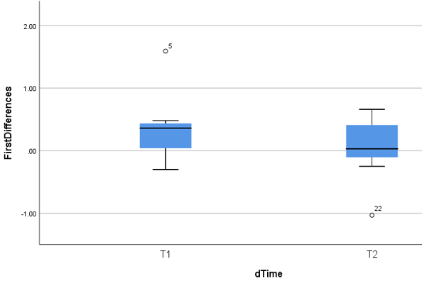
Figure S2. Rate of change of Shannon diversity index expressed as first difference. No significant differences (p = 0.306; Wilcoxon signed rank test) were observed when comparing a short-term change (T0 to T1) and long-term change (T0 to T2). The error bars represent the standard deviation.

Community stability metrics
Figure S3. Turnover metric described in terms of total appearance and disappearance of the species across time

