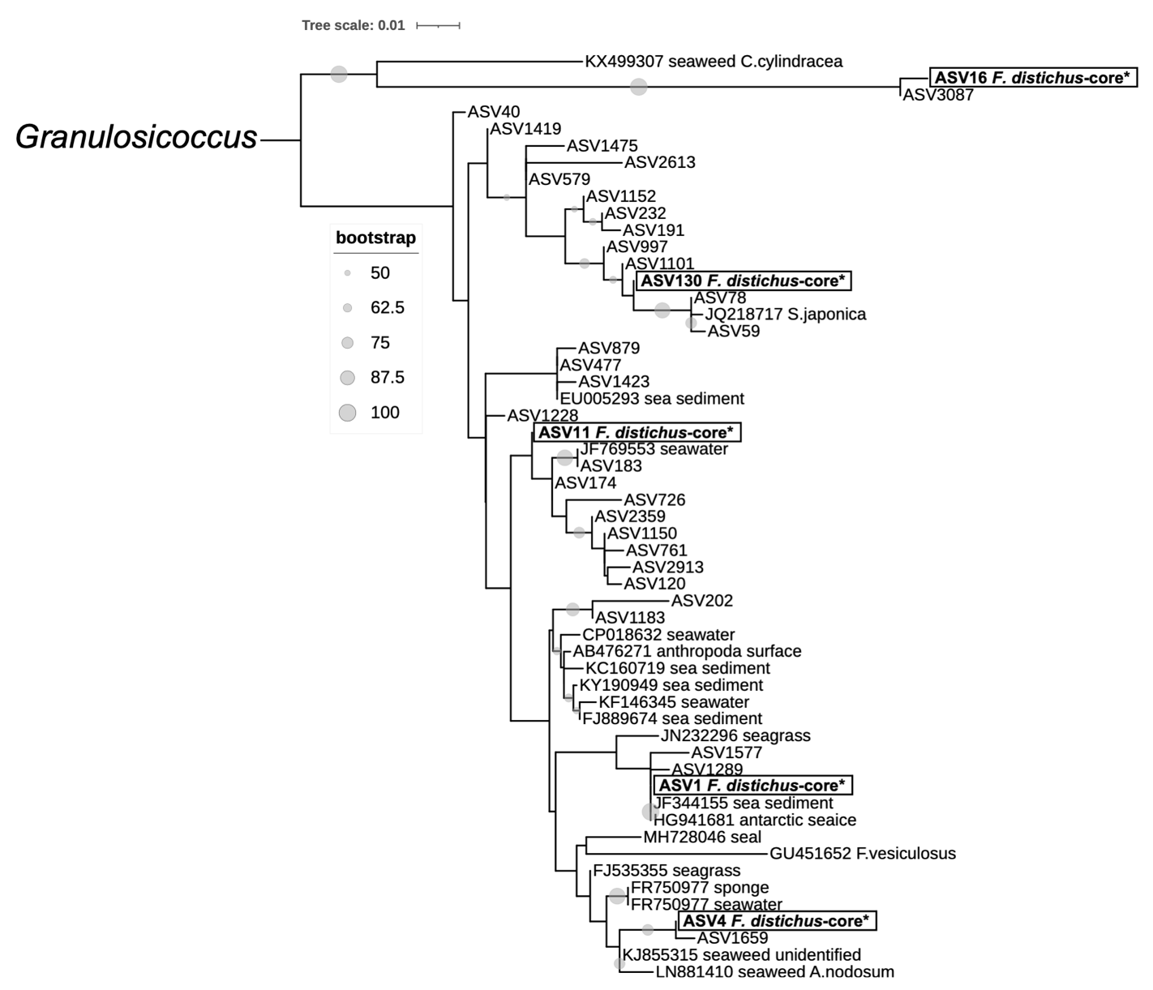

Supplementary Figure.1 | Maximum likelihood phylogenetic tree of F. distichus-core taxa within Granulosicoccus clade constructed in RAxML with rapid bootstrapping. Sequences (ASVs) from this study are placed within a phylogenetic tree. Core sequences are denoted with an * and placed within a box. Core ASVs are distinct from each other and cluster with sequences isolated from other brown algae and environments. Bootstrap values greater than 50 are listed under branches.

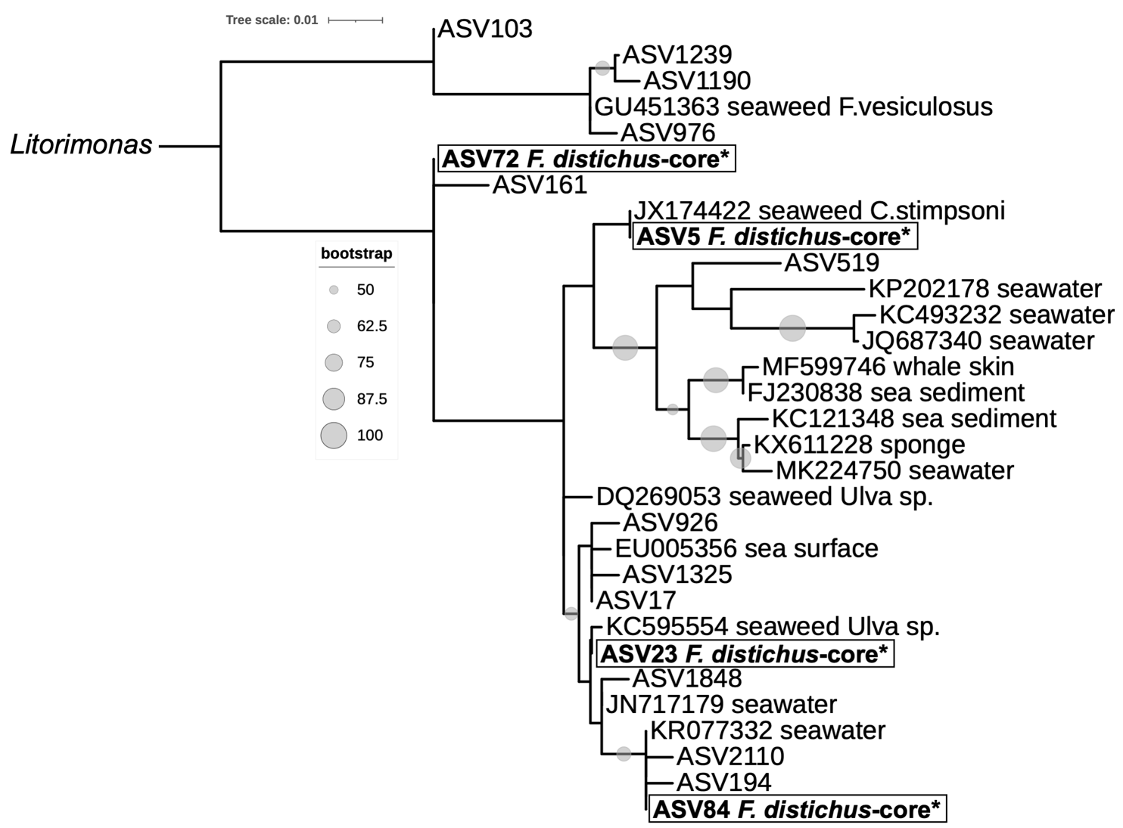

Supplementary Figure.2 | Maximum likelihood phylogenetic tree of F. distichus-core taxa within Litorimonas clade constructed in RAxML with rapid bootstrapping. Sequences (ASVs) from this study are placed within a phylogenetic tree. Core sequences are denoted with an * and placed within a box. Core ASVs are distinct from each other and cluster with sequences isolated from other brown and green algae and environments. Bootstrap values greater than 50 are listed under branches.

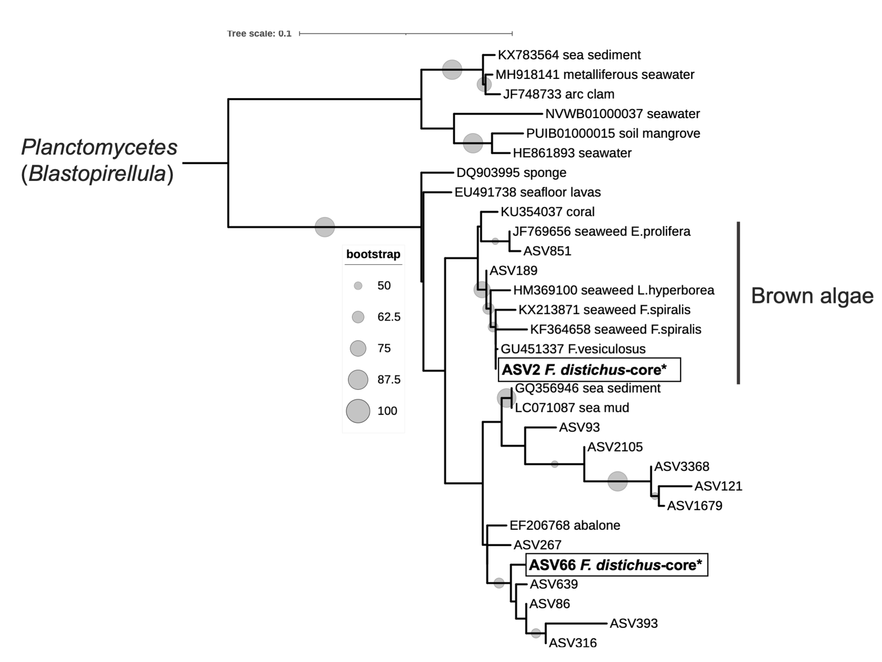

Supplementary Figure.3 | Maximum likelihood phylogenetic tree of F. distichus-core taxa within Blastopirellula clade constructed in RAxML with rapid bootstrapping. Sequences (ASVs) from this study are placed within a phylogenetic tree. Core sequences are denoted with an * and placed within a box. Core ASV2 clusters with sequences isolated from Fucus species and other brown macroalgal species. Bootstrap values greater than 50 are listed under branches.

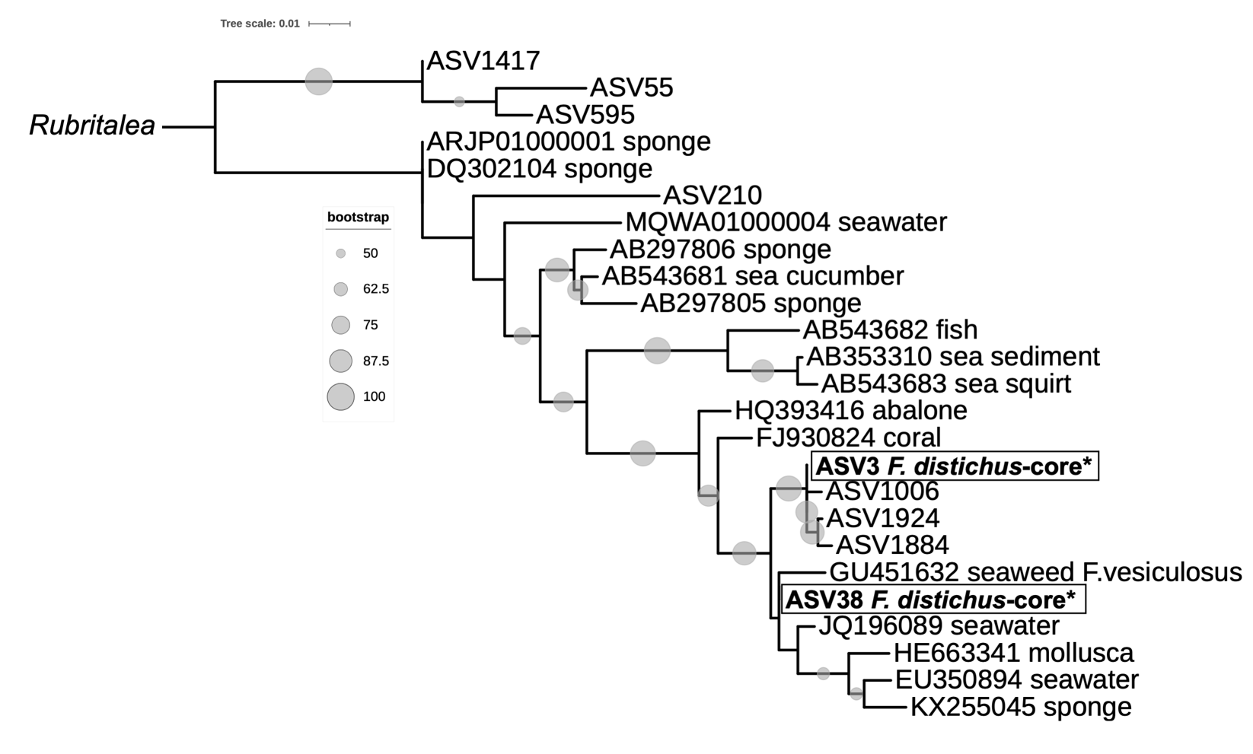

Supplementary Figure.4 | Maximum likelihood phylogenetic tree of F. distichus-core taxa within Rubritalea clade constructed in RAxML with rapid bootstrapping. Sequences (ASVs) from this study are placed within a phylogenetic tree. Core sequences are denoted with an * and placed within a box. Core ASV38 clusters with sequences isolated from Fucus species. Bootstrap values greater than 50 are listed under branches.

