Supplementary Information - Appendices

Appendix 1: Formula for calculating patient risk of experiencing MRH within 8 weeks post hospital discharge
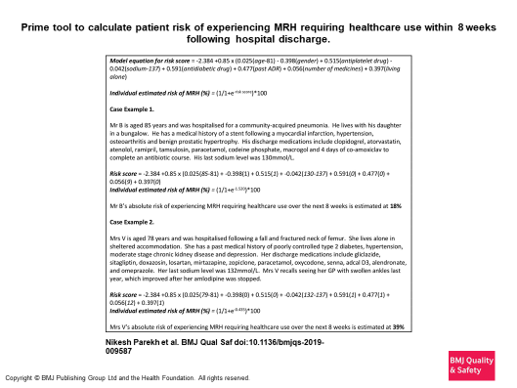

Appendix 2: Visual analogue of risk prediction tool

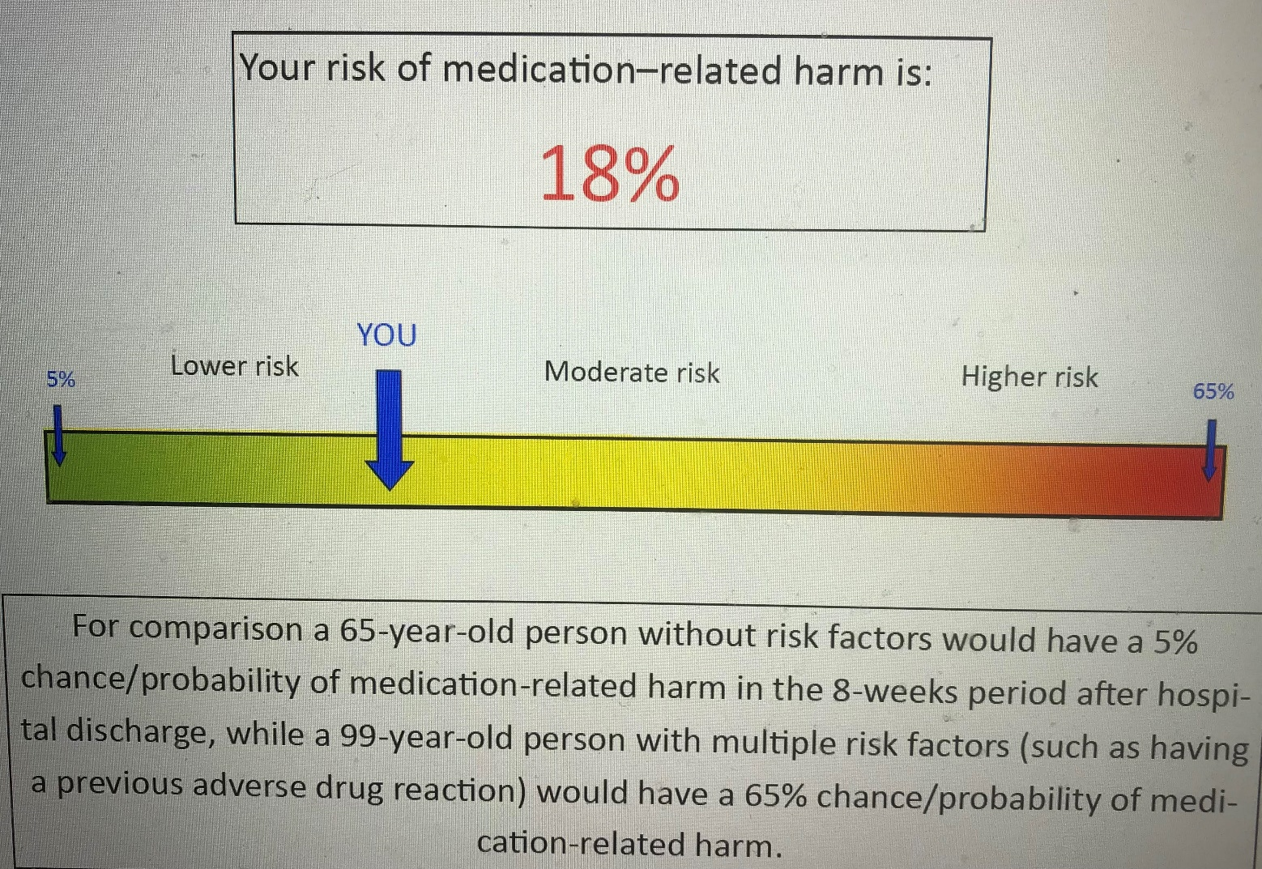

Appendix 3: Study participants flow chart
Implementation of a risk prediction tool to reduce medication-related harm (MRH) in older people post-hospital discharge – Flow Chart.
Screening for eligible study participants by the research nurse (RN)

Eligible participants will be approached by the RN and will be informed that they have an equal chance of being included in the intervention arm or the control arm (randomised)

Eligible participants who agree to be randomised will be asked to provide consent to join the study

Participants who provide consent will then be risk categorised using the risk prediction tool (RPT).

Participants will then be randomised to the intervention or control arm

Intervention arm (RPT + Medicine Management Plan + NHS DMS)

Control arm (RPT + NHS DMS as usual standard of care)

Study participants in both arms will be followed up at 8 weeks by the study pharmacist to verify occurrence of MRH

