Supplementary Information for
DNA Sequence is Critically Involved in the Compact Assembly of Chromatin Arrays

Yaqing Wang^{a,b,1}, Tommy Stormberg^{a,1}, Mohtadin Hashemiª, Anatoly B. Kolomeisky^{c}, and Yuri L. Lyubchenko^{a,}*
ªDepartment of Pharmaceutical Sciences, University of Nebraska Medical Center, Omaha, NE 68198.
^{b}Materials Science Division, Physical and Life Sciences Directorate, Lawrence Livermore National Laboratory, Livermore, CA 94550.
^{c}Department of Chemistry and Center for Theoretical Biological Physics, Rice University, Houston, TX 77005.
¹These authors contributed equally to this work.
*Corresponding author: Yuri L. Lyubchenko 402-559-1971, Nebraska Medical Center, Omaha, NE 68198-6025
Email: ylyubchenko@unmc.edu

Fig. S1. 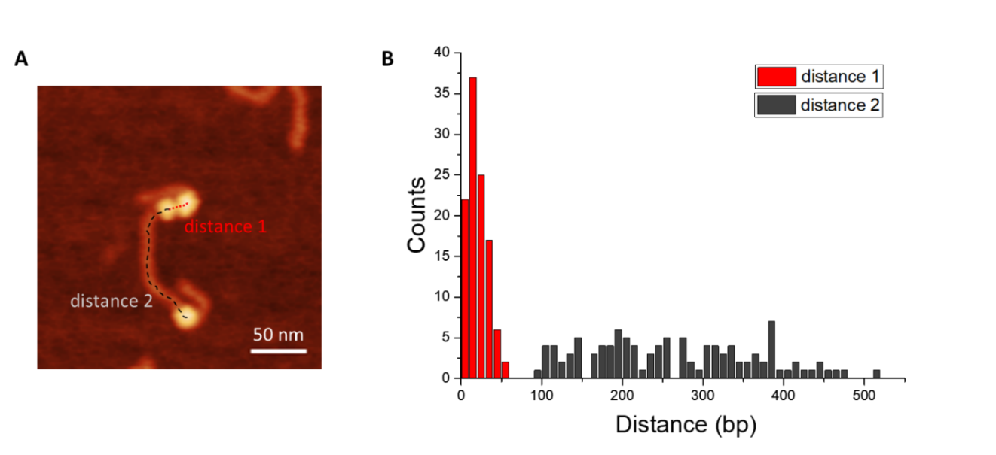 Figure S1. Analysis of the internucleosomal distance in the 2-1 trinucleosome population, n=109. Scale bar indicates 50 nm.

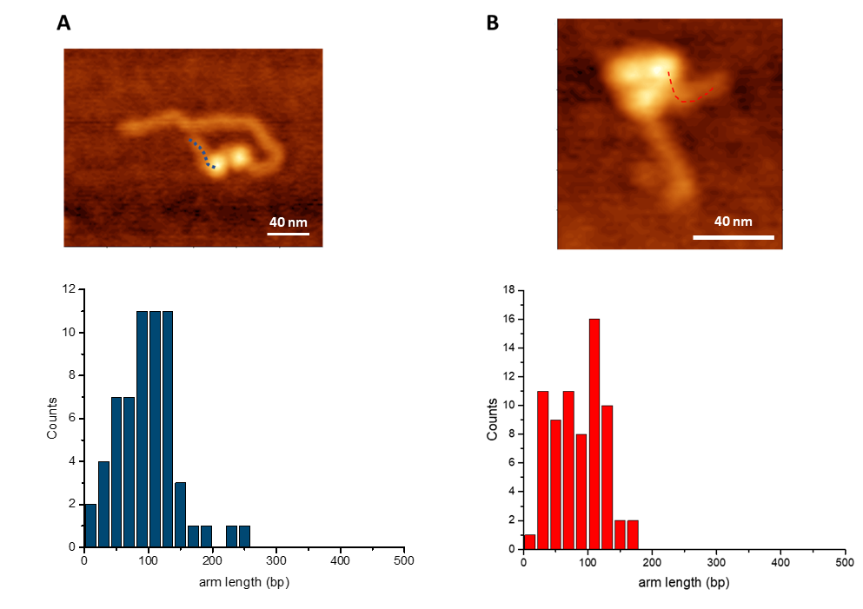
Figure S2. Analysis of flank DNA length in compact dinucleosomes, n=60 (A) and trinucleosomes, n=70 (B). Scale bars indicate 40 nm.

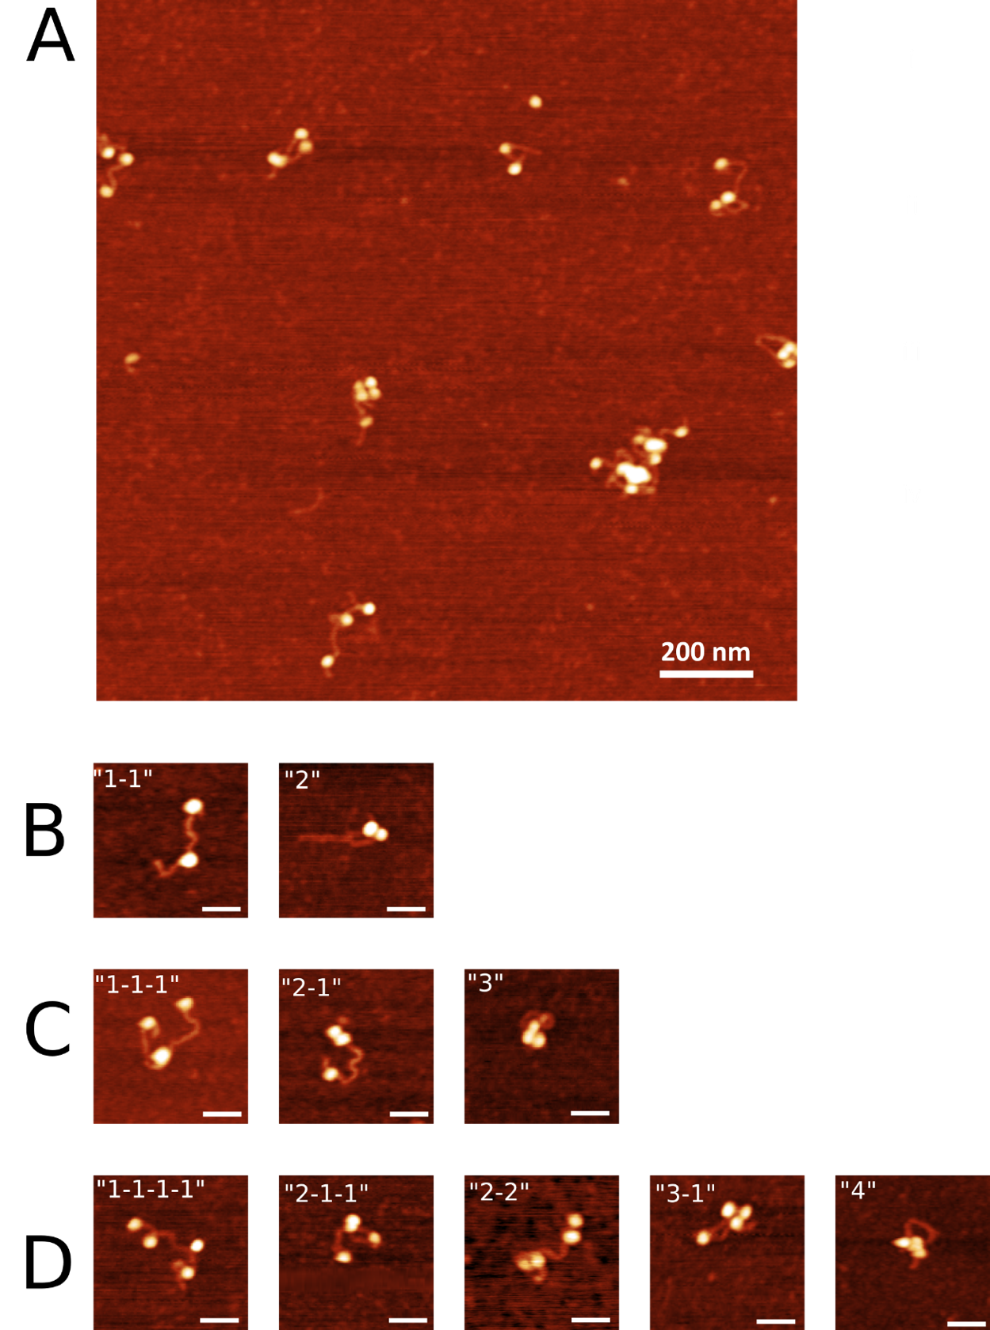
Figure S3. Nucleosomes assembled on non-specific DNA. A. Representative AFM image. B-D. Subpopulations of oligonucleosomes. Scale bars indicate 50 nm.

Table S1. 601 Tetranucleosome Comparison

Comparison of tetranucleosomes assembled on the 601 substrate with simulations on the 601 and shifted 601 substrates.

Table S2. Non-specific Tetranucleosome Comparison
Comparison of tetranucleosomes assembled on the non-specific substrate with simulations on the non-specific substrate.

