QSRR modeling of the chromatographic retention behavior for some quinolone and sulfonamide antibacterial agents using firefly algorithm coupled to support vector machine
Marwa A. Fouad^{a,b*}, Enas H. Tolba^{c}, Manal A. El-Shal^{c}, Ahmed Serag ^{d} and Ahmed M. El Kerdawy^{a,b}
ª Pharmaceutical Chemistry Department, Faculty of Pharmacy, Cairo University, Kasr El-Aini St., Cairo, P.O. Box 11562, Egypt
^{b} Department of Pharmaceutical Chemistry, School of Pharmacy, New Giza University, Newgiza, km 22 Cairo–Alexandria Desert Road, Cairo, Egypt
^{c} National Organization for Drug Control and Research (NODCAR), Giza, P.O. Box 35521, Egypt
^{d} Pharmaceutical Analytical Chemistry Department, Faculty of Pharmacy, Al-Azhar University, Cairo 11751, Egypt

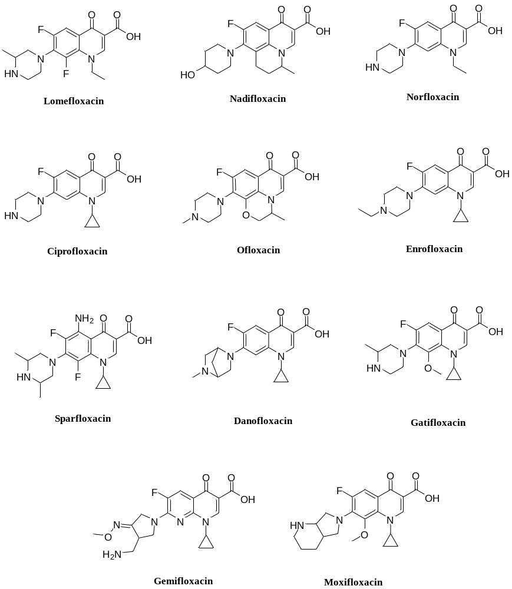
Fig. S1: Chemical structures of the quinolones under investigation

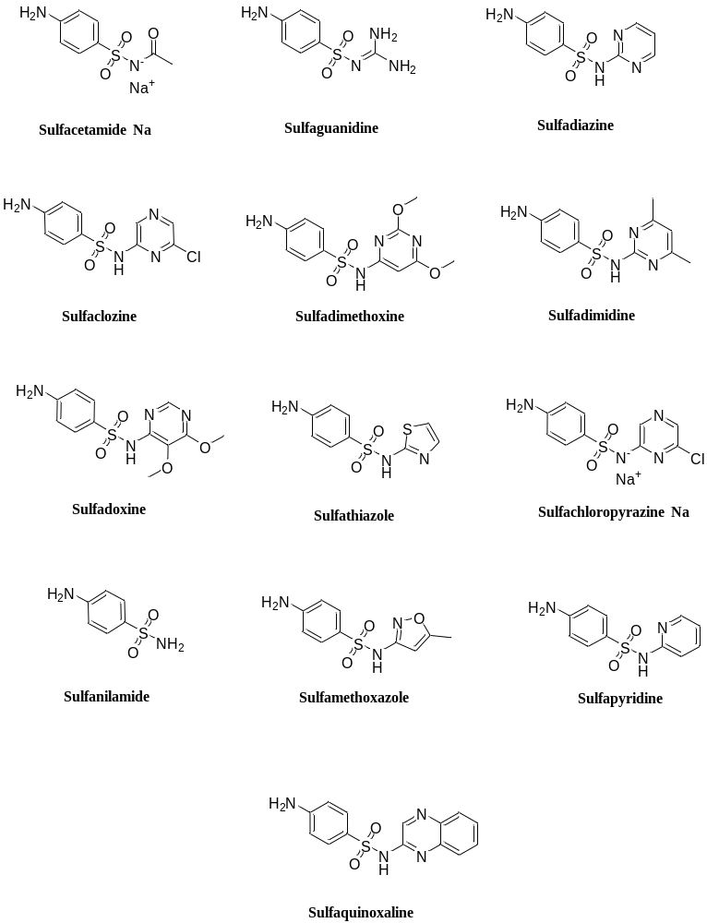
Fig. S2: Chemical structures of the sulfonamides under investigation
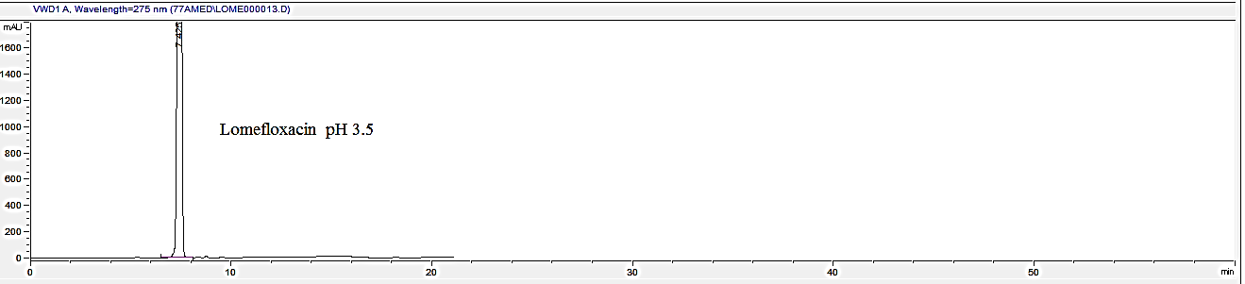
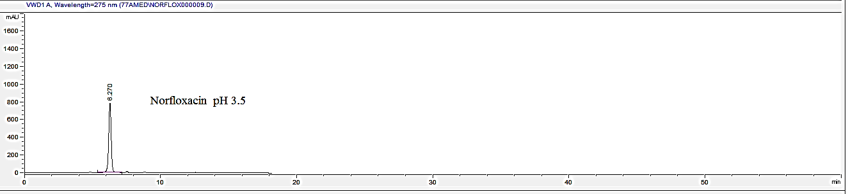
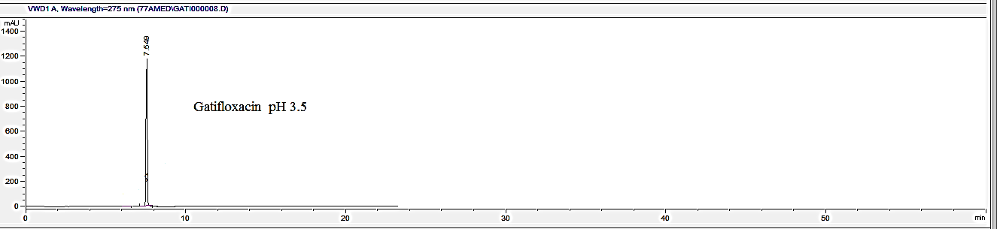

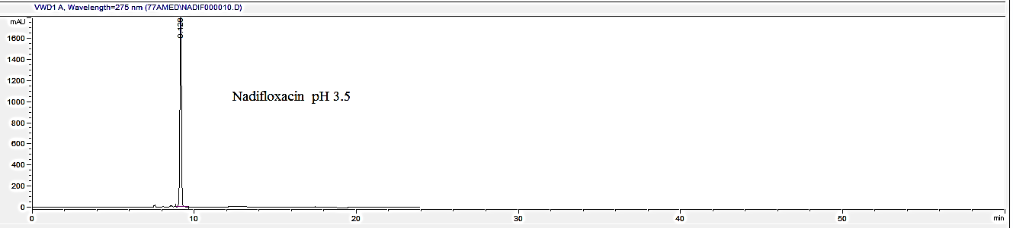
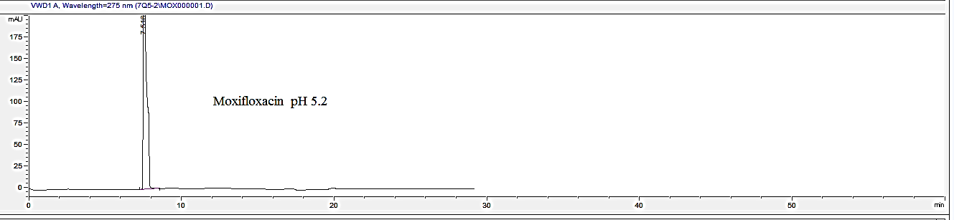
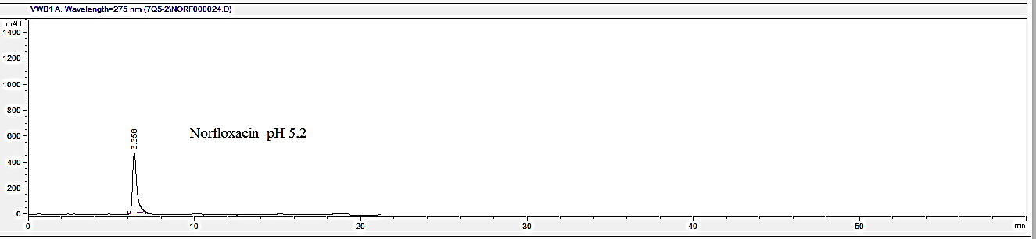

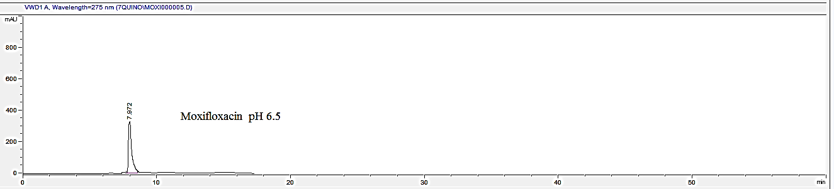
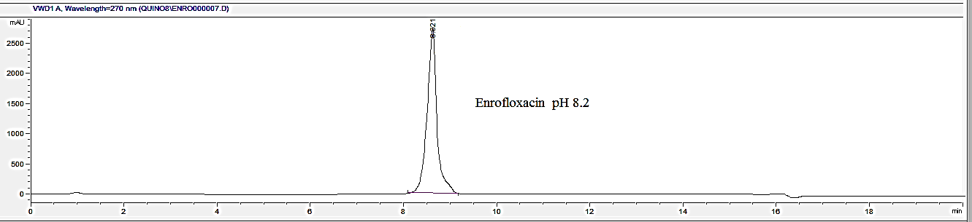
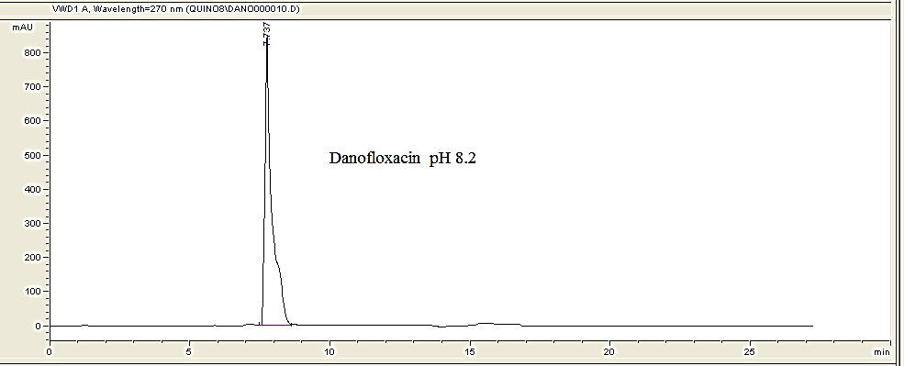
Fig. S3: Representative chromatograms of different quinolones eluted at different pHs.

Fig. S4: Training and test set predictive ability of FFA-SVM for quinolones modeling.

Fig. S5: Cross validation predictive ability of FFA-SVM for quinolones modeling.

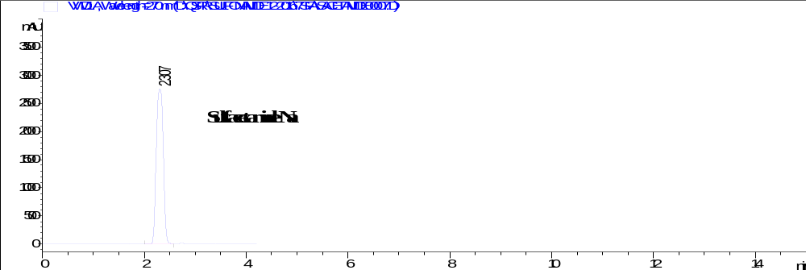
Ratio (50:50) v/v
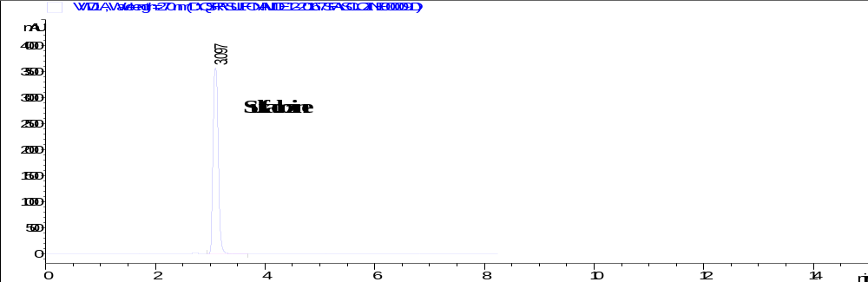
Ratio (50:50) v/v
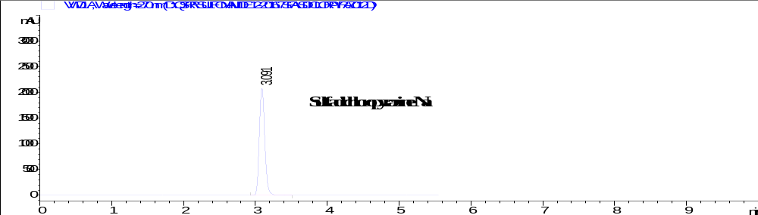
Ratio (50:50) v/v
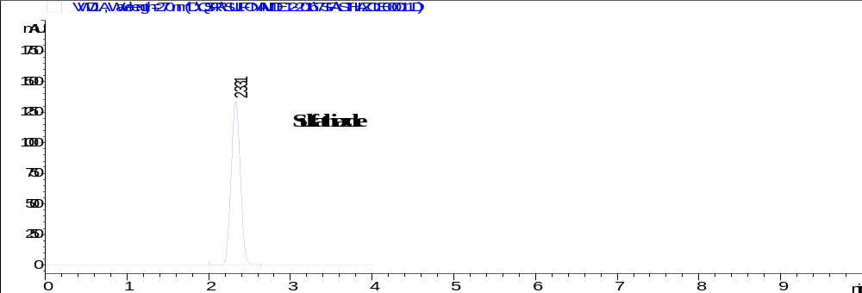
Ratio (50:50) v/v
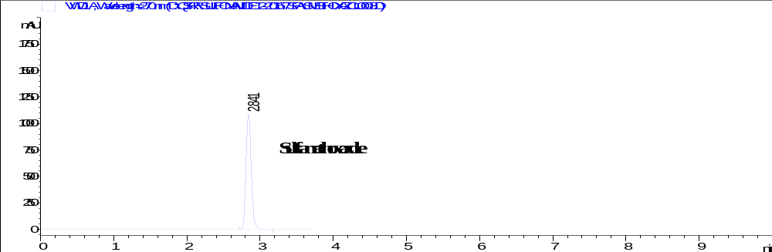
Ratio (50:50) v/v

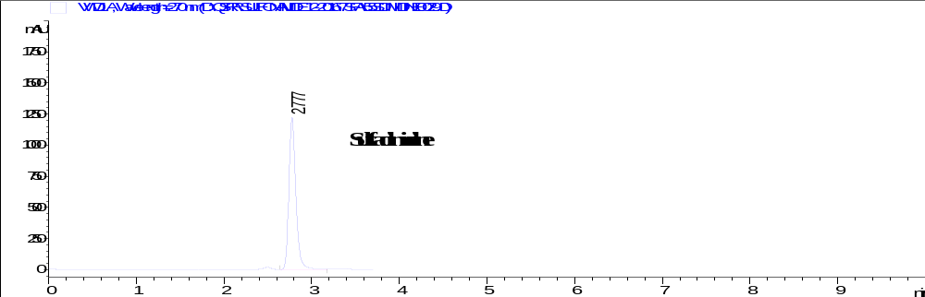
Ratio (45:55) v/v
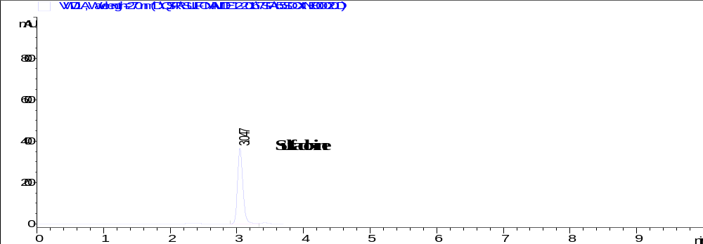
Ratio (45:55) v/v

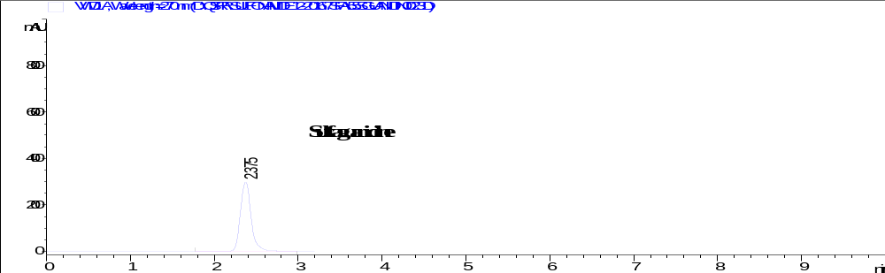
Ratio (45:55) v/v

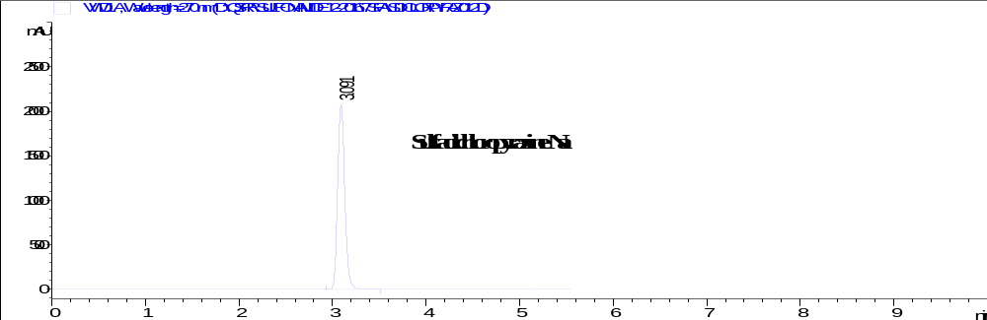
Ratio (45:55) v/v

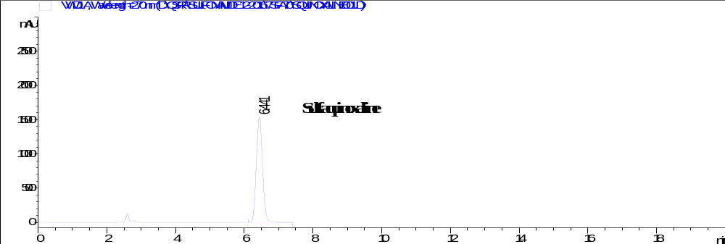
Ratio (30:70) v/v
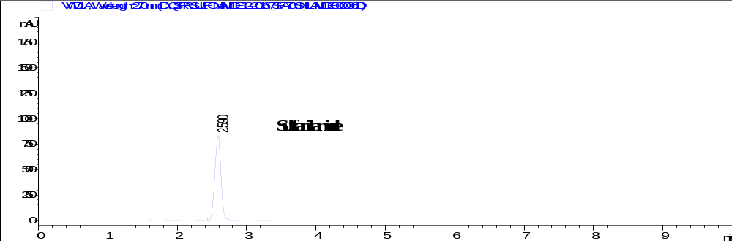
Ratio (30:70) v/v
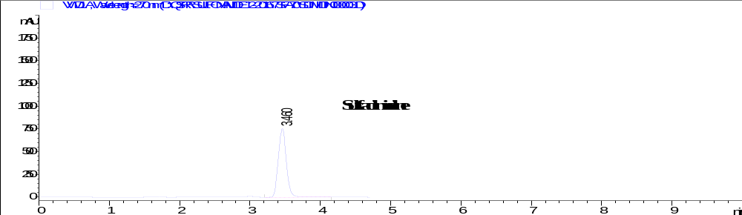
Ratio (30:70) v/v
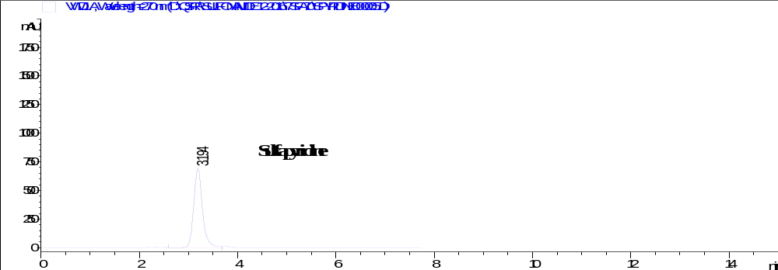
Ratio (30:70) v/v
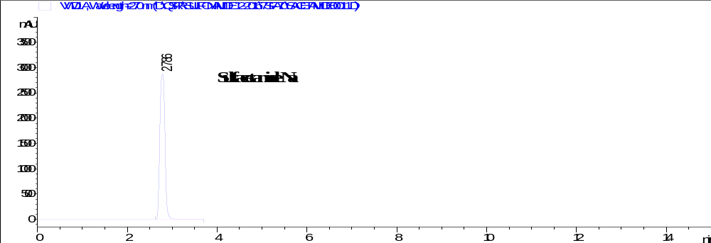
Ratio (30:70) v/v
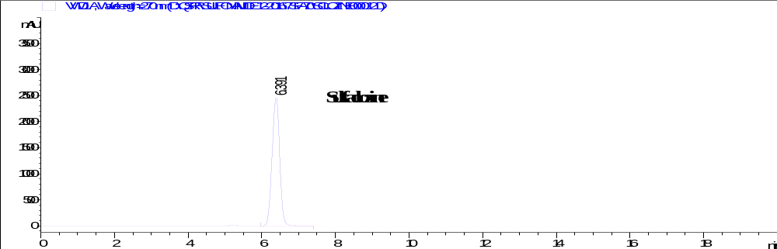
Ratio (30:70) v/v
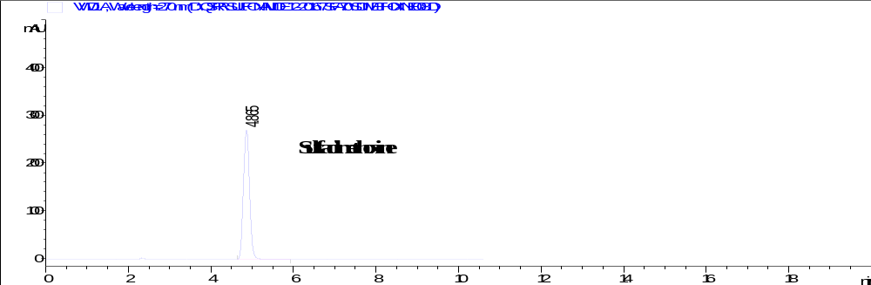
Ratio (30:70) v/v

Fig. S6: Chromatograms of different sulfonamides eluted at different ratios of acetonitrile and water acidified with trifluoroacetic acid.

Fig. S7: Training and test set predictive ability of sulfonamides FFA-SVM model.

Fig. S8: Cross validation predictive ability of sulfonamides FFA-SVM model.

Fig. S9: Residual plot for quinolones QSRR model in the training set prediction.

Fig. S10: Residual plot for sulfonamides QSRR model in the training set prediction.

