Supplementary Information

Asking the right questions: How PMS question phrasing impacts responses in an English speaking, online sample

Gabriella Kountourides ^{1*}, Alexandra Alvergne ^{1,2}
¹ School of Anthropology and Museum Ethnography, University of Oxford, UK ² ISEM, Univ Montpellier, CNRS, IRD, France*
*Corresponding author
gabriella.kountourides@sjc.ox.ac.uk
Orchid: 0000-0003-0144-5100
Word Count: 2989
Key Words: Premenstrual change, Sentiment analysis, PMS, Framing, Bayesian statistics

SI 1 Questionnaire

PDF of the questionnaire that participants filled in. Contains a maximum of 21 questions.
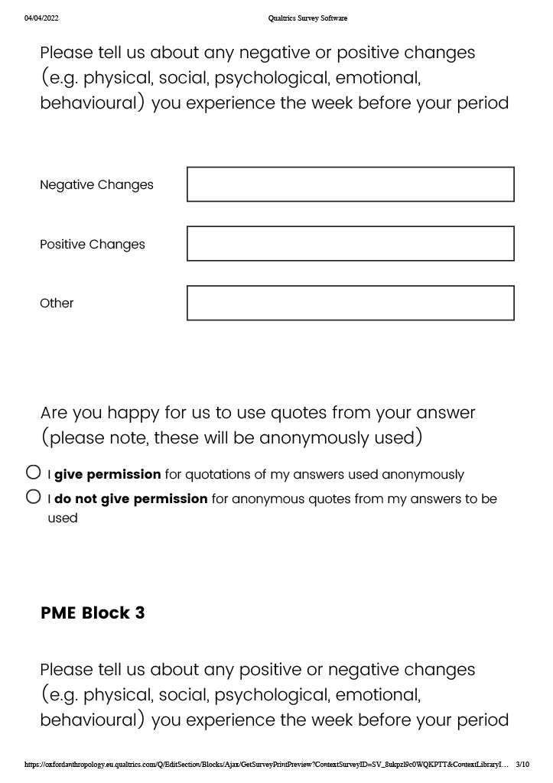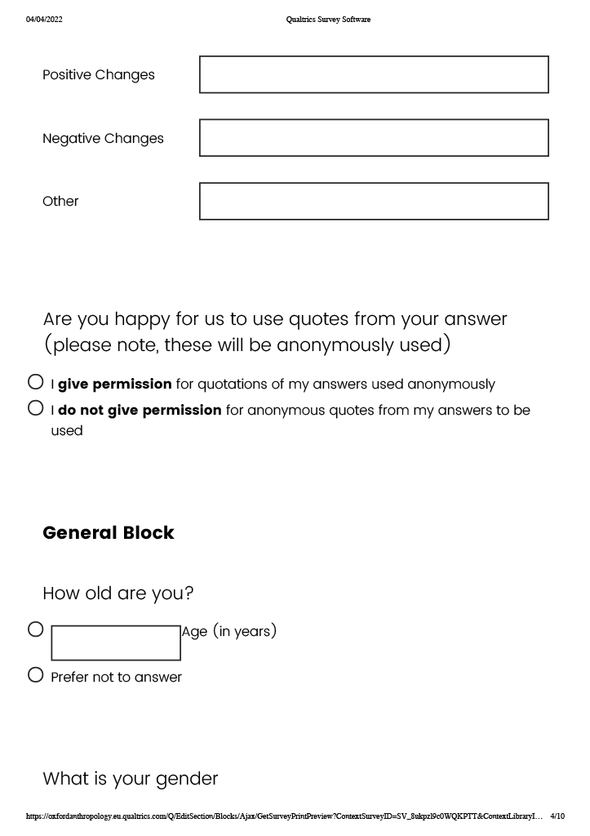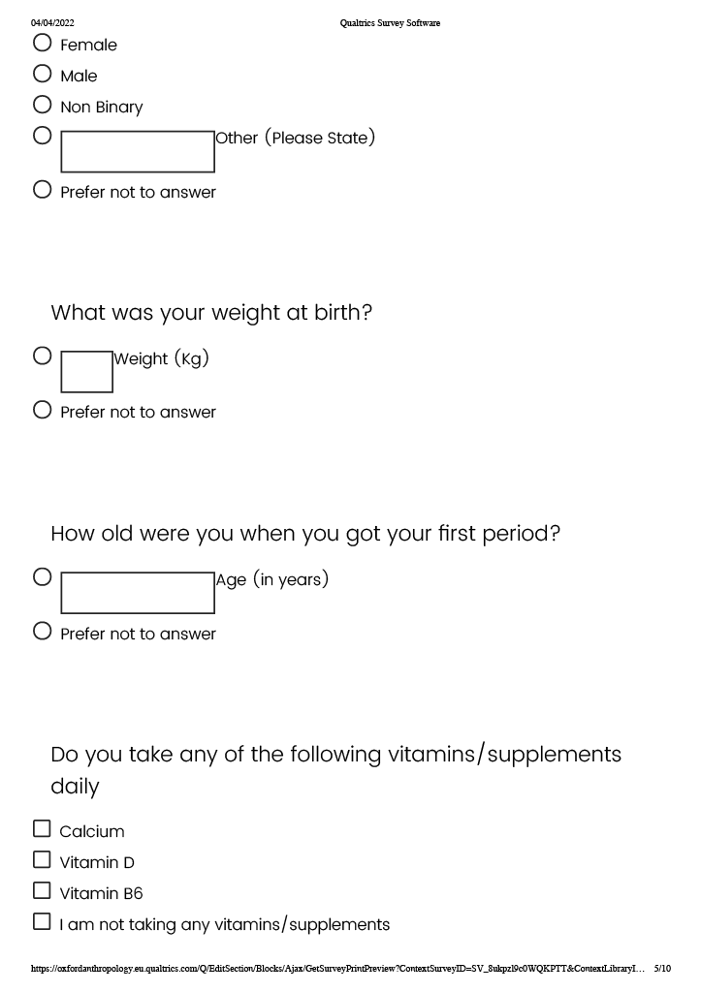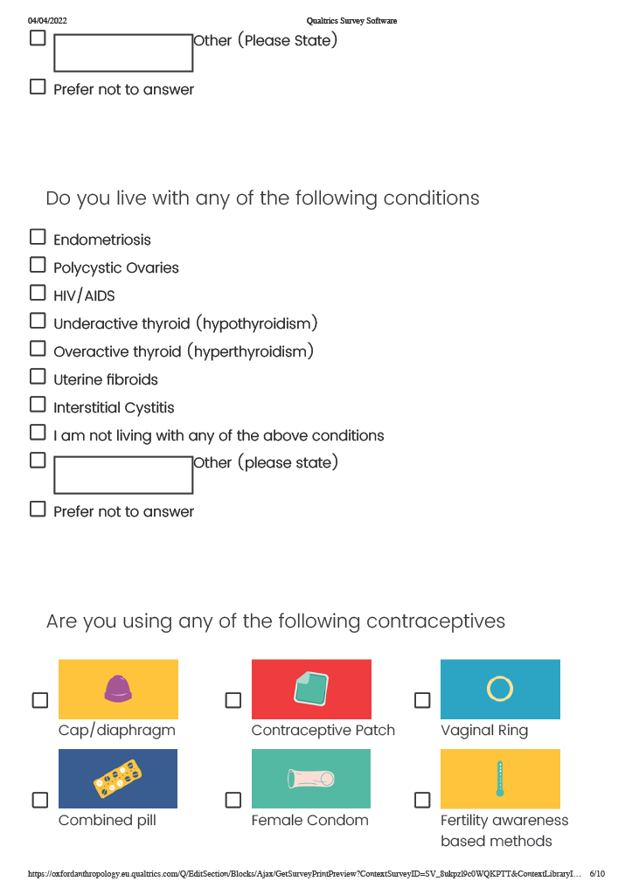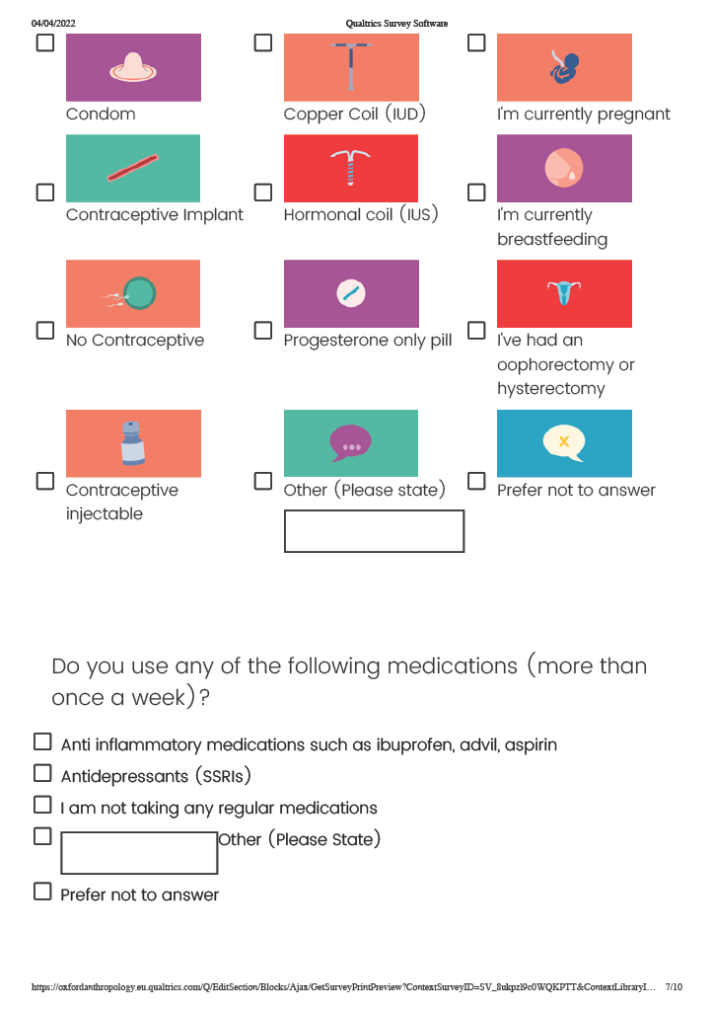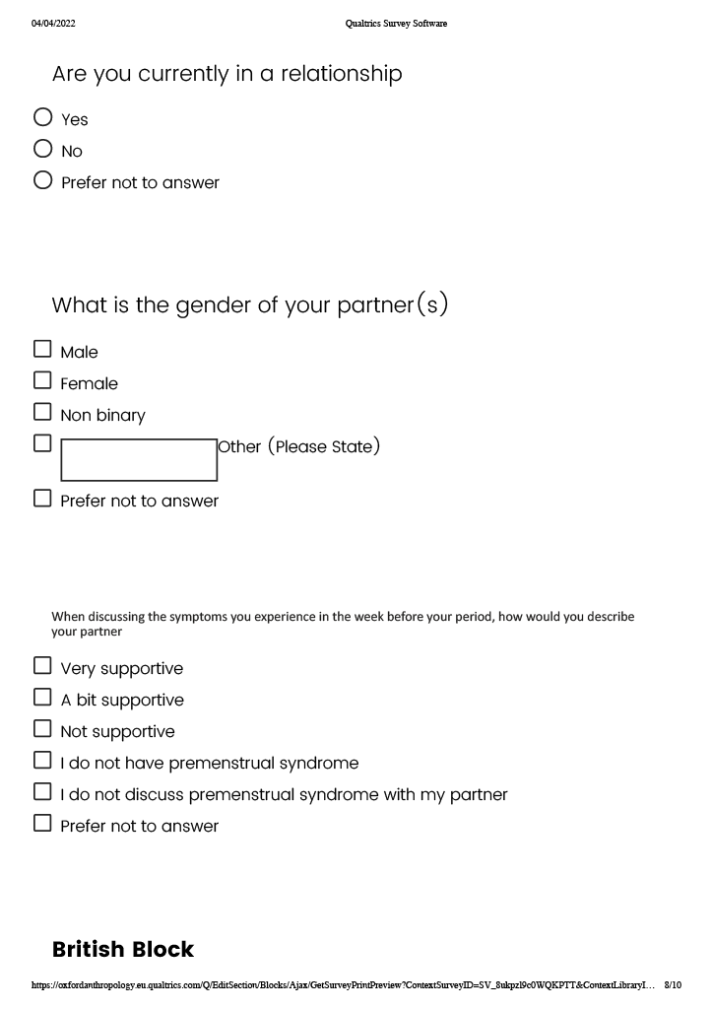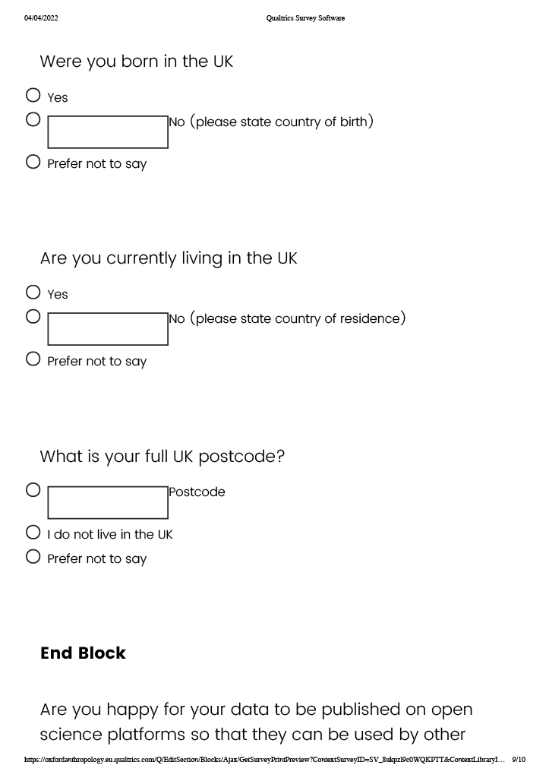

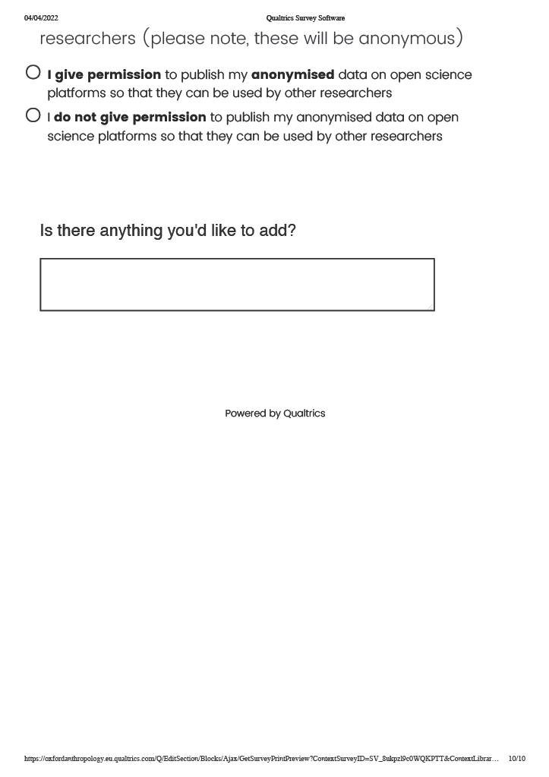

SI 2 Custom Dictionary
As Sentimentr uses a default dictionary, a list of positive and negative words, these were manually corrected to form a custom dictionary (adapted key) which was an updated Sentimentr dictionary, whereby the polarity of relevant words was edited. ‘Tender’ for example is given a default polarity of +0.75. Using word maps helped to inform the intended meaning of some of the most common words, tender was overwhelmingly used in conjunction with ‘breasts’ to mean ‘painful or tender breasts’, as such ‘tender’ was updated to provide a polarity score of -0.75. Words were added to from the original Sentimentr dictionary through the update key function. Additions made to the dictionary were made based off the score roots of the words. For example, ‘cry’ was already in the dictionary, and given a score of -0.75, and ‘tearful’ was added to the dictionary, and given a score of -0.75.
Word in Adapted Key | Score in Adapted Key | Word in Lexicon | Score in Lexicon | Description of change
able | 0.50 | N/A | N/A | given the opposite score of unable
acne | -0.50 | N/A | N/A | given the same score as blemish
actively | 0.25 | N/A | N/A | given the same score as active
activity | 0.25 | N/A | N/A | given the same score as active
angsty | -0.75 | N/A | N/A | given the same score as anxious
arthritis | -0.50 | N/A | N/A | given the same score as inflammation
assertive | 0.80 | N/A | N/A | given the same score as confident
bellyache | -0.50 | N/A | N/A | given the same score as headache
bipolar | -1.00 | N/A | N/A | given the same score as depressed
blackhead | -0.50 | N/A | N/A | given the same score as blemish
bloatedness | -0.60 | N/A | N/A | given the same score as bloat
breakout | -0.50 | N/A | N/A | given the same score as blemish
breakouts | -0.50 | N/A | N/A | given the same score as blemish
calmer | 0.75 | N/A | N/A | given the same score as calm
clumsiness | -0.75 | N/A | N/A | given the same score as clumsy
concentrate | 0.60 | N/A | N/A | given the same score as focus
concentration | 0.60 | N/A | N/A | given the same score as focus
contraction | -0.50 | N/A | N/A | given the same score as painful
cramps | -0.50 | N/A | N/A | given the same score as headache
craving | -0.25 | N/A | N/A | given the same score as hungry
cravings | -0.25 | N/A | N/A | given the same score as hungry
cross | -0.75 | N/A⁕ | N/A | given the same score as angry
demotivated | -0.80 | N/A⁕ | N/A | given opposite score to motivate
drowsy | -0.75 | N/A | N/A | given the same score as tired
dry | -0.50 | N/A | N/A | given the same score as blemish
dryness | -0.50 | N/A | N/A | given the same score as blemish
dysmorphia | -0.50 | N/A | N/A | given the same score as abnormal
eczema | -0.50 | N/A | N/A | given the same score as blemish
emotion | -0.60 | N/A | N/A | given the opposite score to unemotional
emotional | -0.60 | N/A | N/A | given the opposite score to unemotional
emotionally | -0.60 | N/A | N/A | given the opposite score to unemotional
energized | 1.00 | N/A | N/A | Given the same score as energize
energy | 0.75 | N/A | N/A | given the same score as animated
exercise | 0.60 | N/A | N/A | given the same score as sporty
full | 0.25 | N/A | N/A | given the opposite of hungry
gas | -0.60 | N/A | N/A | given the same score as bloat
gassiness | -0.60 | N/A | N/A | given the same score as bloat
gassy | -0.60 | N/A | N/A | given the same score as bloat
glowy | 0.75 | N/A | N/A | given the same score as radiant
goal-oriented | 0.60 | N/A | N/A | given the same score as ambition
heaviness | -0.50 | N/A | N/A | given the same score as fat
hornier | 0.80 | N/A | N/A | given the same score as aroused
horny | 0.80 | N/A | N/A | given the same score as aroused
hypersexual | 0.80 | N/A | N/A | given the same score as aroused
ibuprofen | -0.25 | N/A | N/A | given the same score as pill
in tune | 1.00 | N/A | N/A | given the same score as harmonious
insomnia | -1.00 | N/A | N/A | given the same score as sleepless
libido | 0.80 | N/A | N/A | given the same score as aroused
lightheaded | -0.75 | N/A | N/A | given the same score as dizzy
lightheadedness | -0.75 | N/A | N/A | given the same score as dizzy
migraine | -0.50 | N/A | N/A | given the same score as headache
moodiness | -0.50 | N/A | N/A | given the same score as irritable
moodswings | -0.50 | N/A | N/A | given the same score as irritable
neater | 0.80 | N/A | N/A | given the same score as neat
oily | -0.50 | N/A | N/A | given the same score as blemish
outgoing | 0.75 | N/A | N/A | given the same score as lively and friendly
overeat | -0.50 | N/A | N/A | given the same score as fat
overthinking | -1.00 | N/A | N/A | given the same score as overthink
painkiller | -0.25 | N/A | N/A | given the same score as pill
paracetamol | -0.25 | N/A | N/A | given the same score as pill
pmdd | -1.00 | N/A | N/A | given the same score as depressed
pms | -0.75 | N/A | N/A | given the same score as moody
premenstrual | -0.75 | N/A⬥ | N/A | given the same score as moody
prettier | 0.75 | N/A | N/A | given the same score as radiant
puffy | -0.50 | N/A | N/A | given the same score as swollen
queasiness | -0.50 | N/A | N/A | given the same score as nauseous
relax | 0.50 | N/A | N/A | given the same score as relaxed
sex drive | 0.80 | N/A | N/A | given the same score as aroused
sexual | 0.80 | N/A | N/A | given the same score as aroused
social | 1.00 | N/A | N/A | given the opposite of antisocial
sweat | -0.50 | N/A | N/A | given the same score as sweaty
swell | -0.50 | N/A | N/A | given the same score as inflammation
swing | -0.50 | N/A | N/A | given the same score as irritable
tearful | -0.75 | N/A | N/A | given the same score as cry
tire | -0.50 | N/A | N/A | given a score between tiredness (-.25) and tired (-.75)
whitehead | -0.50 | N/A | N/A | given the same score as blemish
tender | -0.75 | tender | 0.75 | given the opposite of tender
tenderness | -0.80 | tenderness | 0.8 | given the opposite of tenderness
Words added or polarity changed to Jocker's custom dictionary. Positive words in dark green, negative in dark red.
⁕written in sentences about skin
⬥'tender' existed in the dictionary, but we inversed it as the connotation was 'tender and painful breasts'

SI 3 Stop Words
Stop words are frequent words used in text which do not change the meaning of the text, for example “the”. We updated the default stop word library from Natural Language Toolkit https://gist.github.com/sebleier/554280 to include words from our data. Words were added to create a custom stop word list relevant to our responses, are shown below.
a | did | i'd | our | to
about | do | if | ours | too
above | does | in | ourselves | under
after | doing | into | out | until
again | don | is | over | up
against | down | it | own | usually
all | during | its | s | very
also | each | itself | same | was
am | entire | just | she | we
an | few | me | should | week
and | for | more | so | were
any | from | most | some | what
are | further | my | such | when
as | get | myself | t | where
at | had | n | than | which
be | has | na | that | while
because | have | nil | the | who
become | having | none | their | whom
been | he | nor | theirs | why
before | her | now | them | will
being | here | obvious | themselves | will
below | hers | of | then | with
between | herself | off | there | you
both | him | on | these | your
but | himself | once | they | yours
by | his | only | this | yourself
can | how | or | those | yourselves
days | i | other | through
Stopwords added to the default stopword list found in [https://gist.github.com/sebleier/554280]

SI 4 Creation of Lexicon Flow
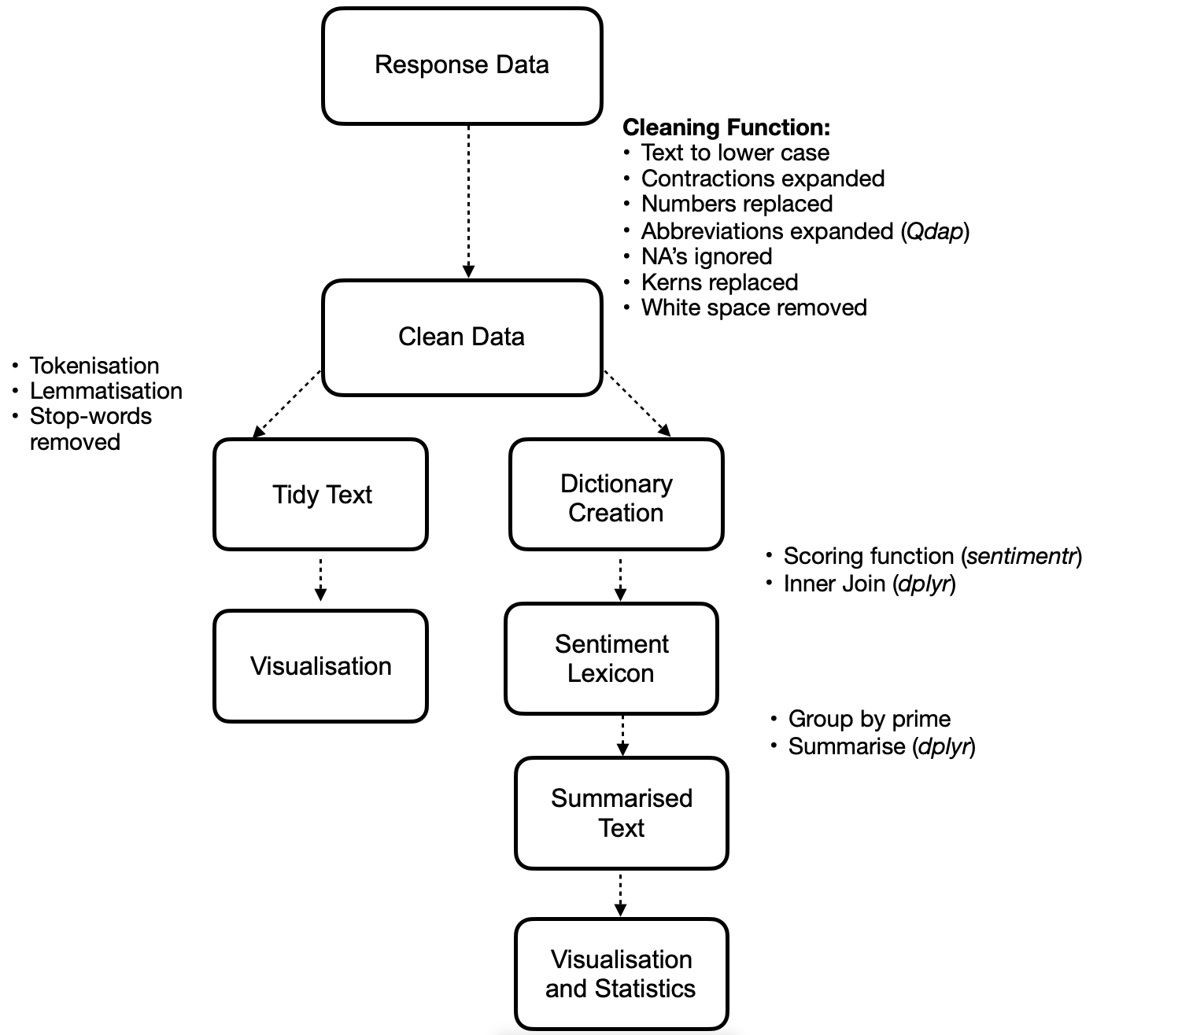

SI 5 Accuracy of sentiment analysis algorithm
We assessed the effectiveness of our sentiment analysis using McNemar’s $χ^{2}$ test to verify whether responses placed in ‘positive’ and ‘negative’ boxes correctly identified as positive and negative respectively. We compared the frequency of individuals providing text other than ‘none’ in the ‘positive’ and ‘negative’ box and the sentiment analysis accurately labelling these responses as positive and negative. In both cases, the accuracy of text analysis was significant (positive box: McNemar’s $χ^{2}$ = 143, df = 1, p-value < 0.001; negative box: $χ^{2}$= 178, df = 1, p-value < 0.001). 649 individuals wrote in the ‘positive’ box, with 506 correctly classified as positive, achieving a 78% accuracy rate. Out of 1,603 individuals who provided negative comments in the ‘negative’ box, sentiment analysis accurately identified 1,425 entries as negative, resulting in an 88.91% accuracy rate.

SI 6 Comparison of unimputed data to imputed data
We ran the full models on complete cases and obtained the similar results, thus we could be confident in our imputed data.

Model 1 on imputed and unimputed data
Output of a multinomial regression model in imputed and unimputed models. The response variable is the polarity of responses with 3 categories (positive, neutral and negative (reference category)). Bold estimates indicate significant effects.

 | Estimate | Est Error | l-95% CI | u-95% CI | Rhat | Bulk ESS | Tail ESS
Unimputed
Intercept [Neutral] | 0.03 | 1.24 | 0.02 | 0.04 | 1 | 78,809 | 82,654
Intercept [Positive] | 0.17 | 1.11 | 0.14 | 0.2 | 1 | 104,187 | 99,818
Treatment Group 1:Neutral | 3.58 | 1.27 | 2.27 | 5.77 | 1 | 90,119 | 97,468
Treatment Group 2:Neutral | 3.81 | 1.27 | 2.41 | 6.16 | 1 | 89,917 | 95,947
standardized Age:Neutral | 1.02 | 1.09 | 0.87 | 1.2 | 1 | 131,500 | 109,535
Hormonal Contraception (True):Neutral | 1.28 | 1.23 | 0.85 | 1.89 | 1 | 129,441 | 106,768
Treatment Group 1:Positive | 1.46 | 1.14 | 1.14 | 1.88 | 1 | 114,731 | 109,684
Treatment Group 2:Positive | 1.47 | 1.14 | 1.14 | 1.9 | 1 | 114,238 | 111,784
standardized Age:Positive | 0.92 | 1.06 | 0.82 | 1.02 | 1 | 139,332 | 106,510
Hormonal Contraception (True):Positive | 1.14 | 1.15 | 0.87 | 1.48 | 1 | 137,304 | 111,651
Imputed
Intercept [Neutral] | 0.03 | 1.26 | 0.02 | 0.04 | 1 | 18,046 | 17,559
Intercept [Positive] | 0.17 | 1.11 | 0.14 | 0.2 | 1 | 24,032 | 19,498
Treatment Group 1:Neutral | 3.73 | 1.29 | 2.3 | 6.21 | 1 | 20,322 | 19,650
Treatment Group 2:Neutral | 4.27 | 1.29 | 2.63 | 7.11 | 1 | 19,760 | 20,542
standardized Age:Neutral | 1.03 | 1.09 | 0.87 | 1.21 | 1 | 29,235 | 20,767
Hormonal Contraception (True):Neutral | 1.31 | 1.23 | 0.86 | 1.96 | 1 | 29,552 | 21,387
Treatment Group 1:Positive | 1.47 | 1.14 | 1.14 | 1.91 | 1 | 27,494 | 23,097
Treatment Group 2:Positive | 1.56 | 1.14 | 1.2 | 2.03 | 1 | 26,078 | 21,660
standardized Age:Positive | 0.91 | 1.06 | 0.82 | 1.02 | 1 | 29,681 | 22,028
Hormonal Contraception (True):Positive | 1.11 | 1.15 | 0.85 | 1.45 | 1 | 28,516 | 21,737

Model 2 (negative) on imputed and unimputed data
Model output for the range of negative polarity scores across experimental groups. The Estimate is the transformed (exponentiated) estimate for the model. The control group is the baseline. Bold estimates indicate significant effects.

 | Estimate | Est Error | l-95% CI | u-95% CI | Rhat | Bulk ESS | Tail ESS
Unimputed
Intercept | 0.49 | 1.03 | 0.46 | 0.52 | 1 | 16,878 | 16,394
Treatment Group 1 | 0.63 | 1.04 | 0.58 | 0.69 | 1 | 18,131 | 16,341
Treatment Group 2 | 0.62 | 1.04 | 0.57 | 0.67 | 1 | 17,972 | 17,416
standardized Age | 1.04 | 1.02 | 1 | 1.08 | 1 | 20,475 | 17,217
Hormonal | 0.99 | 1.05 | 0.9 | 1.08 | 1 | 20,624 | 17,565
Imputed
Intercept | 0.49 | 1.03 | 0.46 | 0.52 | 1 | 84,025 | 85,720
Treatment Group 1 | 0.64 | 1.04 | 0.59 | 0.69 | 1 | 86,451 | 88,743
Treatment Group 2 | 0.62 | 1.04 | 0.57 | 0.67 | 1 | 84,173 | 88,502
standardized Age | 1.04 | 1.02 | 1 | 1.08 | 1 | 104,804 | 90,509
Hormonal | 0.99 | 1.05 | 0.9 | 1.08 | 1 | 106,923 | 89,703

Model 3 (positive) on imputed and unimputed data
Model output for the range of positive polarity scores across experimental groups. The Estimate is the transformed (exponentiated) estimate for the model. The control group is the baseline. Bold estimates indicate significant effects.
 | Estimate | Est Error | l-95% CI | u-95% CI | Rhat | Bulk ESS | Tail ESS
Unimputed
Intercept | 0.18 | 1.09 | 0.15 | 0.21 | 1 | 15,383 | 14,035
Treatment Group 1 | 0.98 | 1.11 | 0.79 | 1.2 | 1 | 15,198 | 16,328
Treatment Group 2 | 0.87 | 1.11 | 0.7 | 1.07 | 1 | 15,249 | 15,475
standardized Age | 1 | 1.04 | 0.92 | 1.09 | 1 | 20,822 | 17,997
Hormonal | 0.92 | 1.11 | 0.75 | 1.14 | 1 | 21,423 | 16,808
Imputed
Intercept | 0.18 | 1.09 | 0.16 | 0.21 | 1 | 75,178 | 76,937
Treatment Group 1 | 0.97 | 1.11 | 0.79 | 1.19 | 1 | 78,321 | 81,899
Treatment Group 2 | 0.86 | 1.11 | 0.7 | 1.06 | 1 | 77,244 | 82,546
standardized Age | 1.01 | 1.04 | 0.93 | 1.1 | 1 | 101,867 | 86,870
Hormonal | 0.91 | 1.11 | 0.74 | 1.13 | 1 | 99,531 | 84,883

SI 7 Model Comparisons

We ran model comparisons for each model used, where the full model was compared to a null model to investigate the relative fit.
This was performed using an approximate leave-one-out cross-validation (LOOCV) (Vehtari 2017).
The difference in the two model's expected predictive accuracy was examined using the ELPD-LOO (expected log point wise predictive density leave-one-out cross-validation), and the better fitting model was selected.

Model 1 we categorized polarity as positive (>0), negative (0<) and neutral (0) and used a multinomial logistic regression with minimally informative priors, with the 'negative' polarity set as reference.
Full Model:
Sentiment score ∼1 + treatment group + standardized age + hormonal contraception
Null Model:
Sentiment score ∼1 + standardized age + hormonal contraception
Model comparison on ELPD-LOO revealed an estimated difference in elpd of 24.2 (SD 6.3) in favour of the full model when compared to the null model.

Model 2 (negative) focused on the range of negative polarity scores, which were inversed for the purpose of using a continuous probability distribution.
Model 3 (positive) we focused on the range of positive polarity scores.
Full Model:
Sentiment score ∼1 + treatment group + standardized age + hormonal contraception
Null Model:
Sentiment score ∼1 + standardized age + hormonal contraception
For the positive and negative models we also compared the full model to a null model, and found for both the positive and negative models an estimated difference in elpd of the null -0.7 SD 1.4 and null positive 0.7 (SD 1.4).
However, the standard errors of difference are more than double the estimate, so these models are not very different from each other.

Model | elpd_diff | se_diff
Model 1 Imputed full | 0 | 0
Model 1 Imputed null | -24.2 | 6.3
Model 2 (neg) Imputed null | 0 | 0
Model 2 (neg) Imputed full | -0.7 | 1.4
Model 2 (pos) Imputed null | 0 | 0
Model 2 (pos) Imputed full | -0.7 | 1.4

SI 8 Posterior Predictive Checks
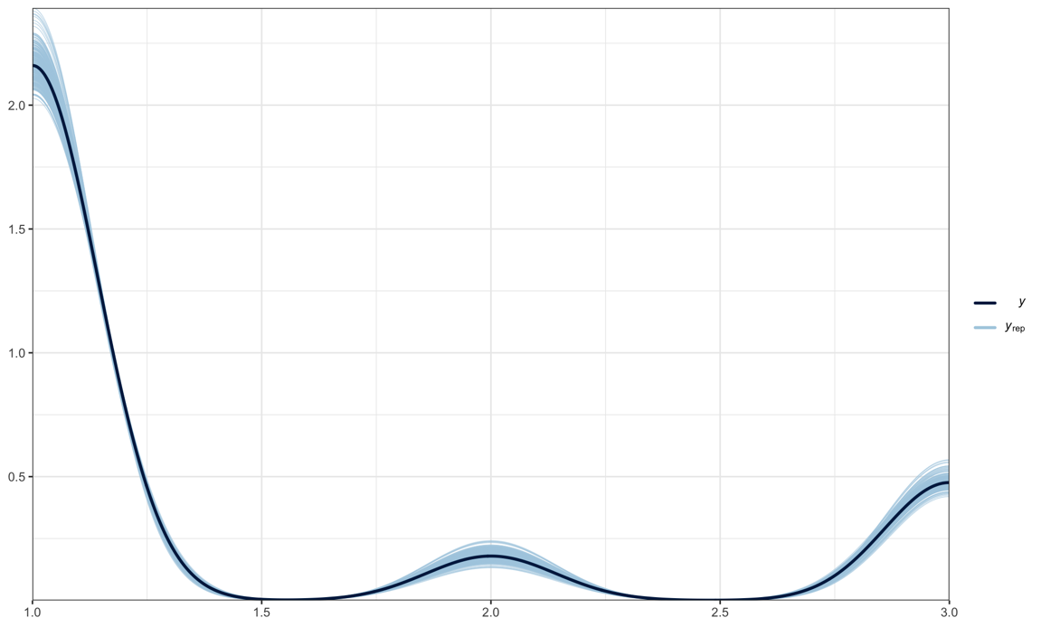
To check the model fits, we ran posterior predictive checks on the data to determine whether there were any inconsistencies between our data and simulated data from the model. These compare the predictive distribution of 𝑦rep to the observed data 𝑦.
Model 1. Posterior predictive check of final model, using 500 posterior draws of the model parameters to simulate new datasets, to check whether their distributions match the distribution of the original data. The light blue lines of the predictive posterior draws (yrep) cover the dark line of the original data (y)
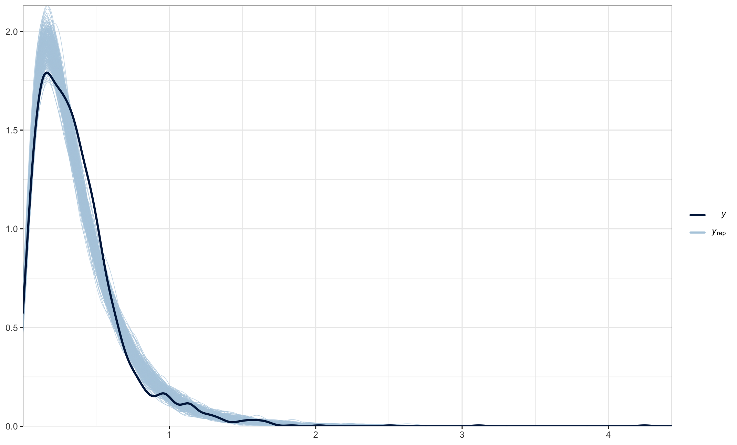
Posterior predictive check of final positive model, using 500 posterior draws of the model parameters to simulate new datasets, to check whether their distributions match the distribution of the original data. The light blue lines of the predictive posterior draws (yrep) cover the dark line of the original data (y)
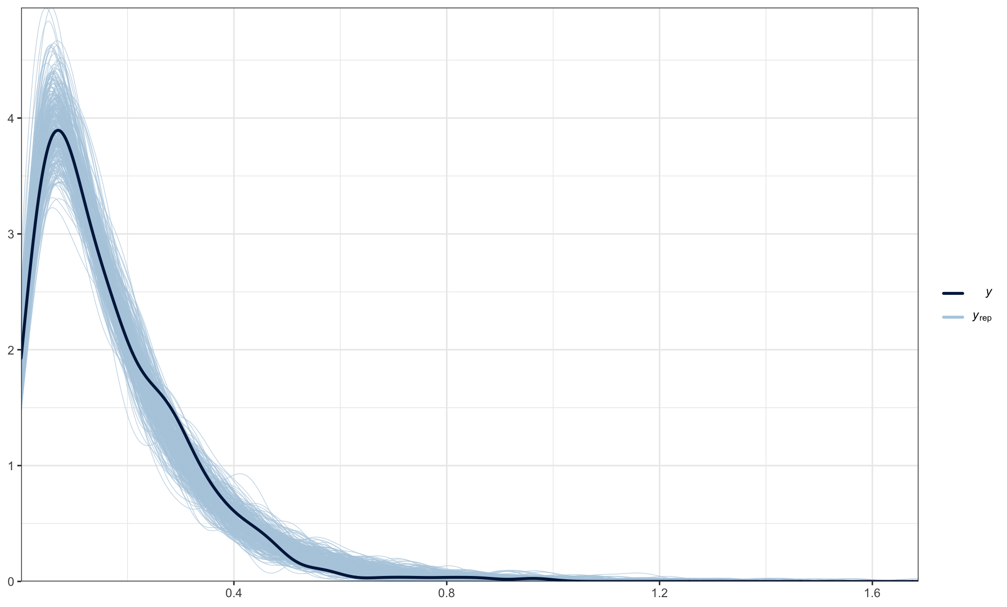
Posterior predictive check of final positive model, using 500 posterior draws of the model parameters to simulate new datasets, to check whether their distributions match the distribution of the original data. The light blue lines of the predictive posterior draws (yrep) cover the dark line of the original data (y)

SI 9 Chain Convergence
Chain convergence was inspected both visually, and by checking the Rhat values.
These values measure the ratio of the variance of pooled samples across all chains to the average variance of samples within a chain.
These were all around 1.0 which suggests that the chains are sampling from the same posterior (Ellis 2021)
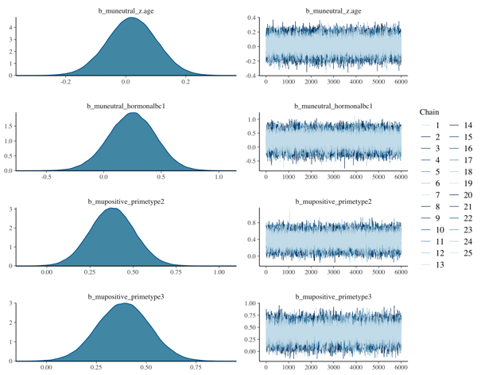
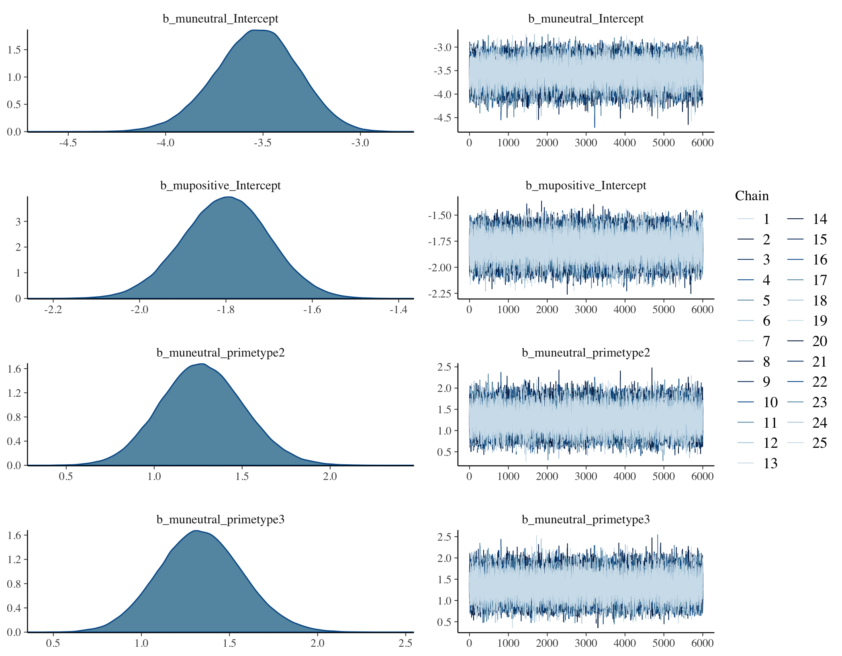
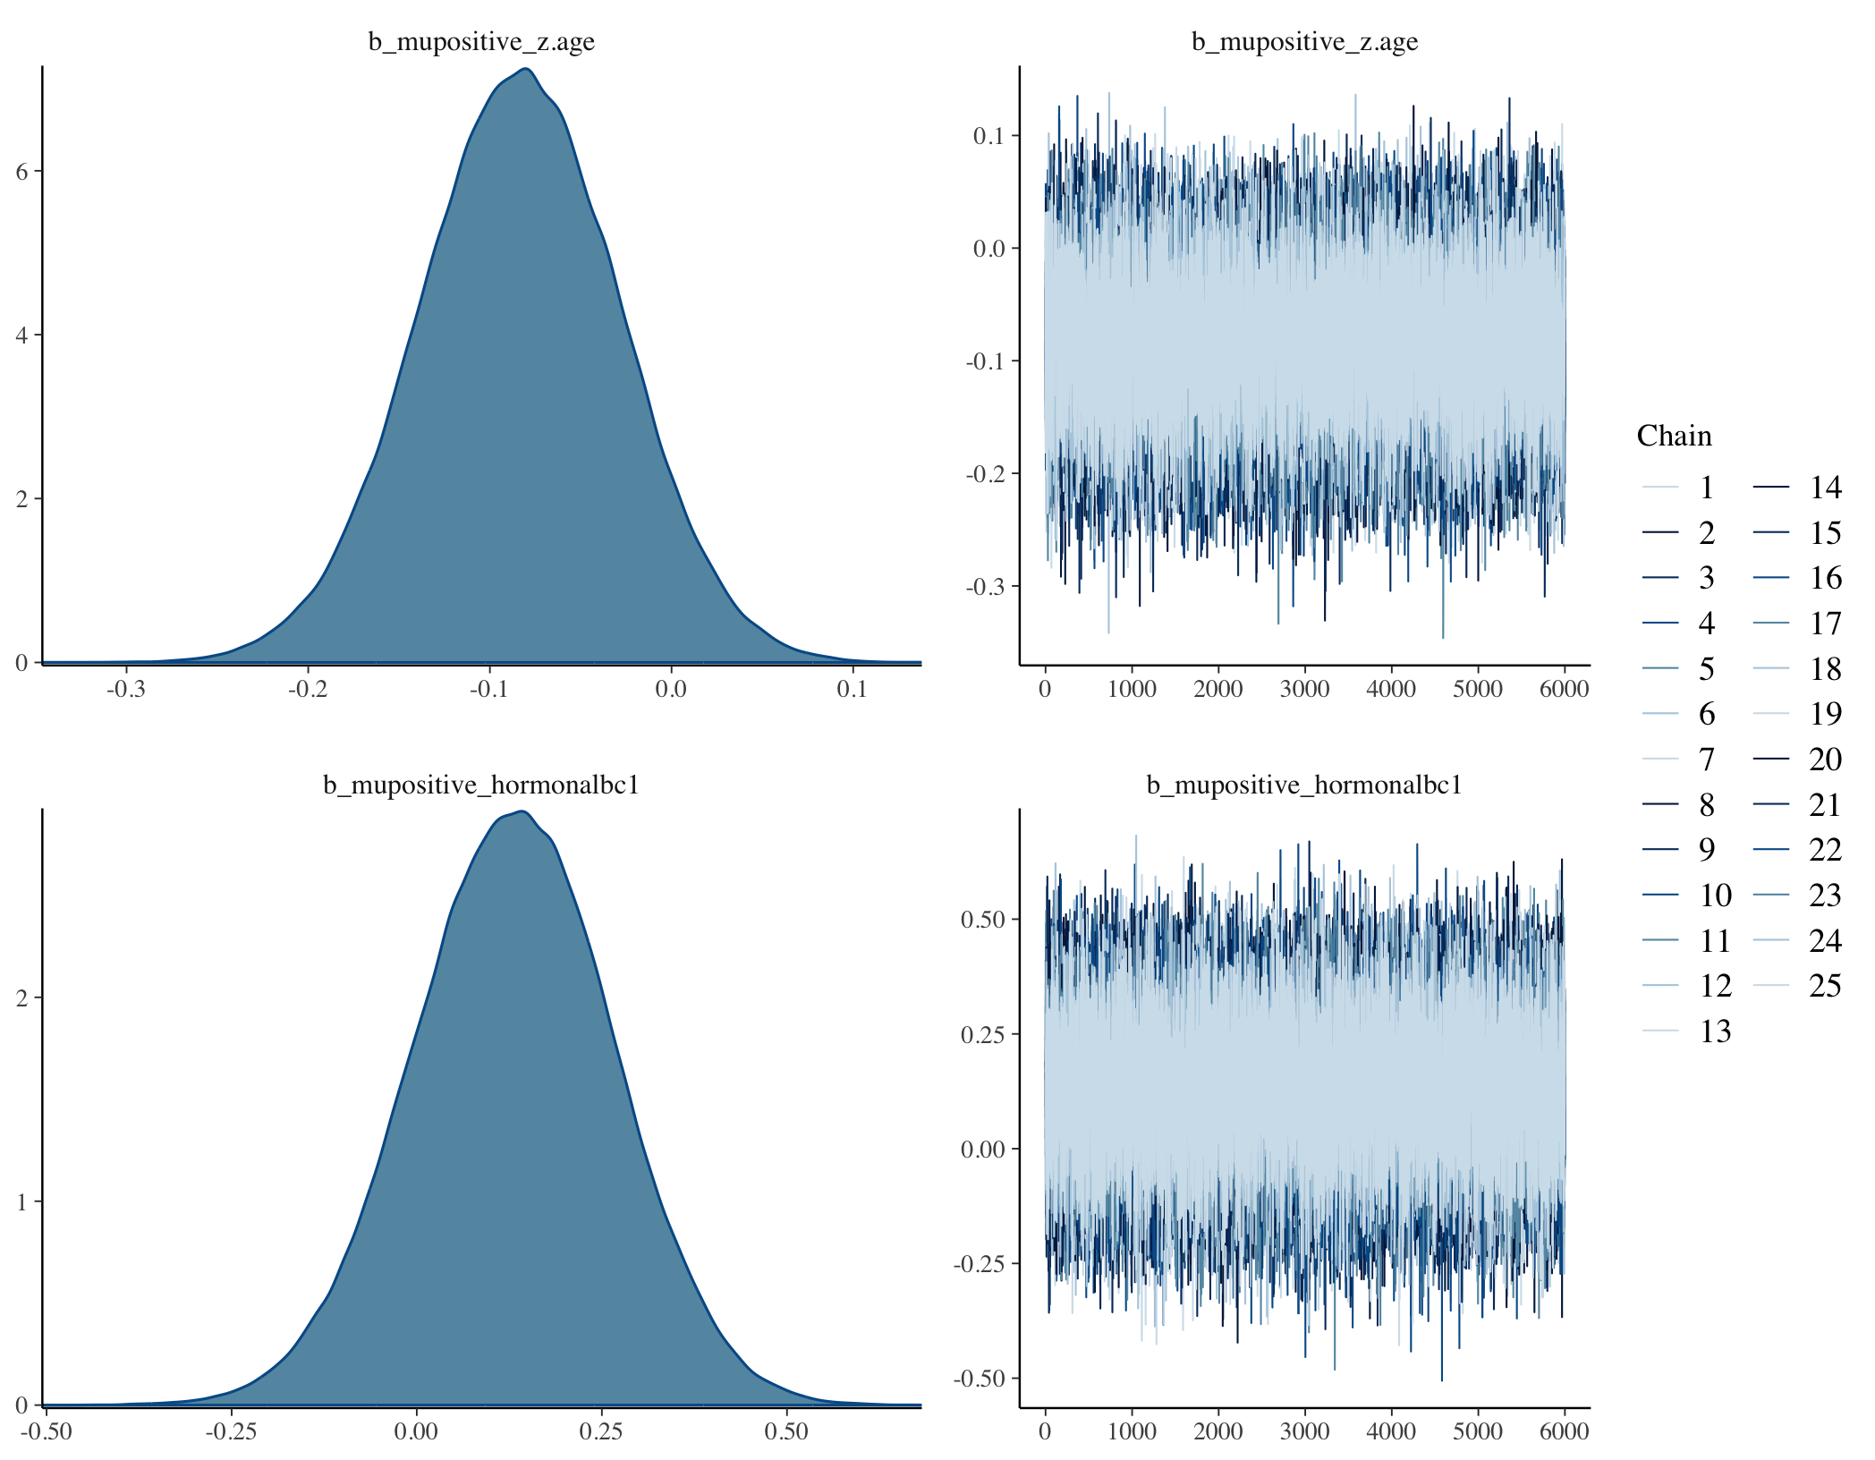
Trace plots to assess chain mixing. Negative is the baseline sentiment, while primetype 2 and 3 refer to treatment 1 and 2.Rhat <1.01 for all variables
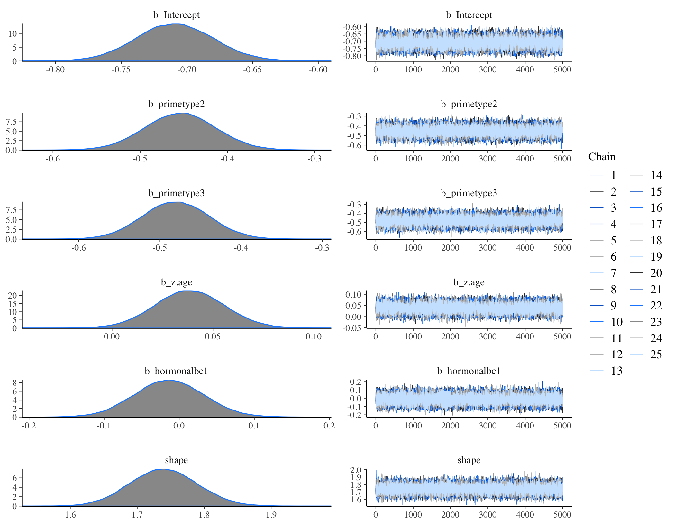
Trace plots for negative model to assess chain mixing. Negative is the baseline sentiment, while primetype 2 and 3 refer to treatment one and two. Rhat <1.02 for all variables.

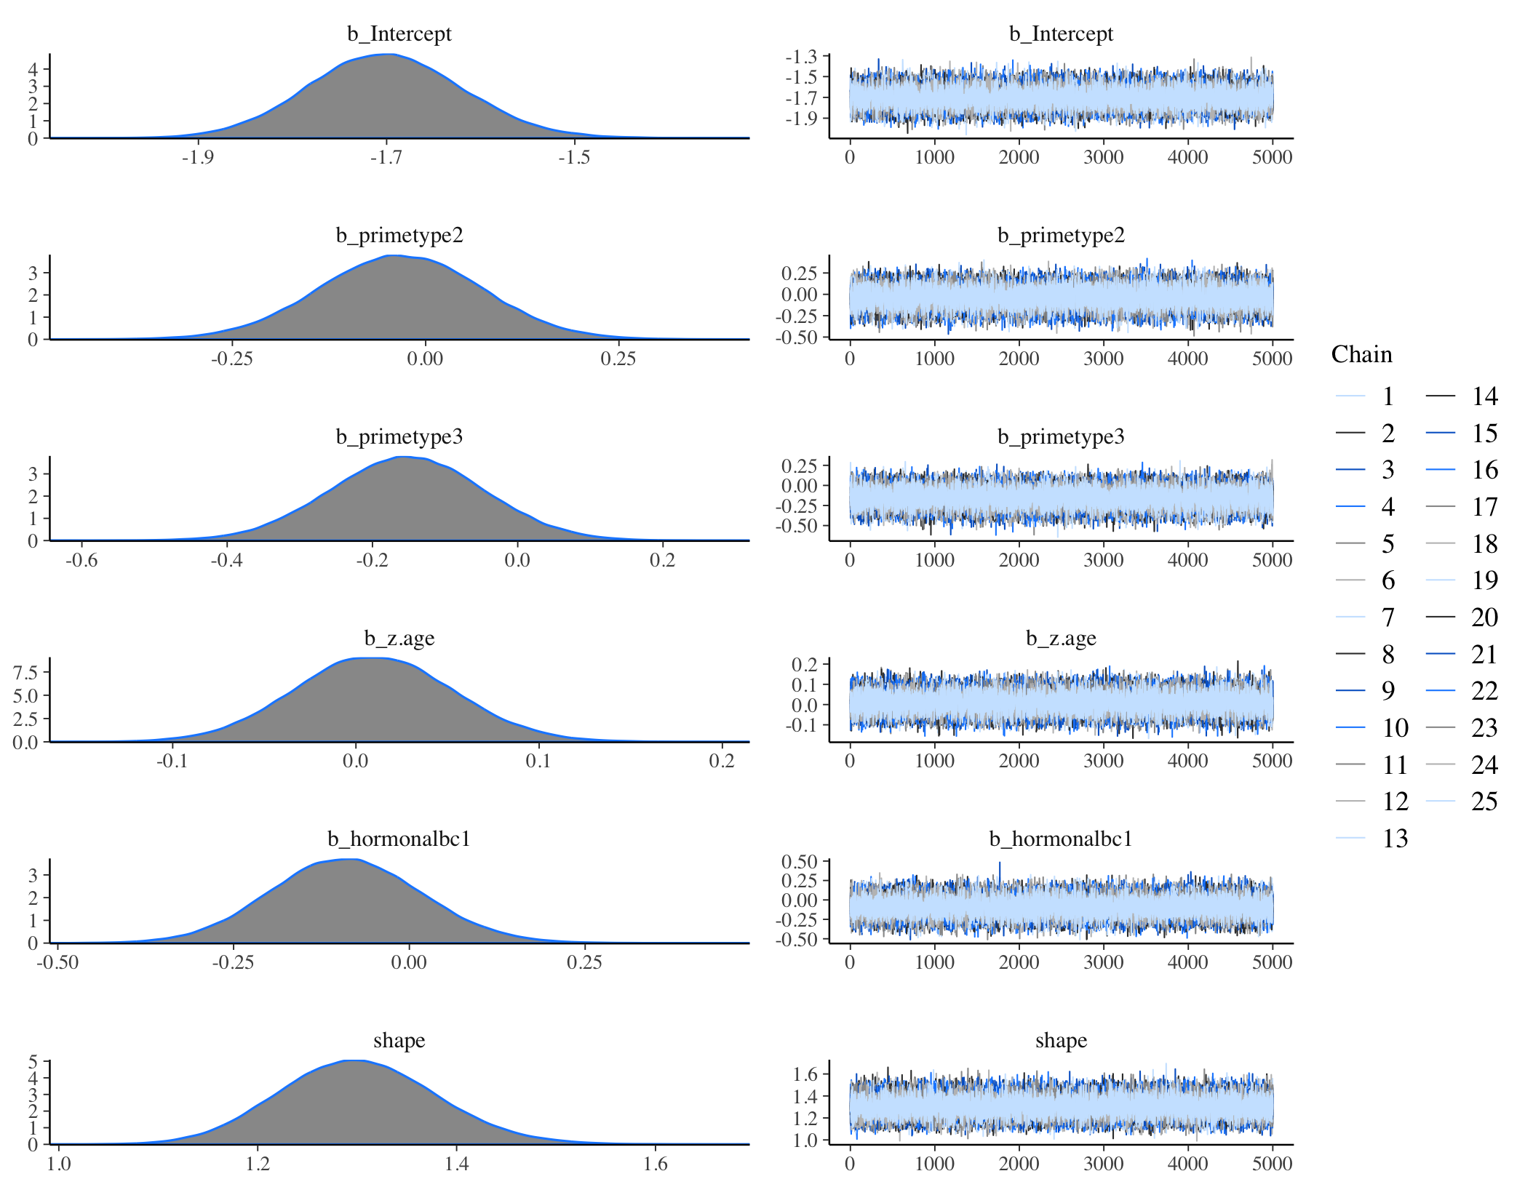
Trace plots for Positive model to assess chain mixing. Negative is the baseline sentiment, while primetype 2 and 3 refer to treatment one and two. Rhat <1.02 for all variables.

SI 10 Skew of Data

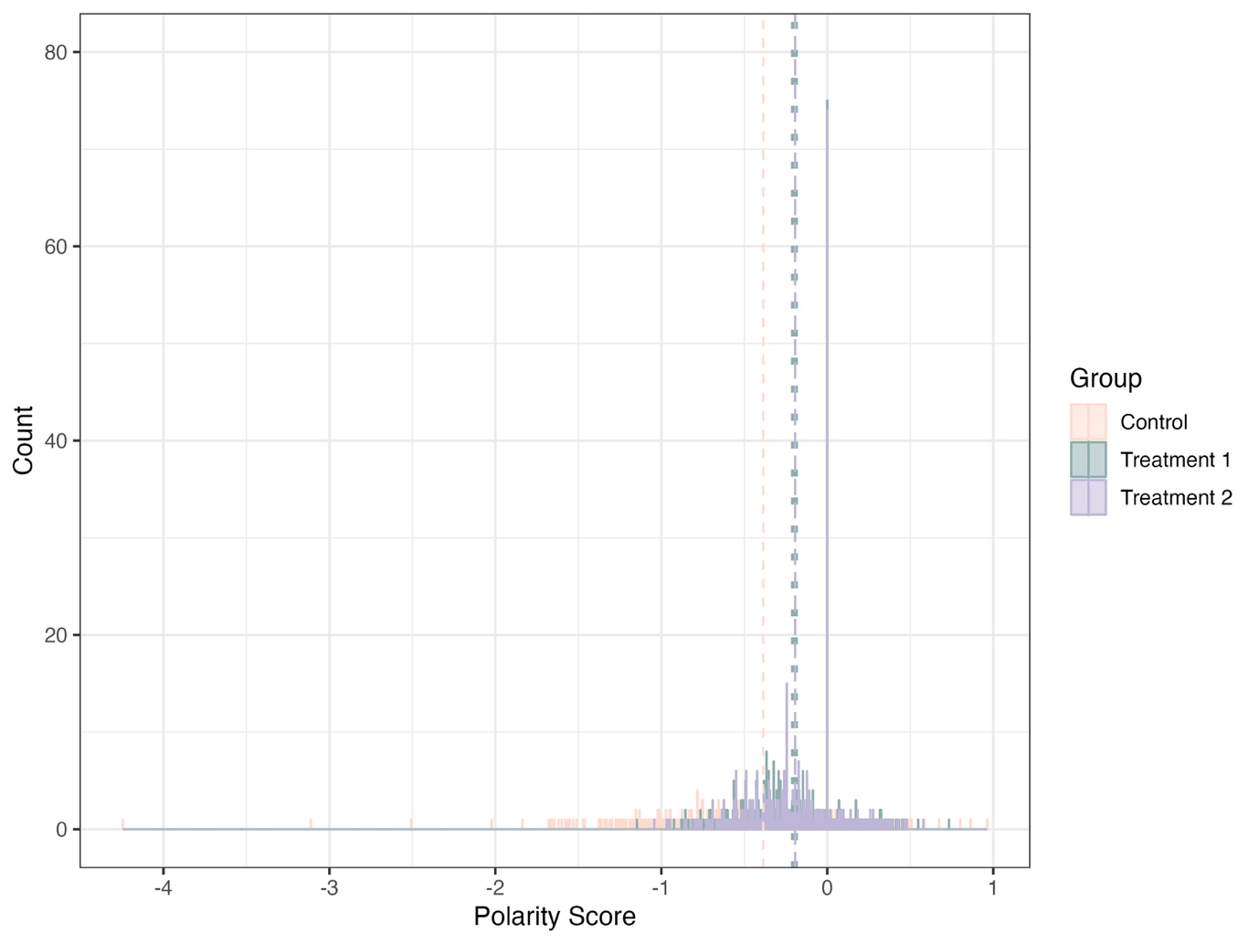
Framing effect on the polarity of premenstrual experience (PME) reports. There is a negative skew for all groups, with the control group showing the most extreme negative responses. The most common score in treatment one and two is 0. The mean for the control group is seen in the dashed pink line, dotted green for treatment one and long dashed purple for treatment two. The most common counts for treatment one and two are at 0, due to the large number of 'neutral' responses, thus the lines overlap.

SI 11 Sensitivity Analysis: age
We ran a sensitivity analysis on age, excluding participants over the age of 40.
We found no difference in the results between the full models as described in the paper and the models excluding participants over 40.
Model 1
 | Odds Ratio | Est Error | l-95% CI | u-95% CI
Intercept [Neutral] | 0.03 | 1.23 | 0.02 | 0.04
Intercept [Positive] | 0.17 | 1.11 | 0.14 | 0.2
Treatment Group 1: Neutral | 3.58 | 1.27 | 2.27 | 5.76
Treatment Group 2: Neutral | 3.81 | 1.27 | 2.42 | 6.14
standardized Age: Neutral | 1.02 | 1.09 | 0.87 | 1.2
Hormonal Contraception (True): Neutral | 1.28 | 1.23 | 0.85 | 1.89
Treatment Group 1: Positive | 1.46 | 1.14 | 1.14 | 1.88
Treatment Group 2: Positive | 1.47 | 1.14 | 1.14 | 1.9
standardized Age: Positive | 0.92 | 1.06 | 0.82 | 1.02
Hormonal Contraception (True): Positive | 1.14 | 1.15 | 0.87 | 1.49
Output of a multinomial regression model, with capped age 40. The response variable is the polarity of responses with 3 categories (positive, neutral and negative). 'Negative' was set as reference category. Bold estimates indicate significant effects. Odds Ratios for polarity response in multinomial regression model, 'negative' set as reference category age <40.
Model 2 and 3
 | Estimate | Est.Error | l-95% CI | u-95% CI | Rhat | Bulk ESS | Tail ESS
Negative
Intercept | 0.18 | 1.09 | 0.16 | 0.21 | 1 | 82,480 | 80,269
Treatment Group 1 | 0.97 | 1.11 | 0.79 | 1.19 | 1 | 84,203 | 88,330
Treatment Group 2 | 0.86 | 1.11 | 0.7 | 1.06 | 1 | 86,308 | 86,685
standardized Age | 1.01 | 1.04 | 0.93 | 1.1 | 1 | 103,038 | 88,130
Hormonal | 0.91 | 1.11 | 0.74 | 1.13 | 1 | 102,965 | 86,201
Positive
Intercept | 0.18 | 1.09 | 0.16 | 0.21 | 1 | 84,278 | 78,372
Treatment Group 1 | 0.97 | 1.11 | 0.79 | 1.19 | 1 | 82,314 | 84,425
Treatment Group 2 | 0.86 | 1.11 | 0.7 | 1.06 | 1 | 83,072 | 87,886
standardized Age | 1.01 | 1.04 | 0.93 | 1.1 | 1 | 107,477 | 87,397
Hormonal | 0.91 | 1.11 | 0.74 | 1.13 | 1 | 106,450 | 86,036
Model output for the range of negative and positive polarity scores across experimental groups with age capped at 40. The Estimate is the transformed (exponentiated) estimate for the model. The control group is the baseline

SI 12 Sensitivity Analysis: Contraception

 | Odds Ratio | Est Error | l-95% CI | u-95% CI
Intercept [Neutral] | 0.02 | 1.3 | 0.01 | 0.04
Intercept [Positive] | 0.17 | 1.12 | 0.14 | 0.21
Treatment Group 1:Neutral | 4.01 | 1.34 | 2.31 | 7.24
Treatment Group 2:Neutral | 5 | 1.34 | 2.91 | 9.03
standardized Age:Neutral | 1.08 | 1.1 | 0.9 | 1.3
Combined(True):Neutral | 1.32 | 1.29 | 0.78 | 2.16
Copper IUD(True):Neutral | 1.24 | 1.41 | 0.61 | 2.34
Progestin (True):Neutral | 1.61 | 1.42 | 0.79 | 3.09
Sterilised (True):Neutral | 0.38 | 3.77 | 0.02 | 2.84
Treatment Group 1:Positive | 1.46 | 1.15 | 1.12 | 1.92
Treatment Group 2:Positive | 1.56 | 1.15 | 1.19 | 2.05
standardized Age:Positive | 0.95 | 1.06 | 0.85 | 1.07
Combined(True):Positive | 1.1 | 1.18 | 0.8 | 1.51
Copper IUD(True):Positive | 0.86 | 1.26 | 0.54 | 1.35
Progestin (True):Positive | 1.1 | 1.27 | 0.68 | 1.72
Sterilised (True):Positive | 0.63 | 1.98 | 0.14 | 2.1
Output of the multinomial regression model 1. The response variable is the polarity of responses with 3 categories (positive, neutral and negative). 'Negative' and 'No contraception' were reference categories. Bold estimates indicate significant effects. Odds Ratios for polarity response in multinomial regression model, 'negative' set as reference category, contraception (none as reference)

 | Estimate | Est Error | l-95% CI | u-95% CI | Rhat | Bulk ESS | Tail ESS
Negative
Intercept | 0.49 | 1.03 | 0.46 | 0.53 | 1 | 19,214 | 17,733
Treatment Group 1 | 0.63 | 1.04 | 0.58 | 0.69 | 1 | 20,813 | 18,802
Treatment Group 2 | 0.62 | 1.05 | 0.57 | 0.68 | 1 | 21,062 | 18,529
standardized age | 1.04 | 1.02 | 1 | 1.08 | 1 | 24,312 | 18,635
Combined(True) | 0.99 | 1.06 | 0.89 | 1.11 | 1 | 22,566 | 18,629
Copper IUD(True) | 1.03 | 1.07 | 0.9 | 1.19 | 1 | 23,958 | 18,484
Progestin (True) | 0.97 | 1.08 | 0.84 | 1.14 | 1 | 25,339 | 18,568
Sterilised (True) | 1.05 | 1.2 | 0.75 | 1.52 | 1 | 24,152 | 16,375
Positive
Intercept | 0.18 | 1.09 | 0.15 | 0.22 | 1 | 18,783 | 16,202
Treatment Group 1 | 0.99 | 1.12 | 0.79 | 1.23 | 1 | 19,617 | 18,480
Treatment Group 2 | 0.86 | 1.12 | 0.69 | 1.08 | 1 | 19,094 | 17,190
standardized age | 1 | 1.05 | 0.91 | 1.1 | 1 | 23,342 | 18,689
Combined(True) | 0.94 | 1.13 | 0.74 | 1.21 | 1 | 23,724 | 18,511
Copper IUD(True) | 0.92 | 1.21 | 0.64 | 1.35 | 1 | 22,444 | 16,588
Progestin (True) | 0.8 | 1.2 | 0.56 | 1.17 | 1 | 23,442 | 17,145
Sterilised (True) | 0.36 | 1.74 | 0.14 | 1.22 | 1 | 21,589 | 12,561
Model output for the range of negative and positive polarity scores across experimental groups.

