Depth (m) | Soil stratigraphy | Sketch of stratigraphy | Soil hardness (mm) | Description
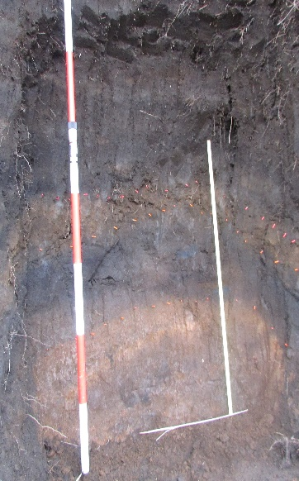 |  |  |  | Topsoil (0.24 m)  Brown-black colour, lowest soil hardness (average 12.6 mm).
Loam (0.20 m)
Brown-black colour, soil hardness higher than topsoil (average 16.8 mm).
0.50 |  |  |  | N1 kuroboku (0.19 m)  Black colour, soil hardness is higher than N3-4 kuroboku (average 16.7 mm).
N2 scoria (0.20 m)
Orange-brown colour, soil hardness is highest in Takadake 1 (average 18.5 mm).
N3-4 kuroboku (0.20 m)
Black colour, soil hardness is lower than N1 kuroboku (average 14.5 mm).
1.00

OJS scoria (0.36 m)
Orange colour, soil hardness is lower than N2 scoria (average 15.7 mm).
1.50
Table 1. Soil stratigraphy; dotted lines indicate slip surface by field observation
- Takadake 1
- Takadake 2
Depth (m) | Soil stratigraphy | Sketch of stratigraphy | Soil hardness (mm) | Description
 | 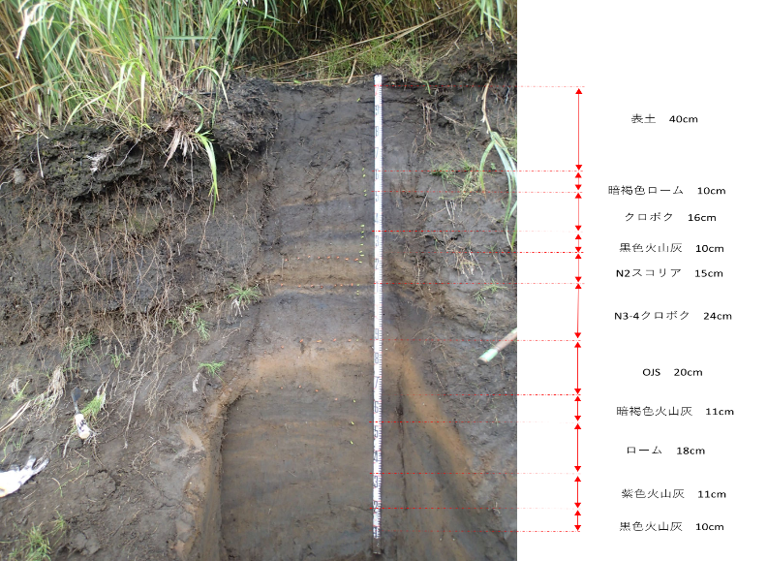 |  |  | Topsoil (0.40 m)  Black colour, generally contains medium to fine grain size.
0.50 |  |  |  | Loam (0.10 m) Brown colour.
 |  |  |  | N1 kuroboku (0.16 m) Black colour, generally contains fine to medium grain size.
 |  |  |  | N2 kuroboku (0.15 m) Black colour, generally contains fine to medium grain size. Fine grain size is higher than N1 kuroboku.
 |  |  |  | N2 scoria (0.12 m) Brown-orange colour, generally contains medium to fine grain size.
1.00 |  |  |  | N3-4 kuroboku (0.24 m) Black colour, generally contains medium to fine grain size.
 |  |  |  | OJS scoria (0.20 m) Brown-orange colour, generally contains medium to fine grain size.
1.50

