Serum interleukin-6 and interleukin-10 responses in patients after major trauma: a prospective observational two centre study

¹Jones M., ²Hanison J., ¹Apreutesei R., ¹Allarakia B., ^{1,4}Namvar S., ¹Ramaswamy D. S., ^{3,4}Horner D., ¹Smyth L., ^{2,6}Body R., ²Columb M., ^{2,6}Nirmalan M., ^{*1}Nirmalan N.

- School of Science, Engineering and Environment, University of Salford, Manchester, M5 4WT.
- Manchester University NHS Foundation Trust (MFT), M13 9PL
- Salford Royal Foundation Trust (SRFT), Stott Lane, Salford M6 8HD
- Division of Infection, Immunity and Respiratory Medicine, University of Manchester
- Faculty of Biology Medicine and Health, School of Biological Sciences, University of Manchester, Manchester Academic Health Science Centre, Manchester, UK
- Faculty of Biology, Medicine and Health, University of Manchester, Oxford Road, Manchester

Corresponding author:
Niroshini Nirmalan
E-mail: N.J.Nirmalan@salford.ac.uk

Supplementary material
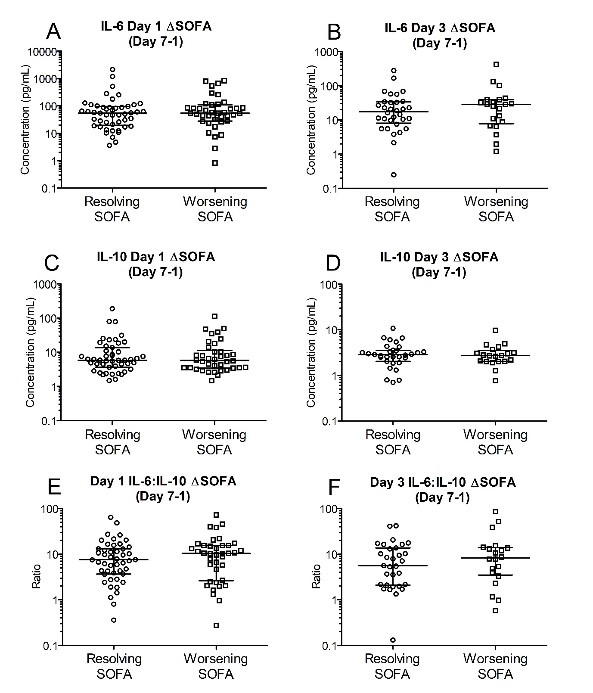Supplementary Figure 1. Early (day 1 and 3) IL-6, IL-10, and IL-6:IL-10 ratios in the two groups based on ΔSOFA (SOFA _{Day 7}-SOFA _{Day 1}).
Patients were retrospectively categorized according to their ΔSOFA, a calculated change in SOFA value (SOFA_{Day7} – SOFA_{Day1} score), creating two patient groups: ΔSOFA <0 (resolving condition) and ΔSOFA ≥0 (worsening condition). A-B. IL-6 levels on day one (56.17 [20.16-92.76] Vs 54.83 [30.22-97.50] pg/mL; n = 89, P =0.904) and day three (17.37 [9.18-32.94] Vs 28.58 [8.83-38.94] pg/mL; n =52, P = 0.506) did not differ between the two groups. C-D. IL-10 levels on days one (5.87 [3.78-12.36] Vs 5.77 [3.51-10.47] pg/mL; n = 89, P =0.757) and three (2.86 [2.22-3.51] Vs 2.72 [2.03-3.29] pg/mL; n = 52, P =0.734) were also not significantly different between the two groups. E-F. IL-6:IL-10 ratios on days one (7.51 [3.78-13.14] Vs 10.36 [3.19-15.46]; n = 87, P =0.411) and day three (5.60 [2.13-13.37] Vs 8.22 [3.86-13.70]; n = 52, P =0.282) were not significantly different between the two groups. All data expressed as median [Interquatiles].
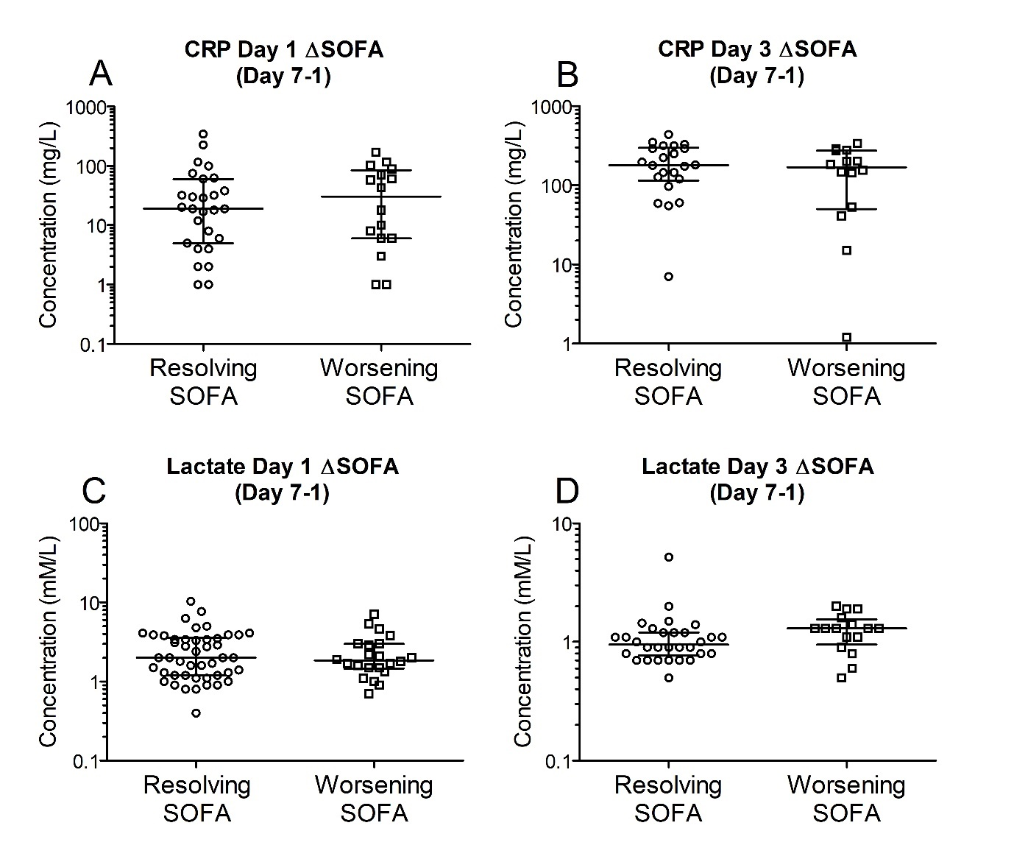Supplementary Figure 2. Early (day 1 and Day 3) C-reactive protein and serum lactate levels in blood in the two groups based on ΔSOFA (SOFA _{Day 7}-SOFA _{Day 1}).
Patients were retrospectively categorized according to their ΔSOFA, a calculated change in SOFA (SOFA_{Day7} – SOFA_{Day1} score), creating two patient groups: ΔSOFA <0 (resolving condition) and ΔSOFA ≥0 (worsening condition). A-B. C-reactive protein levels at days 1 and 3 were not significantly different between the two groups. C-D. Serum lactate levels at days 1 and 3 were also not significantly different between the two groups.

Supplementary Table 1. Patient characteristics and clinical parameters on admission in patients stratified on outcome five days following trauma.
Variable | All Patients  (n=91) | SOFA < 2 on day 5 after admission  (n=53) | SOFA ≥ 2 on day 5 after admission or Death (n=38) | Odds Ratio  (95% CI) | P value
Age (Years) | 41.5 [29.0-60.8] | 39.3 [28.0-53.0] | 43.4 [29.5-64.0] | 1.01 (0.99-1.03) | 0.55
Sex (Male) | 66 (72.5) | 36 (67.9) | 30 (78.9) | 1.56 (0.58-4.21) | 0.38
HR (min⁻¹) | 99.0 [13.0-112.0] | 101.0 [90.0-113.5] | 95.0 [76.0-107.0] | 0.99 (0.97-1.01) | 0.16
SBP (mmHg) | 118.5  [98.8-144.0] | 110.0  [94.5-147.0] | 129.0  [106.0-142.5] | 1.01 (0.99-1.02) | 0.13
DBP (mmHg) | 64.0 [53.0-77.0] | 63.0 [53.0-79.5] | 66.0 [53.0-77.0] | 1.01 (0.98-1.03) | 0.50
GCS | 15.0 [6.0-15.0] | 15.0 [14.0-15.0] | 10.0 [3.0-15.0] | 0.84 (0.75-0.95) | 0.003**
FiO2 | 0.30 [0.21-0.52] | 0.31 [0.21-51.5] | 0.25 [0.21-0.65] | 1.00 (0.98-1.02) | 0.94
PF ratio | 31.4 [7.3-49.4] | 39.2 [21.6-58.0] | 10.3 [3.8-34.2] | 0.99 (0.98-1.01) | 0.99
WCC (x10⁹ L⁻¹) | 14.4 [10.0-19.0] | 13.7 [10.0-18.8] | 15.4 [10.5-19.8] | 1.02 (0.99-1.04) | 0.19
CRP (mg L⁻¹) | 18.0 [6.0-60.5] | 19.0 [5.0-58.0] | 17.0 [6.8-72.0] | 1.00 (0.99-1.01) | 0.29
Lactate  (mmol L⁻¹) | 2.0 [1.4-3.7] | 1.8 [1.2-3.4] | 2.9 [1.7-4.8] | 1.20 (0.90-1.59) | 0.22
ISS | 25.0 (9.0-41.0] | 23.5 [16.0-29.0] | 27.5 [15.5-38.75] | 1.04 (1.0-1.08) | 0.062
APACHE II | 9.0 [6.5-12.0] | 9.0 [7.0-11.0] | 9.5 [3.3-14.0] | 1.05 (0.88-1.25) | 0.60
SOFA | 4.5 [1.0-9.0] | 3.0 [1.0-5.0] | 8.0 [4.0-10.0] | 1.25 (1.10-1.42) | 0.001**
Antibiotics | 62 (68.1) | 41 (77.4) | 21 (55.3) | 0.36 (0.15-0.90) | 0.022*
IPPV | 42 (46.2) | 19 (35.8) | 23 (60.5%) | 2.74 (1.16-6.51) | 0.022*
Data has been stratified according to SOFA scores five days post trauma and presented as median [interquartiles] and count (%). Odds ratio is presented with 95% confidence interval (CI). * = P <0.05, ** = P <0.01.

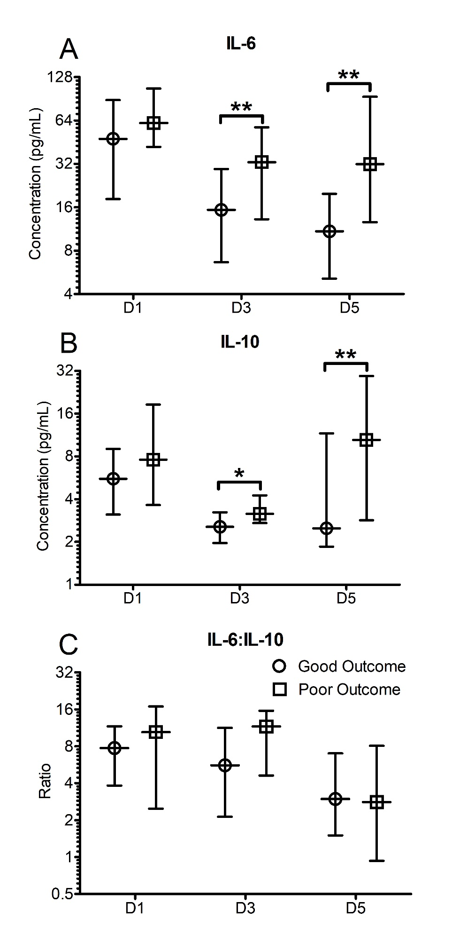
Supplementary Figure 3. Cytokine profiles significantly differ when stratified based on outcomes five days post trauma.
Patients were stratified based on good and poor outcomes based on their SOFA scores five days post trauma. Good outcome was classified as a SOFA score of <2, whilst poor outcome was classified as a SOFA score ≥2 five days post traumatic injury or death. A. The IL-6 levels on day 3 and day 5 were significantly greater in poor outcome patients than good outcome patients at day 5. B. The IL-10 levels on day 3 and day 5 were significantly greater in patients with a poor outcome on day 5 than in patients who had a good outcome. C. The profile of the IL-6:IL-10 ratio was found to not significantly different between the groups. All data presented as median [Interquartiles]. Statistical significance was determined using Mann-Whitney U tests. * = P <0.05, ** = P <0.01.
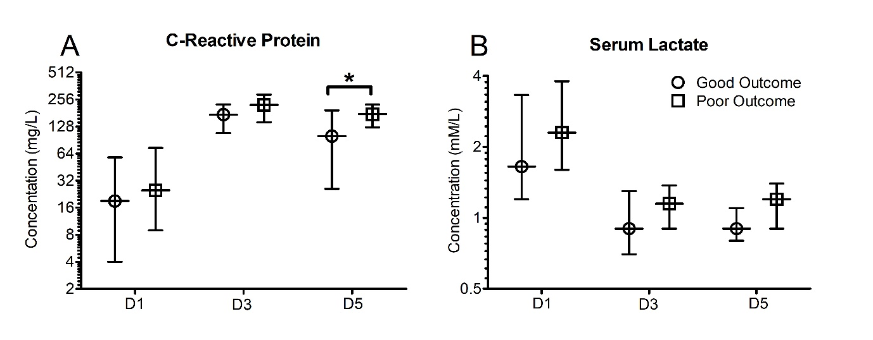Supplementary Figure 4. Early (Day 1, 3 and 5) C-reactive protein and serum lactate poorly predict patient outcome when stratified based on outcome five days post trauma.
Patients were stratified based on good and poor outcomes based on their SOFA scores five days post trauma. Good outcome was classified as a SOFA score of <2, whilst poor outcome was classified as a SOFA score ≥2 five days post traumatic injury or death. A. C-reactive protein levels on day 5 were significantly greater in the poor group. B. Serum lactate concentrations were not significantly different between the groups. All data presented as median [Interquartiles]. Statistical significance was determined using Mann-Whitney U tests. * = P <0.05.
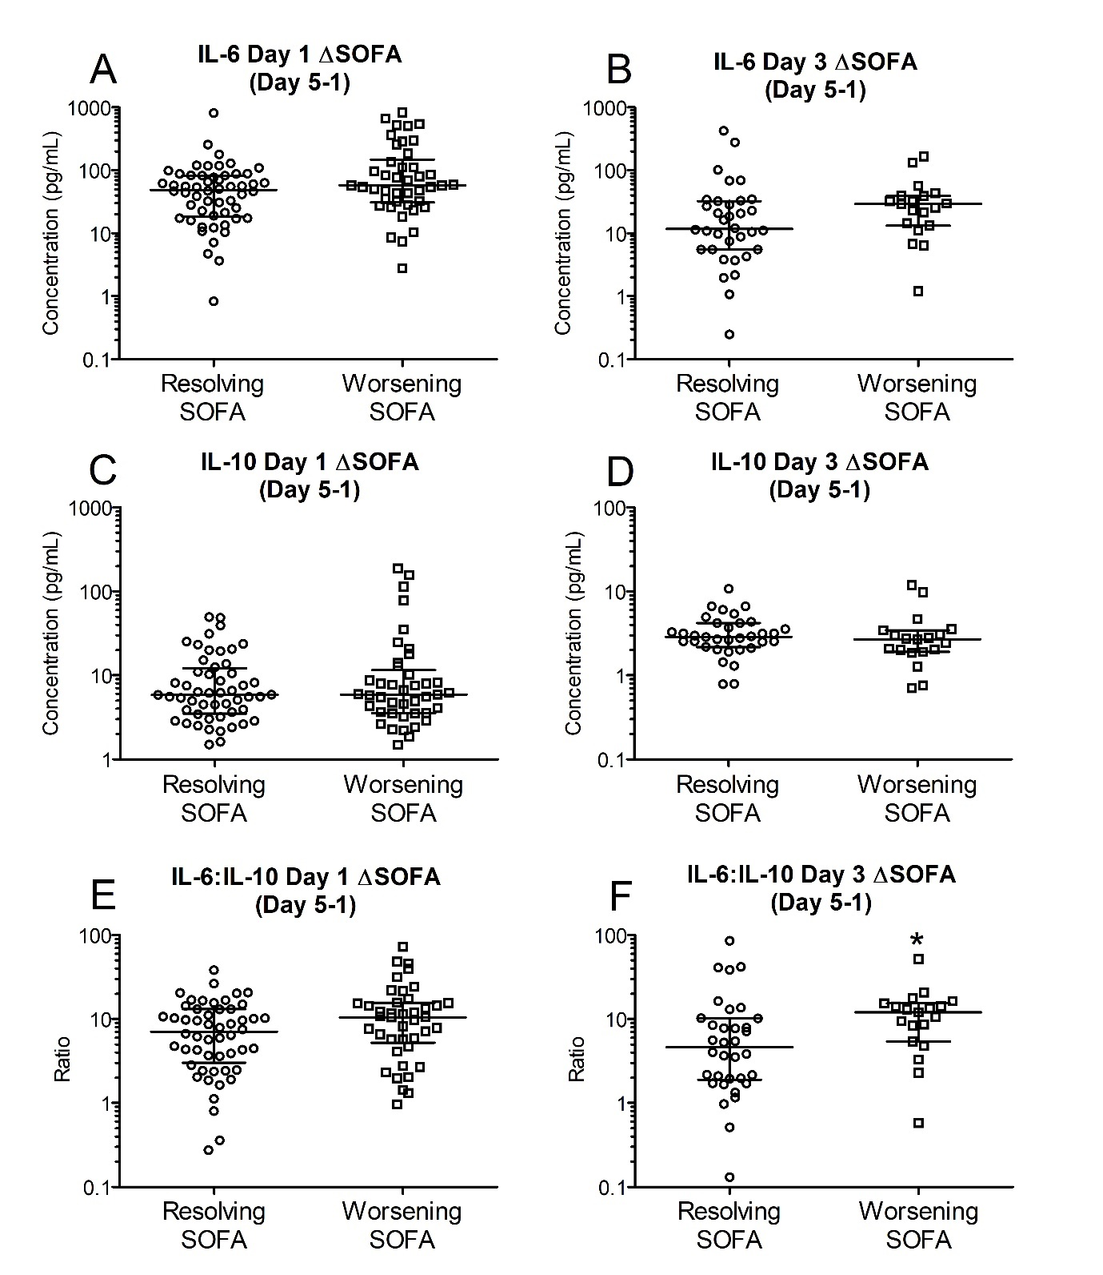 Supplementary Figure 5. Early (Day 1 and 3) IL-6, IL-10, and IL-6:IL-10 ratios in the two groups based on ΔSOFA at day 5 (SOFA _{Day 5}-SOFA _{Day 1})
Patients were retrospectively categorized according to their ΔSOFA (SOFA_{Day5} – SOFA_{Day1} score), creating two patient groups: ΔSOFA <0 (resolving clinical status) and ΔSOFA ≥0 (worsening clinical status). A-B. IL-6 levels on days 1 & 3 were not different between the two groups (Day 1: 48.93 [19.58-82.14] Vs 57.58 [32.17-129.94] pg/mL; n = 89, P =0.077); Day three: (11.71 [5.50-31.27] Vs 29.14 [13.83-39.20] pg/mL; n = 54, P =0.065). C-D. IL-10 levels on days 1&3 were not significantly different between the two groups (Day 1: 5.87 [3.01-10.57] Vs 6.68 [3.51-12.53] pg/mL, (n = 89, P =0.960); Day 3: 2.82 [1.93-3.42] Vs 2.69 [2.03-4.19] pg/mL (n = 54, P =0.278). E-F. The IL6:IL10 ratios on days one (7.11 [3.42-13.11] Vs 10.49 [5.74-15.49]; n = 87, P =0.0758) was not significantly different between the groups. IL6:IL-10 ratio on day 3 however was significantly greater in the group showing clinical deterioration (4.65 [1.95-9.77] Vs [6.88-14.73]; n = 52, P =0.014). Data presented as median [Interquatiles]. Statistical significance was determined using a Mann-Whitney U test. * = P <0.05.
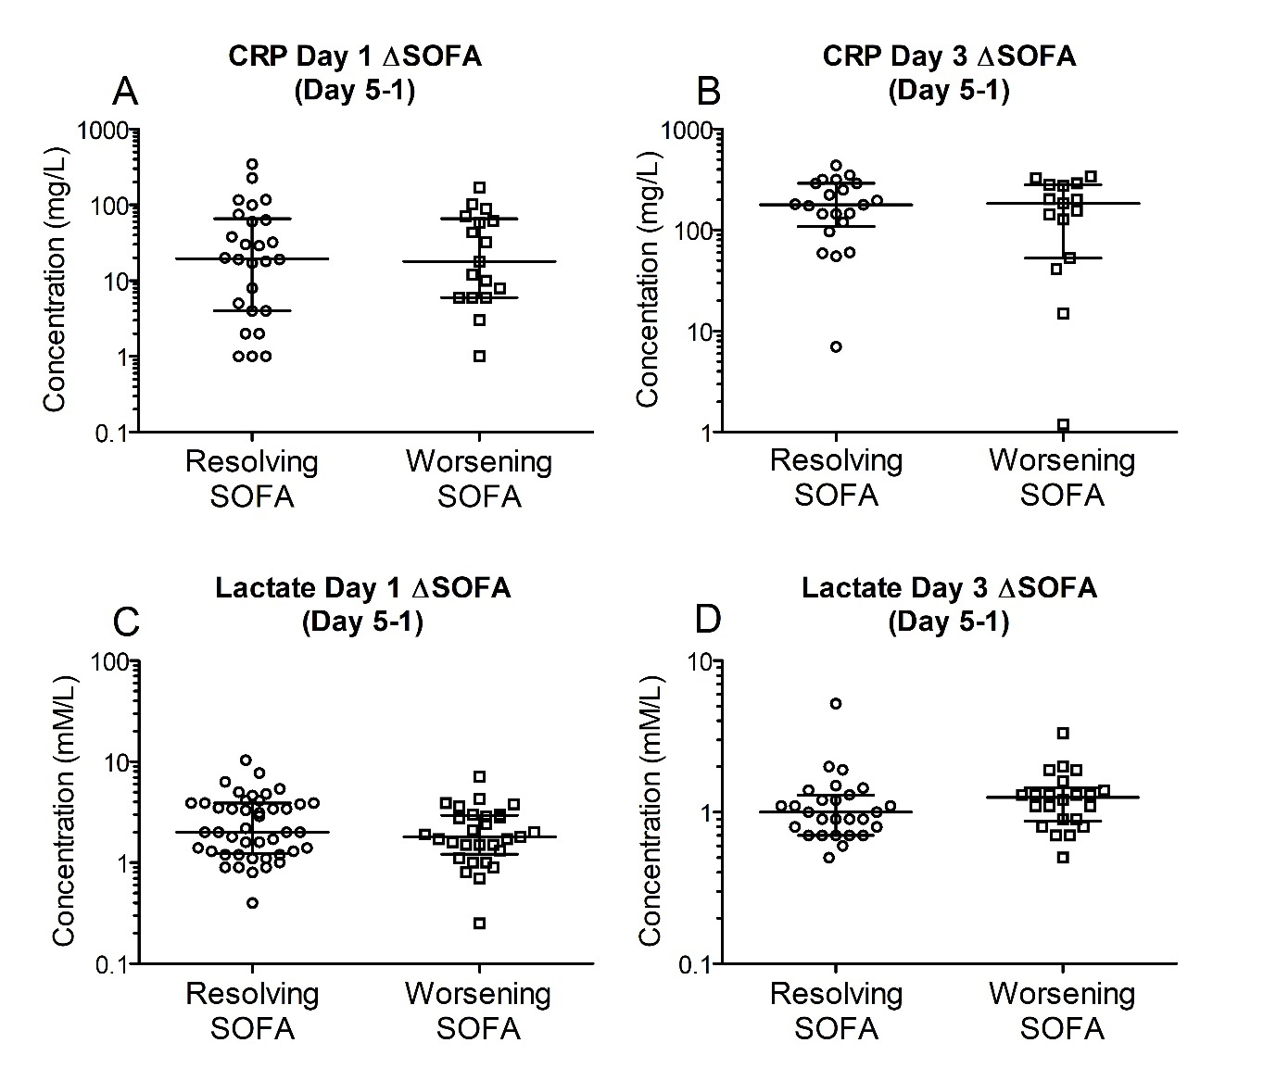Supplementary Figure 6. Early (Day 1 and 3) C-reactive protein and serum lactate levels were unable to differentiate between resolving and worsening patients.
Patients were retrospectively categorized according to their ΔSOFA (SOFA_{Day5} – SOFA_{Day1} score), creating two patient groups: ΔSOFA < 0 (resolving clinical status) and ΔSOFA ≥ 0 (worsening condition). A-B. C-reactive protein levels at days 1 and 3 were unable to differentiate between improving and deteriorating patient SOFA scores at day 5. C-D. Serum lactate levels at days 1 and 3 were unable to differentiate between improving and deteriorating patient SOFA scores at day 5.

