TABLE 1 and 2
TABLE 1 | The demographic and clinical features of cSCC patients with and without recurrence.
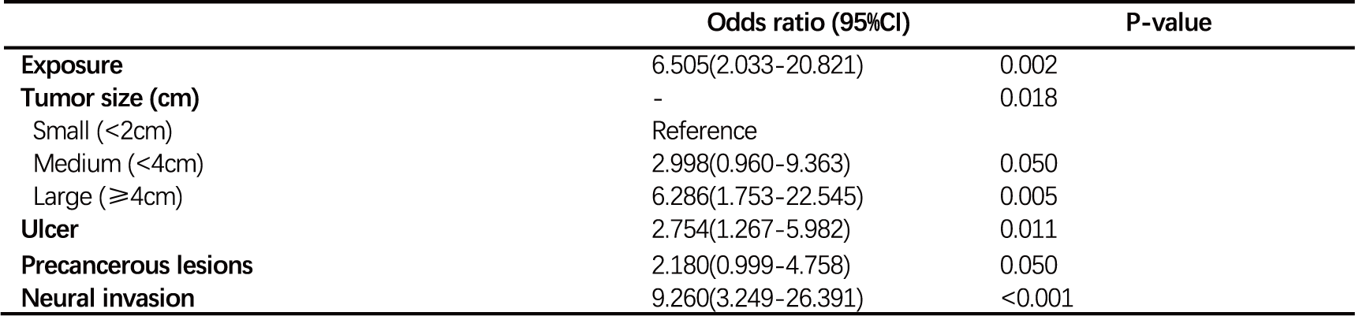
TABLE 2 | The multivariate logistic regression analysis of recurrence of cSCC.

