Supplementary Data

Harnessing plasma absorption in silicon MOS modulators

Weiwei Zhang ¹, Martin Ebert ¹, Ke Li ¹, Bigeng Chen ¹, Xingzhao Yan ¹, Han Du ¹, Mehdi Banakar ¹, Dehn T. Tran ¹, Callum G. Littlejohns ¹, Adam Scofield ², Guomin Yu ², Roshanak Shafiiha ², Aaron Zilkie ², Graham Reed ¹, David J. Thomson ^{1*}
1 Optoelectronics Research Centre, Zepler Institute for Photonics and Nanoelectronics, Faculty of Engineering and Physical Sciences, University of Southampton, Southampton SO17 1BJ, UK
2 Rockley Photonics, 234 E. Colorado Boulevard, Pasadena, California 91101, USA
*E-mail: D.Thomson@soton.ac.uk

Harnessing plasma absorption in silicon MOS modulators 1
Section-I Silicon MOSCAP resonator design and spectrum response. 2
Section-II MOS junction material. 6
Section-III Electrical response (S11) of the lumped MOS ring resonator 7
Section-IV Eye diagrams at different speeds 8
References 10

Section-I Silicon MOSCAP resonator design and spectrum response.
The optical mode confinement and electrically induced optical losses of silicon MOSCAP waveguides are simulated by using Lumerical software and analysed in comparison with experimental values in Fig.I-1. The simulated and experimental phase change efficiency V_{π}L and optical absorption losses are in agreement with each other.
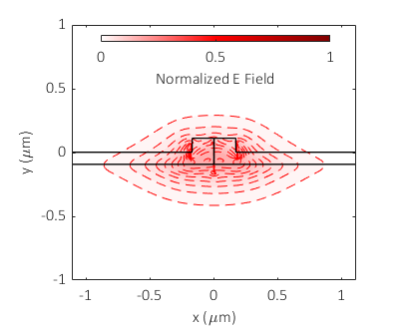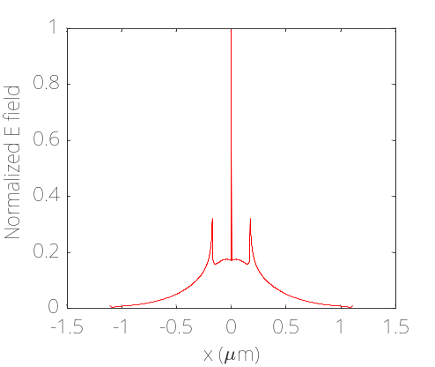
(e)
(c)
(c)
(d)
(b)
(a)
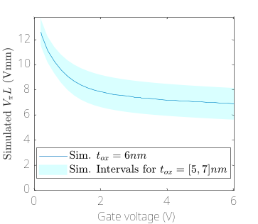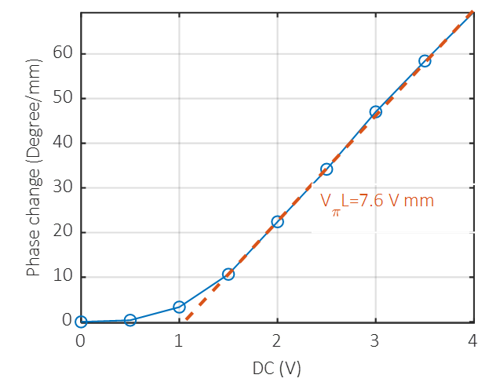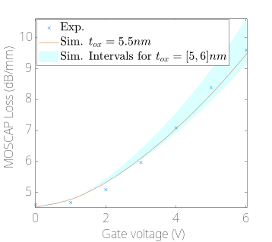

Fig. I-1, Simulation of silicon MOSCAP waveguide phase shifter. (a), Optical field confinement, (b) Electrical field distribution at y = 0.1 µm. (c) Simulated and experimental (d) phase change efficiency V_{π}L. (e) Simulated optical losses versus experimental loss.
A range of MOS ring resonators devices were fabricated with variations in the coupling gap between the bus waveguide and ring cavity in the range of 200 to 400 nm. As the widths of the gap increases the coupling strength decreases. The ER of the resonances at zero gate voltage are low due to over coupling when gap width is small. The ER becomes larger when the gap width is increased to 330 nm where critical coupling occurs. Beyond 330nm the ER decreases again due to weakened coupling (under coupling). The gate voltage induces an accumulation of free carriers that increase the loss within the resonators and changes the amount of coupled light that is required to achieve critical coupling. In figures I-2 (a,b) the ring with a gap width of 230nm is initially well over coupled, but as gate voltage is increased, the coupling condition becomes progressively closer to critical coupling. In figures I-2(c,d) the ring with a gap width of 280nm is initially slightly over coupled but with increases in the gate voltage the critical coupling condition is achieved and then the ring becomes under coupled with further increases in gate voltage. In figures I-2(e,f) the ring with a gap width of 330nm is initially close to being critically coupled and therefore with increases in the gate voltage the ring becomes progressively more under coupled.
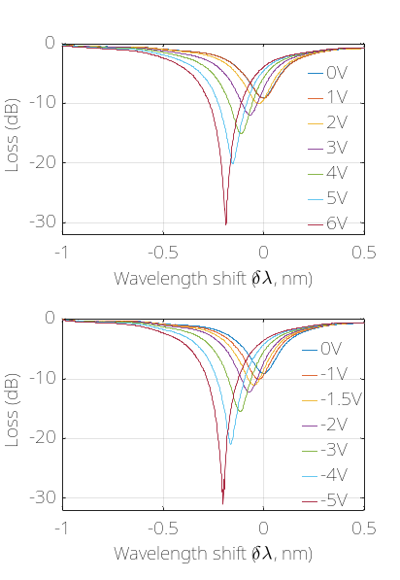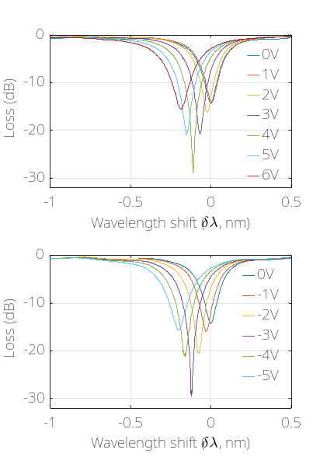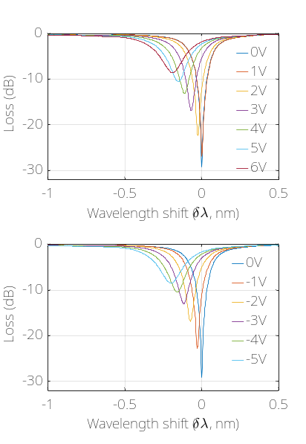
(b)
(f)
(d)
Gap = 330 nm
Gap = 230 nm
Gap = 280 nm
Gap = 330 nm
(e)
(c)
Gap = 280 nm
(a)
Gap = 230 nm
Fig. I-2, Carrier absorption induced coupling detuning for resonators with different gaps between bus waveguide and ring. (a,b), Resonator with a coupling gap of 230nm. The gate voltage induces detuning of the coupling condition from over coupling to critical coupling. (c,d), Resonator with a coupling gap 280nm. The gate voltage induces detuning of the coupling condition around critical coupling. (e,f) Resonator with a coupling gap 330nm. The gate voltage induces detuning of the coupling condition from critical coupling to weak coupling.
By fitting the data in figure I-2 using the ring transmission equation¹, the extracted propagation losses (α), single circulation amplitude attenuation factor of the ring (a) (defined as a²=exp(-α2πR)) and the self-coupling coefficient, t, between the ring and bus waveguide can be extracted. These are plotted in Fig. 1-3 as a function of the applied gate voltage for the three different coupling gaps.
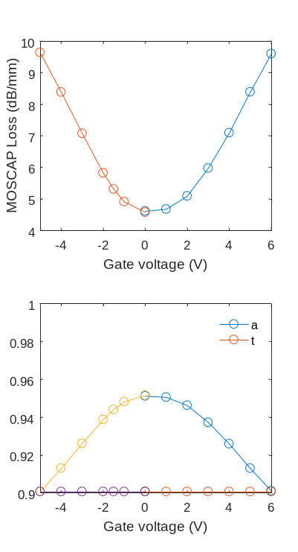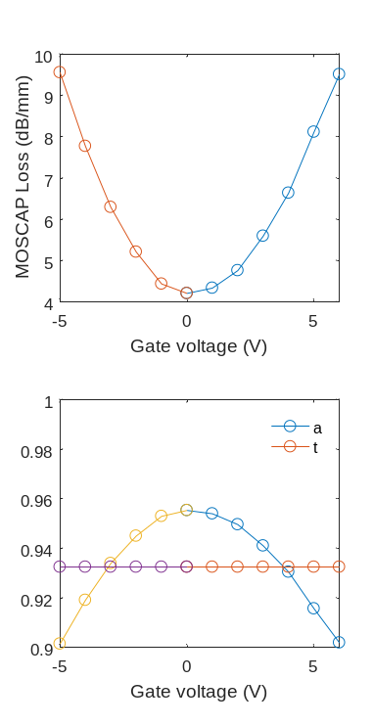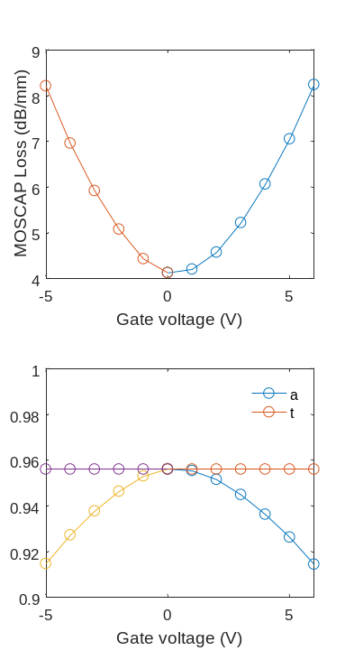
Gap = 280 nm
(d)
Gap = 230 nm
(b)
(a)
Gap = 230 nm
Gap = 280 nm
(c)
Gap = 330 nm
(e)
Gap = 330 nm
(f)
Fig. 1-3 Gate voltages VS MOSCAP ring propagation loss a and the self-coupling coefficient t for ring resonators with different gaps.

In Fig. I-4 the extinction ratio against wavelength for a range of gate voltages is plotted for the three gap widths. The extinction ratio variations are calculated by comparing to the spectral transmission with zero volts applied to the device. The ring resonators with over coupling typical have lower Q-factors, i.e. wider resonance widths and narrower coupling gaps. These rings clearly show a wider optical modulation bandwidth than rings with larger gaps, as shown in Fig. I-4.
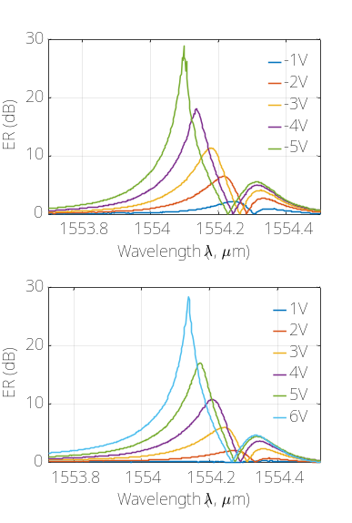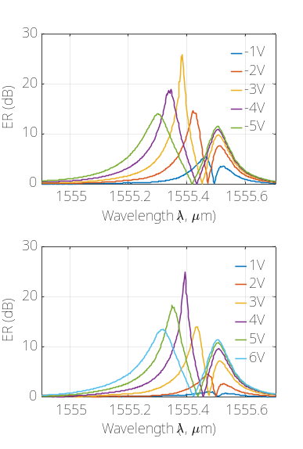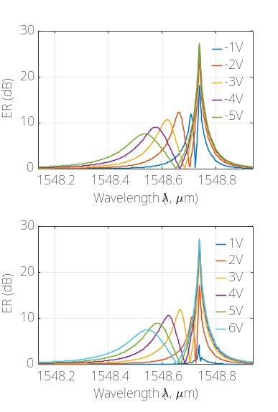
Gap = 330 nm
(e)
Gap = 330 nm
Gap = 280 nm
(c)
(b)
Gap = 230 nm
Gap = 230 nm
(a)
(f)
Gap = 280 nm
(d)
Fig. I-4, Intensity modulation ER at different gate voltages compared to zero gate voltage for resonators with different gaps between the bus waveguide and ring. (a,b), Resonator with a 230nm coupling gap. The gate voltage induces detuning of the coupling condition from over coupling to critical coupling. (c,d), Resonator with a coupling gap of 280nm. The gate voltage induces detuning of the coupling condition around critical coupling. (e,f) Resonator with a coupling gap of 330nm. The gate voltage induces detuning of the coupling condition from critical coupling to weak coupling. All figures are with a spectral window of 0.8nm.
For the ring resonators with the coupling coefficient that provides the highest sensitivity to the round trip loss of the cavity, the required change in gate voltage for high intensity modulation is reduced down to 3V as shown in Fig. I-5. The best performing ring from this perspective shows a carrier absorption induced ER change of 20 dB at resonance, and with the co-operation of carrier absorption and refraction an extinction ratio of 28.5 dB results at a wavelength of 1548.39 nm, when the Vg is changed from -1V to -4V.

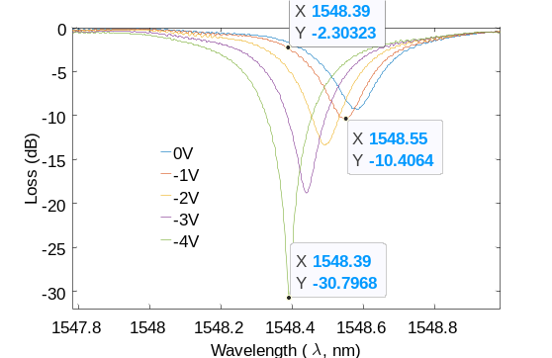
Fig. I-5 Carrier absorption induced ER change of 20 dB at the resonance; and Co-operation of carrier absorption and refraction induced ER change 28.5 dB of at a carrier wavelength of 1548.39 nm, when the Vg is changed from -1V to -4V.
Different rings with gap widths from 210nm to 250nm have a degree of varied performance in terms of the extinction ratio. However, overall all rings in this range show strong optical intensity absorption and detuning of the coupling condition across a wide optical spectrum within the C band, as shown in Fig. I-6.

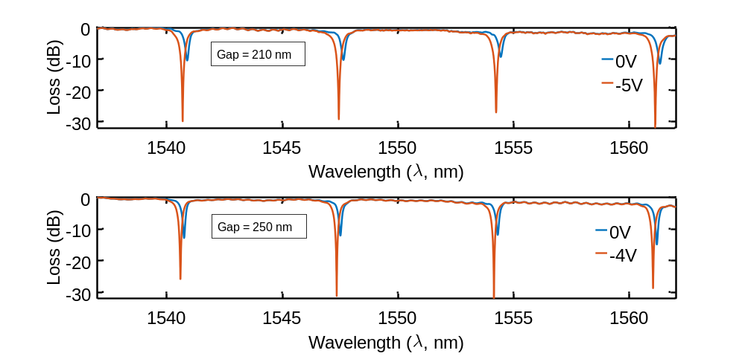
(b)
(a)
Fig. I-6 Strong intensity modulation has been observed for ring resonators with gap widths between the bus waveguide and ring waveguide from 210 nm to 250. The Gate voltage induces detuning of the coupling condition from over coupling to critical coupling.
Parasitic capacitance potentially exists in the MOS junction that usually induces an electrical hysteresis affecting the density of accumulated carriers and resulting in a hysteresis in the transmission of optical power. Optical wavelengths which give insertion losses of 6 dB and 12 dB were chosen for performing double direction gate voltage scans to check for the existence of optical hysteresis, as shown in Fig. I-7. For both wavelengths, no hysteresis has been found, which means that defect based carriers are negligible in the fabricated MOS devices.

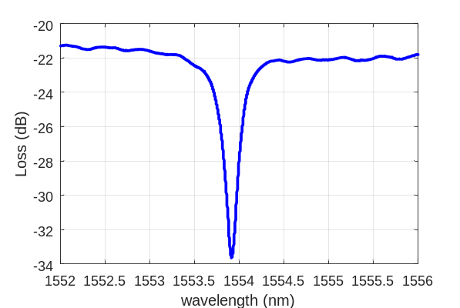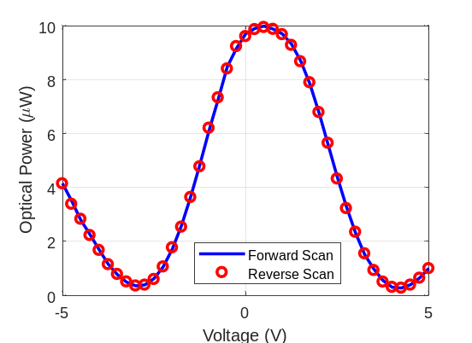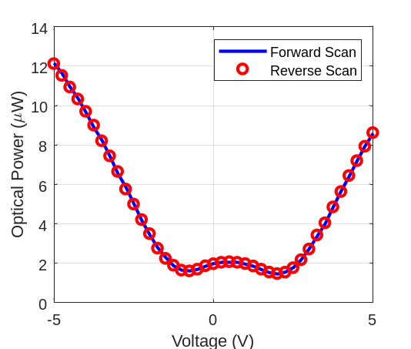
(c)
(b)
(a)
Fig. I-7 Optical hysteresis versus gate voltage verification. (a), One resonance of the ring cavity. Forward and backward gate voltage scan for a carrier wavelength with an insertion loss of (b) 6 dB and (c) 12 dB.
The MOS leakage current is below the detectable level 1pA for -4=<Vg <= 4V as shown in Fig. I-8. The leakage current is largely below 1nA across the range of voltages used for device characterisation -5V=<Vg<=6V.
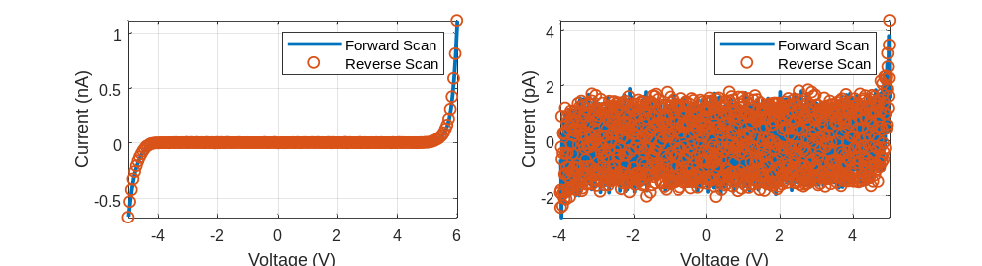
(b)
(a)
Fig. I-8 Measured current of the MOS junction from -5V to 5V (a) and -4V to 4V (b).

Section-II MOS junction material.
The insulator thickness has been analysed for the whole junction using transmission electron microscopy (TEM). Generally, a gradual decrease in width can be observed from the top to the bottom of the waveguide Fig. II-1. There is a small variation in the insulation thickness between the top and middle regions of the waveguide and a larger variation towards the bottom, where the value can be as small as 2.5 nm. For the majority of the insulator, the thickness is approximately 5 nm.
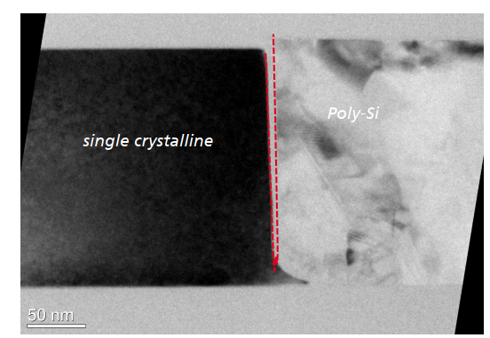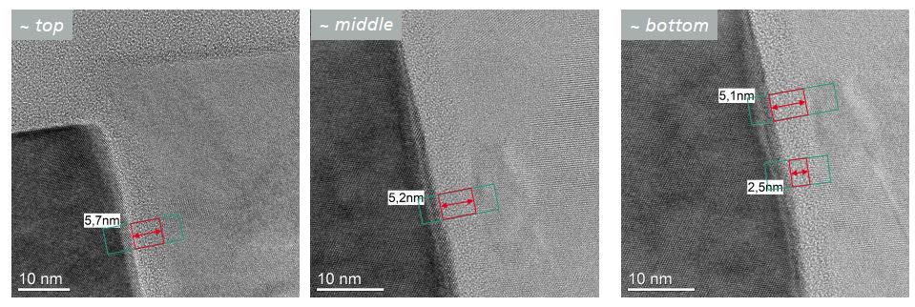
(d)
(c)
(b)
(a)
Fig. II-1. Insulator oxide thickness analysis of the MOS junction (a). Top (b), middle (c) and bottom (d).
The polysilicon grains are analysed again using TEM as shown in Fig.II-2. Grain sizes in a range of 10s to 100s of nm are observed.

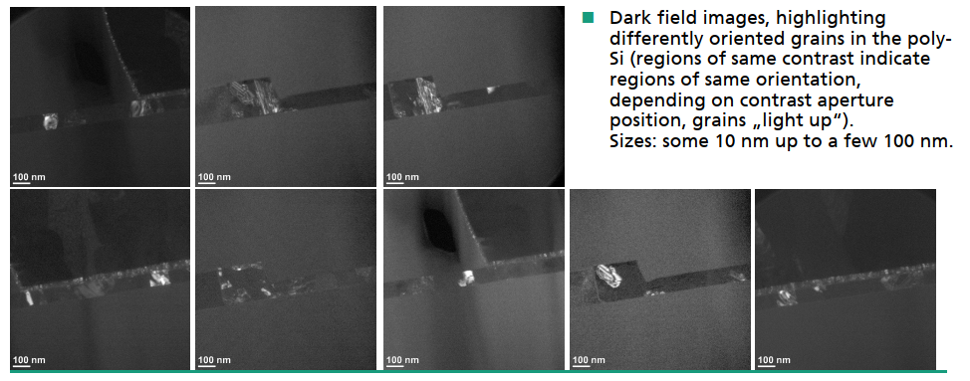
Fig. II-2. Analysis of grain size of polysilicon.

Section-III Electrical response (S11) of the lumped MOS ring resonator
The high frequency electrical response (S11) was characterised by using an Agilent E8361A 67GHz PNA after calibration. The real and imaginary S11 measurements are displayed in Fig. III-1 (a,b), at gate voltages of 0V and -5 V. The reverse bias at -5V in inversion mode typical doesn’t perturb the loaded capacitance in the MOS junction which is in contrast to the accumulation mode. The measured S11 responses are nearly the same for the two voltages.
An equivalent circuit model (Fig. III-1(c)) is used to fit the S11 response and the extracted parameters are summarised in Table. III-1. The parasitic capacitance, Cp is 1.55 fF, GSG metal pad induced capacitance, C_{pad} is 78 fF and the substrate resistance, R_{sub} is 15K Ω. The MOS resistance R_{mos} and capacitance C_{mos} are 37 Ω and 38 fF respectively in inversion mode resulting in an estimated RC circuit bandwidth, BW_{E} = ½πRC = 113 GHz.
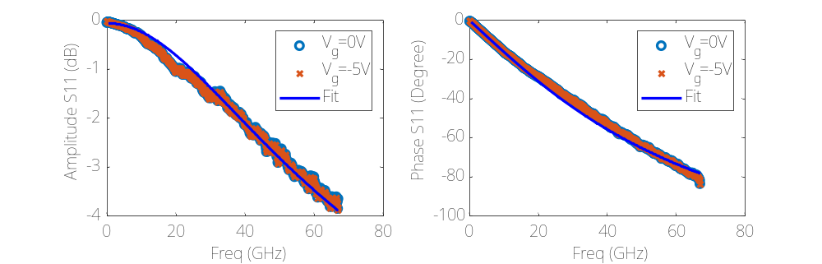
(b)
(a)
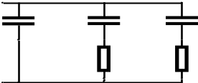
(c)
C_{p}
C_{pad}
C_{mos}
R_{mos}
R_{sub}
Fig. III-1. Analysis of grain size of polysilicon.
Table. III-1, Fitted parameters of S11 in Fig III-1(a,b) by using the equivalent circuits of Fig. III-1(c).
C_{mos} | R_{mos} | C_{pad} | R_{sub} | C_{p}
38 fF | 37 Ω | 78 fF | 15k Ω | 1.55 fF

Section-IV Eye diagrams at different speeds
For measurements in the inversion regime, Vg was set at -5V and the IL of the modulator was then changed from 3 dB to 9 dB by detuning the modulation wavelength close to the resonance where the EO bandwidth is decreased due to photon lifetime restrictions. In Fig. IV-1, the measured the EO bandwidth is ≥ 60 GHz when the IL is ≤ 9 dB. Modulation resonance peaking occurs in the frequency range from 30 GHz to 60 GHz and is dependent on the IL level as shown in Fig. IV-1. The high EO bandwidth benefits from a low loaded capacitance in high frequency of inversion mode as discussed above, which is about 38 fF. This demonstrates that if the capacitance of the device restricted < 40 fF then the rest of the electrical structure including the polysilicon section of the device are suitable to support high speed operation.
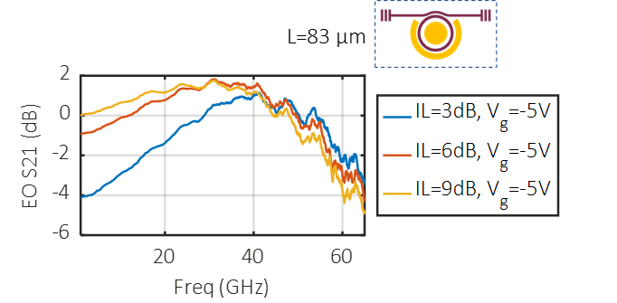
Fig. IV-1 EO bandwidths of inversion and accumulation modes . (d, e) Measured EO bandwidth of the MOS ring resonator modulator with Vg at 1V, 2V and -5V width different insertion loss.

Small signal data transmission measurements of the MOSCAP ring modulator were performed by driving the device directly from the MUX (60 GHz RF amplifier removed). The measured high-speed eye diagrams are summarized in Fig. IV-2. The eye shapes are open for both inversion and accumulation modes up to a data rate off 100 Gb/s without any FFE.

For the cases of Fig. IV-2.a-c, the Vg=-5V and loaded Q-factor is about 3,500. While for accumulation mode, high bias voltages increased the loaded capacitance of the MOS junctions when reducing the Q-factor. Therefore, for the same device, the accumulation mode should be driven at low bias voltage ~1V with higher Q-factor in comparison with situations of inversion mode. Hence, we here show the measured optical waveforms in accumulation mode with low Vg=1V and IL = 3 dB for Q-factor about 4600, which allows open eye up to 100 Gb/s. The inversion mode allows high bias voltage and IL up to 9dB. The eye shapes are closing with higher IL as compared between Fig. IV-2.b and c.

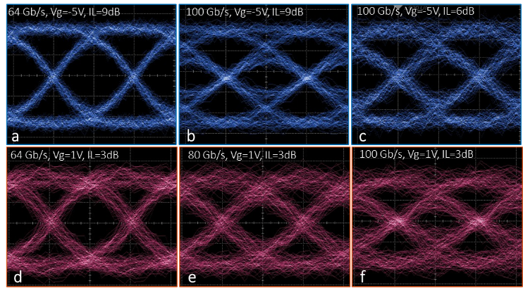
Fig. IV-2 Small signal Eye diagram of inversion and accumulation modes. (a-c), Optical eye in inversion mode with Vg=-5V, and data rates of 64 Gb/s and 100 Gb/s. The waveform of (b) obtained with higher IL 9dB shows eye closing in comparison with (c), with IL 6dB. The obtained waveforms of accumulation modes are (d-f) with open eyes up to 100 Gb/s in agreement with EO bandwidth results.
Fig. IV-3 summarizes the optical eye diagrams at 64 Gb/s, 100 Gb/s and 112 Gb/s by large RF signal driving. In accumulation mode, we have obtained a data rate up to 64 Gb/s for V_{g} = 0.9 V in Fig. IV-3.a for comparison. For reverse biasing in the inversion mode, we set a large bias of Vg = -5 V. Open eye diagrams up to 112Gb/s can be measured. To ensure a dynamic ER of at least 3dB, the IL has to be adjusted to 6dB and 9dB at one levels of the inner eyes for data rates of 64Gb/s and 100Gb/s respectively. The inner eyes are more closed at 100 Gb/s with an IL of 9dB since the modulation wavelength is closer to resonance wavelength, which leads to an EO bandwidth reduction. The IL loss is strictly calculated with reference to the average power before EDFA amplification and with the RF signal applied so as to ensure accurate measurement. The SNR for 64 Gb/s reaches 5.1 in comparison with 5.6 for the input RF signal. The crossing points of the 100 Gb/s and 112Gb/s eye diagrams are lower than 50% due to the high IL loss operating point.
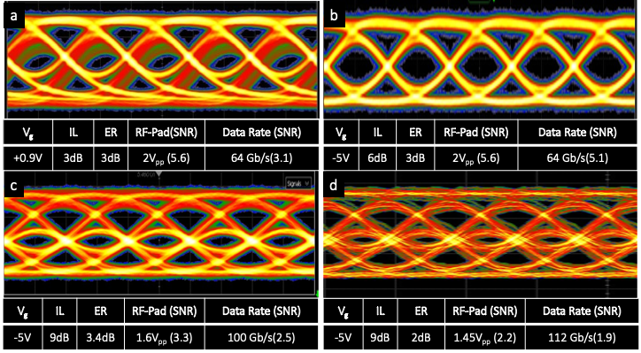
Fig. IV-3 Large signal Eye diagram. Measured optical eye diagrams with an OOK-NRZ input signal of 64 Gb/s (a) in MOS accumulation mode and (b) 64 Gb/s (c), 100 Gb/s (d) and 112 Gb/s in MOS inversion mode.

The signal quality at 100 Gaud is very sensitive to carrier wavelength (ILs), original RF signal quality, RF probe to metal pad attachment, RF passive bias tee and probe losses and dispersions, as well as impedance matching at end of the probe tip to the device. In our test, no pre-equalization is applied to compensate for the RF link bandwidth limitations ², which requires the use of a high bandwidth arbitrary waveform generator (AWG). Besides, the eye diagram measurements were performed without any thermal control of the chips. Typically a one degree temperature change can degrade the eye shape and modulation ER ³ in ring modulators, and therefore improved eye diagrams could be expected with thermal control. A previous demonstrations of the use of an integrated thermal control loop circuit has shown a temperature noise constraint <0.4 K and has allowed an experimental dynamic ER of 2.23 dB to be achieved which is close to the DC static ER of 3dB ⁴ at 64Gbuad (PAM4 format). Wavelength locking and thermal tuning techniques ^{5,6} must be applied to the MOS ring modulator in the future for pursuing high performance modulation. It is expected that the quality of the optical eye diagrams (in terms of ER, SNR) can also be improved significantly by flip-chip bonding dedicated CMOS drivers and thermal control loop circuits onto the modulators ⁷.

References

1. Nitkowski, A., Chen, L. & Lipson, M. Cavity-enhanced on-chip absorption spectroscopy using microring resonators. Opt. Express 16, 11930 (2008).
2. Sun, J. et al. A 128 Gb/s PAM4 Silicon Microring Modulator With Integrated Thermo-Optic Resonance Tuning. J. Light. Technol. 37, 110–115 (2019).
3. Kim, M. et al. Silicon electronic–photonic integrated 25 Gb/s ring modulator transmitter with a built-in temperature controller. Photonics Res. 9, 507 (2021).
4. Li, H. et al. A 3-D-Integrated Silicon Photonic Microring-Based 112-Gb/s PAM-4 Transmitter with Nonlinear Equalization and Thermal Control. IEEE J. Solid-State Circuits 56, 19–29 (2021).
5. Agarwal, S. et al. Wavelength Locking of a Si Ring Modulator Using an Integrated Drop-Port OMA Monitoring Circuit. IEEE J. Solid-State Circuits 51, 2328–2344 (2016).
6. Sun, C. et al. A 45 nm CMOS-SOI Monolithic Photonics Platform With Bit-Statistics-Based Resonant Microring Thermal Tuning. IEEE J. Solid-State Circuits 51, 893–907 (2016).
7. Li, K. et al. Electronic–photonic convergence for silicon photonics transmitters beyond 100 Gbps on–off keying. Optica 7, 1514 (2020).

